Chapter 4:
- Overview of CV system
- Path of blood flow
- Anatomy of the heart
- Conduction system of the heart

- CV system composed of the blood, blood vessels, & heart.

Introduction to Cardiovascular System

Pulmonary Circuit
- Carries blood to and from gas exchange surfaces of lungs
Systemic Circuit
- Carries blood to and from the body

Atria (collecting chambers)
- Receive blood from veins
Ventricles (pumps)
- Pumps blood to arteries

↑ separated by a fibrous skeleton w/valves

Right side of heart
- Deals with pulmonary circuit
Left side of heart
- Deals with systemic circuit

Deoxygenated blood goes to lungs, and returns to the left side of the heart to be pumped in the systemic circuit, and transported to the rest of the body
Sequence goes → Right atria, right ventricle, left atria, left ventricle

The right atrium - receives blood from
- Superior vena cava
- Receives blood from head, neck, upper limbs, and chest
- Inferior vena cava
- Receives blood from trunk, viscera, and lower limbs
- Coronary sinus
- Cardiac veins return blood to coronary sinus
- Coronary sinus opens into right atrium

Anatomy of the Heart – Right Ventricle
- Connected to the right atrium by the right atrioventricular (AV) valve, or tricuspid valve
- Receives blood from the right atria and pumps it through the pulmonary circulation

Anatomy of the Heart – Left Atrium
- Blood from the pulmonary veins is delivered to the left atrium
- Blood from the left atrium passes to left ventricle through left atrioventricular (AV) valve
- A two-cusped bicuspid or mitral valve

Anatomy of the Heart – Left Ventricle
- Holds same volume as right ventricle
- Is larger; muscle is thicker and more powerful
Systemic circulation
- Blood leaves left ventricle through aortic valve into ascending aorta
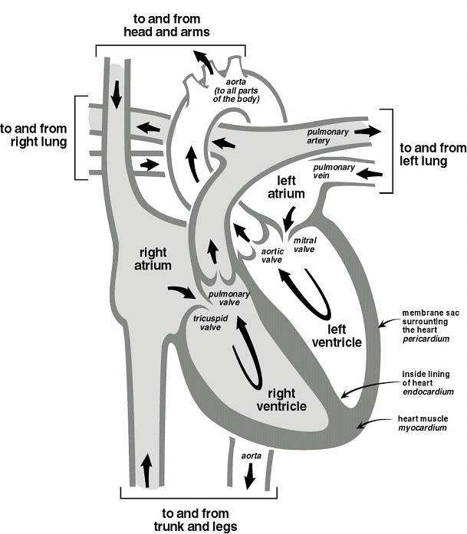
- Ascending aorta turns (aortic arch) and becomes descending aorta

If you were an
erythrocyte,
what structures
would you
pass through?
(blood flow)

Anatomy of the Heart –
Coronary Circulation
- Blood Supply to the Heart

Coronary Arteries
- Originate at aortic sinuses
Coronary Veins
- Drain into right atrium

Circumflex coronary artery can be blocked
Myocardial infarction – Heart attack

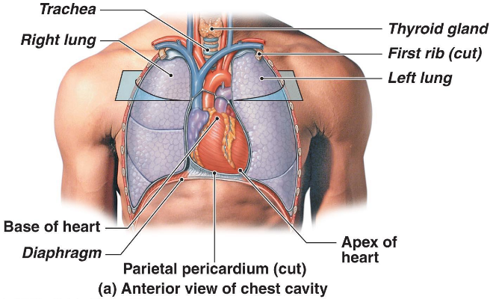

Location of the Heart in Thoracic Cavity

Heart is located in a sac called a pericardium
Pericarditis – Inflammation

Pericardium
- A double-layered fluid-filled sac

Anatomy of the Heart - Heart Wall
- Epicardium (outer layer)
- Myocardium (middle layer)
- Endocardium (inner layer)

Anatomy of the Heart – Cardiac Muscle cells

Two types
- Conducting system
- Controls and coordinates heartbeat
- Contractile cells
- Produce contractions that propel blood

- Intercalated discs
- Interconnect cardiac muscle cells
- Linked by gap junctions (allow fast conduction of signals)
- Convey force of contraction
- Propagate action potentials
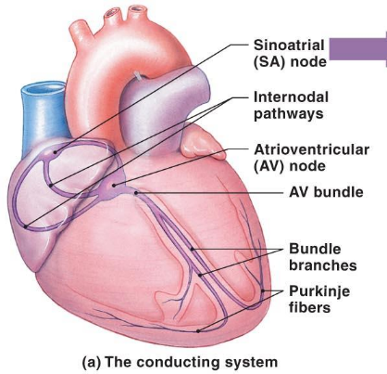
We want the whole muscle to contract, from the bottom up at the same time, so it functions as a pump.

Anatomy of the Heart – Heart Valves
- Septum
- AV valves
- Bicuspid
- Tricuspid
- Pulmonary valve
- Aortic valve
- Subvalvular apparatus
- Papillary muscles
- Chordae tendinae
  - No atrial valves?
The venous system already has valves

As soon as the pressure in the ventricle drops, the blood rushes in and the valve flaps separate

Good vs Bad Hypertrophy
- In real life, the heart is somewhat twisted.

Sometimes, the left ventricle will hypertrophy.

In athletes
- Increase of up to 60% in V-mass (mostly left)
- Increase in performance

In people with hypertension
- Increase of up to 150% in V-mass
- No increase in performance

Cardiac vs Skeletal Muscle
Cardiac Muscle | Skeletal Muscle
Actin and myosin | Actin and myosin
Self-innervated | Requires innervation
Contain intercalated discs | No intercalated discs
Branched | Linear
Highly oxidative | Depends upon fiber type

Comparison of types of muscle
Check Table 12.2 in the textbook

Structure of the Conducting System

Pacemaker cells
- Sinoatrial (SA) node
- Atrioventricular (AV) node
Conduction fibres
- Internodal pathways
- Bundles of His (AV Bundle)
- Purkinje Fibers

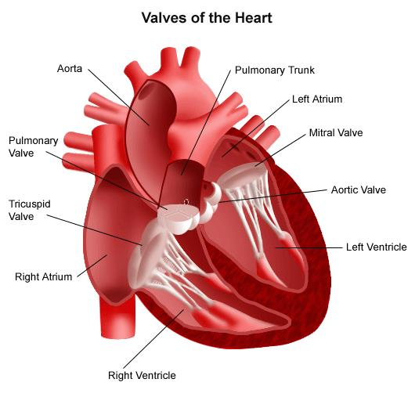
Cardiac vs Skeletal Muscle – Action Potentials
Cardiac Muscle | Skeletal Muscle
Self-potentiating | Requires innervation
Continuous (no resting potential) | Rests (Resting potential: -70 mV)
Threshold: -40 mV | Threshold: -55 mV
Peak polarization:  +20 to +30 mV | Peak polarization +30 mV
Lowest polarization:  -60 to -80 mV | Lowest polarization:  -80 mV

The Conducting System
Heart Rate
- SA node generates 80-100 APs/minute
- AV node generates 40-60 APs/minute
- Regulated by CNS innervation during normal rest and exercise
- If SA node is not working properly, AV node can take over as pacemaker

The Conducting System
Step 1:
- SA node full of modified cardiac muscle cells, create AP

Step 2:
- AP generated at the SA node. Spreads to both atria by cell-cell contact
- Stimulus only affects the atria because they are isolated from the ventricles
- AP spreads fast enough that both atria contract at the same time

Step 3:
- Delay through AV node is due to…
- Nodal cells being smaller in diameter than the conducting cells
- Connection between conducting and nodal cells is less efficient than between conducting cells

(Importance: Allows sufficient time for the atria to contract before the ventricles do, which
would close the AV valves)

Step 4:
- The impulse travels along the IV septum along the AV bundle and the bundle branches to the Purkinje fibers and to papillary muscles of right ventricle (via the moderator band)

Step 5:
- Impulse distributed by Purkinje fibers, relayed throughout the ventricular myocardium. Atrial contraction is completed, ventricular contraction begins

The Contractile Cells - Refractory Period
Advantage?
- Need time for heart to relax, and fill with blood

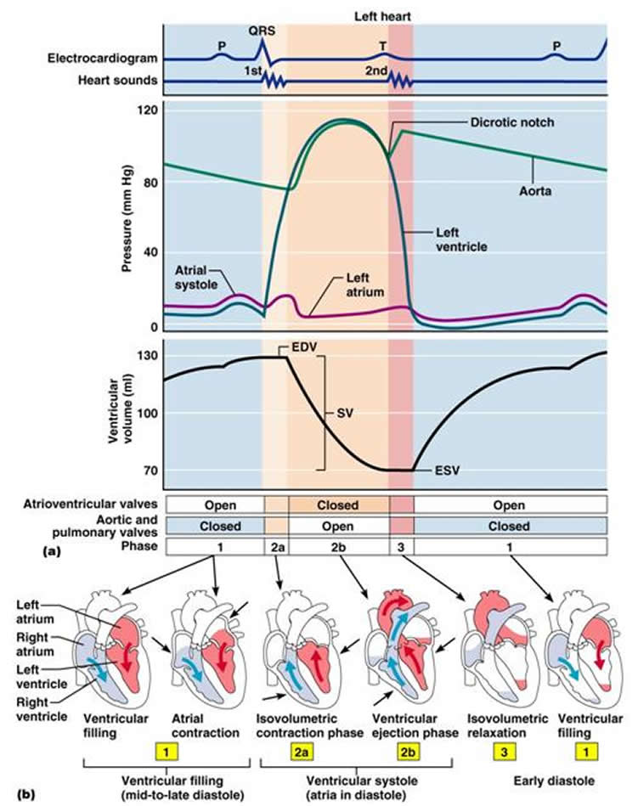
Meaning of Electrocardiography (ECG) (watch vid on slide 30)

