Stuff on lecture slides will be emphasized on the exam.

Steps in metabolism of glucose that are anaerobic: The Krebs Cycle, and glycolysis

Summary of Glucose Oxidation:
Glucose + 6 Oxygen + 38ADP + 38 Pi 6 CO2 + 6 H20 + 38ATP
Oxgyen actually goes into water
CO2 is split off from the glucose

Metabolic pathways involved in protein
Low carb diet protein breakdown, amino acids go into pyruvate/Acetyl CoA

10 PCr and 5 mols of Glucose, 5 mols of Glycogen, how much ATP yield in the presence of oxygen

10PCr (CP) = 1ATP x 10mol = 10 ATP
5 Glycogen = 3ATP x 5mol = 15 ATP
2ATP x 5 Glucose = 10 ATP

So far: 45 ATP
- Afterwards, Glycogen will act same as glucose.
- Krebs Cycle: 2ATP x (5 Glucose + 5 Glycogen) = 20 ATP

ETC (Oxidative Phosphorylation): 34 ATP x (5 Glucose + 5 Glycogen) = 340 ATP

PG – 1 ATP
1 Glucose – 38 ATP
1 Glycogen – 39 ATP

If no oxygen, then take the 340 ATP away.

Recap: Energetics
- Pyruvate Acid can temporarily receive some H ions, and turns into lactic acid
- Exercise harder Need more ATP. You may not have enough O2 right away.

Lactic Acid (C₂H₄OHCOOH) releases a hydrogen ion and, combined with sodium and potassium, forms Lactate
See an increase of lactic acid in the blood. When this happens, it is called lactate threshold.
- Highest concentration of lactic acid which you can maintain. Any higher, have to go into anaerobic glycolysis

If an athlete is well trained, VO2 max (max oxygen) increases. Measured as a % (% of their maximum). They can use higher % of VO2max when going for a run (ex), more Oxygen used than untrained person.

Part of VO2max is increased availability of oxygen. More mitochondria More muscles that can take up oxygen.
Capillaries oxygen rich blood moves around
Enzymes break down

Better ability to break down lactic acid, and better ability to use oxygen (uptake). Usually more efficient in exercising Less ATP required, less lactic acid production

Energy Sources During Exercise
Light exercise: After 1 ½ minutes, most energy will come from anaerobic glycolysis.
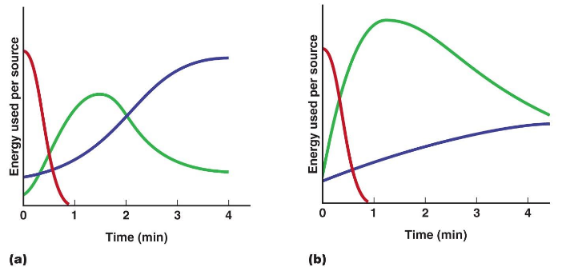

1st – CP,2nd – Anaerobic Glycolysis, 3rd – Oxidative Phosphorylation

Intense: CP depleted within a minute (same as light exercise), anerobic glycolysis yields energy quickly

Need to be aerobically fit also, to clear lactic acid quickly (especially if exercising soon afterwards)

Recovery and Resting
- After exercise has concluded, the muscle restores depleted energy stores used during exercise
- “Repaying the oxygen debt”

Can lower heart rate quickly as well, if trained
1. Lactic Acid present in the cell is converted into Pyruvic acid via the cori cycle (in the liver), 30% of which then enters the Krebs Cycle producing ATP
2. This ATP is then used to
a. rephosphorylate creatine into PCr;
b. convert the remaining Pyruvic acid
into glucose
3. Glycogen is synthesized from glucose molecules in the blood
4. Oxygen from the blood binds to myoglobin in the muscle cell

Muscle Fiber Types
- Slow-twitch, Type I (~50%) – Typically not as strong
- Fast-twitch, Type II (~50%)
- Type IIa (25%) – intermediate
- Type IIx in humans (~25%) ~ IIb in animals
- The percentage of each fiber type is variable among muscles, among individuals, and with exercise training

Glycolysis – Fast twitch. Have more enzymes, specialized in glycolysis.
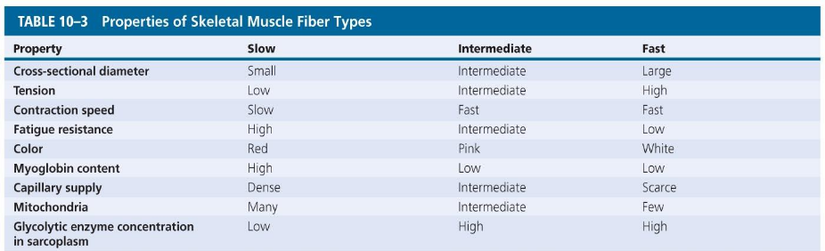

Krebs Cycle and oxidative phosphorylation: Slow twitch, Glycolysis – Fast?
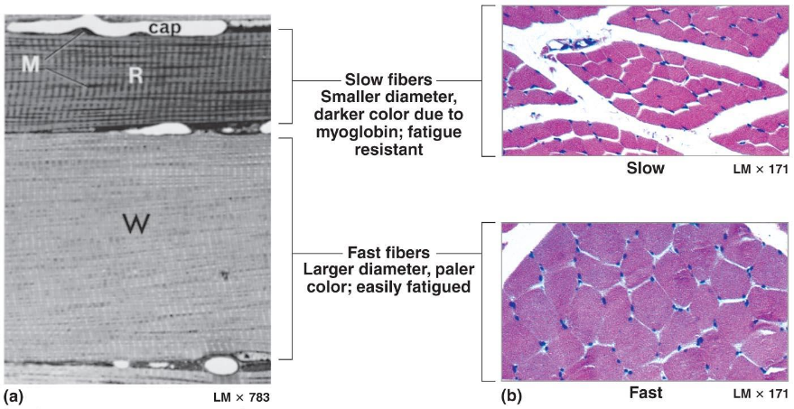
Fast vs Slow Muscle Fibers

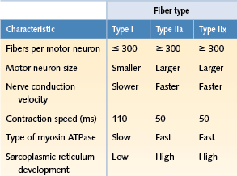
White muscle
- Mostly fast fibers
- Pale (e.g., chicken breast)
Red muscle
- Mostly slow fibers
- Dark (e.g., chicken legs)
Most human muscles
- Mixed fibers
- Pink

Humans typically have a mixture
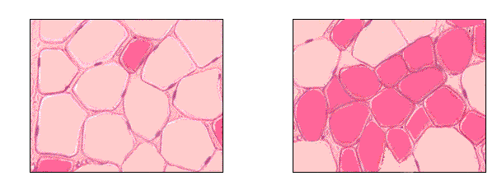

Sprinter – fast twitch, left (lighter, larger cells) produce ATP at high rate for short period of time. Marathon runner (right) needs to produce lower ATP faster and be more fatigue resistant

Muscle Hypertrophy
- Increases diameter of muscle fibers
- Increases number of myofibrils
- Increases mitochondria, glycogen reserves

Muscle Atrophy
- Lack of muscle activity
- Reduces muscle size, tone, and power

Determination of Fiber Type
- Fiber type is genetically determined (twin studies)
- Fiber type is determined by the a-motor neuron that innervates the muscle fibers
- Endurance training, strength training, and muscular inactivity may cause a shift in myosin isoforms
- Exercise training ↓ type IIx, ↑ type IIa
- Aging may shift the relative distribution of type I and type II fibers
- ↓ type II and ↑ type I

