Midterm – Chapter 1-3
- Calcium ions are in terminal cisternae at rest
- During muscular contraction, the length of sarcomeres decrease

AP - Brief reversal of charge that moves along a
nerve axon
- This is a change from the resting membrane potential
- The ions primarily responsible for membrane polarity in neurons are potassium (K+) and sodium (Na+

Electrical Potential -
Same amount of positive and negative ions on both sides of membrane – Neutral Transmembrane Potential

- Some proteins in the membrane allow ions to exit cell (e.g. K⁺ Leak Channels)
- Na⁺ Leak Channels allow ions to enter the cells

Transmembrane Potential:
More positive ions outside than inside, membrane potential is negative.

More positive ions inside than outside, membrane potential is positive.

If transmembrane potential is negative, what direction is the electrical driving force for:
- Sodium (Na⁺) – wants to go in
- Potassium (K⁺) – wants to go out
- Chloride (Cl⁺) – wants to go in
- Calcium (Ca²⁺) – wants to go in

What is the direction of chemical driving force (depend on concentration of the ions) for the ions in this table. Also rank them in terms of strength
- Potassium – Inside to outside
- Sodium – Outside to inside
- Chlorine – Outside to inside
- Calcium – Outside to inside
- Magnesium – Outside to inside
Largest difference in concentration (Potassium), will have highest potential to move

Recap: Electrical & Chemical Driving Forces (work together)

For 100 units of K+ and 100 units of Na+ what is
- Net chemical gradient for each substance?
- Net electrical gradient
- Would this transmembrane potential be positive or negative

Potassium is more likely to move across membrane, larger charge
(Subtract outside from inside cell to find difference)

Ion Channels – Sodium/Potassium Pump
- 3 sodium out of cell, 2 potassium into it

It pumps sodium ions from low to high concentration, and takes potassium from high to low, and creates an electrical gradient. Important for transmembrane potential

Chemical gradient (Potassium leak channel) allowing potassium to exit cell, going from high to low concentration. Inside of cell will eventually become more negative than the outside
- More open channels for potassium than sodium. Membrane is more permeable

Resting Membrane Poential (RMP)
- Difference between electrical charges inside and outside, caused by separation of charges across the cell membrane
- High concentration of potassium inside of the neuron and sodium on the outside of the neuron
- Cell is more permeable to potassium, thus potassium ions can move more freely
- In an attempt to establish equilibrium, K⁺ will move outside the cell
- RMP is maintained at -70mV

Ion Channels
- Chemically regulated ion channels (dendrites and soma)
- Voltage-regulated channels (along the axon)

As the voltage changes, more channels are opened
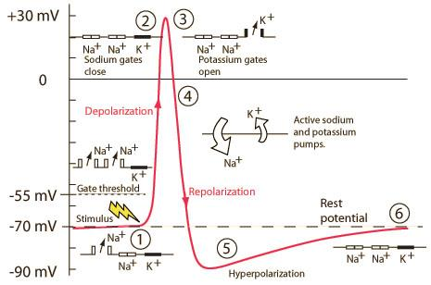

Graded Potentials
- Spread of positive charged ions inside cell membrane produces local current that depolarizes adjacent area
- But it is not propagated along the length of the axon until a threshold voltage is reached (typically -55mV)
- The voltage activated sodium channel would be activated

Action Potential Step

Know how to draw what is going on!
(Electrically stimulated things, voltage channels open, potassium activated, pumps reverse charges, both channels then become locked then unlocked)

Changes in Membrane Potential
- Depolarization occurs when inside of cell becomes less negative relative to outside and is caused by a change in the membrane’s Na⁺ permeability (> –70 mV)
- Hyperpolarization occurs when inside of cell becomes more negative relative to outside (< –70 mV)
- Graded potentials are localized changes in membrane potential (either depolarization or hyperpolarization)
- Action potentials are rapid, substantial depolarizations of the cell membrane (–70 mV → +30 mV → –70 mV in 1 ms)

An action potential runs only one way, because there is a refractory period where channels are locked that just activated

