Comm 223: Marketing Management

Chapter 2: Company and Marketing Strategy
Partnering to build customer relationships.

- A strategic planning is the process of developing a connection between?
  - The companies’ goals,
  - Capabilities
  - And changing marketing opportunities.

- The goal of the strategic planning is to take advantage of
  - Opportunities in a changing environment.

- The Mission statement is the organization’s
  - Purpose

- Market-oriented mission statements want to?
  - Satisfy customer needs.

- It emphasizes the company’s?
  - Strengths in the marketplace

- Product- oriented plans state states more what the companies is?
  - Making

- Market oriented emphasize more on the ________?
  - Experience

- When setting company objectives and Goals the business objectives want to? (3)
  - Build Profitable customer relationships
  - Invest in research
  - Improve Profits

- When setting company objectives and Goals the marketing objectives want to? (3)
  - Increase market share
  - Create local partnerships
  - Increase Promotion

- The business portfolio is all the? (2)
  - Businesses
  - Products in the company

- The best portfolios are the portfolios that best fits the company’s ______ & _____ to _______ (3)?
  - Weaknesses
  - Strengths
  - Opportunities in the environment

- The portfolio analysis is when management?
  - Evaluates business and products that make up the company

- An SBU is know for?
  - Strategic business unit

- A strategic Business Unit is unit in a company which has different? (2)
  - Missions
  - Objectives

- They could be? (3)
  - Product line
  - Company division
  - Brand

- The growth market share Matrix evaluates
  - SBU in terms of (2)
    - Market growth share
    - Market share
- What are the 4 categories of the Matrix?
  - Star
  - Cash cows
  - Dogs
  - Question mark

- Draw the Matrix
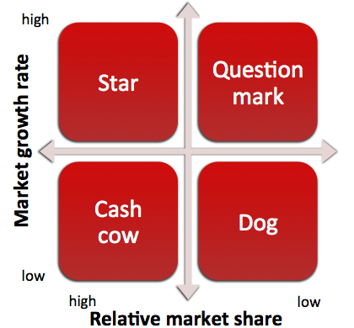

- Stars are? (2)
  - High growth, high share

- They need heavy
  - Investments to finance
    - Rapid growth

- Question market have?
  - High growth rate, low market share
    - They require?
      - A lot of cash to maintain share

- Cash cows are?
  - Low growth rate, high market share
    - Ex: Google
  - They are successful and well established therefor they need less
    - Investments to hold their share

- Dogs are?
  - Low growth rate, low market share

- One of the problems with the matrix is that it focuses only on?
  - Present business and gives little advice for the?
    - Future planning

- 2 other problems with the matrix is that it is?
  - Time consuming
  - Expensive
- Instead Companies place responsible?
  - Divisional managers who are close to their markets to be responsible of?
    - Strategic planning.

- What are the 3 steps to analyze the portfolio?

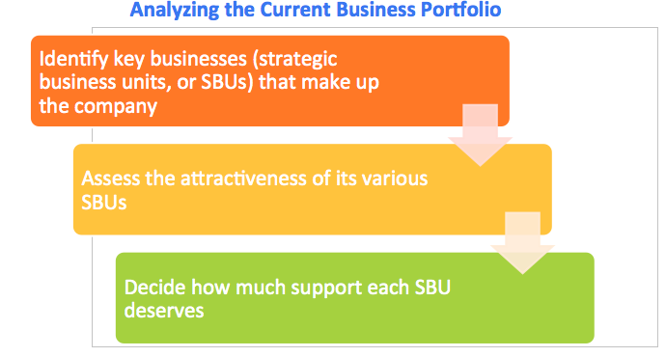

- For developing strategies for growth and downsizing companies use the?
  - Product/market expansion grid

- This grid is a tool to identify a companie’s?
  - Growth opportunity
    - Using? (4)
      - Market penetration
      - Diversification
      - market development
      - Product development

- Draw the Product/marketing expansion grid!
  - 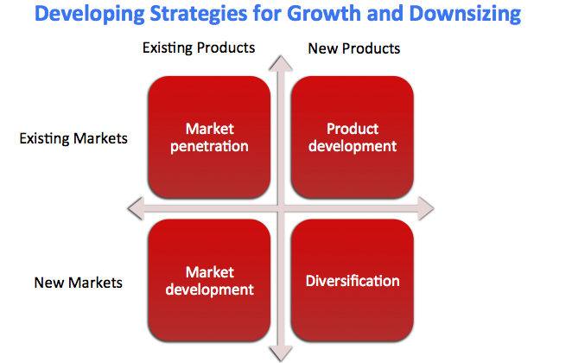

- Market penetration is a strategy to increase sales of current markets without?
  - Changing the product
    - Example?
      - Building new stores
- Market penetration is normally supported with ?
  - Advetrisements

- Market development is a growth strategy that identifies and develops?
  - New market segments for?
    - Current products

- It is used to reach new?
  - Segments of population
    - Ex: Tim Horton in abu Dabbi

- Product development is a growth strategy that offers?
  - New or modified products to?
    - Existing market segments

- Diversification is a growth strategy through starting up or acquiring?
  - Businesses outside a company’s (2)
    - Current products
    - Current markets

- Downsizing is the reduction of a Business portfolio by eliminating? (2)
  - Business units
  - Products
    - That are not profitable anymore or don’t?
      - Fit the company’s strategy
Partnering to build customer relationships

- A value chain is a series of
  - Departments that? (4)
    - Desing, produce, market deliver products

- Does a firm’s activity depends only on the effectiveness of each departments work?
  - No it depends on how the value chain (departments) work together?

- The value delivery network is made up of the? (4)
  - Company
  - Suppliers
  - Distributors
  - Consumers

They partner together to improve performance of the whole system

Marketing strategy and Marketing mix

- Market segmentation is?
  - The process of diving customers who have different ?
    - Needs
    - Characteristics
    - Behaviors
      - Who would require different products of Marketing mix

- They can be devided by ________(4) factors?
  - Geographic
  - Demographic
  - Behavioral
  - Psychological

- A Market Segment is?
    - A group of consumers who share similar characteristics
- Market targeting is the process of?
  - Evaluating each market segments and?
    - Selecting which segments to enter.

Managing the Marketing efforts

- The SWOT analysis is used to?
  - Evaluate a companies internal
    - Strengths
    - Weaknesses
  - Evaluate the companies external
    - Opportunities
    - Threats
- When you manage marketing you must?
  - Analyze (SWOT)
  - Plan
  - Implement
  - Control

- When Analyzing you must? (4)
  - Find opportunities
  - Understand strengths
  - Avoid threats
  - Identify weaknesses

- The Marketing plan then states the (7)
  - Executive summary
  - Analyze current situation
  - Show objectives
  - Targets and position
  - Marketing Mix
  - Budget
  - Controls

- Then you implement, by changing?
  - Strategies and plans into marketing actions.

- This step wants to accomplish?
  - Strategic marketing objectives

- Implementation depends on how well the company blends its? (4)
  - people
  - Structure
  - Reward system
  - Company culture

- Control involves evaluating the (2)
  - Results of the marketing strategies and plans
  - Taking corrective action

- It checks for differences between (2)
  - Goals &
  - Perfomance

- **Control includes
  - Operating control
  - Strategic control

- Return in marketing investment (Marketing ROI) is the net return from?
  - Marketing investment / (divided by) cost of investment

- It provides a measurement of the?
  - Profits made from the marketing investments

Review:

Chapter 3: Analyzing the Marketing environment

- The marketing environment includes?
  - Actors and forces outside the marketing dev. Which affect the marketing’s ability to have successful relationships with consumers.

- In the micro environment there is?
  - Strengths
    - Internal
  - Weaknesses
    - Internal
- Microenvironment consists of actors and forces?
  - Close to the company that affect the company’s ability to serve its? (6)
    - Customers
    - Company
    - Marketing Intermediaries
    - Publics
    - Suppliers
    - competitors
- Company consists of ?
  - Other company groups such as?
    - For example:
      - Management
      - Finance
      - Accounting etc.
- Suppliers are the one that provide the
  - Resources to produce goods and services

- They must always be treated as
  - Partners to provide customer value.

- They must always watch
  - Supply and availability

- The intermediaries help the company? (3)
  - Promote
  - Sell
  - Distribute products

- They include?
  - Resellers
  - Marketing agencies
  - Etc.

- Competitors well are competitors

- Publics are any group that has actual or potential

  - Interest
  - Impact on a companies results

- Examples of publics could be?
  - Financials publics
  - Media
  - Government
  - Locals
  - General public
  - Internal publics

- The 5 type of customers are?
  - Consumers 776
  - Businesses
  - Resellers
  - Government
  - International

- The macroenvironment consists of external?
  - Opportunities
  - Threats

- Macroenviornment consists of 6 factors?
  - Demographics
  - Cultural
  - Economic
  - Natural
  - Technologic
  - Political

- Demographics is the study of
  - Humans
    - It analyzes what is particular?
      - Age,
      - Lifestyle
      - Gender
      - Race
      - Income
      - Occupation
      - Etc..

- Demographics are important important because it involves?
  - People, and people make the markets.

- Some of the trends studied in demographics could also be?
  - Family structure
  - Educational characteristics

- Generational Marketing is important in the demography sector because it segments people by?
  - lifestyle of life state and not age.

- Economic environment consists of factors that affect?
  - Consumer purchasing power
  - Spending patterns
- Value marketing involves offering consumers who?
  - Are more financially cautious greater value.

- Ernst engel or engels law states that as income rises? (3)
  - spending on food decreases
  - spending on housing remains constant
  - savings increase

- The natural environment consists of?
  - All natural resources used for marketers.

- What is the most dramatic force in changing the market place?
  - Technological factor.

- Technology help marketers make products? (3)
  - cheaper
  - faster
  - more practical

- Political environment consists of what? (3)
  - governments
  - laws
  - pressur groups
- they influence businesses in many ways. Same 5 out of 8?
  - Price
  - Competition
  - Product safety
  - Advertising
  - Labeling
  - Environmental protection
  - Fair trade
  - Consumer privacy

- Study legistlation business in book.

- Socially responsible behavior simply means that managers must do the?

  - Right thing

- Cause-related marketing is that companies try to have?
  - A good image by the population by being socially responsible.

- Cultural environment consists of institutions and other forces that affect a society’s?
  - Culture/ values/behaviors

- Core beliefs and values are usually passed down by?
  - Parents
    - And reinforced by?
      - School
      - Churches
      - Businesses
      - Government
- Are core beliefs persistent?
  - Yes

- Secondary beliefs are more open to change? (t/f)
  - True

- Secondary beliefs are influenced? (t/F)
  - t
    - by people, societies, organizations etc.

- What are the 3 ways in wich companies can respond to changes?
  - Proactive
  - Reactive
  - Uncontrollable
- Proactive means to take aggressive actions to ?
  - Affect forces in the environment to prepare earlier

- Reactive means to? (2)
  - watch
  - react
- Uncontrollable means to? (2)
  - React and adapt

