Julia Dubé (7211607)
Professor Ricci
ITA 1113
December 12th, 2014
Final Paper:
The Influence of Francis Bacon and his Art on the Film Last Tango in Paris

Francis Bacon’s art is figurative, often depicting portraits where the subject is fragmented, reminiscent of cubism. Bacon uses warm colours: oranges, reds, and yellows. The skin of the subjects is coloured in flesh tones resembling raw meat. His semi abstract paintings often feature the faces and forms of people grotesquely disproportioned and disfigured. A frequent subject of this was his friend and fellow artist Lucian Freud. The paintings, which influenced Last Tango in Paris, were painted during the 60’s and 70’s, a time when he used warmer and brighter colours. The paintings, however, retained the themes of violence and mortality, which are central to Bacon’s work. In Last Tango, Bertolucci places two of Bacons pieces in the opening credits: Study for a Portrait of Isabel Rawsthorne and Double Portrait of Lucian Freud and Frank Auerbach (annex 1, 2). Bertolucci clearly wanted the link between these paintings and his film to be made. During the pre-production of the Film, Bertolucci visited Francis Bacon’s exhibit at the Grand Palais in Paris. Bertolucci stated about the art:
"[T]he lights of the stores are on, and there is a very beautiful
contrast between the leaden gray of the wintry sky and the
warmth of the show windows...the light in the paintings was
the major source of inspiration for the style we were looking
for." (Tonetti)

Bacon’s paintings, particularly the ones exhibited in the Grand Palais, showed warm colours, contrasts and dimmer light, comparable the light at sunset. We see this influence very clearly in any of the apartment scenes and sex scenes. Even some of the films movie posters share striking resemblances to Bacons work (annex 3). Other central themes of Bacon’s work that are present in Last Tango are suffering, isolation, violence, and death. Both Jeanne and Paul are incarnations of one or more of Bacon’s paintings.

Paul:
Paul, played by Marlon Brando, is an American living in Paris. His wife had just committed suicide and is quite obviously distraught by this. It’s important to note that Bacon’s boyfriend, George Dryer, committed suicide during Bacon’s exhibit at the Grand Palais. Whether it is serendipitous or intentional, it is quite possible that Bertolucci drew inspiration from Bacon’s real-life experiences when writing Paul’s character and background. I was unable to validate this theory; nevertheless the connection or coincidence strengthens the Bacon influence on the character. Wanting Brando to be inspired by the paintings, during pre-production of the film, Bertolucci requested that Brando visit the art exhibit. He stated:

"I wanted him to compare himself with Bacon's human figures
because I felt that, like them, Marlon's face and body were
characterized by a strange and infernal plasticity. I wanted Paul to
be like the figures that obsessively return in Bacon: faces eaten
by something coming from the inside." (Tonetti)
The art featured in the exhibition, and therefore the art that served as the main inspiration for Paul, was Bacon’s work dating before the 70’s. Although the exact catalogue of paintings that were shown is unavailable, it is safe to assume that the paintings included some of his works from the 40’s to the 60’s. “Most of his paintings from the 1940s to '60s depict the human figure, in scenes that suggest alienation, violence and suffering. ” (Bio.com) In the film, Paul is a distressed man who is evidently suffering. His first line in the film is “Fucking God!”, as he hears the train passing overhead, as if the train was actually running him over. When we next see Paul, he’s sulking in the apartment, literally lurking in the shadows. He walks around the apartment, somewhat hunched over, hands in his pockets, dragging his feet. He displays the body language of someone who is depressed and apathetic: “stooped shoulders, chin pressed against chest, ankles crossed, monotone voice - the very body showing everything the mind suffers with” (Volpe) His posture and movements bring us back to Francis Bacons portraits: people who are grotesquely depicted, deformed, fragmented, almost broken. Another place where Paul’s depression blatantly mimics Bacon’s work is in the hotel. Initially when he enters the room where his wife had committed suicide, he sulks about the room while the maid cleans up. Later when he talks to his mother-in-law, and they share a moment of grief. After having sex with Jeanne, and they have a small quarrel, Paul goes off into the other room, sits down, and cries. The scene of Paul with his wife’s body, however, is where his depression and anguish truly come through. As he sits over her body, crying, he says: “I don't know why you did it! I'd do it too, if I knew how...”

Another of Bacon’s themes that relate to the character of Paul is violence and anger. Paul proves to be a very violent person, often having angry outbursts. His first outburst is towards Jeanne in the apartment; she wanted to discuss their outside lives and he roughly put his hand over her mouthed and shoved her to the wall. He also erupts towards his mother-in-law, when she says that she wants a priest to give Rose absolution. Paul becomes furious, yelling that suicides do not deserve absolution. Later, Paul rejects his mother-in-law’s attempts to comfort him, and bites her. His rage continues on and he yells at that if she wants him to make the music stop, he’ll make it stop. He then shuts off the power and ushers her into the lobby, where he proceeds to “introduce” her to the guests; the junkie, Mr. Saxophone, Miss blowjob, etc. The entire time she begs him to turn the lights back on. His next act of violence, in what is indisputably the most famous scene of the film, is towards Jeanne when he rapes and sodomizes her. A few scenes later, Paul is at his late wife’s wake; he enters into the room and sits down next to her body. During this scene, Paul, who is struggling with many mixed emotions, switching from sadness, to anger, to hate, to love. He is clearly suffering when verbally attacks Rose’s body, calling her all manner of names. His monologue plainly shows his violent, anguished state:

“Our marriage was nothing more than a foxhole for you. And
all it took for you to get out was a 10 cent razor and a tub full
of water. You cheap, goddamn, fucking, godforsaken whore, I
hope you rot in hell. You're worse than the dirtiest street pig
anybody could ever find anywhere, and you know why? You
know why? Because you lied. You lied to me and I trusted you.”

His anger melts into pain and sorrow during his monologue scene. His conflicted feelings only continue to make matters worse when later on in the film, Paul chases down a john and roughs him up. Finally at the end of the film, his final act of violence is when he chases Jeanne through the streets of Paris, following her to her mother’s apartment where he forces his way in. In the end, the final act of violence is not perpetrated by Paul, but is perpetrated by Jeanne, who shoots him in the chest.

Another of Bacon’s themes, one that is also present in the portrait that Bertolucci chose for the film’s opening scene, is isolation and alienation. Paul is a very lonely character; he’s in a foreign country, his accent sets him apart, and his cheating wife just committed suicide. He expresses his solitude by roaming the streets, sitting alone in an empty apartment, but mostly by entering into his nameless relationship with Jeanne. With anonymity comes isolation , therefore by not exchanging names and keeping their lives secret from each other, and their relationship a secret from everyone else, he’s distancing himself from her, keeping himself alone. The affair is more erotic and taboo than other affairs; with their anonymity, the relationship isn’t much more than the relationship between a john and a prostitute. Ironically enough, the name Jeanne is the French-feminine form of the name John. Other instances of isolation include his altercation with his mother-in-law, when she tries to comfort him; she tells him “You’re not alone, Paul. I’m here.” The most significant moment of Paul’s expression of his isolation is what he tells Jeanne after he bathes her. He tells her that’s she’s alone, that they’re all alone and they’ll never be aware of how alone they are until they face death itself. Paul is completely aware of how alone he is now, but he doesn’t seem to want to admit to himself that he’s trying to feel his emptiness with Jeanne’s company, since he still insists on keeping her at a distance till its too late.

In terms of specific visual influences, Francis Bacon’s works served as the main inspiration for Paul and his demeanour, his colour palette, and his lighting. In many of Paul’s scenes, he is overcast in hues of orange, in big empty spaces, or dark confining rooms. The most obvious connection to Bacon’s Double Portrait, is the scene where Paul is lying on the mattress and he’s telling the story of his life in America. The lighting, his position, even his clothing are familiar to that of the painting (annex 4). Moreover, it is important to note that the portrait is a double portrait, meaning it’s a portrait of two people shown as one. This can apply to Paul’s character in a few ways. At times, Paul seems to be 2 different people; the Paul who was just recently widowed, and Paul; the nameless man who has sex with strangers. Paul tries very hard to keep the two sides of him separate, as two different entities. Thereupon, the double portrait can be seen as the combination of these two beings.

Likewise, the double portrait can be viewed as being a representation of Rose’s two lovers, Paul and Marcello. During the scene between these men, it is suggested and confirmed that Rose wanted the men to be connected, to be similar. She gave them matching bathrobes, each a bottle of bourbon, etc. Near the end of her life she even tried to make Marcello’s room look more like hers and Paul’s room. It would seem that Rose wanted to make one man out of two. In these respects, the double portrait could be seen as the combination of her husband and her lover.
Jeanne:
Jeanne, played by Maria Schneider, is a young woman engaged to be married. We first see her passing by Paul. The film follows her to the apartment building, then to a bar where she calls her mother. Already, the Bacon influence is visible, as she’s bathed in orange light while she’s on the phone. Even her clothing is of the same warm palette. Afterwards, she meets Paul. Jeanne has a sort of naivety and innocence about her, in comparison to Paul, who seems to be burdened by the years. When the two eventually have sex, they show the same raw passion that Francis Bacon’s art evokes. In terms of Bacon’s themes (violence, isolation and death and suffering), Jeanne also shares in these, but perhaps not to the same extent as Paul.

Violence seems to be Jeanne’s most “Bacon-esque” theme. However, her violence is more contained and less outright than Paul’s. She has small moments of violence that are more out of frustration than anger. Her first spurt of anger is towards the concierge at the hotel, who refuses to let go of her arm. Then she gets angry with Tom, her fiancée, when he tells her that he is making a documentary of her life. She calls him “traitor” and then mockingly tells him that she can’t live without him. When her and Tom visit her home in the countryside, she chases boys out of her childhood yard, threatening them. Next she gets frustrated towards Paul after they’ve had sex. As her time with Paul goes on, her moments of anger and violence become greater. At the metro station, she confronts Tom about the film. After she tells him that she doesn’t want to be in film anymore she and Tom then get into a physical altercation. Her last moment of anger, and the most violent, is after Paul chases her to her apartment. When he forces his way in and declares his love for her, she shoots him the chest as she tells him her name.

Isolation seems to be somewhat of a theme for Jeanne. She experiences alienation via her fiancée’s film. Tom wants to make a documentary about her life, but in doing so, he’s isolating her, singling her out. He doesn’t seem to realize that she isn’t quite comfortable with the whole thing. For this reason, she seeks solace from Paul’s company. But even then, his determination of keeping anonymity isolates her even more. She craves his company, wanting to go out with him, but instead he leaves her behind. In one scene, where they’re doing their toiletries together, Jeanne tells him that she is ready and asks if she’s going with him. Paul then shuts the door in her face, leaving her alone in the apartment. The visual shots themselves isolate her, setting her in vast empty spaces, reminiscent of Bacon’s portraits (annex 5). At one point in the film, Jeanne talks to Paul about her engagement to Tom. Paul says to her:

“ This man that you love, you want him to protect you and
take care of you? […] You want this golden, shinning powerful
knight to build you a fortress you can hide away in. [stutter] So
you never have to be afraid and you never have to feel lonely
and you never have to feel empty. That’s what you want?”

Jeanne tells him that that’s what she wants. For someone to never want to be lonely, or to never feel lonely again, meaning that she must have felt that way before. After this she keeps insisting she’s found “that man”, and that he, Paul, is that man. Despite him appearing to accept her confession, he abandons her without a word. That moment is when he loses her, and she realizes her happiness is with Tom, not Paul.
Jeanne does not appear to suffer as much as Paul. In general, she acts happy enough, despite some upset in her love life. She is, however, aware of Paul’s sufferings, and questions him about it. She appears to suffer most when thinking about the past from her present state. When she talks about her childhood to Tom, she uses the term “melancholic”. She’s still mourning her childhood, and Tom has to tell her to think about her past as if she was a child again. Even so, one of her greatest sufferings is of Paul raping her by sodomy. During this scene she is physically and emotionally abused. Her next suffering is also at the hands of Paul, who empties out the apartment without telling her, leaving without a word. She’s clearly hurt. This betrayal by Paul is what pushes her back to Tom. When Tom comes to see the apartment, he describes it as having a musky odour, as if someone had had sex in it recently. He tells her that they have to find a more mature, adult place, somewhere they can grow up and have a family, not live as oversexed children. This hits Jeanne; it hurts her, but she realizes the truth. The last of her suffering is to suffer through Paul trying to win her over. When they go to the club where the Tango Contest is taking place, as Jeanne sits at the table, that frame is where she most resembles Francis Bacon’s Study for a Portrait of Isabel Rawsthorne; just sitting, passive, in the dark (annex 6). At this point she has lost interest in Paul, and only warms up to him again after a few drinks. Even then, she wants it to be over and she runs away from him. The last scene of her running from him in the streets of Paris also evokes that fury and passion of Bacon’s art. Consequently, this fury leads to the final culmination of pain, violence and suffering for both of them. When she shoots him, it’s with a painful conviction, and he dies, looking one last time at the Parisian skyline. When he dies, he dies alone, as a stranger, Jeanne preparing herself to tell police that he was a stranger, a rapist, she doesn’t even know his name.
Death:
Bacon’s ever present theme of death and mortality in his art is just as omnipresent in the film. Both Jeanne and Paul are followed by death. Obviously Paul is haunted by his wife’s recent suicide. Between scenes of the apartment, we see Paul dealing with the aftermath of her suicide: cleaning the room, dealing with her mother, her lover, and her funeral. It’s something that hangs over him like a dark cloud constantly. He talks about mortality quite a bit as well. When Jeanne arrives at the apartment, soaked from the rain, he wants to give her a warm bath. He tells her:

“Well, first you have to take a hot bath and if you don't you're
gonna get pneumonia. Right?... and then you know what happens?
You get pneumonia... and then you know what happens? You die!
And then, you know what happens then when you die? I get to
fuck the dead rat!”

As much as he may be trying to joke, his line proves that death is always on his mind. Even later he talks to her about death, when he tells her she’ll be alone until she “climbs up into the ass of death”, and then follows up with having her sodomize him and the entire time telling profanities of having relations with a pig and wanting the pig to die. Afterwards, Paul goes to see his wife’s body, and talks to her deceased body, as if she were alive, but still knowing she was dead. He has mixed feelings about her death, as previously stated. He’s angry and hurt but also very sad.

Jeanne is followed by death as well, although more subtly than Paul. When she goes to her childhood home with Tom and the Film crew, one of the first things she mentions is the tombstone of her childhood dog, Mustapha. Later on, throughout the film, Tom wants to know about her deceased father. He is very persistent in his quest to learn about her father. Even her mother is only now packing up her late husbands things. Consequently, Jeanne is constantly being reminded of her father’s death. Death also hangs over her when she’s with Paul. First she tries to tell him about her deceased father, then they find a dead rat in the apartment, after which he asks to bath her so she wont catch pneumonia and die. Following, Paul verbally assaults her with his profanities about the dying pig, after he tells her she’ll be alone until she dies.

Ultimately, death looms over her and Paul in the final scenes of the film, during the chase. We were shown hints of the films end, when Jeanne finds her father’s revolver in her and her mother’s apartment and her mother tells her she wants to keep it, because it’s always good to have a weapon in the house. Jeanne mentions that her mother doesn’t know how to use it, but she does. When Paul chases Jeanne into the apartment, and we see her reach into the drawer as he comes towards her, we know that she is fully capable of shooting him, given also the fact that we know her level of violence is increasing with time and she wants desperately for things to be over with Paul. The shot proves to be fatal.

During the production of the film, Francis Bacon released 2 triptychs: In Memory of George Dyer and Triptych – August 1972. The triptychs were Bacon’s reaction to his lover’s suicide. The film shares striking similarities with aspects of these paintings, and as they were done during the production of the film, it’s reasonable to assume that Bertolucci drew inspiration from the mortality and death theme of these paintings. In particular, there are frames in the film that resemble the central painting of In Memory of George Dyer; the figure in the painting appears to be knocking on a door, in front of a staircase. The scene in question is one of the final scenes, where Paul follows Jeanne up to her apartment and forces his way in (annex 7).

Cinematography:
Not only was the story influenced by the themes of Bacon’s art, the cinematography was also inspired by the aesthetic of Bacon’s art. Vittorio Storaro, who often worked with Bertolucci once told a reporter, regarding the colours of the film:

"after The Conformist I had a moment of crisis; I was asking
myself: what can come after azure?...I did not have the slightest
idea that an orange film could be born. We needed another kind
of emotion...It was the case of Last Tango.” (Tonetti)

Orange is a very versatile colour; it can be warm and maternal, like a womb, or it can be violent and angry, like fire or the blast of an explosion. The film utilizes both of these aspects of the colour orange. First, we are introduced to the orange of a womb; a warm, innocent colour where things are nurtured and grow. The apartment that Paul and Jeanne meet in and consequently where their relationship grows, is always bathed in the warm orange light, like the inside of a womb. Even when we first see the apartment building, it’s gray and cool outside, but through the frosted glass doors you can see the warm light inside; both Jeanne and Paul are immediately attracted to it (annex 8). In this lighting and setting, Jeanne and Paul often become living embodiments of Francis Bacon’s art: their bodies forming and deforming with limbs mingling together in the carnal fashion of his paintings.
There are many examples of this: first when they both enter the apartment, and are sitting in separate rooms, with the indiscernible mass under the white shit between them; on several occasions in this scene, Paul sinks down to the floor, or leans against the wall and the fireplace, deforming his body into grotesque Bacon style shapes; at one point, Jeanne walks in front of a broken mirror and her figure is fragmented and distorted in like manner; then when they first engage in sex, their long coats mask their bodies and they too become like what Jeanne eventually calls the “Monster”(annex 9). Another instance, for example, when they’re sitting together on the mattress in the middle of the living room, they’re so entangled together; their separate limbs are almost indiscernible from one another. In those frames, they could be a Francis Bacon painting (annex 10). When they leave the apartment afterwards, it’s a very symbolic image, as they exit into the street and leave behind the warmth of the orange glow (annex 11).

In the following scene, we lose the warm glow of orange light, but there are still hints of the colour: Tom’s scarf, Jeanne’s dress (annex 12). Something interesting to note, when Tom tells Jeanne about his documentary, he says it’ll be called “Portrait of a Girl”; the title of Bacon’s painting that’s shown in the film opening is entitled Study for a Portrait of Isabel Rawsthorne, and Bacon has many other works with “Portrait of” in the title. This is one of Bertolucci’s subtle, and yet unsubtle, ways of referencing Francis Bacon in his film.

The orange tinge comes back in the next scene, where the girl is cleaning up after Rose’s suicide. But this time the reds and oranges aren’t warm and nurturing; this time they’re violent and grim and drenched in death. The room is dark, dim sunlight coming in, and even the cleaning girl is dressed in orange. The first image we see of this scene is the blood-splattered sheets and it sets the tone for the rest of the scene (annex 13). Then we see Paul sulking around, in his usual Bacon-esque manner, and the camera shows different angles of the bloody room. In one shot, the girl stands behind the frosted shower glass and her figure is distorted and diffused with a background of orange, reminiscent of some of Bacon’s work (annex 14). Paul, however, seems to be always cast in a shadow, never fully in the light. In the end of the scene, after Paul leaves, the girl cleaning up does something slightly disturbing as she turns the water back on and hugs the bloodied sheets: she smiles. Whether it was intentional or not, this smile in the atmosphere of death and tragedy feels so out of place, it leaves the viewers disturbed and uncomfortable (annex 15). This is the same effect that Bacon’s art has on many people.

The glow is still there in the apartment when they return, and it stays there for the rest of the film. But there’s also an orange hue in Paul’s hotel room, where he finds Rose’s mother searching through her daughters things. The orange hue follows Paul around more than it does Jeanne. Jeanne, rather, is followed by hints of the colour, like when she met Tom at the train: peoples clothing, backgrounds, and objects. Paul, on the other hand, almost always has that orange hue around him. It attracts him to the apartment for rent; it follows him into phone booth in the bar, into the apartment, into the hotel; even when he goes to see Rose’s lover, Marcello, the room is dark but orangey. Paul’s character is like a walking Francis Bacon Portrait. Even at the Tango, the orange light is there. On the contrary, Jeanne is only ever in the orange light when she’s near Paul, or when she’s somewhere Paul has been. For instance, she doesn’t go into the apartment building till after Paul; she doesn’t go into the orange bathroom/phone booth till after Paul; the same principal applies to when they go to the Tango and afterwards in her and her mother’s apartment. The only instance where she has an Orange light is in her childhood home, probably because it brings her to that childish state of mind that she has when she’s with Paul. The two portraits from the opening credits hint at this principal, as only the man’s portrait is orange.

In conclusion, Francis Bacon’s art had an influence on the entirety of the film Last Tango in Paris. His art influenced the character backgrounds and developments through means of his reoccurring themes of death, violence, isolation and suffering. Both of the main characters show connections to Bacon’s theme, granted to different degrees of intensity. Moreover, Bacon’s art was a key inspiration in the visuals and cinematography of the film. His paintings inspired the colour scheme and palette for the film, and also influenced the lighting and settings for each character. As a whole, Bertolucci was so influenced by Francis Bacon’s art that his film, Last Tango in Paris, and Francis Bacon remain completely indissociable to this day.

Annex
1 | 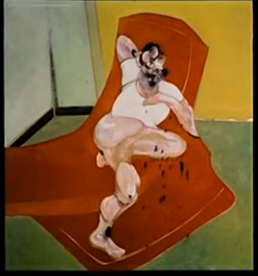 | Double Portrait of Lucian Freud and Frank Auerbach  1964  Francis Bacon  Oil on Canvas
2 | 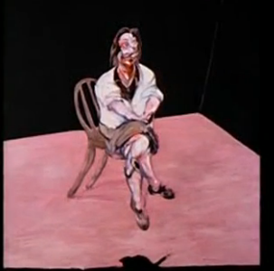 | Study for a Portrait of Isabel Rawsthorne  1964  Francis Bacon  Oil on Canvas
3 | 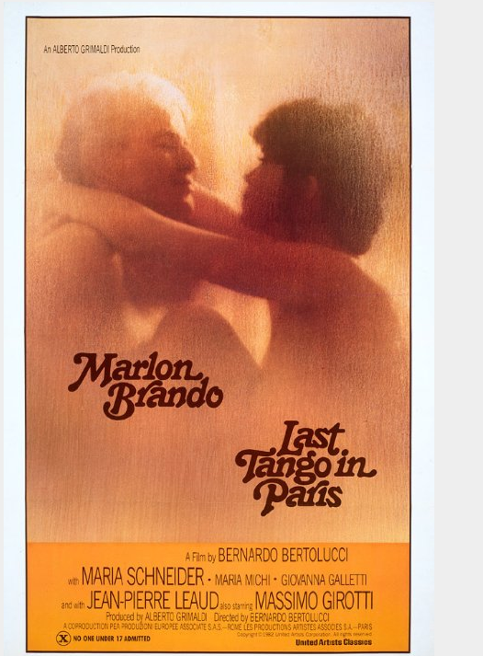 | Last Tango in Paris  Promotional material  1972  Image courtesy of IMDB
4 | 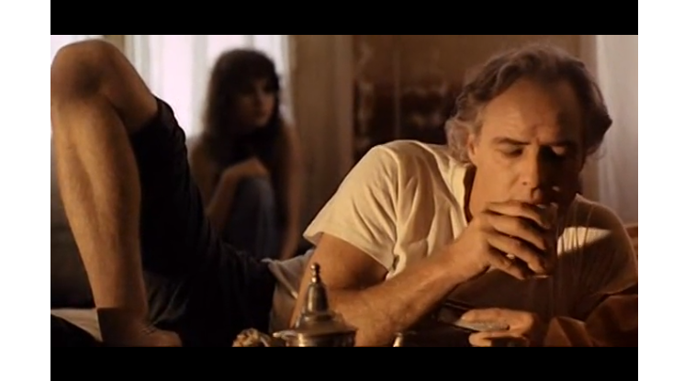  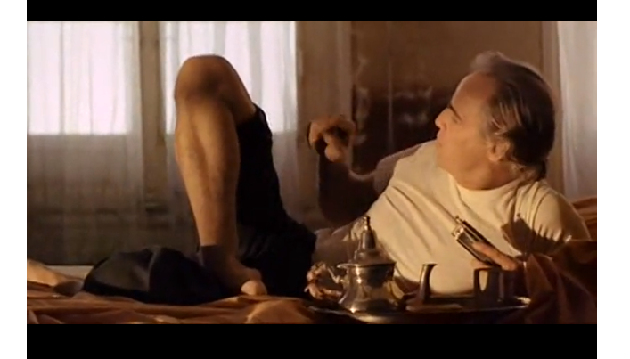 | Marlon Brando as Paul  Last Tango in Paris  1972
5 | 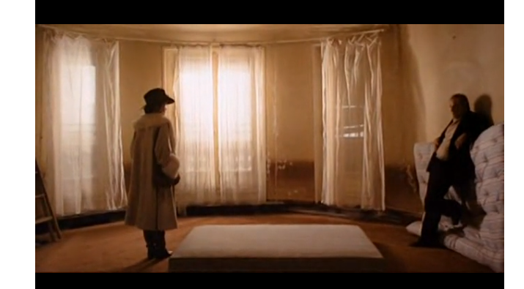 | Maria Schneider as Jeanne  Last Tango in Paris  1972
6 | 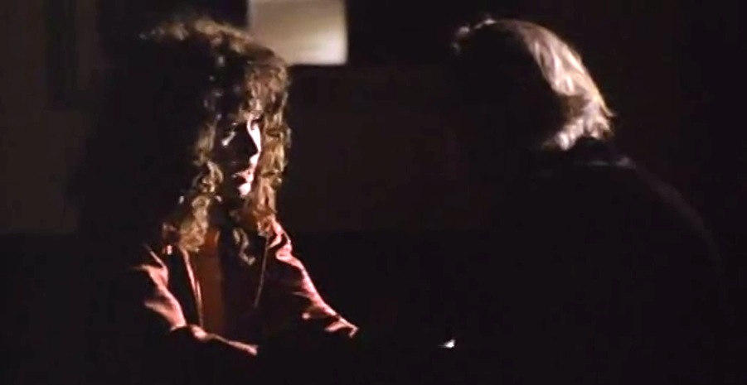  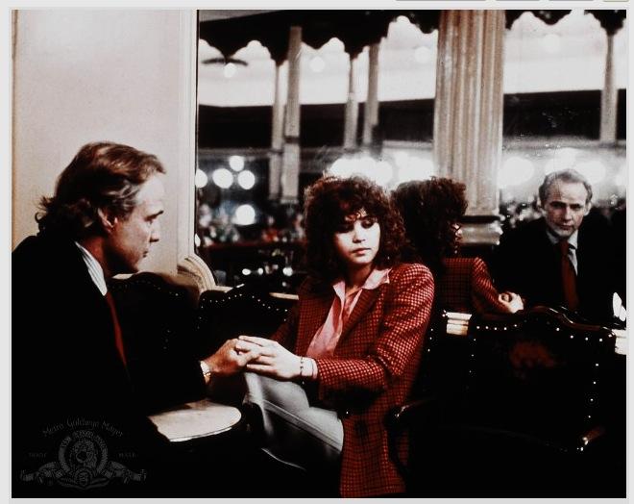 | Maria Schneider as Jeanne  Marlon Brando as Paul  Last Tango in Paris  1972
7 | 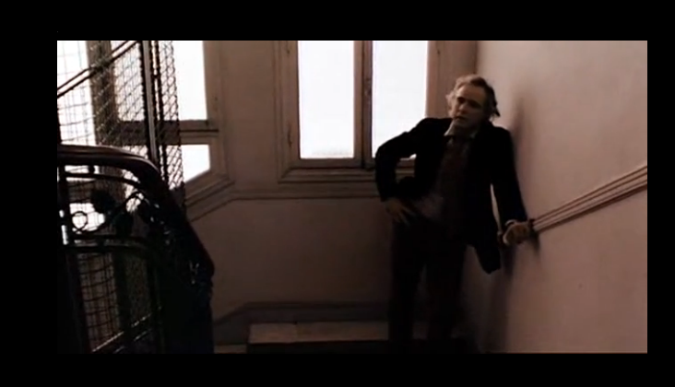  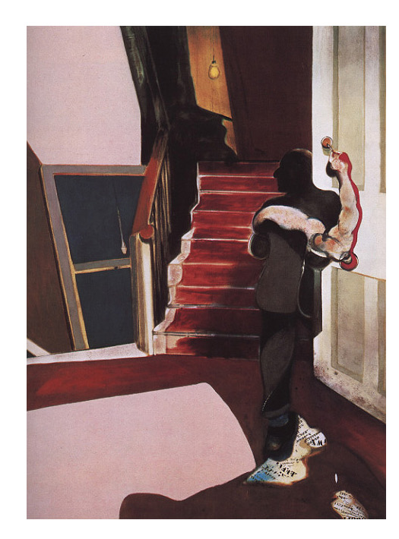 | In Memory of George Dyer (middle panel)  1972  Francis Bacon  Oil on Canvas  AND  Marlon Brando as Paul  Last Tango in Paris  1972
8 | 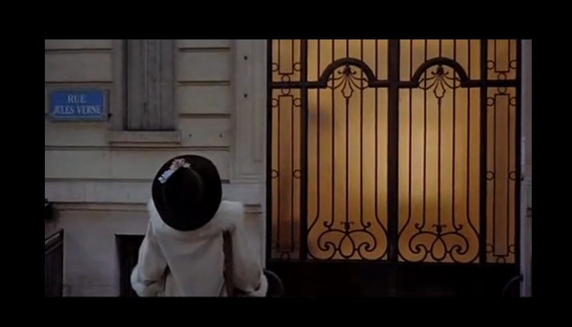 | Maria Schneider as Jeanne  Last Tango in Paris  1972
9 | 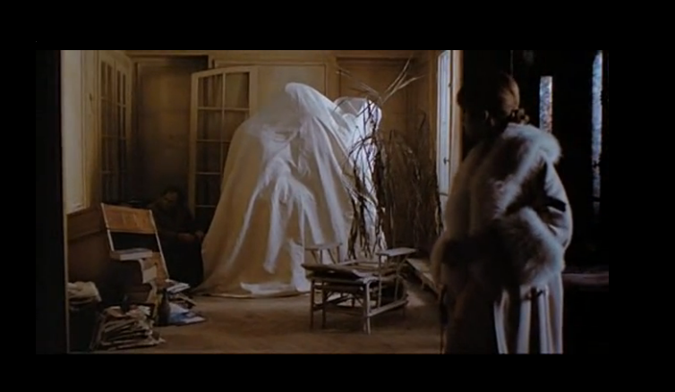 | Maria Schneider as Jeanne  Last Tango in Paris  1972
10 | 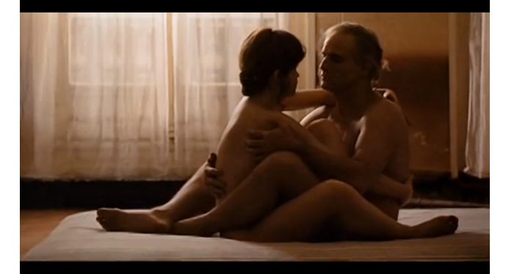 | Maria Schneider as Jeanne  Marlon Brando as Paul  Last Tango in Paris  1972
11 | 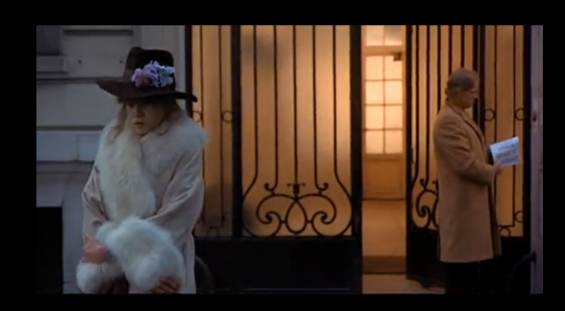 | Maria Schneider as Jeanne  Marlon Brando as Paul  Last Tango in Paris  1972
12 | 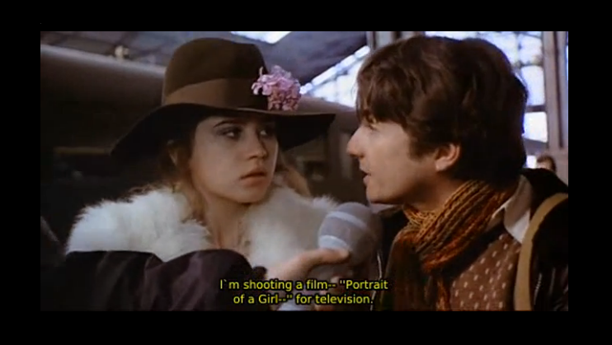 | Maria Schneider as Jeanne  Jean-Pierre Léaud  Last Tango in Paris  1972
13 | 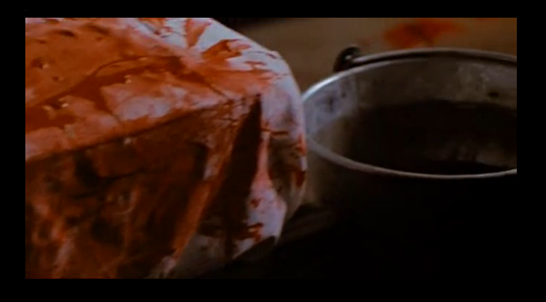 | Bloody Sheets, Rose’s Suicide room  At 19m 25s  Last Tango in Paris
14 | 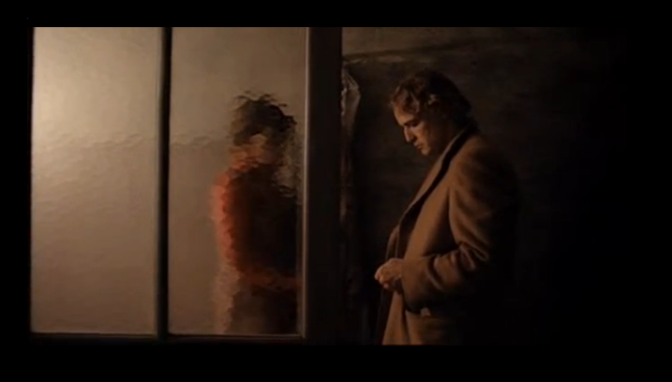 | Marlon Brando as Paul  Catherine Allegrét as Catherine (the maid)  Last Tango in Paris  1972
15 | 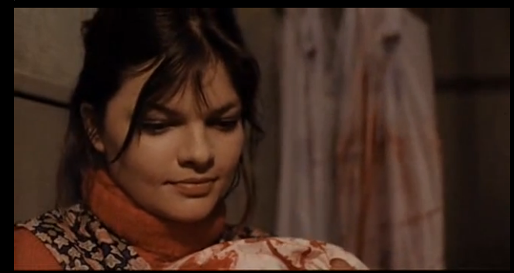 | Catherine Allegrét as  Catherine (the maid)  Last Tango in Paris  1972

Additional Works by Francis Bacon
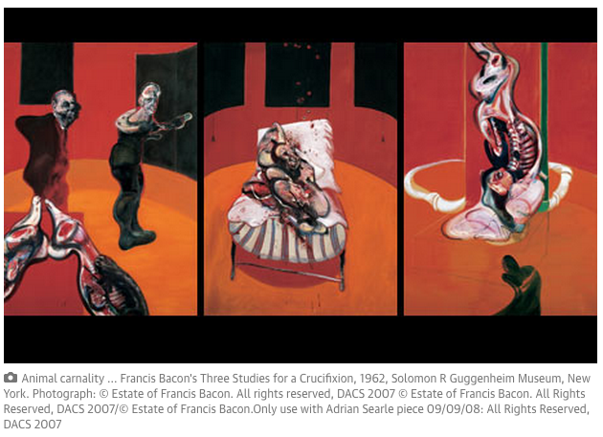

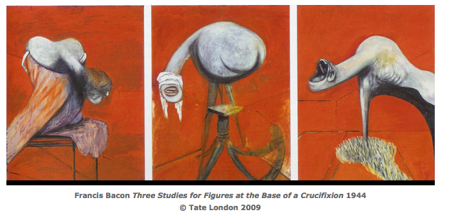

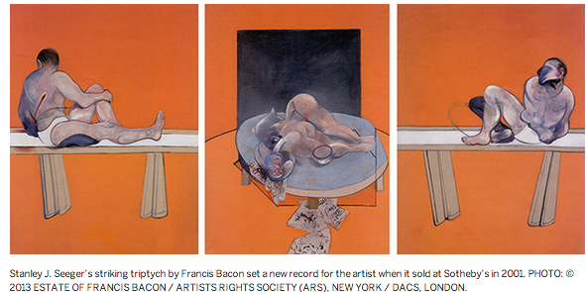
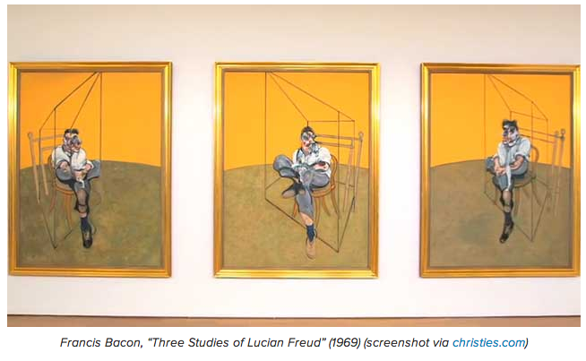
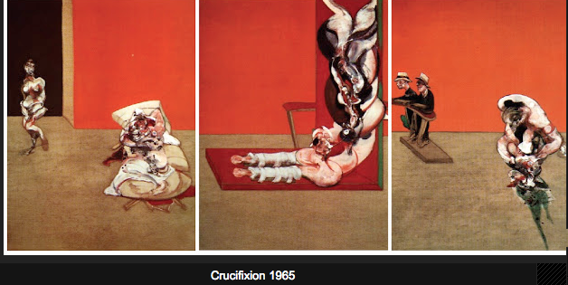
Works Cited

-- "Francis Bacon Biography." Bio.com. A&E Networks Television, 2014. Web. Nov. 2014.
<http://www.biography.com/people/francis-bacon-21415553>.

-- Tonetti, Claretta. Bernardo Bertolucci: The Cinema of Ambiguity. New York: Twayne,
1995. Print. Twayne's Filmmakers Ser.

-- Volpe, Elena, M.A. "The Depressed Body." CAMFT's Professional Exchange. California
Association of Marriage and Family Therapists, May 2003. Web. Nov. 2014. <http://www.camft.org/ScriptContent/Professional_Ex/Articles/DepressedBody.htm>.

