LAB 6–Synchronous Counters

ITI 1100 A/D - Digital Systems
Fall 2015
Course Coordinator: Dr. Ahmed Karmouch

^{h}

Objectives
• Design synchronous counters
• Simulate the functions of the various counters in this laboratory exercise.
• Display counter outputs as binary values on LEDs and test these counters.

Equipment and components
• QUARTUS II Student Edition Software
• Altera UP-1 circuit board
• AC adapter, minimum output: 9VDC, 250mA
• Anti-static wrist straps
• #22 solid-core wires
• Wire strippers

Circuit diagram

4-Bit Synchronous Counter Diagram
Figure 1

Figure 2

Experimental data and data processing
Truth Tables and K-maps

Truth Table
PS |  |  |  | NS |  |  |  | Q₃ |  | Q₂ |  | Q₁ |  | Q₀
Q₃ | Q₂ | Q₁ | Q₀ | Q₃* | Q₂* | Q₁* | Q₀* | J₃ | K₃ | J₂ | K₂ | J₁ | K₁ | J₀ | K₀
0 | 0 | 0 | 0 | 1 | 0 | 0 | 0 | 1 | x | 0 | x | 0 | x | 0 | x
0 | 0 | 0 | 1 | 0 | 0 | 0 | 0 | 0 | x | 0 | x | 0 | x | x | 1
0 | 0 | 1 | 0 | 0 | 0 | 1 | 1 | 0 | x | 0 | x | x | 0 | 1 | x
0 | 0 | 1 | 1 | 0 | 0 | 0 | 1 | 0 | x | 0 | x | x | x | x | 0
0 | 1 | 0 | 0 | x | x | x | x | x | x | x | x | x | x | x | x
0 | 1 | 0 | 1 | x | x | x | x | x | x | x | x | x | x | x | x
0 | 1 | 1 | 0 | 0 | 0 | 1 | 0 | 0 | x | x | 1 | x | 0 | 0 | x
0 | 1 | 1 | 1 | x | x | x | x | x | x | x | x | x | x | x | x
1 | 0 | 0 | 0 | 1 | 1 | 0 | 0 | x | 0 | 1 | x | 0 | x | 0 | x
1 | 0 | 0 | 1 | x | x | x | x | x | x | x | x | x | x | x | x
1 | 0 | 1 | 0 | x | x | x | x | x | x | x | x | x | x | x | x
1 | 0 | 1 | 1 | x | x | x | x | x | x | x | x | x | x | x | x
1 | 1 | 0 | 0 | 1 | 1 | 0 | 1 | x | 0 | x | 0 | 0 | x | 1 | x
1 | 1 | 0 | 1 | 1 | 1 | 1 | 1 | x | 0 | x | 0 | 1 | x | x | 0
1 | 1 | 1 | 0 | 0 | 1 | 1 | 0 | x | 1 | x | 0 | x | 0 | 0 | x
1 | 1 | 1 | 1 | 1 | 1 | 1 | 0 | x | 0 | x | 0 | x | 0 | x | 1

Table 1
From the corresponding K-maps, we can obtain the equations of the synchronous inputs as following.

Latch 3 K-map
a)
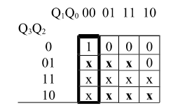 J₃=Q₁'Q₂'

b)
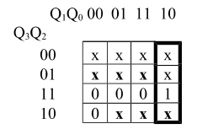 K₃=Q₁Q₀'

Latch 2 K-map
a)
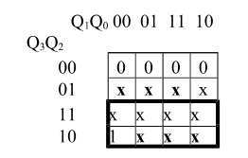 J₂=Q₃

b)
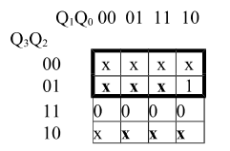 K₂=Q₃'

Latch 1 K-map
a)
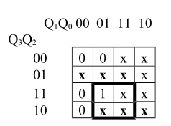 J₁=Q₃Q₀

b)
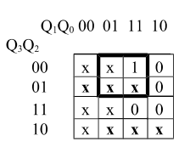 K₁=Q₃'Q₀

Latch 0 K-map
a)
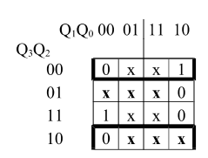 J₀=Q₂xorQ₁

b)
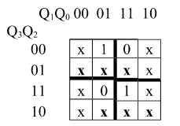 K₀=(Q₃xorQ₁)'
Result of simulation
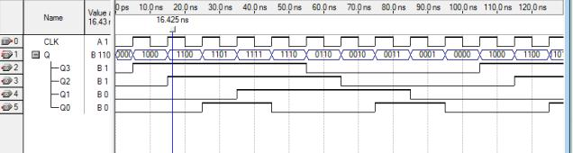
Figure 1

Comparison of Simulated Result and State Diagram
The process 4-bit synchronous counter designed in this experiment can be illustrated by the following the state diagram, which has the same function as the state table showed previously.
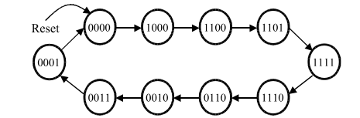
Figure 2

In this experiment, the simulation result can be demonstrated by the following table.
Present State(Q₃Q₂Q₁Q₀) | Next State(Q*₃Q*₂Q*₁Q*₀)
0000 | 1000
1000 | 1100
1100 | 1101
1101 | 1111
1111 | 1110
1110 | 0110
0110 | 0010
0010 | 0011
0011 | 0001
0001 | 0000
Table 2: Experimental Data Table
In conclusion, the experimental data in Figure 1 and Table 2 are the same the data in state table in Table 1 and the state diagram in Figure 2.
Discussion
By conducting the lab, it was shown that the functionality of various counters especially the 4-bit synchronous counter. From this experiment, we can see how to build counters by using JK flip-flops.
Synchronous counters use a common clock signal so that when several flip-flops must change state, the state changes occur simultaneously. A binary counter is a simple counter which counts values up when an enable signal is asserted and will reset when the reset control signal is asserted.
J-K flip-flops are normally used in the synchronous counters due to the feature of the J and K inputs. There are two basic schemes for generating the J and K inputs. One of them is illustrated in the four-bit binary counter. Moreover, the information to the J-K inputs is formed in a parallel fashion. The counter is accordingly termed as synchronous parallel counter. In the parallel scheme the number of inputs to each AND gate increases linearly with the number of stages. For this added expense one gets the fastest possible synchronous counting circuit.
In this experiment, we first see how the counters are designed and how they work through simulation. Second, in our case, the experimental data matches the theoretical data by comparing the state table, state diagram and the result of our simulation. Through this comparing, we understand the function of state table/ state diagram more deeply. Lastly, we grouped several flip-flops together to create sequential circuits. In our case, we use JK flip-flops to create a counter which is a kind of widely used sequential circuits. Through this, we know how to take advantages of features of different flip-flops to create a sequential circuits efficiently.

