Environmental Management Accounting


Presented to Professor
April 2, 2015

Introduction
In 2015, the most valuable asset a firm can have is a strong reputation, and the concept of sustainability has become an important component of corporate reputation. A great majority of stakeholders agree that a sustainable business is an important factor in their decision-making; therefore businesses have started to place more emphasis on sustainability and their triple bottom line. Ever since the United Nations made the world aware of this issue in the late 1990s, people gradually began to understand how the cost of environmental pollution and human health in exchange for the rapid development of the economy is unwise. As people pay more and more attention to environmental issues, precipitated by some major incidents such as oil spills and chemical leaks, businesses are becoming increasingly aware of the environmental implications of their products, services and operations. Environmental issues cannot be ignored as they are now part of operating a successful business and developing a strong and sustainable corporate strategy. Poor environmental behavior has the ability to impact a corporation’s finances, along with possible punishment which includes fines, loss of sales, customer boycotts, increased liability, lawsuits and damage to its reputation.

Overview
To support the ever-growing need for sustainability, the Environmental Management Accounting system has been developed. According to the International Federation of Accountants’ (IFAC) Statement Management Accounting Concepts, EMA is “the management of environmental and economic performance through the implementation of appropriate environment-related accounting systems and practices. While this may include reporting and auditing in some companies, environmental management accounting typically involves life-cycle costing, full-cost accounting, benefits assessment, and strategic planning for environmental management.”
EMA analysis uses two types of information for effective internal decision-making. The first is the incorporation of physical information on the usage of materials, wastes, water, and energy. This type is not typically provided in managerial accounting systems but is an absolutely vital part of the EMA system. In order to support the company’s activities, they need to purchase material, energy, and water to make a profit. Waste is created through the production of products and depending on how materials are managed during production; this can lead to significant carbon emissions and pollution. In the end, some material is converted into final product that is purchased by customers and some is not. These final products can have a substantial environmental impact. EMA serves to reduce this impact and give managers a more well-defined perspective on the environmental impact of the organization.
Secondly, EMA uses monetary information, by collecting related environmental costs, revenues and savings. For example, an EMA system may report information pertaining to materials costs of product outputs, waste and emission control costs, prevention costs and research and development costs.

Why EMA is useful?

As previously stated, for better environmental performance and to create a more sustainable world, public organizations and governments continue to enforce laws and regulation upon companies. Not only must businesses comply with these regulations, they have also come to understand that being at the forefront of sustainability practices is crucial with regards to their competitive advantage over other firms. Essentially, there are increasing societal expectations of corporate performance including the need for greater environmental sustainability.
Below are some additional benefits of applying EMA:
- Identify costs for more accurate product pricing.
- Identify hidden costs in overhead accounts.
- Decrease or eliminate environmental costs
- Gain competitive advantage by designing more environmentally products, processes and services.
- Meet obligations of national or international environmental laws
- Increase company value by enhancing customer value.
Lastly, environmental management accounting has enabled management to focus less on the end result, meaning the company’s net income, and more and more on the triple bottom line, of which the focus is on our planet.

In order to exemplify the EMA strategy in action, Toshiba and Fujitsu have been chosen to demonstrate how EMA has worked to their advantage over the past several years.

Toshiba’s application of EMA
Toshiba is a world-renowned organization that develops technological products and systems including digital consumer products, power systems, and home appliances. It aims to continuously offer leading innovative technologies while promoting harmony with our planet. The company has a slogan “Commitment to people, Commitment to the Future.” They want to improve the lives of everyone through innovation of new technology while fulfilling society’s demand. They also want to help the world achieve a goal that is to improve the environment. By reaching this goal, it will create a more sustainable world for future generations. In order to show their commitment to resolve this issue, they initiated an event called Global Environment Action, and in 2013, 200,000 of its employees participated. Their goal is to become one of the world’s most eco-friendly companies. In order to achieve this position, they will have to achieve certain goals such as:
- Greening Product: Create high quality product and having minimal impact on the environment.
- Greening Technology: Goal to use more energy saving technology and to rely less on carbon power.
- Greening Process: The goal to increase productivity without having a huge impact on the environment.
- Which contributes to the overall aspect of Green Management

The company introduced a new technique of measuring environment management called the T-COMPASS.
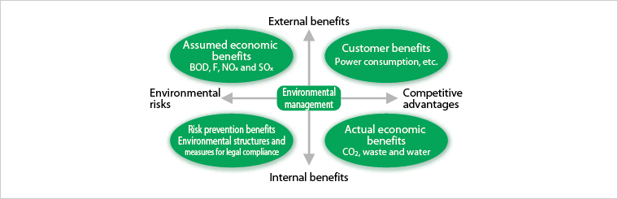
http://www.toshiba.co.jp/env/en/management/account.htm
The T-Compass is based on the four cardinal points North, East, South and West. In other words, it is designed to efficiently use its (N) natural resources, and minimize (E) energy consumption, chemical substances (S) and usage of (W) water resources. They are reducing the use of their scarce resources and using more recyclable materials without affecting the quality of the product. Thus, they would reduce spoilage, waste and rework. Looking at Appendix A, we can see a significant change in resources used. With regards to digital products, there was a significant reduction of 155.1 tons. Furthermore, they plan to reduce the consumption of energy that is noxious to the planet by replacing it with renewable energy such as hydroelectric, wind power and solar energy. In 2013, Toshiba used approximately 10,991 megawatts per hour of renewable energy, resulting in a reduction of 5,353 tons of CO₂ emission. Other initiatives of improving the environment would be to reduce the use of certain chemicals, which would help reduce the risk of contamination. Lastly, they want to reduce the waste of water, thus, they also have been using recycled and rain water. Looking at Appendix B, we can see that they have been recycling a significant amount of water every year. Overall, applying the T-COMPASS method helps in achieving the goals of greening product, greening technology, greening process and overall green management.

Furthermore, Toshiba follows Environmental Accounting Guidelines set out by the Ministry of Environment. In this approach, they consist of four different concepts: internal benefits, external benefits, environmental risks and competitive advantage. These concepts leads to four other categories of benefits by looking at the T-Compass previously depicted:
- Customer Benefit
- Actual economic benefits
- Assumed economic benefits
- Risk Prevention benefits
Toshiba invested a total of 48.3 billion yen in 2013. Appendix C shows the benefits gained from the environmental investments made during the year, with its benefits increasing significantly in 2013. Furthermore, the four categories of benefits come from the reduction of waste, usage of energy, water consumption and chemical substances. The application of the T-Compass management method helps to assess the company’s performance in reducing its impact on the environment from daily operations. As for environmental accounting, it assesses and analyzes its benefits and its costs, which leads to the company making better overall decisions regarding their company and the surrounding environment.

Fujitsu’s Application of EMA
Fujitsu is a Japanese corporation offering a wide variety of products, solutions and services. It employs more than 160,000 employees and is implemented worldwide in more than 100 countries through major subsidiaries. Specializing its expertise around Information and Communication Technologies, Fujitsu is viewed as a leader in the industry. In the world, Fujitsu is the fourth largest IT services provider and is among the biggest top five providers of servers. In 2013, FORTUNE magazine named Fujitsu one of the World’s Most Admired Companies. Like others, this company needs to proactively deal with environmental issues due to its activities and operations. As a result in 1998, in the optic to promote environmental management, the Fujitsu Group introduced environmental management accounting in its reporting activities. Its goal was to collect data related to the investments made to reduce the environmental impact of their activities in order to:
- Clarify the corporate stance through disclosure of information to stakeholders
- Implement long-term, continuous environmental measures
- Raise the efficiency of investment in environmental protection measures
- Energize environmental protection activities
To begin, Fujitsu follows the 2005 Environmental Accounting Guidelines that were issued by the Japanese Ministry of Environment. In its reports, Fujitsu accounts for the actual and estimated benefits it gets from its investments for the protection and conservation of the environment. It is important to note that depreciation and amortization is taken from the investment. More specifically, it uses straight-line depreciation with no residual value based on a useful life of 5 years. This depreciation period is based on the average length of the actual period from the introduction of environmental facilities to the implementation of repairs and upgrades. The benefits Fujitsu gains from its investments comes from the reduction of the environmental impact of the following items:
- Resource usage in business activities
- Environmental loads and waste emissions resulting from business activities
- Goods and services produced by business activities
- Transportation and other activities
Benefits are recorded in their corresponding fiscal year. The Fujitsu group also accounts for the economic benefits coming from public relations activities, and research and development. Another important factor to note is the inclusions of the avoidance of operational loss at business sites due to non-compliance with laws and regulations. This insinuates that it recognizes as a benefit the avoidance of operational loss that could be caused by the non-conformity and negligence of some operational activities. The calculation for this type of benefit goes as follow:
- Benefit = Added value / Operational days x Operational loss days (Max 3).
In the same optic, Fujitsu recognizes the added value derived from the support provided by environmental protection activities as an economic benefit. Appendix D shows a breakdown from the 2013 fiscal year results. In this table, it is easy to recognize all the items that were introduced earlier, the amount of capital that was invested in each, and the economic benefits resulting from these investments. Fujitsu also included a comparison to last year’s report results. In 2013, it was able to obtain a greater economic benefit from its activities except for the environmental remediation, which include activities related to soil and groundwater contamination. This higher level of performance for 2013 is also more explicitly shown in Appendix E where we can see a net benefit of approximately 40% and an increase of 6 % compared to 2012.

EMA Analysis

After assessing both Toshiba and Fujitsu and the impact this method of accounting has on them, we have determined that it is important for a company to get an in-depth insight and understanding about the substantial impact its operations has on the surrounding environment. Most companies are either unaware of their environmental costs or they do not estimate them correctly. Furthermore, the use of conventional management accounting techniques can misrepresent environmental issues, which can lead managers to make poor decisions regarding their business and its impact on the environment.
Overall, we can say that incorporating environmental management accounting in Toshiba and Fujitsu’s corporate strategy has been very advantageous for their companies.

Toshiba, specifically, recognizes that as a society, we must take care of our environment so as to be able to pass it on to future generations. They have a true commitment to the environment and they truly believe that it is our duty to hand it over to future generations as we have found it. Their slogan “Commitment to people, Commitment to the future” is essentially a definition of sustainability. The company promotes environmental management, and focusing on environmental issues is one of their top management priorities. According to their latest available annual report (2013), they aim to establish themselves as one of the world’s foremost eco-companies. In 2013, they have over earned over 1.6 trillion yen (the equivalent of 10.48 billion Canadian Dollars) in sales revenues of environmentally conscious products. They are quite consistent with regards to their financial performance for the past several years. Furthermore, by actively promoting and rigorously implementing EMA, they have been able to reduce 2.76 million tonnes of CO² in 2013, which is quite substantial. They are consistently in line with their CSR objectives as well according to the CSR 2014 Highlight Report. A major part of their success with regards to sustainability comes as a result of the incredible support system of over 200,000 employees they have. These 200,000 employees are able to work together and achieve a high level of motivation in order to further enhance CSR initiatives and increase corporate value.

Ultimately, protecting and preserving the environment is a pillar upon which Toshiba operates its business. They not only use environmental management accounting, this environmental management outlook is deeply ingrained and intertwined in their core structure and vision. It is no wonder Toshiba is the leading company in its field.
Furthermore, in order to promote environmental reporting, the Japanese government has introduced two award systems to benefit companies who disclose under the 2005 Environmental Guidelines. The first one is “Environmental Report Award” hosted by Global Environmental Forum and sponsored by the MOE. The second one is “Green Reporting Award” joint-hosted by the Green Reporting Forum and Toyo-Keizai Inc. In 2001; Fujitsu was awarded its 4th Environmental Report Award and Newsweek Green Rankings, an international ranking agency, ranked Fujitsu as the seventh most eco-conscious company in the world.
Contributing to society and protecting the environment are values that have been part of the Fujitsu Group since 1972 when environmental control sections were established at each plant in Japan. The three main inputs are energy (consumption of electricity and fuel in factories and business offices), raw materials (metal, plastic, paper) and water. Those inputs cause ${CO}_{2}$, ${NO}_{x}$ and ${SO}_{x}$ gas emissions, waste and drainage, all of which damage the environment and increase company costs. Since the implementation of EMA, Fujitsu’s environmental burden had decreased by 22.66% for gas emission, 32.9% water and 14.7% less waste.
From a financial point, Fujitsu has managed to reduce environmental cost by 51 million yen
(approx. $540,000 CAD). A recent survey done by Nielsen shows that consumers around the world are more willing to purchase products and services provided by companies that are committed to positive social and environmental impact. The social responsibility to buy such products is the strongest in Asia with 64%, followed by Latin America with 63%, and North America and Europe at 42%. Fujitsu’s research and development team had been working since 2010 to develop such products. Today, the company offers a variety of products, with new developments to be released by 2015. In 2014, Fujitsu’s sales of green products were 549 million yen higher than expected (equivalent to $ 5 800 000 CAD.)
In order to further reduce the environmental burden, Fujitsu established the “Environmental Protection Program Stage VII” three years ago in 2013.Its goal was to designate all products to be green products, develop technology in environmental performance, and reduce energy consumption and waste. Stage VII will be terminated by the end of fiscal year 2015 and the company estimated the sale of green products to increase 4 times since the termination of Stage VI in 2012.

Conclusion

All in all, society is becoming more and more environmentally conscious. The use of EMA has enabled businesses to focus less on the net income figure, and concentrate more on the triple bottom line. Sustainability has become a concern for many organizations as they begin to realize that stakeholders ultimately value a company that shows true initiative in that respect. EMA has allowed managers to get a clearer perspective of their business activities and the subsequent environmental impact of their corporate actions.
Since Environmental Management Accounting is a relatively new area, the tools for providing the information required are constantly being created and developed. This is an evolving area of accounting; therefore businesses are still trying to discover what information they need, and how they can accurately report it to their stakeholders. However, through the analysis of Toshiba and Fujitsu, it can be seen that their respective use of EMA has been quite beneficial to their business. They are leaders in their field and they are devoted to their goals of operating a sustainable organization. Granted their success cannot only be attributed to their use of EMA systems, as they are both very highly motivated organizations. Ultimately, it’s their desire to operate a highly sustainable business coupled with the use of Environmental Management Accounting that has truly allowed them to thrive and succeed.

References

Burritt, L, Hahn, T and Schaltegger, S (2001) Current Developments in Environmental Management
Accounting - Towards a Comprehensive Framework for Environmental Management Accounting
(EMA) Universitaet Lueneburg

Burrit, Saka. (2003). “Environmental Accounting in Japan”. Global business. Retrieved on March 16
from http://www.unisa.edu.au/Global/business/centres/cags/docs/apcea/APCEA_2003_
9%284%29_Saka_Burritt.pdf

Braun, K. (2013). Sustainability. In Managerial Accounting: Pearson New International Edition (3rd ed., international ed., pp. 884-896). Pearson.

CSR Highlight Report. (2014). Retrieved March 29, 2015, from http://www.toshiba.co.jp/csr/en/report/files/report2014_digest.pdf

Delay, Tom, “Low-Carbon Economy, what are the opportunities?”(2007) The UK Environmental Industry. Retrieve March 22, 2015, from http://www.eic-guide.co.uk/docs/lcarbon.pdf

Environmental Management Accounting (2014) http://www.accaglobal.com/ca/en/student/acca-qual- student-journey/qual- resource/acca-qualification/p5/technical-articles/environmental-
management.html#

Environmental Accounting. (2014). Retrieved March 28, 2015, from http://www.fujitsu.com/global/about/environment/management/ems/accounting/

Fujitsu Financial Report, 2001, page 46, External awards. Retrieved on March 1 from
http://www.fujitsu.com/global/Images/2001report46_e.pdf

Fujitsu Environmental Report, 2014, page 23. Retrieved on March 2 from http://www.fujitsu- general.com/global/corporate/eco/pdf/2014report.pdf

Fujitsu General, “Environmental Protection Program” Retrieved on March 10 from http://www.fujitsu- general.com/global/corporate/eco/approach/actionplan.html

The History of Fujitsu's Environmental Activities. Retrieved on March 1 from
http://www.fujitsu.com/global/about/environment/management/ems/history/)

International Federation of Accountants (IFAC). 2005. International Guidance Document of
Environmental Management Accounting. Retrieve March 22, 2015, from
https://www.ifac.org/sites/default/files/publications/files/international-guidance-docu-2.pdf
Jose, A., & Lee, S. (2007). Environmental Reporting of Global Corporations: A Content Analysis based on Website Disclosures. Journal of Business Ethics, 72(4), 307-321. Retrieved March 24, 2015, from JSTOR.

Peloza, J., Loock, M., Cerruti, J., & Muyot, M. (2012). Sustainability: How Stakeholder Perceptions Differ from Corporate Reality. California Management Review, 55(1), 74-97. Retrieved March 25, 2015, from JSTOR.

Taylor Adams, Anne, (2014) “Global customers are willing to put their money where their hearts when it
comes to goods and services from companies committed to social responsibility” (2014). Nielsen.
Retrieved on March 20 from: http://www.nielsen.com/us/en/press-room/2014/global-consumers-are-willing-to-put-their-money-where-their-heart-is.html

Ulas, Akkucuk, “Handbook of Research on Developing Sustainable Value in Economics, Finance, and Marketing.”(2015) Business Science Reference, Retrieve March 22, 2015, from
www.google.ca/books?hl=zhCN&lr=&id=kiWXBQAAQBAJ&oi=fnd&pg=PA278&dq=environmental+management+accounting&ots=gDlD0ijnWi&sig=M19bmkmUitnplEf9E9iDntPdNB8&redir_esc=y#v=onepage&q&f=false

We Care About The Earth. (2014). Retrieved March 29, 2015, from http://www.telecom.toshiba.com/environment/

Appendix A
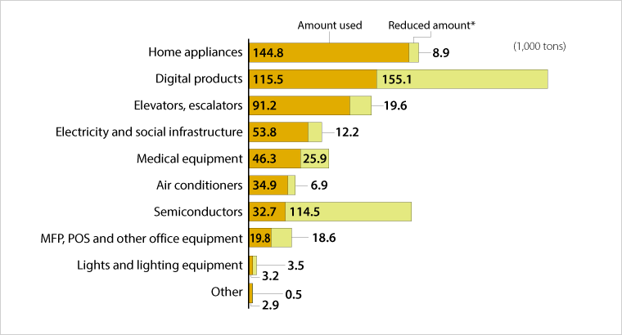
http://www.toshiba.co.jp/env/en/products/resource.htm

Appendix B
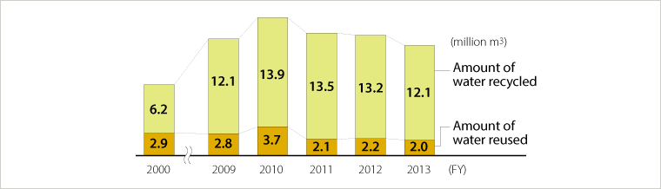http://www.toshiba.co.jp/env/en/industry/water.htm

Appendix C
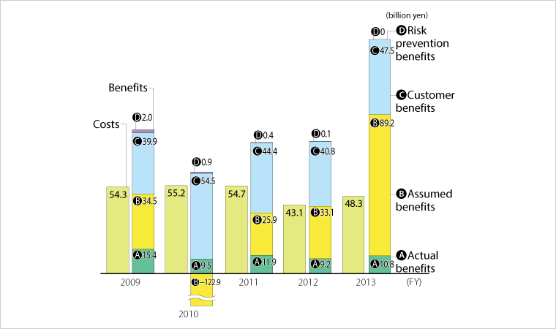
http://www.toshiba.co.jp/env/en/management/account.htm

Appendix D
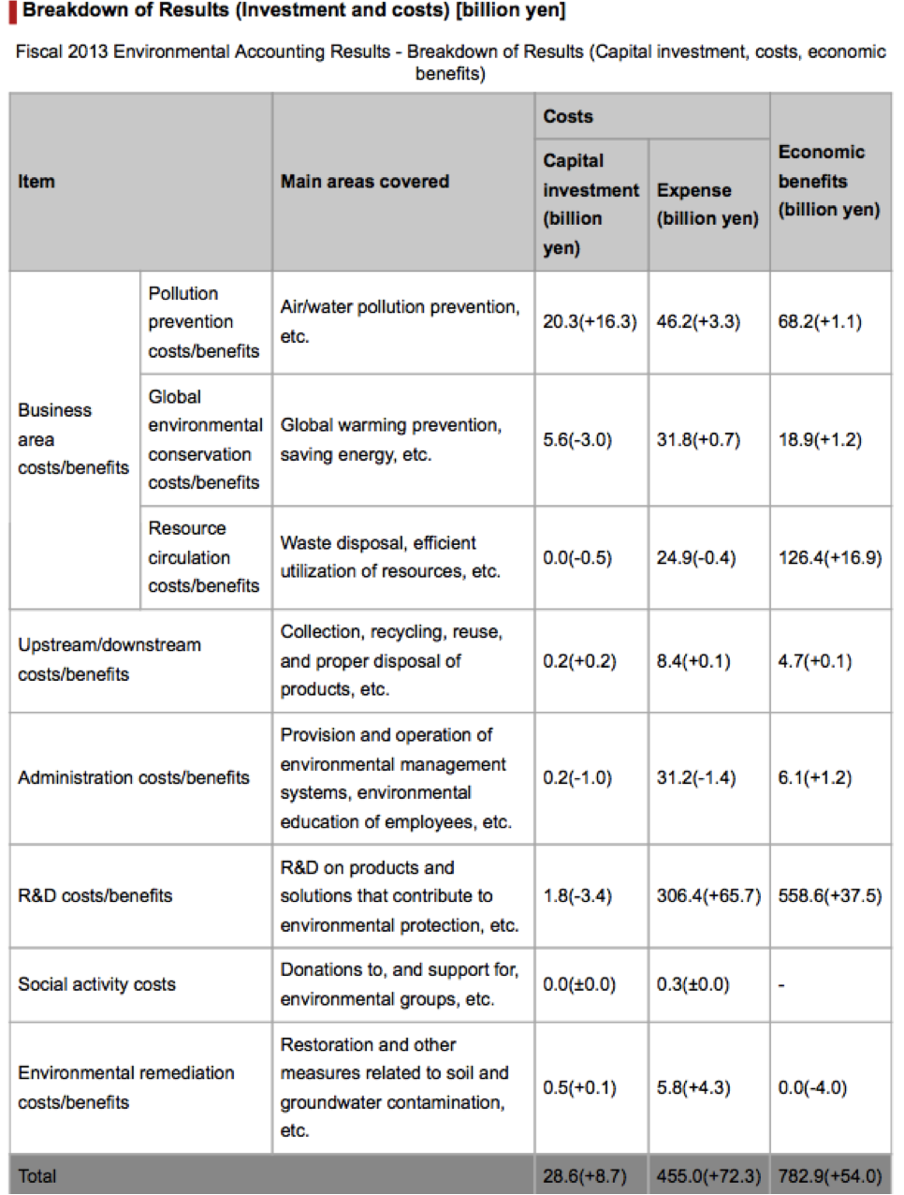

  - Numbers in parentheses indicate increases or decreases in comparison with the previous year.
  - Due to rounding, figures in columns may not add up to the totals shown.
  - Items shown as "0.00" include items for which the value was smaller than the display units used.

http://www.fujitsu.com/global/about/environment/management/ems/accounting/

Appendix E

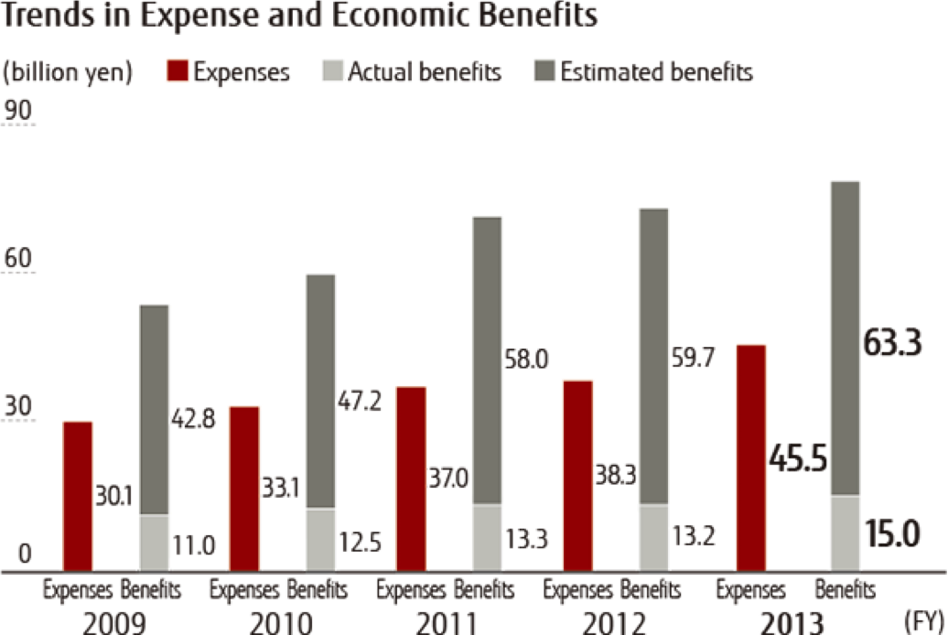
http://www.fujitsu.com/global/about/environment/management/ems/accounting/

Peloza, et al, 2012
IFAC, 2005
Braun, 890
Jose, Shang-Mei Lee “Environmental Reporting of Global Corporations”
Ulas, 2015
www.toshiba.ca
http://www.toshiba.co.jp/worldwide/about/commitment.html
http://www.toshiba.co.jp/env/en/vision/ceo.htm
http://www.toshiba.co.jp/env/en/vision/ceo.htm
http://www.toshiba.co.jp/env/en/vision/ceo.htm
http://www.toshiba.co.jp/env/en/industry/energy.htm
http://www.toshiba.co.jp/env/en/management/account.htm
http://www.toshiba.co.jp/env/en/management/account.htm
http://www.fujitsu.com/global/about/corporate/info/index.html
http://www.fujitsu.com/global/about/environment/management/ems/accounting/
http://www.fujitsu.com/global/about/environment/management/ems/accounting/
Environmental Management Accounting (2014) http://www.accaglobal.com/ca/en/student/acca-qual-student-journey/qual-resource/acca-qualification/p5/technical-articles/environmenta-management.html#
http://www.telecom.toshiba.com/environment/
Toshiba, Green Management, 117 http://www.toshiba.co.jp/env/en/communication/report/pdf/env_report14_Green_Management_e.pdf,
Toshiba Annual Report 2014, pg 54 http://www.toshiba.co.jp/about/ir/en/finance/ar/ar2014/tar2014e.pdf
Toshiba Annual Report (2014)
CSR Highlight Report 2014 http://www.toshiba.co.jp/csr/en/report/files/report2014_digest.pdf
CSR Highlight Report 2014 http://www.toshiba.co.jp/csr/en/report/files/report2014_digest.pdf
Environmental Accounting in Japan, (2003)
Fujitsu Financial Report, (2001)
The History of Fujitsu's Environmental Activities
Fujitsu Environmental Report (2014)
Taylor Adams, Anne (2014)
Fujitsu Environmental Report (2014)
Fujitsu Environmental Report (2014)
Braun, 895

