Lesson 1:
Christianity is the faith based on Jesus Christ’s:
- life
- teachings
- death
- resurrection and ascension into heaven
Jesus lived some 2000 years ago.
The Christian Bible contains:
- Old Testament (OT) + apocrypha/deutero-canonical books
- New Testament (NT): 27 books, including 4 Gospels (“good news”)
- Gospels were written some 40-50 years after Jesus’s death

Left: Folio from Papyrus 46, containing
2 Corinthians 11:33-12:9 in Greek
(Source: Wikipedia) (Click on image in enlarge)

These methods include:
- Historical critical method
- Literal method
- Allegorical method
- Mystical method
- Moral method
The most widespread with scholars today is the
historical critical method
which looks at:
- historical context
- intended audience of the author
- desired effect of the author
Synoptics (Greek for “seen together”):
- Matthew (Mt), Mark (Mk), Luke (Lk).
- Matthew and Luke are based on Mark and Q (from the German word “Quelle” = source).
The historical critical method established that:
- Matthew targets a Jewish-Christian audience, because Jesus is presented as the second Moses and Messiah.
- Luke targets a Gentile audience, because it speaks in universal terms.
The Gospel of John (Jn):
- Jesus is the eternal Son and Logos (or Word) of God, the incarnate God on Earth.
- There are also apocryphal (or secret) gospels attributed to Thomas, Peter, Mary Magdalene, Philip, and even Judas – most of them come from Gnostic circles and are later.
The evangelists, along with their symbols in iconography from the Book of Kells (image), are:
- Matthew the Evangelist, symbolized by a man, to represent the human nature of Christ.
- Mark the Evangelist, symbolized by a lion, to represent Christ as king.
- Luke the Evangelist, symbolized by a bull or a calf, to represent Christ as sacrifice and as priest.
- John the Evangelist, symbolized by an eagle, to represent the Christ as God.

Biblical Prophecies
- Jesus was born in the year 0 of the Common Era (CE) (this is the secular alternative to AD (Anno Domini)).  - There are Old Testament prophecies about the Messiah being born in Bethlehem. | - Jesus’s parents: Mary and Joseph.  - The gospels tell us about Jesus’s birth,  then an episode at age 12, and his life around the age of 30

John the Baptist
An important character, was Jesus's forerunner and he baptized people for the forgiveness of their sins.

Jesus’s baptism by John has been seen as:
- Consecration to God as the Messiah.
- John publicly announcing that the Messiah has arrived.
- Jesus identifies himself with sinful humanity.

After the baptism:
- Jesus undergoes a 40-day retreat in the desert before starting his ministry.
- Jesus then begins to gather his first disciples: Simon, Peter, Andrew, James and John.
- The emphasis of Jesus’s ministry is on a spiritual life.
Miracles are seen as signs of the presence of the Kingdom of God
- turning water into wine
- healing the sick
- restoring life to the dead
- casting devils out of the possessed
- multiplication of bread
The kingdom is “already” here, but “not yet” fully realized.

Jesus’s Radical Ethics

An important question: Is Jesus the Messiah?
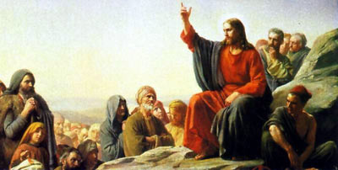 | Jesus reluctantly applies this title to himself because of misunderstandings.  At the Transfiguration (witnessed by three disciples) Moses and Elijah appear to seal the fact that Jesus is the Messiah.

Jesus’s Ethics and Teachings | - touched lepers and a bleeding woman to heal them  - welcomed women as disciples  - extended the command against adultery to adultery in one’s heart  - preached “turn the other cheek” (as opposed to “an eye for an eye”)  - taught love your enemies  - proposed love is for God and for one’s neighbor  - offered forgiveness to those who repented  - challenged the interpretation of the Mosaic law (generally NOT the law itself)  - challenged the Jewish authorities

Jesus’s Crucifixion, Death and Resurrection
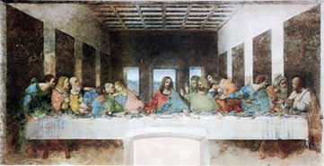 | 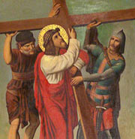
Sequence of events  - Jesus returns to Jerusalem. Has Last Supper with his disciples  - Judas betrays Jesus for 30 pieces of silver, Jesus is arrested  - At the trail Caiaphas, the high priest, asks Jesus if he is Christ (or the Messiah) and Jesus answers: "You have said so", thus answering in the affirmative  - Caiaphas and the other priests see this declaration as blasphemy against God  - Roman authorities are asked to crucify Jesus  - The crucifixion occurs some time between 27-33 CE  (apparent end of the story)  - Resurrection: women visit the tomb; Jesus’s appearances; women’s presence witnesses to the historical truth in claims of Jesus’s resurrection | 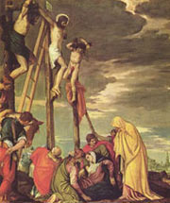
Above left: The Last Supper (1495-1498) by Leonardo da Vinci (1452-1519) (Source: Wikipedia)
Above right: Jesus helped by Simon of Cyrene, 19th-century Brazilian depiction (Source: Wikpedia)
Bottom right: Calvary by Paolo Veronese, 16th century (Source: Wikpedia)

The Early Church
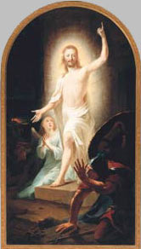 | After Jesus's Death and Resurrection
- Acts of the Apostles (author Luke), Paul’s Letters, the other letters of the New Testement
- Jesus’s ascension to heaven is followed by the descent of the Holy Spirit at the Pentecost (Acts 2)
- Paul’s attempts to convert both Jews and Gentiles to Christianity
- Anti-Christian feelings among Jews which led to anti-Jewish feelings among the early Christians
- The new message Christianity proposes: salvation is by faith (not by circumcision, says Paul)
Left: The Resurrection painted by Johann Heinrich Tischbein the Elder, 1778
(Source: Wikipedia)

The Spread of Christianity
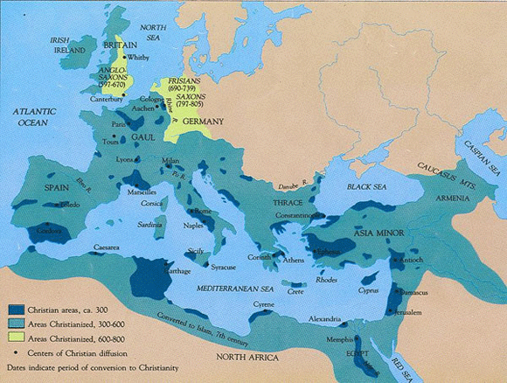
The spread of Christianity, 300 to 800 AD (Source: Agur, Wikipedia)
(Click on image to enlarge)

