Chapter 14: Organizational Culture

Organizational culture: the values and assumptions shared within an organization.

LO1: Elements of Organizational Culture

Figure 14.1 Organizational Culture Assumptions, Values, and Artifacts

Espoused values: values that leaders say they and their staff rely on to guide their decisions and actions.

Enacted values: the values that leaders and employees truly rely on to guide their decisions and actions.

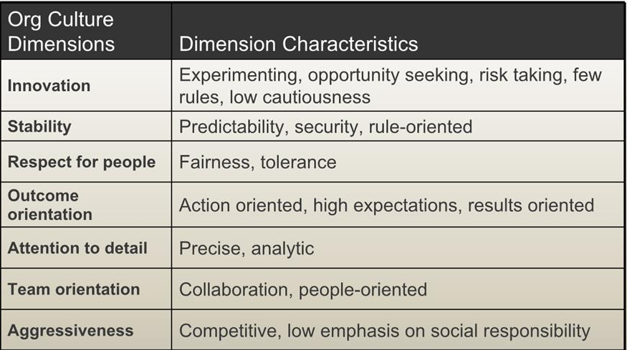
Figure 14.2 Corporate Cultures:

3 concerns of these types of models:
- They oversimplify the diversity of cultural values in organizations (there are many more org. values that these models offer)
- Organizational culture includes shared assumptions about the right way to do things, not just shared values.
- These models adopt and “integration” perspective; they assume that most cultures have a clear, unified culture that is easily understandable

Organizational Subcultures

Dominant cultures:
- The values and assumptions shared most consistently and widely by the organizations members
- Includes senior management
- Not as unified or clear as many business leaders assume

Subcultures:
- Located throughout the organization’s divisions, geographical regions, and occupational groups
- Espousing parallel assumptions and values

Countercultures:
- Embrace values and assumptions that directly oppose the organization’s culture

Subcultures, particularly countercultures, potentially create conflict among employees. But they hold 2 important functions:
- they maintain the organization’s standards of performance and ethical behavior
- they are spawning grounds for emerging values that keep the firm aligned with the needs of customers, suppliers, society and other stakeholders

LO2: Deciphering Organizational Culture Through Artifacts

Artifacts: the observable symbols and signs of an organization’s culture. (ex. The way visitors are greeted, employee rewards, and organization’s physical layout)

Categories of artifacts:

1. Organizational Stories and Legends:
Stories permeate strong organizational cultures. Some tell heroic deeds, others ridicule past events that deviated from the firm’s core values. These stories serve as powerful social perceptions of how things should or should not be done. Stories also create emotions for listeners that improve their memory of the lesson.

2. Rituals and Ceremonies:
Rituals: programmed routines of daily organizational life that dramatize the organizations culture.
Ceremonies: planned displays of organizational culture, conducted specifically for the benefit of an audience.

3. Organizational Language:
The manner in which businesses communicate show the values held by the org’s subcultures

4. Physical Structures and Symbols
Items in the building might convey cultural meaning

LO3: Is Organizational Culture Important?

A strong corporate culture potentially increases the company’s success by serving 3 important functions:

1. Control system:
Organizational culture is a deeply embedded form of social control that influences employee decisions and behavior Culture is pervasive and operates unconsciously.

2. Social glue:
Organizational culture is the social glue that bonds people together and makes them feel a part of the organizational experience. It is a way to attracts new staff and retain to performance.

3. Sense making:
Organizational culture helps employees understand what goes on and why things happen in the company.

Contingencies of Organizational Culture and Performance
- Are the organization’s culture content are aligned with the external environment?
- The degree of the culture strength
- Between cultural strength and organizational culture, does the culture content include adoptive culture?

Adoptive culture: an organizational culture in which employees focus on the changing needs of customers and other stakeholders, and support initiatives to keep pace with those changes.

An organizational culture can affect the ethical conduct of its employees.

LO4: Changing and Strengthening the Organizational Culture

Actions of Founders and Leaders
- An organizations culture begins with its founders
- Founders are often visionaries who provide a powerful role model for others to follow
- Leaders are sometimes able to reshape that culture by applying transformational leadership and organizational change practices

Figure 14.3 Strategies to Change and Strengthen Organizational Culture
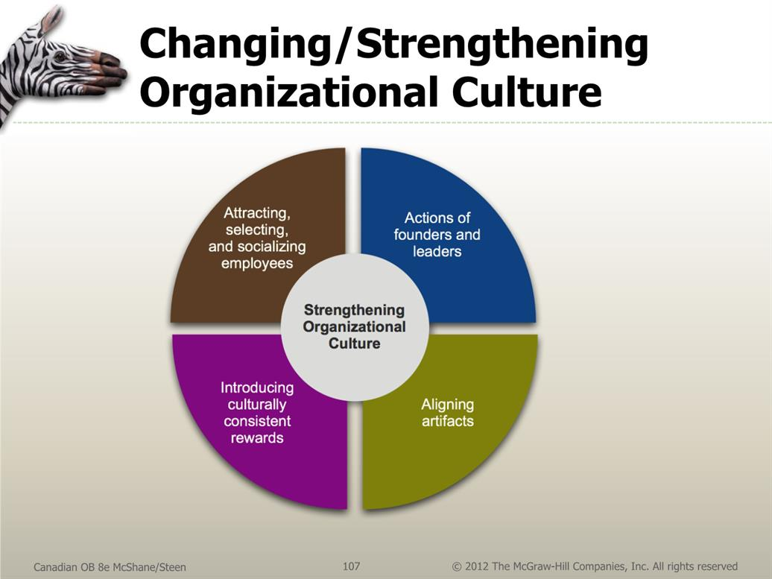

Attracting, Selecting, and Socializing Employees

Attraction-selection-attrition (ASA) theory: states that organizations have a natural tendency to attract, select, and retain people with values and personality characteristics that are consistent with the organizations character, resulting in a more homogeneous organization and a stronger culture.

Attraction:
Job applicants engage in self-selection by avoiding employment in companies whose values seem incompatible with their own values. Applicants also inspect organizational artifacts when visiting the company.

Selection:
How well a person “fits” into the company’s culture. Interview processes help select applicants.

Attrition:
People are motivated to seek out environments that are sufficiently congruent with their personal values.

Organizational socialization: the process by which individuals learn values, expected behaviors, and social knowledge necessary to assume their roles in the organization.

Figure 14.4 Stages of Organizational Socialization

Reality shock: the stress hat results when employees perceive discrepancies between their pre-employment expectations and on-the-job reality.

LO5: Merging Organizational Cultures

Bicultural audit: a process of diagnosing cultural relations between the companies and determining the extent to which cultural clashes will likely occur.

Bicultural audit begins by:
- Identifying cultural differences and artifacts
- Data is analyzed to determine result in conflict/compatibility
- And finally identifying strategies and preparing action plans to bridge the 2 organization’s cultures

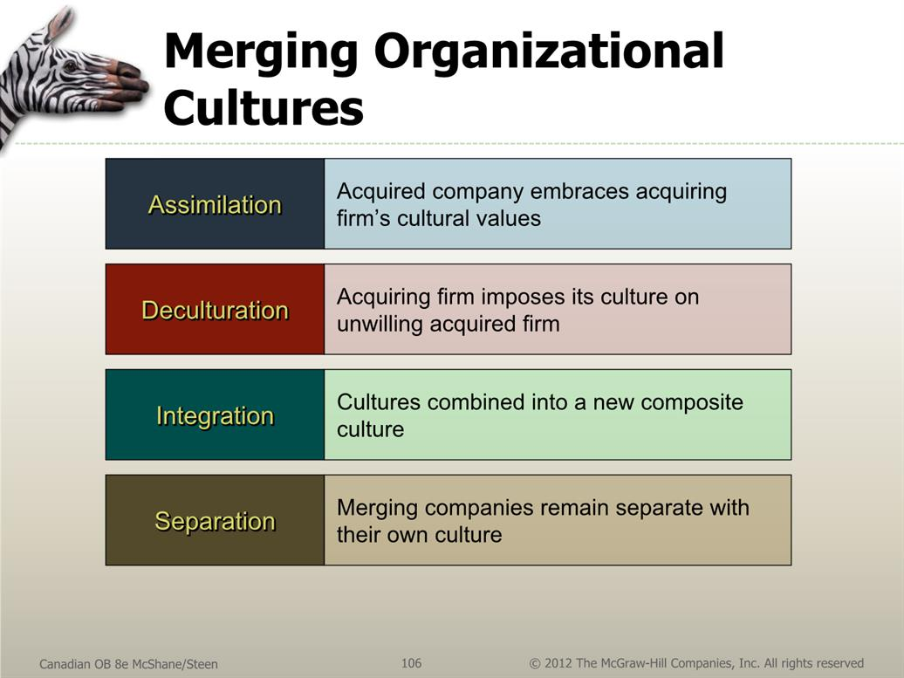
Figure 14.5 Strategies for Merging Different Organizational Cultures

