PHI1101 I: Reasoning and Critical Thinking

Introduction

Five basic assumptions have guided and shaped this book:
- Everyone possesses some sort of reasoning mechanism
- We can all improve our reasoning
- There are basic principles to reasoning
- There are guidelines for defending claims
- Guidelines can be presented in a brief way

Chapter 1
A number of crucial concepts were presented in this chapter. In summary:
An argument is a set of claims, one of which is meant to be supported by the
others.
A conclusion is a claim meant to be supported by reasons offered in an argument.
A premise is a claim put forth as a reason for a conclusion.
(Argument = conclusion + premises)
An inference is a move from premises in an argument to a conclusion.
- Implication is a relation between statements. “This is a leap year” implies “this is an even-numbered year.” Whereas, someone else could infer that Because it is a leap year, it is an even numbered year (which would be wrong).
Inference indicators include premise and conclusion indicators.
Conclusion indicators are words used to indicate that a conclusion is about to be drawn.
Premise indicators are words used to indicate that a premise is about to be given.
Enthymemes are arguments that have implicit (unstated) premises or conclusions.
An intermediate conclusion in an argument is a claim that is supported by some other claim or claims, but that itself also provides support for a further conclusion.
The final conclusion of an argument is the argument’s final point, the conclusion that is not itself a premise for anything else in that argument.
Simple arguments are arguments that have no intermediate conclusions (that contain only one inference).
Complex arguments are arguments that have at least one intermediate conclusion (contain more than one inference).
Note
Premise | Not a Premise
Rhetorical Questions | Reports
Ought imperative or what should be done(unless intended as orders) | Explanations
Conditionals (Ifthen) | Exclamation
 | Command
 | Questions
 | Exhortations

3 General Considerations:
- Arguments can be any length
- Arguments are not the same as Disputes
- Arguments can fail (false premises, inadequate support)

Recognizing arguments
- Inference indicators
  - Conclusion indicators – so, thus, consequently, therefore etc
  - Premise indicators – because, since, seeing as, etc
  - NOT INFERENCE INDICATORS: and, but, also, besides, in addition, nevertheless.
- Implicit premises and conclusions (Enthymemes)
- Example: The bigger the burger the better the burger. The burgers are bigger at Burger King.
- Questions, Commands, Exclamations, and Exhortations are NOT part of arguments
- Since an argument is a claim, then questions, commands, exclamations, and exhortations cannot be a part of an argument.
- An argument has to be a statement that can be verified ex “It is 2 o’clock” vs “What time is it?”
- Multiple Conclusions and Complex Arguments
Simple and Complex Arguments
- intermediate conclusions - conclusions used as premises in a continuing chain of reasoning.
- final conclusion - conclusion that is not itself a premise for anything else but the argument’s final point.
- Because to draw a conclusion is to make an inference, a simple argument can also be characterized as an argument that consists of only one inference; a complex argument consists of more than one inference.
- Simple arguments are arguments that have no intermediate conclusions (that contain only one inference).
- Complex arguments are arguments that have at least one intermediate conclusion (contain more than one inference).
EXAMPLE 1
Erlich forgot to pay his gas bill again. It looks like the poor guy is obsessed with finishing the novel he has been writing. Anyway, he sure will be cold this winter.
PREMISE: Erlich forgot to pay his gas bill again.
CONCLUSION 1: Erlich is obsessed with finishing the novel he is writing.
CONCLUSION 2: Erlich will be cold this winter.
This is a case of two separate arguments:
Argument 1:
PREMISE: Erlich forgot to pay his gas bill again.
CONCLUSION 1: Erlich is obsessed with finishing the novel he is writing.
Argument 2:
PREMISE: Erlich forgot to pay his gas bill again.
CONCLUSION 2: Erlich will be cold this winter.
EXAMPLE 2
If the crippling debts of Third World nations can be eased, then the national economies of these countries can start to grow at a healthy rate. And if these economies can experience growth, then millions of people can work their way out of poverty and starvation. Fortunately, it is possible to ease the debts of these nations; thus their economies can experience growth. Therefore it is possible for millions of the world’s poorest people to find their way out of the cycle of poverty.
PREMISE 1: If the debts of Third World nations can be eased, then the national economies of these countries can start to grow at a healthy rate.
PREMISE 2: The debts of Third World nations can be eased.
CONCLUSION: The national economies of these nations can grow at a healthy rate. (INTERMEDIATE CONCLUSION)
Furthermore:
PREMISE 1: If the economies of debtor nations can start to grow at a healthy rate, then millions of people can work their way out of poverty.
PREMISE 2: The national economies of these nations can grow at a healthy rate.
CONCLUSION: Millions of people can work their way out of poverty.

Chapter 2

Analyzing Arguments
- Showing the Structure of an Argument
  - Simple Arguments: Standard Form (State premises, underline and then conclusion)
  - Complex Arguments: Standard Form
1. Arrange the claims so the premises come before the conclusion they support. Do this for both the intermediate conclusions and the final one.
2. Number the premises and conclusions in the revised order.
3. After each conclusion, write the number of the premise (or premises) that supports it.

  - Diagrams (bracket each claim in a passage, assign each one a number, and use the number in the diagram.
- Strategies of Analysis
  - Indicators and Context
    - Identify inference indicators (circle them in the paragraph)
    - Consider the larger context
  - Dealing with Claims
    - Identify each claim in a passage
    - Discard Elements that do not belong to the Argument
    - Reformulate claims when necessary (Example: “I don’t think Stransky is competent to stand trial. She seems entirely confused
even about her own identity.” Should be interpreted as Stransky is confused about her own identity, therefore she is incompetent to stand trial.)

  - Structures
    - Identify the Main argument (the final conclusion)
    - Identify Subarguments (An intermediate conclusion together with its supporting Premises)
    - Identify any replies to Objections (An intermediate conclusion together with its supporting Premises)

2 Special Problems
- Arguments and Explanations
  - Explaining why she murdered her children is not the same as arguing that she murdered her children.
  - When each example contains single statement about a cause or reason, not two statements, one of which is offered as a premise for the other.
- Conditionals (“If … then … ”), Disjunctives (“Either … or … ”), and “Unless”
  - It may seem that a conditional sentence is an inference itself—that it makes two distinct claims, one a conclusion and the other a premise. This tempting interpretation is wrong; a conditional sentence makes only one claim.
  - A disjunctive sentence presents alternatives in some version of an “Either … or … ” form” The sentence “Either the roof will be patched or the documents will be damaged by the rain” is a disjunctive one. Like conditionals, disjunctive sentences contain other sentences as components, so they too may appear to be making more than one claim. Despite appearances, however, such sentences make only a single claim.
- Analyzing a Complex Argument

Chapter 3
The worth of any argument depends on two considerations: (1) the truth or falsity of its premises and (2) how much support its premises provide the conclusion.

Deductive arguments are meant to be valid; that is, their premises are meant to guarantee the conclusion. In nondeductive arguments, the premises are meant to confer some high degree of probability on the conclusion.
Deductive Arguments
- Concept of Validity
  - Valid argument is one in which there is no possible way for the premises to be true and the conclusion false at the same time. Thus, the truth of the premises of a valid argument completely guarantees the truth of the conclusion. “Harold is Matilda’s son. So Matilda is Harold’s mother.”
  - Invalid argument is one in which the truth of the premises does not guarantee the conclusion. “Crombie was stoned, stabbed, shot, and scalped. So Crombie is dead.” This statement does not guarantee that Crombie is actually dead
- Validity, Truth, and Soundness
  - Validity is the support that premises lend to a conclusion. If we grant the premises, must we grant the conclusion?
    - A valid argument can have false premises+true conclusion, false premises + false conclusion, true premises+true conclusion. “The moon is made of green cheese, and everything made of green cheese orbits the earth. Therefore, the moon orbits the earth
    - Sound arguments are valid arguments whose premises are all true
    - If an argument is valid, then even after adding another premises it will still remain valid “ All platypuses are mammals. Nadine is a platypus. Almost no mammals lay eggs. Nadina lays eggs. Therefore, Nadine is a mammal”
    - If an argument has TRUE premises and FALSE conclusion, then it is not valid.
  - Truth
Here is one more invalid argument:
“The thimbleful of water has been in the 10° Fahrenheit freezer for twenty-eight hours. Thus, it is frozen.”
Clearly, there are possible circumstances under which these premises are true but the conclusion false. For instance, the thimbleful of water is placed in the 10° freezer; it remains there for twenty-eight hours; water has no freezing point—no water ever freezes; the thimbleful of water (of course!) is unfrozen; it is as liquid as
ever. In evaluating the validity of this or any other argument, we must be careful to distinguish what is true from what is possible. It is not true that the water would not be frozen, because the freezing point of water is in fact 32°. But the given premises do not include this fact; they do not rule out the possibility that water never freezes. And since the premises of a valid argument must rule out any possibility that the conclusion is false, this argument as it stands is invalid.
Non-Deductive arguments
- Any argument that is not meant to be valid but is meant to confer some high degree of probability is a nondeductive argument
  - not meant to be valid, but meant to make the conclusion probable
  - nondeductive support of a conclusion is a matter of degree (96% likely, 70% likely, etc)
  - addition of new information in the premises of a non-deductive argument may radically alter the overall amount of support for the conclusion
- Varieties of Nondeductive Arguments
  - Statistical Syllogism – a syllogism is a 3-line argument. In statistical syllogism, the reasoning is from the proportion of a population having a certain attribute to some individual within the population having that attribute “Only 3% of college students know the capital of South Dakota. Morris is a college student. Morris doesn’t know the capital of South Dakota”. This argument means there is 97% chance that morris doesn’t actually know the capital of South Dakota
  - Inductive Generalization – inference is from some sample of a population to all or some % of its members. “Every wolverine so far encountered by humans has been unfriendly and aggressive. All wolverines are unfriendly and aggressive
  - Casual Arguments – further in chapter 6
  - Arguments by analogy – “if hamsters make good house pets, and gerbils are lke hamsters. Then, gerbils will make good house pets”
  - Plausibility arguments – Premises work together to build a case for the conclusion. Howl is superficial and a dated. The second coming has profound social significance. The second coming is a finer poem than howl.
  - At least some of the premises of the argument must be positively relevant to the conclusion. This is a requirement for a successful argument

- HOW TO EVALUATE SUPPORT FOR THE FINAL CONCLUSION:
    - If each inference in a complex argument is valid, the whole argument is valid.
    - If any inference in a complex argument is unsuccessful, the whole argument is unsuccessful
    - If a complex argument is made up of one or more valid inferences and exactly one nondeductively successful inference, the whole argument is nondeductively successful.
    - If a complex argument is made up of two or more nondeductively successful inferences or of two or more nondeductively successful and some valid inferences, the whole argument may be either nondeductively successful or unsuccessful.

Chapter 4
Valid Argument Forms
Sentential Form
Form & Variables
- When letters replace the sentences in an argument (Eg. If P, then Q. P. Therefore, Q)
- Also, it is customary in sentential form to use either the three-dot pattern or the line before the conclusion instead of the word therefore.
Connectives
Ordinary Words | Symbol | Name
Either, or | ˅ | Disjunction
And, but, yet | ● | Conjunction
If, then |  | Implication

Conditional sentences are of the form “If…, then…”. Whatever follows “if” is the antecedent, and whatever is after “then” is the consequent.
Negation (denying)
- Negation is represented by ~
An example of Symbolizing
“If cigarette advertising leads teenagers to smoke and advertisers lie about their aims, then either cigarette advertising should not be allowed or it should be strictly regulated. “
(C●L)(~A ˅R)
Hints on Symbolizing Complex Sentences:
1. Identify the simple component sentences—those that are not made up of further sentences and connective phrases.
2. Identify the main connective. This is the connective phrase that holds the whole together.
3. Try to symbolize the components that are connected by the main connective as separate sentences. This involves applying Steps 1 and 2 again to these subcomponents of the sentence. Think about this procedure as applied to the example already given.

Valid Argument Forms
- Modus Ponens (MP) "method of affirming." :
If P, then Q
P
Therefore, Q.
NOTE:
- Complex as well as simple sentences can occupy the places of P and Q.
- Components can be negative sentences
- Order in which premises are given does not matter
- However, the following form is not an instance of modus ponens:
~(P Q)
~P
Q
- Modus Tollens (MT) "method of denying.":
If P, then Q
Not Q
Therefore, not P.

Can be written as:
PQ
~Q
---
~P

or

~P ~Q
Q
P
- Hypothetical Syllogism (made up entirely of hypotheticals (conditionals))
PQ
QR
---
PR
- Disjunctive Syllogism (“either or”)
P ˅Q
~Q
---
P
- Constructive Dilemma (Set of alternatives)
P ˅Q
PR
QS
---
R ˅ S

A dilemma is a set of alternatives. This argument form uses a set of alter-
natives and a disjunction to allow the inference to another set of alternatives.

- Conjunction
P
Q
---
P ● Q
- Simplification
P ● Q
---
P
- Addition
P
---
P ˅Q
This form may look peculiar, but it is valid. For if P is true, then of course P or anything else whatsoever will be true.
2 Invalid Argument Forms (FORMAL FALLACIES)
- Denying the antecedent is not valid
If P, then Q
Not P
Therefore, Not Q
- Affirming the consequent is not valid
If P, then Q
Q
Therefore, P

Using the Forms to Show Validity
We may quickly discover that many seemingly valid arguments do not have one of these eight forms. Yet, it is possible to use the forms to show their validity.
As when we used standard form before, to the right of each conclusion we write the line(s) from which it follows. We also give the justification for each valid inference; that is, we give the name of the form of the inference, a form we know to be valid. It is natural, now, to think of the valid forms, modus ponens and so on, as inference rules—rules that enable us to move from one step to an- other in a valid way. When we have justified each inference in an argument, we have demonstrated that the argument as a whole is valid. Each inference in the previous argument was explicitly given to begin with. Often that is not the case.
Conditionals
P only if Q is symbolizable as P Q
P provided that Q is symbolizable as Q P
P unless Q is symbolizable as ~Q P
Equivalent Forms
We observed before that it is seldom necessary in arguments to use clumsy sentences such as “It is not the case that cats do not like cream,” because the clearer “Cats like cream” conveys the same claim. We can rephrase this idea now by saying that the sentences are equivalent, for neither one can be true unless the other is. That is:
C~~ C and ~~C C
Then, C ↔~~C
(The double arrow is usually read as “if and only if,” often abbreviated as “iff.”)
- Double Negation
C ↔~~C
- Commutation (Com)
(P ●Q) ↔ (Q● P)
(P ˅Q) ↔ (Q ˅P)
- Contraposition (Contra)
(P Q) ↔ (~Q ~P)
“If the biblical account of creation is correct, then the scientific account is wrong.” is equivalent to “If the scientific account of creation is not wrong, then the biblical account is incorrect.”

- Definition of Implication (Imp)
(P ˅ Q) ↔ (~P Q)
- Exportation (Exp)
[(P● Q) R] ↔ [P (Q R)]
- De Morgan’s Rule (DM)
There are two of them. The first is
~(P● Q) ↔ (~P ˅ ~Q)
“Oh, come now. It can’t be both that Darwell works for the CIA and that he is employed by the FBI.”
is equivalent to “Either Darwell does not work for the CIA or he does not work for the FBI.”
This form is not nearly as mysterious as it may first appear. It says that not both P and Q are true is equivalent to either P is not true or Q is not true.

The second De Morgan equivalence is
~(P˅ Q) ↔ (~P ● ~Q)
“It just isn’t true either that Ellis will have a competent attorney appointed by the court or that he will be able to defend himself.” is equivalent to “Ellis will not have a competent attorney appointed by the court, and Ellis will not be able to defend himself.
This form says that it is not the case that either P or Q is true (neither is true) is equivalent to both P and Q are false
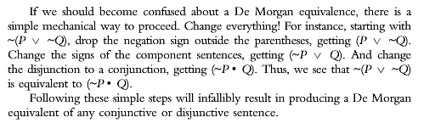
Using Inferences and Equivalence Rules
Deductive Proof strategies
It frequently happens that applying simple argument forms in sequence (as in the previous section) can be combined with certain complex reasoning strategies to prove a conclusion. Here we consider three common proof strategies.
- Conditional Proof
- Reductio ad Absurdum
- Proof by Cases

Chapter 5

Categorical Statements
Categorical statements such as these enter into some reasoning patterns whose validity or invalidity we can conclusively demonstrate. The easiest and perhaps most commonsensical way of showing validity or invalidity in categorical reasoning is to construct intersecting circles to form Venn diagrams.
Example 1: “All Trout Are Fish”

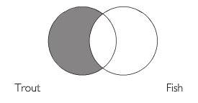
Let’s begin with a diagram of the single statement “All trout are fish.” We need one circle to represent the category trout, and another to represent fish. There are no trout that are not fish, therefore the left circle is shaded in to represent that it is empty.

Example 2: “No Mammals are Snakes” or “No Snakes are Mammals” is equivalent.

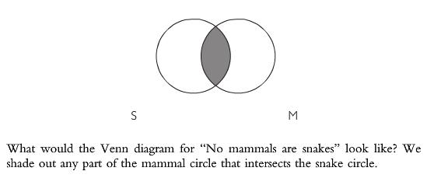

Example 3: Case of “some”

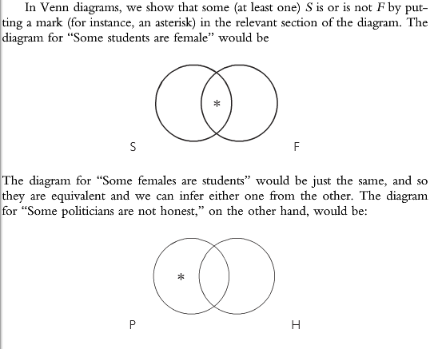

Categorical Syllogism
Categorical syllogisms are syllogisms that have two premises and a conclusion, all of which are categorical statements.
All lawyers are educated people
All educated people are clever people
---------
All lawyers are clever people
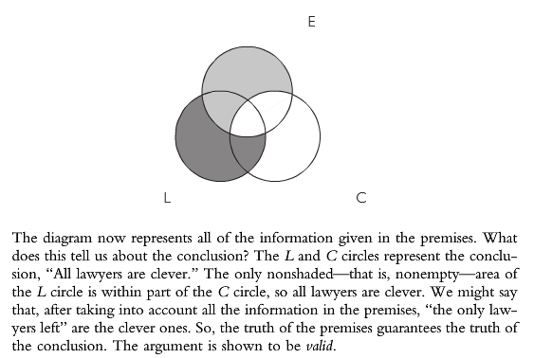

All bankers are wealthy.
No wealthy people are happy.
-----------------------
No bankers are happy.

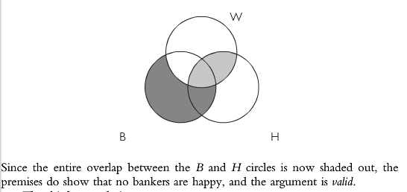
Some novelists are astute observers.
All astute observers are reliable witnesses.
-------------------------------------------
Some novelists are reliable witnesses.
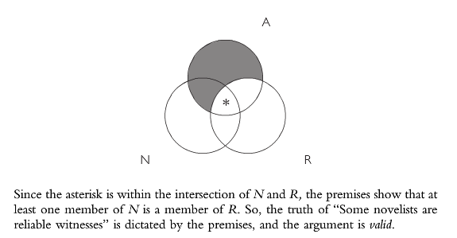
All works of art are profound.
No cartoons are works of art.
------------------------------------
No cartoons are profound.
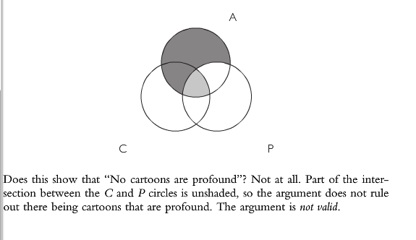
All vegetarians are very thin.
Some very thin people are undernourished.
-----------------------------------------
Some vegetarians are undernourished.
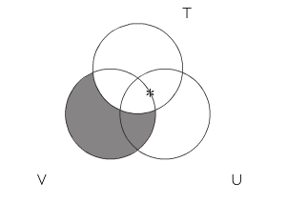
But where do we put the asterisk to represent the second premise? It has to be in the overlap of the T and U circles, but that overlap is divided into two parts, and we have no warrant for choosing one or the other of these. A convenient way of showing this is to put it on the line between the sections.
Since we do not know whether the asterisk is inside the intersection of V and U (the very center section of this diagram), the argument is not valid.

Chapter 6 – Causal Analysis
Basic Causal Relationships
Cause as Sufficient Condition
In this construal of “cause,” the lack of coolant is also said to constitute a sufficient condition for the engine’s overheating. A factor is a sufficient condition for the occurrence of an event if whenever the factor occurs, then the event occurs: Whenever A, then B. We regard factual generalizations of this form, if true, as causal laws.
- Other sufficient conditions can be present besides the one stated
- Causal chains – how the condition stated came to be (what caused the condition)
- Cause as a set of conditions – are there any other conditions after the one stated that could have led to conclusion?
- Effect as a set of outcomes – other conclusions (or effects) that result from condition besides the original conclusion (or effect)

Cause as Necessary Condition
A factor is a necessary condition for an event if the event does not occur in the absence of the factor. Everyone who gets polio has been infected with the polio virus, but not everyone infected with the polio virus gets polio.
If A, then B
If not A, then not B.
Therefore, A is a necessary condition for B
Cause as Necessary and Sufficient Condition
For illustration, assume diamonds are produced only when carbon is subjected to great pressure and in no other way. Carbon and great pressure are each a necessary condition for diamonds, and both together constitute a sufficient condition. Thus, if you know something is a diamond, you know great pressure acting on carbon caused it. Also, you know how to produce (cause) diamonds—subject carbon to great pressure.
Contributing Factors as Causes
Each factor making up a set of factors sufficient (or necessary) for the occurrence of an event can be called a contributing factor. Thus, the methane gas that accumulated in the room was a contributing factor of the explosion that occurred. So, too, was the oxygen present in the room, as well as the spark that set off the mixture.
Triggering Factor (Proximate Cause) - The contributing factor that triggers an event is often designated the cause of the event.
Unusual Factor - The “whole cause” of the explosion was the set of contributing factors: accumulated gas, the presence of oxygen, and the spark from the light switch. But oxygen is usually in the air, and people ordinarily turn on lights. What is unusual is the accumulation of methane.
Controllable Factor – We can then point out that since the factor can be controlled, so can the event.
Causal Explanations
Thus, we can express the claim of a causal relationship between events of type A and type B by the scheme: When A occurs under conditions C then B occurs Generalizations of this form, if true, are causal laws. (We will limit discussion to laws expressing a causally sufficient condition.)
Deductive nomological explanations - Causal explanation thus consists in bringing a case under a law—in showing that a particular case is an instance of a connection that always holds between events of two kinds.
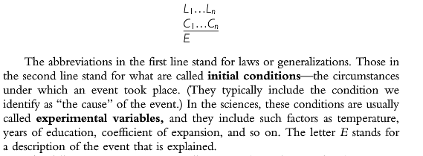
The following criteria are generally accepted as adequate for determining that a deductive nomological explanation is worthy of acceptance:
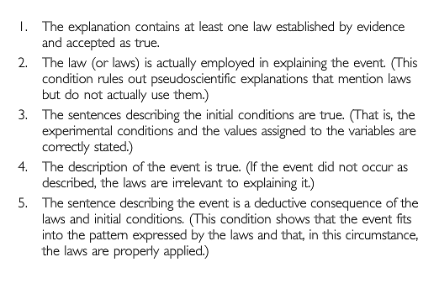

Testing Causal Claims
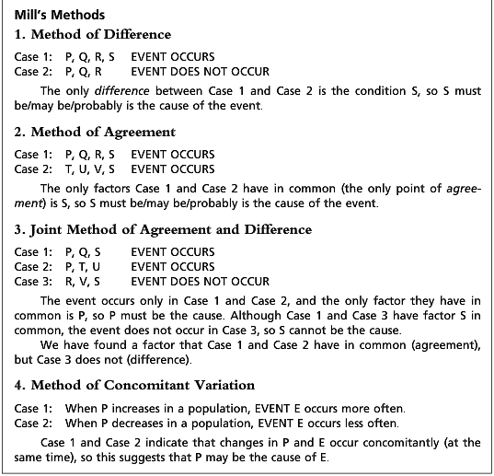

Chapter 7 – Argument by Analogy

Analogical Arguments
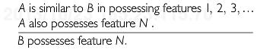
Factual Arguments
Moral Analogical Arguments

Models
Formal Models
A factual analogical argument uses an analogy to establish a claim about some (nonmoral) state of affairs. The two subject matters may be different people, policies, countries, ceremonies, styles of dress, or whatever.
Material Models
Evaluating Analogical Reasoning
Degree of Analogy Must be High
Analogy Should be Relevant to Conclusion

Chapter 8

Chapter 9

