Problem 1
1)

Transfer function of the closed loop system: (C/R) = (kds^(2) + kps)/(s^(4) + 2s^(3) +10s^(2)+ kds + kp)

a) To have 2 dominants oscillating poles kd= 19 and kp = 4 are chosen

p = [1 2 10 19 4];
r=roots(p)

r =
-0.0062 + 3.0914i
-0.0062 - 3.0914i
-1.7482
-0.2394

b) To have one dominant real pole kd= 11 and kp= 1 are chosen

p = [1 2 10 11 1];
r=roots(p)
r =

-0.3895 + 2.9640i
-0.3895 - 2.9640i
-1.1213
-0.0998

2)
% --Unit-Step Response of C(s)/R(s)= (19*s^(2) + 2*s)/(s^(4) + 2s^(3) +10s^(2)+ 19*s + 4)and Partial-Fraction Expansion of C(s)= (19*s^(2) + 2*s)/{s(s^(4) + 2s^(3) +10s^(2)+ 19*s + 4)}%%%%%%%%

num = [19 4 0];
den = [1 2 10 19 4 0];
step(num,den);
[r,p,k] = residue(num,den)

r =
-0.7500 - 0.4319i
-0.7500 + 0.4319i
1.5379
-0.0379
0

p =
-0.0062 + 3.0914i
-0.0062 - 3.0914i
-1.7482
-0.2394
0

k =

[]

3)

Case#1: Where kd= 19 and kp = 4 are taken for 2 dominants oscillating poles

% --Unit-Step ( r(t)=1 ==>R(s)=1/s) Response of C(s)/R(s)= (19*s^(2) + 2*s)/(s^(4) + 2s^(3) +10s^(2)+ 19*s + 4)--%%%%%%%%
num = [19 4 0];
den = [1 2 10 19 4];
t = 0:0.02:10;
y = step(num,den,t);
plot(t,1,'-',t,y,'b')
grid
title('Unit-Step Response')
xlabel('t (sec)')
ylabel('Output')

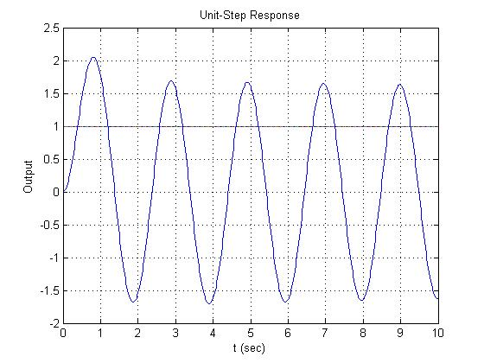

% --Unit-ramp ( r(t)=t ==>R(s)=1/s^2)Response of C(s)/R(s)= (19*s^(2) + 2*s)/(s^(4) + 2s^(3) +10s^(2)+ 19*s + 4)--%%%%%%%%

num = [19 4 0];
den = [1 2 10 19 4 0];
t = 0:0.02:5;
y = step(num,den,t);
plot(t,t,'-',t,y)
grid
title('Unit-Ramp Response')
xlabel('t (sec)')
ylabel('Output')

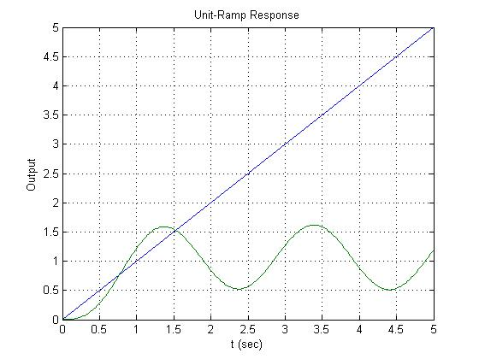

% --Unit-parabola ( r(t)=t^2/2==>R(s)=1/s^3)Response of C(s)/R(s)= (19*s^(2) + 2*s)/(s^(4) + 2s^(3) +10s^(2)+ 19*s + 4)--%%%%%%%%
num = [19 4 0];
den = [1 2 10 19 4];
t = 0:0.01:10;
r = 0.5*t.^2;
y = lsim(num,den,r,t);
plot(t,r,'-',t,y)
grid
title('Unit-Parabola Response')
xlabel('t (sec)')
ylabel('Output')
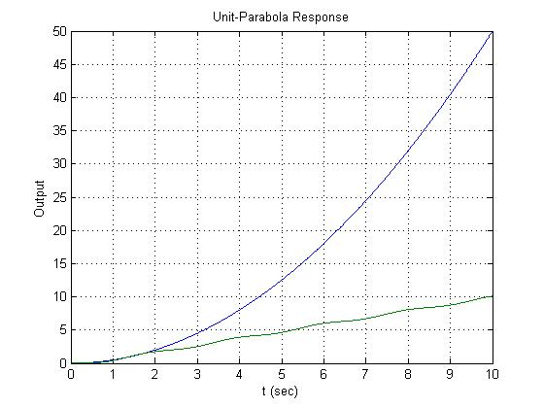

Case#2: Where kd= 11 and kp = 1 are taken for 1 dominant real pole

% --Unit-Step ( r(t)=1 ==>R(s)=1/s) Response of C(s)/R(s)= (19*s^(2) + 2*s)/(s^(4) + 2s^(3) +10s^(2)+ 19*s + 4)--%%%%%%%%
num = [11 1 0];
den = [1 2 10 11 1];
t = 0:0.02:5;
y = step(num,den,t);
plot(t,1,'-',t,y,'b')
grid
title('Unit-Step Response')
xlabel('t (sec)')
ylabel('Output')

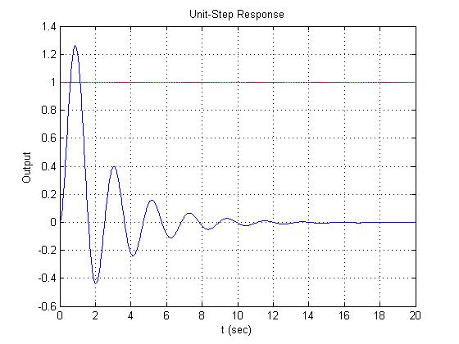

% --Unit-ramp ( r(t)=t ==>R(s)=1/s^2)Response of C(s)/R(s)= (19*s^(2) + 2*s)/(s^(4) + 2s^(3) +10s^(2)+ 19*s + 4)--%%%%%%%%
num = [11 1 0];
den = [1 2 10 11 1 0];
t = 0:0.02:20;
y = step(num,den,t);
plot(t,t,'-',t,y)
grid
title('Unit-Ramp Response')
xlabel('t (sec)')
ylabel('Output')
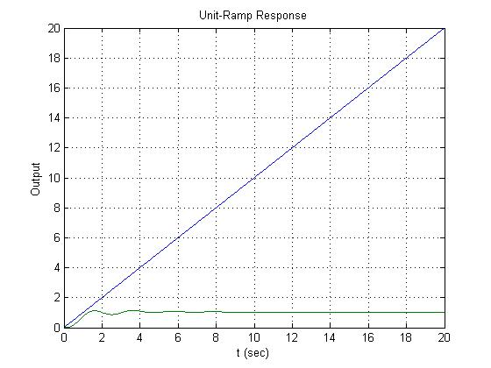

% --Unit-parabola ( r(t)=t^2/2==>R(s)=1/s^3)Response of C(s)/R(s)= (19*s^(2) + 2*s)/(s^(4) + 2s^(3) +10s^(2)+ 19*s + 4)--%%%%%%%%
num = [11 1 0];
den = [1 2 10 11 1];
t = 0:0.01:10;
r = 0.5*t.^2;
y = lsim(num,den,r,t);
plot(t,r,'-',t,y)
grid
title('Unit-Parabola Response')
xlabel('t (sec)')
ylabel('Output')

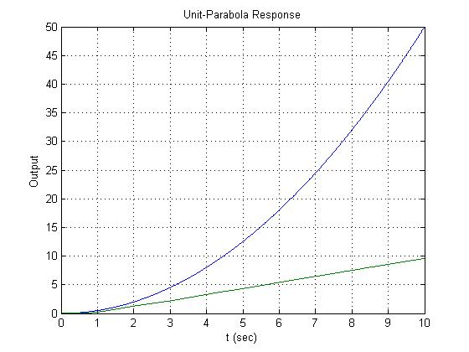

4)
For the unit-step input, the response becomes steady quickly when we have one dominant real pole. But the response takes more time to become steady in the case of 2 dominants oscillating poles. And the same behaviour is noticed for the unit-ramp input. But in the case of the unit-parabola input, the transient response behaves exact same way, for 2 dominant oscillating poles and for 1 dominant real pole.

5)
Here we can see that we have a type 1 system. Base on the table 5-1 of Ogata book on the page 230, the steady-state error for the unit-step input must be zero, for the unit parabola input must go to infinity, and for the unit-ramp input must be a constant (1/Kp, for my case ess=1). And these are exactly what we can see when we analyse each one of our graphs.

6)
The difference between stability and steady state error is that the stability is the behaviour of the system at any given time ‘’t’’. And the steady state error is the behaviour of the system when the time ‘’t’’ goes to infinity and it measures the performance of the system by tracking the reference input.

