Chapter 7: The Skeletal System: The Axial System January 20, 2015
Divisions of the Skeletal System
- 206 bones in the Adult human, most of which are paired (1 on each side of the body)
- Skelton is divided into the Axial Skeleton and appendicular Skeleton
  - Axial Skeleton = 80 Bones
    - Bones that lie around the longitudinal axis (Axis of symmetry) of the body
    - Cranial bones, ribs, sternum, vertebral column
  - Appendicular Skeleton – 126 Bones
    - Appendages – Upper and lower limbs

PICTURE pg 175

Skull
- Skull is the bony framework of the head and contains 22 bones (not counting 3 in middle ear)
- Superior end of Vertebral column
- 2 sets of bones in the skull
  - Cranial Bones
    - Form cranial cavity which encloses and protects the brain
    - 8 cranial bones
  - Facial Bones
    - Form the face
    - 14 facial bones – all of which are paired except Mandible and Vomer
Cranial Bones | Facial Bones
- Frontal (1)  - Parietal (2)  - Temperal (2)  - Occipital (1)  - Sphenoid (1)  - Ethmoid (1) | - Nasal (2)  - Maxillae (2)  - Zygomatic (2)  - Mandible (1) *  - Lacrimal (2)  - Palatine (2)  - Inferior nasal conchae (2)  - Vomer (1) *

General Features and Functions
- Skull forms several several smaller cavities (other than just cranial cavity)
  - Nasal Cavity
  - Orbits (Eye sockets)
    - Nasal and orbits open to external
  - Paranasal sinuses – lined with mucous membrans and open into nasal cavity
  - Middle and Inner ear cavity
    - Within the temporal bones
- Only the auditory ossicles and the mandible have a large range of motion
- Most bone sin the skull held together by Sutures
  - Sutures are joints that attach bone
- Function of cranial bones;
  - Protection of the brain
  - Inner surface attach to meninges (membranes) that stabilize position of the brain, blood vessels and nerves
  - Outer surface of the brain provide attachment for muscles for head movement and facial expressions
  - Framework for face
Cranial Bones
- Frontal bone, Parietal bone, Temporal bone, occipital bone, sphenoid bone, Ethmoid bone,

Frontal Bone
- Forms the forehead (Anterior part of cranium)
- Most anterior part of cranial floor – unpaired bone
- Supraorbital Foramen Medial to the midline – which the supraorbital nerve and artery pass
  - If this foramen is not complete called the Supraorbital notch
Parietal Bone (2)
- Guadrilateral (4 sided) – Form greater portion of sides and roof of cranial cavity
- Each parietal bone articulates with 5 other bones
- Convex in exterior shape - Concave interior
- Internal surface contain protrusions and depressions that accommodate blood vessels
- Sutures of the Parietal Bones
  - Coronal or Anterior Suture: Frontal bone - Parietal bone
  - Sagittal Suture: Parietal bone – Parietal bone
  - Lambdoid Suture: Parietal bone – Occipital bone
  - Squamous Suture: Parietal bone – Temporal bone
Temporal Bone (2)
- Form inferior lateral portion of cranium and part of cranial floor
- Derive from word time – in reference to greying hair at temporal
- Temporal Squama – a thin, flat portion of temporal bone – Anterior, superior part of temple (Around the ear)
- Zygomatic Arch – Anterior to ear formed by zygomatic process and temporal process
- Mandibular fossa & Articular tubercle – articulate with the mandible to form Temporal mandibular joint
- External Auditory Meatus – (Ear canal) directs sound into eat – a relatively large symmetrical hole within the temporal bone
- Mastoid portion - Posterior and inferior to external auditory meatus
  - Mastoid process – rounded projection of the mastoid portion – attachment sight for neck muscles
- Styloid process – Project inferiorly from inferior surface of temporal bone – attachment for muscles and ligament of tongue and neck
Occipital Bone
- Forms posterior portion of the cranium
- Inferior portion is thick, block like that surrounds junction of the brain and spinal cord
- Foramen magnum – (= large hole) - inferior part – inferior part of the brain (Medulla) connects with the spinal cord along with accessory vessels and nerves
- Hypoglossal Canal – Hypoglossal nerves and artery pass
- Occipital Condyles – 2 oval processes on either side of foramen magnum
  - Articulate with depressions on the first cervical vertebra (Atlas) – Form Atlanto-occipital joints
- External occipital protuberance – most prominent projection on the midline (you can feel it on your posterior surface of the head) Superior to foramen magnum

Sphenoid Bone
- Lied in the middle part of the base of the skull
- Called keystone of the cranial floor (Articulates with all other cranial bones, holding together)
- Posterior and slightly superior to nasal cavity and forms part of orbits
- Shape looks like a butterfly or bat
- Sphenoidal sinus – hollow of the sphenoid body, cubelike medial portion between ethmoid and occipital bones
- Sella Turcica (Turkish saddle) – boney, on superior surface of phenoid body
  - Tuberculum sellae – Anterior (forms horn of saddle)
  - Hypophyseal fossa – A depression (seat of saddle) contains pituitary gland
  - Dorsum Sellae – Posterior portion, another ridge
- Greater Wings – project laterally from the body – form anterolateral floor of cranium, part of lateral wall of
- Lesser wings – Form a ridge anterior and superior to the greater wings , form part of cranium floor and posterior portion of orbit
- Optic foramen/canal – Optic nerve pass into orbit
- Pterygoid Process (Ter-i-goyd = winglike) – extend from inferior portion of sphenoid bone – project inferiorly – form part of nasal cavity
- Foramen ovale – At the base of the lateral ptergoid process (under it) – is within the greater wing – opening for nerves
- Foramen Spinosum – Posterior corner of the Sphenoid
- Formamen lacerum – Created by Sphenoid bone (Anterior) and Temperal & Occipital bone (Posterior) – Covered by fibrocartilage which is a joint that holds the three bones together
Ethmoid bone
- Delicate bone, located in anterior part of cranial floor
- Between the 2 orbits – looks spongy
- Anterior to sphenoid bone and posterior to nasal bone
- Forms (1) Part of anterior portion of cranial floor (2) Medial wall of orbits (3) Superior portion of nasal septum and divides nasal cavity into left and right ( 4) Most of the superior sidewals of the nasal cavity
- Major superior supporting structure of the nasal cavity and is extrensive surface area in the nasal cavity
- Lateral Masses – Majority of wall between nasal cavity and orbits
- Perpendicular plate –
- Cribriform plate – Anterior floor of cranium and roof of nasal cavity
  - Contain the Olfactory Foamina – nerves pass
- Crista galli – Project superior from cribiform plate (a process) (goes between eyes toward unibrow)
- Superior nasal concha – increase area of sense smell – near olfactory foramine (were sensory receptors for smell are)
- Middle nasal Concha
- Inferior nasal concha
- Concha – increase vascular and mucous membran surface area in the nasal cavity – trap particles

Facial bones
- Nasal, Lacrimal, palatine, inferior Nasal, Conchae, Vomer, Maxillae, Zygomatic, Mandible,
Nasal bones (2)
- Small paired bones, Are flattened rectangular shape – for bridge of nose
- Protect upper entry to nasal cavity, site of muscle attatchment
- Place were glasses sit
Lacrimal Bones (2)
- Smallest bones of the face (Size and shape of finger nail)
- Posterior and lateral to nasal bones
- Form part of medial wall of orbit
- Lacrimal Fossa – hold lacrimal sac (Which gathers tears and passes on to nasal cavity)
- Medial surface is covered in mucus membrane and forms part of the upper wall of nasal cavity
Palatine Bone (2)
- L-shaped, form posterior of hard palate (roof of mouth) & Form posterior of floor of nasal cavity & Small bit of optic floor bordering optic canal
- Separates the nasal cavity and oracle cavity – separated by Horizontal Plates
- Perpendicular plate – form partically walls of nasal cavity and orbits
Inferior Nasal Conchae (2)
- 2 Inferior Nasal Conchae (inferior to conchae of ethmoid bone)
- Project into nasal cavity from lateral walls
- Separate bones (not paired with ethmoid)
- All conchae (3 in nasal cavity) increase mucouse-covered space in nasal cavity and help filter air
  - Only superior nasal conchae of ethmoid bone involved with sense of smell
Vomer (1- unpaired)
- Triangular-ish in shape
- On floor of nasal cavity;
- articulates superiorly with perpendicular plate of ethmoid bone & the inferior surface of the ethmoid bone
- Articultaes inferiorly with maxillae and palatine bones along midline
- Divide nasal cavity into right and left halves
Maxillae (2)
- Form upper jaw
- Articulates with everybone in the face but mandible (lower jaw)
- Form, floor of orbitals, part of nasal cavity and most of Hard palate
- Hard palate – roof of mouth – formed by Palatine processes of maxillae & horizontal plates of the palatine bones
  - Separates nasal cavity from oral cavity
- Hollow, forms mucosal lined Maxillary Sinus
- Alveolar process (Small cavity) – contains sockets or aveol for upper teeth
- Palatine process – horizontal projection of maxillae – form ¾ of hard plate
- Infraorbital foramen – opening in maxilla inferior to orbital
- Incisive foramen (incisor teeth) – Posterior to incisor teeth (front teeth)
- Inferior Orbital fissure – Associated with Sphenoid bone greater wing and posterior of maxillae
  - Fissure within the eye
Zygomatic process (2)
- Cheekbones, Form cheeks and part if lateral wall and floor or each orbital

- Te mpera process of zygomatic bone – projects posteriorly and articulates with zygomatic process of temporal bone = Zygomatic Arch
Mandible (1)
- Lower jawbone
- Largest and strongest facial bone
- Only moveable skull bone other than 2 auditory ossicles
- Consists of body & 2 perpendicular portions the Rami (Singular Ramus)
- Each ramus contained a condylar process – which articulates with mandibular fossa and articular tubercle (part of temporal bone) = form Temporomandibular joint
- Coronoid process – Anterior projection of Ramus – Muscles attach
- Between Condylar and coronoid process is depression called Mandibular notch
- Aveolar process – sockets arch like for mandibular (lower) teeth
- Mental (chin) foramen – inferior to second premolar tooth (nerve close to it that dentists inject anesthetics)
- Mandibular foramen – medial surface of Ramus (also site for anesthetic injection) – beginning of mandibular canal
Nasal Septum
- Divides the nasal cavity into left and right halves
- 3 components of the Nasal Septon
  - Vomer
  - Perpendicular plate of ethmoid bone
  - Septal cartilage
- Boney nasal Septum – formed by Vomer and perpendicular plate of ethmoid bone – form posterior portion
- Septal cartilage – hyaline cartilage form anterior portion
Orbits
- Orbits are the eye sockets or orbital cavity which contains eyeballs and accessory structures
- Orbits formed by 7 bones of the skull
  - 3 Cranial bones
    - Frontal
    - Sphenoid
    - Ethmoid
  - 4 facial bones
    - Palatine
    - Zygomatic
    - Lacrimal
    - Maxilla
- Each orbital has 4 regions that converge posteriorly (triangular like)
  - Parts of frontal, sphenoid bones make up the roof of the orbit
  - Parts of zygomatic and sphenoid bone make up lateral wall of orbital
  - Parts of maxilla, zygomatic, palatine bones make up floor of orbit
  - Parts of maxilla, lacrimal, ethmoid, sphenoid bones, form medial wall of orbit
- Associated with each orbit is 5 openings
  - Optical foramen – between roof and medial wall
  - Superior orbital fissure – Superior portion of big hole
  - Inferior orbital fissure – inferior portion of big hole
  - Supraorbital foramen – Medial side of supraorbital margin (crest like, above orbit)
  - Lacrimal fossa – on lacrimal bone (where tear duct sits)

Foramina
- Foramina – are openings for blood vessels, nerves or ligaments
Principle Foramina of the Skull – PG 200

Unique Features of the Skull
Sutures
- Sutures: immovable joints – hold most skull bones together
- Sutures in bab, often moveable,
- Coronal Suture – Frontal bone to both parietal bones
- Sagittal suture – Parietal to parietal bone – on Superior midline of skull
- Lambdoid Suture – both parietal bones to occipital bone, also represent greek symbol lambda
- 2 Squamouse sutures – Parietal to temporal on lateral side of skull
Paranasal Sinuses
- Paranasal Sinuses – cavities within certain cranial and facial bones near the nasal cavity
  - Lined with mucous membrante that are continuous with lining of nasal cavity
- Mucus is secreted by the paranasal sinuses into the lateral walls of the nasal cavity
- Absent at birth but develop in 2 periods, Teeth development and puberty
- Bones with a paranasal sinus include
  - Frontal, sphenid, ethmoid and maxillae
- Allows increase in skull size without increase in mass also like echo chambers that intensify and prolong sound –
  - Why when you get sick your voice is of lesser quality
- Evident in saggital section of the skull
Fontanels
- Fontanels “Soft spots” – are areas where unossified mesenchyme develops into dense connective tissues of the skull
- Eventually replaced by bone Function to serve as spacers for growth and provide flexibility to fetal skull (allowing them to exit birth canal and allow rapid growth of brain in infancy)
- Baby can have many – but 6 typical locations
- Anterior fontanel (1) – Located at midline of parietal bone and frontal bone,
  - Diamond shaped and the largest fontanel
  - Closes between 18-24 months
- Posterior Fontanel (1) – located at midline of parental bones and occipital bones
  - Smaller then anterior fontanel and closes around 2 months
- Anterolateral fontanel (2) – Located laterally amount, frontal, parietal, occipital
  - Small and Irregular shape
  - Close around 3 months
- Posterior lateral fontanels (2) – Located amount parietal, occipital temporal
  - Irregular shape
  - Begin to close in first/second month but finish at 12 months
- The amount of closed fontanels help to determine braindevelopment
Cranial Fossae
- 3 regions within the cranium that contains depressions for the brain convolutions, Groves for cranial blood vessels and numerous foramina
- Create appearance of stairs that step down from anterior to posterior
- Named (Anterior to posterior)
  - Anterior Cranial fossa – the highest level
    - Contain [frontal bone which is part of roof of orbitals and nasal cavity] & [Ethmoid bone which holds crista galli and cribriform plate]
    - Hold frontal lobes
  - Middle cranial fossa – inferior and posterior to anterior cranial fossa
    - Shaped like a butterfly (like sphenoid bone which surrounds it), small medial section, 2 large lateral sectins
    - Medial section – formed by body of sphenoid bone
    - Lateral sections – formed by greater wings of sphenoid bone, temporal squama, parietal bone
    - Holds temporal lobes of cerebral hemisphere and the pituitary gland
  - Posterior cranial fossa – most inferior level
    - Formed of mostly occipital cone and petrous and mastoid portions of temporal bone
    - Holds cerebellum, pods, medulla oblongata

Age Related Chages in the Skull
- More bones: in fetal life more bones then at any other time in life
  - EX: 1 occipital bones typically originate from 5 separate bones
- Fontanels: Bones in young kids are separated by connective tissue (fontanels) – decrease in size with age and many end as sutures
- Emergence of paranasal sinuses:
- Loss of teeth: with advancing age
- Bone lose in mandible and maxillae: following tooth lose in older people

Sex differences
- Sexual dimorphism are structural differences that exist between males and females
- Determining sex of an individual based on skull only possible in mature individuals
- Male skulls more massive and female skulls more gracile (Delicate) – some areas difficult to distinguish, sexsfrom different population vary
- Landmarks were muscle attatches typically larger and move developed in males
- Males more pronounced supraorbital ridge and a rounded glabella (portion between eyes) – female more flat does not project forward
- Frontal Squama of male slopes back toward top of skull, on female more vertical and rounded
- Angle of mandible - more square for men (closer to 90), female angle more obtuse (>90)
- Metal eminence (Chin), more prominent in men (Stick out more)
- Teeth often bigger in males – difficult to judge

Hyoid Bone
- Does not articulate with any other bone
- Is suspended from styloid process (of temporal bone) by ligaments and muscles
- Located; Anterior of neck between mandible and larynx
- Supports the tongue – attatchment from some tongue muscles and muscles of neck and pharaynx
- Consists of: body, Lesser horn, Greater horn
- Often fractures in strangulation

Vertebral Column (spine, back bone)
- 2/5 of total height of body
- Composed of vertebrae
- Vertebral column consists of bone and connective tissue that suppround and protects nervous tissue of the spinal cord
- Average length (male = 71cm) (Female = 61cm)
- Functions:
  - Flexible rode – move forward, backward and sideways and can rotate
  - Protects spinal cord
  - Supports head
  - Point of attatchment for ribs, pelvic girdle and muscles of back and lower libs
- 36 vertebrae broken into sections
  - Cervical vertebrae (7) – neck regions
  - Thoracic Vertebrae (12) – Posterior to thorastic cavity, Articulates with ribs
  - Lumbar vertebrae (5) – support lower back
  - Sacrum (1) – 5 fused sacral vertebrae bones
  - Coccyx (1) – consists of 4 fused coccygeal vertebrae
- Cervical, thoracic, lumbar = moveable portions

Normal Curves of Vertebral Column
- 4 slight bends that can be seen from vertical view
- Bends are called Normal Curves –
- Curves are relative to the front of the body
  - Cervical and lumbar curves – convex (come out) [ ) ]
    - Secondary Curve – begin to form months after birth
  - Thorastic and sacral curves – concave (cup in) [ ( ]
    - Primary Curves (retain original curve form embryonic vertebral column)
- Purpose of curves
  - Increase strength of vertebral column
  - Maintan balance in upright position
  - Absorbe shock during waling
  - Protect from fractures
- Fetus only have concave curve down hole spine – Begins to develop with anterior curve when kid holds head up on their own, when start to sit and stand anterior curve of lumbar develops
- All curves fully developed by age 10
Abnormal Curves of vertebral Column
- Exaggerated normal curve or a lateral bend or both = abnormal
- Scoliosis – lateral bending, usually in thoracic region,
  - Most common abnormal curve
  - Result from: malformed at birth, chronic pain in lower back and limbs, paralysis of muscles on one side, poor posture, one leg being shorter
- Kyphosis – Increase in thoracic curve (Hump on back)
  - Results from
    - In TB of Spine, vertebral bodies can collapse and cause irregular angle
    - Elderly degeneration of discs
    - Poor posture and rickets
    - Osteoporosis in females
- Lordosis (lord = bend backwards) – hollow or sway back,
  - Increase in lumbar curve (Anterior)
  - Result from: Increase weight of abdomen (in pregnancy or extreme obese), poor posture, rickets, osteoporosis, TB of the spine

Intervertebral Disc
- Found from 2nd cervical vertebra (C2) to sacrum
- Between adjacent vertebrae
- Make up 25% of vertebral columns height
- Each disk has outer fibrous ring of fibrocartilage (Annulus Fibrosis) and inner soft pulpy, mucoid substance called Nucleus purpose
  - Inner watery mucoid region converts into fibrocartilage with age and becomes less hydrated –
- Form Strong joints that allow certain movement, and absorbed vertical shock
- In a day, disks compress and lose water thus become shorter from compression
- Avasulature thus rely on blood vessels from bodies of vertebrae
- Stretching (like yoga), decompresses disks and increase general blood circulation – increase nutrient/ waste and gas exchange

Parts of typical vertebra
- Vertebra in different regions, vary in size, shape and detail,
- Some structures are typical of all
  - Consist of Body, vertebral arch, several processes
Vertebral Body
- Largest portion of vertebra
- All line up in a row to form anterior of spin
- Holds most of the weight on the vertebral column
- Discs lie between body of vertebrae’s
- Anterior and posterior surfaces; rough for disc attatchments, also have surface that contains foramina for blood vessels to deliver nutrience and oxygen from bone tissue
Vertebral Arch
- A number of projections that provide atattchment sites
- Pedicles (little feet) – base of vertebral arch
  - Project posterior from body to connect body with superior articular process to laminae
  - Have inferior and superior indentations called Vertebral notches
  - When vertebral notches are stacked, Inferior of one vertebra to superior of another vertebra – form opening between joining veritable on both sides of column
    - Called Intervertebral foramen – allow single spinal nerve to pass
- Laminae (thin layers) – flat parts that join to form posterior portion of arch
- Vertebral foramen – Between Body and Vertebral arch, contains spinal cord
  - All collectively form vertebral (Spinal) Canal
Processes
- Multiple come from the vertebral Arc
- Transverse process – were lamina and pedicles join. Project laterally
- Spinous Process – Project posteriorly (comes out from lamina)
- Transverse and spinous process are points of attachment for muscle
- Superior Articular process (2) – Form joint with Inferior articulating process (2) to vertebra superior with them
  - Vice versa
  - Articular processes project from area near junction of pedicles an lamina (like transverse process)
  - Facets – are the articulating surfaces of the articular processes
    - Covered in hyaline cartilage
  - Articulation between vertebrae at articular facets = intervertebral joints

Age Related changes in Vertebral Column
- Changes characteristic of skeletal system in general
- Reduction in mass and denity of bone,
- Reduction of collagen to mineral content in bone – thus more brittle and more easily damaged
- Lose of cartilage over articulating surfaces - lead to arthritic conditions
- Bony growths around discs = Osteophytes - lead to narrowing of vertrbrak canal which leads to compression of spinal nerves and cord = pain and decrease muscle function in lower back and limbs

Regions of the vertebral column
Cervical Vertebrae C1-C7
- Most variable, since first 2 are modified significantly from other 5 cervical vertebrae
- Form a delicate column of bones – vary in range of motion
- Smaller then thoractic vertebra but cervical vertebra have larger vertebral arches
- Transverse foramen – unique to cervical region, found in transverse process
- All cervical vertebrae have 3 foramina
  - Vertebral foramen & 2 Transverse foramen
- Vertebral foramen is biggest in cervical region
- Spinous process on C2-C6 are called bifid spinous process – b/c tip branch into 2
- Atlas (C1) – supports the head
  - Has an anterior and posterior arch
  - large lateral mass –
    - Superior side = superior articular facets –
      - concave, articulate with occipital condyles of occipital bone – form atlanto-occipital joints
      - Allow head movement up and down
    - Inferior side = inferior articular facets
      - Articulate with C2 (Axis)
  - No vertebral body or spinous process
  - Large Transverse process and transverse foramen
- Axis (C2) –
  - Has vertebral body – Dens is a superior projection from the vertebral body
  - Dens (odontoid process) – Projects superiorly through anterior portion of vertebral foramen of atlas (C1) – form pivot – move head left to right = Atlanto-axial joint
- C3-C6 = Typical cervical vertebrae
  - Spinous process, (2) Transverse process, (2) Superior articular process, (2) Inferior articular process
- C7 = Vertebra prominents – has a non bifid LARGE spinous process
  - Can cometimes bee seen/felt at base of neck
  - Otherwise same as typical cervical vertebra

Thoracic Vertebrae
- Larger and stronger then cervical vertebrae, become larger more inferior you go
- Spinose process of T1-T10 are long and point inferiorly, lateral side is flat
- Spinose process on T11-12 are shorter and broader and point more posterior than inferior
- Costal Facets – Unique to thoracic region, articulate with ribs
  - Defining feature – Thoracic vertebrae articulate with ribs
- T1-T10 –Transverse process have costal facets – form synovial articulation with tubercle of rib
- Demifacets are articulating surfaces on the body which articulate with the ribs
  - The head of the rib artibulate with 2 adjacent vertebral bodies
  - EX: T1 has superior facet for first rib and an inferior facet for 2nd rib
  - each side of vertebral body on T2 to T8 is superior and inferior demifacet since ribs 2-9 articultate with 2 rvertebrae
- Vertebrocostal joints – the articulations between thoracic bertebrae and ribs – a distinguishing feature of thoracic vertebrae
- Superior and inferior articulating process
- Superior articulating facet – surface face posteriorly
- Inferior articulating facet – Surface face anteriorly
  - Superior and inferior articulating facets – connect with each other to prevent forward and backward movement of thoractic region
Lumbar vertebrae
- L1-L5 are the largets & Strongest unfused vertebrae – hold most of the pressure in spine
- ID by Large size, no transverse foramina, absent of costal articulating facets
- The different processes are short and thick
- Superior articulating processes – face more medial,
- Inferior articulating processes – fave more laterally
  - Inferior and superior articulating process connect and allow movement to bend anterior (like touching your toes) and posterior (make a bridge) but limit rotation movement
- Transverse process
- Spinous process – quadrilateral, thick, broad, project almost straight - Attach LARGE muscle
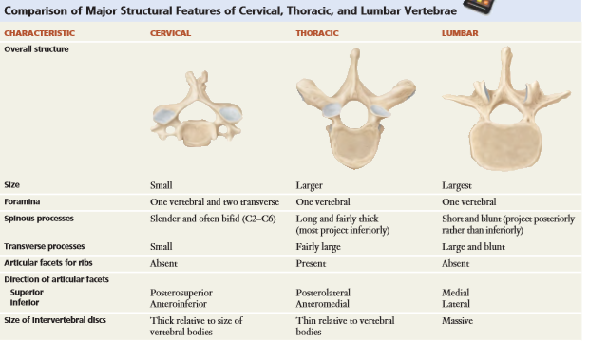

Sacrum
- Triangular bone formed by fusion of 5 sacral vertebrae
  - Begin to fuse b/w ages 16-18 typically complete by 30
- Serves as strong foundation for pelvic girdle
- Found in posterior portion of pelvic cavity – lateral portion fuse to hip bones
- Female sacrum shorter and wider and more curved than males
- Anterior side have 4 Transverse lines – mark joining of individual vertebrae
- Anterior sacral foramina – 4 pairs – anterior side
- Medial sacral crest – fused spinous process on posterior side
- Lateral sacral crests – fused transvers processes on posterior side
- Posterior sacral foramina – 4 pairs on posterior side
- Anterior and posterial sacral foramina, connect with sacral canal – allow passage of nerves and vessels
- Sacral Canal – continuation of vertebral canal
- Sacral hiatus – inferior opening in vertebral canal if laminae of 5th sacral vertebrae does not meet
- Sacral cornu – Each side of the sacral hiatus, are inferior articulating process
  - Connected by ligaments to coccyx
- Narrow inferior portion of sacrum = Apex
- Broad portion of sacrum is= Base
- Sacral Promontory – Anterior projection at the base
- Auricular surface – on lateral surface, articulate with ilium of each hip bone, rough surface
- Sacral tuberosity – contains depression for attatchment of ligaments, also articulates with hip bone – forms Sacroiliac joints
- Superior articular processes of sacrum articulates with L5 at base of sacrum = lumbosacral joint

Coccyx
- Terminal end of the vertebral column
- Triangular bone formed from fusion of 3-5 other vertebrae Fuse between age 20-30

Thorax
- Refers to entire chest region
- Thoracic cage is bony enclosure made of sternum, ribs and costal cartilages and bodies of thoracic vertebrae
- Thoracic cage more narrow at superior end and broadens at inferior end
- Encloses and protects organs, provides support for upper limbs, role in breathing
- Superior thoracic aperture – opening that allow structures to pass b/w thoracic cavity and neck
- Structures passing b/w thoractic cavity and abdominal cavity go through inferior thoracic aperture
Sternum (breastbone)
- Flat narrow bone in center of anterior thoractic wall ~ 15cm long
- 3 parts Manubrium, Body (broken into Sternebrae), xiphoid process
- Suprasternal notch – Depression on superior surface of manubrium (can feel it)
- Clavicular notch – Lateral to suprasternal notch, articulates with medial end of clavicle forms Sternoclavicular joints
- Manubrium also articulates with costal cartilage of 1st & 2nr ribs form sternocostal joints
- Body articulates with part of costal cartilage of 2nd -10th rib
- Xiphoid process made of hyaline cartilage until fully ossified around 40
  - No ribs attached to it
  - Some attachment for abdominal muscles

Ribs
- 12 ribs increasing in length from 1-7, then decrease in length 7-12
- Support the thoracic cavity
- 7 pairs of true ribs that attach to sternum anteriorly via costal cartilage (dense cartilage, still a little flexible to aid with volume in breathing – is actually hyaline cartilage)
  - Costal cartilage that attatch directly to sternum = true ribs
- Rib pairs 8 to 10 are false ribs, connect to sternum via cartilage of the inferior portion of rib 7 or do not attach at all
  - False ribs b/c costal cartilage attatch indirectly to sternum or not at all (floating)
- Ribs 11 & 12 are floating – don’t connect to the sternum at all, provided protection on your back
  - Only attaches posteriorly to thoracic vertebrae
- Costal Cartilage contributes to elasticity of thoracic cage and prevent blows to chest from fracturing sternum or ribs

Typical Ribs (3-9)
- Head – projection at posterior end of rib – contain superior and inferior facets –
  - Facet of head articulate with either into facet of body on one vertebra OR into demi facets of 2 adjoining vertebrae = Verterbrocostal joints
- Neck – narrowing portion lateral to head
- Tubercle – knoblike feature on posterior surface found where neck joins body
  - Non articular part attaches to ligaments – attaches to transverse process of vertebrae
  - Articulating part, articulates with facet of transverse process of vertebra
  - THUS tubercle articulates with transverse process directly and indirectly
- Body/Shaft – main part of rib
- Costal Angle – found where abrupt change to curvature on shaft, just past tubercle
- Costal groove – found on inner inferior surface of rib – protects inercostal blood vessles and nerves
- SUMMARY – posterior portion of rib attatched to thorasic vertebrae bu head and articular parts of tubricle
  - Facets on head fit into facet of body on T1 (ONLY) or into demifacets of 2 adjoing vertebrae
  - Articular part of tubrical articulates with facets on transverse process of vertebrae
- Intercostal space – is the spaces between the ribs – where intercostal muscles, bllod vesssels and nerves are found –

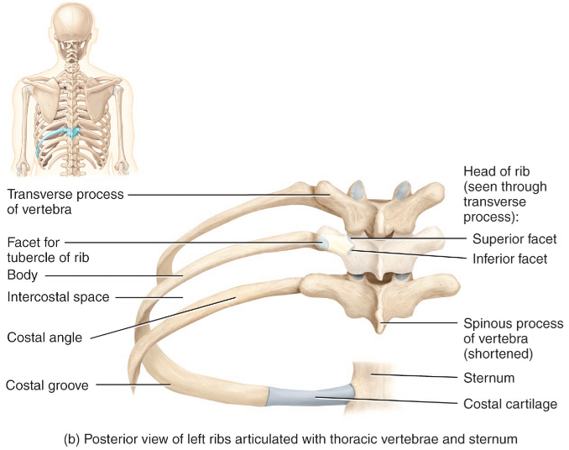
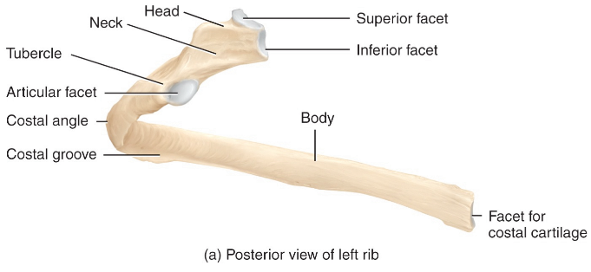

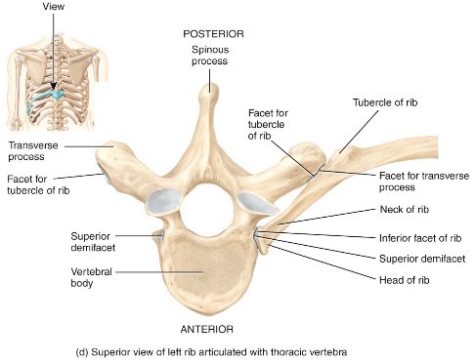
Sternum

