Chapter 6: Bone Tissue January 20, 2015
Introduction:
- Bone is an organ made up of several types of tissue; Bone (Osseous) tissue, Cartilage, Dence connective tissue, epithelium tissue, adipose and verve tissue
- Bone makes up the Skeletal System
- Bone is a living, active tissue engaged in remodeling
- Remodeling is the building of new bone tissue and breakdown of old bone tissue
- 206 bones in human adult

Function of bone and the Skeletal System
- 6 main functions of the skeletal System
- Support
  - Structural framework, support soft tissue, provide attachments
- Protection
  - Protects organs (Ex: Cranial bones protect brain)
- Assistance in movement
  - When muscles are innovated they pull on bone to create movement
- Mineral Storage and release
  - Stores minerals, especially important in calcium and phosphorus (Contribute to bone strength)
  - Store 99% Total body calcium
  - Release mineral into blood to maintain mineral balance when needed
- Blood cell production
  - Within some bones – Red Bone Marrow; produces red & White blood cells and platelets in process called Hemopoiesis
  - Red bone marrow develop, blood cells, adipocytes, fibroblasts, macrophages within reticular firers
  - With increased age, some bone marrow changes from red to yellow
- Triglyceride storage
  - Yellow Bone Marrow is mainly adipose cells which store triglycerides

Types of Bone
- Classified on the basis of shape and location
- 5 types of bone classified by shape
  - Long, short, flat, irregular, sesamoid
- Long Bone
  - Contain a diaphysis (Shaft) and multiple Epiphyses (ends)
  - Slightly curves to add strength – (if straight weight of body would be unevenly distributed and thus fracture more easily)
  - Mostly compact bone tissue but also a good portion is spongy bone tissue
- Short Bones
  - Close to cube shape
  - Mainly spongy bone tissue , at the surface a thin layer of compact bone tissue
  - EX: Carpal bones and tarsal bones
- Flat bones
  - Generally thin, composed of 2 plates of compact bone that surrounds inner spongy bone
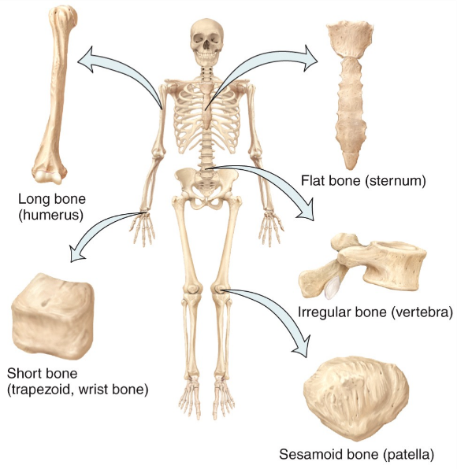
  - Great protection and large area for muscle attatcment
  - EX: Cranial bones, sternum, ribs, scapulae
- Irregular bones
  - Complex shape that don’t fit into groups above
  - Vary in amount of spongy and compact bone tissue
  - EX: vertebra, some facial bones, calcaneus
- Sesamoid Bones
  - Floating bones – wrapped within tendon
  - Take a lot of friction, compression and physical stress
  - Protect tendon from excesive wear
  - EX: patellae
- Bones are also classified by location:

Anatomy of the bone
- Diaphysis – (Growing between) Shaft of the bone
- Epiphyses – (Growing own)extremities – proximal and distal portion of the bone (Ends)
- Metaphysis- (Between) Region between Diaphysis and epiphyses
  - Contains the epiphyseal growth plate – a layer of hyaline cartilage which allows diaphsis of the bone to grow. When growth ends the cartilage of the growth plate is replaced by bone which results in epiphyseal line
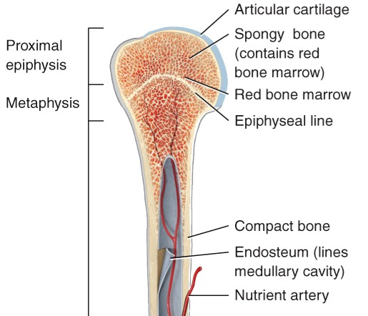
- Articular Cartilage – Thin layer of hyaline cartilage that covers the epiphyses where bone forms a joint (Articulation)
  - Reduces friction and absorbs shock – avasulature thus damage repair is limited
- Periosteum (Around) – tough connective tissue and associated blood supply that surrounds bone surface (Not covered by articular cartilage)
  - Allow some growth in thickness but not in length
  - Assist in fracture repair, protect the bone, helps nourish bone tissue, serves as an attachment pint for ligaments and tendons
- Medullary Cavity/ Marrow Cavity – hollow space within diaphysis (Shaft); contain yellow bone marrow and blood vessels
  - Reduces weight of bone
- Endosteum – thin membrane that lined marrow cavity, contains single layer of bone forming cells and a small amount of connective tissues
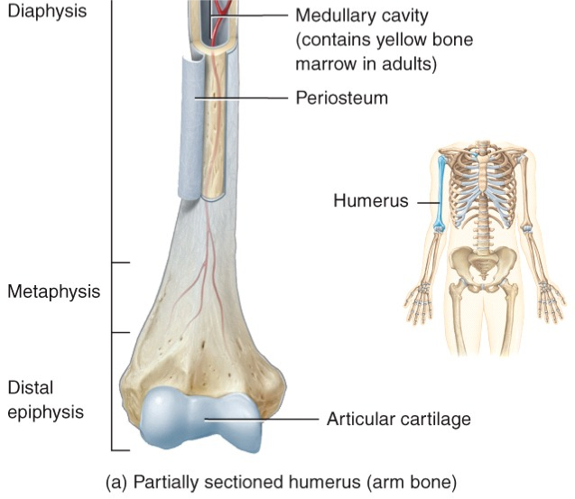
- Long bones are the only bones with a diaphysis and marrow cavity
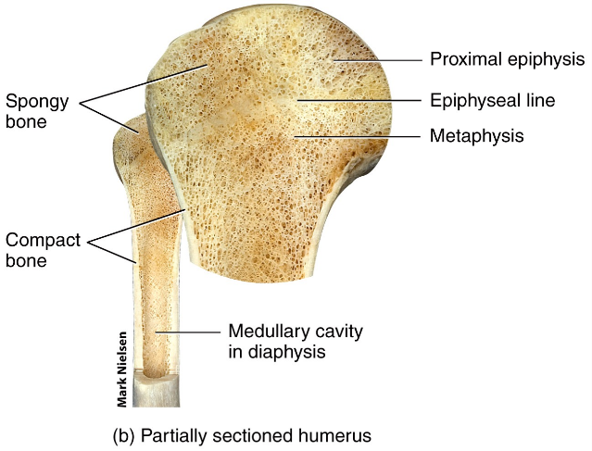

Surface Markings or Osseous landmarks
- Structural features adapted for specific functions
- Bumps, ridges, rough areas – typically attach soft tissues (Tendons, ligaments) to bone
- Grooves, holes – Nerves, blood vessels typically pass through bone
- Smooth surfaces – areas of movement between neighbouring bones
  - Typically smooth surface depression on one, smooth projection on other
- 2 major types of surface markings
  - Depressions and openings – form joints or allow passage of soft tissues (blood, nerves)
  - Processes – Projections that help form joint or serve as attachments for connective tissue ligaments/Tendons)
Bone Surface Markings: Fissure
- Fissure – narrow slit between parts of a bone
- Foramen – Openings for vessels, nerves or ligaments (hole)
- Fossa – shallow depression (ex. Subscapular fossa)
- Sulcus – furrow along a bone to accommodate V/N/T
- Meatus – tube like opening
Bone Surface Markings
- Processes that form joints
- Condyle
- Facet
- Head
- Processes that form attachment points for connective tissues
- Crest
- Epicondyle
- Line
- Spinous process
- Trochanter
- Tubercle
- Tuberosity
PG 154 – Table 6.1 *

Histology of Bone tissue
- Bone have a large amount of extracellular matrix (like other connective tissue) with fewer cells
- Calcification – deposits of mineral salts, primarily hydroxyapatite in a framework formed by collagen fibers which hardens the tissue – also called mineralization. Initiated by osteoblasts
Why is bone tissue classified as connective tissue?
- Develop from mesenchyme cells and has little cells but a lot of extracellular matrix
Composition of bone tissue and their functions – Types of Cells in Bone Tissue
- 4 types of cells in bone tissue
- Ostreogenic cells (Producing)
  - Unspecialized bone stem cells
  - Only bone cells that undergo cell division – develop into osteoblasts
  - Found in the inner portion of periosteum and marrow canals

- Osteoblasts (buds/sprouts)
  - Bone building cells
  - Synthesis and secrete collagen fibers and other organic material needed to build extracellular matrix of bone tissue and initiate calcification
  - Become osteocytes since surrounds itself in secretion of extracellular matrix
  - NOTE: Any name with Blast secretes extracellular matrix
- Osteocytes (-cytes= cell)
  - Mature bone cells – main bone cells in bone tissue
  - Maintains daily metabolism and exchange in nutrients and waste with blood
  - Do not undergo cell division (like osteoblasts)
  - NOTE: end in Cyte maintains tissue
- Osteoclasts (-Clast = Break)
  - LARGE cells derive from fusion of monocytes (White blood cells) – found in endosteum
  - Plasma membrane of osteoclasts are folded into ruffled border on the side that faces bones surface
  - Ruffle border side release lysomal enzymes and acids that digest proteins and minerals from extracellular matrix of bone
  - Cause breakdown of extracellular matrix = resorption (part of normal development, growth, maintenance and repair of bone
  - Help regulate blood calcium

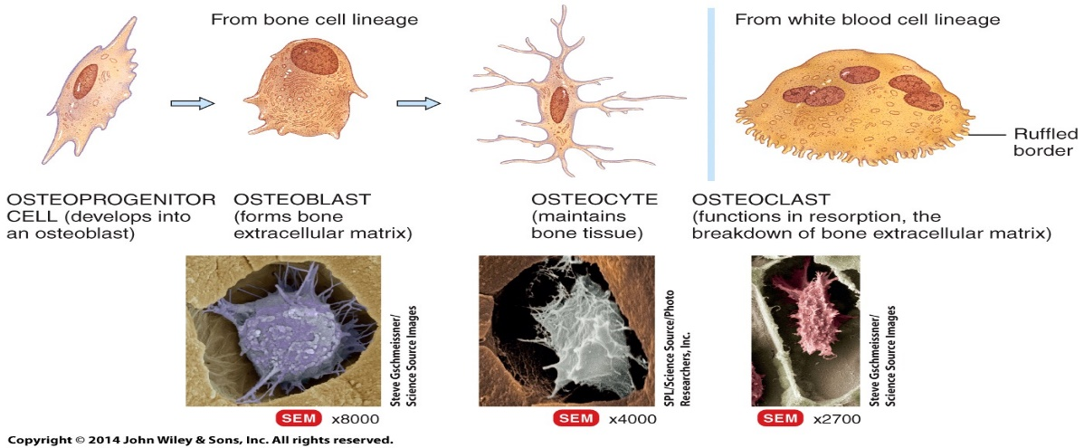

Compact bone:
- At the surface of the bone and can extend deeper into bone tissue
- Looks solid but is pours - microscopic spaces and canals
- Contain Osteons with little spaces between them
  - Osteons consist of Concentric Lamellae which are circular plates of mineralized extracellular matrix which surround central canal were blood vessels and nerves are
  - Spaces between concentric lamellae are canaliculi which are filled with extracellular matrix
- Compact bone tissue lie over spongy bone tissue in the epiphyses and make up most of the bones tissue of the diaphysis
- Function of compact bone protects, supports and resist stress
Spongy Bone:
- Does not contain Osteons
- Consists of trabeculae surrounding spaces filled with red bone marrow
- Spongy bone tissue forms most of the structures of short, flat, irregular bones and the epiphyses of long bones
- Function: trabeculae of spongy bone is resistant alone lines of stress, support, protection of red bone marrow, make bones lighter for easier movement

Bone Growth
- Epiphyseal plate – zone of rapid growth (growth on either side in long bones)
- Still separated then there is still bone growth in your long bone
- Made up partially of cartilage, rapidly developing cartilage cells, as they grow apart they osofy and are then replaced by osteocytes
- Endocondryl ossification – happens near cartilage (on the ends) (type of bone growth)
- Intramebraneossification – along the bone
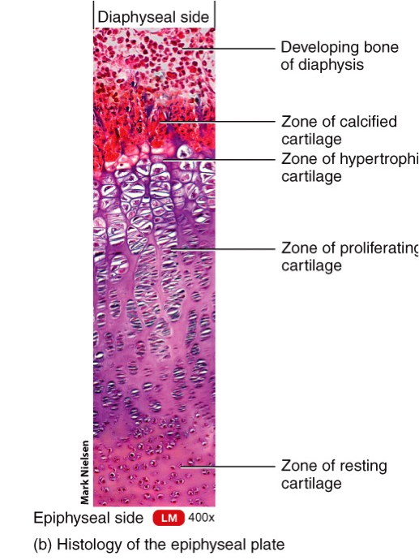
- Increasing the thickness of bone s
- The epiphyseal plate allows the diaphysis of a bone to increase in length
- Eventually the epiphyseal plate fades and becomes a line, no more bone growth (can determine age)
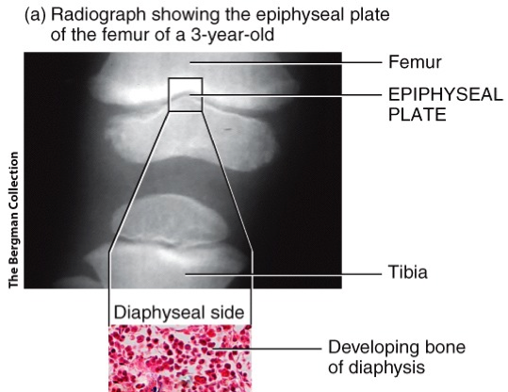

Bone Growth in Thickness
- Periosteumn (outside) protection of
- Bone grows around the blood vessels
- They grow in thickness and distance
- Appositional growth – growing on outside and reabsorbing on inside
- Osteoblasts lay lamella around vessels the space gets completely encapsulated allowing for outward bone thickness
- As it grows in thickness in the periosteium
- Inside (endostemun) osteoblasts will dissolve mineralized bone on the outside
- Continuous process, to make sure bone is healthy and has structure needed for the proper function
- Osteoclasts dissolve bone and osteoblast form the new bone tissue

Osteoporosis
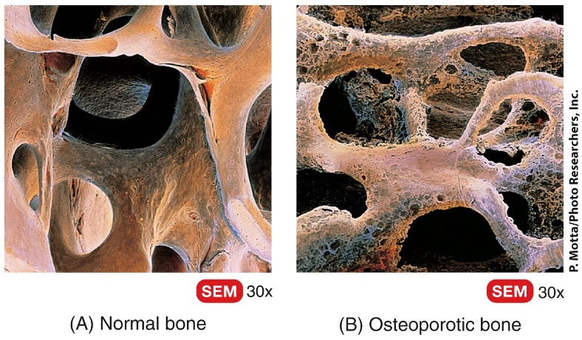
- Due to mineral deposition in the bone (the mineral is needed in the body for other cellular functions)
- Middle age to elderly
- 80% affected are women – menopause proportion of estrogen and testosterone changes, testosterone contributes to the dissolving for the minerals within the bone
- When you have more reabsorption than you do production
- Eat green vegetables (high in calcium) & regular exercise – exercise

Fractures PG 166
- Any break in a bone
- In some cases fractures without visibly breaking = A stress fracture
  - Series of microscopic fractures that form without evidence of injury
  - Result from repeat strenuous activity like running, jumping, aerobic dancing
  - Can be painful and result in osteoporosis
- Open (Compound) fracture
  - Broken end of bone come through skin
- Closed (Simple) Fracture
  - Break does not come through the skin
- Comminuted fracture
  - Bone is splintered, crushed or broken into pieces at the site of impact and smaller bone fragments lie between two main fragments
  - Shattered pieces between 2 main fragments
- Greenstick fracture
  - Partial fracture were one side is broken and the other side bends
  - Similar to how a green twig breaks
  - Occur only in children who’s bones are not fully osteofied and contain more organic material than inorganic
- Impact fracture
  - One end of the fractured bone id forced into the interior of the other
- Pott fracture
  - Fracture of the distal end of the lateral leg bone (Fibula) with serious injury to the distal tibia articulation
- Colles Fracture
  - Fracture of the distal end of the later forearm bone (Radius) in which the distal fragment is displaced posteriorly

Steps in repair of Bone Fracture
- Reactive Phase – blood vessels crossing the fracture line are broken, the blood usually then clots around the cite of the fracture (fractured hematoma), due to the stop of blood flow the nearby bone cells usually die causing swelling and inflammation
- May last up to several weeks
- Reparative Phase – formation of fibrocartilaginous callus and bony callus, blood vessels grow into the fractured hematoma and phagocytes begin to clean up dead bone cells.
- Fibroblasts from the periosteum develop into collagen fibers
- Bony callus lasts about 3-4 months
- Bone Remodeling Phase – of the callus, dead portions of the broken bone are gradually reabsorbed by the osetoclasts, compact bone replaces spongy bone
- Sometimes repair is so thorough the fracture is undetectable by x-ray

- Can take anywhere from weeks to months
- 3 primary phases
    - Right after bone is damaged (hematoma – aggregation of blood and fibrin – forms all within periostemum unless comminuted or open fracture)
    - Periositemum remains in tact, it limits the amount of blood that bleeds out into surrounding cavities
    - Callus forms – invasion from white blood cells (clean up blood) will be ossified and replace
    - Remolding phase – callous gets replaced with compact bone (made up of osteons) any bone fragment splintered into the tissue will be absorbed (can take several months to complete depending on damage)
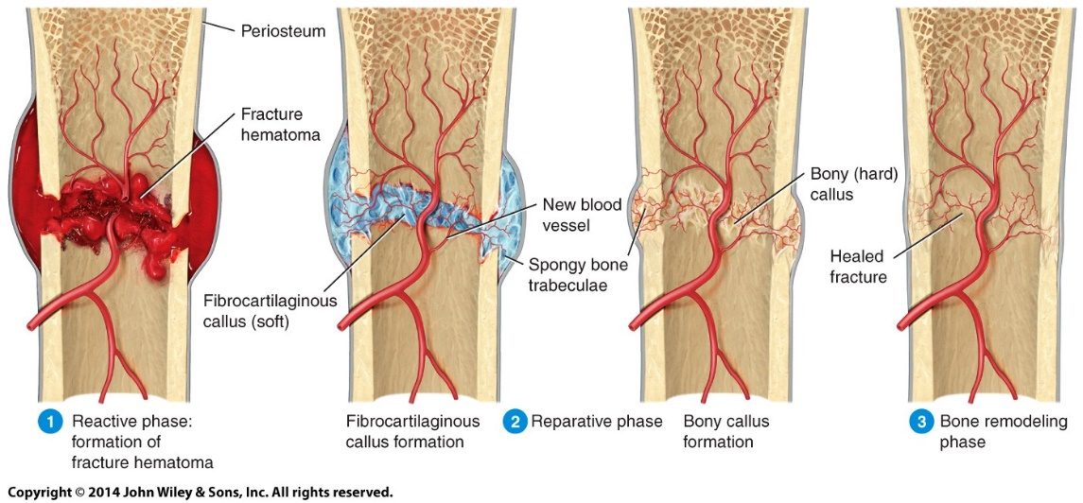

The Effects of Aging on Bone Tissue
- There are two principal effects of aging on bone tissue
- Loss of bone mass results from the loss of calcium and other minerals from bone extracellular matrix (demineralization) (by osetoblasts)
- Brittleness occurs as the production of collagen fibers (which give bone tissue its tensile strength) slows
- Collagen becomes less resistant to bends and bumps
- Lack of sex steroids (especially in women after menopause) a decrease in bone mass occurs because bone resorption by osteoclasts more rapidly than bone gain by osteoblasts

Factors Affecting Bone Growth and Repair
- Availability of minerals, particularly calcium and phosphorus
- Availability of vitamins (A, C, D, K, B12)
- Availability of specific hormones (insulin, insulin-like growth factors (IGFs) and the thyroid hormones)
- Weight bearing exercise – bones will grow more quickly
- Sex hormones (testosterone, human growth hormone, etc)

