Engineering Law GNG 4170
Legal Systems
- Civil Code
  - Came from Roman law. Napoleon code. Set of statements and legal rights. When making legal arguments based on the statements from the civil code. Governments can change civil code.
- Common Law
- Customary Law (Not concerned)
- Religious Law
  - Based off a religious aspect of life, Jewish law may apply. Principles come from religious text or documents
Two Main Sources of Legal Information
- Legislation. Are rules set down by are different levels of government that affect our behavior. Statues, acts criminal code
  - Constitution legislation about running the country. The initial umbrella set of codes for the country. Primary ideas
  - Division of Powers is the division of law making power between the federal government and the provinces and territories. Small ass piece of the library.
- Common Law
  - Unique source of information. Based on the ideas of passed decisions of the court. The long history of making current legal arguments. Court records are what are found in the library. Forever books.
  - Legal principles that are applied in court decisions now but are NOT FOUND in the legislation but can be used in courts.
  - Judge made law, Theory of Precedence past decisions are important to current cases
  - Cases that have come before that material facts are relevant. The result should be the same now. The consistencies between passed cases. Three years ago this happened so let me apply it now. Cases are considered precedent if they came before and have the same materials.
Types of Common Law
Criminal Law
- Find out legal information from the common law. Name of the cases Rv. Tresma
- The legal proceedings are done by the crown. (The represented of the states).
- Victim is
  - Guilty if wrong doing (Language)
  - Does not start the legal proceeding
  - Doesn’t receive any compensation for winning the case
  - Considered a witness
  - Without a reasonable doubt.
Civil Law
- 2-Steps Who’s is liable and what’s owed?
- The victim is bringing private legal action against the wrong doer. If the wrong doer is liable, the victim receives damages.
- Victim
  - The legal proceedings are started by the victim
  - Liable/ Liability if wrong doing (Language)
  - Victim receives a direct benefit.
Contract Law
- Set of promises with someone else which is legally enforceable.
- Renting an apartment, contract on the prices of things in a store, university tuition.
- Depends on having an agreement between two parties
- Can’t be breached if they is no contract.
Tort Law
- Set of rules and standard behaviors
- Rules apply to us because we live in Ontario or Canada
- Concurrent Tortfeasors is when two or more people are liable to the plaintiff

- Intentional Torts
  - Hitting someone. Battery, Assault. Intended to hit him, not intentional to hurt him.
  - Defamation is where the reputation of the victim is damaged by untrue public statements made by the tortfeasor.
    - Slander people talking to others on the internet and tv ect.
    - Libel written forms of defamation.

- Unintentional Torts
  - Accidental striking someone. Didn’t intend for the action to take place.
  - Negligence.
    - No tricks, Straight Forward. Marked on the ability to analyzed the situation. (Hypothetical is not going to be on the midterm)

- Goal of Tort Laws
  - Provided fault is found. The purpose is to compensate the victim and not to punish the wrong doer.
  - Identifying the parties (Only useful for negligence)
    - Plaintiff ($π$) brings the action up. This person has been hurt in some way. This person is the victim
    - Defendant($∇$) responds to the action
Deep Pockets Theory
- Have lots of money and assets. Why we have vicarious liability. Employer on the hook because they have more money.
- When you are an employee lost your characteristics. The employee is considered an agent for your employer.
- Employers will often be held vicariously liable for actions of a negligent employee. This is consistent with the fundamental principle of tort law, which is to compensate the victums of negligence. Since employers usually have more money to pay for negligence, they would be in a better position to pay the victims.
Test for Negligence
When you get negligence hypothetical you must state 3 things first
- State that it is an unintentional tort (Negligence)
- Describe the Tort Law- provided that fault is found; the main goal is to compensate the victim and NOT punish the wrong-doer
- Identify the parties:
  - Plaintiff: person who raises the complaint
  - Defendant: person who defends their actions. When we have more than 2 defendants they are considered potentially concurrent tortfeasors
The plaintiff must prove 3 things on a balance of probabilities.
The test for negligence must be done individually and not together.
- Each defendant owes the plaintiff a duty of care
  - Does the duty of care exist or not?
  - Economics, hurts, properties were damage.
  - Yes or No Question.
  - Is it reasonably foreseeable that the plaintiff could be injured as a result of the defendants work.
- Breached the duty of care.
  - It was breached or it was not
  - In a hypothetical you must define the standard of care for all the defendants
  - Must perform a quality analysis
    - Your actions are compared against The Standard of Care Standard of Care is what a reasonable person would do based on their status or education. It should be expected that an engineer should use proper design tables when designing.

  - What is the duty of care
  - A defendant does not break their duty of care if they are above or on the standard of care. If the standard of care is below then you have breached the duty of care.
- The plaintiff injuries happened due to the direct result of the breaches.
  - Cause and effect. A connection between the breach and the injuries. Explanation of the connection. “A causation”
  - State that it is clear that the plaintiff’s injuries are directly caused by the defendant; therefore the defendant is liable.
  - The “expect for/but for” test. The breach must be directly related. Elevator example elevator falls from the top. Engineering design was shit but it was the cable that was shit and broke. So it wasn’t directly related to the engineering company.
The Duty to Warn- they have the obligation to warn the consumer. Coffee where is says “Caution it’s hot”. Only for ages 8+. This is part of the standard of care. The company has to warn the consumer. If not they did not reach the standard of care.
Donoghue- She and her friend went to a store. Her friend got giner beer, gave to friend beer there was a snail inside. Since miss donughe friend brought there was no pre existing contract between the.
Owen Sound-
Headley Byrne Case
- HB asked their Bank if Customer (C) is credit worthy or not.
- HB’s Bank asked C’s bank if C is credit worthy.
- C’s bank sent back a letter stating:
  - C is credit worthy.
  - You cannot rely on this information (Disclaimer).
- HB’s bank sends HB the letter they received from C’s bank.
- HB did the work but didn’t receive a check from C.
- HB filed for negligence against C’s bank: saying that C’s bank owed valid information.
- The majority of the court decided that C’s bank did owe a duty of care to the group of HB’s bank.
Ultimately the plaintiff is rely on the engineer’s specialized skills and experience. But since court found that the engineers bank was not liable because of the disclaimer they put on the letter.
Questions with Disclaimers
- Look at both possibilities: with and without disclaimers.
- Identify the tort, the plaintiff and the defendant
- Identify where the disclaimer was said.
- Then think of the case as if it wouldn’t have the disclaimer ( Negligence test, stand of care, breach of care)
- Conclude that if the report did not contain the disclaimer that the defendant would be found liable.
- If the report however does has a disclaimer then the defendant is considered liable.
- Disclaimer: Takes away liability that would otherwise be there
Disclaimer: Takes away liability that would otherwise be there
Disclaiming Legal Liability
When one party does not take responsibility for the truth of the statements that they have made. C’s bank was not found liable because of the disclaimer at the end of the note. Information was given in good faith but it was disclaimed. Other party gets told ahead of time of the disclaimer. They are not liable.
Thin Skull Plaintiff
Taking the plaintiff as they are. If injury affects the plaintiff more than it simply would as defined. (Ex. Hand injury to a professional pianist). The type of injury is reasonably foreseeable but the type of plaintiff is not.
Contributory Negligence: is where the plaintiff is found by the court to have contributed to his or her injuries. Two aspects to contributory negligence
- Not taking enough care to prevent the injury
- After the injury steps to improve the injuries weren’t made. (What a normal person would have done if they have gotten that injury)

Contract Law
Time
K

Privity of a Contract: A contract is a private legal relationship; only parties under the contract can be sued or sue
Breach of Contract- When the terms of the contract have been broken
Misrepresentation
If misrepresentation was use to persuade the person into the contract then that person can get a remedy. There are two types of misrepresentation:
- Innocent this is what the person believes is true but it is actually false. The only remedy for innocent is recession, if possible. This is an equitable remedy for misrepresentation. The parties return to the same state before the contract has been made. A reverse in time. Recession can’t be possible when the party changes the original product an can’t be reproduced
- Fraudulent when the person knew they were lying or they were not certain of the truth. Recession remedy or sue for damages for the intentional tort of deceit.
Elements of an Enforceable Contract
- Intention to create a mutually binding legal agreement
- The offer and the acceptance of that contract. Must accept the offer.
- Exchange of consideration.
  - What is being offered by both parties
  - Gratuitous promise not usually enforceable
  - (The consideration for the contract. The exchange of consideration. What is being offered from both parties)
- Both parties have the relevant capacity.
  - (Do you have the legal capacity to enter a legal contract. Must be of age in go into a contract, special provisions for child contracts)
- The nature of the contract is legal.
  - (Court won’t enforce them)
Strict Liability
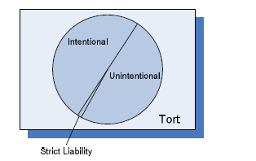
- The court doesn’t ask if a duty of care was owed or breached, it is exclusively about whether or not injuries are a direct result of an action. A causality question.
- EX. If someone keeps something dangerous on your property and someone gets hurt. You are strictly liable.
Equitable Estoppel
- Pre-existing contract between us.
- Strict terms of the contract could not be enforced. The person was promised or reasonably led to believe that the strict terms of the contract would not be enforced.
- The action taken was different due to the promise or understanding that was given. Therefore it would be unfair for the party to rely on the contract.

Equitable Defenses To Capacity
Equitable Defenses is when someone goes into a contract with free will and sound of mind.
Duress- Actual or threaten violence which it intended or enforces you to enter into a contract. The person does not have the capacity to enter into a contract.
Economic Duress – Forced to do it. Have no money need money, had to settle for this. The rich people and the landscaper case.
Undue Influence- One party has this dominant influence over the weaker party. The nature of the relationship is when they went along. The relationship between a doctor and patient. A Religious leader and there followers. If someone has a mental disability or is under the influence of alcohol or drugs.
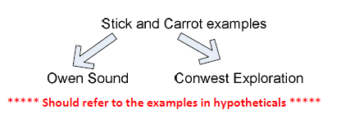Get FROM JENNAA

Conwest Exploration –MINING CASES
John Burrows –Active communication. No complaining repeated breaches. Lead me to believe by your silences that your strict terms were no enforable. You are now not aloud to terminate the contract. THe other side being passive. That silence is called INDULGENCE. Equitable can not be established
- Pre existing contract YES
- Promise and legal lead to believe that the terms were not enforced You were lucky and you dodge a bullet.
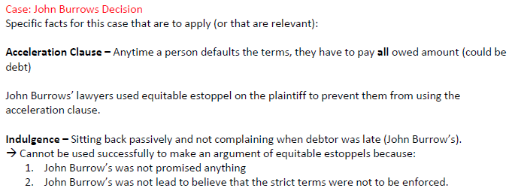
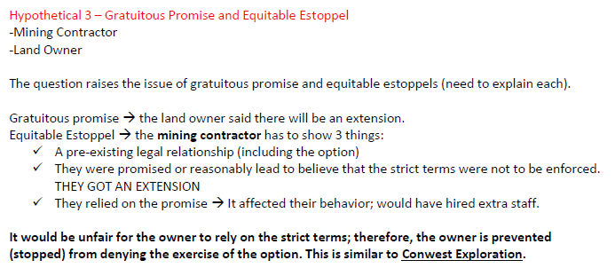
Contracts do not have to be in writing to be enforceable. !!!! But when you write it the terms of the contract of true and can be contradicted.
Amending A Contract straight forward no equitable estoppel or gratuitous promise.
Land owner needs work down property. If contractor finishes between a certain deadline legal
Statues of Frauds- It indicates the kind of contracts that must be in writing for them to be enforceable.
Buying or selling property. Real property is land. Must be in writing
Memorandum: Different separate documents and mix them together. Two different contracts, Exchange of
Tendering Process-
1.Owner providing information about the job.
2.People Bid, submit a tender
3.Evaluate bids and select winner. Work is done.
Belle River Example of how the court use to look at the tendering process. Summited bid and it was incorrect and tried to withdraw. Only saw one contract being formed. Contract where the work is being done. Offer and acceptance. People see biding as an offer. Acceptance the owner accepts the contract. The total was not right. It was an error. Obvious error/mistake.
- OBVIOUS error is when the owner independently found the error.
- UNOBVIOUS error owner couldn’t independently discover the mistake.
- Snapping up an offer: legally you are not to accept an offer than is mistaken.

Ron Engineering It sees 2 different contracts being formed.
Contract A: Is the tendering and selection process itself. Is seen as the offer. He is the criterial I am going to look at. What desposit you have to give. This is now considered an offer. When you bid you are accepting the terms of contract A. You are formally agreeing to be a part of the tendering selection process. When you place a bid you are accepting the tender game rules.
Contract B : Contract work being done at the end of it. The work that’s being done. Final Product
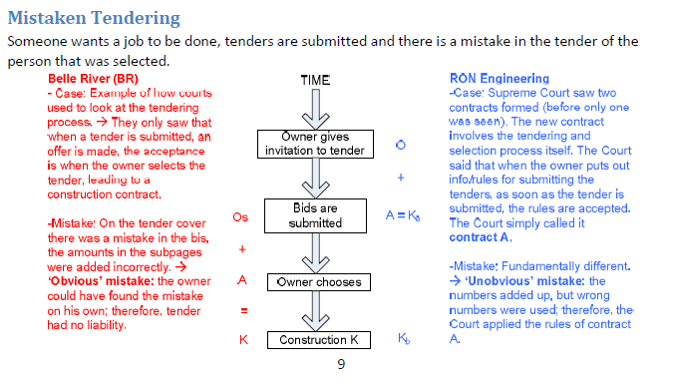

Definitions
Vicarious Liability | An employer is liable for the torts committed by the employees while working. The employee will never be considered a defendant. Only comes up when an employee is involved and is identified. Explain why it exists as a principle.  Good for the employer. Recognizes the benefit for the employees you work for your employer you rock.
Material | Means they have significance to the court. The material facts are considered relevant facts.
Laws | Rules that apply to a certain geographic or derestriction.
Reasonably Foreseeable | Is it reasonably foreseeable that a surgeon owes a patient a “duty of care”.  Think of the snail in Mrs. Donoghues drink. Is it reasonable that someone can get hurt.
Standard of Care | What a reasonable person would do. #Normal
Injuries | The bad things that have happen to you. Economics, getting hurt, is destroying properties.
Damages | The amount of money you are paid to compensate you for your injuries
Reasonable Foreseeable Damages | “Ripple effect” Floor breaking in a manufacturing company example. Reasonable damaged
Disclaimer | Somebody is refusing ownership of something. “It isn’t mine”. Not claiming responsibility for the statements you are making. “If you are skiing in a not safe zone :that was said” Disclaiming legal liability
Representation | is a statement of fact or professional opinion
Misrepresentation | Statements made that were false.
Gratuitous Promise | Promise made without consideration in return. A one way promise. These are not enforceable. One way promise with no given consideration. Not endorsable.
Equitable Estoppel | Stopping him from relieving on the strict rules of the contract.  - Preexisting contract  - Show that you were promise or reasonable lead to believe, that the strict terms of the contract would not be enforced.  - You relied on this promise. The only reason why you broke the contract was because of the contract.  It would be unfair for the contractor to really on the rules. Equitable Estoppel can trump a gratuitous promise. “Equitable Estoppel is the ambulance to gratuitous promise”.  -Have to start by talking what was the gratuitous promise and then combat it with Equitable Estoppel.  Problem with the proof of evidence.
Statue of Fraud | Contracts that need to be in writing for them to be enforceable. This is made from Ontario government.

Hypotheticals
123 Railway hires an Architect. The architect subcontracts ABC Engineering to do a tunnel. An engineering (Smith) working at ABC engineering prepares the plans for the tunnel. Everything is good. The engineering firm however didn’t use the proper design table.
3 months later the tunnel collapsed. (No one was injured, No natural disasters.)
- PLANTIFF 123 Railway, they were injured
- DEFENDANT ABC Engineering Company, Architect
The Architect is not liable because it wasn’t his fault. Architect and ABC Engineering are potentially concurrent tortfeasors. Establish a standard of care
. Engineering firm then standard of care would be using proper design tables. Architect doesn’t have the qualities require designing a tunnel then the standard of care would be to sub contract the design to the engineering firm.
The architect didn’t break the duty of care. The architect can then not be held liable.
The engineering firm however can because they did breach their duty of care, liable in negligence.
If the architect didn’t pass geological area specs then the architect is liable because they haven’t met the standard of care.
“But for test” – Not using the correct design tables are a direct correlation of the tunnel collapsing breaking the duty of care between the 123 Railroad and ABC engineering.
What damages are 123 Railroad get? Reasonable Foreseeable damages. All the cost associated with the repair of the tunnel are reasonable feasible. If two or more defendants are liable then this is one more step. The court then has to divide the liability between the architect and the engineering company. Are they equality at fault or is there more blame on one party then the other
- What percent of liability does each defendant have to pay in damages? 75 percent engineering company, 25 Architect.

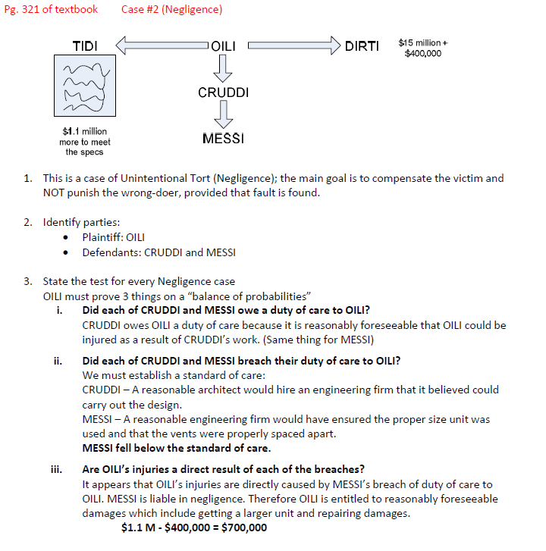
Vicarious Liability and Disclaimer Hypothetical
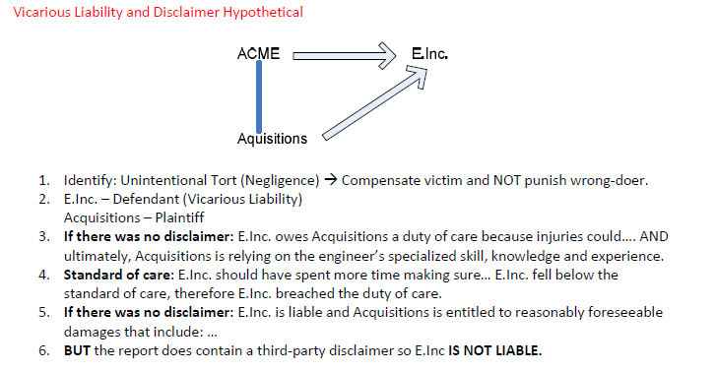
Don’t write the word GUILTY. Because we won’t be talking about criminal law
Criminal Code is federal legislation
Hitting someone- can be the states OR #Civil Law CRIME AND A TORT.
Legislation for Canada and Legislation for all the Provinces and Territories
Professional Engineer Act is provincial laws. The acts are Unique to Ontario. No reason why all the provinces need the same codes.
Canada
At a federal legal we are a common law derestriction. Quebec civil code everything else is civil code.
United States
Not going to be getting a negligence hypothetical
Louisiana uses civil code, everything else common law.
Equitable Principles- a legal relief

ROUND TWO
Interpretation:
Trade Usage:
Contra Proferentem
Parol Evidence Rule: To the side. When the contract has been reduce to writing, recognizes the objective value of the written document. What is verbally agreed on is different in the contract. Before the contract is made.
Cased Chinook Aggregates
M may not vhoose the lowest bidder
M may not coose any bidder.
Would be great economically if a local bidder won. What the miniciality decided to do is to compare the actractiveness of the local bid if in the rankings the same but with 5 percent more monies we will give it to them instead. The non local bider brought a breach of contract. “Access of information” IMPLIED TERM OF CONTRACT A. No bider could be perfered better than the others, all biders can be treated equally.
Express Terms of Contract
Implied Terms
- If there is guidance to that term, it will not be consider an implied term.
- When recognizing if there is an implied term, the court is trying to keep the “business efficacy”. This contract is meant to do somethinggggg
- Court imagines this term is specifically brought up. Would the parties include that at the term. Then it considered an implied term of contract. Contractul value

Self Evident

