Answers
TextBook
Chapter 5Question 17

Price index 2008 = $16 / $16 x 100 = 100
Price index 2009 = $17.28 / $16 x 100 = 108
Price index 2010 = $20 / $16 x 100 = 125
Inflation rate 2008 – 2009 = (108 – 100) / 100 = 8 percent
Inflation rate 2008 – 2010 = (125 – 100) / 100 = 25 percent
Inflation rate 2009 – 2010 = (125 – 108)/ 108 = 15.7 percent

Chapter 6 Question 13
Year | GDP Deflator | Nominal GDP (in billions) | Real GDP (in billions)
2007 | 90.9 | $ 700 | $ 770
2208 | 100.0 | $ 800 | $ 800
2009 | 125.0 | $ 1000 | $ 800
2010 | 140.0 | $ 1400 | $ 1000
2011 | 150.0 | $ 1800 | $ 1200

Question 11
One cannot say that production has increased in Nowhereland from 2010 to 2011 by just looking at nominal GDP. Production may have increased. However, nominal GDP could increase due to inflation while production remains uncharged (as would be the case with 10 percent inflation rate) or even decreases (with a greater than 10 percent inflation rate).

Chapter 7 Question 1

a)
0.5 percent | 140 years
1.0 percent | 70 years
1.4 percent | __ 50 years
2.0 percent | __ 35 years
2.8 percent | __ 20 years
3.5 percent | __ 20 years
7.0 percent | __ 10 years

b)
1.4 percent? __$200_ billion__
2.8 percent? __$400_ billion__
7.0 percent? __$3200 billion

Chapter 9 Question 7
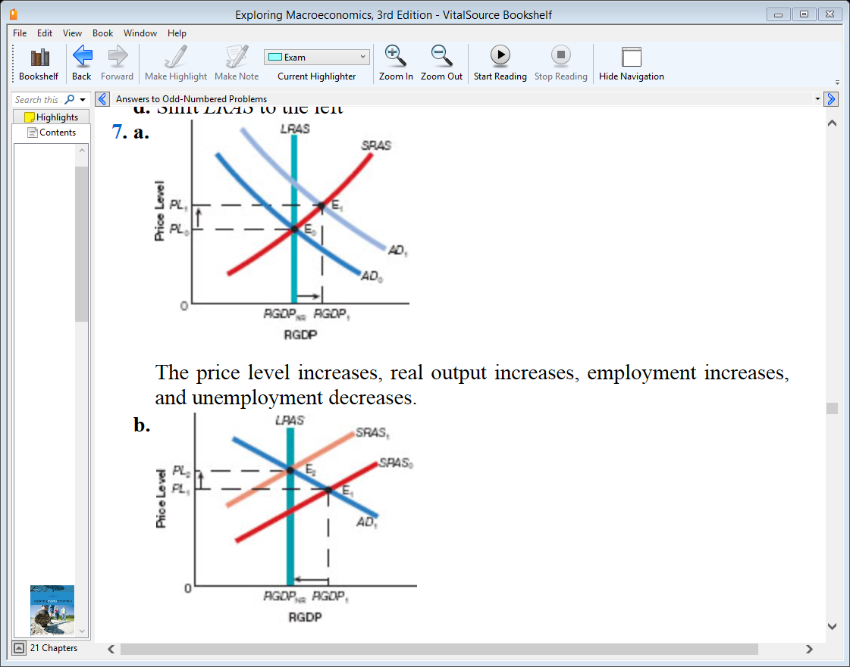

Chapter 10 Question 15
- At point E₃₋
- The economy would end up at a long-run equilibrium E₂₋
- The economy would end up at a long-run equilibrium at point E₀₋
- At point E₁₋
- The economy would end up in long-run equilibrium at E₀₋
- The economy would end up in long-run equilibrium at E₂₋

Chapter 13 Question 5
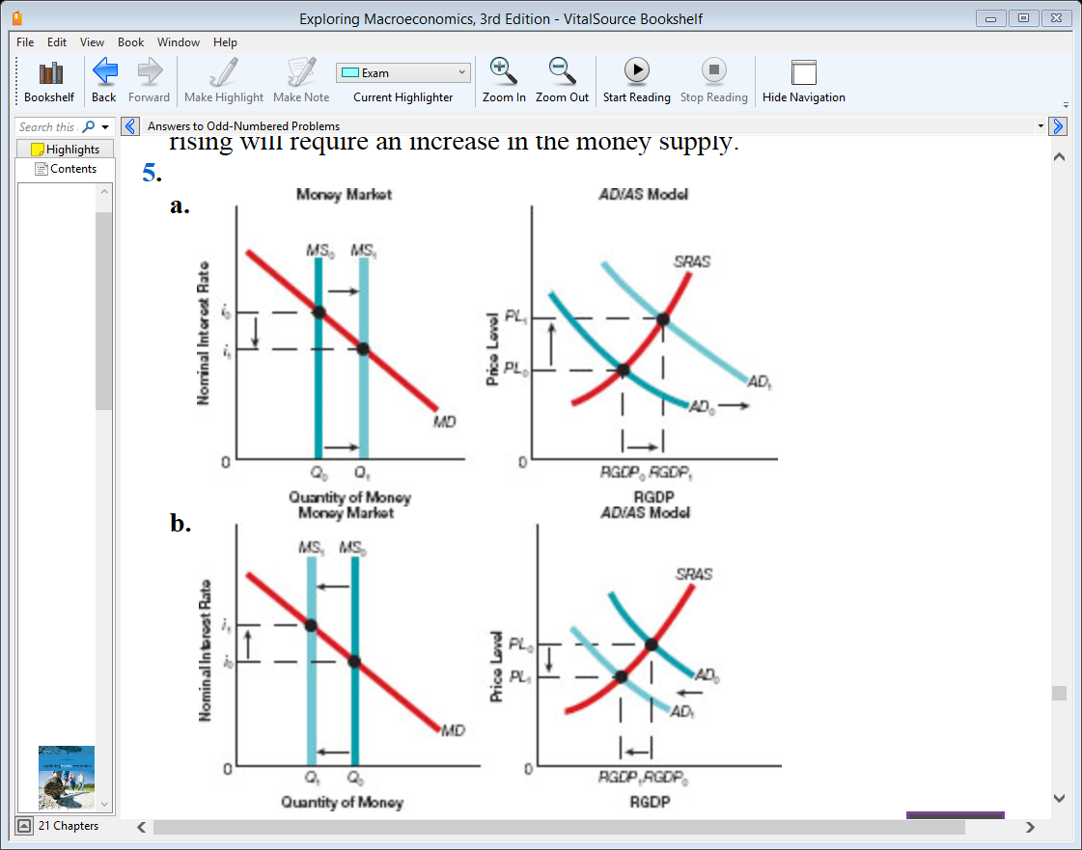

Aplia
Chapter 5 Question 5
Consider a fictional price index, the University Student Price Index (USPI), based on a survey of annual purchases of a typical university student. Suppose the following table shows information on the market basket for the USPI and the prices of each good in 2012, 2013, and 2014

 | Quantity in Basket | 2012  P ($) C.O.B ($) | 2013  P ($) C.O.B ($) | 2014  P ($) C.O.B ($)
Notebooks | 10 | 2 20 | 1 10 | 3 30
Calculators | 1 | 50 50 | 54 54 | 75 75
Large Coffees | 200 | 1 200 | 1 200 | 1 200
Energy Dinks | 100 | 2 200 | 3 300 | 4 400
Textbooks | 10 | 100 1,000 | 120 1,200 | 150 1,500
Total Cost |  | $1,470 | $1,764 | $2,205
Price Index |  | 100 | 120 | 150

The cost of each item in the basket and the total cost of the basket are shown for 2012. Perform these same calculations for 2013 and 2014, and enter the results in the table.

Suppose the base year for the price index is 2012. Calculate and enter value of the USPI for the remaining years in the last row of the table.

Between 2012 and 2013, the USPI increased by ___20%__. Between 2013 and 2014, the USPI increased by__25%__.

Which if the following, if true, would illustrate why price indexes such as the USPI might overate inflation in the cost of going to university?
Check all apply
- As the price of energy drinks increased relative to the price of coffee between 2012 and 2014, students decreased their consumption of energy drinks and increased their consumption of coffee.
- Professors required each student to buy 10 textbooks, regardless of the price.
- The quality of textbooks increased dramatically from 2012 to 2014, with textbook companies bundling new online study aids with their books.

Chapter 6 Question 7
The following table provides the population size, price-level index and nominal GDP of a hypothetical economy over a four-year period.

Use the data provided to calculate real GDP and real GDP per capita from 2011 to 2014 to complete the table.

Year | Population  Size | Price-Level  Index | Nominal  GDP ($) | Real GDP ($) | Real GDP per  Capita ($)
2011 | 100 | 80 | 12,000 | 15,000 | 150
2012 | 110 | 100 | 16,500 | 16,500 | 150
2013 | 120 | 125 | 30,000 | 24,000 | 200
2014 | 150 | 120 | 36,000 | 30,000 | 200

In the 2014, nominal GDP is __greater__ than real GDP. This means that the purchasing power of the currency in 2014 is ___lower___ relative to the purchasing power of the currency in the base year.

Why is real GDP a more accurate measure of an economy’s production than nominal GDP?
- Nominal GDP is adjusted for the effects of inflation or deflation, whereas real GDP is not.
- Real GDP includes the value of exports, but nominal GDP does not.
- Real GDP is not influences by price changes, but nominal GDP is.

The growth rate of real GDP per capita between 2011 and 2012 is ___0%___?

Assume that real GDP per capita is a good measure of living standards. Which of the following sentences best describes what happened in this economy between 2011 and 2012?
Living standards __did not change__ because:
- Real GDP grew at the same rate as the population
- Population growth outpaced real GDP growth
- Real GDP growth outpaced population growth

Chapter 7 Question 3
Consider a hypothetical economy that is currently growing at a rate of 4% per year.
According to the rule of 70, approximately how many years will it take for the economy to double in size? (Round to the nearest year)
- 18 years
- 4 years
- 70 years
- 280 years

Suppose an economist proposes a policy that leads to an increase in the economy’s growth rate from 4% to 5% per year. How many fewer years will it take for the economy to double in size? (Round to the nearest year.)
- 18 years
- 350 years
- 4 years
- 14 years

Chapter 9 Question 5
The following graphs show possible paths taken by an economy to reach long-run macroeconomic equilibrium after a shock hits the economy. Look carefully at the subscripts on each curve, the real GDP value below E2, and the path traced out by the arrows then answer the questions that follow.
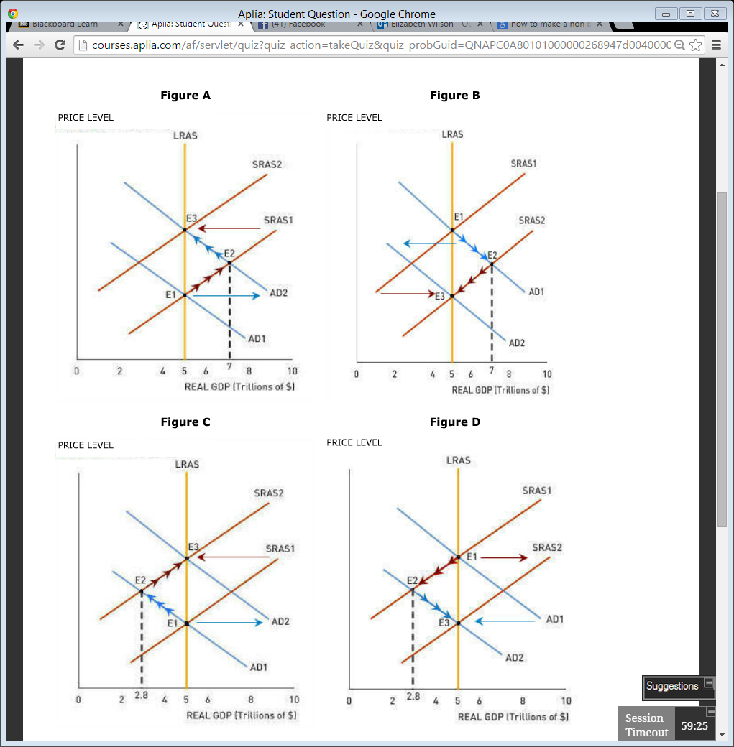

Which graph best represents the long-run adjustment to a negative demand shock?
- Figure B
- Figure A
- Figure D
- Figure C

The correct graph for the previous question indicates that, in the short-run, the economy experiences __a recessionary__ gap.

Chapter 10 Question 5
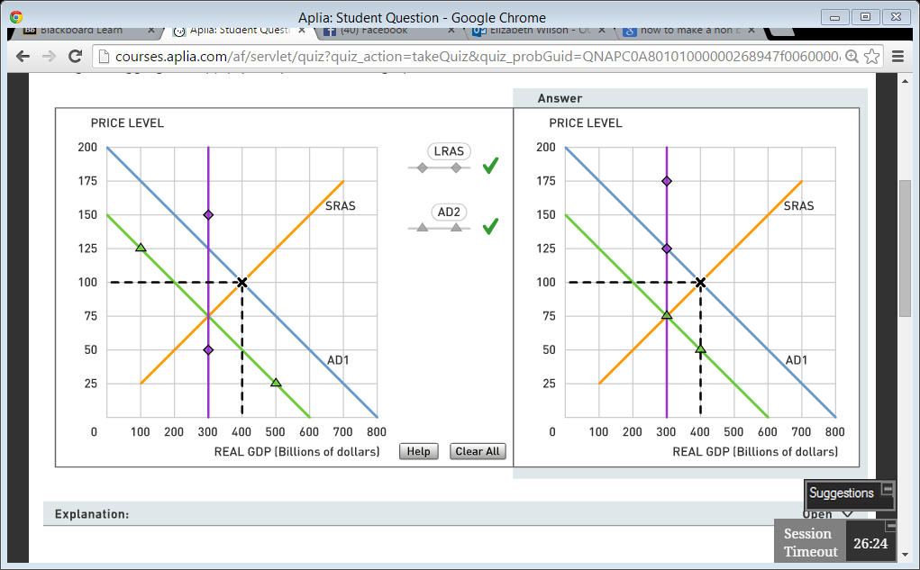

The graph below shows a hypothetical economy whose currency is called the dollar. The economy is in sort-run equilibrium at an output level of $400 billion and a price level of 100

Suppose the natural rate of output in the economy is $300 billon. Plot the LRAS curve on the graph below.

This economy’s output is above potential output, so if the government wanted to take action to restore the economy to its potential, the government would use ___contractionary____ fiscal policy, such as ___increasing____ taxes.

Suppose that the government could implement its chosen policy perfectly, restoring output exactly to its potential. In this case, the AD curve would shift __left___ by___$200 billion___ at each price level, causing output to decrease to $300 billion and the price level to __decrease to __ _75_.

Draw the AD curve to show consistent with these with changes. Be sure to plot the new AD such that it is parallel to AD1 and passes through the natural rate of out.

Suppose that the marginal propensity to consume in this economy is 0.75, and assume, for simplicity, that there are no taxes or other factors that will decrease the multiplier effect of a change in government expenditure. To bring about the shift in aggregate demand indicated above via a change in government expenditures, the government will have to change its expenditures by __$50 billion___.

Chapter 13 Question 4
The following diagram represents the money market in Canada. Suppose that Canada is a closed economy that does not interact with other economics in the world. The money market is currently in equilibrium at an interest rate of 7.00%, and the quantity of money in the economy is $1 trillion, as indicated by the grey star.
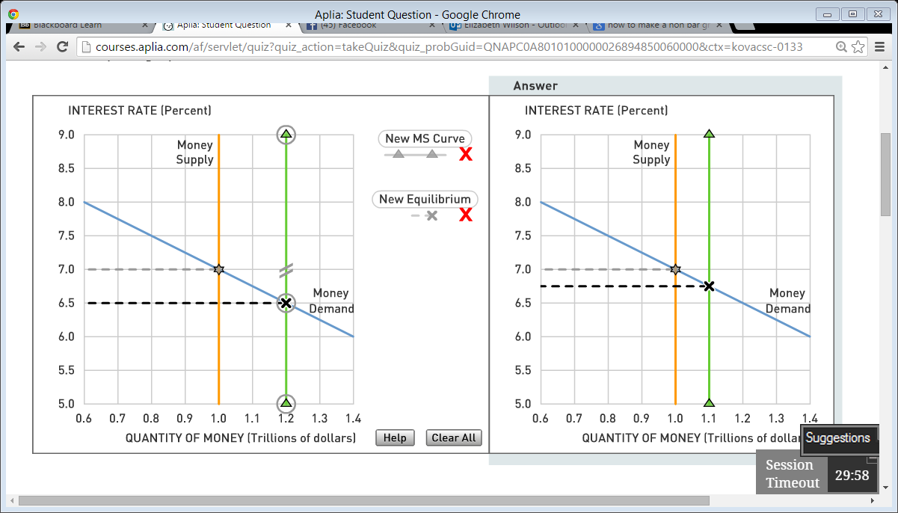

Suppose the bank of Canada that is lowering its target interest rate by 25 basis points, or 0.25%. To do this, the Bank of Canada will use open market operations to ___buy bonds from__ the public in order to __increase__ the _supply of__ money.

Suppose the following graph shows the aggregate demand curve for the Canadian economy. The Bank of Canada’s policy of targeting a lower interest rate will _reduce_ the cost of borrowing, causing residential and business investment spending to _increase_ and the quantity of output demanded to _increase_ at each price level. Shift the curve on the graph to show the general impact of the Bank of Canada’s new interest rate target on aggregate demand.
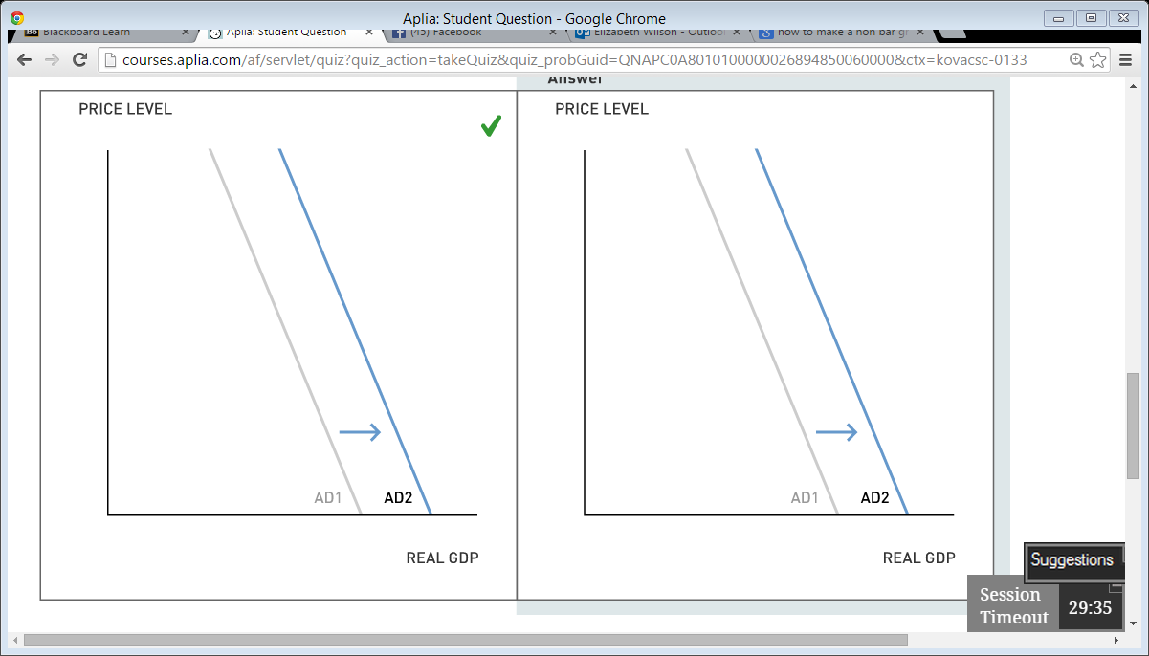
Now suppose that Canada is a small open economy with a flexible exchange rate (as it is in reality) and that the world interest rate is 7.00%
Because the Bank of Canada’s actions have made Canadian interest rates _lower__ than world interest rates, Canadian and foreign savers want to _sell_ Canadian assets, thus increasing the _supply of_ Canadian dollars in the market for foreign currency exchange. As a result, the Canadian dollar _depreciates_, causing net exports to decrease_. This change in net exports results in the aggregate demand curve shifting __further to the right_ it would in a closed economy (that is, in the economy illustrated in the graph above).

