Assignment #2
Linear Programming Formulation, Solution, and Sensitivity Analysis

Date: October 29, 2014

Question 1
Develop and solve an LP model to help determine how the initial angel investment of $20,000 should be spent.
Let x represent the number of Chinon bottles produced each year
Let y represent the number of Chardonnay bottles produced each year

Objective function
P = 12.533x + 10.425y

Constraints
x >= 4,000 selling constraint of Chinon per year
y >= 5,000 selling constraint of Chardonnay per year
1.717x + 1.575y <= 20,000 cost constraint for the two years
x = y production constraint
x, y >=0 non-negativity constraint

Question 2
Produce a report to your partners outlining TSM Premium Wines' strategy for the first two years.

Figure 2.1
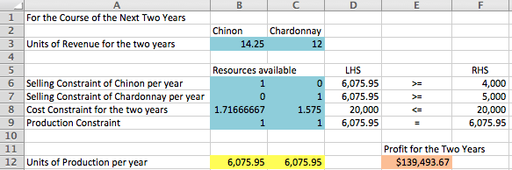

Introduction:

TSM Premium Wines must determine how to spend its angel investment of $20,000 over two years. It faces several constraints. First, it needs to sell at least 4,000 bottles of Chinon and 5,000 bottles of Chardonnay in each year. In the first year, Chinon will be produced using $0.70 worth of Cabernet Franc grapes with a wholesale price of $7.00 per bottle. At the same time, Chardonnay will be produced using $0.60 worth of Chardonnay grapes with a wholesale price of $6.00 per bottle. In the second year, Chinon will be produced using $0.65 worth of Cabernet Franc grapes with a wholesale price of $7.25 per bottle. Chardonnay will be produced using $0.75 worth of Chardonnay grapes with a wholesale price of $6.00 per bottle. For each dollar spent in the first year on marketing Chinon, a demand of up to five bottles is produced. At the same time, a demand of up to eight bottles is produced for each dollar spent on marketing Chardonnay. For each dollar spent in the second year marketing Chinon, a demand of up to six bottles is produced. At the same time, a demand of up to ten bottles is produced for each dollar spent on marketing Chardonnay. TSM Premium Wines’ final constraint it that it would like to sell the same number of bottles of Chinon and Chardonnay in each year.

Analysis:

Calculations for Revenue
R = [(year 1 selling price Chinon)*x + (year 2 selling price Chinon)*x] + [(year 1 selling price Chardonnay)*y + (year 2 selling price Chardonnay)*y]
R = (7x + 7.25x) + (6y + 6y)
R = 14.25x + 12y

Calculations for Expenses
E = {[(year 1 grape cost price Chinon)*x + (year 2 grape cost price Chinon)*x] + [(year 1 marketing cost price Chinon)*x + (year 2 marketing cost price Chinon)*x]} + {[(year 1 grape cost price Chardonnay)*y + (year 2 grape cost price Chardonnay)*y] + [(year 1 marketing cost price Chardonnay)*y + (year 2 marketing cost price Chardonnay)*y]}
E = {[0.7x + 0.65x] + [0.2x + (⅙)x]} + {[0.6y + 0.75y] + [0.125y + 0.1y]}
E = 1.717x + 1.575y

Calculations for Profit
P = R - E
P = (14.25x + 12y) - (1.717x + 1.575y)
P = 12.533x + 10.425y

Results:

The results of our analysis show that TSM Premium Wines could obtain a maximum profit of $139,493.67 for the two years. This result was achieved by placing all the constraints that were from the question. Two of the constraints are selling constraints because the company has a minimum of bottles of wine they wish to produce for Chardonnay and Chinon. There is also a production constraint because the TSM Premium Wines wishes to have the same number of Chinon and Chardonnay bottles produced each year. Our Excel analysis shows that the company should produce approximately 6,076 (6,075.95) bottles of each wine each year. In other words, in year one the company should produce 6,076 (6,075.95) bottles of Chinon and 6,076 (6,075.95) bottles of Chardonnay. In year two the company should produce 6,076 (6,075.95) bottles of Chinon and 6,076 (6,075.95) bottles of Chardonnay.

When it comes to the grapes and marketing expenses for the Chardonnay and Chinon wines we combined the two-year costs of grapes and marketing expenses for these two wine varieties. In other words, the two-year expense related to purchasing grapes and marketing Chinon amounted to $1.717 per bottle. For Chardonnay, the comparable two-year expense for grapes and marketing this wine variety amounted to $1.575 per bottle.

Question 3
After consulting with a wine buyer from the LCBO, you were told that because of forecasted low-priced imports from France and Chile, your price estimate for Chinon in the second year is too high. Assess the price elasticity for Chinon. What would happen if the wholesale price per bottle has to be cut in half? Justify your answer with the results of the sensitivity analysis.

Figure 3.1
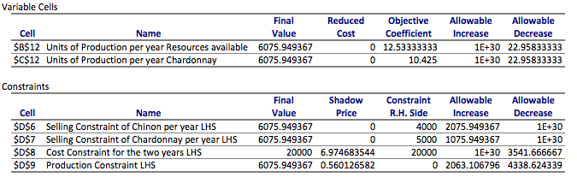

Figure 3.2
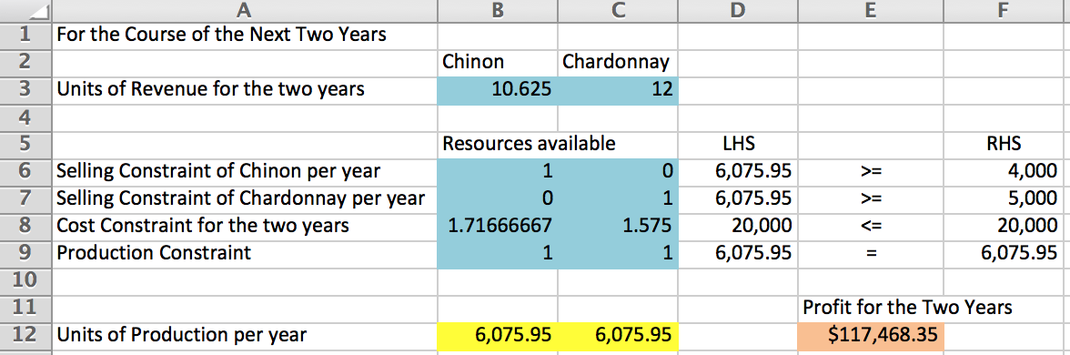

The reason that the optimal solution is the same is because the allowable decrease is infinite as shown in figure 3.1. If the wholesale price per bottle is cut in half for only the second year the new selling constraint for Chinon reduces by 3.625 and the new selling constraint for Chardonnay stays the same. Finally, TSM Premium Wines’ profit will decrease by $22,025.32 if the wholesale price of Chinon is cut by half by bottle in the second year.

Question 4
Your partners are worried about the rather optimistic minimal sales level target for Chardonnay. How would changes in these targets affect the strategic plan? Justify your answer with the results of the sensitivity analysis.

Figure 4.1
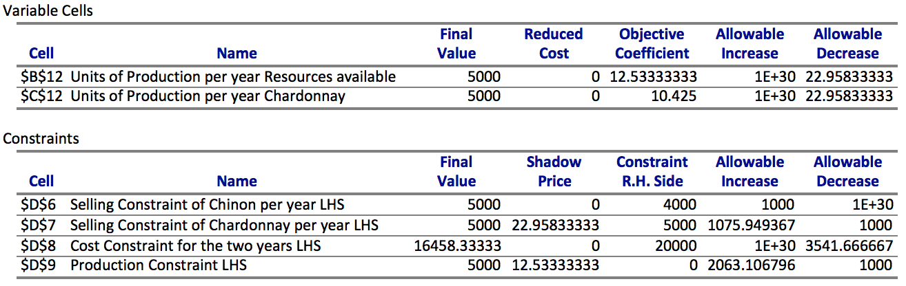

Figure 4.2
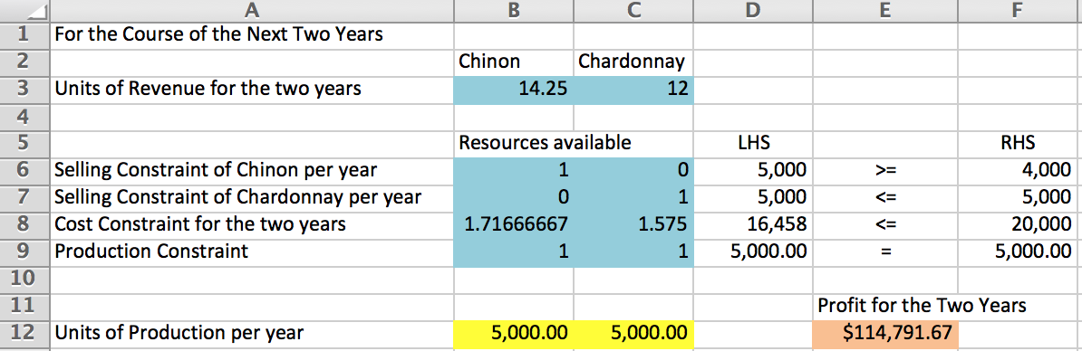

Initially, the TSM Premium Wines expected to produce a minimum of 5,000 bottles of Chardonnay per year. However, the partners were concerned that the company could not reach this minimum sales level target. With this in mind, the constraint needs to be changed from a minimum to a maximum of 5,000 bottles of Chardonnay produced each year. Using Solver, we changed the constraint and analyzed the relevant sensitivity report. The sensitivity analysis shows that the allowable decrease for the amount of Chardonnay bottles produced was 1,000 bottles. Therefore, as long as the 4,000 or more bottles of Chardonnay wine are produced, the optimal solution does not change. However the profit will decrease to $114,791.67.

Question 5
The loan officer from the Bank of Nova Scotia is not convinced that your strategy of selling an equal number of bottles of the two wine varieties makes sense. Which one is better and why? In response you need to re-work the model.

Figure 5.1
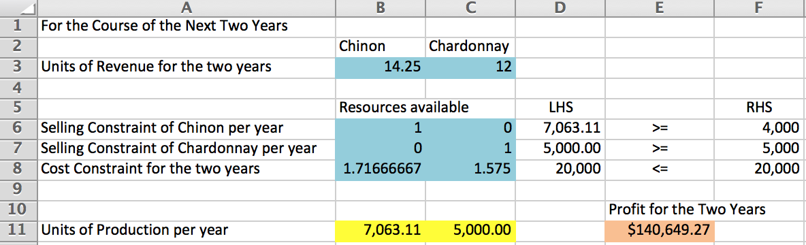

Selling an equal number of bottles of the two wine varieties will yield a profit of $139,493.67 over the two years for TSM Premium Wines. The results for this question show that removing the constraint of selling an equal number of bottles would lead to TSM Premium Wines producing 7,063 bottles of Chinon per year and 5,000 bottles of Chardonnay per year. This would yield a profit of $140,649.27 over the two years. As a result, the corporation’s profit would increase by $1,155.60. Therefore, the loan officer from the Bank of Nova Scotia is correct in believing that TSM Premium Wines strategy of selling an equal number of bottles of the two wine varieties does not make sense from strictly a profit perspective.

