Concordia University
Department of Economics
ECON 201 – INTRODUCTION TO MICROECONOMICS
Winter 2008
FINAL EXAMINATION
STUDENT NAME: __________________________________________________________________ STUDENT NUMBER: _______________________________________________________________
Please read all instructions carefully.
- This is a three-hour exam (180 minutes). The questions are worth 150 marks altogether. It is a good strategy to spend one minute per mark for your answers (150 minutes) and spend the remaining time (30 minutes) to review your answers.
- The exam has 14 pages and it consists of four parts:
(i) Part I: 25 multiple-choice questions (25 marks);
(ii) Part II: Choose 5 out of 7 ―true-false questions (25 marks);
(iii) Part III: Choose 4 out of 5 long questions (80 marks),and
(iv) Part IV. Choose 2 out of 3 ―current events questions (20 marks).
- Write all your answers on this exam. Do not use additional booklets.
- You are allowed to use a non-programmable calculator. You may use either pen or pencil to provide your answers.

Part I: Twenty-five (25) Multiple Choice Questions. Circle your answers (Total=25 marks).
1. Complete the following sentence:
Microeconomics is
a. concerned with the size of the total amount of income earned by all households in an economy.
b. unrelated to macroeconomics.
c. concerned exclusively with the role of the government in the economy.
d. the branch of economics that studies the decisions of individual households and firms.
e. none of the above.

2. In the economic sense, the cost of something used in production is
a. the benefit foregone by not using it in its best alternative use.
b. the explicit cost, the same as accountant’s cost
c. the payment actually made to the factor of production
d. the same as the tax authorities’ definition and. fixed cost and variable cost.
e. fixed cost and variable cost.

3. Suppose that the price of a substitute for a particular good falls and the prices of the raw materials used to manufacture the good increase. What would you expect to occur in the market for this good?
a. The equilibrium price would increase, but the impact on the amount sold in the market would be ambiguous.
b. The equilibrium price would decrease, but the impact on the amount sold in the market would be ambiguous.
c. Both equilibrium price and equilibrium quantity would increase.
d. Equilibrium quantity would increase, but the impact on equilibrium price would be ambiguous.
e. Equilibrium quantity would decrease, but the impact on equilibrium price would be ambiguous.

4. Which one of the following would not shift the supply curve for good X to the right?
a. A decrease in the price of AND, a substitute for the production of X.
b. A reduction in the price of resources used in producing X.
c. An improvement in technology affecting the production of X.
d. An increase in the price of X.
e. An increase in the price of AND, a complement in the production of X.

5. Suppose the total revenue from the sale of Montreal Gazette newspapers last month increased due to a decrease in price (assume a downward sloping demand curve). What can be concluded about the price elasticity of demand for Gazette?
a. Demand is elastic.
b. Demand is inelastic.
c. Demand is unit elastic.
d. Demand elasticity is equal to zero.
e. Nothing can be concluded about the price elasticity.

6. Which of the following statements best differentiates price ceilings and price floors?
a. Price ceilings represent minimum prices, while price floors represent maximum prices
b. Price ceilings are always set below the equilibrium price and price floors are always set above the equilibrium price.
c. Price ceilings are maximum allowable prices, whereas price floors are minimum allowable prices.
d. Price floors cause shortages to appear, whereas price ceilings have the opposite effect.
e. None of the above.

7. At any single output, the height of the demand curve measures
a. the consumer surplus enjoyed from consuming that unit.
b. the difference between the buyers' willingness to pay for that unit and the market price.
c. the profit earned by the seller from the sale of that unit.
d. the value buyers place on that unit of the good.
e. the income elasticity of demand.

8. Currently Joe and Halyna are consuming the same amount of strawberries, but Joe's demand curve is much more elastic than Halyna's. Which statement is true?
a. Halyna's consumer surplus exceeds Joe's.
b. Any comparison of consumer surplus depends on the price of strawberries. c. Halyna's consumer surplus equals Joe's.
d. No statement can be made regarding consumer surpluses.
e. Joe's consumer surplus exceeds Halyna's.

9. Oil-producing countries such as Venezuela have been trying to cut down on oil production in order to increase total revenues. Venezuela believes that the price elasticity of oil demand is
a. Elastic.
b. Inelastic.
c. Positive.
d. Unit elastic.
e. None of the above.

10. A consumer maximizes his total utility when goods A and B are consumed in quantities such that MUA/ MUB
a. equals the ratio of the price of A to the price of B.
b. equals the ratio of total utility of A to that of B.
c. equals the ratio of the price of B to the price of A.
d. equals the ratio of the quantities demanded.
e. always equals unity.

11. The problem with monitoring performance in large companies is often referred to as
a. Moral hazard.
b. Adverse selection.
c. Principal-agent.
d. Risk-neutrality.
e. None of the above.

12. When average total cost is falling, marginal cost must be
a. above average cost.
b. below average cost.
c. constant.
d. above variable cost.
e. below variable cost.

13. Below describes Acme’s production costs:
Quantity (in thousands) 1 2 3 4 5 6
Long-run ATC $100 $90 $100 $120 $150 $160
a. Acme is experiencing economies of scale at output of two or less and diseconomies of scale at higher quantities.
b. Acme is experiencing diseconomies of scale at output of two or less and economies of scale at higher quantities.
c. Acme is experiencing diseconomies of scale at all levels of output.
d. Acme is experiencing economies of scale at all levels of output.
e. Acme is experiencing diminishing marginal product.

14. Minimum efficient scale is the smallest quantity of output at which
a. The short run ATC curve reaches its lowest level.
b. The long run ATC curve reaches its lowest level.
c. The AFC curve reaches its lowest level.
d. The AVC curve reaches its lowest level.
e. None of the above.

15. If a profit-maximizing firm's marginal revenue is greater than its marginal cost, the firm
a. must be making an economic/supernormal profit.
b. will decrease its output.
c. will increase its output.
d. must be experiencing economic losses.
e. will close down.

16. A perfectly competitive firm will produce output in the short run even if P<ATC because
a. As long as P great or equal to MC, it can minimize it losses.
b. As long as P great or equal to AVCmin, it can minimize it losses.
c. Profits are positive.
d. Fixed costs are avoidable in the short run.
e. None of the above.

17. At its current level of output, a perfectly competitive firm’s, average variable cost is $8, average total cost is $10, and marginal cost is $9. If the market price is $10, this firm can increase profits by
a. shutting down production.
b. decreasing output.
c. increasing output.
d. increasing the market price.
e. not changing output because this firm is at its profit-maximizing position.

18. In the short run, a monopolist with a loss of $50, along with marginal revenue of $15, and marginal cost of $10, should
a. Shut down.
b. Expand output and raise price.
c. Expand output and cut price.
d. Cut output and raise price.
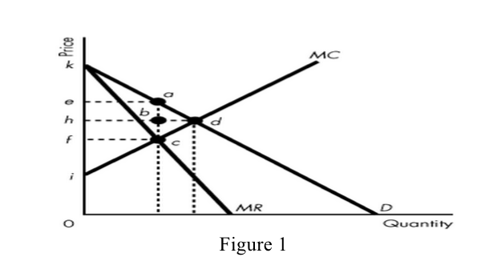
e. Cut output and price.

Figure 1 19. Consider the industry demand curve in Figure 1. If the industry operates under perfect competition, which area in the diagram indicates total surplus?
a. aek.
b. kdi.
c. dhk.
d. breath.
e. None of the above.

20. Consider Figure 1. If the industry is operated by a single-price monopolist, what area is producer surplus?
a. kea.
b. ieac.
c. khd.
d. ihd.
e.. None of the above.

21. Which one of the following statements is true?
a. An individual should specialize according to comparative advantage.
b. An individual should specialize according to absolute advantage.
c. An individual should trade with parties that have the same opportunity costs for the goods and services produced.
d. Comparative advantage exists whenever one person engaging in an activity incurs the same costs as some other individual.
e. An individual must be able to produce more of a good or service than someone else before she can have a comparative advantage in the production of that good or service.

22. Among the following, which is the best example of price discrimination?
a. Airfares are lower in Spring and Fall than in Summer and in late December.
b. Bell Canada charges lower rates for long-distance calls after midnight than during the day.
c. The metro allows senior citizens, the unemployed, and children to ride at reduced fares.
d. Public transportation systems often charge each individual according to the distance traveled.
e. A cinema charges lower prices on Tuesdays than on Fridays or Saturdays.

23. Excess capacity in monopolistically competitive firms is caused by
a. The fact that rival firms entering the industry and reducing the demand for the products of the firms already in the industry.
b. The fact that each firm attempts to maximize profits.
c. Cost curves being higher than they are under perfect competition.
d. The waste associated with many slightly differentiated products serving almost the same purpose.
e.. The fact that each firm faces a demand that is not perfect elastic.

24. Unlike perfectly competitive and monopolistically competitive firms, oligopolists
a. set MR = MC.
b. take account of the reactions of their competitors to their output decisions.
c. always make positive profits.
d. always face a large number of competing firms in their industry.
e. always cooperate with other competing firms in their industry

25. Once a cartel determines the profit-maximizing price,
a. each member will face the temptation to cheat on the cartel price in order to increase its sales and profits.
b. changes in the output of any member firms will have no impact on the market price.
c. entry into the industry of rival firms will raise profits as long as they join the cartel.
d. entry into the industry of rival firms will have no impact on the profit of the cartel.
e. all members of the cartel have a strong incentive to abide by the agreed-upon price.

Part II:
Answer FIVE of the following seven questions in the allotted space. If more than five questions are answered, only the first five will be marked.
State whether each statement is true or false and explain. Use graphs to support your answers when applicable. No marks will be awarded to simply stating “true” or “false” without explanation (Total=25 marks).

1. A tax of $2/unit imposed on the sellers of a specific good will result in raising the market price of this good by $2.

2. A price cut will affect the bottom line.

3.In an economically efficient setting, the production of pollution-generating aluminium would be zero.

4. The presence of external benefits associated with production implies that private output is less than the socially optimal output.

5. Monopolists can increase the general well-being of society by using price discrimination.

6. Monopolistically competitive firms produce the output level that achieves productive efficiency (P=ATC) and allocative efficiency (P=MC).

7. Diminishing marginal product occurs whenever the quality of the available labor pool deteriorates and production costs rise.

Part III:
Answer FOUR of the following five questions. If more than four questions are answered, only the first four will be marked (Total=80 marks).

Question 1 (20 marks)
Consider an alcohol market where demand and supply functions are given by P = 22 - Q
and P = 1 + 2Q, respectively.

(i) Draw the demand and supply curves and compute the equilibrium price and quantity (4 marks).

(ii) Suppose the government imposes a $3 tax per unit on alcohol so that the supply curve becomes P = 4 + 2Q. Illustrate the new supply curve on the same diagram as in (i), and find the new equilibrium price and quantity (4 marks).

(iii) What is the amount of tax revenue generated by the government? What is the tax burden on consumers and on producers, respectively? (4 marks)

(iv) Suppose that the demand for alcohol were given by P = 29 – 2Q instead. Taking into account the differences of these two demand curves, which demand gives rise to a larger deadweight loss? Which demand curve gives rise to a larger tax revenue? Explain intuitively by referring to the price elasticities (8 marks).

(v) The countries have gained from trade. Discuss the source(s) of the gains from trade (4 marks).

Question #2 (20 marks) The PPFs of Country 1 and country 2 are as follows:
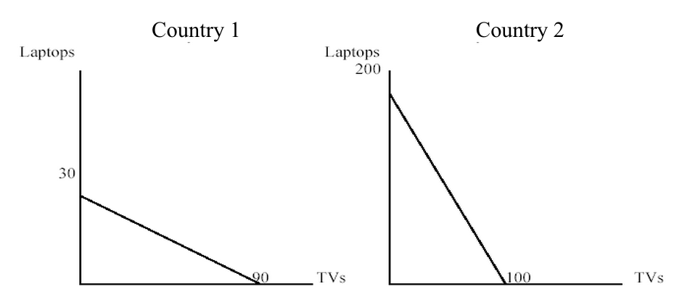
(i) What is the opportunity cost of producing one laptop for Country 1 and Country 2, respectively? (2 marks)

(ii) What is the opportunity cost of producing one TV for Country 1 and Country 2, respectively? (2 marks)

(iii) If we let the two countries specialize in producing the good for which they have comparative advantage, which good should Country 1 and Country 2 produce, respectively? Explain (4 marks).

(iv) Now suppose the two countries decide to trade according to the following ―terms of trade‖ – one laptop can be exchanged for two TVs. Also assume that Country 1 decides to get 30 units of the good produced by Country 2. How many laptops and TVs each country will end up with after the trade? (8 marks)

(V) The countries have gained from trade. Discuss the source(s) of the gains from trade (4 marks).

Question #3 (20 marks)

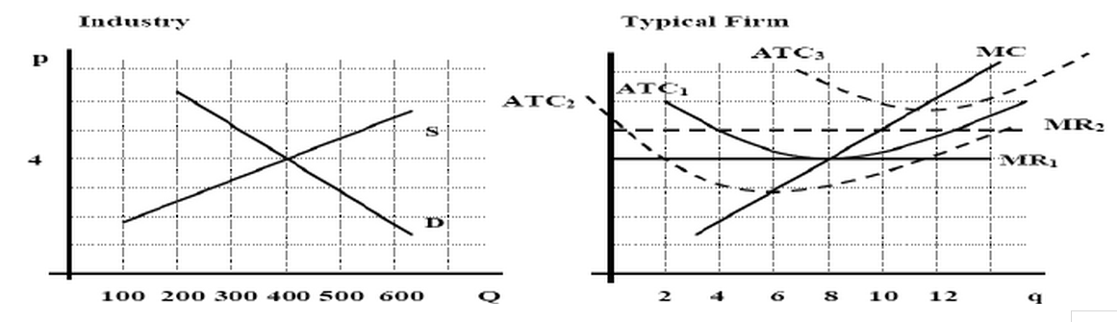
In this question we analyze an industry consisting of a number of identical firms. The graphs below show the cost curves of a typical firm as well as the industry market demand and supply curves.

(i) What are the equilibrium price and total output in this industry or market? (2 marks)

(ii) What is the output of each firm in the industry, and how much profit does each firm make? (4 marks)

(iii) How many firms are there in this market? (2 marks)

(iv) Is this industry in a long-run equilibrium? Explain (2 marks).

(V) Suppose that the technology used to produce this product improves so that the ATC curve shifts. What will be the new quantity supplied by each firm? How much profit does each firm make? (4 marks)

(Vi) Is the industry in a long-run equilibrium now? Explain (2 marks).

(vii) Now suppose that production technology deteriorates so that the ATC curve shifts. At the same time, there is improvement in the market price so that the MR curve also shifts. What will be t he new quantity supplied by each firm, and how much profit does each firm make? (4 marks)

Question #4 (20 marks)
Suppose that Elizabeth Airlines (EA) is a monopolist flying the route from Chicago to Honolulu. The demand for each flight is P = 200 – (1/3)Q. EA’s marginal cost of running each flight is $100 per passenger (Assume a zero fixed cost). MR= 200 – (2/3)Q.

(i) Single-Pricing Scheme: What is the profit of EA? (2 marks)

(ii) Discuss two conditions required in order for price discrimination to succeed (4 marks)

(iii) Price-Discrimination Scheme: EA finds out that two different types of passengers fly to Honolulu, business travellers and students. The demand from the business travellers is Pb = 300-Qb and the corresponding marginal revenue equation is MRb=300-2Qb. The demand from students is Ps = 150-(1/2)Qs and the corresponding marginal revenue equation is MRs=150-Qs. If the company decides to price-discriminate, find the equilibrium price, quantity and profit from each group (6 marks).

(iv) Draw two graphs, one for the business travellers and one for the students. Make sure your graphs are consistent with your answers in (iii) and label all relevant values (4 marks).

(V) Discuss intuitively why the profits under one pricing scheme are higher than the profits under the other pricing scheme (4 marks).

Question 5 (20 marks)
Suppose that in the market for paper, demand is P=100-Q. The private cost of producing paper (marginal cost) is MC = 10+Q. However, pollution generated by the production process creates an external harm that is estimated to be equal to 0.5Q (i.e., the level of the external cost increases with the quantity produced).

- What is the unregulated market equilibrium price and quantity in this market? (4 marks)

- Is the market outcome socially desirable? Why or why not? Explain (4 marks).

- What is the socially optimal quantity of paper that should be produced? Draw a rough graph to show both the unregulated market equilibrium and the socially optimal equilibrium (4 marks).

(iv) Suppose that the government wants to intervene in this market to achieve the socially optimal quantity. What type of policy should the government apply in this a case, impose a tax or pay a subsidy to the producers? What would be the size of the tax or subsidy per unit of paper?(8 marks)

Part IV: Choose TWO out of the following three questions. If more than two questions are answered, only the first two will be marked (Total = 20 marks).

Question #1 (10 marks)

“Ottawa wants Competition in Internet Phone M sheet Nov15, 2006 Globe and Mail Update

Toronto- Industry Minister Maxime Bernier confirmed his free market credentials in Toronto on Wednesday, thumbing his nose at the federal telecommunications regulator by removing regulations on Internet-based telephone services.
The result could be significantly lower telephone bills for consumers and businesses across.
―It is time to have a level playing field from which consumers and small businesses will benefit.‖ Mr. Bernier told the Economic Club of Toronto.
The decision signals that Mr. Bernier will aggressively move forward with his plan to overhaul Canada's highly regulated telecom sector, even though the Conservatives have only a minority government.
Mr. Bernier, a staunch advocate for free markets, wants to let consumers determine the winners and losers. VoIP-based phone services have been taking thousands of customers away from established phone firms such as Bell Canada and Telus Corp. For consumers, Internet-based calling has meant more competition and lower prices in a market traditionally dominated by regional monopolies that had their prices set through the government.
Even though local phone markets were opened up for competition seven years ago, the large incumbents still control about 97 per cent of the market.”

(i) The above article suggests that by allowing smaller companies to compete freely in the internet phone market, consumers and businesses may end up paying lower prices. Discuss one economic reason why this may not necessarily be true (4 marks).
(ii) Contrast monopoly versus free market with many small firms: Use relevant economic concepts to argue whether we should expect more innovative products being introduced to the market or fewer of such products (4 marks).
(iii) The article says even though local phone markets were opened up for the past seven years, the large existing firms still control the majority of the market. Why is this so? Relate your answer to the relevant economic concept (2 marks).

Question #2 (10 marks)

British Airways and Korean Air Fined Millions for Fixing Prices Associated Press, August 24, 2007

“WASHINGTON, Aug. 23 (AP) - Two major airlines were fined $300 million each Thursday after admitting that they had conspired to fix prices on internation to the flights and agreeing to help prosecutors investigate other airlines.
The airlines, - British Airways, Britain’s largest airline, and Korean Air, South Korea’s national carrier — pleaded guilty to antitrust conspiracy charges. They acknowledged colluding with rivals over cargo rates and fuel surcharges, which had been added to fares in response to rising oil prices. That meant higher costs for international shippers and passengers.
Judge John D. Bates of Federal District Court in Washington said the case ―involved considerable commerce and reflected long-term and widespread conduct involving major airlines and players.
―Any anticompetitive behavior is to be condemned at British Airways or at other companies. It will not be tolerated and we remain vigilant in this respect, British Airways’ chief executive, Willie Walsh, said in a statement released after the court proceedings.
Korean Air released a statement saying it was ―committed to antitrust compliance‖ and was taking steps to make sure the conduct was never repeated. Neither company addressed the extent of its cooperation or how widespread the practice was in the industry.”

(i) Set up the matrix of profits depending on the pricing policy of each airliner. The possible profit levels under different pricing policies are $400, $600, $800 and $1,000 (all values are in millions) (4 marks).

(ii) Show and explain the outcome of this game that the two airliners were trying to achieve. How easy it is for this outcome to be reached (2 marks)?

(iii) Show and explain the outcome of this game if the two airliners were active competitors (2 marks).

(iv) Is the $300 million penalty sufficient to deter future price-fixing, assuming that the profit matrix stays constant? Explain (3 marks).

Question #3 (10 marks)

“$300 Per Family - A Costly System For Consumers The Poultry Site Latest News, August 24, 2007

CANADA - The Montreal Economic Institute is estimating that supply management of milk, eggs and poultry costs at least $300 extra per year for a family of four. This amounts to $575 million for everyone in Quebec.
Marcel Boyer explains that astronomical customs duties and the setting of high prices for these food items constitute a particularly regressive tax on low-income consumers. "This system, motivated by protectionism, operates largely as a cartel and is obsolete, costly and unfair," Mr. Boyer says. "The food and agriculture sector must adapt to international competition and stop penalizing consumers, as well as farmers themselves in the long run."
The supply management system lets Canada's milk, poultry and egg producers, most of them located in Quebec and Ontario, adjust production to protect their incomes. For this purpose, quotas are set to match an arbitrary evaluation of domestic demand and meet desired prices.
Under the supply management system, consumers' interests are secondary, In Canada, the price of milk has risen 53% in the last 12 years, double the rate of inflation, whereas production costs actually declined by 3.8%. At the same time, consumption for milk has fallen 18% and is forecast to decline a further 12% band 2020. There exists a huge gap, over 37%, between retail milk prices in Quebec and prices observed in the Unitand States.”
Sylvain Charlebois, associate professor of marketing at the University of Regina, and co-author of the study, added another aspect: "When food distributors are selling two litres of Coke at 99 cents and a carton of milk for $4.50 or $4.75, we're encouraging families to buy cheaper, less nutritious products," he said. "And we're wondering why we have an obesity crisis."
Supporters of the supply management system, along with pressure groups in the food and agriculture areas concerned, take pride in receiving no subsidies. However, supply management resembles in practice a taxation power granted by the government. Rather than subsidize farmers directly with money collected from citizens, the government lets producers raise prices by giving them monopoly privileges. This amounts to the same thing, except that the government does not face the ire of consumers, who are unaware of the situation.

(i) Make a rough graph to show how a milk quota would result in high prices for milk. Discuss the changes in the allocation of society’s surplus from the quota (2 marks).

(ii) Calculate the price elasticity of milk implied in the study from the changes of market magnitudes until now (3 marks).

(iii) On your graph in (i), illustrate how a quota is equivalent to a tax in terms of raising prices (3 marks).

(iv) What is the relation between the two goods, milk and Coke, as this is implied in the article. Explain (2 marks)

