
Fun learning and reading environment
Binta Diallo

Project Soleil
Table of Contents

The project 1

Description

Location

Timeline and deliverables

Funds 2

Budget

Potential value

Conclusion 3

Bibliography

THE PROJECT

- Description

No-one should doubt the importance of children's libraries to children and their families all over the world. They are their first toward learning. They introduce the children to many exciting, rich and varied resources. Every child should be familiar with a library.

Not only, libraries teach children about the original sharing economy by early on showing them how to take care of public property and honour their loan. Also, a library is a community: hosting many activities such as games, movies and clubs that help the kid get involved with others.

However, some children cannot afford to move to a library for the simple reason that they are ill. Is there anything more toxic to a child than the boredom that comes with an extended stay in a hospital room? Sure, they may have little bookshelves and books to read and some scheduled activity per week but wouldn’t it be better to provide them with an amusing learning environment, where they can spend time with themselves or with other children.

- Location

The Jewish General Hospital seems like the perfect place for this project. Even though it is a big hospital and does indeed own a library, it is mainly a medical library offering certain adult books but not entertainment for younger children.

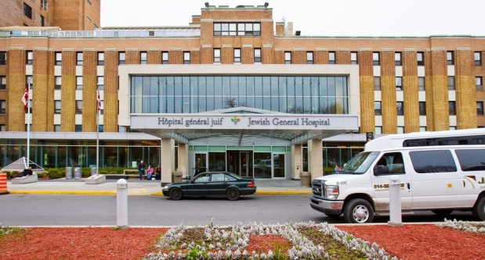

The Jewish General Hospital

- Timeline and deliverables

 | W1 | W2 | W3 | W4 | W5 | W6 | W7 | W8 | W9
Build a team
Security plan
Functional design document
Construction of a small annex
Plumbing and aeration system
Painting and decoration
Creation of shelves and accessories
Installing electronic devices
Quality control
Funds

- Budget

The overall cost will be $56, 000 CAD.
It includes:
The plumbing ($10,000)
The creation of the building itself (25,000 CAD)
The decorating material ($1,000 CAD)
The shelves and windows ($5,000 CAD)
Electronic devices ($15,000 CAD).

- Potential value

The biggest benefit that’ll come out of this project is the education of our children. They will feel part of society again, able to socialize and communicate in a safe environment. Of course, the hospital will pay a monthly tax considering that the library is a private property. Also, the cost of the library’s income (mainly coming from the price of the registration) will be partly going to you, our main benefactor.

Conclusion

The “Project Soleil” is a big step in the development of our children and represents a huge social involvement in our future generations. It is exactly what we need to build a safe, fun and entertaining learning environment for the sick children of the Jewish General Hospital.

Bibliography

http://www.jgh.ca/en/JGHLibraries?mid=ctl00_MainMenu_ctl00_TheMenu-menuItem009

https://www.chusj.org/getmedia/da50055f-ce9c-427e-abb0-ff473e632482/depliant_guide-des-services_EN.pdf.aspx

http://www.ifla.org/files/assets/libraries-for-children-and-ya/publications/guidelines-for-childrens-libraries-services_background-en.pdf

http://www.treehugger.com/green-home/why-going-library-one-best-things-i-do-my-kids-and-planet.html

Children of reading age, between the ages 5-13

