Canadian Business in its social context
Lecture 1

Issues
- Society expectations of business driven by a more informed, affluent and litigious society
- Technological advances facilitate misinformation and disinformation but also puts business in society’s spotlight
- Who in “society” has the greatest influence?
- Who has the right to dictate how business should operate?
- What exactly is “ethical” behavior?
- What exactly is “social responsibly”?

Significance of Business in its social context
- Business affects, and is affected by the society in which it operates
- For managers to operate effectively, an understanding of business “domestic microenvironment is essential

What exactly is business “Macroenvironment”
- It is intuitive that business can affect, and be affected by other business
- But business can affect, also be affected by:
- Government
- Civil society

The modified Boulding Triangle: A way to depict the Canadian macroenvironment

Government
Civil Society
Business

The business segment
All forms of “for profit” business ownership:
- Corporation
- Partnerships
- Proprietorship

The government segment
All levels of government
- Federal
- Provincial
- Municipal

The civil society segment
Organized and unorganized social networks
- Communities
- Non-government organizations
- Chartism
- Volunteers
- Philanthropic efforts

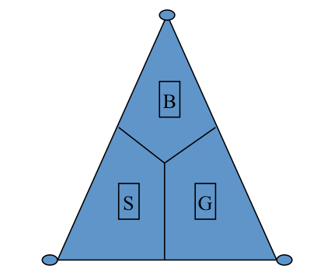
Canada’s Macroenvironment-The Business-Government –Society Nexus
- The modified “Boulding Triangle” depict the three segments of the domestic macroenvironment-
Business (B), Government (G) and Civil Society (S)

- At the apex appears B, G, and S in its purest form
- Pure reciprocity (civil society)
- Pure exchange (business)
- Pure coercion (government)

- All inner territory represents organizations embodying different mixes of the three- a variety of socioeconomic AND governance relationships

- Rules or “sorting” mechanisms of coordination for each segment are based on different principles:
- Business-supply and demand forces (norms)
- Government- redistribution and coercion (rules)
- Civil society-cooperation, reciprocity, and solidarity (principles)

- Note that:
The boundaries between B, S, and G are not well-defined because they are not rigid frontiers- but rather wavering and continually evolving zones of overlap, interaction, and interdependency

