Observing Polytene Chromosomes in the Salivary Glands of Drosophila virilis Using Wet Mounts and Heat Shock Treatments

Devina Chaudhary
7333619

(Savannah Turon)
(7308200)

Section C6

Lab Demos
Mary Ann Perron
Cloe Petrin

Jan 30th, 2015

Department of Biology

University of Ottawa

INTRODUCTION
The purpose of this lab was to observe the polytene chromosome found in the salivary gland of the fruit fly larvae. By using a control sample (in room temperature) and comparing it to a heat shock sample (done in an incubator) both the room temperature and heat shock chromosomes were observed under a compound microscope and digital photos were captured.
The lab was done in three basic sections, in section one the salivary glands were isolated by dissecting a fruit fly larva under the dissection microscope. By putting some saline solution on the larva and using two needles to remove the head(bringing with it the salivary glands). These isolated salivary lands were then placed in a petri dish with a moist tissue underneath and kept aside in room temperature. This process is done again only placing the next petri dish in an incubator at 37 degrees Celsius for 40 minutes. The second part of the lab is colouring the chromosomes using aceto-orcein and returning the slide with the dissected larva into the covered petri dish for five minutes. They slides were then removed and observed under the compound microscope. In the last part of the lab images of the polytene chromosomes were taken using the Infinity Capture program by adjusting white balances and saving them as jpeg files (Genetics Lab Manual, Sofia Perin et. al, 2015).

RESULTS
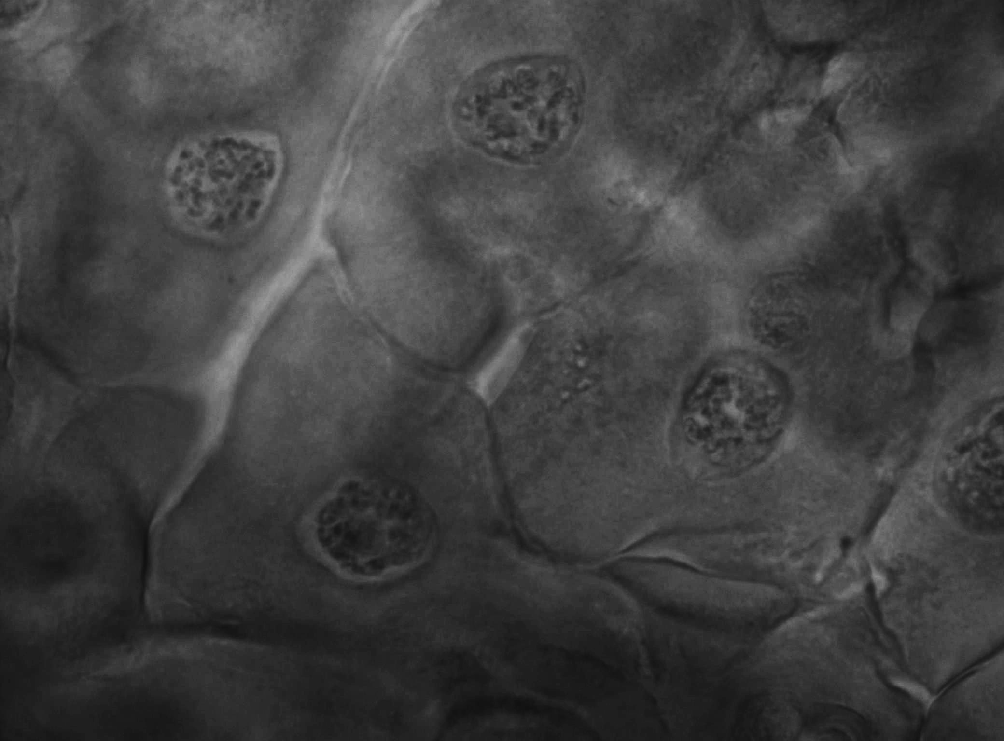
A

Ib
B

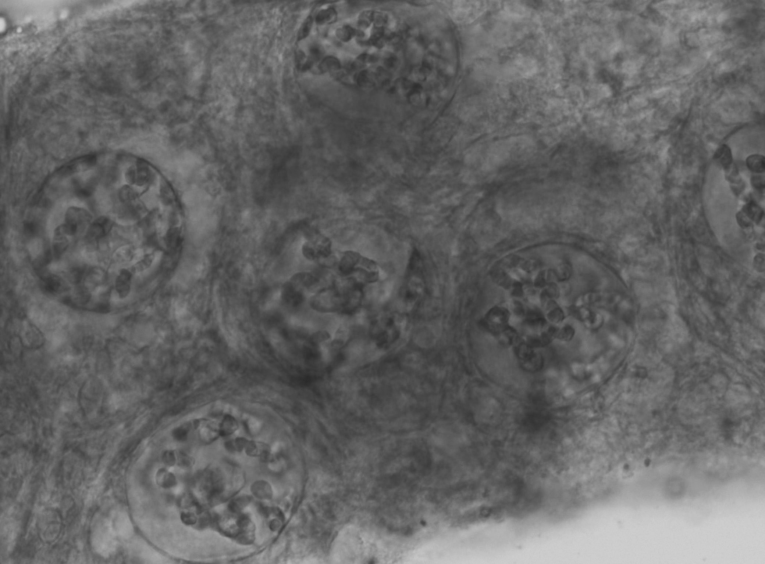
B
Ib
B

Figure 1. (A) The polytene chromosomes in the salivary gland of the Drosophila virilis larva at room temperature; (B) the polytene chromosomes in the salivary gland of the Drosophila virilis larva after a heat shock (37 degrees). With Ib being the interbands and B are the bands. Scale bar is 25 micrometers in width for both (A) and (B).

The figure above shows the cells found in the larva of Drosophila virilis. The chromosomes can b seen inside the nuclei of both the room temperature and heat shock sample. In (A) and (B) the dark banded sections on the chromosomes are called the bands and the more translucent regions are referred to as the interbands. The heat shock chromosomes are more enlarged and clearly visible under the microscope in comparison to the room temperature sample.
DISCUSSION
- The polytene chromosomes are a good model to show interphase stage in the cell, by showing how the chromosomes would be positioned. It also helps us understand the organization of cells while the undergo cell division, the transcription factors and the overall cycle of cell division. This is made possible because of the polytene chromosomes undergo many series of replication containing homologous pairs and those remain attached (or synapsed) even without nuclear division or by being segregated and separated. We also have used heat shock treatments to study the cell stress response when undergoing more rapid environment changes (Nordheim,1981).
Finally scientists have discovered a steroid hormone that undergoes its biochemical pathway through activation genes. This was found to follow a similar activation cycle as the puffing of polytene chromosomes seen in the lab.
- The polytene chromosomes have lots of DNA and always in interphase. This makes them easier to see inside the nucleus as they are enlarged and the bands and interbands are more clearly distinguished. Since heat causes the chromosomes to uncoil during puffing the chromosomes are less in coiled comparable to regular cell division (Nordheim, 1981).
- As the Drosophila virilis larvae grow towards the pupation stage they increase in size by consuming large amounts of food (similar activity as caterpillars before forming a cocoon to become a butterfly. By the Drosophila virilis increasing in its size the salivary glands grow enormously to help with the ingestion and breaking down of food, by providing the digestive enzymes to break down the food into its macromolecules. The salivary glands do not increase in size because of rapid cell division instead the enlarged glands are just the same amount of cells increasing in size and their volume (Ficq, 1957).
- Puffing in the chromosomes is seen when we laced them in a heat shock at 37C because we had activated genes within the various loci of these chromosomes. We see the puffing on the chromosomes when the cell will have a high level of RNA production, which increases the gene activity, due to transcription in the cell. Transcription can be affected when the environment of the cell is high; this results in the uncoiling of the chromosomes which was observed when we placed the slides under the compound microscope (Ashburner,1979).
- The environmental factors can be the effect of hormones that enter or exit the cell and any genetic mutations (Ficq, 1957).

References
Ashburner, M., & Bonner, J. J. (1979). The induction of gene activity in Drosophila by heat shock. Cell, 17(2), 241-254.

Ficq, A., & Pavan, C. (1957). Autoradiography of polytene chromosomes of Rhynchosciara angelae at different stages of larval development.

Nordheim, A., Pardue, M. L., Lafer, E. M., Möller, A., Stollar, B. D., & Rich, A. (1981). Antibodies to left-handed Z-DNA bind to interband regions of Drosophila polytene chromosomes.

