Bioenergetics
When ATP sources are dwindled in the body, the next process will be creatine phosphate.
Energy stored between 2nd and 3rd bond.

When ATP is broken down, ADP and P_{i} are made.

ATP-Phosphocreatine System
Creatine is an amino acid, found in red meat.

ATP-PCr
- Although ATP is being used at a very high rate, the energy from PCr is used to resynthesize ATP, preventing the ATP level from decreasing. At exhaustion, both ATP and PCr concentrations are low.
- ATP-PCr process lasts about 14 seconds until exhaustion.

1 Glucose (3C) 2 Pyruvate (6C)
Need to put in energy, but getting ATP out of it. Can regenerate ATP fairly quickly

Summary of glycolysis
Energy from breaking down glucose turns ADP into ATP
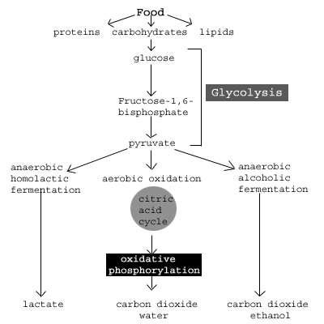
2ATP --> 4ATP + 2(NADH + H+) + 2 pyruvate (net production of 2ATP)

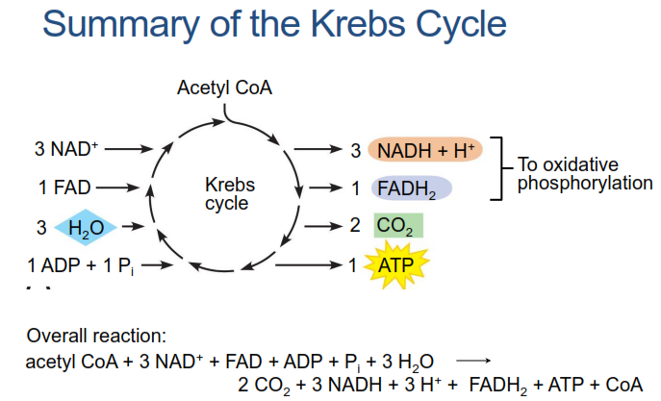

Summary of the Krebs Cycle
- Two molecules of carbon dioxide are given off
- One molecule of ATP is formed
- Three molecules of NAD+ are combined with hydrogen (NAD+ → NADH)
- One molecule of FAD+ combines with hydrogen (FAD+ → FADH)

Look up the Krebs Cycle and ETC
ETC: 34ATP. Only stage where oxygen is being used

Summary of Glucose Oxidation
Oxidation
C₆H₁₂O₆ + 6 O₂ + 38 ADP + 38 P_{i} =
6 CO₂ + 6 H₂O + 38 ATP
Glucose is stored in the form of glycogen in the cells, glycolysis results in 3 ATP

- Fats are not good source of ATP during aerobic exercise
- Pyruvate will take the slack, and turn into lactic acid.
- The brain needs glucose to operate. Prolonged time without it can cause long-term damage

Not expected to know all the steps (before lactic acid slide)

- Pyruvate can pick up/release hydrogen ion, and produce lactate.
- Enzymes are pH sensitive. If environment is too acidic, they will not work properly.

How much ATP?

Anerobic
PCr = 1 ATP per molecule
Glycolysis: Glycogen = 3 ATP
Glucose = 2 ATP
Aerobic
Additional 34 ATP!

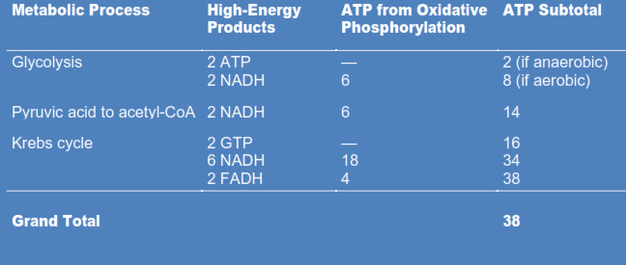
Aerobic ATP Tally: Total of 38 ATP.

Note: 1 PCr = 1 ATP per molecule
Glycogen = 3 ATP

Metabolic Efficiency
C₆H₁₂O₆ 6CO₂ + 6H₂O + 689kcal x mol⁻¹

ADP + 7.3kcal/mol ATP
38 ATP/mol Glucose = 277kcal/mol
~40% energy efficiency
Remainder = heat
- 1 mol of glucose holds 689kcal mol

Efficiency of Oxidative Phosphorylation
- Aerobic metabolism of 1 molecule of glucose yields 38 ATP
- Aerobic metabolism of 1 molecule of glycogen yields 39 ATP
- Overall efficiency of aerobic respiration is 40%, with 60% of energy released as heat

Energy Sources of Skeletal Muscle Charge

Takes 2 minutes to get oxidative phosphorylation running (warm-up)

Summary
- Glycolysis is present in ALL modes of glucose catabolism.
- Glycolysis allows rapid and high production of energy
- Lactic acid temporarily stores H⁺
- Allows regeneration of NAD⁺
- Can limit exercise due to acidity
- Later metabolised back to pyruvate

