Neuromuscular Physiology

ACh attaches to sarcolemma (post-synaptic membrane) and opens up sodium channels.
It’s broken up by Ach-asterase into acetyl and choline. Prolonged muscle contraction will occur, if ACh is not broken down.
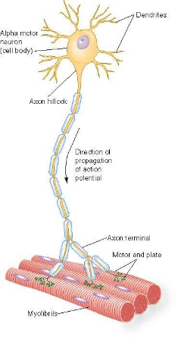
A local anesthetic has the most effect on Type C fibers (small diameter)

Eliciting a Muscle Contraction
- One a-motor neuron innervates many muscle fibers, collectively called the motor unit
- The action potential arrives at the dendrites and travels down the axon to the axon terminal
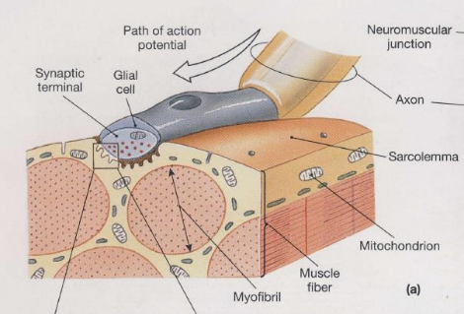
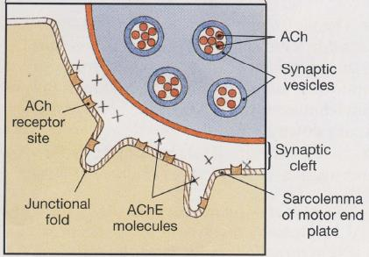

Neuromuscular Junction:
- Many poles, high density a-ACh receptors communicate with muscle fibers
- Where the a motor neuron communicates with muscle fibers
- Axon terminal releases neurotransmitters which travel across a synaptic cleft and bind to receptors on muscle fiber’s sarcolemma
- Neurotransmitter binding causes depolarization, and once a threshold is reached, an AP occurs
- The AP spreads across the sarcolemma, ultimately leading to a muscle fiber contraction

Botulism
- Have a bacteria called botulinium. Found in poorly kept meat (e.g sausages)

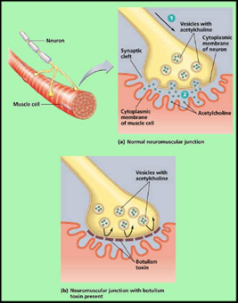
Botulism is a toxin that is taken up
in the axon. It interferes with an
enzyme involved in fusion of
vesicles to membrane
- Prevents ACh vesicles fusing
with membrane, and releasing
contents to the synapse

Botox:
- Local injection of botulism bacteria
- Allows muscles in the area to relax, and wrinkles disappear
- Your facial expressions will also be mute.

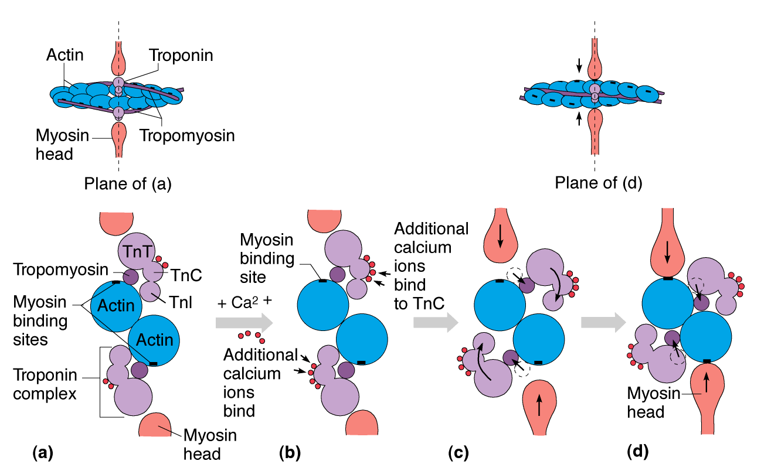
AP goes down T-tubules (perpendicular to sarcolemma, transmit AP so that all muscle fibers contract at the same time) after sarcolemma

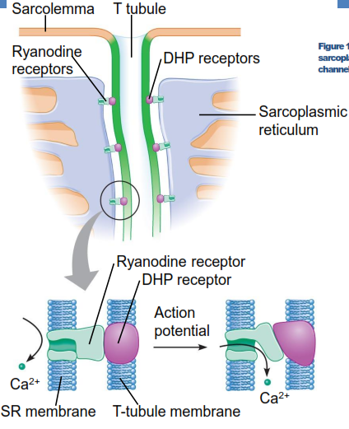

T-tubules beside membrane on SR. They are connected to DHP receptor.

AP passing by: Ryanodine receptor pulled down, opening up calcium channels, to which calcium attaches itself
As soon as calcium is available, calcium gates open, troponin pulls away and rotates tropomyosin from binding site, myosin connects with actin, and cross bridges are formed.

The Contraction Cycle:
Calcium binds to troponin, pulls away tropomyosin, allows actin and myosin to connect. Cross bridges connect now.

- When ATP splits off, it creates energy.
- When ADP+P_{i} leave myosin head, it causes a pinching movement in the head called a power stroke. This pulls the actin. Need ATP to release head from actin molecule.
- Need Calcium for this whole process, because we cannot make a cross bridge without it. ATP is needed to prepare the myosin head, and also to remove the head so that the cross bridge detaches (rigor)

Relaxation
- Calcium pump is continuously pumping. Will reduce amount of calcium in cytoplasm.
- Duration of contraction depends upon the duration of stimulation at NMJ.
- The change in Ca²⁺ permeability of the SR is very brief
- Sarcoplasm Ca²⁺ concentration returns to low levels very quickly by using active transport – a Ca²⁺ pump that uses ATP to return Ca²⁺ ions to the SR
- When Ca²⁺ concentration becomes low enough, Ca²⁺ unbinds from troponin, and cross-bridges cease – passive lengthening
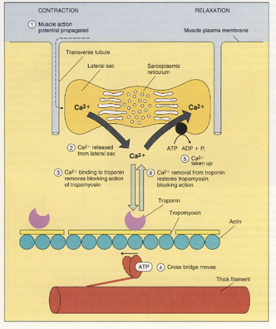

Muscle Fiber Contraction Key Points
- Muscle contraction initiated by a-motor neuron AP
- Motor neuron releases ACh, opens up ion gates in the muscle cell membrane
- Sodium enters the muscle cell, depolarizing the sarcolemma
- The action potential travels throughout the sarcolemma and through the T-tubules, which releases stored Ca²⁺ ions from the SR

- Ca²⁺ ions bind with troponin, lifting the tropomyosin molecules off the active sites on the actin filament
- The myosin head binds to the active actin site
- The myosin head binds ATP, and ATPase on the myosin heads splits ATP into ADP and P_{i}, releasing energy to fuel the muscle contraction
- The myosin head tilts, pulling the thin filament past the thick filament — power stroke
- Muscle contraction ends when Ca²⁺ is actively pumped out of the sarcoplasm back to the sarcoplasmic reticulum

Relaxation – Role of Titin
- Passive elasticity of muscles

Excitation-Contraction Coupling
- Link between generation of AP in sarcolemma and a muscle contraction
- Change in Ca²⁺ permeability of SR lasts 0.03 seconds
- Within 0.001 seconds Ca²⁺ concentration around sarcomere increases ×100
- Effect of Ca²⁺ on troponin and subsequently on cross-bridge formation is almost instantaneous
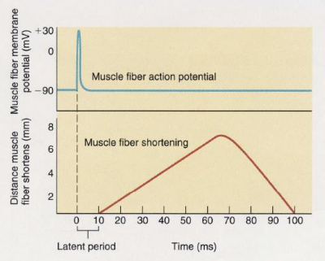

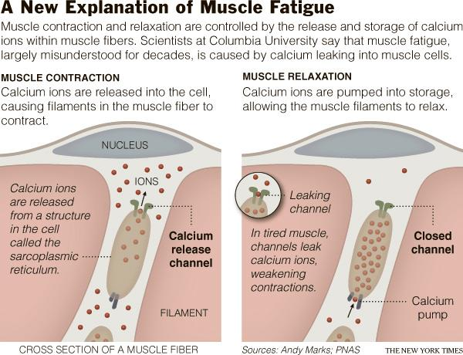

Rigor Mortis
- Calcium is still available, but without ATP, the cross-bridges will remain and muscles stiffen
- Muscle is in constant contraction state (rigor). Rigor mortis happens after death
- With lot of muscle contractions, some channels may be leaking
- Calcium is unable to leak into cytoplasm. Leaky channels causes muscles to fatigue

Muscle Cramps
- Basic mechanism for muscle cramps?
- Usually occurs during dehydration in the heat (profuse sweating)
- Sweat has high concentration of Sodium Chloride (NaCl)
- During cramps, APs fire at 300/s – far greater than voluntary contractions

Extracellular sodium is being removed, TMP becoming more positive. Membrane becomes more excitable
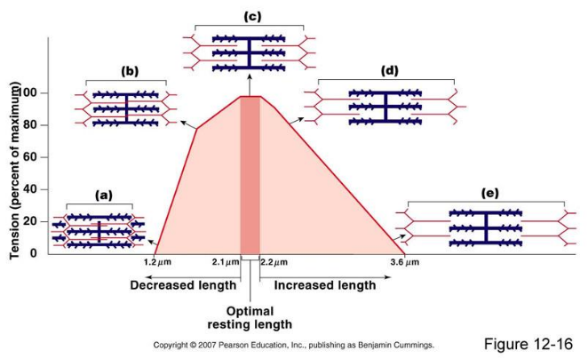

Tension Production
- Amount of tension produced by one muscle fibre solely depends upon the number of cross-bridges
- A given length = A given tension
- No mechanism to regulate the amount of tension produced within a muscle fibre
- Tension produced by a whole skeletal muscle determined by:
- Frequency of stimulation
- Number of muscle fibres stimulated
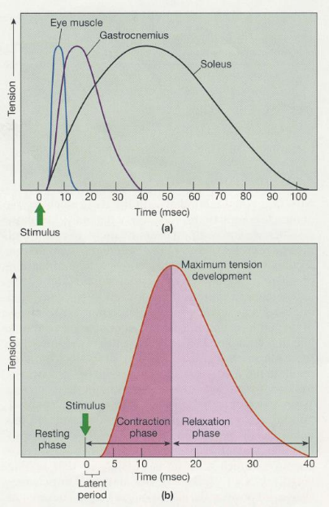
Frequency of Muscle Stimulation
- Twitch is a single
contraction-relaxation cycle
- Duration varies (10-100 msec)
- All twitches are composed of:
- Latent period
- Contraction phase
- Relaxation phase
- Single twitches do not
achieve much
- All activities require
sustained muscle contractions

Twitch depends on
type of muscle fiber



