T-Tubules – Cell membranes that extend to the inside of the muscle cell
- They go into muscle fibre/cell, to reach all myofibrils at same time

- Endomysium – Connective tissue surrounding a muscle fibre
- Sarcolemma – Cell membrane around the muscle fibre

Transmembrane Potential
- The sarcolemma keeps particles either in or out of the cell
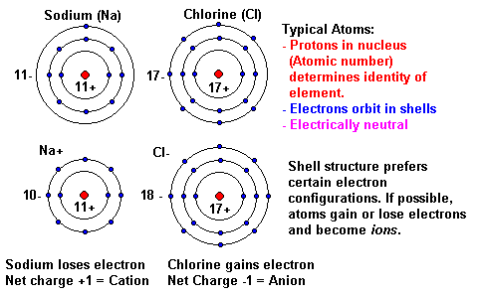
- Movement of ions across the membrane depends on the ion concentration, their charge, and size
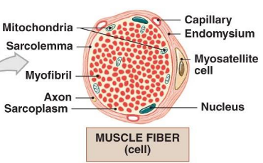

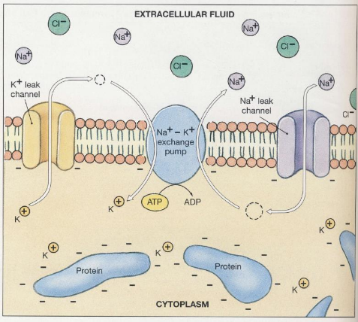
When the membrane is in rest, resting potential difference of -70mV

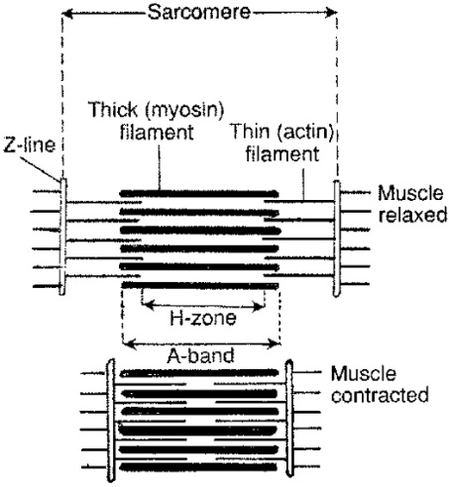
Pump for active transport of ions

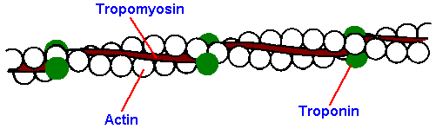
Transverse Tubules
- T-tubules are part of sarcolemma
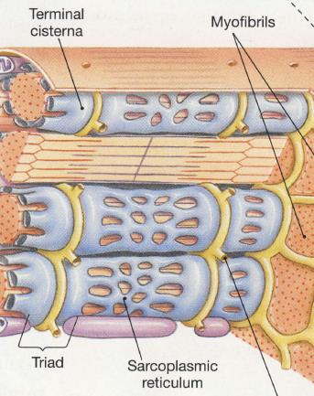
- Carry electrical impulses inside the muscle fibre
- Transmits signal to SR which
releases calcium into sarcoplasm

Sarcoplasm Reticulum
- SR surrounds each myofibril
- Muscle triad
- Terminal Cisternae
- T-Tubule
- Terminal Cisternae
(Almost no space in between)
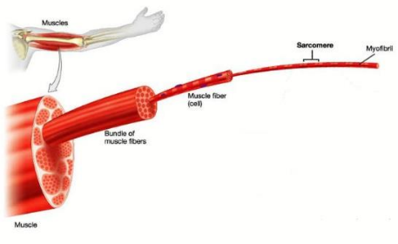
- Ca²⁺ concentration is 40,000 times greater in SR than in sarcoplasm

Sarcomeres
- Smallest contractile fibres

- A muscle contraction begins when stored calcium ions are released into the sarcoplasm. Ions diffuse into individual contractile units called SARCOMERES
- Dark bands – A bands
- Light bands – I bands. No overlaps of filaments
- A band without overlapping areas – H Zone

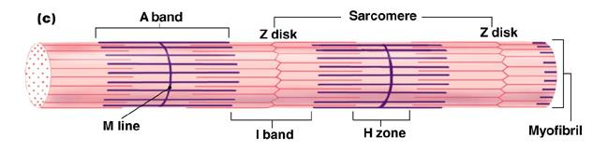

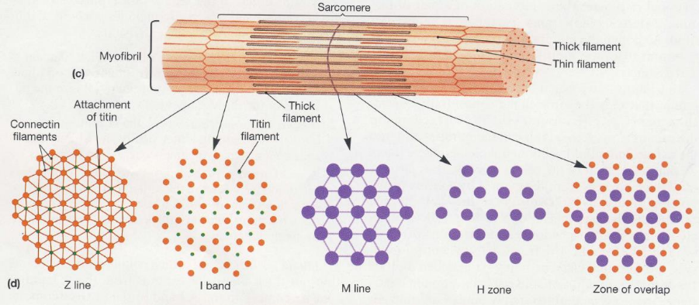

Titin keeps thick filaments in place. Slowly release following contract, allowing muscle to return to regular length

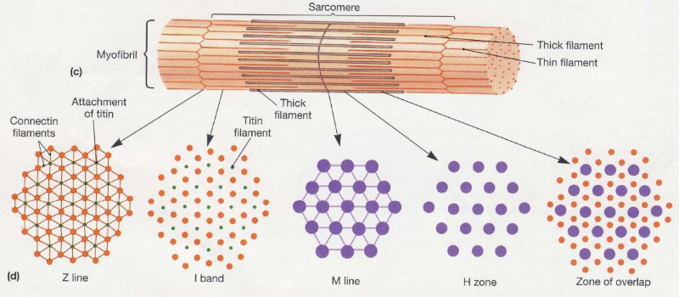
Cross-sectional arrangement of thin and thick filaments at different points throughout a sarcomere

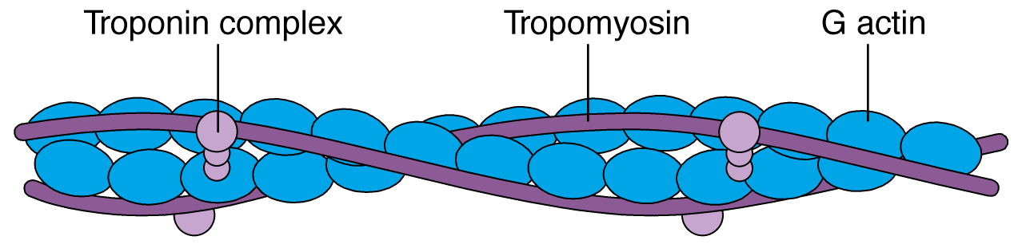

Thin Filaments
- F-Actin Strand: Twisted strand of 300-400 globular molecules of G-actin. Each G-actin molecule has an active site that can bind to a thick filament
- Tropomyosin: Strands cover the active sites of G-actin
- Troponin - 3 globular subunits:
1) to Tropomyosin, 2) to G-actin, 3) to Ca²⁺ ion
- Without calcium, a process cannot be formed because the protein binding sites are covered by tropomyosin
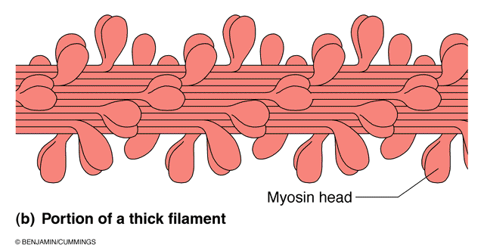
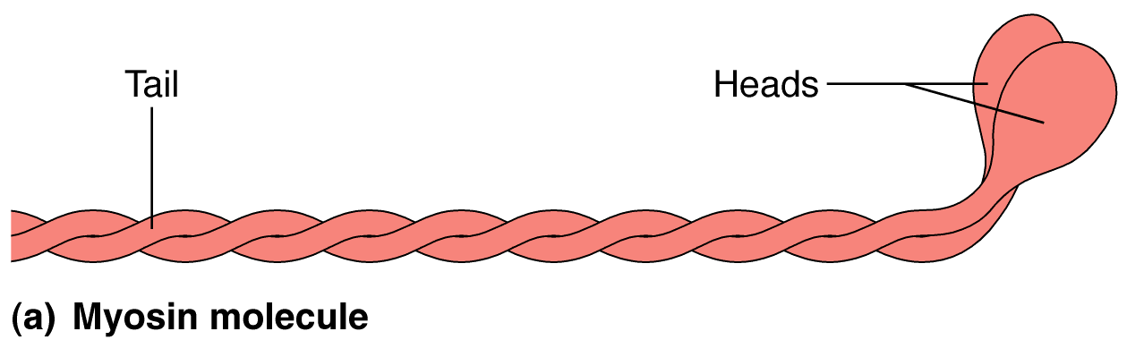

Thick Filament
- Each filament has ~500 myosin molecules
- Each molecule consists of 2 subunits twisted around one another
- Tails point towards M-line with heads projecting outwards
- Core of Titin that extends to Z-line
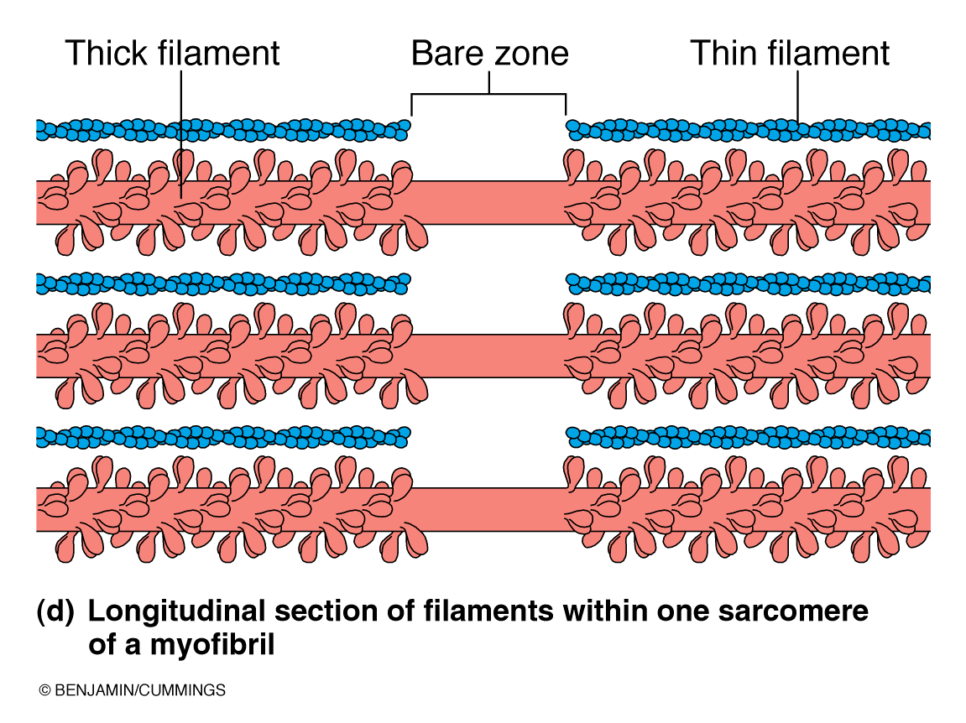

Cross bridges are not 3 dimensional, able to connect with all actin filaments

Arrangement of Thick and Thin Filaments

Key Points
- Myofibrils are made up of sarcomeres
- A sarcomere is composed of protein filaments of myosin and actin
- Interactions between the filaments is responsible for muscle contraction
- Myosin, the thick filament, is composed of 2 protein strands, each folded into a globular head at one end
- The thin filament is composed of actin, tropomyosin, and troponin, with one end attached to a Z-disk

Image on left – Muscle cells
Right – fibres
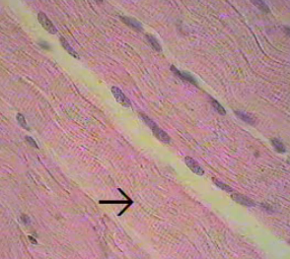
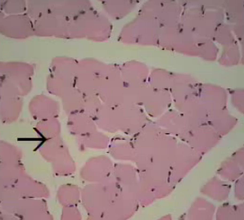

Myofibrils are back to back sarcomeres (horizontal “packs” of sarcomeres). A band is the dark area, I band is the light one.

Muscular Disorders
Duchenne’s: Thickening of CT, weakening of muscles because signals are not coming through
Myopathy: (muscle-disorder) Blots interfere with structure of muscle
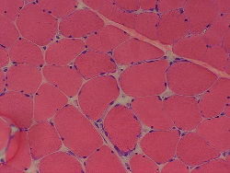
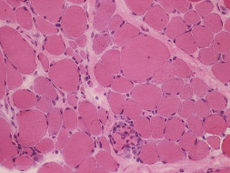
Degenerating fibres Duchenne’s

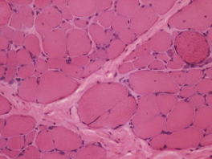
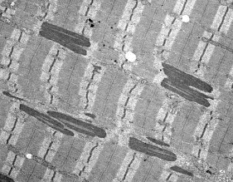
Nemaline Myopathy Split Fibre Dystrophy

Sliding Filament Theory
First, M-Line, Z-line, A-band, I-band, H-zone
On contraction, what happens to…
- Length of one sarcomere? Gets smaller
- I-band? Gets smaller
- H-zone? Gets smaller
- A-band? Stays the same

M-line is in the middle, A band is the dark area, I band is the lighter area beside the A bands
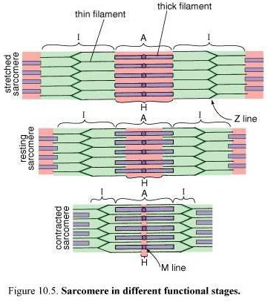

- Z lines move closer to A bands (outer boundaries),
- Difference between H-zone and A-band are the overlapping areas
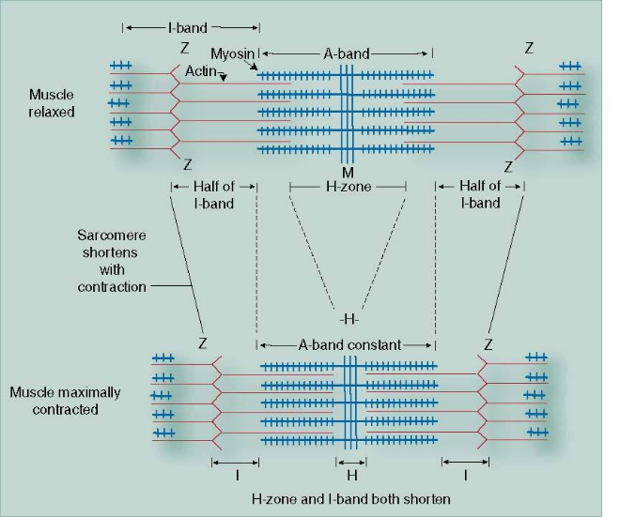

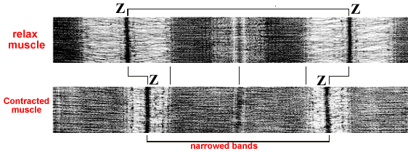
Neurophysiology
- The “message” for a muscle contraction
is carried from the brain to the target body
region in (seemingly) an instant
- The message is transmitted by neurons (nerve cells)
- A group of axons bundled together constitute a nerve
- A nerve impulse—an electrical charge—is the signal that passes from one neuron to the next and finally to an end organ, such as a group of muscle fibers, or back to the CNS
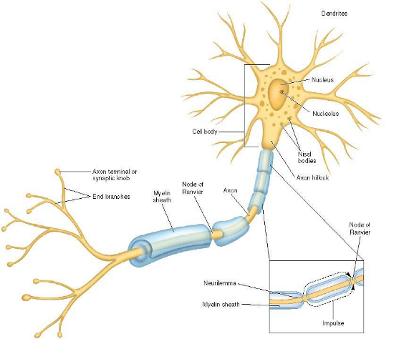
- Actins do not contract by themselves, they need calcium

Neurons:
- Dendrites, axons.
- Myelinated to help conduction speed of peripheral nerve fibres
- Skips from one node to the next
- Transmit action potentials by propagation
- Nerve cells have high metabolism. Can only function a few seconds without oxygen

What is an Action Potential?
- Brief reversal of charge that moves along a nerve axon
- This is a change from the resting membrane potential
- The ions primarily responsible for membrane polarity in neurons are potassium (K⁺) and sodium (Na⁺)

By electrical currents, we can figure out which muscles are being active

Cliffhanger: Does an action potential only run one way?

