CHEAT SHEET TOPICS

BANK RECONCILIATION

- Adjustments required for what the bank knows but what we DO NOT know

- When the bank reconciliation says ADD
Debit Cash
Credit account corresponding with the entry on the bank rec

- When the bank reconciliation says LESS:
Debit account corresponding with the entry on the bank rec
Credit Cash

- NSF: Non-Sufficient Funds
  - Anything mentioned about NSF (the fee related to an NSF cheque or the amount that was returned):
Dr Accounts Receivable
Cr Cash

- Calculating Interest on the Bank Loan
  - Interest is charged on the TOTAL outstanding amount:
(Current Portion of the Bank Loan + Bank Loan) * Interest Rate
    - The Current Portion is the amount owing to the bank THIS year, therefore if they give you an amount on the Bank Reconciliation that represents paying both the principle amount of the loan AND the interest, the principle is the Current Portion (found under Current Liabilities on the Balance sheet) and the remaining amount is the Interest Expense
        - I.e. Bank Rec states that you paid 12,000 toward the bank loan and interest (likely in a footnote), but the balance sheet states that the Current Portion of the Bank Loan is 9,000. The entry would be as follows:
Dr Interest Expense 3,000
Dr Bank Loan 9,000
Cr Cash 12,000

PETTY CASH

- Set Up or Increase Petty Cash Float
Dr Petty Cash
Cr Cash

- Using Petty Cash Through
Dr Whatever the money was spent on (usually an expense)
Cr Cash

- Close or Decrease Petty Cash Float
Dr Cash
Cr Petty Cash

RECEIVABLES

- Recording a Sale
Dr Accounts Receivable
Cr Sales Revenue
- Write – Off
Dr Allowance for Doubtful Accounts
Cr Accounts Receivable
- Recovering a Previously Written off Account (only recover the amount that is actually being collected, not the entire amount)
  - Step 1: Reverse Write Off
Dr Accounts Receivable
Cr Allowance for Doubtful Accounts
  - Step 2: Record the Collection of Cash
Dr Cash
Cr Accounts Receivable

BAD DEBTS VALUATION

- Percentage of Outstanding Accounts Receivable
  - Step 1: Multiply E/B in A/R by the percentage deemed to be uncollectable, this is your E/B in your Allowance for Doubtful Accounts
  - Step 2: Take a T/B in AFDA
  - Step 2: Find the plug in AFDA, this is your Bad Debts Expense

Dr Bad Debts Expense
Cr Allowance for Doubtful Accounts

- Aging Method
  - A schedule of outstanding debts will be given:

Age of Outstanding Accounts | Amount Outstanding | Percentage Deemed Uncollectible
not yet due | 10,000 | 2%
0 – 30 days | 8,000 | 8%
31 – 60 days | 5,000 | 20%
61 – 90 days | 2,500 | 35%
91+ days past due | 2,000 | 50%

  - Step 1: multiply amount outstanding by the percentage deemed uncollectible, add up all amounts, this is the ending balance in AFDA

Age of Outstanding Accounts | Amount Outstanding | Percentage Deemed Uncollectible | Dollar Amount Uncollectible
not yet due | 10,000 | 2% | 200
0 – 30 days | 8,000 | 8% | 640
31 – 60 days | 5,000 | 20% | 1000
61 – 90 days | 2,500 | 35% | 875
91+ days past due | 2,000 | 50% | 1000
TOTAL |  |  | 3715
THIS IS YOUR E/B IN AFDA
  - Step 2: take a T/B in AFDA
  - Step 3: find the plug in AFDA, this is your Bad Debts Expense

Dr Bad Debts Expense
Cr Allowance for Doubtful Accounts

NOTES RECEIVABLE

- Converting an Account Receivable into a Note Receivable (DO NOT record any interest on the day it is converted)
Dr Notes Receivable
Cr Accounts Receivable

- 3 Times to Record Interest Revenue
  - When the customer pays (if within the note term, i.e. 90 days)
  - At the end of the note term
  - At the end of the fiscal period (if the note term spans across two fiscal periods, i.e. assume a January – December fiscal year, if a 90 day note is issued December 1 you would record interest revenue for 1 month)

- Recording Customer Payments:

  - Recording a customer payment when the note lies entirely in this fiscal period (i.e. assume January – December fiscal year, 90 day note issued on March 1, customer pays on June 1)

Dr Cash (Note + Interest)
Cr Note Receivable (Amount outstanding)
Cr Interest Revenue (Note Receivable*Int. Rt.*n/12)

***in this particular example n=3

  - Recording a customer payment when the note lies across two fiscal periods (i.e. assume January – December fiscal year, 90 day note was issued on December 1 of last year, customer pays this year on February 15)

Dr Cash (Note + Interest Receivable + Interest Revenue)
Cr Note Receivable (Amount outstanding)
Cr Interest Receivable (Note Receivable*Int. Rt. *1/12)
Cr Interest Revenue (Note Receivable*Int. Rt.*1.5/12)

***Look to the Balance Sheet for Note Receivable amount (Can also find interest receivable here instead of calculating it)

- Recording Interest at the end of a fiscal period when payment isn’t expected until the next period (i.e. assume January – December fiscal year, 90 day note was issued on December 1 of this year, one month of interest needs to be recorded at the end of the fiscal year)

Dr Interest Receivable (Note Receivable*Interest Rate*n/12)
Interest Revenue (Note Receivable*Interest Rate*n/12)

- Writing Off A Note Receivable

  - Writing off an account when the note was issued in the same period (i.e. assume January – December fiscal year, 90 day Note was issued January 15th, decided to write off November 30th)

    - Step 1: Record Interest Earned
Dr Interest Receivable (Note Rec. * Int. Rt. * n/12)
Cr Interest Revenue (Note Rec. * Int. Rt. * n/12)
***in this case n=3

    - Step 2: Convert Note Receivable and Interest Receivable into an Account Receivable
Dr Accounts Receivable (Note Rec. + Int. Rec.)
Cr Notes Receivable (Amount Outstanding)
Cr Interest Receivable (amount calc. above)

    - Step 3: Write off Account
Dr Allowance for Doubtful Accounts
Cr Accounts Receivable

  - Writing off an account when the note was issued in a previous period (i.e. assume January – December fiscal year, Note was issued December 15th, decided to write off September 30th)

    - Step 1: Record Interest Earned This period
Dr Interest Receivable (Note Rec. * Int. Rt. * n/12)
Cr Interest Revenue (Note Rec. * Int. Rt. * n/12)
***In this case n=2.5 (months this period until the end of the note term)

    - Step 2: Convert Note Receivable and Interest Receivable into an Account Receivable
Dr Accounts Receivable (Note Rec. + Int. Rec.)
Cr Notes Receivable (Amount Outstanding)
Cr Interest Receivable (amount calc. above + amount from the previous fiscal period – found on balance sheet or calculate)
    - Step 3: Write off Account
Dr Allowance for Doubtful Accounts
Cr Accounts Receivable

SALES DISCOUNTS/SALES RETURNS AND ALLOWANCES

- The beginning of the case will have a lot of facts about how the Sales dollars were earned, draw the following tree to help understand the information they are giving you

- Transaction:
Dr Cash (Cash – Discount)
Dr Accounts Receivable (A/R – Discount)
Dr Sales Discounts (Add two discounts)
Cr Sales

- Recording a Sales Discount (this T-Account is used whenever a discount is given based on the method of payment or timing of payment, i.e. paid within the discount period)
Dr Sales Discounts
Cr Cash or A/R

- Recording a Sales Return or Allowance (this T-Account is used whenever a discount is applied for a reason regarding the product, i.e. the front of a refrigerator was scratched, or whenever something is returned)
Dr Sales Returns and Allowances
Cr Cash or A/R

INVENTORY

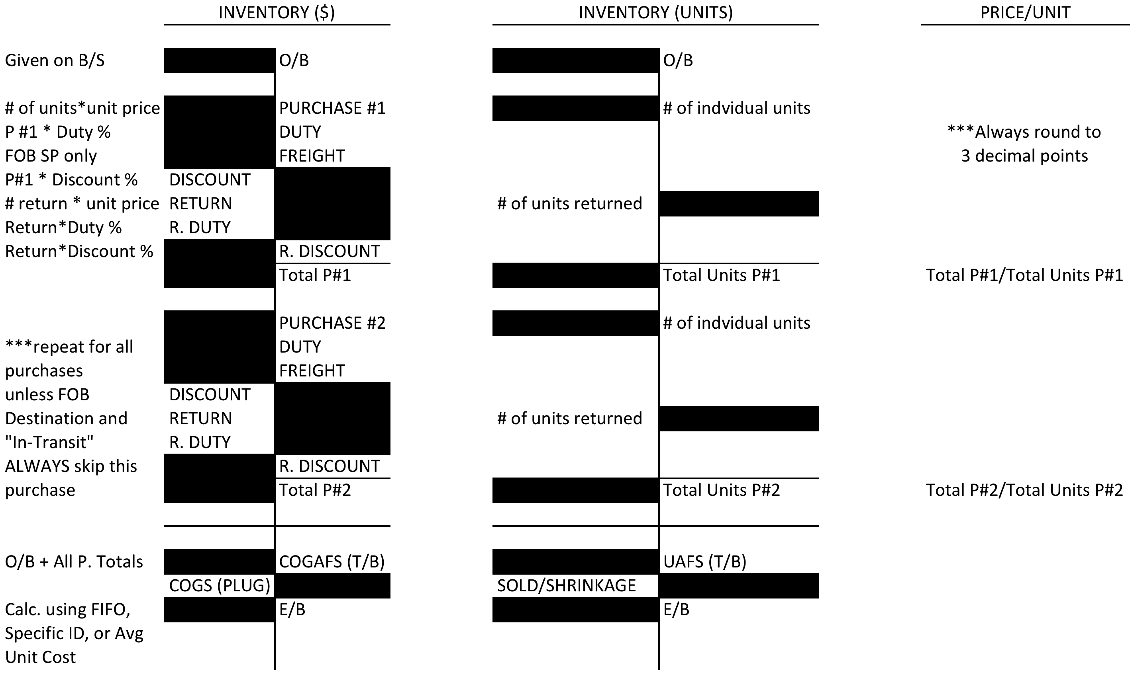

TRANSACTIONS:

- Purchase became part of inventory in the last fiscal period, but was paid for this period
  - To Record a return that happened during THIS period:
Dr Accounts Payable (for the amount of the return)
Cr Inventory (for the amount of the return)
  - To Record a payment that was made in time to receive a discount
Dr Accounts Payable (amount in A/P)
Cr Inventory (for the amount of the discount)
Cr Cash (amount remaining in A/P – the discount)
  - To Record a payment that was NOT made in time to receive a discount
Dr Accounts Payable (amount in A/P, also total purchase price)
Cr Cash (amount in A/P, also total purchase price)

- Purchase became part of inventory this fiscal period and was paid for this fiscal period
Dr Inventory
Cr Cash

- Purchase became part of inventory this fiscal period and will be paid for in the next fiscal period
Dr Inventory
Cr Accounts Payable

INVENTORY VALUATION METHODS

For the following valuation methods, please refer to the example below. All three methods will follow the same example but will calculate a different Ending Balance in Inventory and a different Cost of Goods Sold.
- The case states that a physical count of inventory has been completed and it has revealed that there are 535 units on hand at the end of the year. Purchase #4 was shipped FOB Shipping Point and will not be delivered until after the Fiscal Year End:

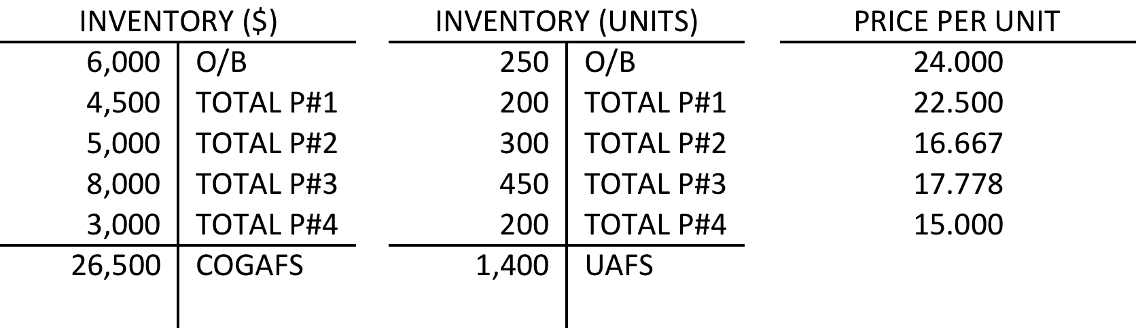

1.) FIFO (FIRST IN FIRST OUT)

- To calculate you ending inventory using FIFO, work backwards up the Inventory T-Account to calculate what the dollar value of ending inventory is
- Ending Inventory in units = units physically in inventory + any FOB Shipping Point Purchases still in transit (these will not be included in the physical count since they will still be on the truck – i.e. you cannot count something that is not physically there)

Ending Balance in Units = 535 units (physically there) + 200 (units in transit P#4)
= 735 units

Purchase #4 ➔ 200 units available, therefore since we are trying to find the value
of 735 units, this purchase must be in the ending inventory in entirety

$3,000

Remaining Units = 735 – 200 units from Purchase #4
= 535 units still to be accounted for

Purchase #3 ➔ 450 units available, therefore since we are still trying to find the
value of 535 units, this purchase must be in the ending inventory in entirety

$8,000

Remaining Units = 535 – 450 units from Purchase #3
= 85 units still to be accounted for

Purchase #2 ➔ 300 units available, therefore since we are still trying to find the
value of 85 units, only a portion of this purchase must be in the ending inventory

85 units * $16.667 = $1414

Total Ending Inventory
=$3000 (P#4) + $8,000 (P#3) + $1,414 (P#2)
=12,414

Cost of Goods Sold:
=Cost of Goods Available for Sale – Ending Inventory
=$26,500 – 12,414
=$14,086

Dr COGS Expense 14,086
Cr Inventory 14,086

2.) SPECIFIC IDENTIFICATION

Something similar to the following chart will be included either in the body of your exam or as an exhibit:

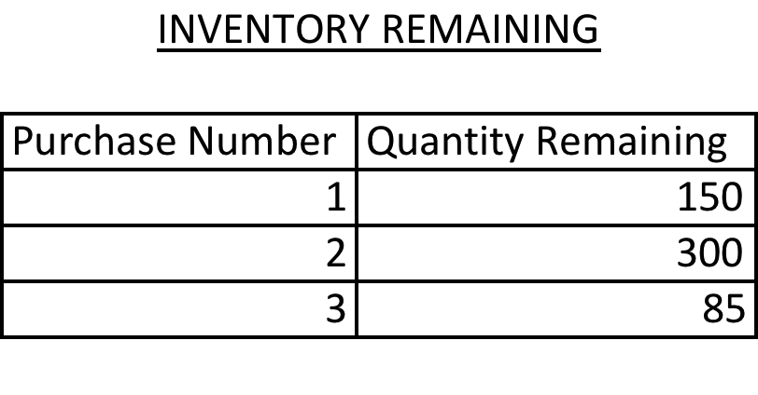
Since Purchase #4 was shipped FOB Shipping Point and will not be delivered until the next fiscal period, this purchase will NOT be included on this exhibit and will need to be added to the ending inventory (cannot count units that are not physically there)

Modify the exhibit in your workbook (always show your work here as they will NOT mark any work that you do on the case itself) to make it look like something similar to this:

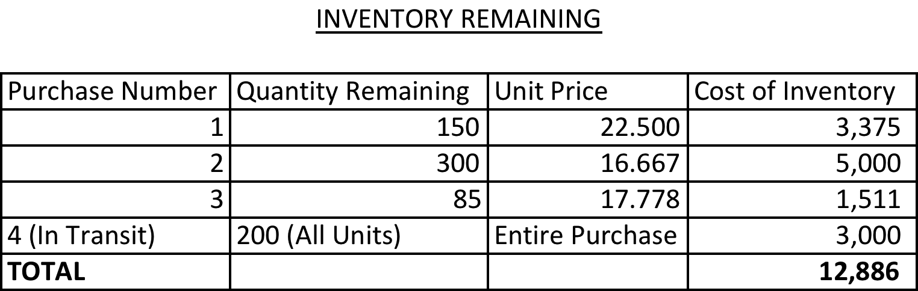

Note:
Purchase #4: DO NOT multiply the number of units by the unit price. Any time you have the ENTIRE purchase in your ending inventory use the dollar figure that you calculated in your Inventory (Dollars) T-Account for this purchase. Since the unit price has been rounded you will end up with a close figure to the number that you calculated for this purchase but it will not be exact. You will end up losing the mark if you do this.

Ending Inventory = 12,886
***This was calculated by adding all of the numbers in the Cost of Inventory column

Cost of Goods Sold:
= Cost of Goods Available for Sale – Ending Inventory
= $26,500 – 12,886
= $13,614

Dr COGS Expense 13,614
Cr Inventory 13,614

3.) WEIGHTED AVERAGE UNIT COST

Average Unit Cost
=COGAFS/UAFS
=$26,500/1,400 units
=18.929 (always round to 3 decimals)

Ending Inventory (Units)
=535 (units physically there) + 200 (units in transit P#4)
=735

Ending Inventory (Dollars)
= Ending Inventory (Units) * Average Unit Cost
=735 units * $18.929
=$13,913

Cost of Goods Sold:
Cost of Goods Available for Sale – Ending Inventory
=$26,500 - $13,913
=$12,587

Dr COGS Expense 12,587
Cr Inventory 12,587

DEPRECIATION FORMULAS

1. Straight Line:

$$\frac{Historical Cost-Residual Value}{Useful Life}*\frac{n}{12}$$

2. Units of Output

$$\frac{Historical Cost-Residual Value}{Useful Life in Units}*\# of units used$$

3. Declining Balance Method

$$(Historical Cost-Accumulated Depreciation)*1/Useful Life*n/12$$

4. Double Declining Balance Method

$$(Historical Cost-Accumulated Depreciation)*2/Useful Life*n/12$$

***When using the Declining Balance Method, or the Double Declining Balance Method you must always check the Net Book Value to ensure that the new amount of depreciation calculated will not cause the New Net Book Value to be lower than the residual Value

$$NBV=Historical Cost-Accumulated Depreciation (Amount in AD account+Depreciation calculated using formula)$$

$$NBV>Residual Value$$

Depreciation calculated will not cause the NBV to go below the Residual Value and the amount calculated can be posted

Dr Depreciation Expense
Cr Accumulated Depreciation


$$NBV<Residual value$$

Depreciation calculated CANNOT be posited because it will cause the NBV to go below the Residual Value

Calculating Allowable Depreciation:

NBV (prior to depreciation calculation) – Residual Value
***Depreciating this amount will cause the NBV to be equal to the Residual Value. In the future if the asset continues to be useful the asset will no longer be depreciated. It is considered to be fully depreciated.

Dr Depreciation Expense
Cr Accumulated Depreciation

FIXED ASSETS

- Recording a Purchase

Dr Asset
Cr Cash/Accounts Payable/Common Shares (however paid for)
***always record at the amount purchased for, not the list price

- Recording a Repair

Dr Repairs Expense
Cr Cash or Accounts Payable (however paid for)

- Recording a Trade-In
  - Step 1: Depreciate Old Asset up until time of trade in

Dr Depreciation Expense
Cr Accumulated Depreciation

  - Step 2: Record the Trade In

Dr New Asset (historical cost)
Dr A/D – Old Asset (O/B in A/D + Amount of Dep’n in Step 1)
Dr Loss on Trade/Cr Gain on Trade (plug)
Cr Old Asset (historical cost)
Cr Cash (H.C. of New Asset – Trade In Allowance)

***Can also calculate the Gain/Loss by comparing the NBV to the trade in allowance
If the NBV > Trade in Allowance… you have a loss
If the NBV < Trade in Allowance… you have a gain
The difference between the NBV and the trade in is your gain or loss

- Recording a Sale
  - Step 1: Depreciate Old Asset up until time of Sale

Dr Depreciation Expense
Cr Accumulated Depreciation

  - Step 2: Record the Sale

Dr Cash (amount received for sale of asset)
Dr A/D – Old Asset (O/B in A/D + Amount of Dep’n in Step 1)
Dr Loss on Sale/Cr Gain on Sale (plug)
Cr Old Asset (historical cost)

***Can also calculate the Gain/Loss by comparing the NBV to the amount received for the sale of the asset
If the NBV > Cash Received… you have a loss
If the NBV < Cash Received… you have a gain
The difference between the NBV and the cash received is your gain or loss

- Recording a Disposal
  - Step 1: Depreciate Old Asset up until time of Disposal

Dr Depreciation Expense
Cr Accumulated Depreciation

  - Step 2: Record the Disposal

Dr A/D – Old Asset (O/B in A/D + Amount of Dep’n in Step 1)
Dr Loss on Disposal (plug)
Cr Old Asset (historical cost)
Cr Cash (cost of disposing of the asset, if applicable)

***Can also calculate the Loss by adding the NBV to the cost of disposing of the asset (if applicable), if not the Loss is just the NBV

INTANGIBLES

- Purchasing an intangible asset
Dr Intangible Asset
Cr Cash

- Amortizing an intangible asset
Dr Amortization Expense
Cr Intangible Asset

- Amortization calculation:
  - If the Intangible was acquired during this fiscal period (n is the number of months from the date of purchase until the end of the fiscal period)

$$\frac{Cost of Acquiring Fixed Asset}{Useful Life}*\frac{n}{12}$$

  - If the Intangible was acquired during a pervious fiscal period (n is the number of months from the date of purchase until the end of the fiscal period, will usually be 12)

$$\frac{Remaining Balance in Intangible Asset T Account}{Remaining Useful Life}*\frac{n}{12}$$

*** the useful life is always the lower of the legal life and the amount of time the company can expect to earn revenues from the intangible asset

NOTE: You cannot capitalize a cost as an intangible asset if it is an internally generated expense (i.e. paying to have a logo designed cannot be capitalized as a trademark).

RESEARCH AND DEVELOPMENT

- Research is ALWAYS an expense

Dr Research Expense
Cr Cash

- Development costs can be capitalized but should not be depreciated until the asset is completely developed and ready for use or brought to market.

Dr Asset Development
Cr Cash

IMPAIRMENT

- Results when the NBV is lower than the Recoverable Amount (this will be given)

  - Step 1: Depreciate asset until the date the recoverable amount is given
Dr Depreciation Expense
Cr Accumulated Depreciation

  - Step 2: Calculate the Impairment (if it exists)
    - If the NBV > RA, impairment exists (find the difference between these two numbers, this is your impairment expense)
Dr Impairment Loss
Cr Accumulated Depreciation
    - If the NBV < RA, no impairment exists, no entry required

OPERATING EXPENSES

- Rent

  - Expiry of Last Year’s Lease
Dr Rent Expense (Amount of months this year * monthly rent)
Cr Prepaid Rent (One month’s rent, found on B/S)
Cr Cash (Rent Expense – Prepaid Rent)

  - Signing a New Lease
Dr Rent Expense (Amount of months this year * monthly rent)
Dr Prepaid Rent (One month’s rent)
Cr Cash (Rent Expense + Prepaid Rent)

- Insurance

  - Expiry of Last Year’s Policy
Dr Insurance Expense (amount given on B/S)
Cr Prepaid Insurance (amount given on B/S)

  - Signing a New Policy
Dr Insurance Expense (amount of months used * monthly rate)
Dr Prepaid Insurance (remaining months * monthly rate)
Cr Cash (Insurance Expense + Prepaid Insurance)

- Salaries/Wages

  - Paying Last Year’s Outstanding wages
Dr Wages/Salaries Payable (Amount found on B/S)
Cr Cash (Amount found on B/S)

  - Paying/Accruing This Year’s Wages
Dr Wages/Salaries Expense (Wages/Salaries Payable + Cash)
Cr Wages/Salaries Payable (Amount Owing)
Cr Cash (Amount Paid)

- Taxes Outstanding from Last Year

Dr Taxes Payable (Amount found on B/S)
Cr Cash (Amount found on B/S)

- Unearned Revenue

  - Money has been collected this fiscal period but work will not be preformed until the next fiscal period:
Dr Cash/Sales Returns & Allowances (if something was return)
Cr Unearned Revenue

  - Money was collected in a previous fiscal period but the work was preformed this fiscal period
Dr Unearned Revenue
Cr Sales
INCOME SUMMARY
C1
 | C2
T/B | NET INCOME
 | C4
T/B
 | C5
 | 0

CLOSING ENTRIES

NET INCOME

- Closing Entry #1: Close all Revenues and Contra Revenues
Dr Revenues (T/B of all revenue accounts)
Cr Sales Discounts (T/B of account)
Cr Sales Returns and Allowances (T/B of account)
Cr Income Summary (Revenues – Sales Returns & Allowances – Sales Discounts)

- Closing Entry #2: Close All Expenses
Dr Income Summary (Sum of all expense accounts)
Cr All Expenses (T/B in each account)

- Closing Entry #3: Record Income Taxes
Dr Income Tax Expense (Net Income * Tax Rate)
Cr Income Tax Payable (Net Income * Tax Rate)

- Closing Entry #4: Close Income Tax Expense
Dr Income Summary (Same amount as C#3)
Cr Income Tax Expense (Same amount as C#3)

- Closing Entry #5: Close Income Summary
Dr Income Summary (T/B in Income Summary)
Cr Retained Earnings (T/B in Income Summary)

INCOME SUMMARY
C1
 | C2
NET LOSS | T/B
C3 | C4
0
NET LOSS

- Closing Entry #1: Close all Revenues and Contra Revenues
Dr Revenues (T/B of all revenue accounts)
Cr Sales Discounts (T/B of account)
Cr Sales Returns and Allowances (T/B of account)
Cr Income Summary (Revenues – Sales Returns & Allowances – Sales Discounts)

- Closing Entry #2: Close All Expenses
Dr Income Summary (Sum of all expense accounts)
Cr All Expenses (T/B in each account)

- Closing Entry #3: Close Income Summary
Dr Retained Earnings (T/B in Income Summary)
Cr Income Summary (T/B in Income Summary)

