CASES

Cases for: The Ethical and Legal Issues Arising out of the Employer-Employee Relationship

1) King v. Biochem
2) Dube v. Volcano
3) Hasanie v. Kaufel
4) Copyfax VS Lambert
5) A.R. Medicom v. Bergeron

Cases for: Contract Law

1) Giroux V. Malik
2) Peter v. Fiasche
3) Carrefour Langelier v. Cineplex Odeon
4) Copiscope v. TRM copy centers

Cases for: Liability, Limitations of Liability and Product Safety

1) Harris v. Ostromogilski
2) Walker v. Singer
3) Farmakis v. Canadian Tire
4) Walford v. Jacuzzi Canada
5) Morse v. Cott beverages

Ethical Articles

1) Ethics in the World of Business: The Relationship of Ethics and Law
2) Framework for Universal Principles of Ethics
3) Resolving Ethical Dilemmas in the Workplace: A New Focus of Career Development

KING VS BIOCHEM THERAPEUTIC INC (PG 29-34)

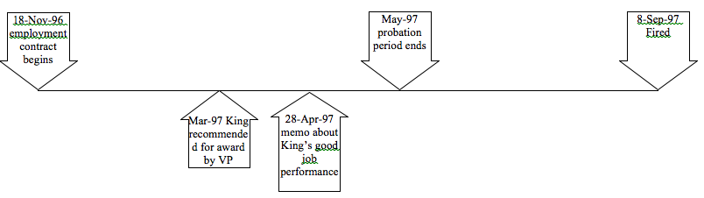
Facts | - Dr. King was hired October 17, 1996  - She was fired less than one year after being hired.  - Biochem says :  - Dr. King was fired after being given due warning for insubordination and lack of respect for fellow EEEs during interactions with them  - Gave her a verbal warning at 5.5 months, and another one month prior to termination  - She should have expected to be fired because of [2094] serious reason (insubordination)  - Good work on research done (contradictory)  - Probationary period terminated early (contradictory)  - Stock options given to King. (contradictory)  - King says:  - She was fired suddenly, no prior warning if being in jeopardy  - It was all because of jealousy and petty complaints, some which were false  - She did not get [2091] reasonable notice
Question | - Did Dr. King deserve to be fired for [2088] cause?  - Had she been warned before hand?
Ratio | Burden of Proof is on EER to explain why King was fired, and to prove that she had been warned  - Argument:  - Recommended for award in March  - Memo about highly satisfactory performance in April, probationary period finished earlier  - Offered stock options in June  = Answer: No [2088] cause for being fired, all the above show contradiction  - Argument: HR Director supposedly verbally warned her, but the witness testifying wasn’t the director who gave the supposed warning so the testimony was hearsay, (HR Director did not take stand)  = Answer: No proof of warning; Person who warned should have been in the witness box. Sending someone else is useless. She was not warned. Employer did not have a serious reason; they tried to make up a serious reason.
Decision | King awarded [2092] indemnity plus interest (also additional [1611] damages) 12 months salary. Rationale is that Biochem recruited King forcing her to leave her current good paying job only to fire her after 10 mths. That’s why she got 12 mths salary.  Total damages received by King = 240,105.41$

Other things to note:

- The Labor Standards Act would not have benefited her so much, because:
- She would have only gotten one weeks salary
- She couldn’t sue for damages

DUBE VS VOLCANO TECHNOLOGIES INC (PG 35-37)

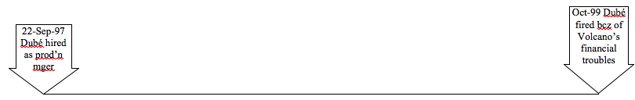
Facts | - Mr. Dube was the plant manager who worked for 26 months  - Due to economic reasons, he, along with 10 other employees, were laid off.  - Dubé received only 2 weeks severance pay, says he deserved [2092] 9 months indemnity including compensation for salary, car allowance, bonuses, moral damages  - Volcano said terms of Dubé’s contract said only 2 weeks notice was necessary
Question | - Are we in an [2090] indeterminate contract?  - Can Volcano [2091] fire Dubé?  - Is economic difficulty a [2094] serious reason for Volcano to fire Dubé?  - Is 2 weeks [2091] reasonable notice?
Ratio | Contract included $75K salary plus car allowance and potential bonus + clause that serious reason or cause for termination will result in only 2 weeks severance pay  - Answer: Yes  - Answer: Yes with [2091] reasonable notice or [2092] indemnity in lieu of reasonable notice  - Answer: No, [2087] it’s not EEE’s fault (Dubé would have received [2094] nothing if fired with serious reason)  - Argument: Dubé signed a contract that said 2 weeks notice was sufficient if fired for serious reason  - Answer: [2092] says you can’t waive your right to [2091] reasonable notice
Decision | Volcano must pay [2092] indemnity in lieu of reasonable notice of 16 weeks salary plus interest (but not the bonuses and car allowance – the bonus was never discussed, and you cant sue for damages because the employer didn’t terminate the contract unjustly, car you don’t need when you’re not doing work.)
Other things to note:

- Big paragraph on pg. 25 says – Your employment with start on Sept 22, 1997, and can be ended at any time by the company for cause, or with a serious reason, with the giving of a notice or indemnity provided in the Labor Standards Act (they said they would pay 2 weeks notice, although they technically don’t have to pay anything under 2094)
- Mr. Dube acknoeleges that its in his contract, but said hes entitled to more than minimum notice, and that hes entitled to reasonable notice under the Civil Code of Quebec (2091).
- Reasonable notice has many elements: time put it, type of work, ranking, age, etc.

HASANIE VS. KAUFEL GROUPE LTD. (PG 38-43)
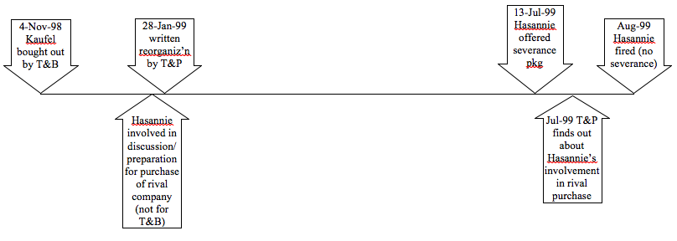

Facts | - Hasannie is a professional (CMA, lawyer), hired as controller, later promoted to director  - His contract was being terminated following a buyout of Kaufel by T&B since his services were no longer needed  - Hassanie is offered 10 months severage, but wanted 12, and it was said that they would discuss it after Hassanie got back from vacation. However, during his vacation time, Thomas and Betts discovered disloyalty (tried to buyout competing co because he knew he was going to be terminated) acts were committed by Hassanie, and instead of being laid off, he was fired for disloyalty (gave him no severance pay) [2087, 2088]  - Hasannie says there was no cause and he deserves severance + damages
Question | - Is T&B required to maintain Hasannie’s contract following the buyout?  - Before they found out about the disloyalty, was T&B required to provide Hasannie with a severance package?  - Did T&B have the right to fire Hasannie without a severance package?
Ratio | - Answer: yes, company was amalgamated but [2097] T&B required to honour terms of employment contracts from Kaufel  - Answer: yes, Hassanie is in a [2090] indeterminate contract and must be offered [2092] indemnity in lieu of [2091] reasonable notice  - Argument: Hasannie did not have permission from new management to personally pursue purchase of the rival company  - Answer: Disloyalty is [2094] serious cause so no [2091] reasonable notice is necessary, and therefore  no severance package is necessary
Decision | T&B wins, not required to pay [2092] indemnity or damages

Other things to note:

- Something about constructive dismissal – something that looks like a resignation(?)

COPYFAX INC VS LAMBERT (PG.44-49)

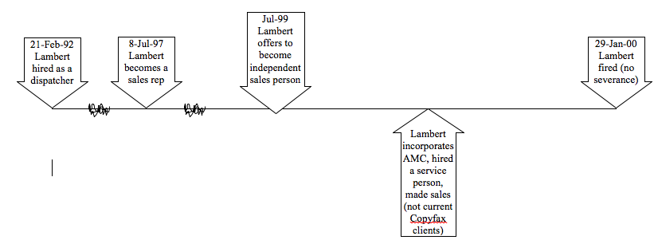
Facts | - Claude Lambert is working for Copyfax, but leaves and want to compete.  - Copyfax had Lambert sign a non-competition clause, so seeking an injunction to prevent Lambert from acting as a salesperson in the photocopier industry.  - The terms of this clause were; cant work within 25 miles of Laval + Montreal, and can’t work in the photocopy industry for 14 months
Question | - Was there [2094] serious reason for Copyfax to fire Lambert  - Should Copyfax be granted an injunction to stop Lambert from acting as a sales person in the industry?  - Should Copyfax be granted an injunction to stop Lambert from using the client list he appropriated?
Ratio | - Answer: yes, disloyalty, Lambert didn’t even contest the firing or ask for [2091] reasonable notice  - Argument: Copyfax says the non-competition clause prevents Lambert from acting as a sales rep. But Lambert appears to have solicited none of Copyfaxes clients. And the [2089] time constraint appears excessive since Copyfax wasn’t attempting to replace Lambert so there’s appears to be a doubtful right for the injunction. And the [2089] geographic limitation appears unclear (epicenter of stated 25 km radius not clear), and even if it was clear the limitations [2089] do not appear reasonable (a huge area covered) therefore there’s further doubtful right for the injunction. Doubtful rights exist therefore we do the Balance of Inconvenience Test:  - If he is allowed to work he would have to pay $6K fee  - If he is not allowed to work he would have to move  For inconvenience, (a) << (b), therefore – Answer: no injunction granted  - Answer: Lambert is obliged to not use any [2088] confidential information from Copyfax for a reasonable time following his dismissal so –  - Answer: injunction granted
Decision | Copyfax denied the interlocutory injunction for Lambert working as a photocopier sales rep, but is granted interlocutory injunction against use of the client list (and Lambert must return the list)

Other things to note:

- This case is not really about a non-competition clause, it’s about an interlocutory injunction (how you enforce a non-competition clause).
* Point in time where you sue *- final judgment
- Between these two points is the trial period (from when you sue to when you get a judgment)

- An injunction is a court order that tells you to do something you’re supposed to be doing, or stop doing something you’re not supposed to do.
Three types of injunctions:
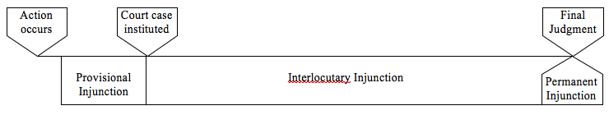
1. Provisional Injunction (AKA “Safeguard Orders”)
- See judge in Chambers (i.e. in his office)
- Judge writes out an order
- Bailiff delivers it
- Only good for 10 days (can be renewed)
*** Granted on the basis of urgency
- Two options following initial grant of a Provisional Injunction:
a. Go to court every ten days to renew (expense)
b. Institute an action: ask for damages and ask for a permanent injunction (+ make a
motion for an interlocutory injunction)

2. Interlocutory Injunction: Issued during a trial to maintain the status quo or preserve the subject matter of the litigation until the trial is over
- Interlocutory Injunction based on two tests, which is decided by the judge:

    - Balance of Inconvenience Test:
- If I don’t grant the injunction and should have, who is harmed?
- If I grant the injunction and I shouldn’t have, who is harmed?
i.e. who will be most inconvenienced?
    - Irreparable Harm: Is the harm irreparable? i.e. money can’t fix it.
e.g. Olympic fencer dropped from Olympic team (can’t pay for the missed
opportunity)
*** Both tests must be passed for Interlocutory Injunction to be granted

3) Permanent Injunction

- You must try to prove:
1) Clear right: Your land VS Georges land.
If you can prove that he is on your land, you have a clear right to the
interlocutory injunction. If you can prove the clear right, you get the interlocutory
injunction, simple.
2) Nonexistent right: George is actually digging on his land, but you think he’s digging on
your land. I thought I had a right, I don’t. You don’t get the interlocutory injunction.

3) Doubtful right – when it’s not clear and not nonexistent - digging in a disputed zone.
Balance of inconvenience test.
Irreparable harm

MEDICOM INC VS BERGERON (PG.49-50)

Facts | - Two employees leave Medicom and have non-competition clauses:  - Bergeron: 2-years world-wide from similar commercial activity/ working for competition  - Hubert: 3-years in Canada from similar commercial activity/ working for competition
Question | - Are the non-competition clauses valid?
Ratio | - Argument: [2089] test for non-competition clause:  - Is the clause in writing? Yes  - Is time/ place/ type of employment stipulated? Yes  - Does the EER have a legitimate interest to stop the former EEEs from working in the industry? Yes (to protect company against competition)  - Are all limitations reasonable? No! Both world-wide and Canada-wide limitations are unreasonable because Medicom serves only the South Shore (a more focused area)  Answer: therefore test not passed
Decision | Neither Bergeron nor Hubert are bound by the clause

Other things to note:

- In both cases, the issue is of restrictive covenants is not only one of non-competition or passing along confidential information, but the two clauses would actually prevent these former employees from working in their chosen fields of work.
- The judge also stated that it cant be a legitimate interest of this employer to so

GIROUX VS MALIK (PG 86-92)
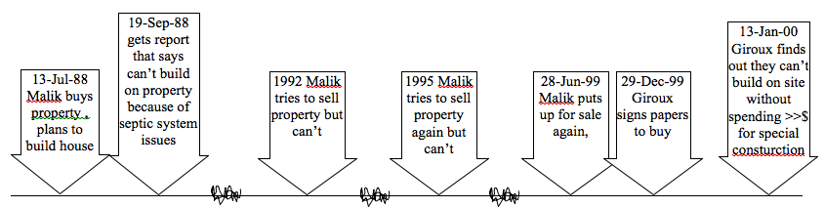
Facts | - Malik buys a house that he cant build on, so he tries to sell.  - Malik informed agents in his 1992 and 1995 sales attempts about issue with building on the land – the land never sold  - Malik less forthcoming with issues in 1999 selling attempt, Giroux buys it, not knowing about the inability to build on it, although when asking Malik if “anything is wrong with the land”, Malik says no.  - Giroux says didn’t know he couldn’t build, now he’s out $40.5k purchase price, had to buy another house (already sold old house), had problems getting kids in school.
Question | 1. Did Giroux know ahead of time that the land was bad?  2. If not, was contract still formed?  3. Are damages allowed?
Ratio | 1. Answer: Judge says no, Malik didn’t tell Giroux (based on evidence presented)  2. Argument: Malik had the obligation to tell, [1375] conduct himself in good faith. Giroux’s consent was [1401] vitiated by Malik’s silence on the building issues.  - Answer: [1407] contract can be annulled or ratified with reduced obligations.  Via [1419] relative nullity, contract was cancelled. But Giroux doesn’t want it ratified since  he can’t even build on it, he wants it cancelled completely.  3. Answer: Contact vitiated by fraud so [1407] damages allowed
Decision | Malik and Giroux placed in their [1422] pre-contractual state (Malik gets land back, Giroux gets money back), damages awarded to Giroux for “great stress and inconvenience”

Other things to note:
- Red herring: agency issue
- If Malik told his agent, then agent and Malik are responsible.
- If Malik didn’t tell his agent, then Malik is still responsible
- Either way, Malik is responsible
- Giroux is asking for cancellation of contract based on fraud, since his consent was vitiated.
- Malik’s counter: “I didn’t tell you anything, how can I defraud?”
- [1401] = fraud may result from silence or concealment
- Principle is liable for wrongful acts of agent third party can cancel contract
- Argued that the agent didn’t tell Giroux

PETER VS FIASCHE (PG 93-105)

Facts | - Gucciardo and Fiasche are longtime acquaintances  - Gucciardo’s losing his job, hears that Fiasche is selling his restaurant  - Gucciardo mortgages his house to buy into restaurant , Fiasche says his restaurant makes money with a special scheme, shows Gucciardo the scheme (faking receipts to show lower income and pay less taxes) once $100k deposit received  - Tax auditor visits restaurant while Gucciardo’s taking over, Fiasche says don’t worry she’s just there to check cash register  - Gucciardo’s losing money from onset, Fiasche says don’t worry, will pick up but business never does  - Gucciardo says I want out, I want my money back, and Fiasche says “what money?”  - Gucciardo sues because there not as much money in it as was said by Fiasche
Question | 1. Should contact be annulled because consent vitiated by G’s error?  2. Does contract exist?  3. Should G receive damages?
Ratio | 1. Argument: G’s consent was [1400] vitiated by the error of believing F’s claims about inflated income  - Answer: The error of G’s believing F’s claims was inexcusable because of conscious wrongful choice (there’s no way he didn’t know that tax evasion was the root cause of this special scheme for >> income than shown on the financial statements), and [1400] only excusable errors can result in vitiation of consent  2. Argument: The [1410] cause of the contract (reason why G’s contracting) is to buy a restaurant and make money through illegal tax evasion  - Answer: [1411] an illegal contract is null, so it’s as if [1418] there never was a contract in the first place (absolute nullity)  3. Answer: contract never existed, therefore no obligations were produced under the contract, therefore no damages
Decision | Judge says the contract never existed, but requires Fiasche to pay back the $100k*, but doesn’t Gucciardo doesn’t receive damages

- A judge can do two things when a contract has been annulled:
#1: Act in equity (in fairness): There’s no contract, but it’s not fair to leave Fiasche with the restaurant and Gucciardo’s $100k, so F must give the $100k back | #2: Dismiss the plantiff and defendant and let them do whatever they want to settle it

Other things to note:
- The judge gives the judgment in equity, saying that “you should not be allowed to benefit from your wrongdoing, must give 100k back”, but he could have easily said “fuck off, this is an illegal contract in the first place”.
- Judge says that Gucciardo was “willfully blind” and that this was an inexcusable error
- “Error was inexcusable since G’s misperception of reality arose from closing his eyes to
the risk he was running”
- “Conscious wrongful choice”

CARREFOUR LANGELIER VS CINEPLEX ODEON CORP. (PG. 106-114)

** About performance of contract, how do we enforce performance of a valid contract?
Facts | - Langelier (lessor/landlord) contracts with Cineplex (lesee) (first contract: lease)  - Before Cineplex is supposed to move in, it subleases the theatre to Guzzo (second contract: sub-lease)  - Before sub-lease can occur, have to tell the landlord, but the landlord wanted Cineplex, so he says no problem, we can sublease, but Guzzo has to operate as Cineplex Odeo.  - Guzzo agreed; offered to run it as Cineplex, signs agreement  - One year later, Guzzo takes down Cineplex signs and puts up Guzzo signs  - Landlord says no, must remain Cineplex Odeon  - Guzzo says no  - Landlord wants a permanent injuction, asks for a “specific performance order.” This order will order Guzzo to specifically operate as a Cineplex.
Question | 1. Should the contract be annulled?  2. Guzzo says not a case [1601] which admits of specific performance (because there is no damage)
Ratio | 1. Argument: Guzzo’s defenses:  a) Says it was under duress when signed, was “fearful,” and consent was [1403]  vitiated by fear, so contract should be [1418] annulled.  - Answer: Judge says no more fear experienced than any other business  (subjective not objective fear) so [1403] can’t be used to vitiated consent. Also  states that if this is true, the contract is nulled due to defective consent, and  therefore the obligation to operate as a Cineplex is canceled, and so there is no  lease; so Carrefour is going to have to give the lease to Cineplex anyways; not  the type of fear that will affect your consent.  b) Signature under false pretenses  c) Misrepresentation of facts: They say that the landlord lied to us, misrepresented  the facts.  - Answer: Judge says maybe theres embellishment, but Mr. Guzzo you’re a savy  businessman, and the misrepresentation (if present) is very small, certainly not  enough to warrant cancellation of the contract – maybe a small reduction in  rent.  So the contract is valid; obligations are valid, so technically, under [1458], Guzzo must perform according to the contract. HOWEVER, they are not done – they attack the ability to ask for specific performance  2. Argument: Specific performance is not allowed when:  i. Obligation has become impossible to perform (e.g. snow shoveller has a stroke, so can’t continue)  ii. The time in which to perform the obligation has elapsed (e.g. a Celine Dion concert, if she refuses to perform  for some reason, once the concert date/time has passed it’s too late)  iii. The property has perished (e.g. ship sunk at sea)  iv. The property has left the patrimony (e.g. no longer own the Lada)  Answer:  - Impossible means absolutely impossible, therefore not applicable here  - Time elapsed? No, because lease = successive performance  - Property perished? No  - Property left patrimony? No  Therefore case does admit specific performance of the obligation.  “Specific performance is a remedy separate from that of reparation” – therefore do not need to prove damages to get a permanent injunction, only need to prove only need to prove the obligation promised must be performed & specific performance is “admit”able
Decision | Injunction granted, Guzzo must operate as Cineplex Odeon

COPISCOPE INC. AND TRM COPY CENTERS (PG. 115-120)

Facts | - Copiescore had a contract with their clients for 1 year, and if the contract is NOT renewed, there is a non-competition clause (have  - Clause states that if the contract was not renewed, then the store is not allowed to put a photocopier from another company within a 25 mile radius in your store  - This basically forces the company to keep putting photocopiers from  copiescore (pretty much monopolizes your business)  - Copiescope starts going after TRM (competitor) customers, and gets some of them.  - TRM tries to get an an interlocutary injunction against Copiescope to prevent Copiescope from encroaching on TRM’s business (placing photocopiers in convenience stores, etc.) because of a non-competition clause TRM made the business owners sign; TRM said stop bothering my clients  - Copiescope appeals the injunction
Question | 1. Is a clause of the contract [1437] abusive and therefore to be annulled? (for consumer and adhesion contracts)
Ratio | 1. Argument: contract is one of [1379] adhesion (business owners couldn’t negiotiate terms), and non-comp clause is [1437] abusive because likely no real “trade secrets” and conditions for business-owners too strict. Answer: excessive non-comp clause means [1437] the clause is annulled, so the non-comp clause falls too because it hinged on this abusive portion; and since the injunction was based on the non-comp clause there are no longer grounds for injunction without the clause
Decision | No apparent right for injunction and appeal is successful (Copiescope can sell again)

Other things to note:

- Not the same type of non-competition clause we saw in employment law
- Business non-comp clauses also have regional, type, time, business restrictions, but are
generally for longer periods of time
- TMR tries to get injunction:
- Judge says the type of contract is a contract of adhesion (you cannot negotiate terms, take it or leave it contract). Clauses which are abusive are deemed not written when you enter into adhesion or consumer contract.
The judge says what kind of trade secret did you give? This clause is abusive, and
its in a contract of adhesion so you cant rely to get an injunction.

HARRIS VS OSTROMOGILSKI (PG.124-127)

Facts | - H is leasing a cab from O  - There was an altercation when H went to O’s house to pay the rent for the cab  - H says O beat the crap out of him  - O says he didn’t do that, that H slipped and fell  - H is suing for damages
Question | 1. Is there fault?  2. Is the cause immediate and direct?  3. Is there damage?  4. Are there compensatory damagers paid?  5. Are there punitive damages paid?
Ratio | Argument:  1. Judge believes that O did beat up H (significant injuries indicate more than a slip and fall), and it’s a fault (breach of law) to beat someone up  2. Injuries are immediate and direct cause of beating  3. Yes = damage  Answer: [1457] All three therefore there is civil liability  4. [1457] H received compensation for bodily, moral, and material damages  5. [49] (p.6) says potential for punitive damages when illegal and intention action, so punitive damages warranted in this case – but O already punished in criminal trial, so [1621] no need for punitive damages
Decision | O pays H compensatory damages (not punitive)

Other things to note:

- You must link the fault-cause-damage
- Understand that if you’re punished once, you can’t be punished again
- Harris is also asking for punitive damages against O. These are not awarded because O
has already been conviceted in criminal court of assault and has been punished in criminal
court, you cant punish a person twice for the same act.
- In order to be considered to get punitive damage, there must be a charter violation (which there was), but as mentioned, O was already convicted in a criminal court, so he was already punished.
- Criminal trial has two stages:
1. Verdict: Guilty or not guilty
2. Sentencing: From 0$ - X$ fine, and/or jail time
O was sentenced to jail time, his punishment that prevented H from receiving
punitive damages.

WALKER VS SINGER (PG.128-133)

Walker = man
Singer = woman
Facts | - Walker meets Singer , he moves in with Singer  - According to walker, Singer aseked her to sign a document about a phony work opportunity, he refused, and singer became upset.  - On July 28, 1989 – Singer was told she was pregnant, mentions it to walker, gets abortion the same day.  - On July 29, 1989 – Walker is away, and Singer goes into hi room and destroys clothes belonging to him  - According to Walker, singer admitted it and promised to make good for it  - Singer is kicked out by landlord (Zito)  - Walker notices that’s some of his clothes are missing, reports incident to police, took pictures of damages  - August 2, 1989 - Walker sues Singer after the cops get her story (criminal complaint)  - April – Singers lawyer called the cops to say that Singer wanted to file a sexual assault complaint against Walker.  - She alleged to have been assaulted on June 26, 1989 and beaten on July 21  - Case was not even brought to court because accusation had no substance  - Walker sues Singer for false accusations: She is convicted but gets an unconditional distcharge… so not really punished (just punitive damages)  - Walker sues her in Civil Liability court for:  - Material damages (clothes)  - Moral damages (reputation – punitive damages)
Question | 1. Is there fault?  2. Is there damage?  3. Is the cause immediate and direct?  4. Are there compensatory damagers paid?  5. Are there punitive damages paid?
Ratio | Argument:  1. Fault = false accusation  2. Damage = every time Walker starts dating he must reveal sexual assault charge to woman, ends relationship  3. Cause = her lie, it’s the immediate and direct cause of the damage  Answer: All three therefore [1457] civil liability  4. [1435] Compensation for moral damages (7000$)  5. Punitive damages (3000$) warranted per [49] and awarded because no punishment in criminal case (no sentence/fine)
Decision | Singer pays Walker compensatory and punitive damages

FARMAKIS VS CANADIAN TIRE CORP. (PG.134-137)

Facts | - Mr. Farmakis decides that he’s going back to Greece to retire  - Before he goes there, he buys a step ladder at Canadian Tire and ships it to Pearson Int. in Athens; waits for ladder there  - He’s renovating his home, and after ~1.5 hours of renovations her falls and breaks his heel  - Comes back to Canada for medical treatment, but first goes to see a lawyer; lawyer says “get me the ladder”  - Ships ladder back to Canada, gets an expert  - Expert examines ladder, says there’s a pre-purchase defect  - Farmakis sues; claims lack of warnings on the ladder; pre-purchase defect
Question | 1. Was there a defect in the product?  2. Was there sufficient indication of attendant dangers of using ladder?
Ratio | 1. Argument: Expert says ladder was defective when it was purchased.  - Answer: no way to prove the defect was pre-purchase after years of ownership and globe-trotting undergone  by ladder  2. Argument: Farmakis says there weren’t [1469] sufficient warning labels on ladder, claimed there originally were three stickers, but only kept two of them. Ladder displays evidence of there being four labels originally (four areas where there was adhesive – looked like there were four stickers)  - Answer: four labels indicates it appears there [1473] was sufficient indication of dangers and Farmakis known or could have known about these dangers  Either way, this doesn’t matter because the cause of the injury was the man, not the ladder – warning  labels are only needed when risk is significant, or danger is very obvious – a ladder is at the low end of  the spectrum in terms of needing a warning
Decision | Farmakis loses suit – no damages awarded

WALFORD VS JACUZZI CANADA (PG.138, HANDOUT)

First instance (book):

Facts | - Family buys a 4-foot deep above-ground pool, 3 ft of water  - They then buy a 10-foot slide  - Mom warned her daughter not to go down the slide face-first, idiot you’ll break your neck  - Stupid girl slides down head-first and breaks her neck, became a quadriplegic  - Girl’s dad sues Jacuzzi because didn’t warn you couldn’t put a 10-foot slide in a 4-foot pool,  - Girl’s dad also sues Pioneer (store) because didn’t advise not to put the slide and pool together  - Also lack of labels
Question | 1. Is there a fault?  2. Is the fault direct and immediate cause of the damage?
Ratio | 1. Answer: Fault = daughter’s, sliding down head-first (she’s [1473] endowed with reason, so she should know better and heed her mother’s warnings)  2. Answer: Daughter’s fault (didn’t listen to momma) was the immediate and direct cause of the damage  (There was also fault on the part of Jacuzzi because there didn’t warn (lack of labels), but this was not the direct and immediate cause of the injury – the girl’s fault was the direct and immediate cause)  All under [1457]
Decision | “not guilty” – no damages awarded
They then Appeal (Handout):
- The court of appeal judge says there is a fault – salesperson at Jacuzzi for not having warned = 75% of damages covered by Jacuzzi

MORRIS VS COTT BEVERAGES WEST LTD (PG. 139-146)

Facts | - Morris woman gets of Cott Beverage, can’t twist cap off of 2-litre pop bottle, so she uses a nutcracker to open it  - Bottle cap pops off, hits her in the eye, she loses consciousness  - Experiences significant damage to eye, lasts for a prolonged period of time  - She hires a lawyer, lawyer takes a look at Cott’s capping process, finds that:  - Cott has a manual on appropriate capping regulations (says don’t cap at >15 lbs of torque)  - Cott changed from recommended 13lbs to 20lbs to avoid spoilage (at 13lbs, caps were popping off in storage, raised the torque to prevent this spoilage)  - Girl sues – she got a hold of a very torqued bottle
Question | 1. Was there fault  2. Was there damage  3. Was the fault the direct and immediate cause of the damage?  4. Should there be compensatory damages?  5. Should there be punitive damages?
Ratio | Answer:  1. fault = not following recommended way to use machine,  2. damages = yes  3. yes = the fault was the direct and immediate cause of the eye injuries.  All under [1457]  4. [1457] Compensatory damages for bodily injury  5. Section 28(1) of Consumer Products and Warranties act says can collect punitive damages if willful and knowing violation of act, this is the case for Cotts so damages awarded
Decision | Compensatory and punitive damages to Morse

Other things to note:
- It was gross negligence on the part of the beverage company; bottle company was aware of the danger (safety defect)
Bottle was too hard to open and was therefore defective because it did not do what it was meant to do
- Court found them liable - didn’t even find her partially liable for using the nut cracker
- Awarded 18,000 in moral damages
- 36,000 punitive damages (in Saskatchewan? Gross negligence)

