Chapter 7 – Human Memory

semantic memory – memory for general information
episodic memory – memory for personal events

Three key processes involved in memory:
- ENCODING: involves forming a memory code (getting information in)
- the next-in-line effect (will not remember what the person before them said because they are too focused on rehearsing what they will say next)
- STORAGE: involves maintaining encoded information in memory over time
- RETRIEVAL: involves recovering information from memory stores (getting it out)

ATTENTION: involves focusing awareness on a narrowed range of stimuli or events (and filtering out other stimuli) (i.e. filtering out conversations happening around you, until you hear your name)
- when people are forced to divide their attention between memory encoding and some other task, large reductions in memory performance are seen
- similarly, when people divide their attention between tasks, they are actually switching their attention back and forth, thus losing some of the performance skill for each

difference in how people attend to information are the main factors influencing how much they remember. different rates of forgetting occur because some methods of encoding create more durable memory codes than other

Incoming information can be processed at different levels

Verbal Information:
- Structural Encoding – relatively shallow processing that emphasizes the physical structure of the stimulus (how they were printed, length of word)
- Phonemic Encoding – emphasizes what a word sounds like; naming or saying the words
- Semantic Encoding – emphasizes the meaning of verbal input; thinking about the objects and actions the words represent

LEVELS-OF-PROCESSING THEORY: proposes that deeper levels of processing result in longer-lasting memory codes

DUAL-CODING THEORY: holds that memory is enhanced by forming semantic and visual codes, since either can lead to recall

ENCODING
- enriched by:
- ELABORATION: linking a stimulus to other information at the time of encoding (i.e. applying your fear of spiders to classical conditioning)
- VISUAL IMAGERY: the creation of visual images to represent the words to be remembered (easier when the word refers to a concrete object rather than an abstract concept)
- SELF-REFERENT ENCODING: involves deciding how or whether information is personally relevant (making material meaningful)

STORAGE
- enriched by:
- SENSORY MEMORY: preserves information in its original sensory form for a brief, usually only a fraction of a second; allows the sensation of a visual patter, sound, or touch to linger for a brief moment after the sensory stimulation is over (afterimage); lasts for less than a second
- SHORT TERM MEMORY (STM): a limited-capacity store that can maintain unrehearsed information for up to about 20 seconds
  - information can remain in your STM by REHEARSAL: the process of repetitively verbalizing or thinking about the information
  - “Working Memory” – plays a role in complex cognitive processes
    - Phonological Loop – recitation to temporarily remember a phone number
    - Visuospatial Sketchpad – permits people to temporarily hold and manipulate visual images
    - Central Executive System – controls the deployment of attention, switching the focus of attention and dividing attention as needed; coordinates the actions of the other modules
    - Episodic Buffer – allows the various components of working memory to integrate information; serves as an interface between working memory and long-term memory
  - durability: loss of information from short-term memory is due to time-related decay of memory traces and by interference from competing material
  - capacity: can be increase by combining stimuli into larger, possibly higher-order units called CHUNKS: group of familiar stimuli stored as a single unit
- LONG-TERM MEMORY (LTM): an unlimited capacity store that can hold information over lengthy periods of time (can store information indefinitely/ permanently)
  - FLASHBULB MEMORIES: unusually vivid and detailed recollections of momentous events (i.e. remembering where you were and what you were doing when you found out about 9/11)

Organizing Knowledge in Memory

CLUSTERING – the tendency to remember similar or related in groups (factual information is routinely organized into simple categories)

CONCEPTUAL HIERARCHY – a multilevel classification system based on common properties among items (which improve recall dramatically)

SCHEMAS – an organized cluster of knowledge about a particular object or event abstracted from previous experience with the object or event
- people are more likely to remember things that are consistent with their schemas than things that are not
- people sometimes exhibit better recall of things that violate their schema-based expectations (attracts attention)

SEMANTIC NETWORK – consists of nodes representing concepts, joined together by pathways that link related concepts (explains why thinking about one word can make a closely related word easier to remember)

CONNECTIONIST (PARALLEL DISTRIBUTED PROCESSING) (PDP) MODELS: assume that cognitive processes depend on patterns of activation in highly interconnected computational networks that resemble neural networks (simultaneous processing of the same information that is spread across networks of neurons); assert that specific memories correspond to particular patterns of activation in these networks

RETRIEVAL
- TIP-OF-THE-TONGUE PHENOMENON: the temporary inability to remember something you know, accompanied by a feeling that it’s just out of reach (often retrieval cues will help us gain access to memories)
- ENCODING SPECIFICITY PRINCIPLE: your memory for information would be better when the conditions during encoding and retrieval were similar
- CONTEXT CUES: trying to recall an event by putting yourself back into the context in which is occurred (i.e. going into a room to get something, forgetting, returning to the original room, remembering)
- STATE- AND MOOD-DEPENDENT EFFECTS: matching the person’s internal state of encoding at the retrieval phase (i.e. studying while intoxicated, remember more when intoxicated)
- MISINFORMATION EFFECT: occurs when participants’ recall of an event they witnessed is altered by introducing misleading post-event information
- SOURCE MONITORING: the process of making attributions about the origins of memories (i.e. what newspaper you read something in)
- SOURCE-MONITORING ERROR: occurs when a memory derived from one source is misattributed to another source
- CRYPTOMNESIA: inadvertent plagiarism that occurs when people come up with an idea that they think is original, when they were actually exposed to it earlier
- REALITY MONITORING: refers to the process of deciding whether memories are based on external sources (one’s perceptions of actual events) or internal sources (one’s thoughts and imaginations); when they reflect on whether something actually happened or they only thought about it happening

Forgetting
- adaptive, to get rid of the clutter, reduce competition among memories that can cause confusion, irrelevant information
- helped subjects remember the information they need to remember
- can be caused by defects in encoding, storage, retrieval or a combination

FORGETTING CURVE: graphs retention and forgetting over time (established by Hermann Ebbinghaus)

RETENTION: refers to the proportion of material retained (remembered)

Methods used to measure forgetting:
- RECALL: measure of retention requires subjects to reproduce information on their own without any cues (i.e. memorizing 25 words and writing them down)
- RECOGNITION: measure of retention requires subject to select previously learned information from an array of options (writing down 25 memorized words out of 100; multiple choice); tends to yield higher scores than recall measures
- RELEARNING: measure of retention requires a subject to memorize information a second time to determine how much time or how many practice trials are saved by having learned it before

Why we forget:
INEFFECTIVE CODING: often referred to as pseudoforgetting due to a lack of attention (i.e. people assume they know what a penny looks like, but most have actually failed to encode this information)
DECAY THEORY: proposes that forgetting occurs because memory traces fade with time (the mere passage of time produces forgetting, yet no proof that decay caused LTM forgetting)
INTERFERENCE THEORY: proposes that people forget information because of competition from other material (greatest when material is similar to one another)
RETROACTIVE INTERFERENCE: occurs when new information impairs the retention of previously learned information (between the original learning and the retest)
PROACTIVE INTERFERENCE: occurs when previously learned information interferes with the retention of new information (rooted in learning that comes before exposure to the test material)
RETRIEVAL FAILURE: may be more likely when a mismatch occurs between retrieval cues and the encoding of the information you’re searching for (i.e. sound of the word and phonemic cues)
ENCODING SPECIFICITY PRINCIPLE: the value of a retrieval cue depends on how well it corresponds to the memory code
TRANSFER-APPROPRIATE PROCESSING: occurs when the initial processing of information is similar to the type of processing required by the subsequent measure of retention
MOTIVATED FORGETTING (REPRESSION): keeping distressing thoughts and feelings buried in the unconscious (i.e. embarrassing, unpleasant, or painful memories)
- often people may believe they have had a repressed memory when really it is not true (often the product of suggestion in hypnosis)

LONG-TERM POTENTIATION (LTP): a long-lasting increase in neural excitability at synapses along a specific neural pathway (opposite of long-term depression)

AMNESIA
RETROGRADE AMNESIA: involves the loss of memories for events that occurred prior to the onset of amnesia
ANTEROGRADE AMNESIA: involves the loss of memories for events that occur after the onset of amnesia

CONSOLIDATION: a hypothetical process involving the gradual conversion of information into durable memory codes stored in long-term memory

IMPLICIT MEMORY: apparent when retention is exhibited on a task that does not require intentional remembering (incidental, unintentional remembering) (unconscious; must be assesse indirectly with variations on relearning)

EXPLICIT MEMORY: involves intentional recollection of previous experiences (conscious; assessed directly with recall or recognition)

It is believed that these memories are different because they rely on different cognitive processes in encoding and retrieval, or that they are handled by independent memory systems

DECLARATIVE MEMORY SYSTEM: handles factual information (recollections of words, definitions, names, dates, faces, events, concepts, ideas) knowing the rules of tennis

EPISODIC MEMORY SYSTEM: made up of chronological, or temporally dated, recollections of personal experiences (i.e. first kiss) “re-experience the past and pre-experience the future” [an autobiography]

SEMANTIC MEMORY SYSTEM: contains general knowledge that is not tied to the time when the information was learned (i.e. Christmas is December 25, dogs have 4 legs) [an encyclopedia]

NONDECLARATIVE OR PROCEDURAL MEMORY: houses memory for actions, skills, operations, and conditioned responses (i.e. how to ride a bike, typing, tying shoes) having the skills to play tennis

PROSPECTIVE MEMORY: involves remembering to perform actions in the future (i.e. walk the dog, turn off sprinkler, and buy tickets)

Time-Based Task: require that an action be performed at a certain time or after a certain length of time has elapsed

Event-Based Task: involve future actions that should be triggered by a specific cue (easier to remember than time-based tasks)

RETROSPECTIVE MEMORY: involves remembering events from the past or previously learned information (i.e. who won the Stanley Cup last year, what your professor said)

(Chapter 7 Recap on Page 325-326 of textbook)

Chapter 8 – Language and Thought

COGNITION: the mental processes involved in acquiring knowledge

LANGUAGE: consists of symbols that convey meaning, plus rules for combining those symbols, that can be used to generate an infinite variety of messages
- symbolic – people use spoken sounds and written words to represent objects, actions, events and ideas
- semantic – they have shared meanings
- generative – limited number of symbols can be combined in an infinite variety of ways to generate an endless array of novel messages
- structured – rules to govern the arrangement of words into phrases and sentences

Hierarchical Structure
PHONEMES: the smallest speech units in a language that can be distinguished perceptually (humans capable of recognizing only about 100 such basic sounds, pronunciations)

MORPHEMES: the smallest units of meaning in a language (approx 50 000 English morphemes, includes roots words, prefixes, suffixes)

SEMANTICS: area of language concerned with understanding the meanings of words and word combinations (includes denotation, dictionary definition, and connotation, emotional overtones and secondary implications)

SYNTAX: a system of rules that specify how words can be arranged into sentences; underlie all language use (i.e. sentences must have subject and verb)

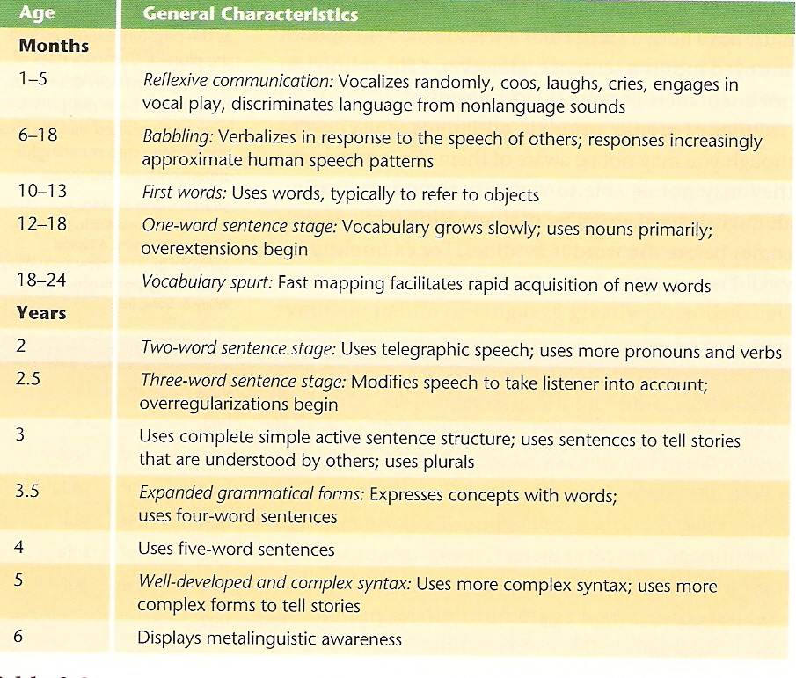
18 months: receptive vocabulary larger than productive vocabulary
6 to 8 years: children understand irony and sarcasm

FAST MAPPING: the process by which children map a word onto an underlying concept after only one exposure

OVEREXTENSION: occurs when a child incorrectly uses a word to describe a wider set of objects or actions than it is mean to (i.e. word ‘ball’ for anything round)

UNDEREXTENSION: occurs when a child incorrectly uses a word to describe a narrower set of objects or actions than it is meant to (i.e. word ‘doll’ for a single, favourite doll)

TELEGRAPHIC SPEECH: consists mainly of content words; articles, prepositions, and other less critical words are omitted (i.e. “give doll” rather than “please give me the doll”)

OVERREGULARIZATIONS: occur when grammatical rules are incorrectly generalized to irregular cases where they do not apply (i.e. I hitted the ball; girl goed home)

BILINGUALISM: the acquisition of two languages that use different speech sounds, vocabulary, and grammatical rules

ACCULTURATION: the degree to which a person is socially and psychologically integrated into a new culture

Theories of Language Acquisition
- Behaviourist – B.F. Skinner; centers on the nature versus nurture issue; argued that environmental factors govern language development; learn language through imitation, reinforcement, and other principles of conditioning; parents encourage correct meaning and pronunciation
- Nativist – Noam Chomsky; idea that children learn the rules of language, not specific verbal responses; humans have an inborn or ‘native’ propensity to develop language; LANGUAGE ACQUISITION DEVICE: an innate mechanism or process that facilitates the learning of language
- Interactionist – biology and experience both make important contributions to the development of language
  - cognitive theories – language development is simply an important aspect of more general cognitive development (which depends on maturation and experience)
  - social communication – functional value of interpersonal communication and the social context in which language evolves
  - emergentist theories – argue that neural circuits supporting language are not prewired but emerge gradually in response to language learning experiences

LINGUISTIC RELATIVITY: the hypothesis that one’s language determines the nature of one’s thought

PROBLEM SOLVING: refers to active efforts to discover what must be done to achieve a goal that is not readily attainable

Types of Problems
- Problems of Inducing Structure – require people to discover relationships among numbers, word, symbols, or ideas (i.e. Lawyer: Client:: Doctor:: Patient, ABMCDMEF)
- Problems of Arrangement – require people to arrange the parts of a problem in a way that satisfies some criterion (i.e. rearrange letters to form a word)
INSIGHT: the sudden discovery of the correct solution following incorrect attempts based primarily on trial and error
- Problems of Transformation – require people to carry out a sequence of transformations in order to reach a specific goal, often you know what the goal is, but not how to achieve it (i.e. hobbits and orcs problem)

Barriers to Effective Problem Solving
- IRRELEVANT INFORMATION: often problems contain irrelevant information that leads people astray (people often assume all numerical information is crucial to solving a problem)
- FUNCTIONAL FIXEDNESS: the tendency to perceive an item only in terms of its most common use (using a tool as something other than for building, i.e. as a weight); young children less vulnerable to this
- MENTAL SET: exists when people persist in using problem-solving strategies that have worked in the past (often expertise in a certain area can backfire; get in a rut)
- UNNECESSARY CONSTRAINTS: people often make assumptions that impose unnecessary constraints on problem-solving efforts

Approaches to Problem Solving
- PROBLEM SPACE: refers to the set of possible pathways to a solution considered by the problem solver (people must choose from among a variety of conceivable pathways or strategies in attempting to solve problems)
TRIAL AND ERROR: involves trying possible solutions and discarding those that are in error until one works (sometimes systematically)
ALGORITHM: a methodical, step-by-step procedure for trying all possible alternatives in searching for a solution to a problem (i.e. writing out all possible arrangements for a jumble of letters until you form a word)
HEURISTIC: guiding principle or “rule of thumb” used in solving problems or making decisions
- Forming Subgoals (intermediate steps towards a solution; i.e. tower of Hanoi problem)
- Working Backwards
- Searching for Analogies (similarities between problems; people don’t focus on underlying structure of problems)
- Changing the Representation of the Problem (verbally, mathematically, spatially)

FIELD DEPENDENCE-INDEPENDENCE: refers to individuals’ tendency to rely primarily on external (dependent; focus on total context of a problem rather than zeroing in on specific aspects) versus internal (independent; focus on specific features of a problem and reorganize it) frames of reference when orienting themselves in space

Holistic Cognitive Style – focuses on context and relationships among elements in a field
Analytic Cognitive Style – focuses on objects and their properties rather than context

DECISION MAKING: involves evaluating alternatives and making choices among them (most people try to be systematic and rational)

THEORY OF BOUNDED RATIONALITY: asserts that people tend to use simple strategies in decisions making that focus on only a few facets of available options and often result in “irrational” decisions that are less than optimal

- People suffer from choice overload and often have increased stress or regret when making decisions

Making Decisions
Additive Strategy: list the attributes that influence decisions and rate each attribute on desirability
Elimination by Aspects: gradually eliminating less attractive alternatives by evaluating them on each attribute or aspect in turn

RISKY DECISION MAKING: involves making choices under conditions of uncertainty (people often try to figure out the expected value in these cases)
Subjective Utility: represents what an outcome is personally worth to an individual

AVAILABILITY HEURISTIC: involves basing the estimated probability of an event on the ease with which relevant instances come to mind (i.e. divorce rate, thinking of friends’ parents)

REPRESENTATIVE HEURISTIC: involves basing the estimated probability of an event on how similar it is to the typical prototype of that event (i.e. more likely of getting all Heads in a coin toss, or a variation; technically the odds are the same)

- People also tend to ignore base rates

CONJUNCTION FALLACY: occurs when people estimate that the odds of two uncertain events happening together are greater than the odds of either event happening alone (yet the probability of being in a subcategory cannot be higher than the probability of being in the broader category)

Understanding Pit Falls in Reasoning about Decisions

- THE GAMBLER’S FALLACY: the belief that the odds of a chance event increase if the event hasn’t occurred recently
- THE LAW OF SMALL NUMBERS: people assume that results based on small samples are representative of the population (yet results based on small samples are more variable and more likely to be a fluke)
- OVERESTIMATING THE IMPROBABLE: people tend to greatly overestimate the likelihood of dramatic, vivid – but infrequent- events that receive heavy media coverage (i.e. plane crashes versus automobile accidents)
- CONFIRMATION BIAS: the tendency to seek information that supports one’s decisions and beliefs while ignoring disconfirming information
BELIEF PERSERVERANCE: the tendency to hang on to beliefs in the face of contradictory evidence
- THE OVERCONFIDENCE EFFECT: people tend to put too much faith in their estimates, beliefs, and decisions, even when they should know better
- FRAMING: refers to how decision issues are posed or how choices are structured; people tend to allow a decision to be shaped by the language or context in which it’s presented, rather than explore it from different perspectives
- When seeking to obtain gains, people tend to avoid risky options, yet when seeking to cut their losses, people are much more likely to take risks

(Chapter 8 Recap on Page 366 of the textbook)

Psychology – Chapter 9 – Intelligence and Psychological Testing

PSYCHOLOGICAL TEST: standardized measure of a sample of a person’s behaviour (measure individual differences) Note – a particular behaviour sample may not be representative of your characteristic behaviour

Types of Tests
- Mental Ability Tests
  - INTELLIGENCE TESTS: measure general mental ability (assess intellectual potential rather than previous learning or accumulated knowledge)
  - APTITUDE TESTS: assess specific types of mental abilities; i.e. Differential Aptitude Tests assess verbal reasoning, numerical ability, abstract reasoning, perceptual speed and accuracy, mechanical reasoning, space relationships, spelling and language usage
  - ACHIEVEMENT TESTS: gauge a person’s mastery and knowledge of various subjects (reading, English, history); measure previous learning instead of potential
- Personality Tests
  - PERSONALITY TESTS: measure various aspects of personality, including motives, interests, values and attitudes (traits)

STANDARDIZATION: refers to the uniform procedures used in the administration and scoring of a test (all subjects get same instructions, questions, and time limits in order to compare scores meaningfully)
TEST NORMS: provide information about where a score on a psychological test ranks in relation to other scores on that test (help you understand what your score means)
PERCENTILE SCORE: indicates the percentage of people who score at or below the score one has obtained

RELIABILITY: refers to the measurement consistency of a test (or of other kinds of measurement techniques); repeated measurements should yield reasonably similar results
CORRELATION COEFFICIENT: a numerical index of the degree of relationship between two variables

VALIDITY: refers to the ability of a test to measure what it was designed to measure (also the accuracy or usefulness of the inferences or decisions based on a test)
CONTENT VALIDITY: refers to the degree to which the content of a test is representative of the domain it’s supposed to cover (i.e. achievement tests and educational tests)
CRITERION-RELATED VALIDITY: estimated by correlating subjects’ scores on a test with their scores on an independent criterion (another measure) of the trait assessed by the test
CONSTRUCT VALIDITY: the extent to which there is evidence that a test measures a particular hypothetical construct (measure abstract qualities such as creativity, independence, etc)

Sir Francis Galton
- studied family trees and concluded that “success runs in families because great intelligence is passed from generation to generation through genetic inheritance
- coined the phrase nature versus nurture, as well as invented the concepts of correlation and percentile test scores

Alfred Binet
- developed the first useful test of general mental ability in 1905
- expressed the child’s score in terms of “mental level” or “mental age”

MENTAL AGE: indicated that he or she displayed the mental ability typical of a child of that chronological (actual) age

Stanford-Binet Intelligence Scale (revised by Lewis Terman)
INTELLIGENCE QUOTIENT (IQ): a child’s mental age divides by chronological age, multiplied by 100
IQ= Mental age
Chronological age x100

- this made is possible to compare children of different ages

David Wechsler
- in 1939, published the first high-quality IQ test designed specifically for adults (Wechsler Adult Intelligence Scale, WAIS)
  - less verbal ability components than the Stanford-Binet
  - changed the scoring system from intelligence quotient to normal distribution

NORMAL DISTRIBUTION: a symmetric, bell-shaped curve that represents the pattern in which many characteristics are dispersed in the population
DEVIATION IQ SCORES: locate subjects precisely within the normal distribution, using the standard deviation as the unit of measurement (translated from raw scores) (modern IQ scores indicate exactly where you fall in the normal distribution of intelligence)

- IQ tests measure a blend of potential and knowledge (require subjects to apply relatively common knowledge)

Three Basic Components of Intelligence
- Verbal Intelligence
- Practical Intelligence
- Social Intelligence

Extremes of Intelligence

MENTAL RETARDATION/INTELLECTUAL DISABILITY: refers to subnormal general mental ability accompanied by deficiencies in adaptive skills, originating before age 18.
(Adaptive skills include: communication, self-care, home living, social interaction, community use, and health/safety)

Levels of Retardation
- MILD: IQ range- 51-70, sixth grade education, special education helpful, can be self-supporting in stable environment, may need help with stress
- MODERATE: IQ range- 36-50, second to fourth grade, special education needed, can be semi-independent in sheltered environment, needs help with even mild stress
- SEVERE: IQ range- 20-35, limited speech, toilet habits, can help contribute to self-support under total supervision
- PROFOUND: IQ range- below 20, little or no speech, not toilet-trained, relatively unresponsive to training, requires total care

Causes of Retardation
- Down Syndrome – extra chromosome
- Fragile X Syndrome – mutation in the inherited gene
- Phenylketonuria – metabolic disorder due to an inherited enzyme deficiency
- Hydrocephaly – excessive accumulation of cerebrospinal fluid in the skull destroys brain tissue

Giftedness
- Moderately gifted children (IQ of approx 130-150) are average or above average in physical health, emotional stability, social satisfaction, height, weight and strength
- Profoundly gifted children (IQ of above 180) are often introverted and socially isolated

Heredity Influence on Intelligence
- Twin Studies: correlation for identical twins = 0.86; correlation for fraternal twins = 0.60
  - Although reared in different locations, identical twins still display greater similarity in IQ than fraternal twins reared apart
- Adoption Studies: when adopted children resemble their biological parents in intelligence even though they were not reared by these parents
- HERITABILITY RATIO: an estimate of the proportion of trait variability in a population that is determined by variations in genetic inheritance
  - group statistic based on studies of trait variability within a specific group (not individuals)
  - may vary from one group to another, depending on a variety of factors
  - there really is no single fixed value that represents any true, constant value for the heritability of IQ or anything else
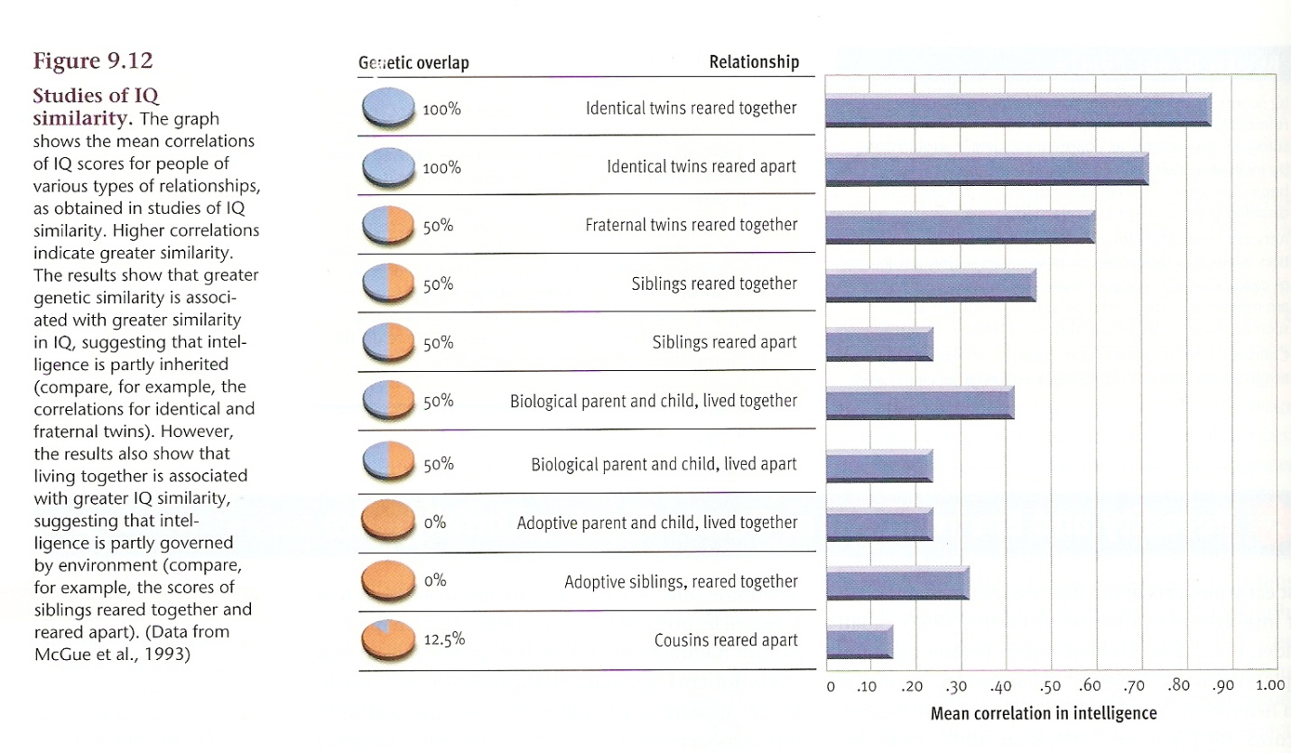

Environmental Influence on Intelligence
- Adoption Studies: children showing similarities in IQ to their adoptive parents (because the parents shape their environment) and unrelated children raised in the same home also show a significant resemblance in IQ
- Environmental Deprivation and Enrichment: children who are raised in substandard circumstances (i.e. orphanages) should experience a gradual decline in IQ as they grow older (cumulative deprivation hypothesis) OR children who are removed from a deprived environment and placed in circumstances more conducive to learning should benefit from their environmental enrichment (IQ gradually increases)

- the current thinking is that heredity may set certain limits on intelligence and that environmental factors determine where individuals fall within these limits
- REACTION RANGE: refers to these genetically determined limits on IQ (or other traits)
- children raised in high-quality environments that promote development of intelligence should score near the top of their potential IQ range; children reared under less idea circumstances should score lower in their reaction range
- differences in the average IQ of various human populations could be entirely due to environmental differences, even if within each population all variation were due to genetic differences

Explanations of Cultural Differences in IQ
- Socioeconomic: minority students tend to grow up in deprived environments that create a disadvantage (come from large families or single-parent homes which give them less attention, exposed to fewer books, learning supplies, less privacy for studying, less parental assistance, poorer role models, less pressure to work hard, poorer-quality schools, need to learn street smarts, malnutrition, exposure to environmental toxins)
- Racial Stereotype Vulnerability: can undermine group members’ performance on tests and other academic achievement; can create belonging uncertainty, doubts in their mind about the quality of their social bonds and relationships in these situations; negative stereotypes can undermine emotional investment in academic work or create anxiety for IQ tests which will disrupt their cognitive functioning
- Cultural Bias on IQ tests: IQ tests are constructed by white, middle-class psychologists and naturally draw on experience and knowledge typical of white, middle-class lifestyles as well as language (exposure to information); reflect differences in knowledge rather than ability

FACTOR ANALYSIS: (developed by Charles Spearman) correlations among many variables are analyzed to identify closely related clusters of variables (if a number of variables correlate highly with one another, the assumption is that a single factor is influencing all of them)

Carve intelligence into seven distinct factors called Primary Mental Abilities: (concept developed by L.L. Thurstone): word fluency, verbal comprehension, spatial ability, perceptual speed, numerical ability, inductive reasoning, and memory

Raymond Cattell and John Horn: general mental ability divided into FLUID INTELLIGENCE: involves reasoning ability, memory capacity, and speed of information processing (assumed to be determined by biological factors); and CRYSTALLIZED INTELLIGENCE: involves ability to apply acquired knowledge and skills in problem solving (assumed to be determined by education and experience)

Robert Sternberg’s Triarchic Theory of Human Intelligence
- Contextual subtheory: specifies the behaviours considered intelligence in a particular culture (i.e. verbal skills in N.A. culture versus hunting skills in another culture)
- Experiential subtheory: specifies how experiences affect intelligence and how intelligences affects a person’s experience (ability to deal with new tasks, demands, situations and ability to handle familiar tasks automatically and effortlessly)
- Componential subtheory: specifies the cognitive processes that underlie all intelligent behaviour (research on specific thinking strategies that contribute to intelligence problem solving)
  - Meta-components: control, monitor and evaluate cognitive processing
  - Knowledge-acquisitions components: encode, combine and compare information
  - Performance components: execute strategies assembled by metacomponents

Sternberg’s “Successful Intelligence”
- Analytical Intelligence: involves abstract reasoning, evaluation, and judgement (critical to most schoolwork and assessed by conventional IQ tests)
- Creative Intelligence: involves the ability to generate new ideas and to be inventive in dealing with novel problems
- Practical Intelligence: involves the ability to deal effectively with the kinds of problems that people encounter in everyday life, such as on the job or at home

Howard Gardner: concluded that humans exhibit eight intelligences:
- logical-mathematical (logical or numerical patterns, long chains of reasoning)
- linguistic (sounds, rhythms, meanings of words, functions of language)
- musical (produce rhythm, pitch, timbre, forms of musical expressiveness)
- spatial (perceive visual-spatial world, transform one’s initial perception)
- bodily-kinesthetic (control one’s body movements, handle objects skillfully)
- interpersonal (respond to moods, temperaments, motivations, desires of other people)
- intrapersonal (access to own feelings, strength, weaknesses, desires, intelligences)
- naturalist (recognize and categorize objects and processes in nature)

EMOTIONAL INTELLIGENCE: consists of the ability to perceive and express emotion, assimilate emotion in thoughts, understand and reason with emotion, and regulate emotion
- accurately perceive emotions in themselves and others, express own emotions effectively
- aware of how emotions shape thinking, decision making, and coping with stress
- able to understand and analyse their emotions
- regulate their emotions to dampen negative emotions and use effectively positive emotions
Psychology – Chapter 10 – Motivation and Emotion

MOTIVES: the needs, wants, interests, and desires that propel people in certain directions
MOTIVATION: involves goal-directed behaviour

Theories of Motivation:
- Drive Theory: (internal states of tension push people to do something) explored by Clark Hull, derived from Walter Cannon; observation that organisms seek to maintain HOMEOSTASIS: a state of physiological equilibrium or stability
  - DRIVE: internal state of tension that motivates an organism to engage in activities that should reduce this tension (drive reduction) Ex. hunger causes slight discomfort, motivates you to get food
- Incentive Theory: (external stimuli pull people to do something) the source of motivation lies outside the organism, in the environment
  - INCENTIVE: external goal that has the capacity to motivate behaviour
  - Expectancy-value models: one’s motivation to pursue a particular course of action depends on (1) expectancy about one’s chances of attaining the incentive and (2) the value of the desired incentive
- Evolutionary Theory: argue that natural selection favours behaviours that maximize reproductive success- passing genes on to the next generation (i.e. dominance in males)

Biological Motives – originate in bodily needs, such as hunger, thirst, sex, temperature, excretory, sleep and rest, activity, aggression (everyone has basically the same)
Social Motives – originate in social experiences, such as the need for achievement, affiliation, autonomy (independence), nurturance, dominance, exhibition (impress others), order (organization), play (these can vary depending on experiences)

Biological Factors in the Regulation of Hunger
- Brain Regulation: controlled by the hypothalamus (structure involved in the regulation of a variety of biological needs related to survival)
  - Lateral hypothalamus (LH) and Ventromedial nucleus of the hypothalamus (VHM) were believed to be the brain’s on-off switch of hunger
  - Paraventricular nucleus (PVN) believed to play a larger role in the modulation of hunger
  - Neural circuits and increased levels of ghrelin play a role in stimulating hunger
- Glucose and Digestive Regulation: Jean Mayer proposed that hunger is regulated by the rise and fall of blood glucose levels (GLUCOSE: simply sugar that is an important source of energy) which are monitored in the brain by GLUCOSTATS: neurons sensitive to glucose in the surrounding fluid
- Hormonal Regulation: Secretion of insulin (hormone secreted by the pancreas) is associated with increased hunger (often stimulated by the sight and smell of food); leptin, a hormone produced by fat cells throughout the body and released into the bloodstream, provide the hypothalamus with information about the body’s fat stores

Environmental Factors in the Regulation of Hunger
- Food availability and related cues: availability and palatability of food are the key factors in regulating hunger; often we eat tasty foods even when we are full; seeing images, videos, descriptions of foods can make us hungrier; eating is a social actions (behaviour and presence of others affects the amount of food we eat)
  - sensory-specific satiety: as you eat a specific food, its incentive value declines (we get bored of it, want variety)
- Learned Preferences and Habits: food preferences acquired through learning, different cultures display very different patterns of food consumption; children can be conditioned to prefer certain flavours; food can also be associated to certain events, locations; taste aversion can be acquired through conditioning; eating habits can be shaped by observational learning
- Stress and Eating: studies have shown that stress leads to increased eating in a substantial portion of people (eating tasty foods during emotional distress to make them feel better)

OBESITY: the condition of being overweight (a major health concern)
- overweight people more vulnerable to cardiovascular diseases, diabetes, hypertension, respiratory problems, gallbladder disease, stroke, arthritis, muscle and skeletal pain, cancer
BODY MASS INDEX (BMI): an individual’s weight (in kilograms) divided by height (in metres) squared

Causes of Obesity
- Genetic Predisposition: differences in physiological makeup and genetics affect ability to gain weight, appears that some people inherit a genetic vulnerability to obesity
- Excessive Eating and Inadequate Exercise: people eat too much in relation to their levels of exercise; junk food is readily available, inexpensive and easy to prepare; elevators and cars, as well as desk jobs, diminish our exercise levels
- The Concept of Set Point:
  - SET-POINT THEORY: proposes that the body monitors fat-cell levels to keep them (and weight) fairly stable (explains why people lose weight dieting, and then gain it all back right after)
  - SETTLING-POINT THEORY: proposes that weight tends to drift around the level at which the constellation of factors that determine food consumption and energy expenditure achieves an equilibrium (if an obese person makes long-term changes in eating or exercise, that person’s settling point will drift downward without active resistance)
- Dietary Restraint: thought to lead to frequent overeating and thus contribute to obesity (when their cognitive control is disrupted, they become disinhibited and eat to excess), overeating just prior to beginning a diet
- Eating Disorders: often due to social prescriptions for thinness
  - Anorexia Nervosa – disorder in which (mostly) young women starve themselves, sometimes to death
  - Bulimia Nervosa – (mostly) young women alternate between binge eating and purging

Sexual Motivation and Behaviour
- Sex is essential for the survival of a species, but it’s not essential to an individual’s survival

Factors that influence our sexual behaviour
- Hormonal Regulation: hormones secreted by the gonads can influence sexual motivation
  - ESTROGENS: principal class of gonadal hormones in females
  - ANDROGENS: principal class of gonadal hormones in males

Evolutionary Analyses of Human Sexual Behaviour
- Parental Investment Theory: maintains that a species’ mating patterns depend on what each sex has to invest (time, energy, survival risk) to produce and nurture offspring
  - Males: invest little into the production of offspring, results in males showing more interest in sexual activity, more desire for variety in sexual partners and more willingness to engage in uncommitted sex, with someone they have known for only a brief period
  - Females: invest nine months in pregnancy and years of breastfeeding and nurturing, results in females being more selective in mating, thought to be conservative, and highly selective in choosing sex partners, seeking partners who can contribute to feeding and caring for offspring
- Gender differences in patterns of sexual activity
  - Males: show a greater interest in sex, initiate sex more often, more interested in sex for its own sake, pursue sex with a variety of partners, more likely to have sexy with someone they’ve known for a short time
  - Females: due to double standards, women worry more than men about being viewed as sexually permissive, which may lead them to downplay their sexual motivation
- Gender differences in mate preferences (often subconscious due to evolutionary forces)
  - Males: ancestors wished to find females with good reproductive potential who would be sexually faithful and effective in nurturing children therefore prefer females who are youthful (more reproductive years) and attractive (assumed to be correlated with health and fertility)
  - Females: ancestors wished to find a male who could provide material resources and protect his family and who was dependable and willing to invest his resources in his family, therefore prefer males with characteristics like intelligence, ambition, income, and social status (which are associated with the ability to provide more material resources)

Pornography
- studies show that erotic materials stimulate sexual desire in many people; men are more likely than women to report that they find erotic materials enjoyable and arousing
- the vast majority of erotic materials are scripted to appeal to males and portray women in degrading roles
- although erotic materials don’t appear to incite overpowering sexual urges, they may alter attitudes in ways that eventually influence sexual behaviour (can create unrealistic expectations about sexual relations)
- aggressive pornography can increase aggression in males, may lead to more rape

Sexual Orientation
- SEXUAL ORIENTATION: refers to a person’s preference for emotional and sexual relationships with individuals of the same sex, the other sex, or either sex
  - HETEROSEXUALS: seek emotional-sexual relationships with members of the other sex
  - BISEXUALS: with either sex
  - HOMOSEXUALS: with members of the same sex
- Environmental Theories
  - Freudian theorists: male is likely to become gay when raised by a weak,, detached father who is a poor heterosexual role model and an overprotective, close-binding mother
  - Behavioural theorists: homosexuality is a learned preference acquired when same-sex stimuli have been paired with sexual arousal
  - most homosexual people report they can trace their homosexual leanings back to early childhood
- Biological Theories
  - genetic predisposition to homosexuality indicated by the fact that more identical twins were gay than fraternal twins, more genetic overlap
  - caused by hormonal secretions during critical periods of prenatal development (increased level of androgens in females result in homosexuality)
The Human Sexual Response Cycle
- Excitement Phase: level of physical arousal escalates rapidly, muscle tension, respiration rate, heart rate, and blood pressure increase quickly
  - VASOCONGESTION: engorgement of blood vessels – produce penile erection and swollen testes in males and swelling/hardening of the clitoris, expansion of the vaginal lips, and vaginal lubrication in females
- Plateau Phase: physiological arousal continues to build, but at a slower rate; lengthy foreplay results in fluctuation (erections increase and decrease noticeably, vaginal lubrication changes in women)
- Orgasm Phase: ORGASM: occurs when sexual arousal reaches its peak intensity and is discharged in a series of muscular contradictions that pulsate through the pelvic area; heart rate, respiration rate, and blood pressure increase sharply, in males ejaculation of the seminal fluid; women are more likely than men to be multi-orgasmic yet also more likely to engage in intercourse without having an orgasm
- Resolution Phase: physiological changes produces by sexual arousal subside; men experience REFRACTORY PERIOD: a time following an orgasm during which males are largely unresponsive to further stimulation (varies, and increases with age)

