ECON 1000

Ch. 1: Definition of Economics
- Economics: the social science that studies the choice individuals, businesses, governments, and entire societies make as they cope with scarcity and he incentives that influence and reconcile those choices
- Scarcity: inability to satisfy all wants/needs because of limited resource
- Incentive: a reward that encourages an action or a penalty that discourages an action
- Microeconomics: the study of the choices that individuals and businesses make, the way these choices interact in markets and influence the government
- Macroeconomics: the study of the performance of the national economy and the global economy
  - Microeconomics vs. Macroeconomics: no money involved in microeconomics
- Two big economics questions
  - How do choices end up determining what, how, and for whom goods and services get produced?
  - When do choices made in the pursuit of self-interest also promote the social interest?
- Factors of production
  - Land: earns rent
    - Natural resources: minerals, oil, gas, coal, water, air, forests, fish, etc.
    - some renewable (can be recycled), some non-renewable (resources to make energy)
  - Labour: earns wages
    - work, time and effort that people devote to production goods and services
    - physical and mental efforts
    - quality depends on human capital (knowledge and skill that people obtain from education, training, and experience)
  - Capital: earns interest
    - tools, instruments, machines, buildings used to produce goods and services
    - financial capital used to buy physical capital, but is not a productive resource as it is not used to produce goods and services
  - Entrepreneurship: earns profit
    - human resources that organize labour, land and capital
- Self-interest: if the choice is the best available for an individual. Using time and resources in ways that make sense to an individual. Don't think how choices affect society.
- Social interest: self-interested choices promote social interest if they lead to an outcome that is the best for society as a whole. An outcome that uses resources efficiently and distributes goods and services equitably among individuals
  - used efficiently when goods and services produced:
    - at lowest possible cost
    - in quantities that give the greatest possible benefit
- interaction of self-interest and social interest
  - Globalization
    - expansion of international trade, borrowing, lending , ad investment
  - The information-age economy
    - technological change of the 1990s and 2000s
  - Global warming
    - climate change and political issues associated
  - Natural resource depletion
    - Over-fishing in international waters, clear-cutting rainforests, etc.
  - Economic instability
    - Choices leading up to recession, etc.
- tradeoff: an exchange, giving up one thing to get something else
    - as a society tradeoff current consumption and leisure time for economic growth and higher future consumption
      - saving, education, research and development
  - What: spending income on various things, what to produce
  - How: choosing among alternative production technologies
  - Whom: distribution of buying power(voluntary payment, theft, taxes and benefits)
- big tradeoff: between equality and efficiency
- opportunity cost: the highest valued alternative forgone
  - "There's no such thing as a free lunch"
- margin: the consequences of making incremental changes in the use of resources
  - marginal benefit: the benefit that arises from an increase in an activity
    - decreasing function
  - marginal cost: the cost of an increase in an activity
    - increasing function
  - If marginal benefit exceeds marginal cost, incentive to do more of that activity.
  - If marginal cost exceeds marginal benefit, incentive to do less of that activity.
  - Incentives are the key to reconciling self-interest and the social interest.
- Economists emphasize the role of institutions in creating incentives to behave in the social interest
  - Paramount: the rule of law that protects private property and facilitates voluntary exchange in markets.
- Positive statements: what is
- Normative statements: what ought to be
- economic model: description of some aspect of the economic world - unscrambles cause and effect
  - natural experiment: situation that arises in the ordinary course of economic life, factors of interest is different, other things are similar
  - statistical investigation: looks for correlation
  - economic experiment: puts people in decision-making situation and varies influence of one factor at a time to see response
- Economics as a policy tool
  - Personal economic policy: marginal benefit and marginal cost for personal decisions
  - Business economic policy: marginal benefit and marginal cost for businesses, interaction of individuals with the firm
  - Government economic policy: marginal benefit and marginal cost of government decisions, interaction of individuals with businesses

Graphs
- time-series graph: time on x-axis, variable on y-axis
- cross-section graph: value of variable of different groups at a particular point in time
- scatter diagram: plots points to show relationship between to variables
  - positive/direct relationship: variables move in same direction
    - linear relationship: straight line
  - negative/inverse relationship: variables move in opposite directions
- Ceteris paribus: if all other relevant things remain the same

Ch. 2: The Economic Problem
- Production possibilities frontier (PPF): boundary between combinations of goods and services that can and cannot be produced.
    - outward bowed-out shape reflects increasing opportunity cost
      - not all resources are equally productive in all activities
  - cannot attain points outside of frontier (scarcity)
  - points inside frontier are inefficient
    - resources are unused or misallocated
- production efficiency: if goods and services produced at lowest possible cost
- allocative efficiency: goods and services are produced at the lowest possible coast and in the quantities that provide the greatest possible benefit
  - intersection of marginal cost and marginal benefit
- preferences: description of a person's likes and dislikes
  - illustrated on marginal benefit curve
- Economic growth: expansion of production, PPF shifts right. Opportunity cost of economic growth is less current consumption
  - technological change: development of new goods and of better ways of producing
  - capital accumulation: growth of capital resources, including human capital
- comparative advantage: a person can perform the activity at a lower opportunity cost than anyone else
- Absolute advantage: a person who is more productive than others. Production per hour
  - gain from trade if specialization at comparative advantage
- dynamic comparative advantage: gaining comparative advantage from learning-by-doing
  - Learning-by-doing: specialize and by repeatedly producing a particular good or service become more productive in that activity and lower the opportunity cost of producing that good over time.
- Economic coordination: decentralized economic planning
  - Firms: economic unit that hired factors of production to produce and sell goods and services
  - Markets: arrangement that enables buyers and sellers to get information and to do business with each other
    - facilitates trade
  - Property rights: social arrangement that govern ownership, use, and disposal of anything people value
    - Real property: land, buildings, equipment, etc.
    - Financial property: stocks, bods, money, etc.
    - Intellectual property: intangible product of creative effort: books, music, etc.
  - Money: any commodity or token that is generally acceptable as a means of payment
- Circular flow through markets
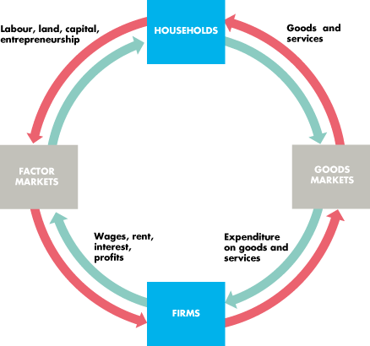

Ch. 3: Demand and Supply
- competitive market: a market that has many buyers and sellers, so no single buyer or seller can influence the price
- money price: the amount of money needed to buy an item
- relative price: opportunity cost, the ratio of price over price of the forgone alternative

Demand
- demand: relationship between price and quantity demanded
- If demand exists then:
  - must want it
  - can afford it
  - plan to buy it
- Wants: unlimited desired or wishes that people have for goods and services. Demand reflects which wants to satisfy
- quantity demanded: amount that consumers plan to buy during a given time period at a particular price
- Law of Demand
  - other things remain the same, the higher the price of a good, the smaller is the quantity demanded; the lower the price of a good, the greater is the quantity demanded
    - Substitution effect: when relative cost (opportunity cost) increases, people seek substitutes, thus quantity demand decreases
    - Income effect: when cost increases, and income remains the same, people cannot afford to buy all of the same things, thus quantity demanded decreases
- Willingness and ability to pay: demand curve, the more quantity, the less people are willing to pay. The less the quantity, the more people are willing to pay.
- Change in demand: movement of entire demand curve
  - prices of related goods
    - substitute: increase in price of substitute, increase in demand; decrease in price of substitute, decrease in demand
    - complement: increase in price of complement, decrease in demand; decrease in price of complement, increase in demand
  - expected future prices
    - increase in future price, increase in current demand; decrease in future price, decrease in current demand
  - income
    - normal good: increase in income, increase in demand; decrease in income, decrease in demand
    - inferior good: increase in income, decrease in demand; decrease in income, increase in demand
  - expected future income and credit
    - increase in future income and credit, increase in current demand; decrease in future income and credit, decrease in demand
  - population
    - increase in population, increase in demand; decrease in population, decrease in demand
  - preferences
    - change in preference affects demand in same way
- Change in quantity demanded: movement along demand curve
Supply
- supply: relationship between the price of a good and the quantity supplied
- If supply exists then:
  - firm has the resources and technology to produce
  - can profit from producing
  - plans to produce and sell
- quantity supplied: the amount that producers plan to sell during a given time period at a particular price
- law of supply
  - the higher the price of a good, the greater is the quantity supplied; the lower the price of a good, the smaller is the quantity supplied
    - marginal cost increases, so producers are willing to bear the increase if price is high enough
- minimum supply price: lowest price is marginal cost, as production increases so does price
- Change in supply: shift of the entire supply curve
  - prices of factors of production
    - increase in cost, decrease in supply; decrease in cost, increase in supply
  - prices of related goods produced
    - substitutes: increase in price of related good produced, decrease in supply; decrease in price of related good produced, increase in supply
    - complement: increase in price of complement, increase in supply; decrease in price of complement, decrease in supply
  - expected future prices
    - increase in future price, decrease in current supply; decrease in future price, increase in current supply
  - number of suppliers
    - increase in number of suppliers, increase in supply; decrease in number of suppliers, decrease in supply
  - technology
    - technology lowers price of factors of production
  - state of nature
    - weather and other natural phenomenon influence supply in various ways
- Change in supply demanded: movement along supply curve
Market Equilibrium
- Equilibrium: situation in which opposing forces balance each other. In a marker, occurs when price balances the plans of buyers and sellers
  - price regulate buying and selling plans
  - price adjusts when plans don't match
- equilibrium price: price at which the quantity demanded equals the quantity supplied
- equilibrium quantity: quantity bought and sold at the equilibrium price
- Price adjustments
  - a shortage forces the price up
    - consumers want more than is supplied
    - price increases, demand decreases, supply increases, equilibrium found
  - a surplus forces the price down
    - suppliers produce more than consumers demand
    - price decreases, supply decreases, demand increases, equilibrium found

Ch. 4: Elasticity
Elasticity of demand
- price elasticity of demand: unit-free measure of the responsiveness of the quantity demanded of a good to a change in its price when all other influences on buying plans remain the same
  - $\frac{Percentage change in quantity demanded}{Percentage change in price}=\frac{{∆Quantity}/{Average Quantity}}{{∆Price}/{Average Price}}$
    - Percentages and proportions
    - unit-free measure
    - magnitude, no positive/negative values
- Elastic demand: percentage change in quantity demanded is greater than the percentage change in price. elasticity > 1
- Inelastic demand: percentage change in quantity demanded is less than the percentage change in price. elasticity = between 0 and 1
- Perfectly inelastic demand: quantity demanded remains constant when price changes. elasticity = 0 (vertical line)
- Unit elastic demand: percentage change in quantity demanded equals the percentage change in price. elasticity = 1
- Perfectly elastic demand: quantity demanded changes by an infinitely large percentage in response to a tiny price change. elasticity= ∞ (horizontal line)
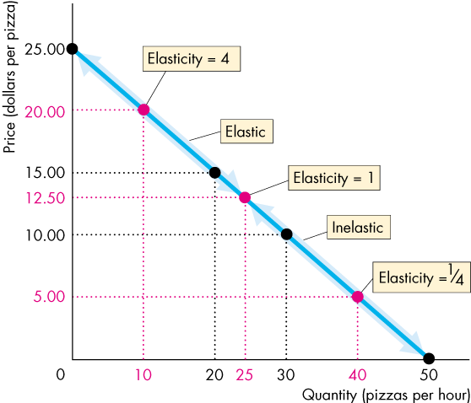
- Elasticity along a straight-line demand curve

- at midpoint: unit elastic
- above midpoint: elastic
- below midpoint: inelastic

- total revenue: price of good multiplied by the quantity sold
  - If demand is elastic, a 1% price cut increases quantity sold by more than 1% and total revenue increases
  - If demand is inelastic, a 1% price cut increases quantity sold by less than 1% and total revenue decreases
  - If demand is unit elastic, a 1% price cut increases quantity sold by 1% and total revenue does not change
- total revenue test: method of estimating the price elasticity of demand by observing the change in total revenue that results from a change in the price
- Expenditures
  - If your demand is elastic, a 1% price cut increases the quantity you buy by more than 1% and your expenditures on the item increases
  - If you demand is inelastic, a 1% price cut increases the quantity you buy by less than 1% and your expenditures on the item decreases
  - If your demand is unit elastic a 1% price cut increases the quantity you buy by 1% and your expenditures on the item does not change
- Factors that influence the elasticity of demand
  - closeness of substitutes
    - the closer the substitutes for a good/service, the more elastic the demand is
      - necessities are inelastic
      - luxuries are elastic
  - proportion of income spent on the good
    - the greater the proportion of income spent on the good, the more elastic the demand is
  - time elapsed since price change
    - the longer the time has elapsed since a price change, the more elastic the demand is
- cross elasticity of demand: measure of the responsiveness of the demand for a good to a change in the price of a substitute o complement
  - $\frac{Percentage change in quantity demanded}{Percentage change in price of a substitute or complement}=\frac{{∆Quantity}/{Average Quantity}}{{∆Price}/{Average Price}}$
  - substitutes: positive relationship: increase in price of substitute shifts demand curve right
  - complement: negative relationship: increase in price of complement shifts demand curve left
- income elasticity of demand: responsiveness of the demand for a good/service to a change in income
  - $\frac{Percentage change in quantity demanded}{Percentage change in income}$
  - Greater than 1: normal good, income elastic (luxury)
    - percentage increase in quantity demanded exceed the percentage increase in income
    - percentage of income spent on the good increases as income increases
  - Positive and less than 1: normal good, income inelastic (necessities)
    - percentage increase in quantity demanded is positive but less than the percentage increase in income
    - percentage of income spend on the good decreases as income increases
  - Negative: inferior good
    - quantity demanded of an inferior good and the amount spent on it decreases when income increases
Elasticity of Supply
- elasticity of supply: measures the responsiveness of the quantity supplied to a change in the price of a good
  - $\frac{Percentage change in quantity supplied}{Percentage change in price}=\frac{{∆Quantity}/{Average Quantity}}{{∆Price}/{Average Price}}$
- Perfectly inelastic supply: quantity supplied remains constant when price changes. elasticity = 0 (vertical line)
- Unit elastic supply: percentage change in quantity supplied equals the percentage change in price. No matter of slope, if it is linear and passes through origin, it is unit elastic
- Perfectly elastic supply: If there is a price at which sellers are willing to offer any quantity for sale. elasticity= ∞ (horizontal line)
- Factors that influence the elasticity of supply
  - resource substitution possibilities
    - The easier it is to substitute among the resources used to produce a good or service, the greater is its elasticity of supply.
  - time frame for the supply decision
    - The more time that passes after a price change, the greater is the elasticity of supply.
      - Momentary supply is perfectly inelastic. The quantity supplied immediately following a price change is constant
      - Short-run supply is somewhat elastic
      - Long-run supply is the most elastic

Ch. 5: Efficiency and Equity
Resource Allocation Methods
- market price
  - people who are willing and able to pay get the resource
    - people can choose not to pay, or people are too poor to afford it
- command
  - command system: allocated resources by the order of someone in authority
  - works well in firms (job allocation) with clear lines of authority, but badly in an entire economy
- majority rule
  - allocates resources in the way that a majority of voters choose
  - Works best when decisions being made affect large number of people and self-interest must be suppressed (decisions on taxes, etc.)
- contest
  - allocates resources to a winner (or group of winners)
  - works well when the efforts of the "players" are hard to monitor and reward directly
- first-come, first-served
  - allocated resources to those who are first in line
  - works best when a scarce resource can serve just one user at a time in a sequence
    - minimizes the time spent waiting for the resource to become free
- sharing equally
  - everyone gets the same amount
  - works best for small groups that share a common goal
- lottery
  - allocate resources to those that win (unlike contest, no skill is involved; luck)
  - works best when there is no effective way to distinguish among potential users
- personal characteristics
  - allocates resources on the basis of personal characteristic
    - can be discriminatory on certain basis like job selection
- force
  - allocated resource by force
  - war, theft
  - effective in transferring wealth from the rich to the poor
    - provides legal framework in which voluntary exchange in markets takes place
Demand and Marginal Benefit
- value: what we get
  - value of one more unit is marginal benefit
- price: what we pay
- willingness to pay determines demand
  - a demand curve is a marginal benefit curve
- individual demand: relationship between the price of a good and the quantity demanded by one person
- market demand: relationship between the price of a good and the quantity demanded by all buyers
  - market demand cure is the marginal social benefit cure
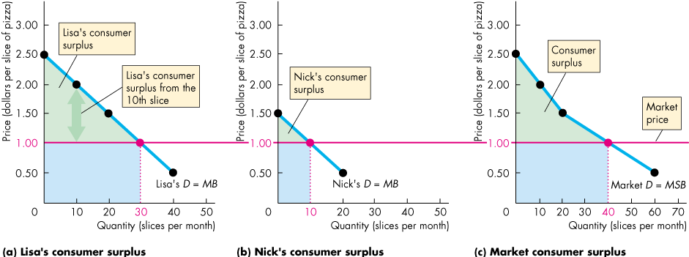
- consumer surplus: value of a good minus the price paid for it, summed over the quantity bought

  - area of green triangle is sum of all surpluses = consumer surplus
  - area of blue rectangle shows price paid
Supply and Marginal Cost
- cost: what a producer gives up
  - cost of producing one more unit is the marginal cost
- price: what a producer receives
- marginal cost is the minimum price a producer must receive to offer one more unit for sale
- minimum supply-price determines supply
  - a supply curve is a marginal cost curve
- individual supply: relationship between the price of a good and the quantity supplied by one producer
- market supply: relationship between the price of a good and the quantity supplied by all producers
  - market supply curve is the marginal social cost curve
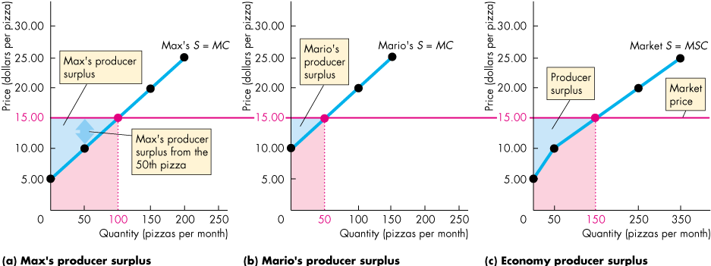
- producer surplus: price received for a good minus its minimum supply-price (marginal cost), summed over quantity sold

  - area of blue triangle sum of all surpluses = producer surplus
  - red area shows cost of production
Is the Competitive Market Efficient?
- Efficient if
  - marginal social benefit = marginal social cost
  - total surplus (sum of consumer surplus and producer surplus) is maximized
- The Invisible Hand: Adam Smith's Wealth of Nations
  - competitive markets send resources to their highest valued use in society
  - consumers and producers pursue their own self-interest and interact in market
  - market transactions generate and efficient (highest valued) use of resources
- Inefficiency occurs if too little of an item is produced (underproduction) or too much is produced (overproduction)
  - Deadweight loss: the decrease in total surplus (gray triangle). It is a social loss
    - underproduction: surplus is lower than maximum level
    - overproduction: resources are wasted, reducing surplus
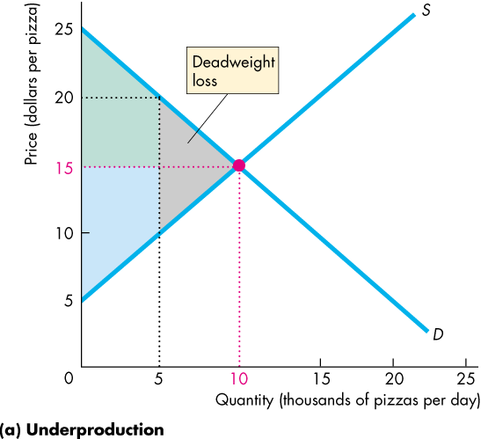
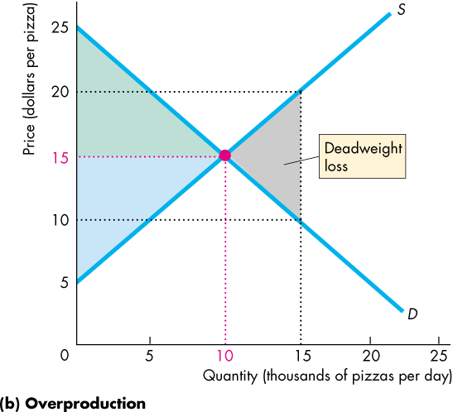

- Obstacles to efficieny
  - price and quantity regulations
    - blocking price adjustments leads to underproduction
    - limiting amount of production leads to underproduction
  - taxes and subsidies
    - taxes increase prices paid by buyers and lowers prices received by seller
      - leads to underproduction
    - subsidies lower prices paid by buyers and increases prices received by sellers
      - leads to overproduction
  - externalities
    - cost or benefit that affects someone other than the seller or buyer
  - public goods and common resources
    - public goods benefit everyone and no one can be excluded
    - common resources are owned by no one but available to everyone,
    - tragedy of the commons: overuse of the resource
  - monopoly
    - a sole provider of a good or service
    - typically under produces and charges high price
  - high transaction costs
    - transaction costs: opportunity cost of making trades in the market
- Alternatives to market: no efficient mechanism for resources efficiently
  - majority rule
  - first-come, first-served
Is the Competitive Market Fair?
- It's not fair if the result isn't fair
  - utilitarianism: principle that states that we should strive to achieve "the greatest happiness for the greatest number"
    - transferring income from the rich to the poor increases total benefit
      - the rich have a lower benefit of income than the poor
    - utilitarian ideal ignore the cost of making income transfers
      - John Rawls solution: make the poorest as well off as possible
- It's not fair if the rules aren't fair
  - symmetry principle: requirement that people in similar situation be treated similarly
    - equality of opportunity
    - Robert Nozick suggests fairness based on two rules:
      - the state must enforce laws that establish and protect private property
      - private property may be transferred from one person to another only by voluntary exchange
    - for resource to be allocated efficiently they must be allocated fairly

Ch. 6: Government Actions in Markets
A Housing Market with a Rent Ceiling
- price ceiling (price cap): a government regulation that makes it illegal to charge a price higher than a specified level
  - price ceiling above equilibrium price has no effect
  - price ceiling below equilibrium price has powerful effects on a market
- rent ceiling: when a price ceiling is applied to a housing market
  - create a housing shortage
    - quantity demanded at ceiling price exceeds the quantity supplied
  - search activity: time spent looking for someone with whom to do business
    - a shortage increases search activity
    - opportunity cost = rent + time and resource spent searching
  - black market: an illegal market in which the equilibrium price exceeds the price ceiling
    - ex. scalpers overcharging for tickets
    - Sneaky tactics like charging renters for keys, etc.
    - level of black market depends on level of enforcement of price ceiling
- inefficiency of a rent ceiling
  - inefficient underproduction of housing services
  - marginal social benefit exceeds marginal social cost
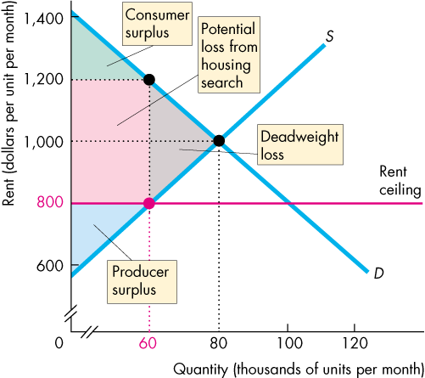
    - deadweight loss shrinks consumer and producer surplus

- fairness
  - according to fair rules: unfair because it blocks voluntary exchange
  - according to fair results: unfair because it does not generally benefit the poor
    - decreases quantity so resources allocated through: lottery, first-come-first-served, discrimination
A Labour Market with a Minimum Wage
- price floor: a government-imposed regulation that makes it illegal to charge a price lower than a specified level
  - price floor below equilibrium price has no effect
  - price floor above equilibrium price has powerful effects on a market
- minimum wage: when a price floor is applied to a labour market
  - minimum wage creates unemployment
    - quantity of labour exceeds the quantity of labour demanded
      - surplus of labour
    - quantity of labour hired at minimum wage is less than quantity that would be hired in unregulated labour market
- inefficiency of minimum wage
  - supply curve measures the marginal social cost of labour to workers
    - leisure forgone
  - demand curve measures the marginal social benefit from labour
    - value of goods and service produced
  - marginal social benefit exceeds marginal social cost
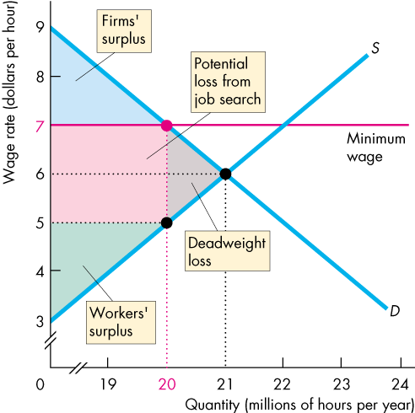
    - deadweight loss shrinks the firms' and workers' surplus

- Is the minimum wage fair?
  - those with jobs keep them and benefit from minimum wage
  - increased job search = increase in incurred costs
  - most economists believe a minimum wage increases the unemployment rate of low-skilled younger workers
Taxes
- tax incidence: the division of the burden of tax between buyers and seller
  - when item is taxed, price may:
    - increase by full amount: buyer pays tax
    - increase by part of amount: buyer and seller pay the tax
    - not increase: seller pays tax
- tax on sellers
  - increase of cost so decrease in supply
  - position of new supply curve
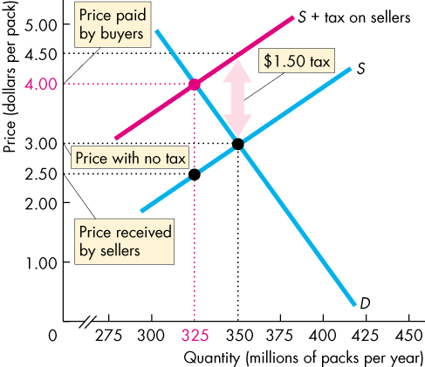
    - add the tax to the minimum price that sellers are willing to accept for each quantity sold

d
- tax on buyers
  - lowers amount buyers are willing to pay seller, so decrease in demand
  - position of new demand curve
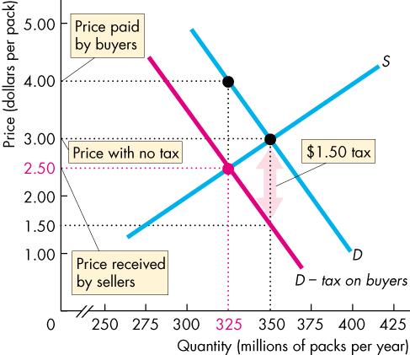
    - subtract tax from the maximum price that buyers are willing to pay for each quantity bought

- equivalence of tax on buyers and sellers
  - same effects if buyers or sellers are taxed
  - buyers respond to the price that includes tax
  - sellers respond to the price that excludes tax
- tax incidence and elasticity of demand: more inelastic demand is, larger is buyers' share of tax
  - perfectly inelastic demand → buyers pay
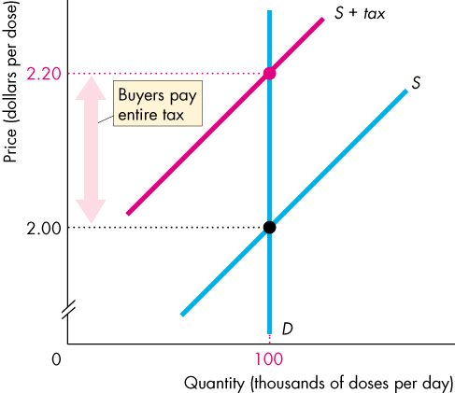

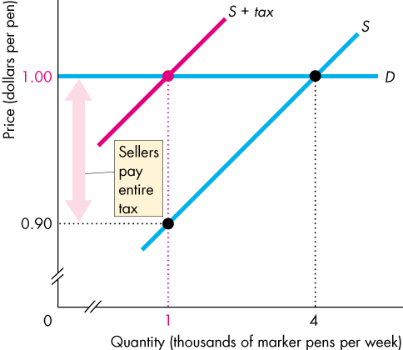
  - perfectly elastic demand → sellers pay

- tax incidence and elasticity of supply: more elastic demand is, larger is buyers' share of tax
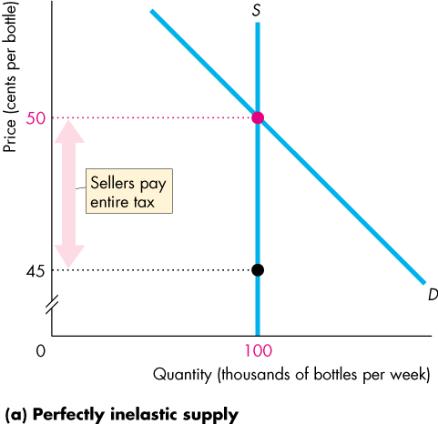
  - perfectly inelastic supply → sellers pay

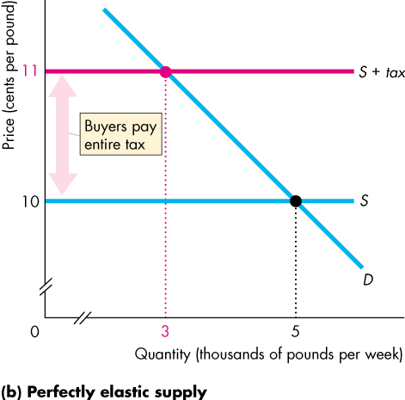
  - perfectly elastic supply → buyers pay

- taxes in practice
  - taxes usually levied on goods with inelastic demand or inelastic supply
    - tobacco and alcohol have inelastic demand so buyer pays the tax
    - labour has a low elasticity of supply, so the seller (worker) pays the income tax
- taxes and efficiency
  - price buyers pay is also the buyers' willingness to pay
    - marginal social benefit
  - price seller receives is also the sellers' minimum supply-price
    - marginal social cost
  - tax MSB exceed MSC
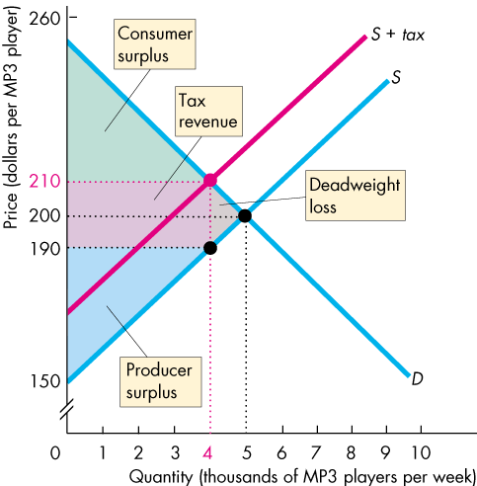
    - shrinks consumer and producer surplus, creates deadweight loss

  - only in extreme cases of perfectly inelastic demand and perfectly inelastic supply does tax not change the quantity bought and sold so no deadweight loss arises
- taxes and fairness
  - the benefits principle: people should pay taxes equal to the benefits they receive from the services provided by government
    - fair because those who benefit pay
  - the ability-to-pay principle: people should pay taxes according to how easily they can bear the burden of the tax
    - rich people can bear the burden easier
Production Quotas and Subsidies
- often used in farming industry
- production quota: upper limit to the quantity of a good that may be produced in a specific period
  - quota above equilibrium quantity, no effects
  - quota below equilibrium quantity big effects
    - decrease in supply
    - rise in price
    - decrease in marginal cost
      - less efficient resources take away from production
    - inefficient underproduction
      - marginal social benefit = market price (increased)
      - marginal social cost decreases
      - MSB > MSC = deadweight loss
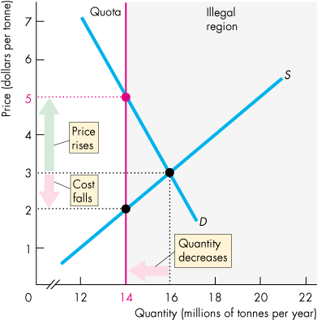
    - incentive to cheat and overproduce

- subsidy: payment made by the government to a producer
  - increase in supply
  - fall in price and increase in quantity produced
  - increase in marginal cost
    - use more resources that are less ideal
  - payments by government to farmers
  - inefficient overproduction
    - MSB = market price (decreased)
    - MSC increases
    - MSC > MSB
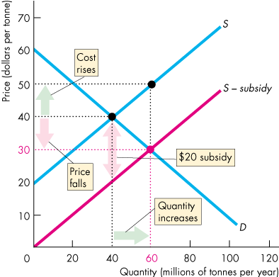
    - spillover to other countries as world supply increases

Markets for Illegal Goods
- Free market for an illegal drug: functions the same way regular free market does, however...
- a market for an illegal drug
  - penalties on sellers: decrease supply
    - add cost of breaking the law to the minimum price that drug dealers are willing to accept
      - S + CBL
  - penalties on buyers: decrease demand
    - subtract cost of breaking the law from maximum price buyers are willing to pay for drugs
      - D - CBL
  - penalties on both sellers and buyers
    - if CBL is the same then shift of equilibrium point left
      - same price, but lower quantity
    - In Canada seller CBL is larger
      - lower supply
        - increase in price, lower quantity
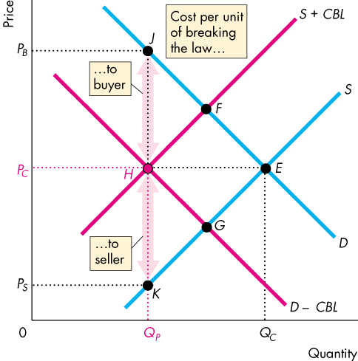

- legalizing and taxing drugs
  - an illegal good can be legalized and taxed
  - high enough tax rate would decrease consumption to the level the occurs when drug is illegal

Ch. 8: Utility and Demand
Maximizing Utility
- utility: the benefit or satisfaction that a person gets from the consumption of goods and services
  - total utility: the total benefit that a person gets from the consumption of all the different goods and services; generally more consumption gives more total utility
  - marginal utility: the change in total utility that results from a one-unit increase in the quantity of a good consumed
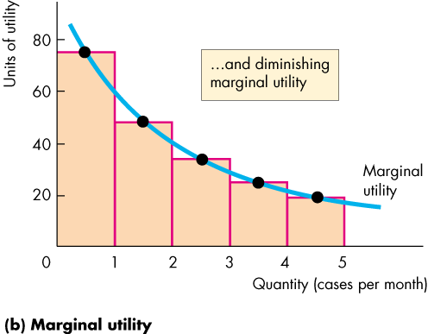
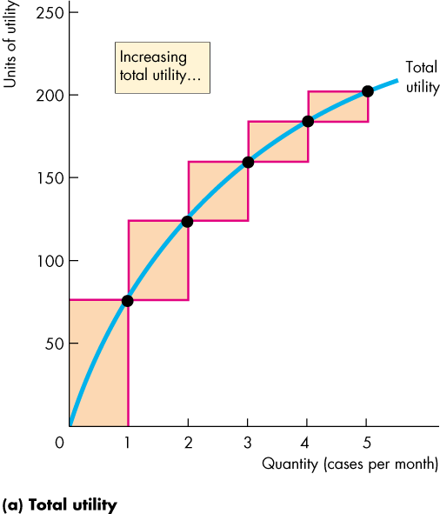
    - diminishing marginal utility: decrease in marginal utility as the quantity of a good consumed increases

- Consumer equilibrium: utility-maximizing combination of two or more products
- Choosing at the margin: consumer’s total utility is maximized by the following rule
  - spend all the available income
  - equalize the marginal utility per dollar for all goods
    - marginal utility per dollar: marginal utility divided by price
      - marginal utility from a good obtained by spending one more dollar
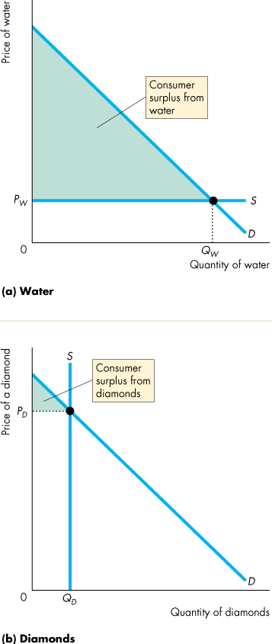
- utility maximizing rule
  - MU₁ and MU₂ are the marginal utilities of two products
  - P₁ and P₂ are the prices of the tow products
  - MU₁/P₁ = MU₂/P₂
  - MU₁ = MU₂ x P₁/P₂
- Paradox of value
  - Why is the price of an essential cheaper than the price of a luxury?
    - Water has low marginal utility but high total utility
    - Diamonds have high marginal utility but low total utility
      - Marginal utility per dollar is the same
  - Water supply is perfectly elastic so quantity consumed is large and consumer surplus is large
  - Diamond supply is perfectly inelastic so price is high and consumer surplus is low

Ch. 9: Possibilities, Preferences, and Choices
Consumption Possibilities
- Budget line: describes the limits to a household’s consumption choices
  - any point left of or on the budget line is affordable
  - any point to the right of the budget line is unaffordable
  - like a PPF but for consumption
- changes in price and changes in income shifting the budget line
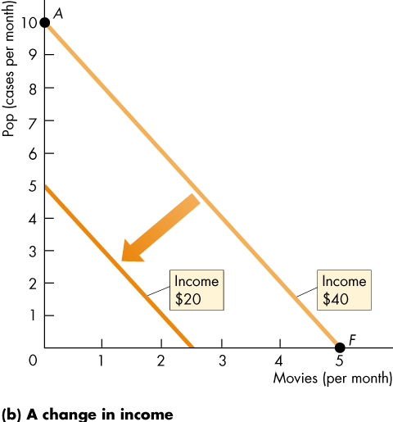
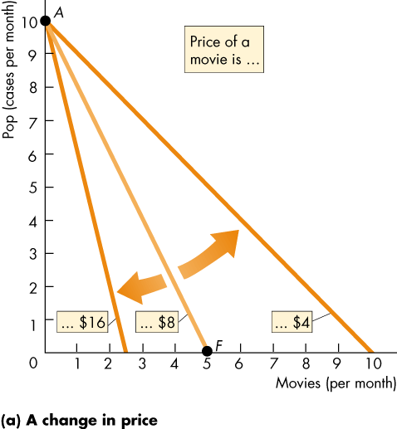

- Budget equation
  - Expenditure = Income
  - P₁Q₁ + P₂Q₂ = Y
    - Q₁ = Y/P₁ – Q₂(P₂/P₁)
  - Real income: income expressed as a quantity of goods that a household can afford to buy
    - At the point where the budget line intersects the y-axis
    - =Y/P₁
  - Relative price: the price of one good divided by the price of another good
    - =P₂/P₁
    - Opportunity cost
Preferences and Indifference Curves
- Indifference curve: a line that shows combinations of goods among which a consumer is indifferent
  - any point on indifference curve is preferred to any point below an indifference curve
  - any point above the indifference curve is preferred to any point on the indifference curve
- preference map: a series of indifference curves
- marginal rate of substitution (MRS): the rate at which a person will give up good y to get an additional unit of good x while remaining indifferent (on the same curve)
  - tangent: magnitude of the slope of an indifference curve measures the MRS
    - steep slope = willingness to give up a lot of y to get an extra unit of x
    - flatter slope = willingness to give up little y to get an extra unit of x
  - diminishing marginal rate of substitution: general tendency for a person to be willing to give up less of good y to get one more unit of good x, while at the same time remaining indifferent as the quantity of x increases
- degree of substitutability
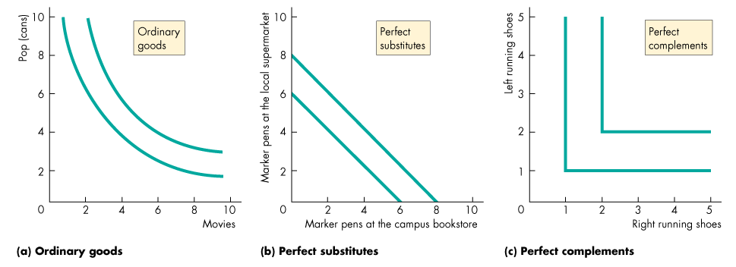
  - shape of the indifference curve reveals the degree of substitutability
Predicting Consumer Choices
- Best affordable choice
  - On the budget line
  - On the highest attainable indifference curve
  - Marginal rate of substitution equals relative price
- Price effect: the effect of the change in the price on the quantity of a good consumed
  - Movement between best affordable choices on different indifference curves due to price effect mirrors the demand curve.
- Income effect: the effect of the change in income on the quantity of a good consumed
  - Movement between best affordable choice on different indifference curves (parallel budget lines) is a shift of a demand curve
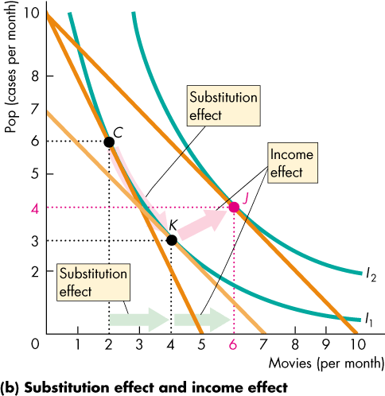
  - Income effect and substitution effect

Work-Leisure Choices
- Hours of the week divided between work and leisure
  - More leisure means less income
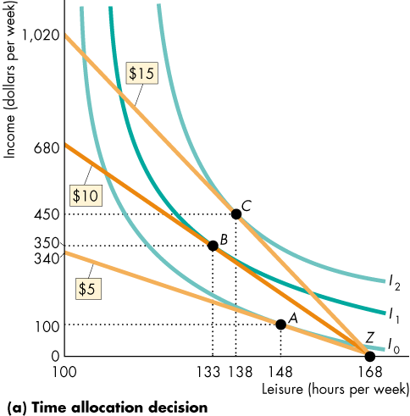
  - Income-time budget line: relationship between leisure and income

- If income effect is weaker than substitution effect the quantity of work hours increases as the wage rate rises
- If the income effect is stronger than the substitution effect the quantity of work hour decreases as the wage rises
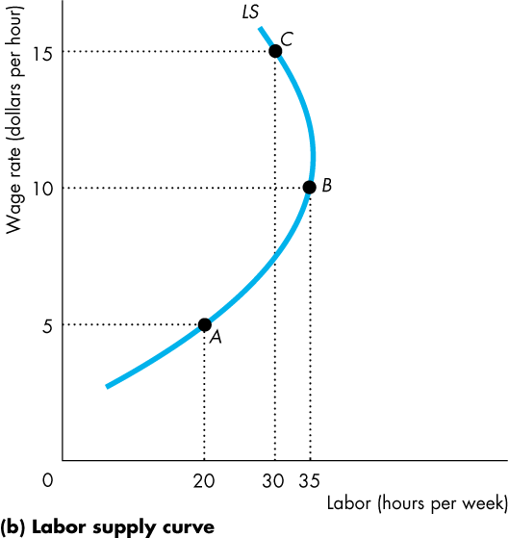
- Labour supply curve

  - Relationship between income effect and substitution effect

Ch. 10: Technological and Economic Efficiency
- Technological efficiency: occurs when the firm produces a given output by using the least amount of inputs
- Economic efficiency: occurs when the firm produces a given output at the least cost

Ch. 11: Output and Costs
- Short run: time frame in which the quantity of at least one factor of production is fixed
  - Capital, land and entrepreneurship tend to be fixed
  - Labour, raw materials, and energy can usually be changed
  - Short run decisions easily reversed
- Long run: time frame in which the quantities of all factors of production can be varied
  - Long run decisions are not easily reversed
  - Sunk cost: a cost incurred by the firm and cannot be changed
- Short-run technology constraint: to increase output in the short run, a firm must increase the quantity of labour employed.
  - Total product: the maximum output that a given quantity of labour can produce
  - Marginal product: the increase in total product that results from one-unit increase in the quantity of labour employed, other inputs remaining the same
  - Average product: equal to the total product divided by the quantity of labour employed
- Product curves: graphs of relationships between employment and the three product concepts
  - Total product curve: similar to PPF, separates attainable product levels from unattainable product levels
    - Height of each bar measures marginal product
  - Marginal product curve: how the marginal product relates to total product
    - Law of diminishing marginal returns: as a firm uses more of a variable factor of production, with a given quantity of the fixed factor of production the marginal product of the variable factor eventually diminishes
      - Factors of production become less suited, and less access to capital
  - Average product curve: shows average product and its relationship with marginal product
    - when marginal product equals average product, average product is at a maximum
- short-run costs: to produce more output in the short run, a firm must employ more labour, which means that it must increase its costs
  - total cost (TC): cost of all the factors of production it uses (total fixed costs and total variable costs)
    - TC = TFC = TVC
    - total fixed costs (TFC): costs of firms fixed inputs, do not change with outputs
    - total variable costs (TVC): cost of firms variable inputs, change with outputs
  - marginal cost: the increase in total costs from a one-unit increase in total product
  - average cost (ATC): total cost per unit of output
    - ATC = AFC + AVC
      - TC/Q = TFC/Q + TVC/Q
    - average fixed cost (AFC): total fixed cost per unit of output
    - average variable cost (AVC): total variable cost per unit of output
      - marginal cost curve intersects the average variable cost curve and the average total cost curve at their minimum points
      - when marginal product is rising, marginal cost is falling
      - when average product is rising, average variable cost is falling
- shifts in cost curves: technology and price of factors of production
- production function: relationship between maximum output attainable and the quantities of both capital and labour
- long-run average cost curve: relationship between the lowest attainable average total cost and output when the firm can change both the plant it uses and the quantity of labour it employs

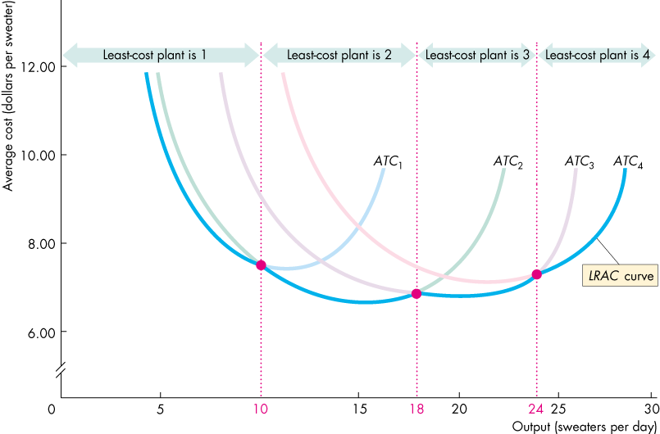

- economies of scale: features of a firm’s technology that make average total cost fall as output increases
- diseconomies of scale: features of a firm’s technology that make average total cost rise as output increases
- constant returns to scale: features of a firm’s technology that keep average total cost constant as output increases
- minimum efficient scale: smallest output at which long-run average cost reaches its lowest level

Ch. 12: Perfect Competition
- Perfect Competition:
  - Many firms sell identical products to many buyers
  - There are no restrictions on entry into the market
  - Established firms have no advantage over new ones
  - Sellers and buyers are well informed about prices
- How perfect competition arises:
  - Minimum efficient scale of a single producer is small relative to the market demand for the good or service. Room for many firms
  - each firm is perceived to produce a good or service that has no unique characteristics, so consumers don’t care which firm they buy from
- Price taker: firm that cannot influence the market price because its production is an insignificant part of the total market
  - Each firm’s output is a perfect substitute for the output of the other firms, so the demand for each firm’s output is perfectly elastic.
- Economic profit: total revenue minus total cost
  - Total cost is the opportunity cost of production which includes normal profit
- Total revenue: price multiplied by quantity sold
- Marginal revenue: change in total revenue that results from a one-unit increase in quantity sold
  - Demand, Price and Revenue (next page picture)

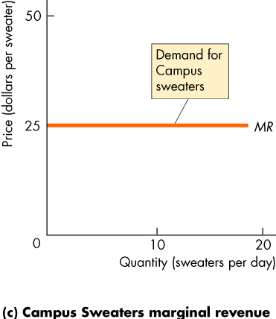
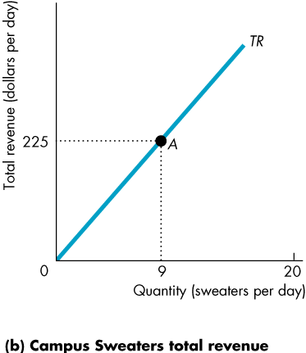
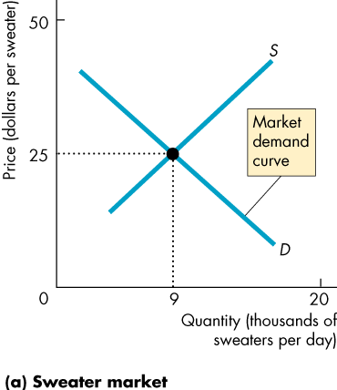

- A firm must decide
  - How to produce at minimum cost
  - What quantity to produce
  - Whether to enter or exit the market
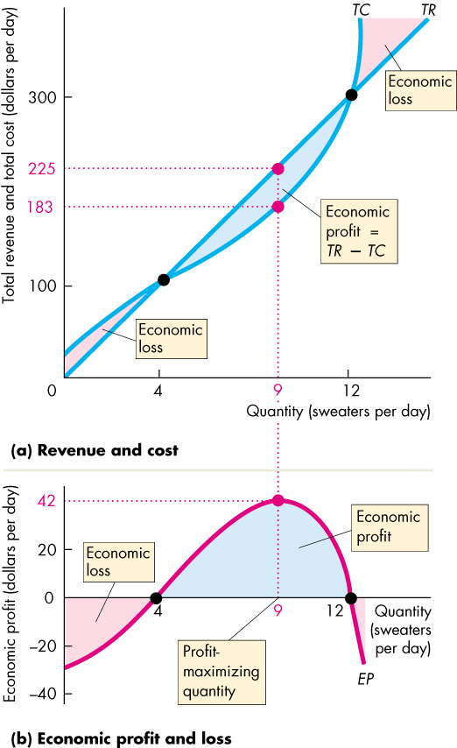
- Profit-maximizing output

- Marginal analysis: if marginal revenue exceeds marginal cost economic profit is made
  - Profit-maximizing point: when MR = MC
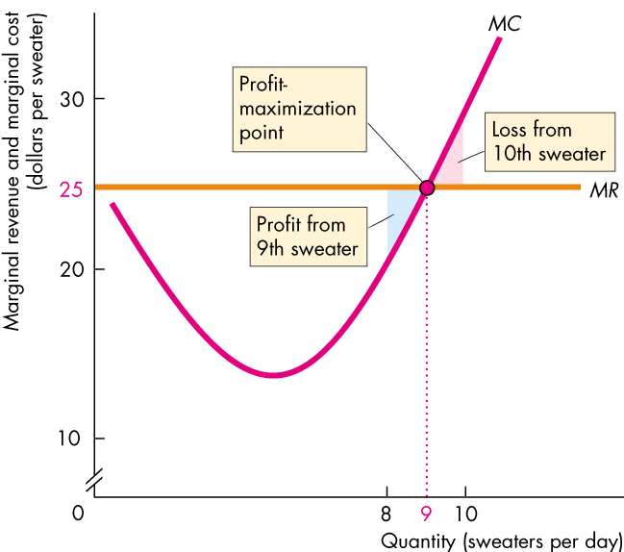

- Temporary shutdown decision: if a loss is inevitable, a firm must decide whether to shut down
  - Economic Loss = TFC + (AVC – P) X Q
  - If shut down, loss is TFC because Q = 0
- Shutdown point: price and quantity at which it is indifferent between producing and shutting down
  - Average variable cost is at a minimum
  - Average variable cost curve crosses marginal cost curve (AVC = MC)
  - If price falls below minimum AVC: then shutdown
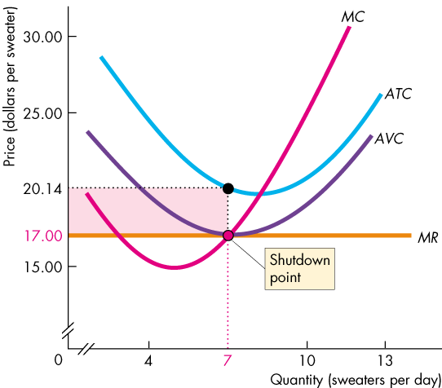
  - If price is between minimum AVC and ATC: firm continues production, but incurs loss less than TFC

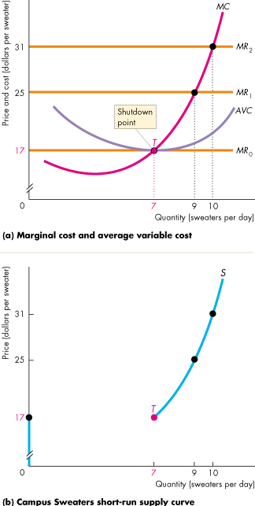

- Supply curve: derived from marginal cost curve and average variable cost curve
  - Price exceeds minimum AVC firm maximizes profit by producing where marginal cost equal price
  - Price less than minimum AVC firm maximizes profit by temporarily shutting down
  - Price equals minimum AVC firm maximizes profit by either temporarily shutting down or producing at point where AVC is minimum (shut down point)
- Short-run market supply curve: shows the qunatity supplied by all firms in the market at each price when each firm’s plant and number of firms remain the same
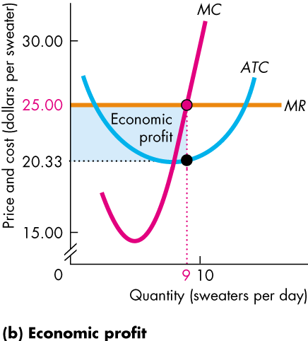
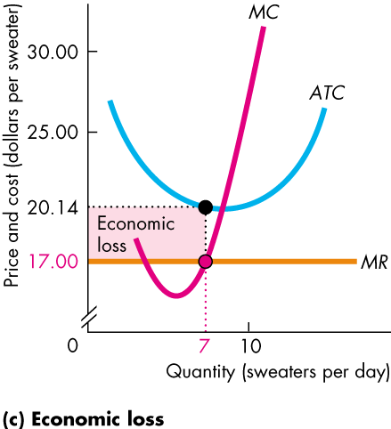
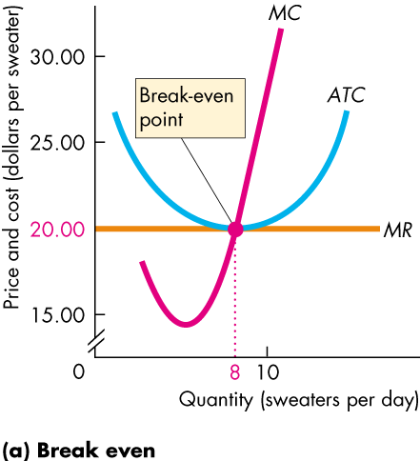
- Profits and losses in the short run

- Entry and exit: only persistent economic profit or loss trigger entry or exit
  - New firms enter a market in which existing firms are making an economic profit
  - As new firms enter a market, the market price falls and the economic profit of each firm decreases
  - Firm exit a market in which they are incurring an economic loss
  - As firms leave a market, the market price rises and the economic loss incurred by the remaining firms decreases
  - Entry and exit stop when firms make zero economic profit
  - 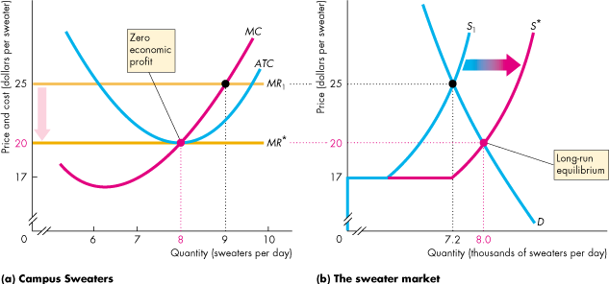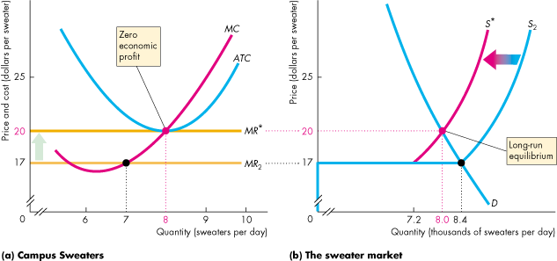
- Permanent change in demand: When demand decreases, movement along supply curve decreases price. Firms begin to incur economic losses, thus some firms exit, creating a decrease in supply.
  - Difference between initial and new long run equilibrium is the number of firms
  - 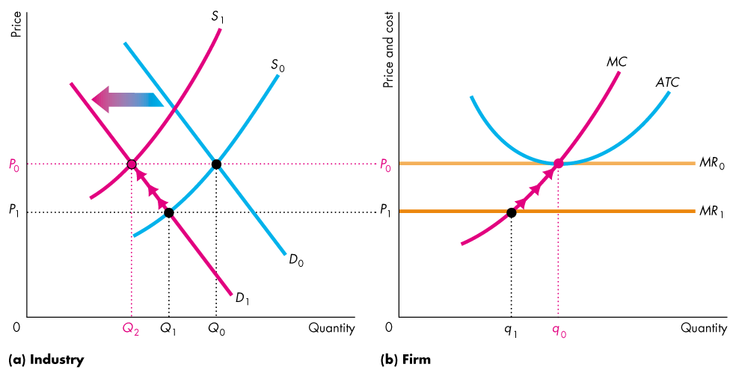
- External economies: factors beyond the control of an individual firm that lower the firm`s costs as the market output increases
- External diseconomies: factors outside the control of a firm that raise the firm`s costs as the market output increases
  - Absence of external economies or diseconomies keep the firm`s costs constant as market output changes
- Long run market supply curve: shows how the quantity supplied in a market varies as the market price varies after all the possible adjustments have been made, including changes in each firm`s plant and the number of firms in each market
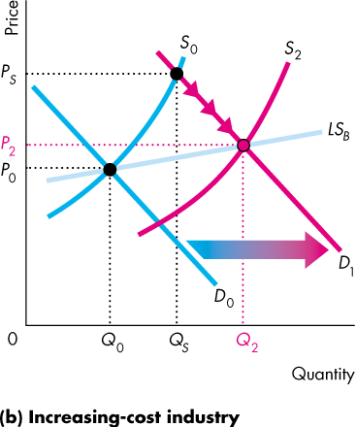
  - Absence External diseconomies
  - 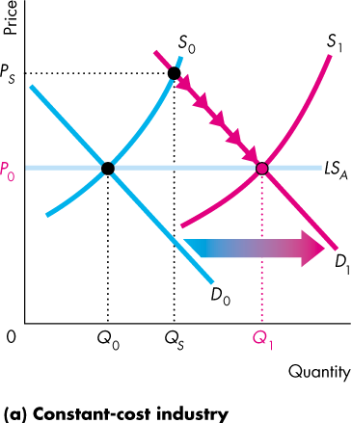

  - External economies
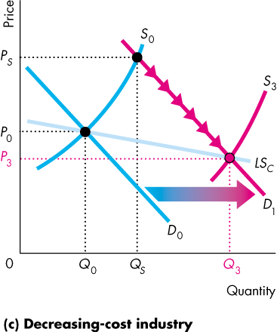

- Efficient use of resources: when no one can be made better off without making someone else worse off
  - marginal social benefit equal marginal social cost
  - Choices
    - Consumers get most value from resources along demand curve
    - No external benefits means demand curve is the marginal social benefit curve
    - Firms get most value from resource along supply curve
    - No external cost means supply curve is the marginal social cost curve
  - Equilibrium and efficiency
    - The gains from trade for consumers are measured by consumer surplus.
    - The gains from trade for producers are measured by producer surplus.
    - Total gains from trade equal total surplus.
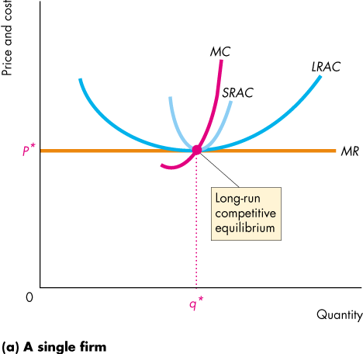
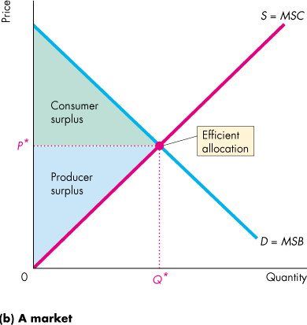
    - In long-run equilibrium total surplus is maximized.

Ch. 13: Monopoly
- Monopoly: a market:
  - That produces a good or service for which no close substitutes exist
  - In which there is one supplier that is protected from competition by a barrier preventing the entry of new firms
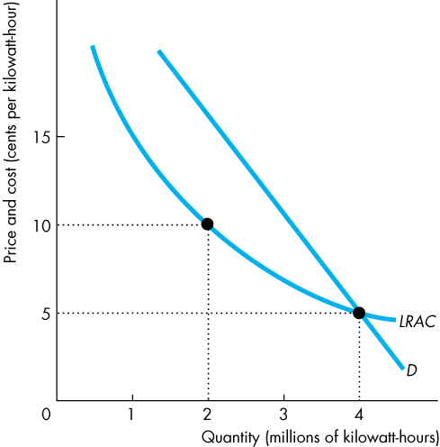
- Natural barrier to entry: creates a natural monopoly
  - Natural monopoly: an industry in which economies of scale enable one firm to supply the entire market at the lowest possible cost
    - In a natural monopoly, economies of scale are so powerful that they are still being achieved even when the entire market demand is met.
    - The LRAC curve is still sloping downward when it meets the demand curve.
- Ownership barrier to entry: if one firm owns a significant portion of a key resource
- Legal barrier to entry: creates a legal monopoly
  - Legal monopoly: a market in which competition and entry are restricted by the granting of a public franchise, government licence, patent, or copyright
    - Public franchise: an exclusive right granted to a firm to supply a good or service
      - Like Canada Post
    - Government licence: controls entry into particular occupations
      - Licence to practise law or medicine
    - Patent or copyright: an exclusive right
- Single-price monopoly: a firm that must sell each unit of its output for the same price to all its customers
- Price discrimination: practice of selling different units of a good or service for different prices. Many firms price discriminate: but not all of them are monopoly firms
Single-Price Monopoly
- Price setter not a price taker
  - Demand for monopoly’s output is the market demand (one firm)
  - Total Revenue = Price x Quantity
  - MR < P
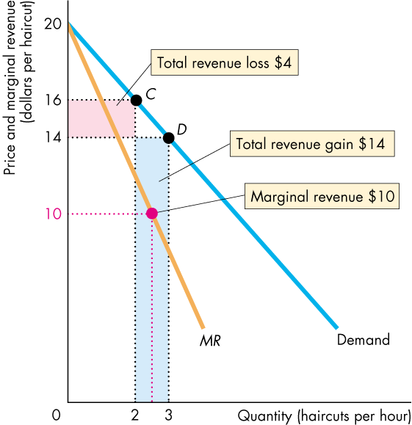
    - Marginal revenue is always less than price

    - Moving from a price of $16 to $14, the monopoly sells one extra unit. However, it loses $2 on the first two haircuts (2 x $2 = $4) and makes $14 on the extra unit. Therefore marginal revenue is $10 ($14 - $4 = $10)
- Marginal revenue and elasticity
  - If demand is elastic a fall in price brings an increase in total revenue
- If demand is inelastic a fall in price brings a decrease in total revenue
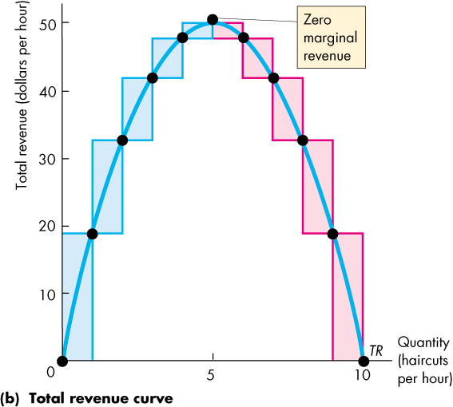
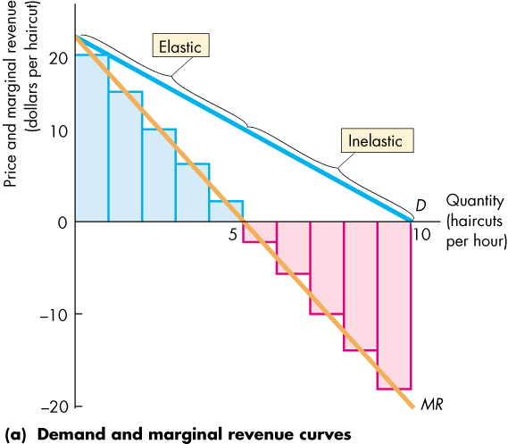

    - Total revenue is maximized when MR = 0
    - In a monopoly demand is always elastic
      - No point in producing in inelastic demand
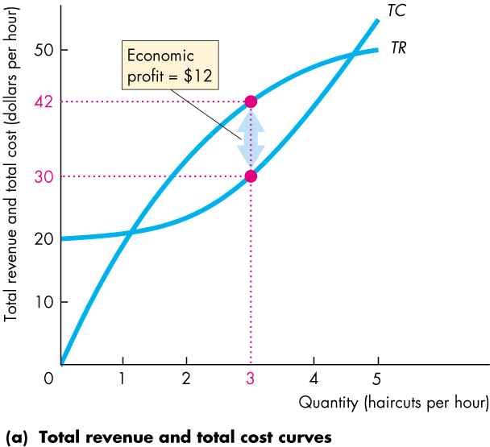
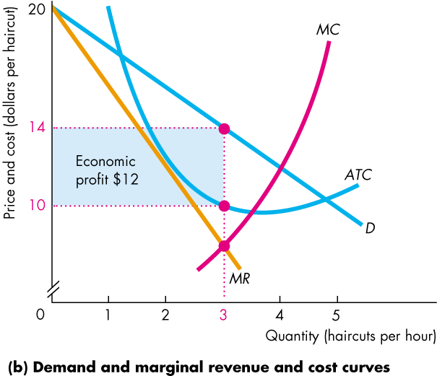
- Profit-maximizing point at MC = MR

- Production efficiency when MSC = MSB (marginal social cost = marginal social benefit)
    - Monopoly: P >MSC , so MSB > MSC
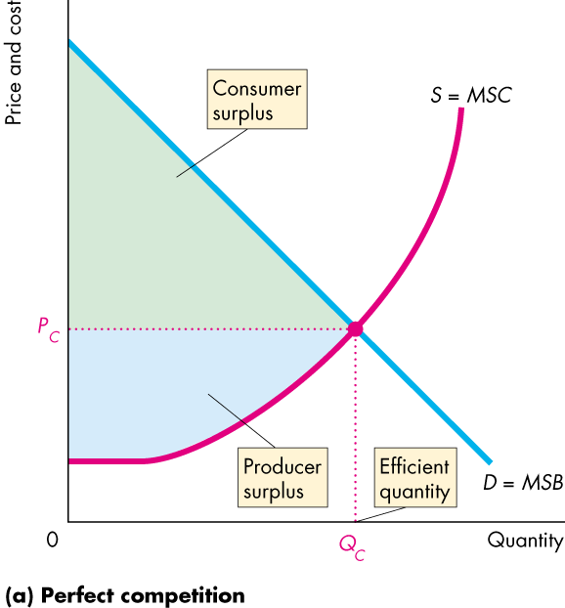
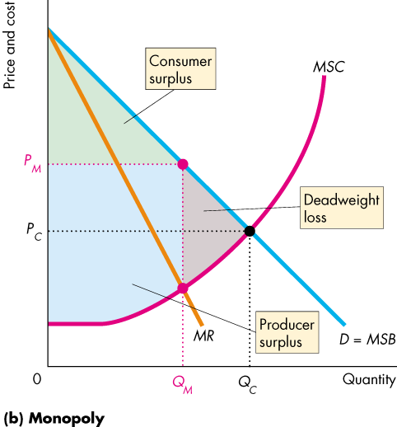
    - Monopoly produces where MC = MR

    - Monopoly is inefficient because it can charge more and produce less and make more profit
      - Some lost consumer surplus goes to producer surplus
- Economic rent: any surplus – consumer surplus, producer surplus, economic profit
- Rent seeking: pursuit of wealth by capturing economic rent
  - Buy a monopoly: transfers rent to creator of monopoly
  - Create a monopoly: uses resources in political activity
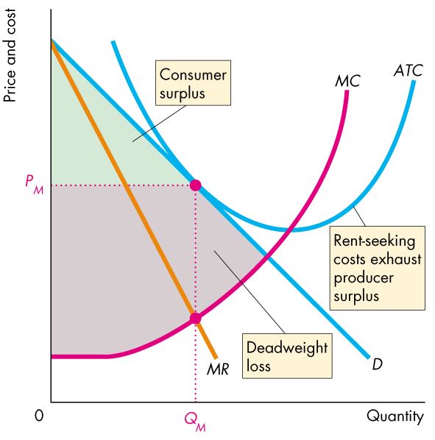
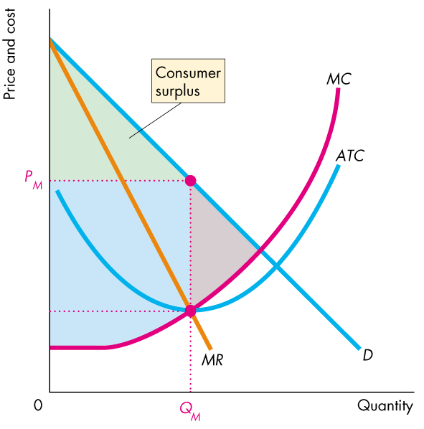
    - Lobbying and influencing politicians

    - Resources used in rent seeking can exhaust economic profit
      - Average total cost goes up and profits disappear
Price Discrimination
- To be able to price discriminate
  - Identify and separate different buyer types
  - Sell a product that cannot be resold
- Price discrimination captures consumer surplus and converts is to economic profit
- Firms can discriminate
  - Among groups of buyers
    - Advanced ticket sales, business travellers vs. vacation travellers
  - Among units of a good
    - Quantity discounts (not if discount for bulk purchase arises from lower costs of production)

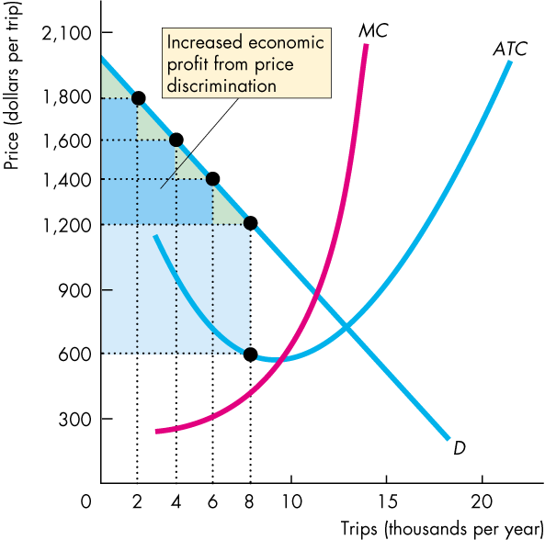
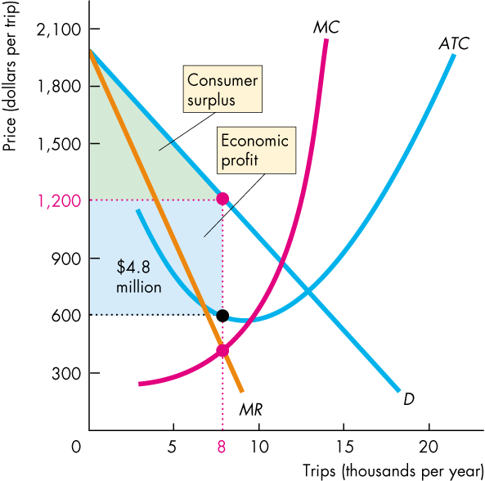

    - Market research helps find different categories (of travellers) and different price levels increases economic profit
- Perfect price discrimination: occurs if a firm is able to sell each unit of output for the highest price anyone I willing to pay for it
  - entire consumer surplus is eliminated
  - Demand curve becomes marginal revenue curve
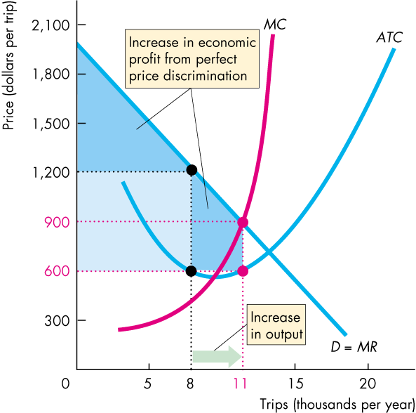
    - Marginal revenue = price

- The profit-maximizing output increases to the quantity at which price equals marginal cost.
- Economic profit increases above that made by a single-price monopoly.
- Deadweight loss is eliminated.
- The more perfectly a monopoly price discriminates the closer is the output to competitive output (P = MC), more efficient
  - Differs from perfect competition
    - The monopoly captures the entire consumer surplus
    - The increase in economic profit attracts even more rent-seeking activity that leads to inefficiency
- Regulation: rules administered by a government agency to influence prices, quantities, entry and other aspects of economic activity
- Deregulation: process of removing regulation of prices, quantities, entry, and other aspects of economic activity in a firm or industry
- Social interest theory: the political and regulatory process relentlessly seeks out inefficiency and regulates to eliminate deadweight loss
- Capture theory: regulation serves the self-interest of the producer, who captures the regulator
- Marginal cost pricing rule: a regulation that sets the price equal to the monopoly’s marginal cost
  - Regulation of a natural monopoly to produce efficient quality
  - Average cost exceeds price so loss is incurred
    - Uses price discrimination or two-part pricing to cover costs
- Government subsidy could be granted to cover economic loss
- Average cost pricing rule: sets price equal to average total cost
  - zero economic profit
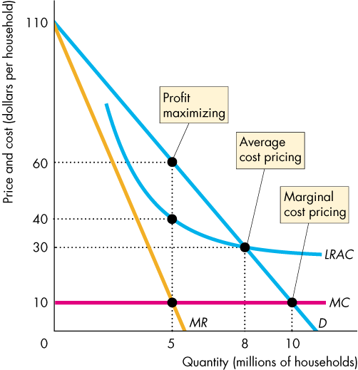
  - ATC > MC, quantity produced is less than efficient quantity so deadweight loss arises

  - Average cost pricing hard to implement because it is not possible for a regulator to be sure of firm’s costs
- Rate of return regulation: a firm must justify its price by showing that its return on capital doesn’t exceed a specified rate
  - type of regulation can end up serving self-interest of the firm rather than social interest
  - managers have an incentive to inflate costs and use more capital than the efficient amount
- Price cap regulation: price ceiling
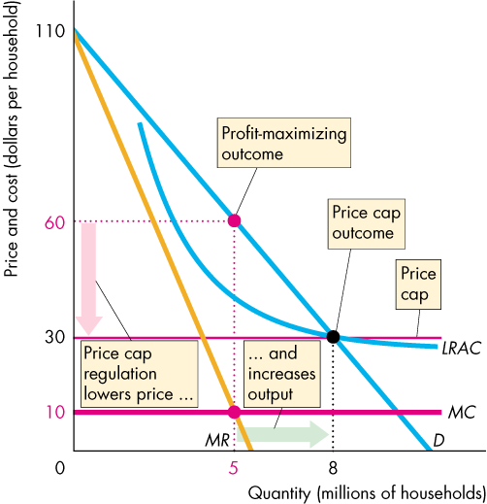
  - Type of regulation gives the firm an incentive to operate efficiently and keep costs under control

Ch. 14: Monopolistic Competition
- Monopolistic competition: a market structure in which:
  - A large number of firms compete
    - Each firm has only a small market share and therefore has limited market power to influence the price of its product
    - No firms actions affects other firms
    - Collusion is impossible
  - Each firm produces a differentiated product
    - Product differentiation: firm makes products that are slightly different from other products of competing firms
  - Firms compete on product quality, price, and marketing
    - Product differentiation allows for competition
      - Quality: design, reliability, and service
      - Tradeoff between price and quality
      - Marketing takes on the form of advertising and packaging
  - Firms are free to enter and exit the industry
    - No barrier to entry
      - So firms cannot make an economic profit in the long run
- Firms decide on price based on demand curve
  - Highest price that a firm can charge for the profit-maximizing quantity (or loss-minimizing if ATC > P)

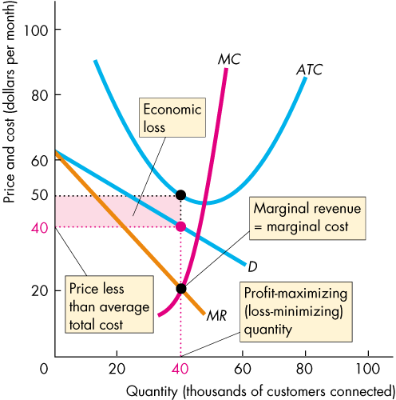
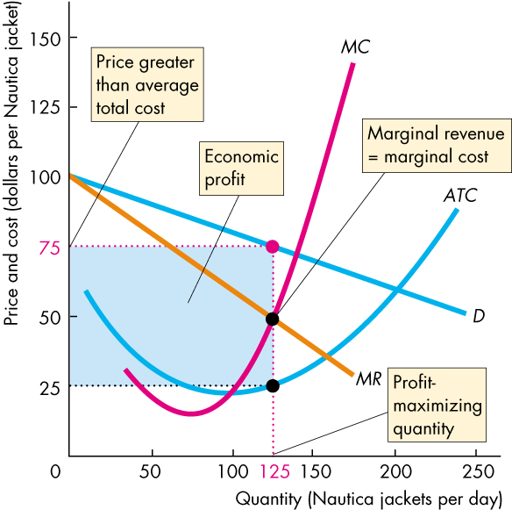

    - In the long run economic profit induces entry
      - As firms enter, each existing firm loses some market share
        - Demand decreases and shifts leftward
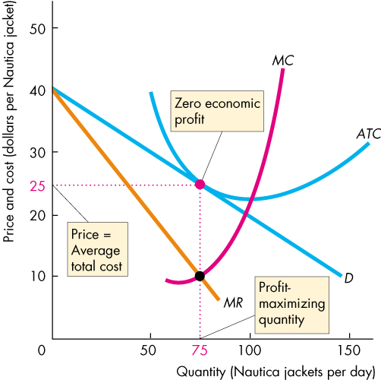
        - Eventually economic profit = 0

- Differences between monopolistic competition and perfect competition
  - Excess capacity: if a firm produces less than the quantity at which ATC is minimum
  - Produces below efficient scale
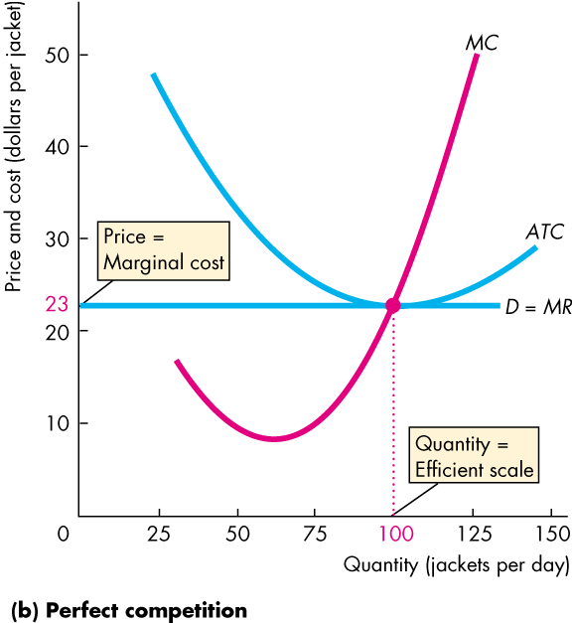
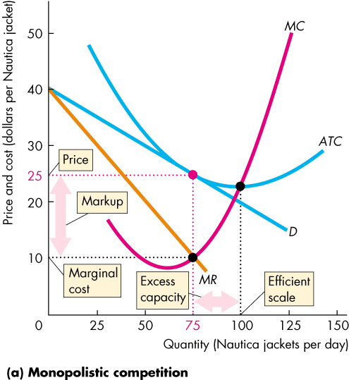
  - Markup: the amount by which its price exceeds its marginal cost

- Efficiency
  - In the long run produces less than efficient quantity
    - Price = Marginal Social Cost
    - Marginal Cost = Marginal Social Cost
    - Price > Marginal Cost
      - Marginal Social Benefit > Marginal Social Cost
- Making the relevant comparison
  - Markup that drives the gap between price and marginal cost arises from product differentiation
  - Efficient degree of product variety is when MSB = MSC
  - The loss that arises because the quantity produced is less than the efficient quantity is offset by the gain that arises from having a greater degree of product variety.

