Comm 222-Final Study Guide

Midterm chapters (MCQs) 30% of the final aproximately
Chapter 2- Personality & Learning

- Personality is the relatively stable set of psychological characteristics that influences the way an individual interacts with his or her environment. It is reflected in the way people react to other people, situations, and problems.
  - Dispositional approach: individuals possess stable traits or characteristics that influence their attitudes and behaviours (from within).
  - Situational approach: characteristics of the organizational setting influence people’s attitudes and behaviour (from environment).
  - Interactionist approach: individuals’ attitudes and behaviour are a function of both dispositions (from both dispositional/situational).
  - Trait activation theory: traits lead to certain behaviours only when the situation need it.
- The Five Factor Model of personality: OCEAN
Psychologists have discovered that there are about five basic, but general dimensions that describe personality:
- Openness to Experience Curious, original vs. dull, unimaginative.
- Conscientiousness Dependable, responsible vs. careless, impulsive
- Extraversion Sociable, talkative vs. withdrawn, shy.
- Agreeableness Tolerant, cooperative vs. cold, rude.
- Neuroticism / Emotional Stability Stable, confident vs. depressed, anxious.

There is evidence that each of the “Big Five” dimensions is related to job performance. High conscientiousness is related to performance for all occupations and the best predictor of performance of all the “Big Five” dimensions. The “Big Five” dimensions have also been found to be related to motivation, job satisfaction, and career success.
- Locus of control is a set of beliefs about whether one's behaviour is controlled mainly by internal or external forces. High "externals" see their behaviours controlled by factors like fate, luck and powerful people. High "internals" see stronger effects on their behaviour as a consequence of self-initiative, personal actions and free will.
  - Self-monitoring is the extent to which people observe and regulate how they appear and behave in social settings and relationships. Low self-monitors act like they feel and say what they think without regard to the situation. High self-monitors behave somewhat like actors, taking great care to observe and control the images that they project.
  - Self-esteem is the degree to which a person has a positive self-evaluation. People with high self-esteem have favourable self-images. According to behavioural plasticity theory, people with low self-esteem tend to be more susceptible to external and social influences than those who have high self-esteem.
- Learning

What employees learn? :

-Practical Skills : job specific skills, knowledge, technical competence
-Intrapersonnal Skills : problem solving, critical thinking, alternative work processes
-Interpersonnal Skills : Interactive Skills(communicating, teamwork and conflict resolution)
-Cultural awareness : Social norms of org., company goals etc.

  - According to Operant Learning theory (J-F SkinnerLearning by doing), the subject learns to operate on the environment to achieve certain consequences. Operant learning can be used to increase or reduce the probability of behaviour. It is learning by doing, by operating in the situation you learn to do the task better.
    - Positive Reinforcement : increases or maintains the probability of some behaviour by the application or addition of a stimulus to the situation in question. This stimulus is called the positive reinforcer. Although positive reinforcers tend to be pleasant stimuli, this is not always true since the resultant increase or maintenance of behaviour determines whether or not a given stimulus was a positive reinforcer.
    - Negative Reinforcement : increases or maintains the probability of some behaviour by the removal of a negative stimulus from the situation in question. Remove an impediment to someones performance (ex. restrictive workspace, noisy environment).
  - Extinction is the gradual dissipation of behaviour following the termination of reinforcement. If the behaviour is not reinforced, it will gradually dissipate or be extinguished.
  - Punishment : application of an aversive stimulus following unwanted behaviour to decrease probability of that behaviour.

- Social Cognitive Theory is when people learn by observing the behaviour of others. Individuals also manage their own behaviour by thinking about the consequences of their actions, setting performance goals, monitoring their performance and comparing it to their goals, and rewarding themselves for goal accomplishment. (3 Components for sustained SCT)
  - Observational Learning: observing the behaviour of others (role models)
  - Self-efficacy refers to beliefs people have about their ability to successfully perform a specific task (you have to believe you can do it). It is a cognitive belief that is task specific and is the result of four sources of information: experience performing the task; observation; verbal persuasion and encouragement; and physiological state.
  - Self-regulation involves observing your own behaviour VS others(models), goal setting, rehearsal, and self-reinforcement. A key part of the process is self-set goals that guide people’s behaviour

Chapter 3- Perception, Attribution, & Diversity
- Perception is the process of interpreting the messages of our senses to provide order and meaning to the environment. Among the most important perceptions that influence organizational behaviour are the perceptions that organizational members have of each other.(perceiver→ situation → target)
  - Bruner’s model of the perceptual process. According to Bruner, when the perceiver encounters an unfamiliar target, the perceiver is very open to the informational cues contained in the target and the situation surrounding it. In this unfamiliar state, the perceiver really needs information on which to base perceptions of the target and will actively seek out cues to resolve this ambiguity.
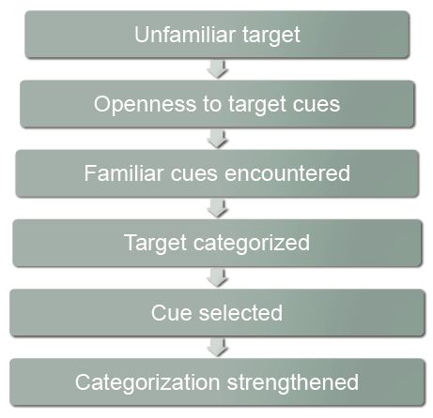
New co-worker

Observation : search for information

Co-worker is Stanford graduate with good grades

Co-worker is ‘’good man’’ with ‘’great potential’’

Co-worker poor performance ignored or distorted

Co-worker is still a ‘’good man’’ with ‘’great potential’’

- Biases in person perception
  - Primacy and recency effects
    - Primacy is the tendency for perceivers to rely on early cues for first impressions
    - Recency is the tendency to rely on the recent or last cues
  - Reliance on central traits
    - Central traits: personal traits of a target person that are of interest to the perceiver
  - Implicit personality theory: personal theories that people have about which personality characteristics go together
  - Projection: attributing your own feelings and thoughts to others.
  - Stereotyping is the tendency to generalize about people in a social category and ignore variations among them(ex. all scientist are bright and all football players are ignorant)

- Attribution Theory: attribution is the process by which we assign causes or motivesexplain people’s behaviour
  - Dispositional attributions: person acts a certain way because of internal characteristics(personality, values, intelligence, desires, etc.)
  - Situational attributions: person acts a certain way because of the situation or the environment
  - Biases in attribution
    - Fundamental attribution error: the tendency to overemphasize dispositional explanations for behaviour at the expense of situational explanations
    - Actor-Observer Effect is the tendency for actors and observers to view the causes of the actor’s behaviour differently.
    - Self-serving bias is the tendency to take credit for successful outcomes and to deny responsibility for failures.

- Workforce diversity refers to differences among employees or potential recruits in characteristics such as race, gender, age, religion, cultural background, physical ability, and sexual orientation.
  - Valuing diversity: A critical motive for valuing diversity is the basic fairness of valuing diversity. In addition, there is increasing awareness that diversity and its proper management can yield strategic and competitive advantages (cost, marketing, ressource-aquisition, marketing, creativity, problem solving).

Chapter 4- Values, Attitudes & Work Behaviour
- Values are broad tendencies to prefer certain states of affairs over others. What we consider good from bad.

- Hofstede’s Study
  - Power distance
    - Small power distance cultures, inequality is minimized, superiors are accessible and power differences are downplayed
    - Large power distance societies, inequality is accepted as natural, superiors are inaccessible and power differences are highlighted
  - Uncertainty avoidance
    - Strong uncertainty avoidance cultures stress rules and regulations, hard work, conformity and security.
    - Weak uncertainty avoidance cultures are less concerned with rules, conformity, and security, and hard work is not seen as a virtue.
  - Masculinity/Femininity
- Masculinity : differentiate gender roles, support dominance of men and stress economic performance
- Feminity : accept fluid gender roles, stress sexual equality and quality of life
  - Individualism/Collectivism
- Individualism : stress independence, individual initiative
- Collectivism : stress interdependence and loyalty to family
  - Long-term/Short-term orientation
    - Long-term orientation cultures tend to stress persistence, perseverance, thrift, and close attention to status differences
    - Short-term orientation cultures stress personal steadiness and stability, face-saving, and social niceties.
- Attitude is a fairly stable evaluative tendency to respond consistently to some specific object, situation, person, or category of people.
Values + Beliefs→ Attitude Behaviour
- Job satisfaction refers to a collection of attitudes people have toward their job. It results from an evaluation of the job in general (specific facets of the job: security, benefits, pay, etc.)
  - According to discrepancy theory, job satisfaction stems from the discrepancy between what you think you should receive VS what you actually receive(expected vs obtained).
  - Fairness
    - Distributive fairness is the fairness that occurs when people receive the outcomes they think they deserve from their jobs (outcomes we receive)
    - Procedural fairness is the fairness that occurs when the process to determine work outcomes reasonable .
    - Interactional fairness is the fairness that occurs when people feel they have received respectful and informative communication about an outcome(treatment)
  - According to the dispositional view of job satisfaction, some people’s inherent personality traits allow them to be more or less satisfied despite changes in discrepancy and fairness.
  - Moods are the less intense than emotions, however, they are longer-lived feelings
  - Emotions are more intense, short-lived feelings resulting from a particular event.
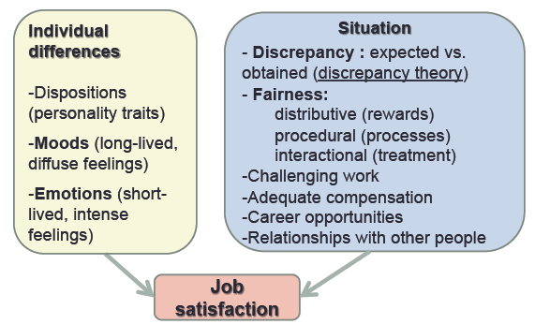
- Job satisfaction on absenteeism/turnover/performance: Higher job satisfactionlower absenteeism and lower turnover (employee leaving the office permantly) and higher performance but it depends (not a perfect relationship-external factors such as skill).
  - Organizational citizenship behaviour (OCB) : is voluntary, informal behaviour that contributes to organizational effectiveness.
Examples of OCB : Helping another worker, being friendly and cooperative, volunteering for extra work, and conscientious attention to detail = GOOD OCB
  - Customer satisfaction is related to job satisfaction and organizational profitability. Organizations with higher average levels of employee satisfaction are more effective. The reasons for this include reduced absenteeism and turnover which contribute to the seamless delivery of service..
- Commitment
  - Organizational commitment is an attitude that reflects the strength of the linkage between an employee and an organization.
  - Affective commitment is being there because you want to be there
  - Continuance is based on the costs that would be incurred in leaving an organization (you have to be there)
  - Normative commitment is based on ideology or a feeling of obligation to an organization (you feel you should be there)

Chapter 5- Theories of Work Motivation
- Motivation is the extent to which persistent effort is directed toward a goal. The four basic characteristics of motivation are effort, persistence, direction, and goals
  - Intrinsic motivation stems from the direct relationship between worker and task, usually self-applied (reasons from within)
  - Extrinsic motivation stems from the work environment external to the task usually applied by others (reasons from outside)
  - Self determination theory is the theory of motivation that considers whether people’s motivation is autonomous or controlled.
    - Autonomous motivation(SDT) is when people are self motivated by intrinsic factors and because they choose to achieve a certain goal
    - Controlled motivation (SDT) is when people are motivated to obtain a desired consequence or extrinsic reward or punishment, they are motivated by an external force.
- Performance can be defined as the extent to which an organizational member contributes to achieving the objectives of the organization (Conscientiousness linked to performance). Factors that predict performance:
  - General cognitive ability refers to a person’s basic information processing capacities and cognitive resources(intelligence).
  - Emotional Intelligence has to do with an individual’s ability to understand and manage his or her own and others’ feelings and emotions (involves empathy and self regulation).

- McClelland’s needs theory is a nonhierarchical need theory of motivation that outlines the conditions under which certain needs result in particular patterns of motivation. Individuals have needs for achievement, affiliation, and power. The theory outlines the conditions under which these needs result in particular patterns of motivation.
- Expectancy theory a process theory that states that motivation is determined by the outcomes that people expect to occur as a result of their actions on the job (outcomes, instrumentality, valence, expectancy, force). First level outcome benefit the organization and second level is to benefit yourself (expectancy theory is culturally transferrable Work all around the world).
- Equity Theory is a process theory that states that motivation stems from a comparison of the inputs one invests in a job VS outcomes one receives in comparison with the inputs and outcomes of another person or group of similar statue.
- Goal setting theory goals are motivational when they are :
1-specific
2-challenging
3-organizational members are committed to them
4-Feedback about progress toward goal attainment is provided (goal specificity, goal challenge, goal commitment, goal feedback).
GOALS Mechanisms Performance

- Cross-cultural limitations of theories of motivation
In general :motivational theories which explain the behaviour of workers in North American companies do not always apply to workers elsewhere. It is safe to assume that most theories that revolve around human needs will come up against cultural limitations to their generality.

For example, in more collective societies, self-actualization is not the motivator that it is in North America .

In collective cultures : tendency to favour reward allocation based on equality rather than equity. Because of its flexibility, expectancy theory is very effective when applied cross-culturally.

Setting specific and challenging goals : should also be motivational when applied cross-culturally. However, to be effective, careful attention is required to adjust the goal-setting process in different cultures.
For example, individual goals are not likely to be accepted or motivational in collectivist cultures.

Chapter 6- Motivation in Practice
- Money as a motivator: Money can be a motivator to the extent that it satisfies a variety of needs, is highly valent, and it is clearly tied to performance. Money is a motivator because it allows you to buy what you want, however, it is controlled motivation (extrinsic).
- Job Design as a motivator: The use of job design as a motivator represents an attempt to capitalize on intrinsic motivation. The goal of job design is to identify the characteristics that make some tasks more motivating than others and to capture these characteristics in the design of jobs.
  - Job scope is the breadth and depth of a job
    - Breadth is the number of different activities performed on a job
    - Depth is the degree of discretion or control a worker has over how work tasks are performed.

- Job Characteristics Model, use model before conducting job enrichment to analyze what needs to be improved ( REMEMBER STTAF) like the word STAFF or VISAF(see underline letters)
  - Skill Variety :degree a job provides the opportunity to do a variety of different activities using various skills and talents.
  - Task Identity : job involves doing a complete piece of work (Beginning End).
  - Task Significance job has a substantial impact on other people.
  - Autonomy : job freedom degree to schedule one’s own work activities and decide work procedures.
  - Feedback : information about the effectiveness of one’s work performance.
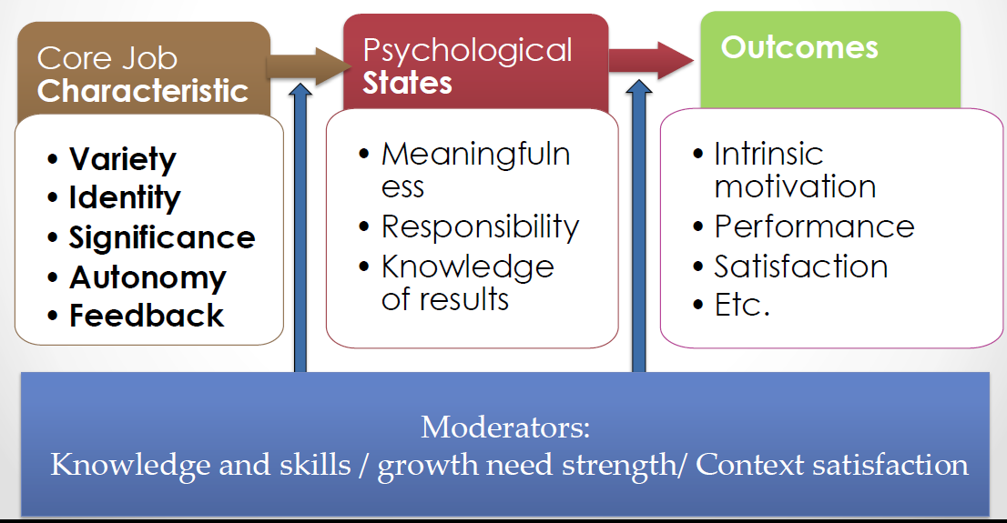

- Job enrichment is the design of jobs to enhance intrinsic motivation, the quality of working life, and job involvement. Job enrichment means manipulating one or more of the five job characteristics model to make the job more interesting to the employee.

Examples of job enrichment:
-Combining tasks
-Establishing external client relationships and internal client relationships
-Reducing supervision or reliance on others,
-Forming working teams
-Making feedback more direct.

Negative effects of job enrichment:
-Demand for rewards
-Union resistance, supervisory resistance
-Lack of desire or skill

- Management by objectives(MBO) is an elaborate, systematic, ongoing program designed to faciliate :
1-Goal establishment and Goal accomplishment
2- Employee development

Examples of MBO : In a well-designed MBO program, objectives for the organization as a whole are developed by top management and diffused down through the organization through the MBO process.

- Alternative work schedules, the purpose of alternative work schedules is to meet the diverse workforce needs and promote job satisfaction.
  - Flex time: arrival and quitting times are flexible.
  - Compressed Workweek: employees work fewer than the normal five days a week but still put in a normal number of hours per week.
  - Job Sharing: two part-time employees divide the work of a full-time job.
  - Telecommuting: a system by which employees are able to work at home but stay in touch with their offices through the use of communications technology

Main Focus of the Final Exam (70% aproximately)

Chapter 7- Groups & Teamwork
- Groups :two or more people interacting interdependently to achieve a common goal.
  - Formal groups are established by organizations to facilitate the achievement of organizational goals (Consist of Manager and employees).
  - Informal groups are groups that emerge naturally in response to the common interests of organizational members.
- Stages of Group Development TIPS****PANFS think of the word PANTS with a F
(Pants because sometimes in group someone have to wear the pants and make decisions)

  - Forming: Group members try to orient themselves by “testing the waters”.
  - Storming: Confrontation and criticism occur as members determine whether they will go along with the way the group is developing.
  - Norming: Members resolve the issues that provoked the storming, and they develop social consensus.
  - Performing: The group devotes its energies toward task accomplishment
  - Adjourning: Rites and rituals that affirm the group’s previous successful development are common. Members often exhibit emotional support for each other.

***Not all groups go through these stages of development
- Punctuated Equilibrium model describes how groups with deadlines are affected by their first meetings and crucial midpoint transitions
  - First meeting (Phase 1): Starts with the first meeting- sets agenda and tone for the phase until the midpoint.
  - Midpoint: transition that occurs halfway before the deadline.
  - Project deadline (Phase 2): decision from midpoint is applied.

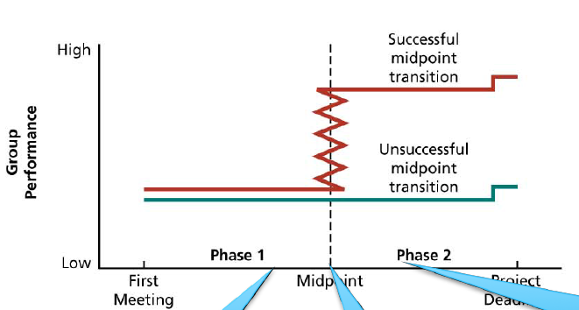

- Group structure(and its consequences) refers to the characteristics of the stable social organization of a group, the way a group is “put together’’.

  - Group Size: consequences caused by group size depends on the type of task(additive, disjunctive, conjunctive) the group initiates. (satisfaction is higher in small groups)
  - Group Size and Performance : the relation between group size and performance depend on the task to complete and how we define good performance
    - Additive tasks in which group performance is dependent on the sum of the performance of individual group members.
    - Disjunctive tasks in which group performance is dependent on the performance of the best group member.
    - Conjunctive tasks in which group performance is limited by the performance of the poorest group member.
  - Diversity: diverse groups have a more difficult time communicating and becoming cohesive, so group development takes longer.
  - Norms : collective expectations that members of social units have regarding the behaviour of each other.
Example of Norms :They are codes of conduct that specify what individuals should do and not do and standards against which we evaluate the appropriateness of behaviour.
  - Roles are positions in a group that have a set of expected behaviours attached to them. The most consistent consequences of role conflict are job dissatisfaction, stress reactions, lowered organizational commitment, and turnover intentions.
  - Status: Consequences of Status Differences Status affects the ways in which people communicate with each other. Most people like to communicate with others at their own status or higher, rather than with people who are below them.
- Group cohesiveness. Cohesive groups are those that are especially attractive to their members. Members especially desirous of staying in the group to describe the group in favourable terms.
- Factors making a group more cohesive:
  - Threat and Competition : External threat and competition CAN force members to work together when group goals in danger. External threats to survive have often resulted in greater cohesiveness.
  - Success : When a group accomplishes a goal, members feel pride and tend to become more cooperative with each other more attractive to its members.
  - Member Diversity : Task accomplishment will be a more important factor than member similarities in determining cohesiveness.
  - Size : Larger groups have a more difficult time in becoming and staying cohesive.
  - Toughness of Initiation : Groups that are tough to get into are more attractive than those that are easy to join. (same thing with girls and boys relationship)
- Consequences of Cohesiveness
  - More Participation: Leads to lower turnover and lower absenteeism.
  - More Conformity: members respect group norms, pressure may be applied on “deviants”
  - More Success: fewer differences in productivity of group members.
- Social loafing is the tendency to withhold physical or intellectual effort when performing a group task.
-Consequence of social loafinglow motivation

Also, It is one of the reasons for process losses in large groups and takes two forms :
1-Free rider effect : people lower their effort to get a free ride at the expense of other group members
2- Sucker effect : people lower their effort because of the feeling that others are free riding.

Chapter 8- Social Influence, Socialization & Culture
- Organizational culture consists of the shared beliefs, values, and assumptions that exist in an organization. These beliefs, values, and assumptions determine the norms that develop and the patterns of behaviour that emerge from these norms. Organizational culture is what defines the organization and it is what the company stands for :
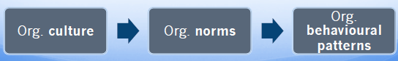

- Assets of strong cultures
  - In a strong culture, the beliefs, values and assumptions that make up the culture are both intense and pervasive across the organization.
    - Coordination is the overarching values and assumptions facilitate the coordination of different parts of the organization and communication.
    - Conflict resolution, sharing core values is a powerful mechanism that facilitate conflict resolution.
    - Financial success, strong cultures contribute to financial success and other indicators of organizational effectiveness when the culture supports the mission, strategy and goals of the organization.
- Liabilities of strong cultures
  - Resistance to change : can damage a firm’s ability to innovate
  - Culture clash : can mix badly when a merger or acquisition pushes two together with different POV’s.
  - Pathology : culture based on beliefs, values and assumptions that support infighting, secrecy and paranoia.
- How to diagnose an organizational culture
  - One way of learning about a culture is to examine the symbols, rituals, and stories that characterize the organization's way of life.
    - Symbols such as a corporate motto or mascot provide common meaning and reinforce cultural values and what the company considers important.
    - Rituals and ceremonies such as parties and gatherings are expressive events that define and build the culture. They send a cultural message and convey the essence of a culture.
    - Stories, the folklore of organizations – stories about past organizational events – is a common aspect of culture. Stories and anecdotes, both pleasant and unpleasant, are told repeatedly across generations of employees to communicate informally “how things work”. Such stories reflect the uniqueness of organizational cultures.
Chapter 9- Leadership
- Leadership is the influence that particular individuals exert on the goal achievement of others in an organizational context.
  - Formal leadership : holds a position of authority within the organization (they are expected to influence others).
  - Informal leadership : without a formal position of authority within the organization (they emerge to occupy leadership roles).
- Trait theory of leadership (trait approach), leadership depends on the personal qualities or traits of the leader.
  - Trait predictors of leadership effectiveness:
-Intelligence -Honesty and integrity
-Energy and drive -Need for achievement
-Self-confidence -Sociability
-Dominance -Emotional stability
-Motivation to lead
- Limitations: only moderate relationships b/w these traits and leadership effectiveness

- Leadership behaviours (behavioural approach)

  - Consideration:extent to which a leader is approachable and shows personal concern and respect for employees.
  - Initiating structure: degree to which a leader concentrates group goal attainment (defines tasks, procedures etc.)
    - Limitations: situation is not considered and these behaviours are not related to effectiveness equally across circumstances (view consequences in book)

- House’s path-goal theory(situational approach)

  - Directive behaviour, directive leaders schedule work, maintain performance standards, and let employees know what is expected from them
  - Supportive behaviour, supportive leaders are friendly, approachable, and concerned with pleasant interpersonal relationships
  - Participative behaviour, participative leaders consult with employees about work issues and consider their opinion
  - Achievement-oriented behaviour, leaders encourage employees to exert high effort and strive for a high level of goal accomplishment

- Participative leadership, involving employees in making work-related decisions.
  - Vroom and Jago Model (situational model of participation) a model that attempts to specify in a practical manner when leaders should use participation and to what extent they should use it (Read model in book)

- Transactional leadership, based on a straightforward exchange relationship between leader and followers
  - Contingent rewards: gives rewards based on employee performance
  - Management by exception: takes corrective action on the basis of results of leader-follower transactions.

- Transformational leadership, provides followers with a new vision that instils true commitment.
  - Intellectual stimulation: stimulates employees to think about problems, issues, strategies in new ways
  - Individualized consideration: treats employees as distinct individuals
  - Inspirational motivation: communicates visions that are appealing and inspiring to employees
  - Charisma (most important): commands strong loyalty and devotion, thus has a potential for strong influence
***Best leaders are both transactional and transformational leaders

Chapter 10- Communication
- Communication is the process by which information is exchanged between a senderreceiver.
  - Chain of command:lines of authority and formal reporting relationships
  - Grapevine: is the informal communication network that exists in any organization (word or mouth, written notes)

Chapter 11- Decision Making
- Decision making is the process of developing a commitment to some course of action. This is a process that involve :
-Making a choice
-Making a commitment of resources such as time, money or personnel.

  - Well-structured problems the existing state and desired states are clear, and how to get from one state to the other is fairly obvious (solutions not controversial).
  - Ill-structured problems the existing and desired states are unclear, and the method of getting to the desired state is unknown (often risky decisions)

- Perfect vs Bounded rationality
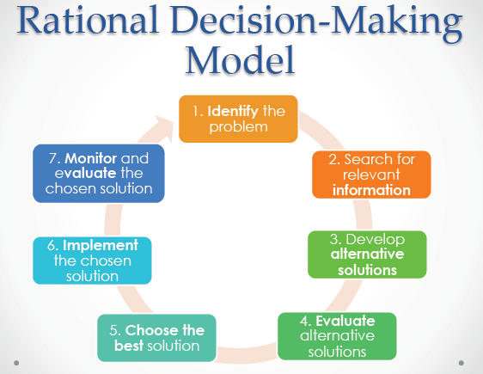
***To make a perfectly rational decision you need to have all of the relevant information (cost effectively/low cost/no cost)

Perfect rationality involves a decision strategy that is :
-Completely informed
-Perfectly logical
-Oriented toward economic gain
***While useful for theoretical purposes, these characteristics do not exist in real decision makers.

According to Herbert Simon, administrators use bounded rationality rather than perfect rationality. While they try to act rationally, they are limited in their capacity to:
-Acquire and process information
-Time constraints
-Political considerations
***Framing and cognitive biases illustrate the operation of bounded rationality. [IMPORTANT]

- Framing refers to aspects of the presentation of information about a problem that are assumed by decision makers.
- How problems and decisions are framed can have a powerful impact on resulting decisions.
  - Cognitive biases are tendencies to acquire and process information in an error-prone way. They involve assumptions and shortcuts that can improve decision making efficiency but frequently lead to serious errors in judgment.
  - Escalation of commitment. The tendency to invest additional resources in an apparently failing course of action

- How do Emotions and moods affect decision making
Strong emotions frequently figure in the decision-making process that corrects ethical errors (Chapter 12) and strong (positive) emotion has also been implicated in creative decision making and the proper use of intuition to solve problems.

Such intuition (Chapter 1) CAN lead to the successful short-circuiting of the steps in the rational model when speed is of the essence.
Example of many cases : strong emotions are a hindrance such as when people experiencing strong emotions are often self-focused and distracted from the actual demands of the problem at hand.

Mood affects what and how people think in making decisions and it has the greatest impact on uncertain, ambiguous decisions of the type that are especially crucial for organizations. Research on mood and decision making has found that:
- People in a positive mood tend to remember positive information.
- People in a positive mood tend to evaluate objects, people, and events more positively.
- People in a good mood tend to overestimate the likelihood that good events will occur and underestimate the occurrence of bad events.
- Positive mood promotes more creative, intuitive decision making.
The impact of mood on decision making is not necessarily dysfunctional. If the excesses of optimism can be controlled, those in a good mood can make creative decisions. If the excesses of pessimism can be controlled, those in a negative mood can actually process information more carefully and effectively.

- Pros and Cons of using groups to make decisions
There are a number of reasons for employing groups to make organizational decisions.
Decision Quality. Groups or teams can make higher quality decisions than individuals. This argument is based on several assumptions:
- Groups are more vigilant than individuals.
- Groups can generate more ideas than individuals.
- Groups can evaluate ideas better than individuals.
  - Groupthink(Disadvantage to groups) is the capacity for group pressure to damage the mental efficiency, reality testing, and moral judgement of decision making groups
  - Risk assessment: “throw good resources after bad”. to an apparently failing course of action, in which the escalation involves devoting more and more resources to actions implied by the decision. As well, because changing one's mind is often perceived as a weakness, many wrong decisions continue to be endorsed in the name of consistency.

Chapter 12- Ethics
- Ethics is the systematic thinking about the moral consequences of decisions
  - Ethical dilemmas that managers face: sexual harassment, conflict of interest (benefit you)
- Sexual harassment :form of unethical behaviour that stems in part from :
-Abuse of power
-Perpetuation of a gender power imbalance in the workplace

Many organizations are slow to react to complaints of sexual harassment and many do nothing about it until the complainant has reported it. This phenomenon has been referred to as the "deaf ear syndrome" which refers to the "the inaction or complacency of organizations in the face of charges of sexual harassment".

Organizations can effectively deal with allegations of sexual harassment and increase their responsiveness by taking a number of important measures:
- Examine the Characteristics of Deaf Ear Organizations.
- Foster Management Support and Education.
- Stay Vigilant.
- Take Immediate Action..
- Establish Clear Reporting Procedures.

In general, organizations that are responsive to complaints of sexual harassment have top management support and commitment.

Chapter 13- Conflict & Stress
- Interpersonal conflict is a process that occurs when one person, group, or organizational subunit frustrates the goal attainment of another. In its classic form, conflict often involves antagonistic attitudes and behaviours such as name calling, sabotage, or even physical aggression.

  - Causes of interpersonal conflict
    - Group identification and intergroup bias: tendency of people to develop a more positive view of their own "in-group" and a less positive view of "out-groups" of which they are not a member.
    - Interdependence is when individuals or subunits are mutually dependent on each other to accomplish their own goals, the potential for conflict exists. The abuse of power in such relationships and the on-going need for coordination are both potential problem areas.
    - Differences in Power, Status, and Culture
    - Ambiguity: Ambiguous goals, jurisdictions, or performance criteria can lead to conflict. Under such ambiguity, the formal and informal roles that govern interaction break down and it may be difficult to determine responsibility. Ambiguous performance criteria are a frequent cause of conflict between managers and employees.
    - Scarce Resources: Differences in power are magnified when common resources are in short supply. Resources may also act as buffers in sufficient quantities which, when removed, allow conflict to surface. Scarcity has a way of turning latent or disguised conflict into overt conflict.

  - Types of conflict
    - Relationship related: interpersonal tensions, that have to do with the relationship
    - Task related: disagreements about the nature of the work to be done
    - Process related: disagreements about how work should be organized and accomplished

- Managing conflict ****TIPS to remmeber them all remember them all : CACAC
(CACAC First letter of all and Conflict = shit in a org. So remember CACA just add a C shitty word trick but it works)
  - Avoiding is a conflict management style characterized by low assertiveness of one's own interests and low cooperation with the other party.
  - Accommodating is a conflict management style in which one party cooperates with the other party, while not asserting one's own interests. This may be seen as a sign of weakness.
  - Competing is a conflict management style that maximizes assertiveness for your own position and minimizes cooperative responses. The conflict tends to be framed in strict win-lose terms
  - Compromise is a conflict management style that combines intermediate levels of assertiveness and cooperation. This tends to be a satisficing approach — neither true competition nor true accommodation. Compromise does not always result in the most creative response to conflict
  - Collaborating is a conflict management style that maximizes both assertiveness and cooperation. Collaboration works as a problem-solving approach where the object is to determine a win-win solution to the conflict that fully satisfies the interests of both parties.
- Positive effects of stimulating conflict: Conflict→ Change→ Adaptation→ Survival
- Stressors are environmental events or conditions that have the potential to induce stress.

Examples of stressors : These can include a person's job, a person's co-workers, conditions like extreme heat and cold, as well as the hostility of others.
  - Stress is a psychological reaction to the demands inherent in a stressor that has the potential to make a person feel tense or anxious because the person does not feel capable of coping with these demands.
  - Stress reactions are the behavioural, psychological, and physiological consequences of stress. Some of these reactions are passive over which the individual has little control such as elevated blood pressure.

- Personality and stress, Personality can affect both the extent to which potential stressors are perceived as stressful and the types of stress reactions that occur.
- Three key personality traits are :
-Locus of control
-Type A behaviour pattern
-Negative affectivity.
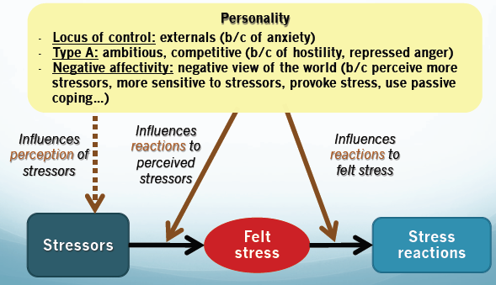

- Sources of stress encountered by various organizational role occupants
  - Executive and Managerial Stressors: Executives and managers make key organizational decisions and direct the work of others which leads them to experience special forms of stress.
    - Role overload occurs when one must perform too many tasks in too short a time period. This is an especially common stressor for managers. Management is an ongoing process, and few managers get time to rest or even to think about a new work strategy.

  - Operative-level stressors. Operatives are individuals who occupy nonprofessional and nonmanagerial positions in organizations. The occupants of operative positions are sometimes exposed to a special set of stressors :
    - The job demands-job control model is a model that asserts that jobs promote high stress when they make high demands while offering little control over work decisions.

  - Boundary Role Stressors, Burnout, and Emotional Labour. Boundary roles are positions in which organizational members are required to interact with members of other organizations or with the public. Occupants of boundary role positions are especially likely to experience stress as they straddle the imaginary boundary between the organization and its environment.

  - General Stressors. Some stressors are probably experienced equally by occupants of all roles.

  - Interpersonal Conflict. The entire range of conflict, from personality clashes to intergroup strife, is especially likely to cause stress when it leads to real or perceived attacks on our self-esteem or integrity. A particular manifestation of interpersonal conflict is workplace bullying. Bullying refers to repeated negative behaviour directed toward one or more individuals of lower power or status that creates a hostile work environment. Mobbing occurs when a number of individuals, usually direct co-workers, “gang up” on a particular employee. Victims of bullying and mobbing experience stress because they feel powerless to deal with the perpetrator(s).

- Reactions to stress
  - Behavioural reactions to stress are over activities that the stressed individual uses in an attempt to cope with the stress and include problem solving, performance, withdrawal, and the use of addictive substances.

  - Psychological reactions to stress primarily involve emotions and thought processes, rather than overt behaviour, although these reactions are frequently revealed in the individual’s speech and actions. The most common psychological reaction to stress is the use of defence mechanisms. Defence mechanisms are psychological attempts to reduce the anxiety associated with stress. Thus, they concentrate on anxiety reduction. Some common defence mechanisms include the following:
    - Rationalization : is attributing socially acceptable reasons or motives to one's actions so that they appear reasonable and sensible.
    - Projection : is attributing one's own undesirable ideas and motives to others so that they seem less negative.
    - Displacement : is directing feelings of anger at a "safe" target rather than expressing them where they may be punished.
    - Reaction formation : is expressing oneself in a manner that is directly opposite to the way one truly feels, rather than risking negative reactions to one’s true position.
    - Compensation : is applying one's skills in a particular area to make up for failure in another area.

  - Physiological reactions. There is evidence that work stress is associated with electrocardiogram irregularities and elevated levels of blood pressure, cholesterol, and pulse.
  - Workplace stress can double the risk of heart attacks.
  - Stress has also been associated with the onset of diseases such as respiratory and bacterial infections.

