Human Resources Planning

Prof: Amanda H. & Brittany H.
Format:
- Multiple Choice Questions – 30 Questions/30 Marks
  - 3 from Chapters 8,10,11 and 12
  - 4 from Chapters 7 and 8
  - 5 from Chapters 9 and 14
- Short Answer Questions – 5 Questions/30 Marks
  - 1 from Chapters 8,10,12,13 and 14
Chapter 7
Human Resources Supply
- The sources of workers to meet demand requirements, obtained either internally (current employees) or from external agencies, or both.
- In order to meet the HR demand, HR planners must know from where they can source out a supply.
- Most organizations would rather use internal candidates, but as in previous chapters, this does not always produce optimal results.
Skills Inventory
- An individualized personnel record held on each employee except those currently in management or preofessional positions.
- It is advantageous for an organization to have accurate records on its employees in order to aid HR planning and succession planning/management.
- Typical items in a skillls inventory:
  - Personal Information
  - Education, Training, Skill competencies
  - Work History
  - Performance Ratings
  - Career Information
  - Hobbies and Interests
Management Inventory
- An individualized personnel record for managerial, professional, or technical personnel that includes all elements in the skills inventory with the addition of information on specialized duties, responsibilities, and accountabilities

- Typical Items in a management inventory:
  - A history of management or professional jobs held
  - A record of management or professional training courses and dates
  - Key accountabilities for the current job
  - Assessment centre and appraisal data
  - Professional and industry association memberships
Succession or Replacement Analysis
- Critical to effective organizational functioning
- Helps the organization in being more effective to fill vacant positions
- The HR supply source comes from:
  - Internal: Current employees
  - External: Potential employees
  - Both: Internal and external
- Succession Management: The process of ensuring that pools of skilled employees are trained and available to meet the strategic objectives of the organization
  - Two aspects to succession planning:
    - Long-term succession: Process of training and work experience to enable individuals to assume higher-level job appointments in the future
    - Short-term emergency replacement: : Of individuals who have quit, been terminated due to performance problems, have died, and so on.
    - There is a constant ebb and flow of employees in most organizations.
    - Employees are required to fill gaps in an organization that occur when other individuals are promoted, and they are also required due to attrition.
  - There are several reasons why succession planning is critical for effective HR planning:
    - Enables an organization to respond appropriately and stay on track when inevitable and unpredictable changes occur; provides for continuity and future direction even in the turmoil of change
      - Succession planning allows an organization to be flexible and adapt to the uncertainty associated with employment.
    - Develops people as they prepare for new experiences and jobs, which improves their future performance
    - Takes into account employees’ performance and promotes them for it; therefore, employees are positively motivated
      - Succession planning also reviews employees for their potential to move into other positions.
      - As always, there is a reward for good performance which may result in a promotion.
    - Supports new organizational structures and flexibility by explicitly providing backups to various positions, thereby reducing organizational dependency on any one employee
    - Saves time and money, and smoothes internal employee movement and continuity
      - Succession planning is a dynamic process that enables an organization to modify its course as need be.
      - Ultimately, there is a cost to not planning for the unexpected, and so succession planning avoids some of those unexpected costs and time.
- Replacement management: The process of finding employees for key managerial positions
Documents Used in Succession Planning
- Succession/Replacement Chart: Represents the organizational hierarchy and the key jobs with their inherent reporting relationships (similar to an organizational chart)
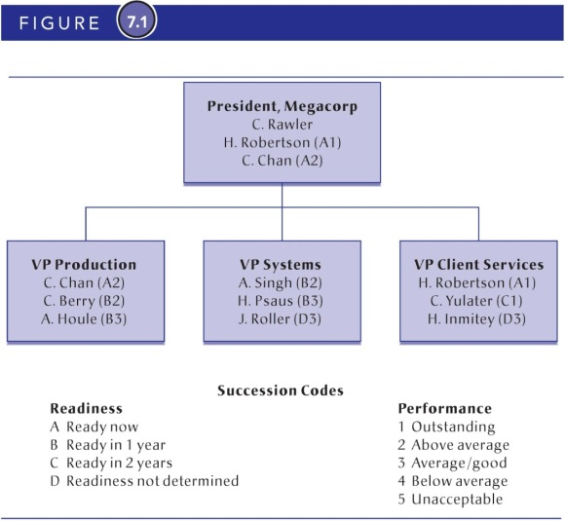
- Succession/replacement table: Complements the succession/replacement chart in that it provides additional information on each specific job, the incumbent jobholder, and all potential internal successors
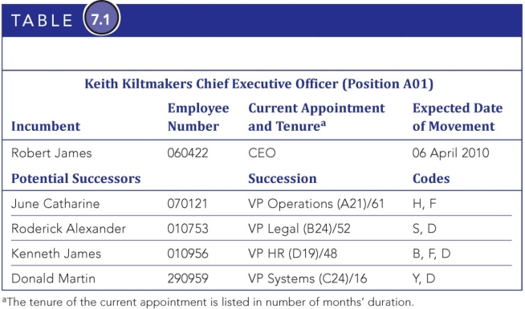
- Sucession readiness codes: Codes listed next to the names of all potential successors, which summarize these essential elements for succession planning:
  - the employee’s level of performance in the current job
  - the employee’s readiness for movement or promotion
- Ripple or Chain Effect: The effect caused when one promotion or transfer in the organization causes several other personnel movements in the organization, as a series of subordinates are promoted to fill the sequential openings
  - An organization is not static, and when employees move around the company, there are consequences to other employees.
- Markov Model: A model that produces a series of matrices that detail the various patterns of movement to and from the various jobs in the organization
  - Also referred to as a probabilistic or stochastic model
  - The Markov model uses probabilities in conjunction with the pattern of employee movements throughout an organization’s system of jobs.
  - Assumptions:
    - Movement patterns are historical.
    - The model requires the use of transitional probabilities or the likelihood that an individual will exhibit movement behaviours.
    - Sequence of movements between jobs is called Markov chains.
    - Vacancies create a multiplier effect.
    - Movement is tracked annually.
  - Employee movement patterns:
    - Remaining in the current job
    - Promotion to a higher classified job
    - A lateral transfer to a job with a similar classification level
    - Exit from the job (e.g., termination, layoff, voluntary leaving by the employee)
    - Demotion (which is relatively rare)
  - Information:
    - The number of personnel who move annually between job levels
    - The number of external hires required
    - The movement patterns and expected duration in specified jobs associated with patterns of career progression
    - The number and percentage of starters at a particular job who target a future job within a specified time
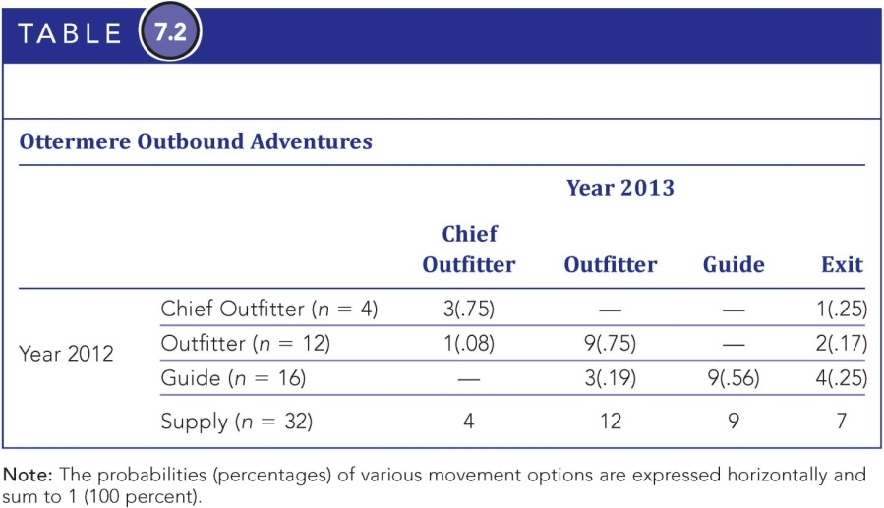
- Linear Programming: A complex mathematical procedure commonly used for project analysis in engineering and business applications
  - It can determine an optimum or best-supply mix solution to minimize costs or other constraints
  - There is an assumption that the variables in the model must have a linear-relationship-like regression.
  - If the linear relationship does not hold, then quadratic programming techniques would be used to determine HR supply.
- Movement Analysis: A technique used to analyze personnel supply, specifically the chain or ripple effect that promotions or job losses have on the movements of other personnel in an organization
  - This technique needs to be rationalized carefully from the top of the organization chart on downward.
  - The total number of personnel movement is always greater than or equal to the number of vacant positions to be filled.
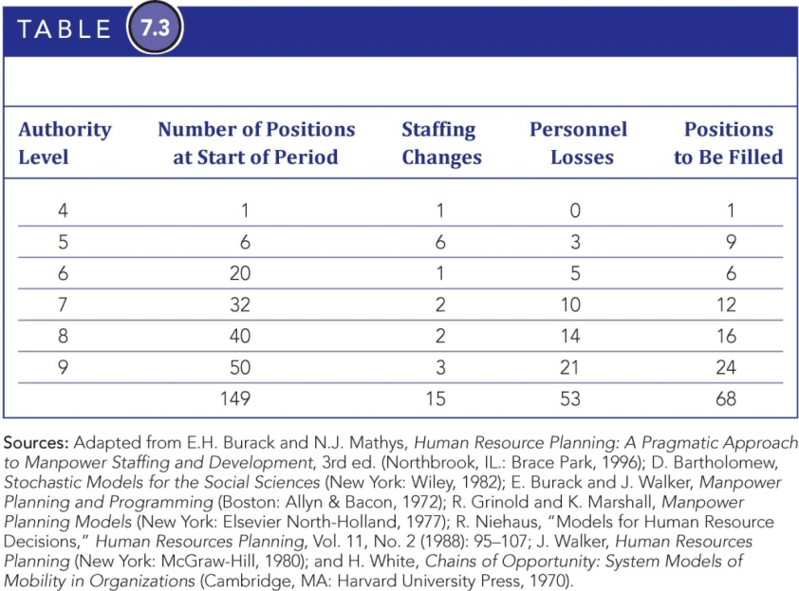
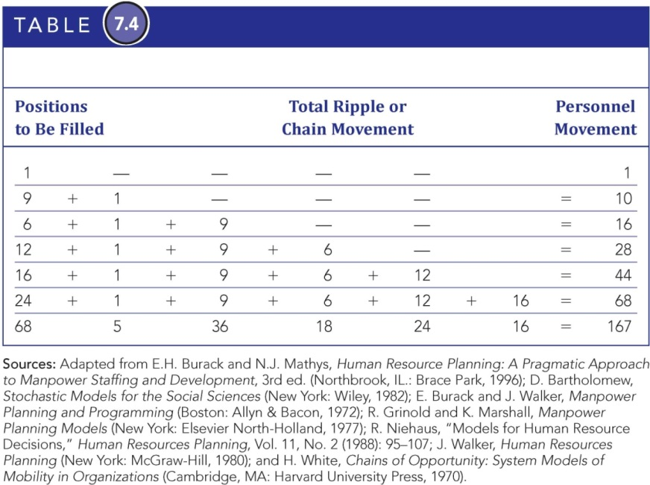
- Vacancy model (Renewal or sequencing model): analyzes flows of personnel throughout the organization by examining inputs and outputs at each hierarchical or compensation level
HR Supply and Retention Programs
- Organizations need to monitor and control levels of absenteeism and turnover (labour wastage)
- Retention programs are key to retaining experienced, high-performing employees in order to achieve organization goals
- Cost of replacement employees:
  - Hard Costs:
    - Advertisements
    - Headhunter, recruiting fees
    - Interview training
    - Travel costs
    - Admin expenses
    - Costs of lost production
    - Bonuses
    - Increased salaries
    - Cost to replace a trained worker ranges from 70 to 200 percent of the departing person’s salary
    - This is an example of typical costs associated with replacing an employee.
    - If the recruitment and selection process are dysfunctional, then tremendous costs can be generated.
  - Soft Costs:
    - Lost business and customer contacts
    - Decreased quantity or quality of work due to training and learning curve gaps
    - Orientation and training time
    - Decline in team morale and productivity
    - Increased turnover due to the “follow-me” effect
    - The soft costs are sometimes more difficult to trace than hard costs, especially if they are linked to customers, quality, time, and mimicry.
- Retention Programs
- Retention can be greatly enhanced by:
  - Offering effective communication programs
  - Facilitating an enjoyable and collegial work atmosphere
  - Formulating and administering performance and compensation systems that reward better performers
- Retention programs will be ineffective if there is not an organizational culture that supports the intentions and policies behind retention.
- Retention programs must be perceived to be fair and based on performance as opposed to favouritism.
- Retention can be greatly enhanced by:
  - Designing meaningful jobs
  - Offering more flexible and attractive work arrangements): flextime, telecommuting, cafeteria-style benefits plans
  - Mentoring and developing intellectual capital
Chapter 8
Importance of succession management
- The process of ensuring the pools of skilled employees is trained and available to meet the strategic objectives of the organization.
- Succession planning implies that once you have a plan, it is not monitored and modified.
- Succession management includes this constant monitoring and updating.
Linkage to talent management process
- Succession management is part of the talent management process, which includes:
  - Selection process
  - Career management
  - Exiting the organization
- Succession management must not be viewed in isolation of its linkage to the entire talent management process.
New focus on critical roles
- In the past, succession management focused on the CEO only. Now, it focuses on the following critical roles:
  - CEO
  - Senior management (executives)
  - Critical roles based on long-term values
Drivers of succession management programs
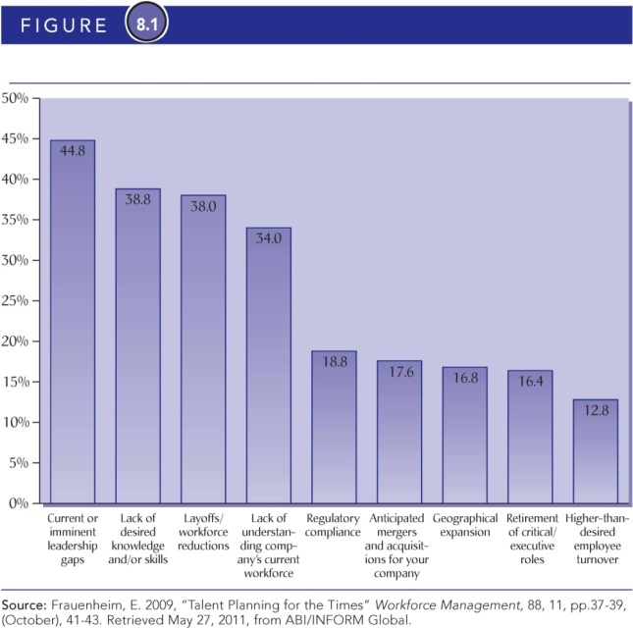

Evolution of succession management
- Replacement planning: the process of finding replacement employees for key managerial
- Replacement planning has evolved into succession management by:
  - Broadening the focus
  - Expanding the time horizon
  - Creating a talent pool of replacements
  - Improving the evaluation system
Reasons for succession management
- Provide opportunities for high-potential workers
- Identify replacement needs
- Icrease the talent pool of promotable employees
- Contribute to implementing the organizations strategic business plans
- Help individuals realize their career plans
- Tap the potential for intellectual capital
- Encourage the advancement of diverse groups
- Improve employees ability to respond to changing environment demands
- Improve employee morale
- Cope with the effects of voluntary separation programs
- Decide which workers can be terminated
- Cope with the effects of downsizing
- Reduce headcount to essential workers only

Steps for succession management process
- Align succession management plans with strategy
  - Organizations must start with the business plan and strategies
  - Using environmental scanning, managers try to predict where the organization will be in three, five, or ten years
- Identify the skillls and competencies needed to meet strategic objectives
  - The skills and competencies of successful managers must be identified using the:
    - Job-based approach: Focus on duties, skills, job experience, and responsibilities required to perform the job. Not adequate since jobs change rapibly.
    - Competency-based approach: Focus on measurable attributes that differentiate successful employees from those who are not. Hard and soft skills. Produces more flexible individuals.
- Identify high-potential employees
  - Organizations use several approaches to identify managerial talent, including
    - Temporary replacements
    - Replacement charts
    - Strategic replacement
    - Talen management culture
  - A talent management culture is becoming more significant relative to the intense competition for talent.
- Provide development opportunities and experiences
  - Two basic questions here are:
    - Are leaders born or made?
    - Can leaders be bought or made
  - Management development methods:
    - Promotions: An employee’s upward advancement in the hierarchy of an organization
    - Job rotations: : A process whereby an employee’s upward advancement in the hierarchy of an organization is achieved by lateral as well as vertical moves
    - Special assignments: On-the-job learning is still a favourite method of developing management skills. To test high-potential employees, they can be given a special assignment in addition to their regular duties. Special assignments develop new skills and provide network opportunities.
    - Formal training and development: These traditional and passive techniques are the least effective, but they are fast and easy to use. They include lectures, seminars, and discussion groups. More effective training and development techniques include:
      - Role-playing
      - Case studies
      - Behaviour modelling
      - Action learning
      - Experiential learning
    - Mentoring and coaching: Executives who coach, advise, and encourage junior employees. Internal mentors are best for strengthening and assuring continuity of organizational culture. Mentors are usually senior people who volunteer within an organization.Coaches are typically paid counsellors from outside the organization.
- Monitor succession management: Corporations with strong succession management programs are higher performers in revenue growth, profitability, and market share.
  - HR metrics can be used to help monitor succession management
    - Increased engagement scores
    - Increase positive perceptions of development opportunities
    - High potentials’ perceptions of the succession management process
    - Higher participation in developmental activities
    - Greater number involved in the mentoring process
  - Lag measures:
    - Increased average number of candidates
    - Reduced average number of positions having no identified successors
    - Increased percentage of managers with replacement plans
    - Increased percentage of key positions filled according to plans
    - These lag measures are only meaningful if they are compared to benchmarks from the previous year or otherwise.
    - Increased ratio of internal to external hires
    - Increased retention rates of key talent
    - Increased percentage of positive job evaluations
    - Increased number of bosses as talent developers
Employee role in succession management
- Participatory process between managers and employees that has replaced the top-down approach
- Gain employee commitment to and ownership of the plans
- Employees have a “voice” in the process.
- Employees must consider that their relationship with the organization is not static
- The implied employment contract once thought to protect employees is no longer valid
- A new, transactional employment contract is in place that provides benefits to employees for their contributions in the short-term only.
- Organizations still need to manage their employees and view their value and contributions in light of the intense competition for leadership talent.
Risks to the organization
- There are significant risks to the organization in the talent management process including:
  - Vacancy risk: Organizations that are unable to fill key vacant positions quickly with effective leaders may suffer business losses and/or an inability to move forward on strategic goals.
  - Readiness risk: HR must develop employees so that when opportunities arise, there are qualified and motivated personnel in place.
  - Transition risk: In addition to preparing employees for key roles, HR must develop programs to retain key employees, and to monitor competitors and others to be able to quickly identify external candidates.
Chapter 9
Information technology (IT): All hardware and software, including networking and communication technologies
What can it do for HRM?
- Can help project supply and demand for HR
- Can support succession planning and career development plans
- Provides powerful storage and retrieval capabilities
IT + HRM
- HR has historically gathered employee information
- IT can mine HR information faster, cheaper, and more effectively
- “HR without technology is becoming an unthinkable proposition” (HRfocus, 2007)
- IT helps HRM achieve operational and strategic efficiency
- Typical HR Functions with high IT Support:
  - Data storage: Wages, vacations, sick time
  - Transferring data from HR to payroll
  - Generating organizational charts
  - Posting job openings
  - Tracking labour costs
- Typical HR functions with low IT support
  - Employee career development
  - Employee ergonomic assessments
  - Measuring diversity needs and results
  - Self-service or menu-driven employee benefits
  - Online delivery of Employee Assistance Programs (EAPs)
Web Based HR
- Web-based HR allows service delivery that pushes employees and managers into making transactions
- E-recruiting and E-learning are highly visible applications
- E-Learning: The process of learning contents distributed in digital format via computers over the Internet or other network
- Enterprise portals: Knowledge communities that allow employees from a single or multiple companies to access and benefit from specialized knowledge associated with tasks
- Self-Service: A technology platform that enables employees and managers to access and modify their data via a web browser from a desktop or centralized kiosk
  - ESS: Employee self-service application
  - MSS: Manager self-service application
IT for HR Planning
- IT Supports six HR planning functions:
  - Workforce analytics
  - Workforce management and scheduling
  - Forensic reporting
  - Skills inventories
  - Replacement charts
  - Succession management
Workplace Analytics
- Workforce analytics: Applications address the challenge of getting business intelligence for strategic decision making
- Business intelligence: Includes the applications and technologies for gathering, storing, analyzing, and providing access to data to help users make better business decisions
Workplace Management and Scheduling
- Workforce management and scheduling are often quite complex.
- Workforce scheduling and optimization software provides applications for deploying employees most effectively.
- Based on forecasts, which are then used to creates schedules
- It is important to emphasize the optimal goal with workforce scheduling.
- If the workforce is scheduled efficiently, then there should be associated cost savings.
- Cost savings are significant when typically 50+ percent of expenses come from employee salaries and wages.
Forensic reporting: A detailed technical analysis of data that leads to conclusions about why certain behaviours occur within the HR function.
Skills Inventories: Typically contain a personal record or skills profile of each member of the workforce
Replacement Charts
- Used to support the process of finding replacements for key managerial positions
- Typical information includes
  - Predicted departure dates
  - Shortlist of possible successors
  - Performance appraisal information
  - How ready successors might be as replacements
Succession Management
- Preparing employees for future jobs within the organization and developing the next generation of leaders
- The process relies on intensive information like: competencies, talent pools, developmental plans, performance assessments, and developmental opportunities.
Different IT Solutions for different needs
- Human resource information system (HRIS): A comprehensive across-the-board software system for HRM that includes sub-systems or modules such as:
  - Recruitment and selection
  - Time and attendance management
  - Payroll
  - Training and development
  - Pension administration
- An HRIS is extremely powerful because of its comprehensive nature.
- It can be used in whole or partial versions depending on the size and needs of the organization and whether some of these functions have been outsourced to another external company.
- Specialty products: Software solutions for specific or specialized applications that may or may not interface with the main database
- Enterprise resource planning (ERP): Commercial software systems that automate and integrate many or most of a firm’s business processes
  - An ERP can integrate HR data with other systems in the firm (e.g., finance, logistics, production, and accounting)
  - For example, SAP is the third largest independent software provider in the world, with more than 76,000 customers in 120 countries.
  - SAP ERP HCM is a complete and integrated human capital management solution that delivers unmatched global capability.
  - It allows HR professionals to hire the best talent and to train and cultivate its workforce.
- Relational database: A database that can share information across multiple tables or files, which allows the same information to exist in multiple files simultaneously
  - Some problems with ERPs are related to their generic focus for multiple customers and their potential ability to be adapted to the needs of a specific organization.
  - The result is that this lack of adaptability may create some tension for the organization regarding its unique identity.
Steps to select HRM Technology Solutions
- Conduct a needs analysis
- Explore the marketplace
- Request for proposal
- Evaluate vendors and products
Typical questions for needs analysis
- Is the HR dept. spending too much time on manual processing?
- Are there data security risks?
- Is the current HRM system obsolete?
- Are we maintaining redundant info?
- Are we managing our human capital strategically?
A scripted demo
- An in-person demonstration of the product that follows a clear agenda (in fact, a written script) that you have prepared for the vendors
- The scripted demo is used to evaluate both the vendor and the software product.
- A consistent approach to soliciting vendors is useful because it ensures that the same information about the organization is being given to all the potential vendors.
Implementation and evaluation technology:
- Implementing HR technology is a major organizational change.
- The best technology will not be effective unless it is implemented properly.
- Implementation takes commitment, time, and patience, since much can go wrong.
IT Implementation Pitfalls
- Lack of user involvement
- Incomplete definition of needs
- Change of needs
- Lack of management support, planning, and resources
- New technology
- Size and complexity of project
- Lack of technical knowledge
- Lack of knowledge on new technologies
- Project no longer needed
- Unrealistic expectations
- Unclear goals
- Unrealistic time frames
- With so many pitfalls for IT implementation on these slides, it is logical to conclude that IT implementation must be done carefully and with significant planning; otherwise a failed IT implementation is a waste of money and will not achieve organizational goals and objectives.
Implementing Technology
- The fundamental rethinking and radical redesign of business processes to achieve dramatic improvements in critical, contemporary measures of performance, such as cost, quality, service, and speed
- For business process re-engineering to work with the HR function, it is important for HR professionals to fully understand their processes and to change anything that gets in the way of achieving competitive advantage.
Ensuring Data Security
- Employers have a legal obligation to protect employees’ personal, medical, and employment records.
- This necessary information privacy requires robust security to protect the data.
- Golden rule: Only authorized persons should have access to employee data.
- It is important to note how easily information privacy can be breached and it is all too frequently the subject in the media.

Evaluating HR Technology
- Technology acceptance: The extent to which users intend or actually use technology as a regular part of their jobs
- Competitive Advantage: HR technology must be evaluated to determine its contribution to competitive advantage. This contribution exists if the HR IT:
  - Develops firm-specific competencies
  - Produces complex social relationships
  - Generates tacit organizational knowledge
- Knowledge Management: A systematic and organizationally specified process for acquiring, organizing, and communicating both tacit and explicit knowledge of employees so that other employees may make use of it to be more effective and productive in their work
- Sample Technology Effectiveness Items:
  - Attitude
  - Usefulness
  - Information satisfaction
  - System satisfaction
  - Information quality
  - System quality
Chapter 10
The Downsizing Phenomenon
- Downsizing became popular in the 1990s.
- It has resurfaced aggressively with the global financial crisis in 2008.
- Historic growth strategies and talent wars increased the size of the workforce.
- Today, expensive human capital is being eliminated again with downsizing.
- Note: The economic bubble burst in the late 1980s, which led to the development of the phenomenon of downsizing in the early 1990s.
Downsizing Strategy:
- Downsizing: Strategies to improve an organization’s efficiency by reducing the workforce, redesigning the work, or changing the systems of the organization
- Survivor: An employee remaining with an organization after a downsizing.
Workforce Reduction Strategy
- A short-term strategy to cut the number of employees through attrition, early retirement or voluntary severance packages, and layoffs or terminations
- This strategy is less harsh on the employees and uses kinder techniques to reduce the size of the workforce with fewer negative consequences to the employees.
Work Redesign Strategy
- A medium-term strategy in which organizations focus on work processes and assess whether specific functions, products, and/or services should be changed or eliminated
- This strategy eliminates functions, groups, or divisions and all the associated bureaucracy.
- It also redesigns tasks that employees do with the focus on efficiency – doing more with less.
Systematic Change Strategy
- A long-term strategy that changes the organization’s culture, attitudes, and employees’ values with the goals of reducing costs and enhancing quality
- Additional goal = continuous improvement
- This strategy is deliberately meant to take time because behaviours and values need to be incrementally changed.
- The focus here is on evolution and continuous improvement.
- Both human capital and the financial situation of an organization are important.
- The human capital investment does take longer to detect a return on investment and so this strategy is less frequently used for this reason.
- It would be considered a more proactive strategy than the other two reactive strategies.
Restructuring
- There are three types of restructuring in the following slides:
  - Portfolio restructuring:
    - Involves changes to the organization’s business portfolio
    - This means changes in the mix or percentage makeup of the organization’s businesses, divestitures, and acquisitions
  - Financial restructuring
    - Includes the financial changes to an organization, like reducing cash flows or increasing debt levels
  - Organizational restructuring
    - Organizational restructuring is the focus for this chapter.
    - It includes major restructuring of an organization’s structure linked to management change programs

Why Do Organizations Downsize?
- Declining profits
- Business downturn
- Increased pressure from competitors
- Organizational merger
- New technology
- Reduce operating costs
- Decrease levels of management
- Getting rid of employee “deadwood”
- The reasons for downsizing are varied but essentially they all have some financial underpinnings.
Downsizing Paradox
- Downsizing is done with the intention to cut costs for labour in the future.
- There is considerable evidence that workforce reduction fails to meet its objectives.
- According to Pfeffer: “Layoffs don’t even reliably cut costs.”
Downsizing Alternatives
- Short-Term:
  - Hiring freeze
  - Mandatory vacation
  - Reduced workweek
  - Reduced overtime
  - Reduced salaries
  - Facility shutdowns
  - Employee input for alternatives to cutbacks
  - These short-term alternatives have various impacts on the financial situation and the workforce.
  - They should be considered “picking the low hanging fruit” because they are easier to implement.
- Medium-term:
  - Extending reductions in salaries
  - Voluntary sabbaticals
  - Lending employees
  - Exit incentives
Inplacement and Outplacement Issues
- Outplacement: providing a program of counselling and job-search assistance for workers who have been terminated
- Inplacement: a career management approach aimed at reabsorbing excess or inappropriately placed workers into a restructured organization
Ethical Considerations
- Downsizing may infringe on principles of distributive, procedural, and interactional justice
- Communication during a downsizing is often mismanaged
- Managers may use and abuse information as a source of power or choose to conceal or distort information regarding the financial status of the business
Planning for Downsizing
- Determine how many people will lose their jobs
  - Who will be let go
  - How will the reduction be carried out
  - Determine the legal consequences
- Planning for downsizing follows a Who? What? When? Where? Why? How Many? Format.
- Other considerations include:
  - Designing current and future work plans
  - Implementing the decision
  - Performing follow-up evaluation and assessment of the downsizing efforts
Adjusting to Job Loss
- Advance notification of layoffs
- Severance pay and extended benefits
- Education and retraining programs
- Outplacement assistance
- Clear, direct, and empathetic announcement of layoff decisions
- Consideration of HR planning practices that represent alternatives to large-scale layoffs
Can losing a job be a good thing?
- There are some benefits of losing a job:
  - Time to reflect
  - Grow new ideas, direction, and career plan
  - Get out of a job that was substandard
  - Spend more time with family and hobbies
Can Losing a job be a bad thing?
- Suicide risk increases with long periods of unemployment
- For employment of less than five weeks, there is no greater suicide risk with job loss
The Survivors of downsizing
- Survivor syndrome: A description of the emotional roller coaster that survivors experience
- Some of these emotions include: Anger, pain, fear, cynicism, stress, mistrust, risk aversion, overwork, job insecurity
- Some survivor reactions include:
  - Negative attitudes and behaviours
  - Reduced performance capabilities
  - Lower organizational productivity
- Job insecurity: an employee’s expectations of continued employment and the future existence of the job
Perceptions of Justice
- Procedural justice: Procedures or rules used to determine which employees will be downsized
- Interactional justice: The interpersonal treatment employees receive during the implementation of the downsizing decision
- Distributive justice: The fairness of the downsizing decision
Financial Performance and Downsizing
- A downsizing strategy is typically implemented to improve the bottom line.
- Evidence suggests that some companies improve profits while others do not.
- Investors usually respond negatively to downsizing if it is financially motivated
- Improvements to financial performance are not carved in stone and can be as varied as the strategies used to implement a downsizing.
- Companies that offer incentives for voluntary resignations are viewed more favourably.
- Stock prices typically respond negatively to the downsizing announcement.
- Downsizing accompanied with relocation strategies generally were better received by the shareholders.
Reputation for Corporate Social Performance (RCSP)
- RCSP: The firm’s reputation for principles, processes, and outcomes related to the social impact of the firm’s operations
- This is an important concept to discuss because once a poorly planned and implemented downsizing occurs, it becomes history and an indicator of whether the organization stayed true to its values and principles in dealing with its workforce.
- The impact both internally (on current employees) and externally (on other stakeholders) can be considerable if the downsizing is ineffective.
- RCSP is an organization’s most important intangible asset and an important source of competitive advantage, yet it receives little attention with respect to downsizing
Effective Downsizing Strategy
- Consider the consequences.
- Plan carefully.
- Authorize managers with downsizing experience.
- Focus on rightsizing.
- Establish a shared vision that is understood by all employees and managers.
- Instill a sense of ownership.
- HR department should play an active role.
- Increase communication.
- Increase employee participation.
- Perform a systematic analysis of tasks and personnel requirements.
- Ensure visibility of senior management.
- Interactive role of senior management
- Identification, development, and implementation should involve employees.
- Monitor downsizing and link to organizational strategy.
- The issue of management training in downsizing techniques is really significant since most managers may have no experience, or at a minimum may have only one previous downsizing.
- Proper downsizing needs to be placed in context with following the law so that legal liabilities do not spiral out of control following a downsizing.
- Train management with downsizing techniques.
- Create a culture of trust prior to the downsizing.
- Best Practices of Downsizing:
  - Downsizing should be initiated from the top but include involvement at all levels.
  - Workforce reduction must be selective in application and long-term in emphasis.
  - Special attention should be paid to both those who lose their jobs and to the survivors who remain in the organization.
  - Decision makers should identify where inefficiencies and costs exist.
  - Should result in the formation of small, semi-autonomous organizations within the broader organization.
  - Must be a proactive strategy focused on increasing performance.
- Communication is difficult during downsizing. The outcome can be negative unless:
  - Rumours are managed.
  - Survivors are kept informed.
  - Survivors are given new goals.
  - Expectations are clarified.
  - Survivors are told they are valuable.
  - Time is devoted to grieving.
Psychological Contract
- An unwritten commitment between employers and their employees that historically guaranteed job security and rewards for loyal service
- Psychological contracts brought a lot of comfort and reduced the anxiety of employees related to work and the continuation of work in the future.
- Employees believed that hard work would be rewarded
Downsizing and ‘High Involvement HRM
- High involvement HRM: A commitment to HRM practices that treat people as assets
(as opposed to costs)
- Organizations with high-performance work practices may rely more on workforce reductions
- However, the restructuring may be less harsh – like attrition and voluntary severance
Labor Relations and Downsizing
- Labour-management relations and cooperation can be affected with downsizing.
- Many downsizing programs have destroyed the positive labour relations programs.
Should Unions participate in restructuring efforts?
- Interventionist response: Union gets involved early in the restructuring process through development and implementation
- Pragmatic response: Union relies on management to make workplace changes and then negotiates the
impact of the changes with management
- These responses indicate whether unions will choose to take a passive or more active role in the downsizing – hence, owning more or less of the process.
Chapter 11
Key Challenges affecting SIHRM
- Workforce diversity
  - SIHRM systems must consider and accommodate the needs of an increasingly diverse labour force and tailor international HR policies and practices accordingly.
  - Diversity issues in Canada include:
    - Increased number of older workers
    - Employees with disabilities
    - Gender issues
    - Ethnic and cultural differences among employees
- Employment legislation
  - HR managers are faced with a complex legislation framework.
  - When crossing national borders, Canadian HR managers encounter additional, host-country employment legislation.
  - HRM cannot be effective if legislation is only learned after the fact.
- The role of the HR function
  - HR departments are often understaffed, underfunded, and limited to a supporting role with little key decision-
making power
  - Employment legislation and socioeconomic and technological differences in local markets demand sophisticated SIHRM systems.
  - The increased complexity of the HR function requires HR managers to redefine their role and outsource some of their responsibilities to specialists and consultants (e.g., international employment lawyers).
  - With international initiatives, the HR function cannot be all things to all people and so specialization and outsourcing are solutions.
- Flexibility
  - The ability to respond to various demands from a dynamic competitive environment
  - When working in an international environment, flexibility is essential because many circumstances are out of control.
  - Often changes can occur suddenly and without warning, so it is imperative that the HR strategies are adaptable to the unexpected.
- Security
  - Business environments are becoming increasingly unsafe and so it is important to consider the security of employees overseas.
  - SIHRM policies should include:
    - Risk assessments
    - Precautionary measures
    - Safety procedures
    - Contingency plans for employees and their families
  - Establishing relationships with Canadian government representatives is essential, such as :
    - Embassies
    - Chambers of commerce
    - Consulates
    - High commissions
Strategic International HR Planning
- Projecting global competence supply, forecasting global competence needs, and developing a blueprint to establish global competence pools within companies
- SIHR planning is all about creating a plan and determining if the competencies exist to realize it currently or through other initiatives in the future.
- SIHRM: Human resource management issues, functions, policies, and practices that result from the strategic activities of multinational enterprises and that affect the international concerns and goals of those enterprises
- Fit: The degree to which the needs, demands, goals, objectives, and/or structure of one component are consistent with the needs, demands, goals, objectives, and/or structure of another component
  - Internal fit: Focus on organization
  - External fit: Focus on local environment
Corporate International Business Strategies
- Four stages of growth as multinational corporations evolve:
  - Domestic strategy: Internationalizing by exporting goods abroad as a means of seeking new markets
  - Multidomestic strategy: A strategy that concentrates on the development of foreign markets by selling to foreign nationals
  - Multinational strategy: Standardizing the products and services around the world to gain efficiency
  - Global strategy: A strategy that aims to introduce culturally sensitive products in chosen countries with the least amount of cost
Adaptive IHRM Approach: HRM systems that will be consistent with the local, economic, political, and legal environment
Exportive IHRM approach: Transferring home HRM systems to foreign subsidiaries without modifying or adapting to the local environment
Integrative IHRM approach: Combining home HR practices with local practices and selecting the most qualified people for the appropriate positions no matter where these candidates come from
International Recruitment
- Home-country nationals (HCNs): Individuals from the subsidiary country who know the foreign cultural environment well
- Parent-country nationals (PCNs): Individuals from headquarters who are highly familiar with the firm’s products and services, as well as with its corporate culture
- Third-country nationals (TCNs): Individuals from a third country who have intensive international experience and know the corporate culture from previous working experience with corporate branches in the third country
- Expatriate: Any individual who gives up residence in his/her home country to take up residence in a foreign country either temporarily or permanently
- Selection Criteria of Global Managers
  - The five-factor personality model is crucial to expatriate adjustments and includes the following:
    - Emotional stability
    - Extraversion
    - Openness
    - Agreeableness
    - Conscientiousness
  - Trainability: An individual’s ability to acquire certain skills to a desired level of performance
  - Other Personal Characteristics:
    - Self-maintenance competencies: Capabilities to substitute sources of reinforcement and deal with alienation and isolation
    - Relationship competencies: Capabilities to develop and maintain relationships with HNCs
    - Perceptual competencies: Capacity to understand why foreigners behave the way they do
  - Cross-Cultural Training (CCT): Positively influences expatriate self-development, interpersonal skills, and cross-cultural perception. Part of the pre-assignment process.
  - Post-Assignment Activities
    - Repatriation: The PCNs, TCNs, or even HCNs finish their overseas assignment and come back to their home headquarter or home subsidiaries.
    - Reverse culture shock: Feelings of anxiety, uncertainty, and disorientation upon reintegration into one’s home country and culture
  - Career Development
    - There are two primary issues related to career development for global managers:
      - The international assignment is ONLY one step in the career development plan.
      - With subsequent assignments, it is important to make use of the KSAOs developed internationally.
    - Performance Appraisals
      - Technical/staff specialist
      - Managerial
      - It is important that performance criteria be developed prior to the international assignment.
      - Know the extent of the interaction the position requires.
      - Know the differences in accounting between countries.
      - Know the volatility of the foreign labour market.
      - Know the common problems with telecommunications and transportation.
    - International Compensation
      - Goods and services (e.g., food, clothing, furniture, recreation, transportation, medical care)
      - Housing (major costs associated with principal residence)
      - income taxes (personal income taxes to federal and local governments)
      - Reserve (e.g., education expenses, retirement savings, investments)
      - Shipment and storage (major costs associated with shipping and storing personal and household items)
    - International Rates of Unionization
      - Finland: 70 percent
      - Sweden: 68.4 percent
      - Canada: 27.5 percent
      - Germany: 18.6 percent
      - Japan: 18.4 percent
      - United States: 11.4 percent
Chapter 12
Review Strategic Types
- Corporate strategy: Organizational-level decisions that focus on long-term survival
  - Restructuring: Includes turnaround, divestiture, liquidation, and bankruptcies (Ch 10)
  - Growth: Includes incremental, international, and mergers and acquisitions
  - Stability: Maintains status quo
Mergers in Post-Global Economic Crisis
- Mergers and acquisitions peaked in 2007.
- Buyers are typically focused on M&As to support growth strategies.
- Sellers have become more reluctant to sell due to issues with valuations of organizations and the economic climate.

Definitions
- Merger: The consolidation of two organizations into a single organization
- Horizontal merger: The merging of two competitors
- Vertical merger: The merger of a buyer and seller or supplier
- Conglomerate merger: The merger of two organizations competing in different markets
- Acquisition: The purchase of an entire company or a controlling interest in a company
- Consolidation: Two or more organizations join and form a new organization
- Takeover: One company acquiring another company
Urge to Merge
- Strategic Benefits
  - Operating synergy: The cost reduction achieved by economies of scale produced by a merger or acquisition
  - Vertical integration: The merger or acquisition of two organizations that have a buyer-seller relationship
  - Horizontal integration: The merger or acquisition of rivals
  - Note that sometimes economies of scale is synonymous with operating synergy.
- Financial Benefits
  - The Urge to Merge
  - Companies merge for three reasons:
  - Strategic benefits
  - Financial benefits
  - Needs of the CEO or managing team
  - Note that sometimes economies of scale is synonymous with operating synergy.
  - All mergers have complex financial implications that need to be addressed carefully.
  - Other financial benefits include the following:
    - Developing new products and entering new markets is expensive.
    - Financial statement analysis often reveals undervalued organizations.
    - Goal is to increase shareholders’ wealth.
  - Although one of the objectives is to increase stock price for shareholders, 80 percent of mergers fail to do so.
- Needs of the CEO or Managing Team
  - Managers may pursue their personal interests at the expense of stockholders.
  - Often the motives of executives can be deemed unconscious.
  - Some managers make decisions only to prove their capabilities.
  - Other studies link personality factors such as the need for power in making management decisions.
  - Also note that alongside of power and influence, there is a role for ego in mergers as well.
Merger Methods
- Hostile takeovers: Are dramatic and complex when one company takes over control of another
- Poison pills: Refers to the right of key players to purchase shares in the company at a discount, making the takeover extremely expensive
- White knights: Buyers who
will be more acceptable to
a targeted company
- Pac-Man: A defensive manoeuvre where the targeted company makes
a counteroffer for the
bidding firm
The Success Rate of Mergers
- Only about 15 percent of all mergers (and acquisitions) successfully achieve the financial goals.
- Best success rates are with similar businesses rather than dissimilar ones
- One of the greatest indicators of merger success is related to the acceptance of organizational culture.
- Given the 15 percent success rates, it would behoove merger transitions teams to focus more on culture.
- Mergers take so much time and resources that often the original business is neglected.
- Mergers are more successful when a large firm absorbs a small firm.
- Mergers are less successful in service industries (compared to manufacturing) due to greater risk.
Reasons for Failures of M&As
- Intergration difficulties
- Inadequate evaluation of target
- Large or extraordinary debt
- Inability to achieve synergy
- Too much diversification
- Managers overly focused on acquisitions
- Too large an acquisition
- Difficult to integrate different organization cultures
- Reduced employee morale due to layoffs and relocations
- Financial Impact:
  - Estimated financial returns are rarely realized.
  - Many mergers fail because the buyer overextends itself financially with high debt loads and then must apply cost- cutting measures to service the debt
  - Some forecasted economies of scale are never achieved.
- Human Resources Impact:
  - Lower productivity
  - Sabotage
  - Stress and anxiety
  - Survival tactics
  - Higher turnover
  - Lower efficiency
  - Reduced employee/manager morale
What is culture?
- The set of important beliefs that members of an organization share
- These beliefs are often unspoken.
- They are an accumulation of the group’s shared history and experience.
- Culture is known as the “social glue” that binds individuals together and creates organizational cohesiveness.
- Four Cultural Options for mergers and acquisitions:
  - Assimilation: Occurs when one organization willingly gives up its culture and is absorbed by the culture of the acquirer or the dominant partner
  - Integration: Refers to the fusion of two cultures, resulting in the evolution of a new culture representing the best of both cultures. This form rarely occurs because the marriage is rarely one of two equals, and one partner usually dominates.
  - Deculturation: Sometimes the acquired organization does not value the culture of the dominant partner and is left in a confused, alienated, marginalized state known as deculturation. This is a temporary state, existing until some integration or separation occurs
  - Separation: In some instances, the two cultures resist merging, and either the merged company operates as two separate companies or a divorce occurs.
HR Planning in Mergers and Acquisitions
- M&A planning moves beyond the traditional concepts of HR planning for several reasons:
  - The contingency plan:
    - Plan should identify the contact person and the merger coordinator
    - Plan should outline the chain of command, communication methods, procedures, and negotiation skills training
  - HR due diligence:
    - A process through which a potential acquirer evaluates a target firm for acquisition, including the review of:
    - Collective agreements
    - Employment contracts
    - Executive compensation contracts
    - Benefit plans and policies
    - Incentive, commission, and bonus plans
    - Due diligence includes the review of:
      - Pension plans and retirement policies
      - WSIB statements, claims, assessments, experience rating data
      - Employment policies
      - Complaints: employment equity, health and safety, wrongful dismissal, unfair labour practices, certification and grievances
  - Transition team
    - Appoint a transition team to deal with:
      - Urgency
      - Information gaps
      - Stress
    - HR policy review might uncover complementary, duplicated, or contradictory HR policies for the merger companies
    - The goals of the transition team are to:
      - Retain talent
      - Maintain productivity (both quality and quantity)
      - Select individuals for the new organizations
      - Integrate HR programs
      - Begin the process of integrating cultures
- Impact of the Merger on HR
  - Merger affects the following functions:
    - Selection:
      - The two most critical issues for HR are related to:
        - Retention
        - Reduction
      - How many employees does the merged company need?
      - How many duplicate and redundant employees need to be eliminated?
      - Caveat: Lean and mean cuts to the workforce result in greater work overload and stress.
    - Compensation
      - Compensation decisions for merged company include:
        - Merge compensation systems?
        - Adopt a new compensation system?
        - Create a new compensation system?
      - All employee benefits will be subjected to the same scrutiny.
    - Performance appraisal
      - Employee behaviour and performance is usually not typical after a merger or acquisition.
      - Employee behaviour post-merger can be modelled into three categories:
        - Not knowing: Remedied by more communication
        - Not able: Solution is training
        - Not willing: A strong case for performance management through feedback and incentives
    - Training and development
      - Managers and peers may need some additional training in the role of coach and counsellor to deal with post-merger behaviours.
      - Employees need training for stress reduction and relaxation techniques.
    - Labour relations
      - At a minimum, the collective agreement must be read to determine what provisions exist for job security and what the notification periods are for layoffs and terminations.
      - It is important to interpret the collective agreement for all relevant clauses that may affect employees and/or managers and their rights to job security, seniority, buy-outs, and so on.
      - Collective agreements ultimately need to be renegotiated to protect the rights of employees and/or managers that belong to unions.
      - Early union participation helps the merger process go more smoothly because unions make valuable contributions.
  - Post-Merger Changes in Employment Status
    - Demotion: Under the new organizational structure, some employees are given less responsibility, less territory, or fewer lines due to amalgamation.
    - Competition for the same job: Some companies force employees to compete for their old jobs.
    - Termination: Some employees are let go strategically.

Chapter 13
Outsourcing
- A contractual relationship for the provision of business services by an external provider
- Outsourcing requires a contract that must be negotiated for specific functions covering a specific time period.
Offshoring
- HRO or HR offshoring: Occurs when outsourcing is done in a foreign country
Characteristics of potential outsourcing functions
- Rule based
- Repetitive
- Frequently undertaken
- Predictable
- Able to be fully or partly automated with technology
- Able to be delivered by remote sites
Outsourced HR functions
- HR functions most likely to be outsourced:
  - Temporary staffing
  - Payroll
  - Training
  - Recruiting
  - Benefits administration
- Compensation:
  - Payroll
  - Benefits
  - Compensation administration
  - Pension
- Recruitment and Selection:
  - Advertisements
  - Screening of applications
  - Testing
  - Reference checking
  - Preliminary interviews
  - Executive salary negotiations
  - Exit interviews
- Training:
  - Program delivery
  - Program design and development
  - Training consulting
  - Training needs analysis
  - Program evaluation
  - Strategic planning
  - Administration
  - Training policies
- Health and Safety:
  - Employee assistance programs
  - Wellness programs
Reasons for Outsourcing
- Financial savings
  - Cost reduction is typically 10 to 20 percent
  - Economies of scale from specialized outsourcers who are more efficient
  - Cost control
  - Decreased capital commitments
  - The average cost savings from outsourcing is about 15 percent.
- Strategic focus
  - Decision to focus on specific core competencies, like customer service or innovation
  - Core work is transformational and adds value to employees or customers.
  - Move secondary functions (or non-core work), like benefits administration, to firms that do these things well (they are core competencies for the outsourced firm).
  - An organization cannot be completely proficient at all functions and so it makes sense to source out to firms whose core competencies are for functions that the organization needs.
- Access to advanced technology
  - Technology has been a main driver of outsourcing.
  - Organizations want to improve technical service.
  - Technology enables a company to reduce transaction time (the time it takes to handle a request).
  - The use of technology is a vital aspect of outsourcing, with the emphasis on faster processing.
  - Technology also enables the outsourcing vendor to be located anywhere in the world as long as the technological network supports its requirements.
- Improved service levels
  - Quality improvement
  - Outsource to those who are excellent performers
  - More flexibility in hiring and rewarding employees
  - Improved response time, performance, and confidentiality
- Access to specialized expertise
  - “Outsource when somebody can do it better than you.”
  - Experts understand the complex laws and regulations required in HR.
  - Use of experts reduces the risks and liabilities for organizations.
  - Access to best practices
- Organizational politics
  - Outsourced function is not as visible as an in-house department performing the same tasks
  - Outsource to get rid of a troublesome department (e.g., employees who are underperforming)
  - Outsourcing reduces headcount
  - HR outsourced ratio 1:231
  - Traditional HR ratio 1:100
- Outsourcing: Risks and Limitations
  - Some questions to consider:
    - Are the anticipated benefits realized?
    - What are the risks to service levels?
    - What is the effect on employee morale?
    - Does outsourcing reduce the value of the organization?
- Projected Benefits vs Actual Benefits
  - Outsourcing is not as cost-effective and problem-free as expected.
  - Fifty percent found that it was more expensive to outsource.
  - Incompatible systems and client demands are the reason for excessive costs.
  - Organizations often duplicate some of the outsourced work for anomalous employees.
  - About 30 percent of outsourcing contracts are not renewed.
  - Think about the inefficiencies, time demands, and costs that are generated when an organization has to terminate a contract and/or not renew a contract and then search for a new outsourcing vendor.
- Service Risks
  - Contractual arrangements dictate which services will be provided.
  - Flexibility is compromised to add new features or change service levels.
  - Disruption of service could pose challenges from potential labour relations problems with outsourced organization
- Employee Morale
  - Outsourcing is a form of restructuring that can create displaced, resentful, alienated, and anxious employees.
  - Organizations that outsource face a backlash.
  - About one-third of HR professionals resist outsourcing because they worry about:
    - Losing their jobs
    - Being forced to work for a vendor
    - Fear that management believes outsiders are more competent
- Security Risks
  - There is always a risk for information leaks.
  - This is particularly important for software development, where intellectual property is concerned.
  - When an organization no longer controls all its functions, information is placed in the hands of the outsourcing vendor that might be vulnerable to hacking and misuse.
  - There are also security risks associated with leaking confidential employee data.
  - Issues are also related to information privacy because much of the employee data is related to performance and or health or medical information.
  - Information privacy needs to be mentioned here because employees do not know how vulnerable their personal information is until it is violated.
- Reduced Value
  - Extreme levels of outsourcing hollow out a company.
  - An organization experiences a reduced capacity to generate profits or innovate.
  - The internal image of HR may deteriorate.
  - Up to 20 percent of outsourced HR functions ultimately are brought back in-house.
Management of Outsourcing
- Selecting the vendor
  - Once outsourcing has been selected, the organization needs to do the following:
    - Inform the staff of the affected function.
    - Prepare a request for proposal (RFP).
      - RFP: Describes the responsibilities to be outsourced and invites potential providers to present their proposal for carrying out the job
    - Invite internal and external bids.
    - Establish a team to evaluate these bids.
- Negotiating the contract
  - Customize and negotiate the outsourcing contract.
  - Set performance standards or penalty clauses for the outsourcing company.
  - Establish benchmarks for service expectations.
    - Response time
    - Response cost
    - Customer satisfaction ratings
- Monitoring the arrangement
  - Two most frequent causes of outsourcing problems are:
    - Poor service definition
    - Weak management processes
  - Establish a relationship to ensure the outsourcer acts in the best interests of the organization, and has relevant knowledge of the organization.
  - Check the outsourcing company’s references.
  - Demand frequent and accurate reporting.
  - Conduct internal and external client satisfaction surveys.
Chapter 14
The Scorecard
- Corporate scorekeeping: Allows organizations to make the adjustments necessary to reach their goals
- Scorecard: Has measures of key indicators that focuses managers’ and employees’ attention on what is important to the organization
The Importance of Evaluating HRM
- Until the HR managers can talk about the contribution and value of HR activities in the numbers and language of business, the HR department and the HR profession will be vulnerable to destructive proposals.
- Some HR managers resist measuring their work because outcomes such as employee attitudes or managerial productivity are impossible to calibrate meaningfully.
- Slow growth in HR Measurement
  - Business improvement efforts
  - Positioning HR as a strategic partner
  - The need for objective indicators of success
Sabanes-Oxley: A case of HR Measurement
- U.S. legislation that affects Canadian companies operating in the United States
- Disclosure requirements include:
  - Executive compensation
  - Pension plans
  - Whistleblower protection
- Sarbanes-Oxley is an important contributor to improvements to HR measurement and the transparency of the three specific disclosures.
Reasons for measuring HRM effectiveness
- Labour costs are most often a firm’s largest controllable cost.
- Managers recognize that employees make the difference between success and failure, and therefore good performance can be rewarded objectively.
- Organizations have legal responsibilities to ensure compliance with laws governing the employer-employee relationship.
- Evaluations are needed to determine which HR practices are effective (and not fads).
- Measuring and benchmarking HR activities will result in continuous improvements. Performance gaps can be identified and eliminated.
- Audits will bring HR closer to the line functions of the organization.
- Data will be available to support resource allocations.
- Investors want this information.
- HR managers are more likely to be welcomed at the boardroom table and to influence strategy if they use measures to demonstrate the contribution of their function.
The 5C Model of HRM Impact
- Compliance
  - Ensure that organizational practices comply with the law in areas such as:
    - health and safety
    - employment equity
    - industrial relations
    - employer-employee relationships
- Client satisfaction
  - Organizations are tracking their success by measuring customer satisfaction.
  - Managers are turning to client or stakeholder perceptions about the effectiveness of HR performance.
  - “Keeping the clients happy” has important political reverberations for the HRM department because clients like when the CEO controls the purse strings
  - Advantages:
    - Measuring client satisfaction reminds the HR department that it provides a service to the clients and must meet their expectations.
    - Surveying clients about their unmet needs increases the credibility of the HR function.
    - It is important to survey the stakeholders before, during, and after a change program.
  - Methods of measuring
    - Informal feedback
    - Surveys
    - Critical incident method
  - Problems with measuring:
    - High expectations of clients
    - Conflicting expectations
    - Professional affiliations
- Culture management
  - Culture: A set of important beliefs that members of a community share
  - Attitudes: Perceptions or opinions about organizational characteristics
- Cost control
  - Three ways to reduce labour expenses by reducing the size of the labour force:
    - Technology (Chapter 9)
    - Outsourcing (Chapter 13)
    - Downsizing (Chapter 10)
- Contribution
Increasing Efficiency
- Efficiency: Results achieved compared to resource inputs
- Measures of efficiency include:
  - Time (e.g., time to process a claim)
  - Volume (e.g., number of people interviewed)
  - Cost (e.g., cost per training hour)
- Sometimes strategic decisions to an organization like downsizing, restructuring, mergers, and so forth can be eliminated by improving the efficiency of employees.
- This seems like an intuitive place to start.
Cost of Employee Behaviour
- All of these HR costs can be measured, benchmarked, managed:
  - Absenteeism
  - Turnover: Includes termination, replacement, lost revenues, learning curve, and productivity losses
  - Occupational injuries
  - Illnesses
- Benchmarks for employee behaviours are important to obtain since they can be used to verify trends for any changes to behaviour that must be rationalized.
How Organizations measure the return on investment
- Identify and evaluate HR’s contribution.
- Beyond its use of financial resources, HR must contribute to the bottom line.
- HR practices can affect organizational performance via:
  - Increased knowledge, skills, and abilities
  - Improved motivation
  - Reduced shirking
  - Increased retention of competent employees
- Financial Mesures
  - Survival is the first measure of effectiveness.
  - If an organization does not go bankrupt, it is a success.
  - This is called a life-or-death index.
  - New organizations survived better with effective HR practices.
  - ROI: Return on investment
  - ROE: Return on equity
    - Ratios measure the relative success of an organization in meeting its goals.
    - They do not capture managerial perceptions of effectiveness.
- Measures of Managerial Perceptions of effectiveness
  - Non-financial measures need to be used:
    - Management’s assessment of the organization’s performance relative to its competitors
    - Achievement of one group’s political objectives at the expense of a competing group
    - Adaptation of an organization to its environment
    - Goal optimization: An organization is effective if its employees behave in a manner that is conducive to the achievement of organizational goals and the long-term adaptability of the organization to its environment
- Approaches to measuring HRM practices
  - Typical ways of measuring HR activities include:
    - Activity-based measures: Training, hiring
    - Costing measures: Training program, hiring
    - Client satisfaction: Solving problems effectively and efficiently
- Cost-benefit analysis:
  - The relationship between the costs of a program and its benefits
  - Direct costs: The hard costs that can be measured by expenditures
  - Indirect costs: The soft costs whose value can be estimated but not measured easily by financial expenditures
  - The most basic method to measure HRM effectiveness is to conduct a cost-benefit analysis.
  - Note the difference between estimates or indirect costs that rely on professional judgment (like impact of trainee’s absence when taking a training course) and direct costs, which have easily obtained objective evidence (like the cost of software training).
- Utility Analysis
  - A method of determining the gain or loss that results from different approaches
  - A tool that calculates the costs and probable outcomes of decisions
  - It assists HR managers in making choices between the usefulness of programs.
  - In an economic sense, something is said to have utility if its usefulness can be established.
- Auditing and Benchmarking
  - Audit: A measurement method that assesses progress against a plan
  - Benchmarking: A tool that can enhance organizational performance by establishing standards against which processes, products, and performance can be compared and improved
- HR Scorecard
  - Balanced scorecard: A balanced set of measures to show contribution to organizational performance
  - Assumes that financial measures alone do not capture organizational performance
  - Assumes that successful business satisfies the needs of investors, customers, and employees
  - There are four main areas to be considered in the balanced scorecard:
    - Customer perspective
    - Internal business perspective
    - Innovation and learning perspective
    - Financial perspective
- Measuring the worth of employees
  - Great slogans like “Our product is steel; our strength is people” indicate the importance of employees’ human capital for organizational success.
  - Human capital typically includes employees’ knowledge, skills, capabilities, and attitudes.
  - Some attempts have been made to measure human capital using historical costs, replacement costs, and present value of future earnings models.
- Challenges in measuring the impact of HRM
  - Universality of best practices:
No single best practice works in every situation.
  - Separation of cause and effect:
It is difficult to determine what causes organizational success.
  - Successful measurement: All measures should be assessed against the following:
    - Alignment
    - Actionable
    - Trackability
    - Comparability
    - Drill deep
    - Report and communicate a limited number of measures
  - The HR profession does not have a set of principles that are universally understood (like the accounting profession has) from which to develop generic measures. This makes the development of measures more difficult because there are three hurdles to overcome:
    - Measures that are grounded in research and theory
    - Acceptance of measures by stakeholders
    - Consistent application of the measures over time

