The image shows chlorophyll, and photosynthetic organisms contain chlorophyll. There is little photosynthetic life in the oceans where it is warm.
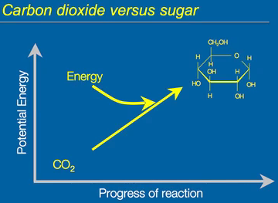
Photosynthesis transforms energy from light. It can be defined as a light dependent reaction to convert CO₂ or inorganic carbon into an organic form. It is metabolic process where light energy is used to drive the conversion of CO₂ into sugar. There is no usable energy in inorganic carbon because it contains oxygen. Usable energy means you can extract electrons from those molecules. You cannot get electrons from inorganic carbon. Sugar has high energy content because it contains a lot of C-H bonds. Neither carbon nor hydrogen is very electronegative, so it is easy to pull those electrons away and use them. Photosynthesis overall is an endergonic process and the energy come from light. Photosynthesis is basically is the opposite of respiration, therefore respiration is exergonic.
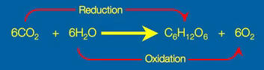
Whether you are talking about respiration or photosynthesis, you are talking about redox reaction. The electrons move from one molecule to another. In the case of photosynthetic carbon reduction/fixation, CO₂ is reduced to sugar. Redox reactions are coupled; you don’t get reduction without oxygen and vice versa. Water gets oxidized into oxygen.
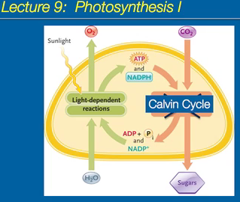
Photosynthesis can be distinguished into 2 processes: light reactions and not light reactions. The goal of light reactions is to create ATP and NADPH. It is an endergonic process. The energy to drive the reaction comes from ATP. The breakdown of the ATP drives the fixation of CO₂ into sugar. NADPH is not an energy source; it is the reducing part. It gives the electrons that can readily be used. ATP is the energy source and NADPH is the electron source.
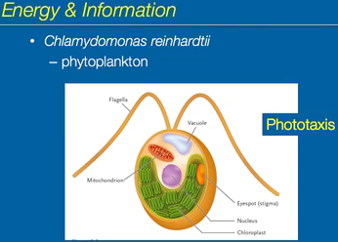
The single cell alga uses light for energy AND for vision. It contains an eyespot, which is a very primitive eye. Using the eye spot, it can detect light in its surroundings. The information it gathers from its eye spot is used to regulate the distance it wants to be from light. The ability to move toward or away from light is called phototaxis, and the eyespot regulates that.
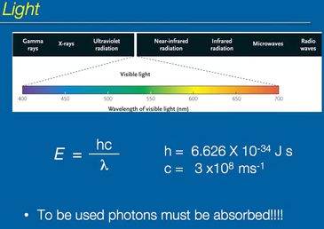
Light is wavelengths of electromagnetic radiation. Visible light is a narrow band. Light can behave like waves or particles. Photons are packets of light, like particles. The energy of a photon is inversely related to the wavelength. Gamma waves have shorter wavelengths and higher energy. Radio waves have longer wavelengths and lower energy. A photon of blue light has more energy than a photon of red light. To use the photons, the photons have to be absorbed. To see our surroundings, the photons that impinge on our retina have to be absorbed for information.
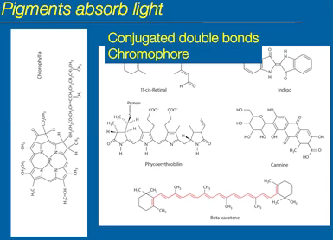
The molecules that absorb protons are called pigments. They all have one thing in common: conjugated double bonds (double, single, double, single, etc.). The conjugated double bonds represent electrons that are not really involved in bonding; they are π-orbital electrons. The electrons are not involved in bonding; they sit above and below the plane of the molecule. They are involved in photon absorption though. In a photosynthetic system, there are no free pigments. The pigments are bound precisely to specific proteins, not unlike moco binding. They are like cofactors. The pigment in a state where it is attached to a protein is called a chromophore.
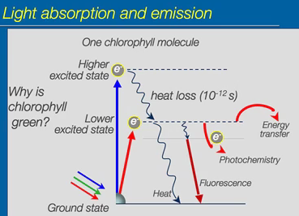
A single molecule of chlorophyll that contains one nonbonding electron is shown. It is then exposed to white light (the full visible spectrum), which can be divided into three major subsets: red, green and blue light. Chlorophyll can absorb a photon of blue light. Blue light has high energy which is transferred to the electron, exciting the electron. The excited state is quite unstable, making it decay in 10⁻¹² seconds. It dumps the energy as heat, moving the electron to a lower excited state. If the electron absorbs a red photon of light, the electron moves the lower excited state. Red photons have less energy than blue photons; they do not get to the same initial level as blue photons. The goal is to use the energy to do work. The fate of electrons in the lower excited state differs. All of the energy can completely decay as heat. Another fate is that it can lose a little heat and spits the photon right back out. The photon that comes out is of lesser energy than the photon that was initially absorbed because energy transformations are not 100% efficient. The reemission of a photon is called fluorescence. It always has a slightly lower energy and longer wavelengths. The energy can be used for photochemistry to drive photosynthesis, the light reactions. Photochemistry oxidizes the chlorophyll. The energy can decay and excite a neighbouring molecule, transferring the excited state of another pigment molecule. This is called energy transfer. If fluorescence occurs, why don’t we see red? It is because it does not occur as much as photochemistry and energy transfer. Why is chlorophyll green? It is because chlorophyll does not have an excited state that matches with the green photon’s energy. The green photons get bounced off, which are absorbed by our retinas, making us see green.
Note: 1 photon excites only 1 electron in a pigment. For absorption to take place, the energy must match. The energy required to move an electron from the ground state to the excited state must match the energy of a photon. If the energies do not match, the photon cannot be absorbed by the pigment. Color is light that pigments do not absorb.
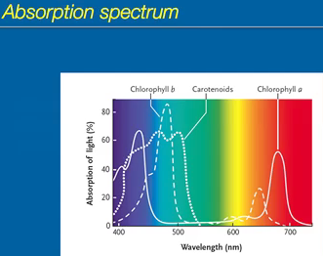
This is an absorption spectrum as a function of wavelength. Chlorophyll absorbs strongly in the blue and red because the energies match. There is no excited state for green.
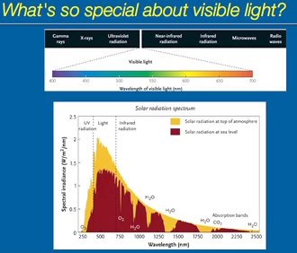
Visible light drives photosynthesis and used for vision. One reason why this spectrum is used is because visible light is the dominant light that hits the surface of the earth. Gamma rays don’t hit the surface of the earth. Ozone blocks the UV rays. There are certain molecules in the atmosphere that absorb longer wavelengths of light. To use light, you have to excite an electron. Microwaves and radio waves can’t excite a pigment because they do not contain enough energy. Gamma rays and x-rays essentially annihilate the electron. You destroy the electron instead of just exciting it. The energy is too strong, ionizing the molecule.
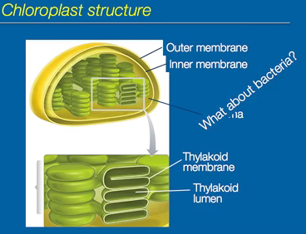
Photosynthesis in eukaryotes occurs in chloroplasts. Chlorophyll is contained in the thylakoid membrane. The Calvin cycle occurs in the stroma. Photosynthesis doesn’t need chloroplasts. Within bacteria, the thylakoid membranes are within the cytosol of the bacterium, just no chloroplasts.
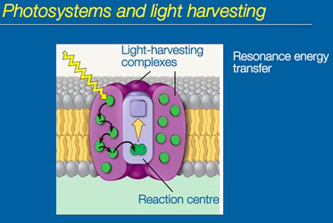
Chlorophyll is not free, it is found in proteins. The thylakoid membrane is the unit involved in light capture, light transfer and photochemistry. It is made up of light-harvesting complexes (also known as antennas), which are integral membrane proteins to which the pigments are bound. The green dots are individual pigments. The light-harvesting complex surrounds the reaction center. Resonance energy transfer is how energy flows through the light-harvesting complex. The molecules are very close together and are bound very precisely, the energy flows to the reaction center that contains a special chlorophyll. This is the chlorophyll that gets oxidized.
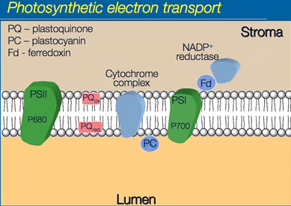
This is the thylakoid membrane. There are two photosystems: photosystem I and photosystem II. The reaction centers chlorophylls that get oxidized are P680 (in PSII) and P700 (in PS1). Plastoquinone is an electron carrier that moves; diffuses through the membrane and are found within the membrane itself. The cytochrome complex is a big multi protein.
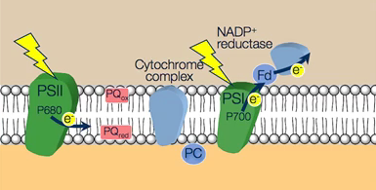
Light hits PSI and PSII; one photon of light. It gets trapped by the light harvesting; resonance energy transfers the energy to the reaction center. It excites the electron and is spit out of the reaction center. The electron from PSI flows to ferrodoxin and is then held by NADP+ reductase for a fraction of a second. P700 is oxidized to P700+, but it needs to be reduced, which is what the electron from PSII does.
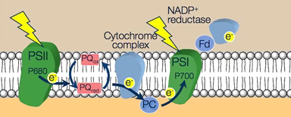
The electron moves through and reduces P700+ back down to P700.
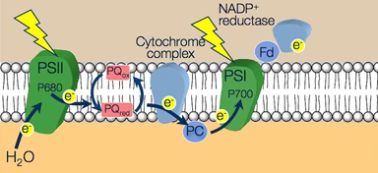
P680 is now oxidized. It gets an electron from H₂O. The electron from the water reduces P680 back from being positively charged to having no charge. To get an electron to move to NADP+ reductase, you need two photons on light.
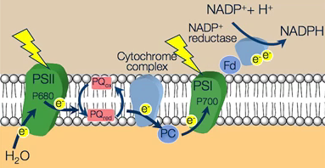
NADP+ reductase needs 2 electrons to make NADPH, which means 4 photons of light are needed to reduce it to NADPH.
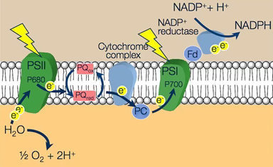
For 4 photons, a molecule of water is split apart to get the 2 electrons. But, splitting a molecule of water into half oxygen is not possible, so 2 molecules of water are needed for oxygen to float up the membrane. Therefore there are 4 electrons that go through it, meaning 8 photons of light are needed to complete the reaction to evolve a single molecule of oxygen. This is where the oxygen in the atmosphere comes from.
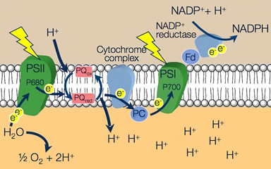
PQ is oxidized, to reduce it, you pick up an electron. Then PQ would be negatively charged. When it is not charged, it picks up a proton. The proton converts PQ_{ox} to PQ reduced. As it dumps the electron, it dumps the proton as well. Thus, the lumen of the thylakoid becomes progressively acidic.
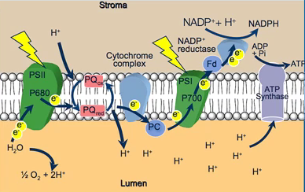
The protons are trapped; they are charged and cannot go across the membrane. The only way they can get back across is through ATP synthase. As the protons rush through, ATP synthase spins and catalyzes the phosphorylation of ADP, producing ATP. Electron transport is coupled with proton pumping. The proton gradient that is built up is used to synthesize ATP.
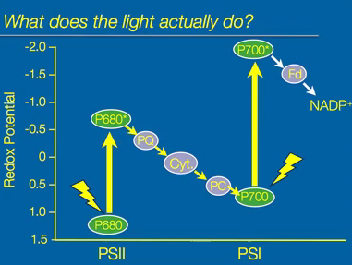
Light is needed for photosynthetic electron transport. The redox components that are attached to the proteins are organized in a very specific way, which allows for spontaneous flow of electrons. They are organized from low to high redox potential. The more positive the redox potential, the more oxidizing the molecule is. It pulls the electrons away from other molecules. The more negative the redox potential, it means the molecule can strongly donate electrons. It has capacity to reduce other electrons. The electron flow from plastoquinone to the cytochrome complex is spontaneous. The plastoquinone pool has a more negative redox potential. It has a tendency to donate electrons. While the cytochrome complex has a more positive redox potential has a greater tendency to accept or pull those electrons from plastoquinone. Likewise, plastocyanine, PC, has a stronger tendency to oxidize the cytochrome complex. Electron flow is spontaneous. The reaction centers have POSITIVE redox potential. P680 has a redox potential that is greater than one; it cannot spontaneously donate electrons to the plastoquinone pool. This is what light does in regards to photosynthetic electron transport. The ground state reaction center chlorophyll P680, when it absorbs a photon of light, an electron within P680 gets excited. P680 in the excited state is called P680*. Light absorption changes the redox potential of that P680. It makes it much lower, from 1 to -1.0. P680* will spontaneously donate electrons to PQ and goes down the chain to PC. The same issue occurs in PSI; the reaction center has positive redox potential, while NADP+ has negative redox potential. P700 is excited by a photon of light and becomes P700* in the excited state. It has a very negative redox potential. It readily gives up that electron in the excited state. The electrons flow spontaneously from P700* to ferrodoxin to NADP+ to produce NADPH. The light shifts the redox potential to a more negative state in the reaction center chlorophylls.
This is not the physical organization of the membrane. The position of these molecules doesn’t change, all that changes is the redox state potential of the reaction center chlorophylls.
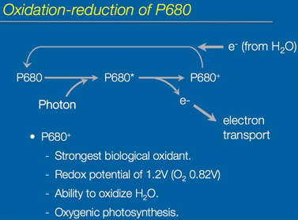
P680 has a positive net redox potential, it is not easy to oxidize. Upon the absorption of the photon of light or through resonance energy transfer through light harvesting, the energy excites P680 into the excited state, P680*. Once it is in the excited state, it is very easy to remove the electron from P680*. The electron is then removed and the electron is what drives electron transport. Now, you are left with a very strong oxidant, P680+, which is then reduced back to P680 by donation of electron from water. There is a lot of water from the luminal side, and there is an enzyme complex there that donates electrons. The electrons get ripped from water to make P680 neutral again so that it can accept another photon of light to continue the cycle. P680+ is the strongest known oxidant in biology. It has a very positive redox potential, even greater than oxygen. It has the ability to oxidize water, which leads to the oxidation of water. This leads to the formation of oxygen, which is then released from the thylakoid. The type of photosynthesis that has water molecules as the electron donors for PSII is called oxygenic photosynthesis.
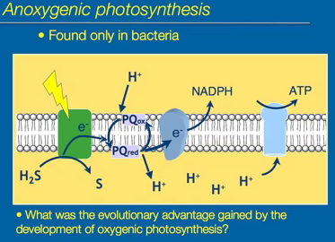
There are types of photosynthesis that don’t use PSI and PSII. They simply use a single photosystem. This is found only in bacteria. All algae and plants use pxygenic photosynthesis. There are groups of bacteria that undergo anoxygenic photosynthesis. The type of photosynthesis that does not involve oxygen is called anoxygenic photosynthesis. Oxygen is not released. It only requires a single photosystem. They use molecules such as hydrogen sulphide (H₂S), which is easier to oxidize than water and only need one photosystem. Oxygenic photosynthesis is more common. The development of oxygenic photosynthesis was an evolutionary advantage. They evolved the ability to use water as the electron donor. The significance of this is that water is much more common on earth than hydrogen sulphide. The increase in oxygenic photosynthesis led to increase of oxygen in the atmosphere.

