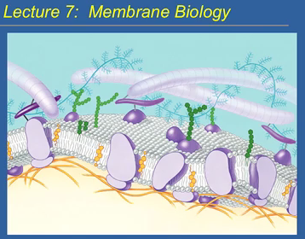
The image is of a typical membrane. Membranes are not completely lipids; there are those that are 50% proteins. Lipids are the backbone.
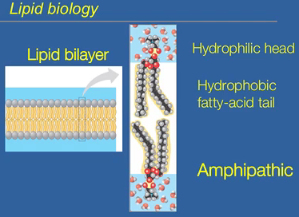
The foundation of the membrane is the lipid bilayer. Lipid molecules contain hydrophilic and hydrophobic groups within the single molecule. The part of the lipid that interacts with the aqueous environment is the polar hydrophilic molecule, enabling it to interact with the environment. The internal part, the fatty acid part, of a lipid is hydrophobic. Based on the tendency of hydrophobic groups to condense together, the force is a low energy state and is spontaneous. The lipid molecules produce the hydrophobic effect. Amphipathic: molecules that is both polar and non-polar. An example would be detergents. They can solubilise lipid molecules and hydrophilic molecules.
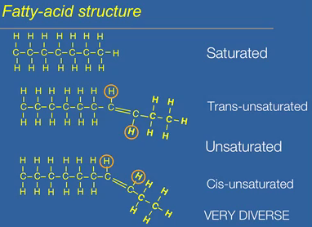
They are hydrocarbons, essentially carbon and hydrogen. The top is a saturated fatty acid; saturated with hydrogens and the molecule is linear. The second shows an introduction of double bonds. Lose two hydrogens for every C=C bond, making the compound unsaturated. Cis imparts a kink in the fatty acid tail, making it not linear. Trans shows that the hydrogens are across the double bond, and the kink is not as severe. Cis is kinkier. Trans fatty acids don’t occur in nature, but cis fatty acids are common in plants. Trans fats behave like saturated fats. The molecules are very diverse. The fatty acid can vary in length, number of double bonds and the position of those bonds. We care about the structure of the fatty acid to help with the fluidity of the membrane.
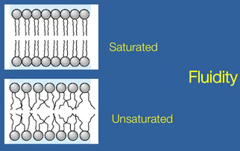
If the membrane is made up of saturated fats, it would be less viscous and fluid. If the membrane is made up of unsaturated fluids, then it would be more vicious and very fluid. You need to maintain membrane fluidity within a certain range. Molecules can’t pass through membrane if not fluid enough. If membrane is too fluid, then the membrane can be leaky and molecules you don’t want move through the membrane are able to. Humans are endothermic; we get to control out temperatures. Reptiles and others are ectotherms; cannot control their temperature. Whatever the temperature is, it is the temperature of the organisms.
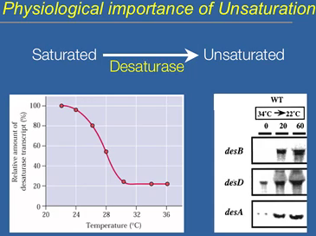
There is a physiological importance to unsaturation; of controlling the number of unsaturated fatty acids in the membrane. When fats are synthesized, they are fully synthesized. Desaturases are enzymes that introduce C=C bonds; they act on a fully saturated fatty acid. The diversity of unsaturated fatty acids is dependent on the type of desaturase enzyme. Each desaturase introduces a C=C bond in a different position. The graph shows an ectotherm, a bacterium. At low temperatures, the fluidity of the membrane decreases. Harder to transport things, so it fixes this by elevating the number of desaturase enzymes. It tries to maintain the fluidity in the membrane. It shows transcriptional control. Shows northern blot analysis. The bacteria rapidly transcripts the enzyme, denaturase.
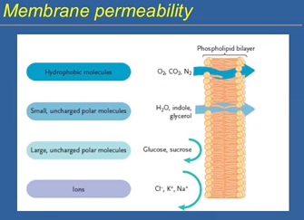
Need to separate the living processes inside the cell and outside of it. The environments are different, such as concentrations. The membrane is not an absolute barrier. Certain molecules that have no charge and are hydrophobic are so small that they can get in quickly through the membrane with no hassle. Charged molecules can’t cross the membrane. They cannot interact with the hydrophobic core. Size and charge impedes transport. Maintaining ionic balance is important and large molecules are needed in the membrane.
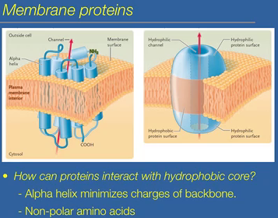
How do big and charged molecules get across the membrane? Proteins that span the membrane assist in their transport. Proteins have hydrophilic and hydrophobic groups; they can interact with the hydrophobic core. The core of the protein has a channel that the molecule can move through. The parts of the protein facing the channel are hydrophilic and the hydrophobic parts are exposed to the fatty acids of the membrane. How can these protein act with a hydrophobic core? Because proteins are a mixture of polar and nonpolar, they are admissible in the aqueous environment of the cell. The alpha helix secondary structure is why. It minimizes the charges of the backbone by producing an alpha helical structure. As well as having nonpolar amino acids in the regions that interacts with the core of the membrane. These proteins are called integral proteins or transmembrane proteins.
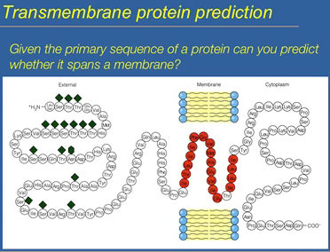
Given the primary sequence, you can predict the area that spans a membrane. It takes about 20 amino acids to cross a membrane. All you have to do is look for areas of the protein that are 20 amino acids long that have more nonpolar amino acids than the rest of the protein, and interacts with the membrane.
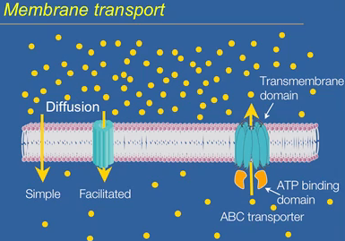
How are the molecules transported from one side to the other?
- If the molecules are small and uncharged, they can just go through simple diffusion to go across the membrane. Rates of diffusion are very fast, since there is nothing stopping them. It is a free energy driven process. Entropy drives diffusion. It is less disordered than if you had equal amounts on both sides. Entropy goes up.
- If molecules are slightly charged or larger, then they cannot simply diffuse. Diffusion is facilitated by using a specific protein transporter, which is specific to the molecule. Facilitated diffusion is driven by the entropy change and does not require ATP.
- There are times that the intracellular concentrations are much higher than the extracellular concentrations, and this is wanted. This is when diffusion is not wanted and you try to go against it; against the concentration gradient. This is called active transport, and a large group of transporters that facilitate this movement against diffusion are called ABC transporters. It contains a transmembrane domain and an ATP binding domain. The energy comes from ATP breakdown after the ATP binds to the ATP binding domain. The transmembrane domain dictates what molecules get moved by the transporter. ATP binding is just the engine that drives the transport.
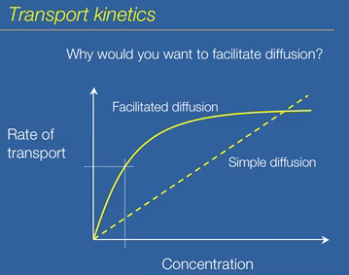
Rate of transport of the molecule vs. the concentration gradient from one side to the other. If it is simple, like oxygen, the rate is dependent on how big the concentration gradient is between the compartments that are separated by the membrane. The rate may be too small for the movement of slightly charged or larger molecules, so facilitated diffusion is used. Facilitated diffusion shows saturation kinetics. At low concentrations, the rate of transport is much higher compared to simple diffusion.
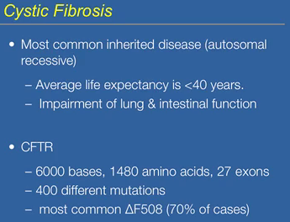
Cystic fibrosis impairs lung and gastinal intestinal function. It is common for those inflicted by the disease to have lung transplants. CF is caused by a defect in a single protein, a single ABC transporter called CFTR. CFTR is the gene and is very large. There are a number of mutations that could occur to make it defective. Most of the cases are caused by the ∆F508 mutation. ∆ stands for deletion and F stands for a specific amino acid. So there is a deletion of the amino acid from the position 508.

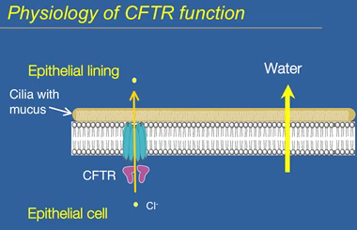
CFTR is found on a plasma membrane. It is expressed heavily in lung tissue and in the intestinal tract. CFTR sits on the membrane. People with CF cannot breathe properly because the mucus lining is dry. Mucus in the lungs is critical to get rid of dirt and bacteria that you breathe in. The mucus works with cilia to clear debris in your lungs, making you cough it up. This process only works because the mucus is wet. In CF patients, their mucus is dry. They cannot clear their lungs. They cannot clear the bacteria in their lungs and are susceptible to bacterial infections. CFTR pumps chloride from the epithelial cell into the epithelial lining in your lungs. The shift in ionic balance drives the osmotic release of water from the epithelial cells. Chloride pumping is linked to water movement. The water movement is what keeps the mucus wet.
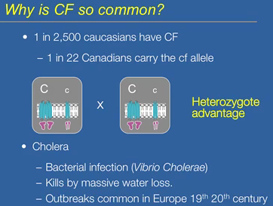
CF is very common. If you have Cc, then you are a carrier of the defective cf allele. You can have a 1 in 4 chance of having a child with full blown CF. Even if you carry the allele, it is not noticeable. People from Asia or Africa aren’t carriers of CF. it is of European ancestry. There is an advantage of being a carrier, such as being infected by cholera. It kills by massive water loss and is linked by poor sanitation. If you were a carrier of the CF allele, you were less susceptible to death by cholera. There was a heterozygote advantage to carrying CF.
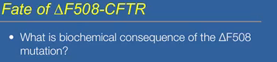
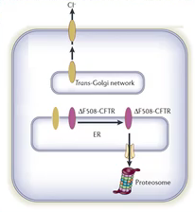
∆F508 mutation is a single mutation on one amino acid. If you take the mutation, you can synthesize the defective protein, then the protein transports chloride. It works, not as well as the wild type, but good enough. The problem is that the protein is synthesized in the ER, and does not actually get to the plasmamembrane. It gets tagged and degraded in the ER by the proteosomes. They are a group of enzymes that break down proteins.
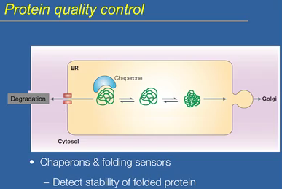
It gets tagged because in the ER it doesn’t fold correctly. Protein quality control in the ER; there is a chaperone helps to ∆F508 form but it cannot. The protein does not fold correctly, so it gets tagged for degradation. Chaperons can help proteins fold and they can sense if the protein is not working, leading it to tag the protein. CF can be solved if the levels of control by the chaperones are decreased.

