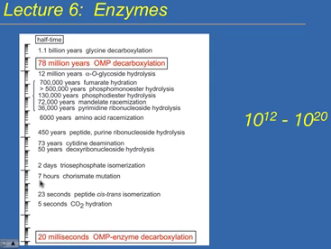
Spontaneous reactions can occur over a really long time. If you add an enzyme, then the reaction speeds up. Enzymes usually increase the rate of the reaction 10¹²-10²⁰ times.
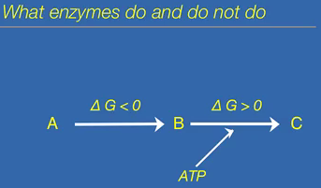
Enzyme is a specific group of proteins that catalyze reactions, but they do not get consumed (definition of a catalyst). Conversion of A to B is exergonic reaction; enzyme can speed up the reaction. Conversion of B to C is an endergonic reaction, can’t use an enzyme, instead energy coupling is needed. Enzymes can’t provide energy to a reaction. It cannot make an endergonic reaction into an exergonic reaction. To drive the endergonic reaction, you need energy from ATP breakdown.
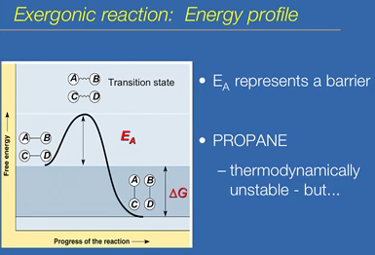
The free energy of the products is negative, than the starting molecule. For the reaction to proceed, they need to acquire free energy from the surroundings. The transition state is where they are in a higher level of free energy. This is when the bonds are ready to break. The amount of energy state you need to get to reach the transition state is called activation energy. Activation energy represents a kinetic barrier, prevents the reaction from going very fast. Ex. Propane. The breakdown of propane is spontaneous. It is thermodynamically unstable, it can spontaneously breakdown and energy is released. Kinetically, it is a very stable compound. It cannot simple combust. If a spark is introduced, it represents energy, letting reaction occur quickly.
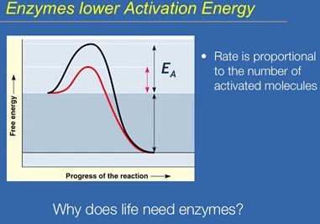
Enzymes lower the energy required to reach the transition state. Activation energy is lowered in the presence of a catalyst. If the energy is lowered, then there are more molecules that are able to reach the transition state than without the presence of the enzyme. This enables the reaction to go faster since it was easier to overcome the kinetic barrier. An enzyme does not change the ∆G, the starting free energy and ending free energy is the same. All that is changed is that path in which the reaction takes place. Enzymes must have evolved very early. Life needs enzymes because we need reactions to occur quickly within the body, but with no heat being released. The only way to increase the rate of reaction without increasing temperatures is to use catalysts, specifically in life are enzymes.
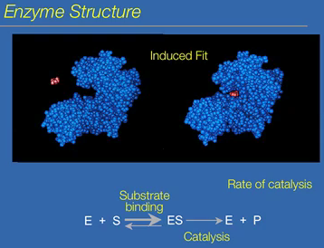
Enzymes are proteins. Substrate only interacts with a specific part of the enzyme called the active site. Catalysis/reaction takes place in the active site of the enzyme. The primary sequence of the enzyme cannot be used to determine the area of the active site. The active site is only apparent when you acquire the correct native conformation. Difficult to protein folding, thus it is difficult to predict the area where the active site is. Enzymes must be flexible and be able to change their conformation; this is called induced fit. When the substrate binds to the active site, the enzyme changes its shape for catalysis to occur. The reaction that takes place: enzyme + substrate ↔ enzyme-substrate complex → enzyme + product. The direction of this reaction is strongly towards the enzyme-substrate complex. Substrate binding occurs, and then catalysis occurs. Then the enzyme and product are produced and released. The rate of catalysis: most enzymes can do this reaction 1000 times a second, which is faster than enzymes. Can measure the rate at which product is made or substrate is used to measure the rate of catalysis.
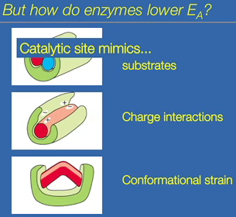
- Enzyme increases probability that the two substrates will interact in the right way for them to react together. The substrates can do this without the enzyme, but the probability that they will get the correct interaction is slim.
- Enzyme may provide a specific charged environment which helps catalysis. The charged environment may be rare without the presence of the enzyme.
- Maybe the molecule needs to be strained. The substrate’s bonds needs to be strained. The enzyme can create strain on the substrate.
Each of these represents what the molecule would be like at the transition state. Enzyme-substrate complex is putting the substrate in the orientation/conformation it would be in at the transition state. Catalytic site/active site mimics the transition state without requiring as much energy input.
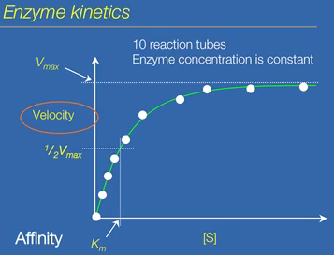
Isolate an enzyme in vitro. There are 10 reaction tubes with a buffer, which makes enzymes reactive, with equal amounts of enzymes in each tube. What is the effect of the addition of increasing amounts of substrate to each tube on the reaction rate (velocity)? Measure the disappearance of substrate. With no substrate, no velocity is seen. Velocity is dependent on substrate concentrations. As substrate is increased, velocity increases proportionally. Eventually, the rate of reaction stops increases and plateaus. It is a saturated curve. The reaction shows saturation kinetics. There comes a point where the enzymes can only turnover substrates so fast, it cannot work any faster. Turnover rate I shown on the graph. The saturation rate is enzyme dependent. The maximum rate is V_{max}, which is the maximum rate it can turn over substrate. Affinity between substrate and enzyme is K_{m}. it is the substrate concentration that gets you ½ V_{max}.
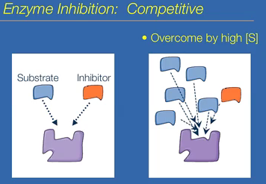
Some things can inhibit enzyme function. There are metabolic inhibitors, others wipe out enzymes. Competitive inhibition: inhibitors compete with substrate for the active site. Inhibitor must be similar to the substrate to compete for active site, blocking the normal reaction. This can be overcome with high abundance of substrates. The inhibitor can be reversible or irreversible. The inhibitor can bind to the active site and never let go. It can covalently link to enzyme, being irreversible. Others are reversible and leave afterwards.
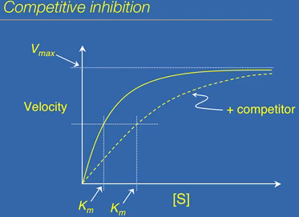
Substrate concentrations are increased while the amounts of inhibitors are kept constant. Graph shows you can overcome inhibitors with high concentrations of substrate. The V_{max} is the same since the inhibitor was overcome by substrate concentration. What changes is K_{m}; you need more substrate than usual to overcome the presence of the inhibitor. To get ½ V_{max} in the presence of the inhibitor K_{m} shifts to the right.
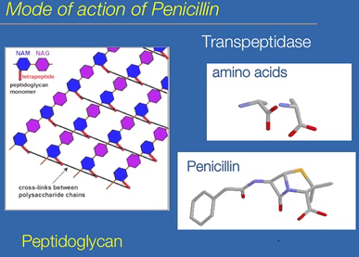
Penicillin is a classic example of an inhibitor. It is an antibiotic and kills bacteria. Peptidoglycan is the bacterial cell wall. The peptides need to be linked via peptide bond to create the cell wall. Bacteria have transpeptidase to link the peptides together. The active site of the enzyme recognizes a certain shape, which is mimicked by penicillin. Transpeptidase recognizes penicillin, and with high doses of it, the peptides cannot compete for transpeptidase. Penicillin is an irreversible competitive inhibitor of transpeptidase. Every molecule of penicillin that binds destroys the enzyme, essentially wiping out the bacteria.
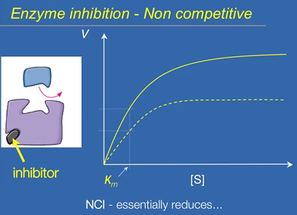
Non-competitive inhibitors don’t bind in the active site. Upon binding, it changes the conformation of the overall enzyme, changing the conformation of the active site. Therefore, the substrate is unable to bind to the active site. In the presence in a non-competitive inhibitor, it essentially shuts own the enzyme, making it inactive. It reduces the amount of functional enzymes. It basically is like doing the experiment with fewer enzymes. V_{max} would be lower in the presence of the non-competitive inhibitor since there are less functional enzymes, but K_{m} does not change.
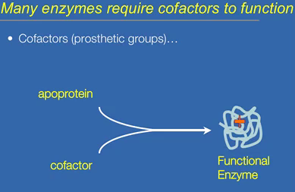
Many enzymes are not functional on their own. They need something else; a cofactor. It is a non-protein group that attaches to the enzyme to give it function. It has a major role in catalysis; without it, the enzyme doesn’t work. Need the protein part of the enzyme (apoprotein) to synthesize and bind to cofactor to produce a functional protein. The regulation is post-translational. It can regulate enzyme by regulating cofactor binding.
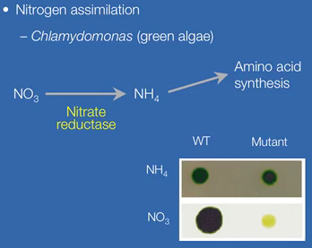
Nitrogen is required for amino acid synthesis, but in the form of ammonia. The common nitrogen form in the biosphere is nitrate. Humans don’t have this enzyme, but it converts nitrate to ammonia. One of the genes is defective in nitrogen reductase. On ammonia, the wild type and mutant are undistinguishable, but on nitrate, the mutant dies on nitrate because they don’t have the enzyme.
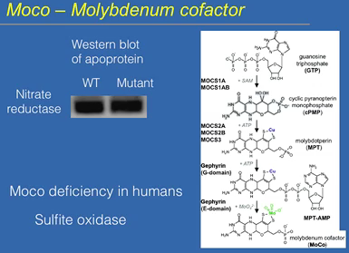
Nitrate reductase gene in the genome, there is no mutation found. The protein is synthesized perfectly. There is no difference in the apoprotein in the mutant. The defect is that the mutant does not have the cofactor. It needs Moco. The mutation is in the biosynthetic pathway. To make the enzyme functional, you need not just the apoprotein, but you need the biosynthetic pathway to be intact. The steps are enzyme catalyzed steps that drive the conversion to get Moco. Humans need Moco, and there are 4 moco requiring enzymes, one of them being sulphite oxidase. It is an inborn error. Sulphite oxidase deficiency is a result defect in MOCS1; the children cannot convert GTP to the next step. They feed intravenously high concentration of cPMP rescues them to continue the pathway in order for the children to survive.

