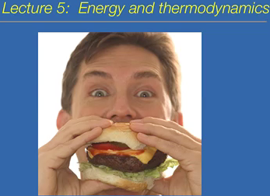
Thermodynamics: Energy and Energy Transformations. Why do you need to eat food?
Energy: capacity to do work
- Kinetic: energy associated with motion/movement
- Potential: energy associated with the object’s structure or its position in a gravitational field
  - Chemical-potential: energy associated with chemical bonds
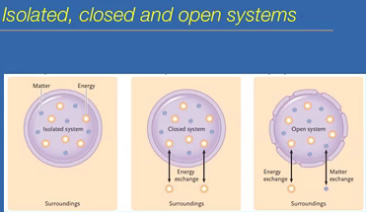
System: what we are interested in looking at. Example: cell, molecule, planet, galaxy, etc.
Surroundings: everything surrounding the system
- Isolated: neither matter and energy move in and out
- Closed: only energy can exchange with the surroundings, not matter. Ex. Earth (if take exceptions on meteorites)
- Open: both energy and matter can be exchanged
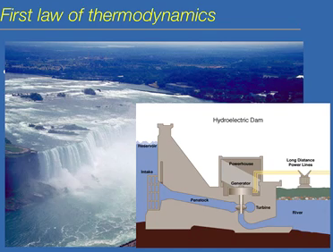
Two laws in thermodynamic. The total amount of energy in the universe is constant. Transformation of energy can be done. Light to chemical, heat, sound, etc. cannot make or destroy energy. Best example is Niagara Falls. There is more energy at the top than at the bottom. As it flows over, energy can be transformed. The gravitational drop spins the turbine and the energy used to spin the turbine transforms into electricity. Energy transformations are never 100% efficient.
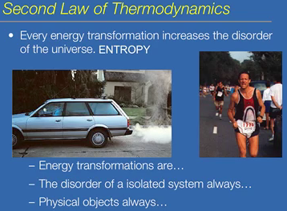
Second law states that energy transformations increase the disorder of the universe because entropy steals some of it. Energy in gasoline is used to power the engine, but the engine gets pretty hot. So, some of the energy is lost as heat. If the transformation is 100%, then the engines wouldn’t get hot. If you run, you burn calories and sugar, to drive muscle contractions, but energy transformation is not 100% so you heat up. Energy transformations are not 100%. If you have an isolated system, the disorder will always rise. Ex. Buy a new car, as time goes on the car erodes and you have to buy a new car. Physical objects always break down, which is entropy at play.
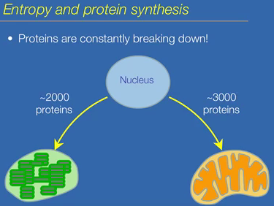
The reason why photosynthesis/respiration declines is because the proteins break down. Proteins are constantly breaking down in you cells. Protein synthesis, if it is inhibited, then the cells die. You can never switch off transcription or translation because proteins break down over time. They require thousands of proteins to work. Organelle function decays over time if proteins are not synthesized constantly.
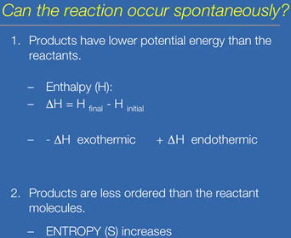
Spontaneous reaction: reaction that can take place without energy input does not mean it is a fast reaction though. Reactions tend to spontaneous when two things:
- Products have less energy associated with them than the reacting molecules in the system. The energy content of a system is called enthalpy (H). Reactions tend to be spontaneous when the ∆H is negative, when the reaction is exothermic. Endothermic is it has a positive ∆H.
- Products have more disorder/randomness than the reacting molecules. Entropy (S) increases.
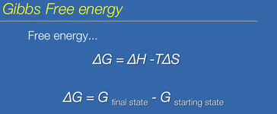
Free energy: energy that you can use, not used by entropy. The change in free energy is dependent on the change in heat content of enthalpy, but entropy steals some of this.
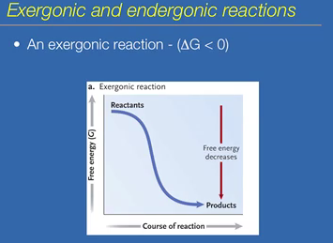
If ∆G is negative, then reaction is spontaneous. It is an exergonic reaction if ∆G is less than zero. Energy is released during the course of the reaction during an exergonic reaction, when the energy of the reactants has more free energy than the products.
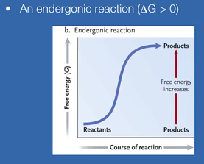
Endergonic reaction is the opposite. Reactants have less energy associated with them than the products. It would not be spontaneous.
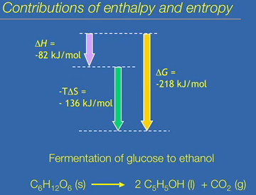
If a system undergoes a phase change, it is an increase in entropy. The amount of disorder increases, more random molecular motion. The reaction is spontaneous because of the negative ∆G. The reaction is exothermic (-∆H), and reactions tend to be spontaneous when they are exothermic. Entropy increases.
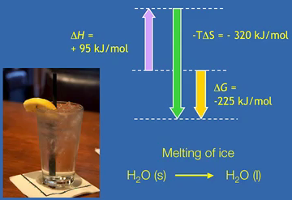
Melting of ice is spontaneous. It is exergonic. Has a strong -∆G. It is an endothermic reaction, the heat content increases overtime the product has more energy associated with them over time. The large increase in entropy makes it spontaneous.
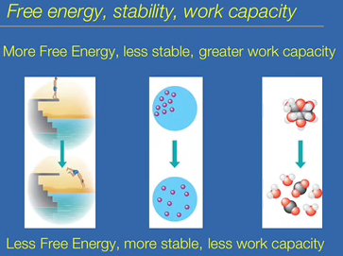
Free energy, stability and capacity to do work. The top photos have more free energy, less stable and a greater capacity to do wok. The bottom pictures have less free energy, more stable and less work capacity. Glucose is less stable than the breakdown products of glucose, which is why you can do a lot of work.
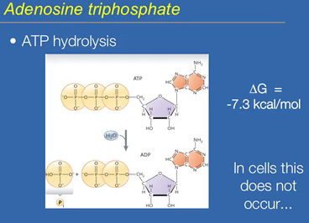
ATP. Adenosine is a building block of nucleic acids. It is a good energy source is that it contains 3 phosphate groups. There is strong repulsion in those bonds. They are negatively charged phosphate groups. Though a hydrolysis reaction, you remove the terminal phosphate and energy is released. An exergonic reaction. Then an orthophosphate (Pi-inorganic phosphate) and adenosine diphosphate are released. The energy released increases the heat of the surroundings. ATP hydrolysis is spontaneous, but doesn’t really occur in cells. It is not very fast and the heat would damage the cells. ATP is energy used to drive reactions.
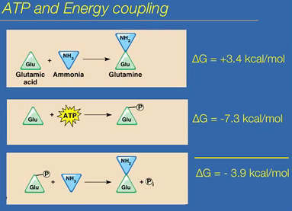
The ATP is harnessed through energy coupling. The amino acid, glutamic acid, is converted to the amino acid glutamine. You need both of these in large amounts. Glutamic acid reacts with a molecule of ammonia to create glutamine. It is an endergonic reaction, does not occur by itself. To drive the reaction, you link it with the energy in ATP. Energy coupling reaction is when you couple an endergonic reaction with an exothermic reaction. The exothermic reaction drives the endergonic reaction. Exothermic BREAKDOWN of ATP is used to drive the endergonic reaction to create glutamine. The breakdown of ATP is phosphorylating the glutamic acid. The phosphate group is negatively charged; tends to be unstable. There is more free energy associated with the phosphorylated glutamic acid; it’s more unstable and reactive. In this form, it readily reacts with ammonia to create glutamine. The overall reaction has a -∆G.
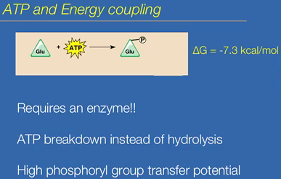
Energy coupling requires an enzyme. Energy comes from ATP breakdown, not hydrolysis. ATP and glutamic acid come very close together, that water can’t get into the active site, therefore no hydrolysis occurs. The terminal phosphate is transferred to the substrate. There is no free orthophosphate. There is no inorganic phosphate made. There is no heat made because the phosphate is transferred directly, and the energy is conserved in the phosphate bond. ATP is useful because it has high phosphoryl group transfer potential. It has great capacity to transfer a phosphate to another molecule, making that molecule more reactive.
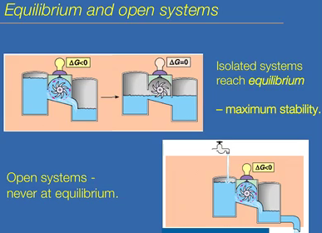
Work lights up the light bulb. In an isolated system, eventually free energy runs out, equalling zero. Closed system reach chemical equilibrium. The change in free energy equals zero and the system is in maximum stability. In an open system, ∆G will always be less than zero as long as the water doesn’t run out.
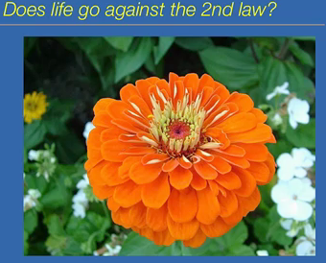
Life is not disordered; there is a structure to it. Life is not a closed system, it is open.
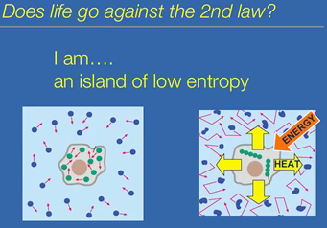
In the first image, there is no order. In the second image, it shows that life is ordered due to the input of energy. Heat increases the disorder of the surroundings. Basically, we need to eat to maintain order. I am an island of low entropy in a sea of randomness.

