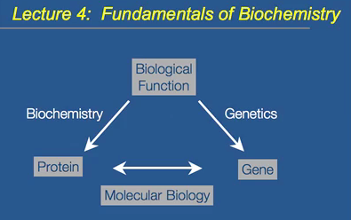
Biological Function from a cellular point of view, so how do organisms work? There are two major paths in understanding biology and how it works. One is to take a living creature and take it apart to understand subcellular components, from that you can learn how the living system works. The fundamental component of most cells that is important to cell structure and function are proteins. Biochemistry is the area of biology where you figure out biological function by isolating certain proteins. It looks at the function of the cell. Other pathway looks at organism as a whole and tries to get insight into biological function by looking at genes and taking a genetic approach. It looks at mutants. Molecular biology brought both parts together.
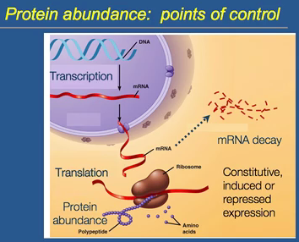
Proteins are the structural and functional molecule of a cell. Peptides produce proteins. Protein abundance is the key. If protein is more abundant, the function of that protein goes up. If less protein is made, the function of that protein should go down. How do you control protein abundance?
- Transcriptional control: converting gene, DNA, into mRNA. Make more mRNA, make more protein.
- Translational control: make lots of transcript, but may not lead to an increase in protein abundance because it is regulated at translation. The recruitment of tRNAs and the function of the ribosome.
- Post-transcriptional control: After transcription, before translation. Control abundance of mRNA about the transcript. mRNA can break down, it can degrade. It is a regulate process. mRNA turnover/decay is a regulated process. Break down more mRNA or keep them around longer.
- Post-translational control: can influence activity of a protein.
*Protein abundance vs. activity.
Gene expression
- Constitutive expression: gene is always on, always making the same level of protein. Doesn’t really change. Levels of certain proteins don’t change. Housekeeping genes. Fundamental aspects of cell need a constant supply of this.
- Induced expression: switched on. Usually on, but a certain condition or in a certain tissue, gene is switched off. The protein is switched off.
- Repressed expression:
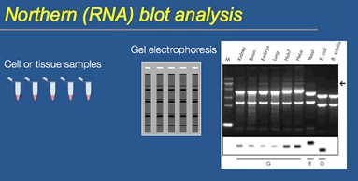
We’re interested transcript abundance. Transcriptional control is a major mechanism that dictates how much protein is made. How is transcript abundance measured? Using Northern (RNA) blot analysis.
- 5 samples of different tissues or cell samples. Isolate RNA and collect them into different tubes.
- Run RNA on a gel. Use gel electrophoresis to load samples and isolate RNA and separate them based on size by using electric currents.
- What a normal RNA gel looks like. The large bands are seen. The dominant type of RNA in a cell is ribosomal RNA. 97% of RNA in a cell is ribosomal. Those bands are ribosomal RNA. Don’t really see mRNA bands.
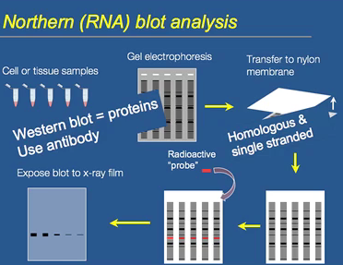
Want to look at a specific RNA and see how its abundance changes depending on sample.
- Transfer gel to nylon membrane. Lay membrane on top of gel, through capillary reaction, the RNA will transfer to membrane.
- All RNA on nylon membrane. It’s easier to work with than the gel.
- Looking at transcript abundance of a specific gene, doesn’t work if you don’t know what gene you are interested in looking for. Need a radioactive probe which is a single stranded DNA that corresponds to gene you are looking for. The DNA will find the complementary RNA, which is also single stranded. The two strands will anneal to each other. The complementary base pairing and is very specific it will only bind the complementary strands which are essentially identical. Homologous in a single stranded probe.
- Lay a piece of film on it. The probe is stuck in a certain area and it will expose the film where the probe is bound. Lt will stick to where on the membrane the complementary strand is. Amount of binding is proportional to how much transcript is there.
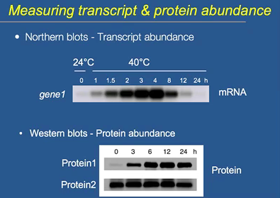
Western blot is similar. Isolate proteins, not RNA. Don’t use radioactive probe, but use antibodies instead.
Expression of a gene and transcript abundance of certain mRNA. Function of time. This is a heat shock experiment. Expect some genes to be switched on or off. Transcript abundance goes up. In gene 1, shows induction, then repression later on in gene 1.
Western blot, protein 1 shows induction. Protein 2 shows constitutive expression.
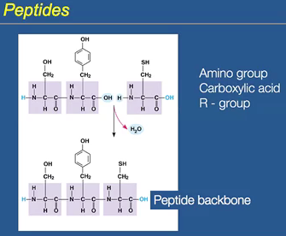
Proteins are peptides. Peptides are made of amino acids. Amino acids have three groups: amino group, carboxylic group and an R-group (variable part of an amino acid). Amino acids are linked together by peptide bonds, which are linked together by dehydration reaction. Purple is the peptide backbone.
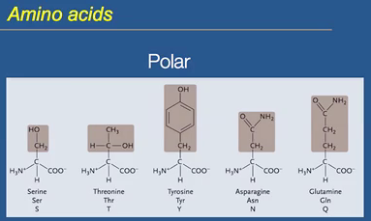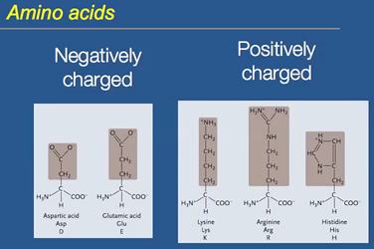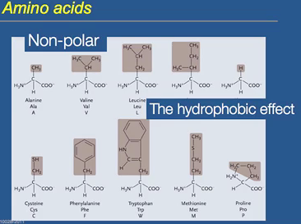
Amino acids. There are polar, charged, and non-polar. Non polar are an interesting group. They contribute to the hydrophobic effect. Nonpolar amino acids tend to not want to interact in an aqueous environment. They want to stay well away from water and hang out with themselves. The hydrophobic effect is the tendency to stay away from an aqueous environment.
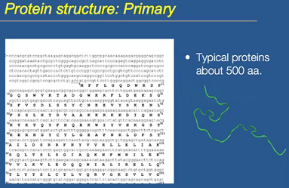
There are three structures of protein. Primary sequence of the transcript. Protein in capitals, RNA is small. The linear sequence constitutes the primary sequence. Linear ordering of amino acids. Typical protein. Human has 30000 different proteins; average protein is 500 amino acids long.
Backbone is the blue. α-helical structure, which is a classical type of secondary structure. 1 interacts with 5, a hydrogen bond is produced, specifically the hydrogen associated with the amino group and the fifth amino acid along. The oxygen of the carboxylic group produces the hydrogen bond. Every 5th amino acid interacts.
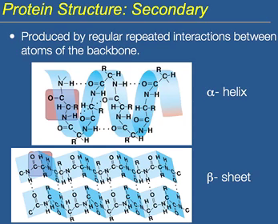
Similarly, a β-sheet is when one peptide folds over and has two individual peptides. Hydrogen bonding between the amino group and carboxylic group constitute the backbone.
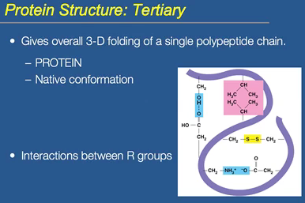
Tertiary structure depends on interactions between the R-groups, giving its overall 3D shape. Peptide newly synthesized is unfolded, and then the secondary structure forms, then the tertiary structure forms. Then the protein actually folds into the correct conformation. The conformation takes the peptide from being inactive to being a protein, which does have a function. The function requires it to fold. The tertiary structure imparts the correct conformation, or folded state. Peptide is newly synthesized and unfolded and lacks function. The functional state is called the native conformation.
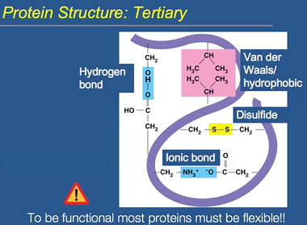
R-groups: components of the amino acids that are different. The purple is the backbone. Hydrogen bonding also occurs in tertiary structures. Ionic interactions, hydrophobic interactions (nonpolar residues interact), disulphate bridge (contain oxidized sulphur). Disulphide bridges are covalent bonds. To be functional, proteins are not rigid. They have to maintain flexibility. Some of the interactions are weak, allowing it to remain flexible. There are organisms called extremophiles that grow under extreme conditions.
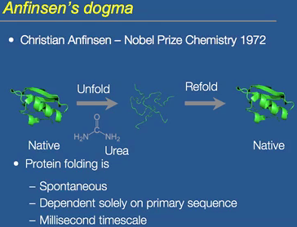
For a protein to be functional, it has to acquire the correct 3D conformation. What determines how it folds? (In vitro=outside of cell) native conformation is 100% active; he added urea, which denatured the protein. It removed its 3D structure, preventing the hydrophobic interactions, resulting in the unfolding of the protein. The denaturing of a protein can be done with temperature as well. The protein has 0% activity. He then removed the urea and the protein refolds, retaining the same amount of activity it had. Shows that protein folding is spontaneous, which means it occurs naturally and does not require energy. The folding depends solely of the primary sequence. The occurrence is very fast.
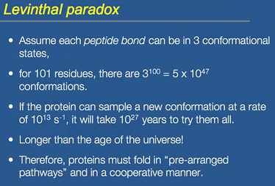
If a protein with a certain number of amino acids, if it has to go through and try all the possible different confirmation, then it would way too long. There must be something else involved to drive protein folding.
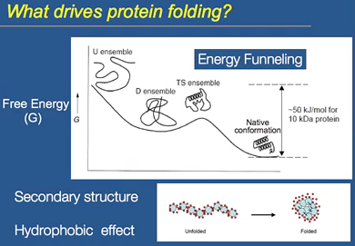
Given that the protein does not try all the different conformations, what does drive protein folding? The correct native conformation is always the lowest energy state of that protein. A newly synthesized peptide has much higher free energy. The final native conformation is the lowest energy state that the protein can exist in. it may go through various intermediate steps along the way. It may try folding, but eventually it goes to the native conformation. The secondary structure, hydrogen bonding between the backbone and the hydrophobic effect comes into play before the final tertiary structure is acquired. The process is called energy funnelling. All the energy funnels to the lowest energy state. In the unfolded state, a lot of the amino acids interact with the aqueous environment, which is less stable. There is higher energy associated. When the protein folds, the hydrophobic parts of the protein are buried and interact with each other.
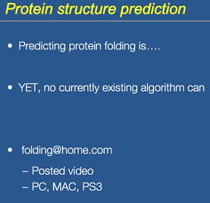
Predicting protein folding is important. If function is controlled by protein folding, then figuring out how a protein folds is important. There are many diseases which are caused by the misfolding of proteins, such as cystic fibrosis. Given the primary sequence, can the protein folding be predicted? No you cannot. There is no existing way to tell how a protein folds given the primary sequence. folding@home.com
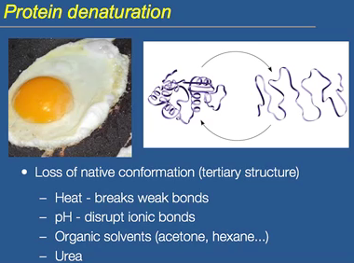
Denaturation: lose the native conformation, lose the tertiary structure. Use heat, pH, solvents and urea. Anything that breaks the tertiary structure. Sometimes you can renature it, sometimes you cannot. Like frying eggs, it is irreversible denaturation.
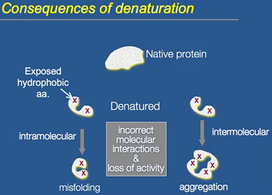
Consequences of denaturing are often the hydrophic amino acids become exposed to the aqueous environment, creating misfolding. Preventing it from acquiring the native conformation, losing activity.
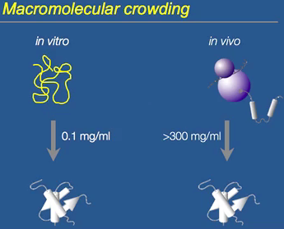
In vitro, take a protein and it will fold correctly. Only works in low concentrations of proteins. In a cell, (in vivo) the concentrations of proteins are much higher. Peptide should fold naturally to the native conformation, but if there are so many peptides around, this can cause misfolding. The peptides interact causing misfolding and improper interactions being made. Macromolecular crowding: disruption of normal folding because of the abundance of peptides being synthesized. In vivo, macromolecular crowding can interfere with normal folding of a peptide. To acquire the correct folding, many proteins need help.
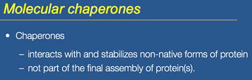
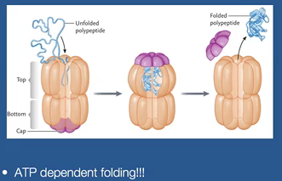
Chaperones: group of proteins that can help interact and stabilize the non-native forms of a protein. The problem of macromolecular crowding is helped by the presence of chaperones. They help proteins fold even in the presence of an abundance of proteins. They have nothing to do with the final protein, but they help it assemble.
Chaperones are very common. The unfolded protein interacts with the chaperone and then it is released when it acquires the final conformation, but does not keep a part of the chaperone. This is ATP dependent.

