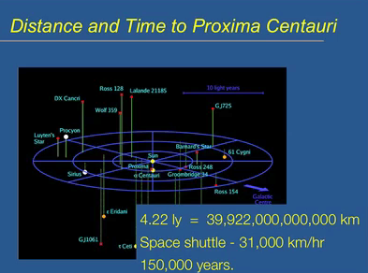
- Getting to the nearest star, Proxima Centauri Picture of the local group, which are about 20 stars. It is 4.22 light years away. 150,000 years to get there through space travel.
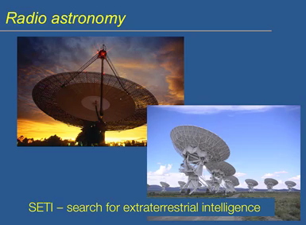
- We rely on radio astronomy. We should be able to detect the presence of other forms by noticing the radio waves they emit. Radio waves travels at the speed of light, which is why it is advantageous. It listens for ET. SETI=search for extra-terrestrial intelligence.
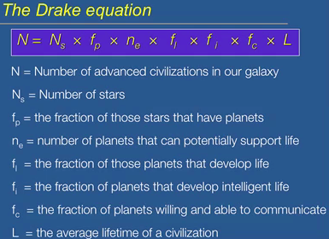
- We are interested in the number of advanced civilizations WITHIN OUR GALAXY, not universe as a whole. Just the Milky Way.
N_{s}=number of stars. Planets don’t form by themselves, they always orbit stars. 100 billion stars make up the Milky Way.
f_{p}=fraction of stars have planets
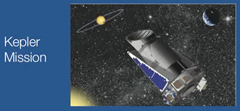
- Can we detect extrasolar planets? Can we detect if there is a planet moving around it?
- Kepler Mission: detects other planets. It doesn’t move; it’s trained one specific part of the sky that encompasses about 150,000 stars.
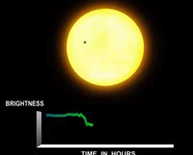
- It picks up the decrease in brightness that occurs when a planet transits in front of the star in relation to where we are. Picks up minute decrease in brightness when planet moves in between the star and kepler. Starlight should dim and come back up in a very regular pattern.
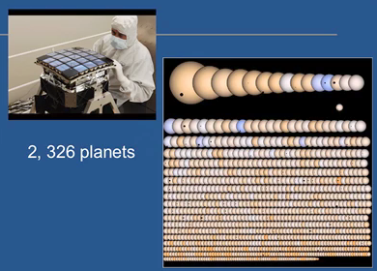
- Many of those planets orbit around binary systems (like in Star Wars)
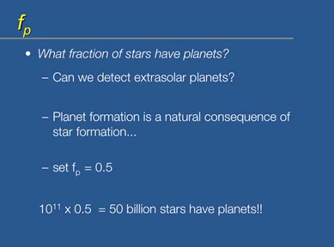
fp=fraction of stars that have planets
- Can we detect extrasolar planets?
- Why are there so many planets? It’s a natural consequence of star formation. It’s rare that you produce stars that don’t also produce planets.
- Set the fraction to a half since there may be some stars that don’t have planets???
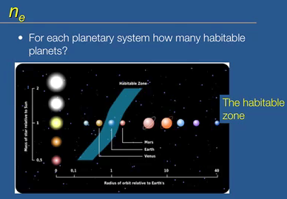
n_{e}=habitable planets
- Interested in planets that would develop life
- Two factors: mass and distance from parent star.
  - Mass: Planet has to be right mass. If too small, not massive enough to hold an atmosphere. Too big, then atmosphere is too big like Jupiter, a big ball of gas.
  - Distance: there is a zone that is a certain distance from the parent star that would be conducive to development of life. Called the habitable zone, where the temperature would be just right. Also called the goldilocks zone. This depends on the star, if star is not that bright, habitable zone moves closer. If star is brighter, then habitable zone moves farther.
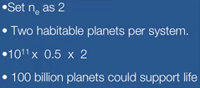
- Set the number to 2. Venus or mars may have had life on it. So two habitable planets per system. 100 billion planets could support life.
- The numbers are not absolute.
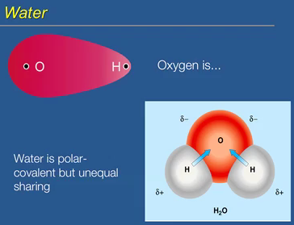
- Mars is dry. There is no water on Mars. Water is the fundamental requirement of life. Water and life go hand in hand. Oxygen is electronegative. It’s a covalent bond but oxygen takes more of the electron density than the hydrogen. Water is a polar molecule. There is a dipole moment with the bonds. Oxygen is slightly negative and hydrogen is slightly positive. This causes hydrogen bonds to form. Water should not be a liquid at zero and at a hundred degrees should be a gas. Hydrogen sulphide is a gas. Hydrogen bonding keeps the molecules together and requires a lot of energy to break the bonds to make it a gas. Habitable zone defined by water existing in a liquid state.
- Emergent properties that come out of the hydrogen bonding:
  - High cohesion
  - High heat capacity
  - High heat of vaporization
    - All defined in purple pages of textbook
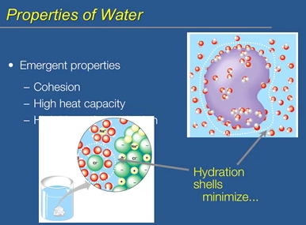
- From a biological point of view, water solvates other molecules. When molecules go into a solution, water molecules shields the electrostatic charges of the molecules, called hydration shells. It minimizes the charge effect of those molecules. Proteins have a lot of charged groups; the hydration shell around it minimizes the effect of those charge groups on how the protein interacts. Two proteins interact based on other things, not usually on charge. Without a hydration shell, everything would stick together. Hydration shell minimizes electrostatic interactions.
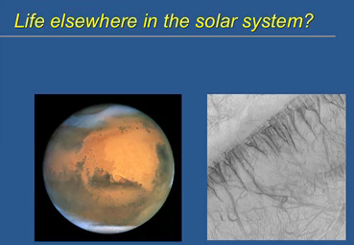
- Water may have existed on mars. Geological evidence in the liquid form flowed on mars at one time. There may be dry ice as well as ice on the polar ice caps.
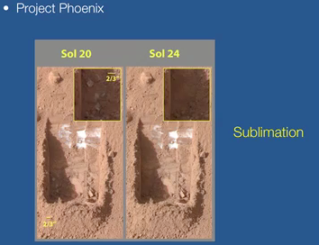
- Project phoenix was a spaceship that scooped dirt away and ice may have been discovered. Frozen water. Sublimation of ice. It was not the sublimation of co2, because that would have occurred rapidly, as soon as it was exposed. Sublimation: transition from solid straight to a gas. Mars was at one time a wet planet.
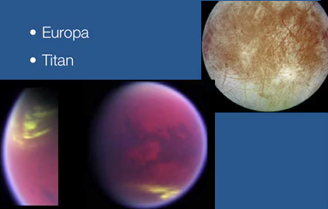
- Europa and Titan. Moons of Saturn and Jupiter. Could have ice.
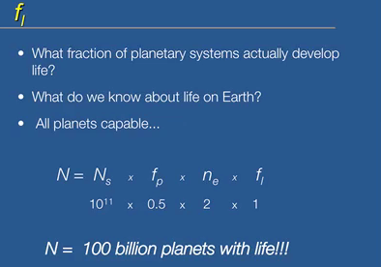
NO LIFE has been found yet.
f_{l}=fraction of planets with life
- Once planet was cool enough, life developed. Suggests that all planets capable of developing life in the habitable zone do so. They develop life.
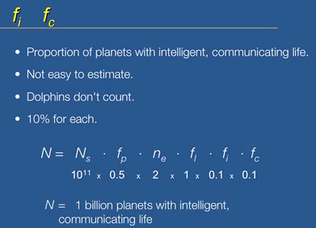
f_{i} and f_{c}= proportion of planets with intelligent, communicating civilizations.
- If they are not communicating and not intelligent, we can’t detect them. Radio astronomy can’t pick up snails. This is not an easy estimate and dolphins don’t count.
- 10% of planets with life actually have intelligent and communicating life.
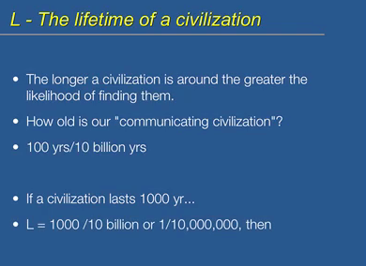
- Right now how much intelligent and communicating life? We can’t detect civilizations that are active at this moment.
- L=how long is the average time that a civilization is in existence.
- How long has our intelligent, communicating civilization been in existence? 100 years.
- As a proportion of the age of the galaxy, this is an estimate of 10 billion years.
- If civilizations last 1000 years, then we can actually detect them.
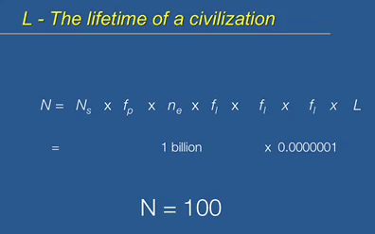
- If average lifetime is 1000 years, N=100.
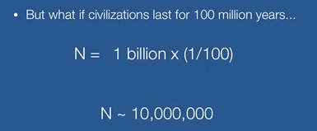

- Why is everything so quiet? Radio waves have been searching space for the last 40 years.
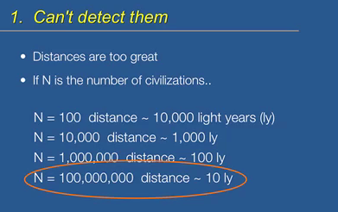
- Can’t detect them: distances are still too great. We can’t go anywhere on a spaceship. Even if radio waves travel at speed of light, still not enough. If they are randomly distributed, 100 civilizations, there are 10000 light years to pick up radio waves from the planet. The size of 100 is awfully spall compared to the number of planets in the Milky Way. Technologically incompatible. We think radio communication is fundamental, but maybe it only makes sense for us. We don’t perceive what they use as communication.
- No other civilizations exist

