INTRODUCTION TO INVESTING
Passive managers = want to match an index. Active managers generally outperform passive managers. However, active managers/funds are generally outperformed by their benchmark
Why do active funds underperform? Given that the semi-strong form holds, asset managers cannot obtain a “competitive advantage” in terms of information gathering and insight derivation. Their performance objective is only to match an index. Asset managers can hence only systematically beat the market if they obtain insider information.
Autocorrelation = a trend continues to the next day (today positive return, tomorrow positive return is positive autocorrelation)
Anomalies in Financial Markets
Size Effect (Small Firm Effect) - Small companies (in terms of market capitalization) have shown higher risk-adjusted returns. Greater opportunity for growth.
P/E-(M/B-)Effect - Companies with comparably low P/E-Ratio (high Book-to-Market-Ratio), commonly known as value stocks, have shown higher returns
Dividend Yield-Effect - The stock return increases with the dividend yield
January Effect/Turn of the Year-Effect - „Past“ research : Stock returns in January are higher compared to all other month. Attributed to an increase in buying, following a drop in price that typically happens in december (when investors seek to offset capital gains for tax purposes).
End-of-Month-Effect - First month halves bring higher returns than the second
Change of Exchange Segment Effect- Change of market segment or newly listing in an equity index shows price effects
Jensen‘s Alpha shows in comparison to a (passive) benchmark the under- or over- performance (excess returns) achieved by active management. Jensen‘s Alpha is widely used to compare the performance of e.g. investment strategies or mutual funds. Technically Jensen’s Alpha measures the risk-adjusted excess return of a portfolio compared to its benchmark.
Fama-French Analysis if t-value > |1.96| = Significant → T-value = Coefficient / StErr
Alpha > 0 = Positive abnormal returns. Consistently outperform the benchmark
Beta > 1 = Riskier than the benchmark, measures systematic risk
SMB > 1 = mostly small cap stocks with high Book-to-Market ratio and low PE ratio
HML > 1 = Value Stocks (opposite = Growth/Tech stocks)
Alternative investment (AI) = is any asset that is not a publicly-traded stock, bond or mutual fund
Hedge Funds Private Equity Commodity Manager
Traditional Investments = money market investments, bonds, stocks and mutual fund investments.
“Super Classes”
1) Capital Assets: have continuous development/claim on future cash flows
2) Consumable and Transformable Assets: to which an economic value is assigned
3) Store of Value Assets: assets for conservation of value (eg.
COMMODITIES
Participants in commodity markets: Hedgers Speculators (Traders) Arbitrageurs
What are the benefits from investing in an active long / short strategy in the commodity markets? Better risk and return properties of CISDM CTA compared to GSCI TR . Active exploitation of backwardation and contango with good forecasting power. Benefitting from both market directions in the spot market. Lower drawdowns (due to Active risk manager) or possible participation in decreasing commodity prices
Why Invest in Commodities? Commodities as an asset class have historically gained positive returns in long-term periods, which are uncorrelated to stock and bond returns. Commodities therefore reduce the portfolio risk and enhance the risk-and-return tradeoff (diversification of market price risks).
1) Purchase of the physical assets= Buying the physical good on the spot market (direct real investment) Disadvantage: Immediate delivery of the commodities(or within 2 days) is not tractable in most cases, regarding specific requirements for storage and logistics and due to high ongoing costs (e.g. feeding costs for live cattle) (exception: precious metals, e.g. gold, platinum, silver)
2) Commodity stocks = Investments in commodity stocks (natural resource companies)
Advantages: Yield major returns through trading of physical commodities (i.e. exploration, mining or harvesting, refining, processing, selling and delivering commodities)
Disadvantage: Indirect,securitized investment in commodities(e.g.investment in petrochemical stocks) is an insufficient substitute for direct investments, i.e. the investor does not gain an immediate exposure in commodities
3) Commodity funds
Advantage: Appropriate potential for diversification at moderate transaction costs
Disadvantage: Low liquidity Intransparent investment strategies for investors
4) Commodity Futures
Advantages: Investors gain from price movements of the underlying commodities without specific requirements in storage and logistics High flexibility, i.e. roll-over of existing futures positions is possible on short notice (long and short positions) High degree of liquidity and low transaction costs
Disadvantages: Low amount of futures in highly volatile commodities Long-term exposure in commodity price risk requires proactive roll-over of contracts (might be very costly, depending on the market structure) Permanent margin calls if value depreciates Management of futures positions requires higher effort Risk of a physical settlement / delivery
5) Commodity Indices= tradable passive commodity indices (keep in mind that most alternative asset classes do not have “appropriate” tradable indices) Index-oriented investments are cost efficient alternatives to gain exposure to single commodities or segments of the commodities market Listed commodity index funds or index trackers (Exchange Traded Funds (ETF)): Advantage: relatively easy and cheap to trade, no solvency risk of the issuer, since ETFs are guaranteed deposits Commodity indices, like the commodities themselves, are denominated in U.S.-Dollars, i.e. investors are exposed to exchange rate risk Some ETFs or investment certificates provide a currency insurance and are called “Quanto”
Disadvantage: Prices of the index or ETF can decline even if the spot price of the underlying commodities increase, which is caused by the structure of the Futures-curve
Contango: the futures price is above the spot price, thus, the futures curve has a positive slope (precious metals, some cereals). Usually a market with high/volatile prices.
Backwardation: the futures price (today) is lower than the current spot price, thus, the futures curve has a negative slope (some industrial metals, crude oil, energy and livestock). Occurs when the convenience yield > risk free rate + storage costs.
Excess Return = Spot Return + Roll Return
Total Return = Spot Return + Roll Return + Collateral Return
Prices Go Up in the Investment Phase, But Go Down in the Exploitation Phase
PRIVATE EQUITY:
- Lower investment volumes but still high number of deals
- Mainly in USA, UK - pension funds, funds of funds, and banks.
- Funding: There are also special situations.
Value Capturing: Accounting Magic
Value Creation: Actual revenues
- PE improves productivity significantly.
- High priced acquisition = more debt used (vice versa)
- VC is more volatile than BO
Problems with IRR:
1) no TVM
2) Assumes reinvestment at IRR
The evaluation of a Private Equity investment does not have to coincide with its true value due to diverse biases...
1) Stale Pricing: Book values of stakes do not reflect actual market values and react delayed to Public Equity
2) Appraisal Smoothing: Volatility is underestimated due to backing on valuation history of illiquid investments
3) Illiquidity: Based on longer valuation periods (low numbers of observations) volatility is underestimated.
4) Managed Pricing: GP disposes of scope in assessing illiquid investments (often problematic in situation of total losses).
Hedge funds:
-Target: positive and risk-efficient value creation independently of market situation or phase, can use short selling, any financial instrument, leverage.
-Active risk management: adjust strategies to the changing market to protect investment. Manager is not interest in normal economic developments
-Hedge fund managers has a significant equity stake in the fund and is compensated based on returns
-Strategies: 1. Relative-value-strategies: convertible arbitrage, fixed income arbitrage, equity market neutral. 2. Event-driven-strategies: merger arbitrage, distressed securities. 3. Opportunistic strategies: long/short equity, short sellers, emerging markets, global macro, and corporate governance. 4. Managed futures and global macro (3) is tactical trading.
-1 and 2 are non-directional strategies, 3 is directional
- 1 shows lowest returns over 20 years (6.09%) for medium risk 5.77% 2 shows best returns for the lowest risk (8.49% for 4.72%) compared to 3. (8.53% for 11.06%) and tactical trading (8.28% for 8.57%)
2. Merger arbitrage: -T=0: long acquired firm A, short acquiring firm B for the same number of shares offered for each share of A. - T=1: short additional shares of B if offer is adjusted upwards (more of B for A). –T=3 (expiry of offer) Sell long position A, Buy short position B and cash in profit. You can achieve a profit by calculating the probabilities of a merger not happening or happening and profit from market uncertainty.
1. Fixed income arbitrage: profit from increasing spread due to convexity.
3. Global macro strategies: Short out-of-the-money Put options on index futures ex: Victor Niederhofer long thai bank stocks and short out-of-the-money Puts on the S&P. An Asian crises hit and local currency depreciated at the same time S&P was down 7% leading to 50 M USD loss in margin call an the total loss of over 100 M$.
1. Convertible arbitrage: Junior bond +warrant (long-term equity call option) Arbitrage from valuation inefficiencies of convertibles, price volatility of the underlying equity, interest income from bond and interest on proceeds from short sale. Strategy consists in going long on convertible bonds and shorting the stocks of the same company for the same amount, you can therefore benefit from long position and compensate for any loss on short position, because the bonds always have an intrinsic value from the interests even if stocks fall
-Advantages of hedge funds: new sources of investment for return to use many risk premiums left out by traditional investors
-Hedge funds make money by finding a mispricing opportunity (alpha) and leveraging their investment to improve returns.
- H.F. have a positive exposure to traditional risk factors, more than 85% of the variability is explained by systemic factors.
- Risk premium: don’t disappear, permanent price effect, result of non-homogenous risk aversion (non-diversifiable risk) excess return compensate investor for systematic risk, easy to test, is considered to be 60 to 80% of Hedge fund return. VS Return based on market inefficiencies: temporary effect, disappears quickly, requires intense research, computer capacity and special managers skills, hard to test, 20-40% of returns of the HF. Alpha used to be 48% of returns in 1995-99 and it dropped to 35% in 200-04 to 20% now…
- Traditional betas are exposed only to broad stock market, interest rates, credit risk and emerging markets Versus HF betas are exposed to style factors; small cap vs. large cap, value vs. growth, (long/short equity, equity market neutral), to event risk (merger arbitrage), to volatility (convertible and/or volatility arbitrage), risk of commercial hedgers in futures markets (managed futures), liquidity risk (distressed securities, fixed income arbitrage), spread risk (global macro). Exposure to HF beta requires techniques like short sales, leveraged and use of derivatives.
Risk premium (strategy): Interest duration prem. (buy long-term gov. bonds), credit risk prem.(buy corp. bonds) Event risk prem. (buy acquisition targets’ stock), liquidity risk prem.(buy illiquid investment) small firm risk prem.(buy small caps or private equity), convergence risk prem. (engage in spread position), commodity hedging demand risk prem.(follow trend), FX risk prem. (carry trade(sell currency with low interest rates and buy another currency with higher yields to capture the difference between rates)), short volatility/short option prem. (short sales of options), emerging markets (invest in EMM)
- Manager skills to exploit inefficiencies: 1 – exploitation of information ineff.(violates semi-strong EMH): better research and analysis skill(proprietary models), faster and better access to relevant info, and better understanding of macro factors. 2- Exploitation of statistical ineff. (violation of weak EMH): prediction of market behaviour through.statistical methods, underpricing or overpricing of volatilities, technical analysis.
- Alfred Winslow Jones created the first hedge fund in 1949 to use leverage and short sales, he used pair trading(have a short and long position in two different correlated stocks to profit from the spread between the securities, the spread increases in a volatile environment on the right selection of stocks) Target of his fund: gains in bull and bear markets.
-Strong HF performance after a financial crisis.
- inefficiencies exist on the short side because restrictions and aversion of risk selling doesn’t allow/attract investors to trade their pessimism, overvalued securities = inefficient pricing.
-HF cash + cash at margin account were at historical high levels during the 2008 crisis.
-Fee structure: 1 to 2% fixed management compensation (max 5%)(median 1%), add a 10 to 30% of positive return for the performance (incentive) fee (median20%). There can be a hurdle rate factor to calculate performance fee (positive returns in excess of benchmark)) or a High-Watermark (profit-based compensation) to net possible previous losses.
-Theory of the black swan: Black swan events are typically random and unexpected.
Long Term Capital Management is not taking black swan event into account, what would be the magnitude of the worst case? LTCM was using a fixed income arbitrage, 90% loss of the fund’s value in 1998 due to the Russia crisis. To serve call margins position had to be sold at loss to generate liquidity. LTCM was liquidated in December 1999.
- Amaranth lost $5B in value due to bullish bets on natural gas in September 2006. In august the fund was worth $9.2B its losses hit funds of funds like MS, CS, Deutsche Bank and GS.
-Distressed securities strategy: buy stock (higher risk) or bond of the company that significantly gain value in the case o f a successful restructuring.
-Regulation D (SEC law): invest in small/micro caps that raise funds on private capital markets.
Asset allocation:
-Alternative investment classes can increase a portfolios return while decreasing its volatility
- The average invested portfolio is not on the efficient frontier, diversification benefits are lost, Stocks have normally too much weight while alternative investments don’t have enough weight, this poor average allocation is due to ambiguity risk aversion. Because the possible outcome of alternative investment is not well known. Hedge funds and Private equity have high Sharpe-ratio for that reason.
-The normal distribution is the typical reference to measure risk and return. The kurtosis of a normal distribution is 3 in that case the excess kurtosis is 0. The skewness is 0. The top of the distribution is the mean. A normal distribution is described by mean and std. dev.
- A normal distribution have 68% of results within 1 std.dev. of the mean and 95% within 2
- Negative skewed (left ) is when most of the results is at the right(long tail at the left).
- Positive skewed(right) : is when most of result is at the left (long tail at the right).
- Risk averse investors have a preference for positively skewed distributions because symmetrical or negatively skewed distributions features more returns at the left edge of the (more negative returns). In the positively skewed distribution more returns are below the expected value but extreme loss can be avoided. And the probability for high profits is higher.
- High kurtosis (Leptokurtic) leads to higher /narrower distribution than low kurtosis (platykurtic). The kurtosis is the fourth moment of the return, skewness being the third.
- Risk averse investors prefer distribution without excess kurtosis, because positive Kurtosis distribution feature extreme returns more often then negative kurtosis ones. Expected absolute losses and probability of profits is higher for leptokurtic distributions
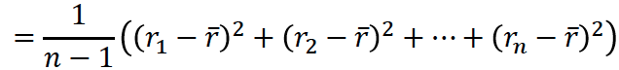
- Jarque-Beta Test is a measure of skewness and kurtosis JB= n/6*(skewness²+((kurtosis-3)²/4) n=observation#, H₀=data is normally distributed H₁=opposite, H₀ is rejected at the 5% (1%) confidence level if JB is higher than 5.99 (9.21).
- Variance : 𝜎_{𝑃}²=Var(r_{p})
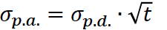
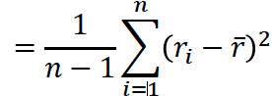
- Std(r_{p})= 𝜎_{𝑃} =square root of Var(r_{p}) to annualize standard deviation, multiply it by sq.rt of t
- Calculating the semi-volatility involves calculating the st.dv. from a variance that used only observations below the mean and 1/n instead of 1/(n-1).
-Maximum Draw Down (MaxDD) indicates highest loss ever recorded
-Short fall risk (lower partial moment)
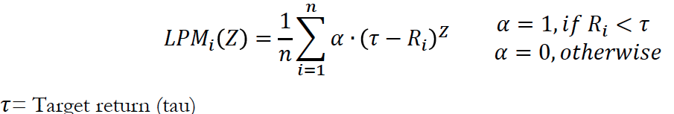

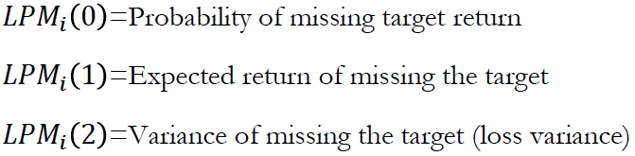
-Value-at-risk: the maximum loss a portfolio can’t exceed with a given probability and a given time horizon
- Disadvantage of VaR is that it doesn’t take into account that in 1% of cases (that would be 2-3 trading days in a year with daily VaR) the loss is expected to be greater than the VAR amount. Value At Risk does not say anything about the size of losses within this 1% of trading days and by no means does it say anything about the maximum possible loss.
- Conditional Value-at-risk: indicates the average expected loss beyond VaR and therefor doesn’t only account for the magnitude, but also the probability of extreme risk.
- The sharpe-ratio measure (the excess return of a portfolio over Rf) per risk unit= (R_{p}-R_{f})/ st.dev._{Rp}
The sharpe-ratio measures the slope, high slope=high sharpe-ratio.
-The Sortino Ratio measures the excess return of a portfolio per sq.rt. of LPM(2) =(R_{p}-R_{f})/√LPM(2)
-The Sterling Ratio measures the excess return of a portfolio per sq.rt. of MaxDD =(R_{p}-R_{f})/√MaxDD_{p}
- The Reverse Calmar Ratio calculates the average period an investor has to wait in years until the loss is caught up rCR_{p}=MaxxDD_{p}/R_{p}(p.a.)
- The return on Value-at-Risk measures the excess return of a portfolio per risk unit measured by VaR in absolute terms for a given probability and time period : RoVaR(α)_{p} = (R_{p}-R_{f})/ I Var(α)_{p} I
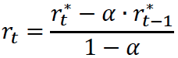
Abnormality(?): High sharpe-ratio for hedge fund indices, returns on hedge are in general not normally distributed: negative skewness and positive excess-kurtosis especially with high sharpe-ratio, high autocorrelation of first order for the returns and high autocorrelation yields to an underestimation of volatility = sharpe ratio is overestimated, reasons: illiquid trading strategy = daily appraisal not possible
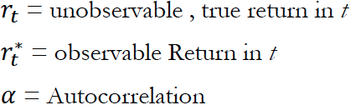
-De-smothing of the returns of the auto-correlation:
-Advanced De-smoothing techniques: Using that
method, the observable return is the weighted sum of past returns.Needed because returns of alternative investments often show high level of autocorrelation because of appraisal smoothing, stale pricing (not updated, old) and illiquidity.
-Modern portfolio theory: assumptions of Markowitz’ portfolio selection: perfect and complete capital market, risk averse investors, investment with the mean-variance principle, time horizon is 1 period, n linear independent and risk bearing securities, number of securities is 2 or more, securities have finite variances and expected values.
-Optimization: the multiple asset portfolio has to be optimized by using risk measures (volatility, semi-variance, CVaR(5%) and MaxDD) for different commodity benchmarks This is done to determine if commodities are useful components of a portfolio under various level of risk and returns expectation.
We obtain an optimization by minimizing the RM (risk measures)
Actual chapter 6:
Investment decision: 1. Capital allocation between risky portfolio and risk free asset, 2. Asset allocation across broad asset classes, 3. Security selection of individual assets within each asset class.
Portfolio of 2 risky assets: portfolio variance depends on the correlation between the return of the assets
Covariance and correlation coefficient provide a measure of the way returns of two asset move together
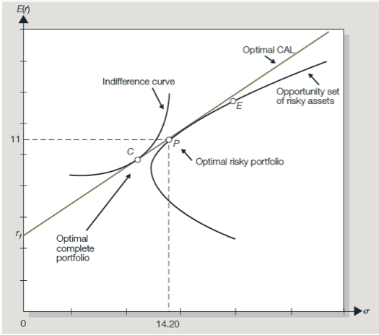
Portfolio return: weighted average of expected returns. Portfolio variance:$σ_{p}= \sqrt{W_{A}^{2}σ^{2}}+ W_{B}^{2}σ^{2}+2W_{A}W_{B}ρ_{AB}σ_{A}σ_{B}$where${{Cov}_{AB}= ρ}_{AB}σ_{A}σ_{B}$and
= correlation coeff.
Correlation coefficient is between -1.0 and 1.0, the smaller the correlation=greater risk reduction potential
At correlation=1 no risk reduction is possible.
- The optimal combination given the Markowitz portfolio selection model is the lowest level of risk for a given return. The optimal trade-off is the efficient frontier
- The point at which CAL touches the efficient frontier is the highest reward-to-variability ratio. Everyone invest in P, The portfolio will then be adapted to risk aversion by using different weights of the risk-free asset.$M$
$$-Min Variance Portfolio= \frac{σ_{B}^{2}-{Cov}_{AB}}{σ_{A}^{2}+ σ_{B}^{2}-2{Cov}_{AB}}$$
$$- Perfectly Hedged position if ρ=\left(-1\right)→ W_{A}= \frac{σ_{B}}{σ_{A}σ_{B}}=1-W_{B}$$
$$- Max Sharpe Ratio=Optimal Risky Portfolio. See next formula: \\ W_{A}= \frac{\left(E_{rA}-rf\right)σ_{B}^{2}-\left(E_{rB}-rf\right){Cov}_{AB} }{\left(E_{rA}-rf\right)σ_{B}^{2}+ \left(E_{rB}-rf\right)σ_{A}^{2}-\left(E_{rA}-rf+ E_{rB}-rf\right)* {Cov}_{AB} } \\ - Risk Aversion:y=Portfolio Proportion \left(1-y\right)=Tbill proportion = \frac{E_{rp}-rf}{Aσ_{p}^{2}}$$
Derivative Pricing:
Call holder payoff: (S_{t}-X) if S_{t} > X, 0 if S_{t}<=X Profit/loss to holder= Payoff - call purchase price
Call writer payoff: -(S_{t}-X) if S_{t} > X, 0 if S_{t}<=X Profit/loss to writer =Payoff + call purchase price
Put holder payoff: (X-S_{t}) if S_{t} < X, 0 if S_{t}>=X Profit/loss to holder= Payoff – put purchase price
Put writer payoff: -(S_{t}-X) if S_{t} < X, 0 if S_{t}>=X Profit/loss to writer =Payoff + put purchase price
- Intrinsic value: value for immediate exercise, Real value has an additional time value premium
- Binomial model: u= up, d=down movement - Risk Neutral Probability = q = [(1 + r ) – d] / (u – d)
→ C₀ = sum of (C_{u&d} * respective probability) = remember to discount to C_{o}
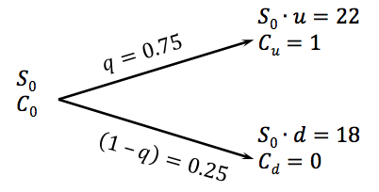
Black-scholes Framework: C₀ = current call value // P₀ = current put option value //
S₀ = current stock p: rice // N(d) = probability of random being less than d
X = strike price // r = risk free continuous // t = time in years
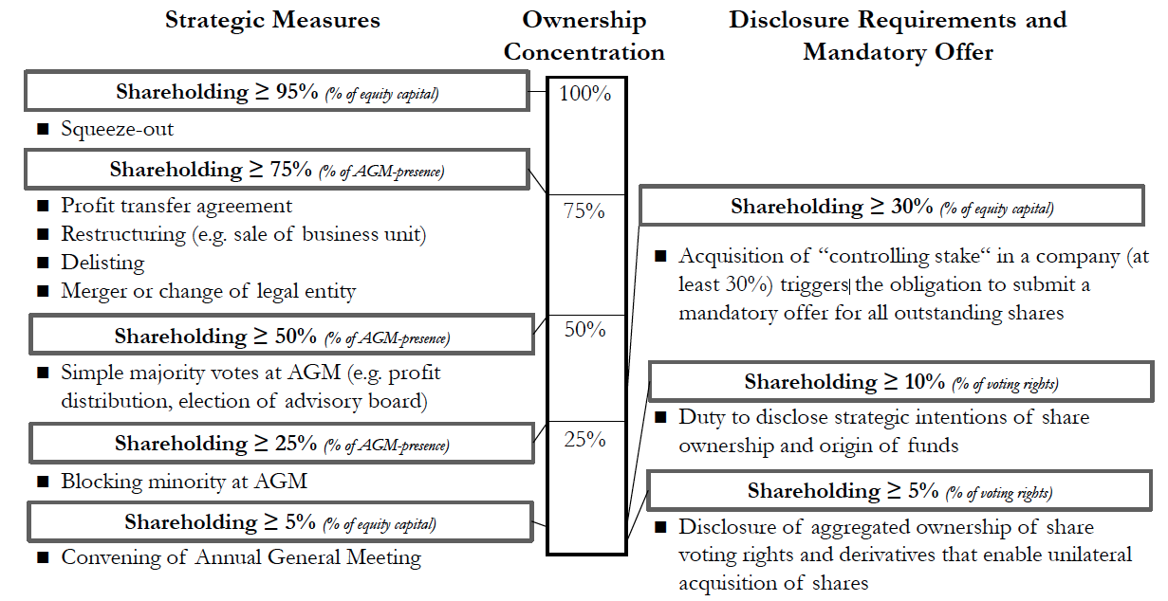
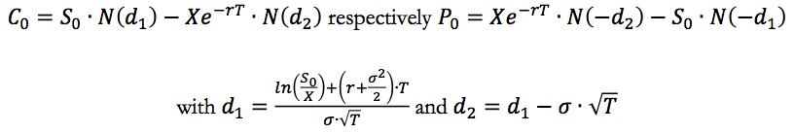
Delta: Measures the rate of change of the theoretical option value with respect to change in the underlying assets price = der(V) / der(S), Always lower than sensitivity of the asset ( = 1)
Long calls and short puts = Positive Delta (and vice versa (negative delta))
Gamma: Measures the rate of change in the delta with respect to the changes in the price of the underlying asset = der(delta) / der(stock price)
High gamma = small changes in the underlying value induce high changes in the delta
Long calls and puts = Positive Gamma (and vice versa(negative gama))
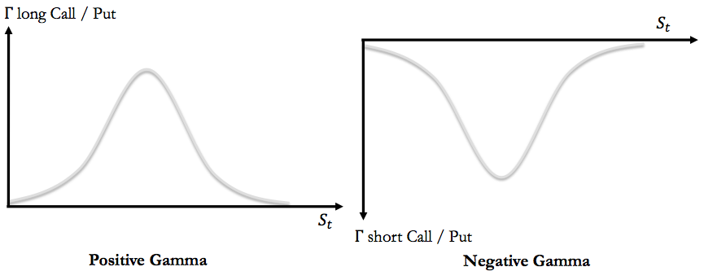
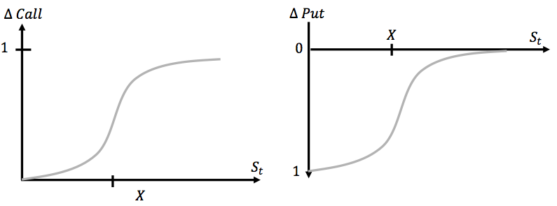

Options Formulas
$$P= C + PV * X - S_{o} H= \frac{C_{u}- C_{d}}{uS_{o}-dS_{o}} P=C+Xe^{-rT}- S_{o}$$
Porsche/VW Case:
Reason for Merger: Limited growth prospects as luxury company. Long lasting collaborations between companies. VW = broad brand and tech. portfolio. VW had a large free float (random individual investors).
Acquisition Obstacles:
- Resource constraints: 3b cash vs 12b market cap.- Management acquisition: VW board might suggest reverse takeover.- VW Law: Lower Saxony had blocking minority vote.
How the option-strategy worked:
- short squeeze: a rapid increase in stock price (VW) because of lack of supply + high demand.
- Investment banks hedged short position by acquiring more and more stock, driving the price up.

