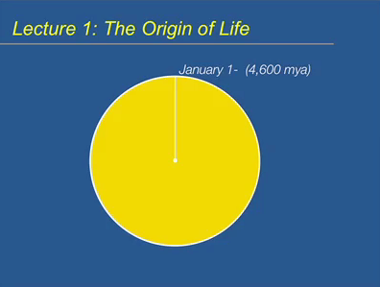
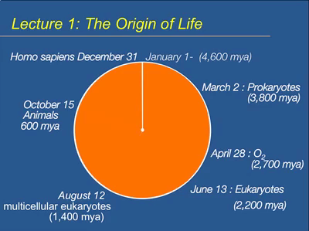
4.6 billion Years is how old the Earth is. If we condensed the age of the Earth in one year, it was born on January 1st. 1st evidence of life (fossil) was 3.8 billion year ago. Prokaryotic cells were found on March 2nd. The actual origins of life were probably at 4 billion years ago since we can’t rely on fossils. Oxygen begins to accumulate 2.7 billion years ago, about April 28th. Note that oxygen comes in after life. Eukaryotes were found about 2.2 billion years ago. Multicellular eukaryotes were found 1.4 billion years ago. And animals were found 600 million years ago. Homosapiens, us, show up on December 31st at 11:49 pm, 150,000 years ago.
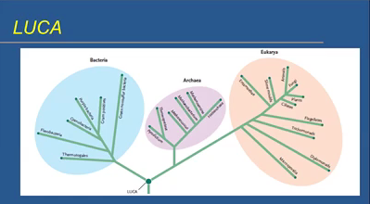
There are three domains of life on Earth: bacteria, archea and eukarya. We used to group them together as prokaryotes. Everything on Earth descends from LUCA, Last Universal Common Ancestor. All forms of life descend from a single common ancestor. The evidence that they are from the same ancestor are that they contain:
- Cells made of lipids
- Genetic system based on DNA
- DNA to RNA to transfer to Protein transfer of information
- Common system of protein assembly (ribosomes, mRNA, tRNA, etc.)
- Proteins (fundamental functional and structural molecule)
- ATP
- Glucose
This does not mean life evolved only one time. There might have been life that didn’t have all the characteristics listed, but they obviously died out. The life forms we see today all come from a common ancestor we call LUCA, but it’s not the only form of life that ever existed.
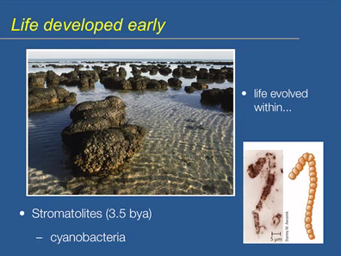
Life evolved pretty fast, about 600 million years for life to evolve. This occurred pretty rapidly, especially considering that life had to cool down; it was molten. Stromatolites are the earliest form of life that we found, about 3.5 billion years ago. They are produced by microbial activity; there are layers of minerals that are produced today by microbial activity, specifically cyanobacteria. Indicates that cyanobacteria, or something similar to it was around 3.5 billion years ago. It is a filamentus prokaryotic cell.
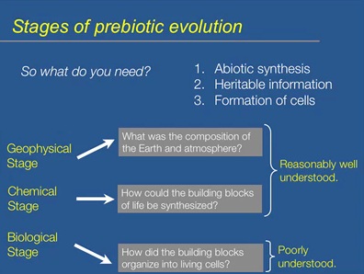
What do you need for life?
- Abiotic synthesis: in the absence of biology, we have to be able to produce proteins, amino acids or sugars outside of living things. The planet itself must be able to make these molecules; at least simple versions of them.
- Heritable Information: might not have been DNA, but need to be able to pass on information to daughter cells.
- Formation of cells: it is fundamental
GEOPHYSICAL STAGE | What was the composition of the Earth early on?  Were the conditions conducive/right for developing life as we know it? | Reasonably well understood.
CHEMICAL STAGE | How could you build the building blocks?  Were conditions right of the planet after it cooled? | Reasonably well understood.
BIOLOGICAL STAGE | How do you go from here to organizing stuff into cells | Poorly understood

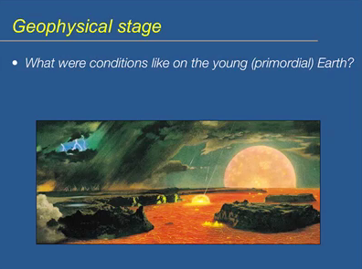
Have to give time for Earth to cool. The conditions on primordial Earth, fire and brimstone.
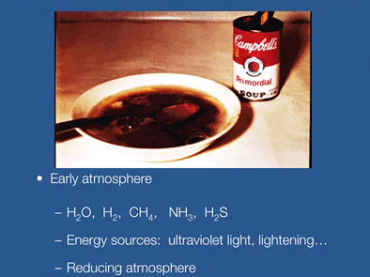
What were the conditions in what we call the primordial soup? Before the oceans cooled, what was in it?
The Early atmosphere contained certain compounds, some of these are still in the atmosphere, and some aren’t. Certain compounds are found in nucleic acids. Was there everything you need to create those molecules? There was a lot of energy to create macromolecules, not immediately create protein. There was no ozone layer. It was a reducing atmosphere: lots of hydrogens, which have electrons. The atmosphere is conducive; allows the building of complex highly reduced molecules; a lot of electrons associated with the molecules. You have these molecules and energy; there is nothing that would stop the formation of complex biologically important molecules. Molecules can be reduced by the donation of electrons from some of these electron rich sources.
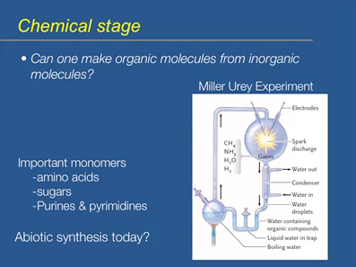
Is it possible? We have the atmosphere. Can you make this abiotic synthesis?
Stanley Miller is known for the Miller Urey Experiment that shocked the world. He worked in Urey’s lab. He got a lot of important monomers created. Can the atmosphere today crate abiotic synthesis? No, because there is oxygen in the atmosphere. It is highly electronegative, rips off electrons. It’s an oxidizing atmosphere, not reducing plus we now have the ozone layer.
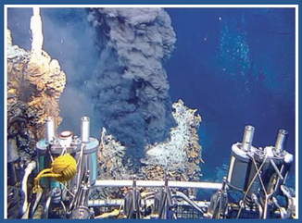
Life could have been formed in deep sea vents as well as in the atmosphere. They are on the floor of the ocean floor. The vent spews hot gasses, mineral rich and very hot. This is from within the mantle of the earth. There is a lot of life surrounding the vents, as well as sulphur and ammonia.
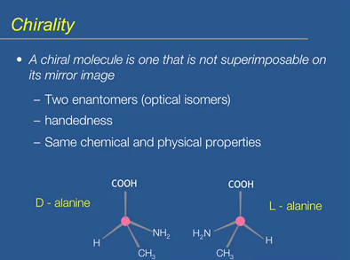
A chiral molecule is not superimposable on its mirror image. Right hand is identical to left hand, they are chiral. Chiral molecules come in two forms, but they are identical. In chemistry, chirality is not a big deal. In biology it is incredibly important. L versus D molecules.
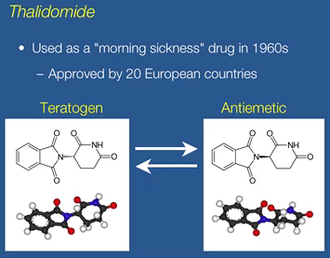
Chiral molecules have the same chemical and physical properties, but they can have vastly different biological properties. Great example is thalidomide. It was created in the 60s for pregnant women to prevent morning sickness. Problem is, when you gave birth, child is deformed. The drug was not approved in North America. The antiemetic prevented morning sickness, but it could readily convert to the other form called teratogen, which cased birth defect. The drug was created in labs, and the molecules convert till you have 50 % of each. Teratogen affects the children’s development. The molecule was chiral.
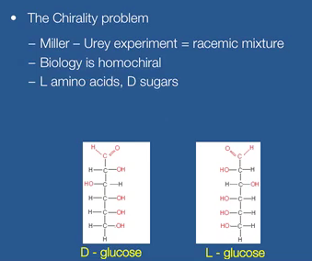
The chirality problem in the Miller-Urey experiment was that the mixture was racemic. When he analyzed his amino acids and sugars, he had 50% of each. He did not get just all D-alanine or all L; he had 50% of each. Biology is not racemic, it’s homochiral. Everything uses D-alanine, D-amino acids, we don’t use L. L amino acids and D sugars.
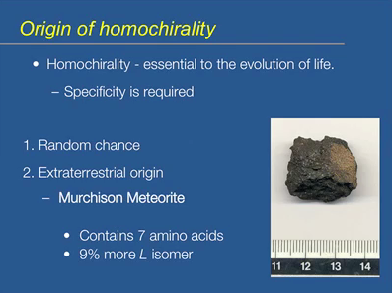
Homochirality is essential to the evolution of life because specificity is required. The binding site of an enzyme with a substrate is very specific, so specific that if you replace one chiral form for another, you can’t expect it to interact with the enzyme’s active site. The specificity requires that you use one form.
- Random chance: LUCA must have decided that can’t use one form, so chose just one
- Extra-terrestrial origin: amino acids may be ET
- Murchison Meteorite found in Australia
  - Contained amino acids that had more L than D if Miller-Urey processes occurred where the rock came from. It may be possible that early Earth was showered with meteors that created this slight bias for a certain chiral form.
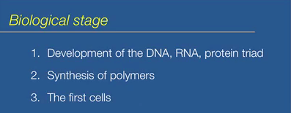
LUCA has the development of DNA, RNA and protein, but they are all polymers, not monomers. There are 3 questions we have to address. Miller-Urey created monomers, not polymers.
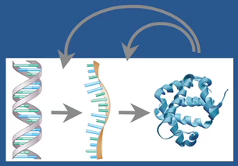
It is a fundamental transfer of information. Encoding DNA to RNA and the instruction here are used to build proteins that are fundamental to life. But transcription and translation requires enzymes. They don’t just happen by themselves. Very elaborate proteins and enzymes catalyze the reactions. The product of the evolutionary information transfer of information, protein, is needed to catalyze the intermediate steps (Chicken and egg). How did it evolve if I need enzymes to catalyze transcription and translation? How did LUCA do it?
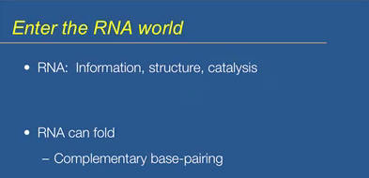
The answer lies in the intermediate molecule, RNA. It may have been the jack of all trades. It contains information that is identical to DNA. It’s not so clear how it could have a catalytic purpose, how it could have catalyzed reactions. Well single strands of RNA can fold. DNA is held together by hydrogen bonds within the strand, but RNA is just a single strand. It can fold, just like proteins. The functional aspects of a protein are because when the peptide is formed; it can fold, to produce a very elaborate 3D structure that imparts function to the protein. RNA can also fold by hydrogen bonding between one end of the strand to the other, to produce an elaborate 3D structure like shown below:
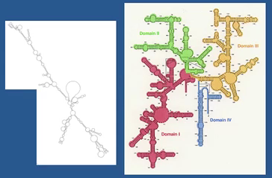
They are all RNAs that fold back amongst themselves to produce an elaborate structure.
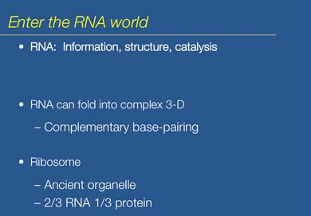
Every form of life has Ribosomes. They carry out the transfer of from RNA to proteins. They are ancient, LUCA must have had them. It is 2/3 RNA. The fundamental organelle is RNA, only 1/3 protein. Has a fundamental position that is mostly RNA.
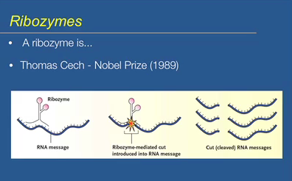
Thomas Cech got a Nobel Prize for the discovery of a ribozyme. A ribozyme is an RNA molecule that can catalyze a reaction. It has catalytic ability. Enzymes are not the only biological catalysts, and enzymes are proteins. A precursor RNA is being produced. The ribozyme (3D RNA molecule), through complementary base pairing, attaches specifically to the RNA and catalyzes the cleavage. The RNA is not functional in one pat, and it produces functional mRNA in another part, it requires the cleavage step, which is mediated by a ribozyme and not a protein. Not a lot of ribozymes out there.

Ribosome aminotransferase activity of the ribosome is catalyzed by the RNA component of ribosome. Self-splicing of introns is a ribozyme catalyzed process.
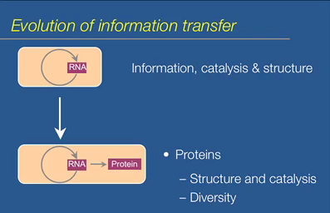
How do we think it worked? How do we think we went from a primitive cell with Information, catalysis and structure? RNA does it all. What’s the advantage? There must have been an evolutionary advantage to evolve to what we have today. What are the steps we think that occurred? We think that there was a system where the information in RNA was used to bring amino acids together to produce proteins. The proteins that were made were probably really simple. Proteins are much better at catalysis. Enzymes functions. Cells have ribozymes, catalytically, they aren’t that good. Enzymes catalyze reactions faster than an RNA molecule and they are much better at structural components of the cell. Proteins are much more diverse. There are only 4 nucleotides that can make up RNA. Proteins have 20 different amino acids that could be brought together in different orders to make peptides to make proteins that can do many more diverse things than a RNA molecule ever could.
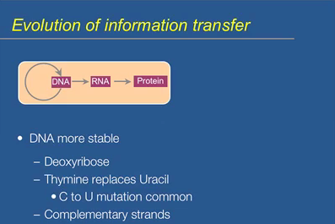
Why DNA over RNA? DNA is more stable. Deoxyribose, without the oxygen in the ribose, it makes DNA much more stable. You isolate RNA in a lab, it breaks down quickly. On the other hand, DNA can be taken from ancient fossils (Jurassic Park) and can actually sequence the DNA. You want it to be the repository of genetic information, so it better be stable. Take uracil in RNA and replace it with thymine, this is because a C to U mutation is not uncommon. SO if you had a string of DNA that had U in it, how do you know if the uracil is supposed to be there or if it’s not the product of a cytosine mutation? SO get rid of uracil and replace it with thymine. You have complementary strands. If you screw up one strand, you can still use the other strand.
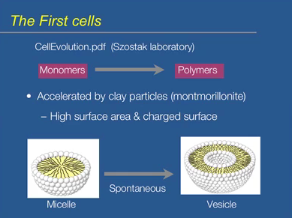
How do you go from having monomers to polymers? What kind of abiotic processes would lead to the polymerization of amino acids or nucleotides small proteins or nucleic acids? How were the first cells made/come about? The questions are answered by the research of Szotak lab in Harvard. Look at the paper. Lab is interested in how to go about creating polymers from monomers. The major macromolecules nucleic acids and proteins are polymers of monomers. Clay particles represent the surface in which polymerization reaction would occur. Clay has a high surface area and it is charged. Individual molecules would be attracted to the charged surface. You can align them in such a way that polymerization would occur. Clay helps in the conversion and forming of micelles into vesicles. Micelle is a single layer of lipid molecules. Hydrophobic tails are found in the interior core of the micelle, the polar head groups face the aqueous external environment. A vesicle is a lipid bilayer, which is two layers of lipid molecules, which results in the interior being an aqueous environment. So analogous to an actual cell, a vesicle is like a cell. How did vesicles form in an abiotic environment? There’s evidence that clay can accelerate this process. The conversion of a micelle into a vesicle is spontaneous. Spontaneous means it doesn’t require energy. The process accelerates in a faster rate in the presence of clay.
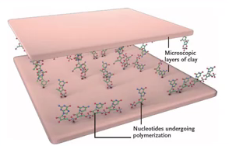
Here is a figure that shows two microscopic layers of clay. You can have short chains of nucleotides being produced as the charged components get attracted to the charged components of the clay can align. This can help facilitate the polymerization of the nucleotide strand or strand of amino acids. The polymers you get are pretty short though. A typical protein today is about hundreds amino acids, on clay it’s about 20. Even though they are short, it may be long enough to impart a specific function to a small peptide. This gives cells with the peptide a selective advantage over cells that don’t.
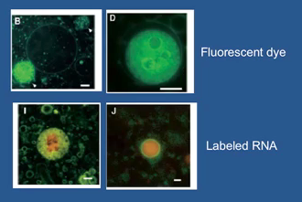
Looking at vesicles produced in a lab. They looked at how long a fluorescent dye can be retained within one of the abiotically synthesized vesicles. In D, the dye stays within the cell for a long time. The fundamental aspect if a cell is that it separates biological processes from the external environment. Concentrations can be much higher, ionic concentrations, metabolites; molecules can be contained within the cell making for an environment that is distinctly different than the external environment. The dye is retained, did not leak out. Labeled RNA is retained within the cell. This is fundamental because it is able to retain molecules within the cell so that the concentrations can be much higher internally compared to the external environment.

