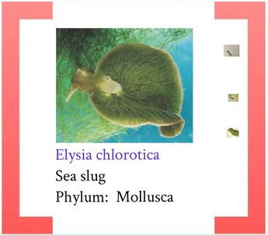
An animal that is photosynthetic. Goes against idea of what defines a plant and an animal. Elysia it a sea slug, a molluck, invertebrate with a simple body plan. Has a mouth, digestive system, circulatory system, can sense surroundings, has eyes. It’s a simple invertebrate. Snails and slugs are similar. It’s aquatic.
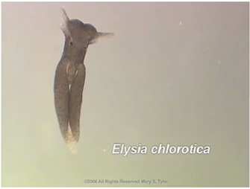
It has chloroplasts. It doesn’t have chloroplasts when it is young, which is why it is young.
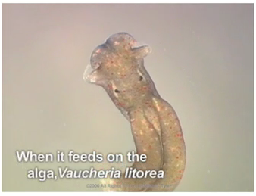
Then it feeds on an alga, vaucheria litorea.
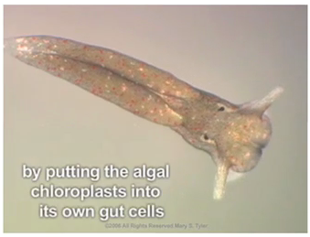
The plant’s chloroplasts turns elysia green because it puts the algal chloroplasts into its own gut cells.
There is a specific relationship; the slug does not feed on just any plant, it feeds one specific pieces. It has little teeth and sucks out contents of the algal filament. Everything is digested except the chloroplasts. Adults are green because it retains the intact chloroplasts.
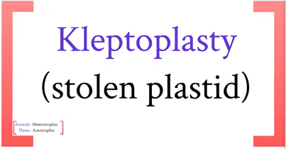
Kleptoplasty. The sea slug steals the chloroplasts and retains them. Chloroplasts are a plastid. The chloroplasts remain functional within the animal. It is a photosynthetic animal; the chloroplasts are not destroyed. They get incorporated within the cells, within the gut of the sea slug.
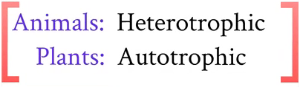
This changes the definition of animals and plants. Heterotrophs obtain carbon/organic matter/energy from an outside source-reduced organic molecules re broken down, the energy released is what we use to live. Converting reduced organic molecules, like glucose, fats and proteins, into simpler molecules with less energy associated with them. Autotrophs obtain energy from sunlight(photoautotroph), obtains energy from a direct energy source, takes in an inorganic form of carbon, most common form is CO2. CO2 is an inorganic form of carbon, no C-H bonds and no energy within CO2. Photoautotrophy: use light to convert CO2 into a more complex reduced form. Chemoautotrophy: use energy in a compound to drive the reaction. Elysia is an animal, but once chloroplasts are in the gut, it is entirely autotrophic. It doesn’t consume any organic molecules from enviro, it uses sugars produced by the functional chloroplasts instead. Cannot easily define elysia.
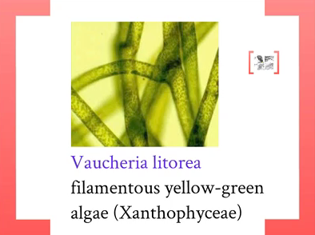
Alga, it a simple form of plantlife. Single tube that has chloroplasts in it. It’s a eukaryote. Contains a nucles, chloroplasts, mitochondria and others.
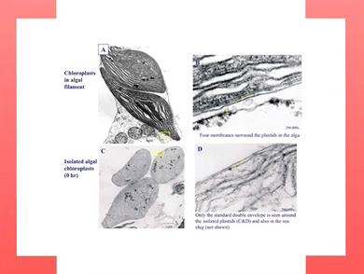
Chloroplasts are pretty big. The organelle is 10 microns across. Destroys everything but the chloroplasts so that it remains functional when it is incorporated in the cells of the gut of elysia. Within the algal strand, there are 4 membranes surrounding the chloroplast, but in the sea slug, it only has two.
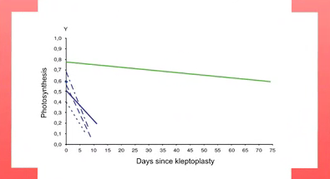
Measuring photosynthesis. To measure photosynthesis if light is constant, look at amount of oxygen released or the consumption of CO2. The green line is klepoplasty in elysia and the blue lines are kleptoplasty in related slugs. Kleptoplasty is not restricted to just Elysia. There are a number of simple animal species can retain chloroplasts like ELysia. The main difference is that ELysia can retain chloroplasts for a very long time since they remain very functional. The rates of phtotosynthesis in these chloroplasts stays remarkably high. If we isolate chloroplasts in a lab, photiosynthesis decreases at a rapid rate till it ceases to exist. Why does it decline at all? (Discussion board)
Mitochonria does the same thing, it will decline rapidly.
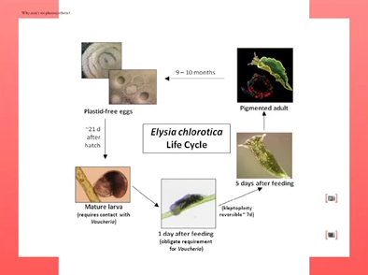
You have a larvae, it is high then settles on the algal filament. Then it gets converted to the slug and it develops. The whole lifecycle of Elysia is absolutely dependent on this obligate, essential relationship between elysia and vaucheria. It is species specific. If vaucheria is not around, life cycle cannot be completed.
Elysia is a hermaphrodite, has male and female parts. Does not mate with itself, needs to find a partner, engage in sexual recombination and go through miosis and make eggs and they get fertilized and they lay eggs in the spring. These eggs don’t have plastids in them. Although the adults have chloroplasts in their gut cells, the chloroplasts do not end up in their germ line, do not end up in gametes or eggs.
These eggs hatch in spring, they hatch and live all year, then next spring, they lay their eggs. And then all the adults die. Remember the adult salmon swimming upsteam and spawn and die. Elysia die simultaneously, the whole population.
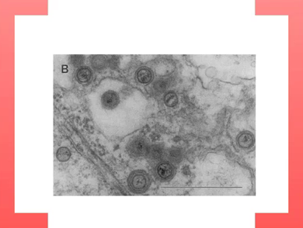
It looks like they do this. This is a transitional electron micrograph through an adult elysia in the spring. The round things inside the cells are viruses. The cells are full of viruses.
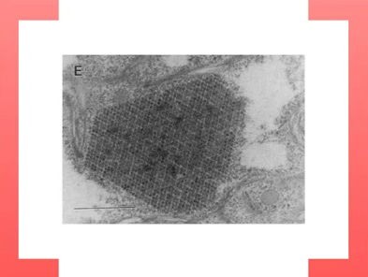
Billions of viruses in the cell. It makes a virus crystal, which kills the cells. They are retroviruses, like HIV, but they don’t act like most retroviruses. These viruses are trapped within the host cell, they are endoginous retroviruses (ERVs). They don’t know how to get out and infect other hosts, so they just reinfect the same host. In that process, they kill their hosts all at once. Hosts takeover the virus and used them for the important purpose of dying all at one time. You are full of endoginous retroviruses. They don’t kill you. You inherit them from you parents. Its part of your genome. These endogenous retroviruses are part of the genome of Elysia.
QUESTIONS:


