PURIFYING CHEMICALS BY
DISTILLATION

I N T R O D U C T I O N

This laboratory experiment concentrated on the technique of distillation, which is traditionally used to separate liquid compounds that have different boiling points. By using a constant temperature, the distillation is performed with a controlled heat that eventually separates the compounds. There is also a distillation flask that is used to hold the mixture that undergoes boiling in order to evaporate the compound with the lower boiling point. A thermometer is used to record the temperature of rising vapor. A condenser of cold running water, which turns the compound into liquid form, then cools the vapor. The condensed liquid will then be collected into a receiving flask, which was measured by temperature every 2.0 mL. In the end, the compound with the lower boiling point will hopefully be collected within the receiving flask first. There are two types of distillation that were performed in this experiment: simple and fractional. Raul’s Law can be also be used to determine the total vapor pressure of the mixture using partial pressure and molar ratios by using this formula:
P = P_{A}N_{A} + P_{B}N_{B}

Simple Distillation
The most basic method of distillation and has similar methods as stated in the above paragraph. Not very effective in separating two liquids (the vapor that rises first may not be completely the substance with the lower boiling point) but is effective during the separation of solids within a mixture, for example.

Fractional Distillation
This type of distillation is similar to simple distillation but contains different devices within the system. There is a fractional column between the distillation head and the flask, leaving a high surface area in the fractional column. The purpose of this is for the vapor to have more room to condense and revaporize. This method is more effective in separating two liquids with differing boiling points because the compound with the higher boiling point will just condense and travel back to the original flask.

P R O C E D U R E

Simple Distillation
- Set up the hot plate and attached it to the variac
- Added 50 mL of 50:50 2-propanol and 1-butanol mixture to the reaction flask through a funnel
- Acquired necessary equipment and attached a reaction flask to the distillation head
- Placed the reaction flask, cushion, stir plate, and hot plate on the a lab jack to adjust the height of the mechanism
- Placed a 50 mL graduated cylinder as a collection flask and heightened it with cork plates
- Clamps were used to make sure everything was secure
- Attached two rubber tubes to each end of the condensers, one attached to a nozzle and the other dipped into a sink (for water to exit the mechanism)
- Placed a thermometer adapter and the actual thermometer into the tub, making sure the probe didn’t touch the sides of the glass
- Started the experiment, turning on water and variac,
- Observed the temperature rise and while after approximately 90 °C accumulated, vapor began to condense and 2 mL was collected
- Recorded information every 2 mL until the collection flask had about 50 mL of liquid in it
- Turned off the technology and removed distillation head, getting ready for the fractional distillation process
- Mixture was placed back through the distillation flask with a funnel

Fractional Distillation
- Fractional column was obtained and wrapped in aluminium foil while the magnetic pill was placed in the solution within the distillation flask
- Fractional column was placed onto reaction flask and clamped the condenser at an appropriate angle
- Collection flask was placed properly and everything was then heighted accordingly
- Added thermometer making sure not to touch the sides
- Turned on water flow/variac and measured the temperature for every 2 mL collected
- Turned off variac and water flow and placed everything neatly away

O B S E R V A T I O N S

TABLE 1: Simple Distillation*

Volume of Distillation (mL) | Recorded Temperature (°C)
0.0 | 25.4
2.0 | 91.1
4.0 | 91.6
6.0 | 92.6
8.0 | 93.2
10.0 | 94.0
12.0 | 95.1
14.0 | 95.7
16.0 | 96.4
18.0 | 97.9
20.0 | 98.9
22.0 | 100.7
24.0 | 102.0
26.0 | 104.0
28.0 | 105.4
30.0 | 107.7
32.0 | 109.4
34.0 | 111.2
36.0 | 112.7
38.0 | 114.4
40.0 | 116.3
42.0 | 117.6
44.0 | 118.7
46.0 | 119.0
48.0 | 119.1
50.0 | 74.3

*Volume of 50:50 2-propanol: 1-butanol mixture = 50.0 mL

TABLE 2: Fractional Distillation*

Volume of Distillation (mL) | Recorded Temperature (°C)
0.0 | 24.3
2.0 | 87.1
4.0 | 87.9
6.0 | 88.4
8.0 | 89.2
10.0 | 90.0
12.0 | 90.8
14.0 | 91.9
16.0 | 93.0
18.0 | 94.6
20.0 | 97.3
22.0 | 98.8
24.0 | 101.4
26.0 | 104.6
28.0 | 108.3
30.0 | 111.9
32.0 | 114.9
34.0 | 116.4
36.0 | 117.9
38.0 | 118.6
40.0 | 118.9
42.0 | 119.0
44.0 | 118.9
46.0 | 118.3
48.0 | 107.8
50.0 | 90.8

*Volume of 50:50 2-propanol: 1-butanol mixture = 50.0 mL

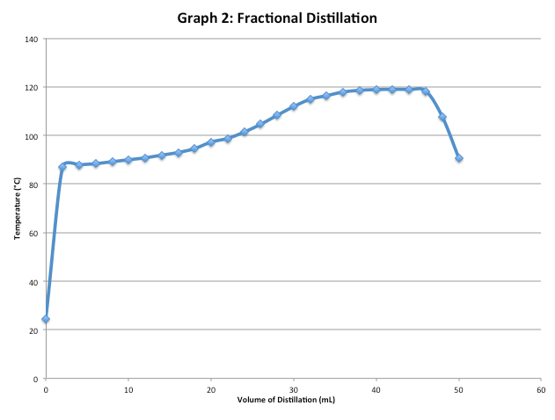
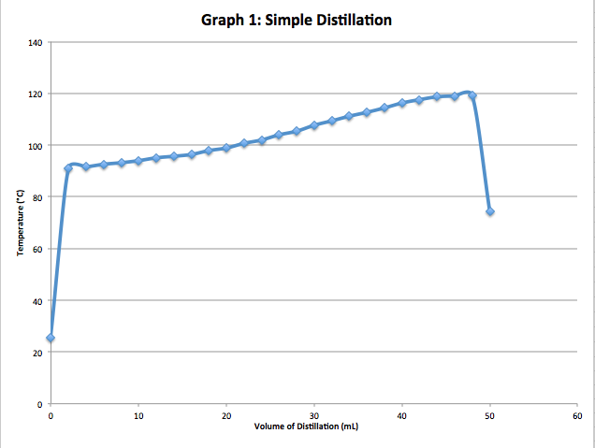
D I S C U S S I O N

The results of the two graphs illustrating the temperature of the two different types of distillations proved to be quite similar. This is illustrated by the gradual change between both liquids within the compound (although the simple distillation graph looks to be a bit more linear). It was found that in both cases, the distillation would start at a lower temperature (0 mL) and then gradually increase until it reached a maximum (on average 45.0 mL). It decreased at a faster rate once the volume of the receiving flask got to approximately 48.0 mL. The temperature steadily started to increase once the mixture reached an approximate 85°C, which is fitting considering that 2-propanol has a boiling point of 82.6°C while 1-butanol has a boiling point of 117.4°C. However, during the distillation of 2-propanol and 1-butanol, the compounds will never get fully separated due to the fact that they have such a poor difference when it comes to their boiling points. It’s quite possible that they could both get mixed up slightly during the condensing process. In the two graphs, a miniscule plateau can be seen before it drops down after 48.0 mL. This represents that less vapor is available within the tube to be able to drip into the collection flask, meaning that the distillation process would almost be complete. This is also because as the temperature of the mechanism increases, the concentration of the 2-propanol decreases because of the majority of it being vaporized. When the 2-propanol vaporizes, the thermometer reads its temperature that steadily increases as more of the solution condenses.

The beginning of each graph represents a slope that demonstrates the boiling point of propanol. As the distillation process continues, the temperature shows that there is possibility for the processing of impure vapor from the similar concentrations of the 2-propanol and 1-butanol. The small difference within the two boiling points is apparent on the graph due to the gradual increase in both cases instead of being sharp and concise, which can be attributed to a source of error in terms of purity. Graph 2, however, has a somewhat sharper slope, indicating that this fractional distillation method was more applicable to how distillation should occur in theory. Fractional distillation is a much more efficient method because the fractional column allows for many re-condensation and re-vaporization processes to take place. This method makes it more difficult for the substance with the higher boiling point to continue up the column. The substance with the lower boiling point would then have the opportunity to be able to travel to the collection flask at a purer state.

Like mentioned above, the small difference in boiling points can contribute to a source of impurity when it comes to lab error. Another error is that a small amount of flooding within the column could have occurred, although not enough in this experiment to cause any significant harm to the test results. This would have happened due to a higher temperature that caused the vaporization to occur too rapidly. In turn, the compound with the higher boiling point would have not been able to flow back down into the distillation flask properly, which would have resulted in flooding within the fractional column.

Q U E S T I O N S

- To begin the process, liquid must flow back through the fractional column in order to separate the two liquids during the fractional distillation. Water flowing through this column re-condenses the vapor in the column. The substance with the lower boiling point re-vaporizes (and goes into the collection flask) while the compound with the higher boiling point will stay as a liquid and travel back down the distillation flask. The purpose of the column is to ensure that re-condensing and vaporizing continues to occur, which safeguards that the compound with the lower boiling point can be the one to rise in vapor form.

- It’s important to maintain a uniform temperature gradient in a fractional column because it’s based on the theory that vapor will only rise through the column if the boiling point of the compound is maintained. The purpose of distillation is to separate a compound by obtaining the pure substances due to the differing boiling points. If the temperature is not uniform, the vapor that rises will not be pure and the distillation will be a failure.

- The vapor pressure would have to be at 1 atm due to the fact that a compound can only reach its boiling point and vaporize is if it is at the same pressure as its surroundings.

- By increasing the atmospheric pressure, it causes the boiling point of a given liquid to increase, as well. If the atmospheric pressure is increased more heat would to be added to achieve the boiling point in order to overcome the atmospheric pressure.

- Water is located at the bottom so that the water can properly fulfill its purpose as filling the column while working against gravity. If water is placed on the top, it would flow down the column quickly in favour of gravitation, making it less efficient for the distillation process to occur. This would not fully cool down the vapor.

- Rault’s Law:

P = P_{A}N_{A} + P_{B}N_{B}
= (350 mmHg)(0.75) + (150 mmHg)(0.25)
= 300 mmHg

C O N C L U S I O N

In conclusion, it was proven that fractional distillation is more efficient to use during the separation of 2-propanol and 1-butanol than simple distillation. Even though both graphs seem quite similar, the fractional distillation method is seen to provide better results when the increase of temperature is observed. The fractional column’s extra surface area allows for a better purity of the substance with the lower boiling point (2-propanol) when it comes to how the substances condense and vaporize.

