COMM 226– BUSINESS TECHNOLOGY MANAGEMENT

Ch. 1 Information Systems & You (E-MIS)

INFORMATION SYSTEMS
Information System: a group of components that interact to produce information.
- All information systems comprise a five-component framework of:
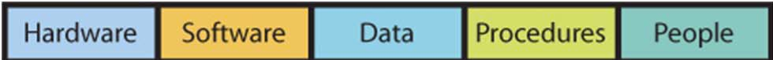
- Computer Hardware: the electrical components and associated gadgetry that constitute a computer system.
- Software: programs/applications that run or operate on computer systems.
- Data: the basic building blocks of information, i.e. facts & observations.
- Procedures: instructions or processes that one follows to achieve objectives.
- People: actors who want to achieve a particular outcome by interacting with the system.

MANAGEMENT INFORMATION SYSTEMS
Management Information Systems (MIS): comprises the development and use of information systems that help organizations achieve their goals and objectives.

- One must take an active role in order to ensure that system will meet their needs.
- Understand how they are constructed.
- Consider the user’s needs during development.
- Learn how to employ the system.
- Take into account other important functions like security, backup, & recovery.
- Information systems are used to help organizational actors achieve their goals and must be developed for the right reasons. Always ask: What is the purpose? How does this help us achieve our goals?

I.T. VS. I.S.
Information Technology (IT): represents raw technology components of I.S. and it only concerns hardware, software, and data components.
- I.T. refers to methods, inventions, standards, and products.
- I.T. can help an organization only when it is embedded into an I.S.
- I.T. must be combined with people and procedure components.

IMPORTANCE OF INFORMATION SYSTEMS IN THE ECONOMY
- The Information & Communications Technology sector includes companies involved in software & computer services, cable & other program distributors, telecommunication services, ICT manufacturing, and ICT wholesaling.

- Some of the basic IS are:
- E-Mail
- Web Pages
- Word Processors, Spreadsheets & PowerPoint
- Using Cell Phones
- Instant-Messaging & location-based services on their smart phones.
- To be effective in today’s economy, you need more than the basics. Business professionals need to expand their knowledge to include the following:
- Use of mobile devices and applications.
- Use of project-management software – Microsoft Project, OpenProject.
- Business graphics – MS Visio, SmartDraw.
- Collaborative systems such as Google Docs.

SHAPE OF THINGS TO COME
- Moore’s Law noted that the density of circuits on an integrated chip was doubling approximately every two years or so.
- This prediction has been generally accurate for more than 40 years.
- Moore’s Law is one of the few predictions in area of IT that has really stood the test of time.
- The cost of computers has declined over the past 55 years or, the same amount of money can buy increased computer capacity.

- David Ticoll suggested that within the next decade:
- Unlimited storage will be almost free.
- Analytical software will reveal hidden treasures.
- The real and virtual world will collide as wide-area networks become cheap, reliable, and widely available.
- These technology trends will enable deep, powerful, performance-enhancing innovations that will be felt in almost every industry.
________________________________________
Ch. 4 Hardware & Software (E-MIS)
HISTORY OF I.T.
- The first digital computing devices were invented in the 1940s.
- The first commercial computers were available in the 1950s and the first PCs in the 1980s.
Early Computers: 1939–1952
- Electronic Numerical Integrator And Computer
- It was very large, complex and expensive.
- Only a single user could operate and only one program run at a time.

Mainframes: 1952–Present
- First digital computers - large, room-sized devices.
- Mainly used by business and government.
- 1st generation: vacuum tube technology.
- 2nd generation: transistors.
- 3rd generation: operating systems & multiprocessing.

Microcomputers: 1975–Present
- Integrated circuits.
- Small microprocessors
- These microcomputers had monitors, keyboards, portable floppy disks and software.

Networking Personal Computers: 1985– Present
- Local Area Networks (LANs).
- Linking many personal computers together.
- Shared access to data, printers, and other peripheral devices.
- Wide Area Networks (WANs)– the Internet, email & web browsing.

Mobile & Tablet Computing: 1990s– Present

EVOLUTION OF TECH: WHAT’S IMPORTANT
- Price & Performance Advances
- Small is powerful: the 3 main components of the computer– the processor, the memory, & the storage, have all been getting smaller and costing less.
- Network is “The Thing”: the value of I.T. is also measured in the power of the network that can be accessed through the machine.

HARDWARE
Hardware: consists of electronic components and related gadgetry that input, process, output, and store data according to instructions encoded in computer programs or software.
- Basic hardware categories:
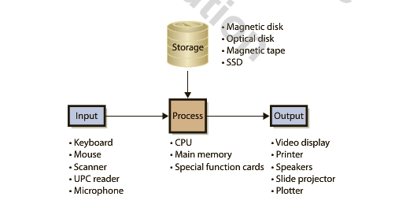
Input: keyboard, touchscreen, barcode scanner, microphones, & cameras.
Processing: CPU, which works with the RAM.
Output: display/monitor, printers, and speakers.
Storage: hard drive, optical disks, flash or solid-state device memory (SSD) i.e. USB, special function cards i.e. graphics or video cards.

COMPUTER DATA
Binary Digits (bits): used to represent data.
- Represented as either 0 or 1.
Sizing Computer Data: Computer data are represented in bits.
- Bits grouped in 8-bit chunks.
K Kilobyte 1,024 Bytes
MB Megabyte 1,024 K
GB Gigabyte 1,024 MB
TB Terabyte 1,024 TB

HOW A COMPUTER WORKS
CPU (Central Processing Unit): Transfers program or data from disk to main memory.
- Moves instruction from main memory via data channel or bus.
- Has small amount of very fast memory called cache.
- Keeps frequently used instructions.
- Large cache makes computer fast, but is expensive.

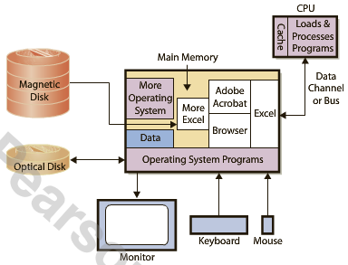

Memory Swapping: Main memory is too small to hold all data so the CPU loads programs into memory in chunks, places new program into unused memory and if none available, the operating system will remove the chunk being used and replace it with requested data.

- Cache & main memory are volatile. Magnetic & optical disks are not!

CLIENT VS. SERVER
- Client computers used for word processing, spreadsheets, & database access.
- Connect to servers for Web, e-mail, & database.
- Servers provide service and are faster, larger, & more powerful than client computers.
Cloud Computing: Similar to the concept of servers that supply applications and data, i.e. Google Docs.
Computer Software– two types:
1. Operating System (OS): program that controls computer’s resources.
2. Application Programs: perform specific user tasks.
- Constraints: a particular version of an operating system is written for a particular type of hardware. Application programs are written to use a particular operating system.

FOUR MAJOR OPERATING SYSTEMS
Windows
- Used by 85% of the world’s desktops  95% of business users.
- Current version is Windows Vista
Mac OS
- Apple Computer, Inc. developed for Macintosh computers.
- Easy-to-use interfaces. Used primarily by graphic artists and art community.
- Current version is Mac OS X
Unix
- Developed by Bell Labs.
- Workhorse of scientific and engineering community.
- Sun Microsystems is a major vendor of computers employing this operating system.
Linux
- A version of Unix.
- Developed by open-source community.
- This community is a loosely coupled group of programmers.
- Volunteers - contribute code to develop and maintain Linux.
- IBM is a primary proponent.

APPLICATION SOFTWARE
- Application Software consists of programs that perform a business function.
- Some are general purpose, i.e. Excel or Word.
- Some are specific, i.e. QuickBook– an application program that provides general ledger and other accounting functions.
- Types:
Horizontal-Market Application Software: Provides capabilities common across all organizations and industries, i.e. Word, Excel, PowerPoint, Acrobat, Photoshop, Paint Shop Pro.
Vertical-Market Application Software: Serves the need of a specific industry and usually altered or customized, i.e. appointment scheduling software, tracking system for mechanics.
One-Of-A-Kind Application Software: Designed for a specific, unique need, i.e. IRS software.
Other (Dual-Category) Application Software: CRM software

FIRMWARE & UTILITY SOFTWARE
Firmware: Computer software installed into devices, i.e. printers, print servers, and other communication devices.
- Coded like other software but installed into read-only memory.
- It becomes part of device’s memory and can be changed or upgraded.
Basic Input/Output System (BIOS): Used when a computer is initially booted up.
- Required because all volatile memory is lost when the computer is shut down.

THIN & THICK CLIENT
- The terms thin and thick refer to the amount of code that must run on the client computer.
- An application that requires nothing more than a browser on the client is called a thin client.
- An application such as Microsoft Outlook that requires programs other than a browser on the user’s computer is called a thick client.
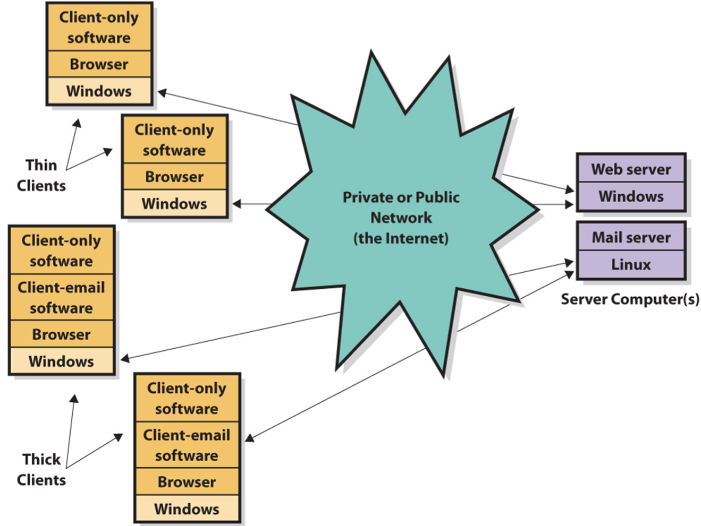

MANAGEMENT’S CONSIDERATIONS
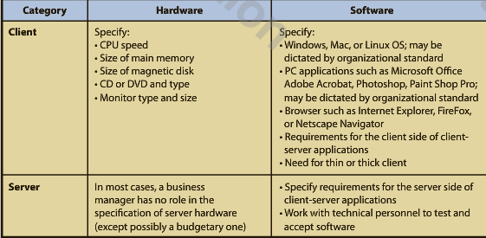
VIRUSES, WORMS & ZOMBIES
Virus: Computer program that replicates itself, consuming computer resources.
- Payload is a program code that causes unwanted activity. It can delete programs or data.
Macro Viruses: Attached themselves to various types of documents and when the document is opened, the virus is placed in startup files of the application. Thereafter, the virus infects every file the application creates or processes.
Worm: A virus that propagates using Internet or network.
- It spreads faster than other viruses.
- Specifically programmed to spread.
Zombies: Subsequent computers infected with worm or virus.
Botnet is a compromised machine; a set of computers and applications that are coordinated through a network and used to perform malicious tasks undetected.
________________________________________
Ch. 3 Productivity, Innovation, & Strategy (E-MIS)
IMPORTANCE OF PRODUCTIVITY & INNOVATION
Productivity/Labor Productivity: the ratio of the Canadian gross domestic product (GDP) over the total paid hours worked by Canadians.
- It measures the value that Canadian workers generate per hour.
- The Conference Board of Canada has suggested that labor productivity is the primary indicator of our per capita income.

- Increasing productivity in tour current global environment is about working smarter.
- Most experts agree that to enhance productivity, Canada must foster a culture of innovation, open its industries to more competition, and increase the amount of machinery & equipment (particularly in the ICT Sector) in the economy.

How does IT add to productivity– how can it be used to create business value?
- Productivity – IT allows a company to make either more output from the same inputs, and/or to make better output and/or to make the output faster than before the technology.
- Structure of competition – IT can alter the way corporations compete.
- Benefits to the End customer – IT helps make processes more efficient and changes the nature of the competition. Consumer may see cheaper and better goods and services.

BUSINESS TECHNOLOGY MANAGEMENT
- The ICT industry sector is an important industry for productivity and innovation because it includes technologies that can enhance individual and organizational productivity.
- The need for students with combined technology and business skills has increased the need for educational programs combine tech and business training.
- The Canadian Coalition for Tomorrow’s ICT Skills (CCICT) was founded by Bell for this purpose.
- BTM programs include a variety of course topics, such as:

- Business and technical training
- Financial accounting
- System analysis and design
- Project management
- IT infrastructure
- Marketing
- International business management
- Writing and business communication
- Organizational behavior
- Teamwork skills.

- BTM programs are designed for students who are inspired to use technology to change the way the world does business.

HOW I.T. HELPS IMPROVE PRODUCTIVITY
- Increasing efficiency means that business processes can be accomplished either more quickly or with fewer resources and facilities (or both).
- “Doing things right.”
- Increased effectiveness means that the company considers offering either new or improved goods or services that the customer values.
- “Doing the right things.”

BUSINESS PROCESSES & VALUE CHAINS
Value Chain: a network of activities that improve the effectiveness (or value) of a good/service.
- It is therefore made up of many business processes.
- There are two types of activities that support value chains:
1. Primary Activities: activities where value is added directly to the product, i.e. shipping the raw materials for a product.
2. Support Activities: activities that do not necessarily add value directly to the product but are instrumental in helping the primary activities along, i.e. scheduling for shipment of raw materials.

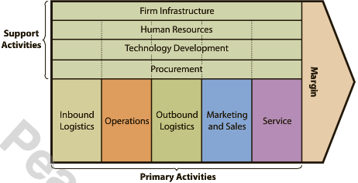
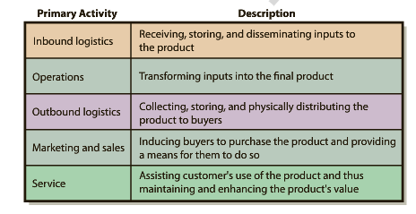

- Value chains help to understand how information systems increase productivity and enable the development of more efficient or more effective supporting activities.
- Information systems increase productivity by offering new and improved services.
ORGANIZATIONAL STRATEGY & INDUSTRY STRUCTURE
- Organizational Strategy reflects an organization’s goals and objectives.
- The strategy is influenced by the competitive structure of the company’s industry.
- It establishes the structure, features, and functions of information systems.
- There are five forces that determine industry structure:
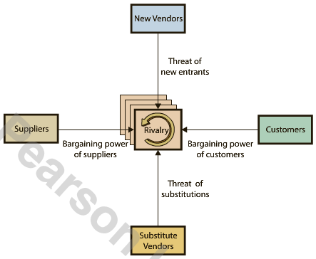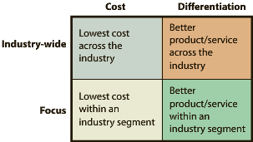
Porter’s Model of Industry Structure Porter’s Four Competitive Strategies

- The intensity of each of the five forces determines the characteristics of the industry, how profitable it is, and how sustainable that profitability will be.
- An organization responds to the structure of its industry by choosing a competitive strategy.

- Porter identified four competitive strategies:
1. Cost leadership across industry
2. Cost leadership focused on particular industry segment
3. Differentiation across industry
4. Differentiation focused on particular industry segment
- Porter says goals, objectives, culture, and activities must be consistent with strategy.

INNOVATION & INFORMATION TECHNOLOGY
- Changes to industry structure often occur through innovation.
- Bower and Christensen suggested two general types of technology innovations:
Sustaining Technologies: changes in technology that maintain the rate of improvement in customer value.
Disruptive Technologies: introduce a very new package of attributes to the accepted mainstream products.
- When a company gains a competitive advantage using a disruptive technology, the potential to alter the structure of an industry is created.
- Some times, the competitive advantage is so large it leads to a new industry altogether.
- One must also think about how quickly the innovation “catches on” in society or diffused through it.
- The theory of the diffusion of technology:
- Everett Rogers defined this theory.
- The process by which an innovation is communicated through certain channels over time among the members of a social system.
- Stages of diffusion of an innovation are: 1) Knowledge, 2) Persuasion, 3) Decision, 4) Implementation, & 5) Confirmation.

INFORMATION SYSTEMS & COMPETITIVE ADVANTAGE
Competitive Advantage Via Products:
Competitive Advantage Via Products:
- Organizations can gain a competitive advantage by implementing business systems.
- Locking in customers: high switching costs.
- Locking in suppliers: making it easy to connect to and work with organization.
- Create entry barriers: making it expensive for new competition to enter market.
- Establish alliances.
- Reducing costs.

Is competitive advantage through I.T. sustainable?
- It is almost impossible to keep competitors from developing competing technology.
- However, long-term competitive advantage lies not with the technology but rather in how a company and its people adopt the technology.
- Information Systems are the key to sustainable competitive advantage.
________________________________________
Ch. 5 Using I.S. to Improve Processes (PS&I, p. 130-155)

FUNDAMENTAL TYPES OF PROCESSES IN AN ORGANIZATION
Business Process: a sequence of activities for accomplishing a function.
Activity: tasks within a business process.
Resources: items necessary to accomplish an activity.
Actors: resources that are either human or computers.
Role: subset of activities in a business process performed by a particular actor.
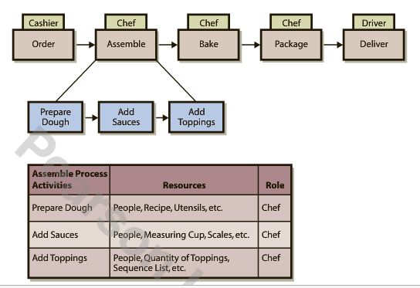
Scope of Processes
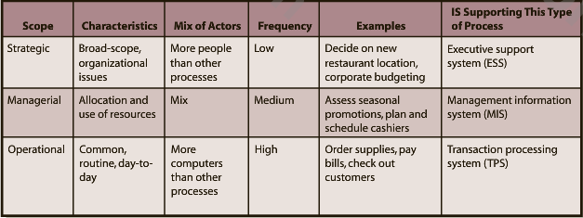

Objectives of Processes
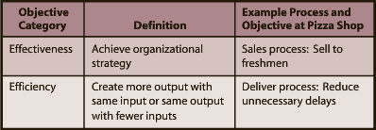

Processes Within a Value Chain
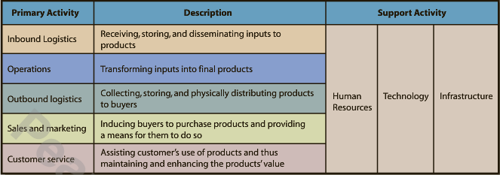

- A value chain is composed of five primary activities and several supporting activities.

Inbound Logistics Processes
- Processes include procurement, manage inventory, and evaluate potential suppliers.
- Procurement is an operational process that acquires goods and services.
Operations Processes
- Schedule the equipment, people, and facilities necessary to build/assemble a product/service.
Outbound Logistics Processes
- Collect, store, and distribute products to buyers.
Sales & Marketing Processes
- Find prospects and transform them into customers by selling them something.
Service Processes
- Providing after-sales support to enhance or maintain the value of a product.

Human Resource Processes
- Assess the motivations & skills of employees; create job positions; investigate employee complaints; and staff, train, & evaluate personnel.
Technology Development Processes
- Designing, testing, and developing technology in support of the primary activities.

Value Chain Activities and Processes
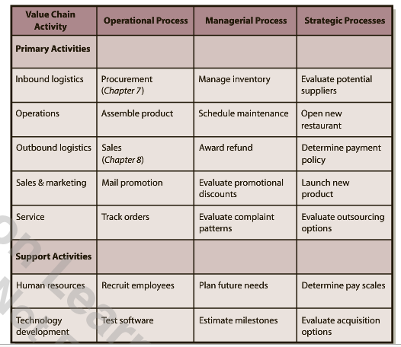

IMPROVING PROCESSES
- There are three fundamental steps in a process for improving processes:
- Objectives: specify & improve.
- Measures: specify & improve.
- IS: implement I.S. improvements.

Process Objectives
- Each process has one or more objectives, classified as either efficient or effective.
- Objectives must be explicitly stated and classified.
Process Measures
- Measures a.k.a. metrics are quantities assigned to attributes, i.e. elapsed time is a measure for the delivery process.
- Measures must be reasonable, accurate, & consistent.
I.S. Process Improvements
- Improve efficiency or effectiveness or activities, i.e. GPS improves delivery process.
- Provide linkages (impact of one activity on another) across activities, i.e. order display improves offsite delivery process.
- Improve control of the process.
Non-I.S. Process Improvements
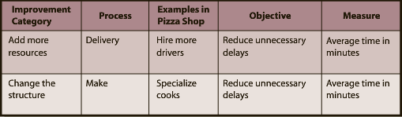

Six-Sigma
- The most common approach to process improvement.
- Seeks to improve process outputs by removing causes of defects & minimizing variability in the process.
- Gets its name from its goal that 99.99966% of process outputs will be free from defects.

Participants & Diagrams in Process Improvement
- Typically, the process includes the users who are the actors in the process, managers, and business analysts.
- Managers help by coordinating the changes, acquiring the necessary resources, and motivating participants.
- Business analysts contribute by understanding the fundamentals of process change and by creating diagrams of processes.
- Diagrams of the current process are called as-is diagrams.
- Diagrams of suggested improvements are called out-to-be diagrams.

I.S. & HINDERING PROCESSES
- An I.S. can also reduce process efficiency & effectiveness and limit its improvement.
- Storing data in multiple locations can hinder a process and make it difficult to improve.
- The key disadvantage is that the data become difficult to share.
Information Silos: a condition that exists when data are isolated in separated information systems or when data are duplicated in various files & databases.
- Because they operate in isolation from one another, they create islands of automation or information silos that can diminish the efficiency & effectiveness of a process & limit the opportunities to improve it.

S.O.A. & IMPROVING PROCESSES
- Service-Oriented Architecture helps solve the information silos problem.
- It is a new I.S. approach designed to make it easier to share data among process activities.
- S.O.A. enables the development of middleware– software that sits between two computer programs and facilitates inter-program communication & data sharing.
- S.O.A. is not a piece of hardware or software; it is a design philosophy.
- It is a design in which every activity is modeled as an encapsulated service and exchanges among those services are governed by standards.

Service– Repeatable task that a business needs to perform
Encapsulation– Hides data within containers so that services can communicate
Standards– Standardized formats for data exchange
________________________________________

Ch. 6 Supporting Processes with ERP Systems (PS&I, p.156-183)
SAP– a German multination software corporation that makes enterprise software to manage business operations and customer relations– realized that fiber optic cables & advances in database storage allowed them to create large, centralized, well-connected databases that spanned entire companies.

- The KEY to ERP systems is that data are consolidated in one central database.
- ERP systems help solve the information silo problem.
- Another solution is called Enterprise Application Interface (EAI).

ENTERPRISE APPLICATION INTERFACE (EAI)
- It provides layers of software that connect information systems together.
- It allows silos to communicate and share data with each other.
- It provides integrated data.
- Leverages existing systems, leaving departmental information systems as is, but providing an integration layer over the top.
- Converting to an EAI is not nearly as disruptive as converting to ERP and it can be less expensive, while providing many of the same benefits of an ERP.
- EAI is often a stepping-stone to an ERP.
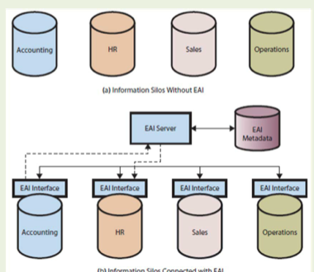

ENTERPRISE RESOURCE PLANNING (ERP)
- A suite of software, a database, procedures and a set of processes for supporting business operations with a single, consistent, information system.
- It integrates data and supports processes across departmental areas into a SINGLE database.
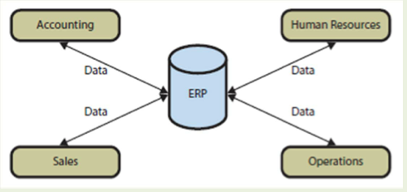

ELEMENTS OF AN ERP SYSTEM
- Current ERP systems are particularly strong in the areas in which they were first developed, such as manufacturing and supply processes.
- In the 1970s, businesses began to buy their own mainframe computers and manufacturing companies began to use software called:
Material Requirements Planning (MRP) to efficiently manage inventory, production, and labor.
Manufacturing Resource Planning (MRPII) was then developed adding financial-tracking capabilities as well as the opportunity to schedule equipment and facilities.

- Today, ERP systems include applications that integrate the processes in the following business functions:
- Supply Chain Management (SCM; procurement, sales order processing, inventory management, supplier management)
- Manufacturing (scheduling, capacity planning, quality control, bill of materials)
- Customer Relationship Management (CRM; sales prospecting, customer management, marketing, customer support)
- Human Resources (payroll, time & attendance, HR management, commission calculations, benefits administration)
- Accounting (general ledger, accounts receivable, accounts payable, cash management, fixed-asset accounting)

Five Components of an ERP System

– Software
– Hardware
– Databases
– Procedures
– People

Software
- Accomplishes interprocess data integration.
- It can be customized to meet customer requirements without changing program code– customization.

Databases
- ERP systems have extensive databases with over 25,000 tables.

Procedures
- IS procedures are instructions & methods for users to interact with the application.
- ERP vendors have developed training curricula to enable users to learn the system.
- Train the Trainer: vendors train the organization’s users to become in‐house trainers

Hardware
- Each ERP implementation requires a wide variety of hardware, i.e. disk storage, servers, clients, printers, scanners, network devices, and cables.
- ERP hardware dilemma: Should the firms allow individuals to user their private smartphones with installed company apps to interact with the ERP products or should they purchase company smartphones for its employees?

People
- There are 3 roles for the people involved with ERP systems:
- Users– employees of the firm implementing the system.
- Analysts– employees with specialized training that enables them to support, maintain, and adapt the system after it has been implemented.
- Consultants– helps budget, plain, train, configure, and implement the system.

Inherent Business Processes in ERP
- ERP systems also specify processes for the implementing organization called inherent processes (sometimes called process blueprints).

BENEFITS OF AN ERP SYSTEM
- An I.S. can improve a process by improving:
- Activities
- Links among activities
- Control of the process
- An ERP system also provides benefits to the organization as a whole, such as:
- Implements processes that are industry’s best practices.
- Data sharing occurs in real time.
- Management can be more insightful and provide better oversight.
- The information silo problem is solved.
CHALLENGES OF IMPLEMENTING AN ERP SYSTEM
- The process of converting an organization into an ERP-supported one is daunting & expensive.
- There are a lot of details involved in implementation decisions that an organization will have to face with an ERP system.
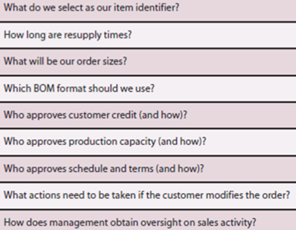
- In addition to the challenge of sorting through all these decisions, the actions & attitudes of the people in the implementing organization can make the situation even more challenging.
- People tend to resist change even when the benefits are well known.

TYPES OF ORGANIZATIONS & ERP
- Two important factors that influence whether an organization uses ERP systems are:

- Industry
- Size

ERP by Industry Type
- The first major companies were large manufacturers in the aerospace, automotive, industrial equipment, & other industries.
- Distribution, mining, materials extraction, medical care, government & public service, utilities, retail & education are among other examples.

ERP by Organization Size
- ERP solutions differ for companies depending on their size and subsequent needs.

International ERP
- One way the needs of large organizations do differ in character from those of small organizations is international presence.
- Most billion-dollar companies operate in many countries, and the ERP application programs must be available in many languages & currencies.

MAJOR ERP VENDORS

ERP Vendor Market Share
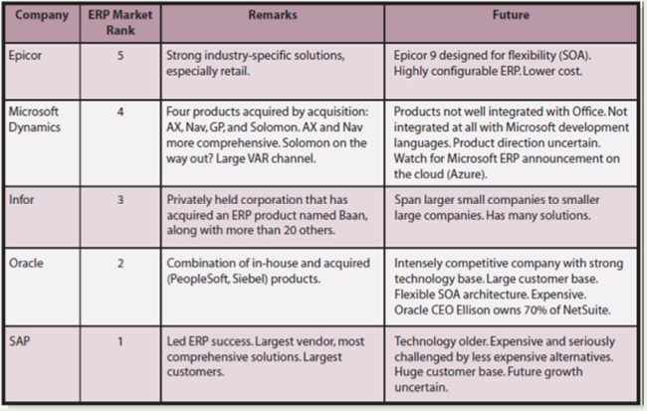

ERP Products

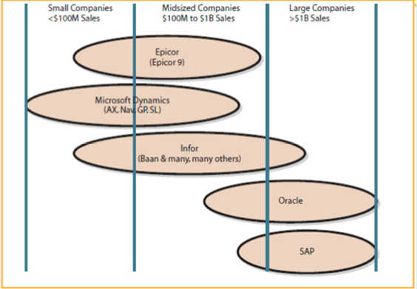

SAP VS. OTHER ERP PRODUCTS
- Systems, Applications, Products is a product of SAP AG, a German firm.
- It is the gold standard of ERP products.
- It is the third largest software company in the world.
- Over 80% of Fortune 500 companies use SAP.
- To speed up the configuration process, SAP produces & sells industry-specific platforms.
- A common way to view SAP is as a collection of interconnected & interdependent modules.
Module: a distinct & logical grouping of processes.
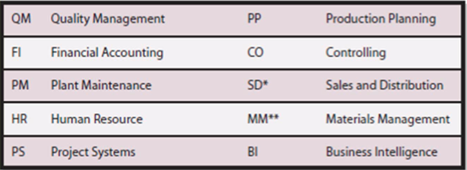

- Different roles in the organization give people access to different screens & different data.
- SAP software was the first ERP software designed to work at different companies.
- One of the more well-known versions of SAP is called R/3– the first truly integrated system that was able to support most of an organization’s major operational processes.
- R/3 has been rebranded as the SAP Business Suite, which runs on a program called an application platform.
- The SAP application platform is NetWeaver (like an OS)– it connects SAP to hardware.
________________________________________
Ch. 7 Supporting the Procurement Process with SAP (PS&I, p.184-211)
FUNDAMENTALS OF A PROCUREMENT PROCESS
Procurement: the process of obtaining foods & services, i.e. raw materials, spare parts, & cafeteria services.
- The 3 main procurement activities are:

- Order
- Receive
- Pay

- We consider the portion of procurement that supports the inbound logistics process in the value chain, where procurement obtains the raw material needed for subsequent assembly in the production process of the operations activity in the value chain.
*Note: Other value chain activities also develop & execute procurement processes to obtain things other than raw materials. i.e. legal services, machine parts, & transportation services.
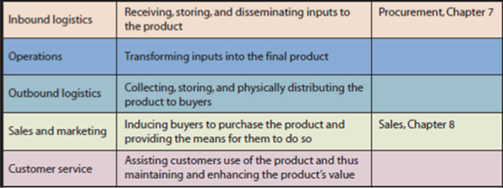

Example of the Procurement Process at CBI
- Six Roles: Two roles performed by people.
• Warehouse Manager and Accountant
– Four roles performed by separate computer applications with separate databases (DB)
• Sales DB, Purchase Order DB, Warehouse DB, & Accounting DB
- These resulted in information silos in addition to other inefficiencies.

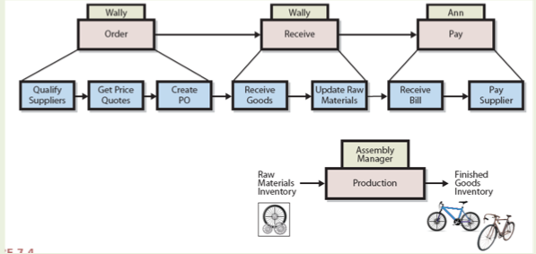

*Note: Before Accountants pay the bill, they make sure that data on the invoice matches the data in the purchase order & the goods receipt (three-way match).

PROBLEMS WITH PROCUREMENT PROCESS BEFORE SAP
Warehouse Problems
- Growth in finished goods inventory reduces warehouse space for raw material inventory.
- Warehouse manager does not have data on sales price discounts.

Accounting Problems
- Three-way match discrepancies take time to correct.
- Accounting data are not real time.

Purchasing Problems
- Purchasing agents not centralized, low training experience, and motivation difference.
- Weak internal controls lead to limited scrutiny of purchases.
Internal Control: limit the actions and behaviors of employees, processes, & systems within the organization to safeguard assets and to achieve objectives.

CBI IMPLEMENTATION OF SAP
- CBI had to reexamine & refocus their strategy.
- The strategy examination process has three activities:
- Determine industry structure.
- Commit to specific competitive strategy.
- Develop objectives & measures for processes to support the competitive strategy.

Chapter 5
Database and Content Management

Q1 What is content?
Content= Intellectual Property
- a form of creative endeavor that can be protected through a trademark, patent, copyright, industrial design, or integrated circuit topography.
Advertising Content: pictures, commercials, text used to promote
Publishing Content: words.
Before content was only available in physical words written down. Now, with computers digital content was created that can be stored. Organizations have databases that can store a large amount of data pertaining to employees, orders, etc.

Q2 How can Content be Organized.
-The challenge in content management is indexing or cataloguing the right information, processing and storing it, and then getting it to the right person in the right format at the right time.
-Data management focuses on how to efficiently and effectively store process these bytes (what content is represented by). This has typically been done through organizational database management systems (DBMS’s).
-DBSM’s are central to the management of content data.
-The presentation of content has gone through changes as company websites have matured. In the early days employees could post content directly to a companies website. This left the consistency of the look and feel of the site in jeopardy as well as the risk of incorrect data being posted.
-The presentation of content in organizations today is increasingly handled through the use of software.
-This can be done using content management systems (CMS’s)
Now when an employee wants to place some content on the organizations website they must access the web CMS (usually located on the website server).
The system now actively seeks out documents located across an organization and automatically manages access to this content.

-Media files, word-processing documents, html pages and many other documents can all be categorized and searched by CMS’s.
The CMS mainly helps manage each step of the process and enables a company to standardize the look and feel of a website and control the information available to customers and employees.
-This ability allows for a wider range of corporations’ data assets.
-Current CMS also handle document archiving and the increased use of electronic files for document management.

Q3 What is the purpose of a Database?
-Keeps track of things
-Most things can be kept n one list however if there are many themes for one subject a database would better suit this task.
- Keeping track of things that involve more than one theme.

Q4 What Does a Database Contain?
- A byte is a character of data
- Bytes are grouped into columns (also called fields)
Student # | Student Name | HW1 | HW2 | Midterm
123124 | sdfasasd | 87 | 98 | 86
234234 | asdfsadf | 76 | 65 | 76
645622 | asdfasdf | 87 | 86 | 89
- Columns or fields are grouped into rows, which are also called records.
- A group of similar rows or records is called a table or file.
Example:

Relationships Among Records:

- A key is a column or group of columns that identifies a unique row in a table.
- A foreign key is a key from a different or (foreign) table from the table it currently resides in.
- Databases that carry their data in the form of tables and that represent relationships using foreign keys are called relational databases.
Metadata:

- Data that describes data
- Makes the database much more useful because no one has to guess, remember or even what is in the database.

Q5 What is a DBMS, and What Does It Do?
Database Management System (DBMS): is a program used to create, process, and administer a database.
- Companies do not make their own databases
- Companies usually license DBMS products from vendors, such as IBM, Microsoft, and Oracle.
- The largest DBMS’s are DB2, Access, and Oracle.
- Open source database; MySQL
- A DBMS is a software program while a database is a collection of tables, relationships, and metadata. (the two concepts are different)

Creating the Database and Its Structures.
- Adding new columns

Processing the Database
- Four operations: read, insert, modify, or delete the data.
- The communication within the relational database: Structured Query Language (SQL).
- The SQL is the international standard language of processing a database.
- Ex: inserting a new row into a table.

Administering the Database
- Could be setting up a security system in the database, limiting certain users to read only, backing up data, etc.

Q6 What is a Database Application
- The collection of forms, reports, queries, and application programs that process a database.
- A database can have one or more applications, and each application can have one or more users.
- The applications have different purposes, functions, and features, but they all process the same inventory data stored in a common database.

Forms, Reports and Queries:

- Forms include reports.
- Reports can compute values as they present the data
- Queries are forms used to enter a search phrase

Database Application Programs:

- Application programs process logic that is specific to a given business need.
  - Ex: in a student database, an application is one that assigns grades at the end of the term. If the professor grades on a curve, the application then reads the breakpoints for each grade from a form and then processes each row.
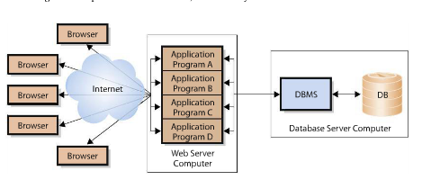
Multiuser Processing
- Multiple users processing the data.
- The lost-update problem ex: Andrea and Jeffrey.
  - Both are on the phone with customers and one processes an order with one customer while the other attempts to process a new order not seeing the updated inventory levels have decreased from the order before.
- In order to prevent this problem some sort of locking must be used to coordinate the activities of users who are unaware of each other.

Q7 What is the Difference between an Enterprise DBMS and a personal DBMS?

-Enterprise DBMS: process large organizational and workgroup databases, supporting many users and many different database applications.
They also support 24/7 operations and can manage databases that span dozens of different magnetic disks with thousands of GB or more of data.
These include: DB2, SQL Server, and Oracle.

-Personal DBMS: designed for smaller, simpler database applications. Usually fewer than 100 users and normally under 15. Microsoft Access is the last personal DBMS application.

Application Extension 5a
How are database Systems Developed?

- Developers interview users and develop the requirements for the new system. Analyzing existing forms, reports, queries, and other user activities.
- The requirements are then summarized in something called a data model (logical representation of the structure of the data).
  - The data model contains a description of both data and the relationship among the data (like a blueprint).
- Once the users have validated and approved the data model, it is transformed into a database design.
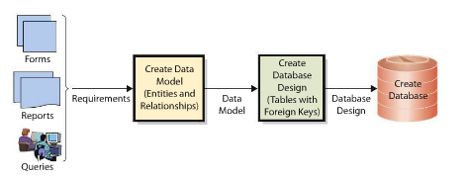

What are the Components of the Entity-Relationship Data Model?
- The most popular technique for creating a data model is the entity-relationship (E-R) data model. With it, developers describe the content of a database and the relationships among these entities.
- A second less popular tool for data modeling is Unified Modeling Language (UML).
Entities:
- An entity is something that the users want to track.
- Examples: Order, Customer, Salesperson, and Item.
- Entities have attributes that describe the characteristics of the entity.
  - Examples: OrderNumber, OrderDate, SubTotal, etc.
- Entities have an identifier, which is an attribute whose value is associated one and only one entity instance.
  - Ex: OrderNumber is an identifier for Order.
Relationships:
-Small lines at the end of the relationship line are called a Crows Foot
-typically used in one-to-many relationships (1:N), or many-to-many (N:M) relationships.
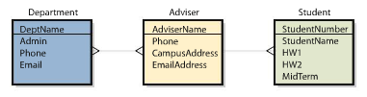
This type of diagram is called the crows foot diagram.
-The crow’s foot notation shows the maximum number of entities that can be involved in a relationship. (Also called maximum cardinality).
- Minimum (also called minimum cardinality)

How is the data model transformed into a database design?
- Normalization
- The representation of two kinds of relationships.

Normalization:
- The process of converting poorly structured tables into two or more well-structured tables.
- Ex: Poorly structured tables sometime contain duplicate names.
(Data Integrity Problems)
Normalizing for Data Integrity:
-delete all duplicated data
-construct tables such that each table contains only one subject or theme.
Leaving the data in normal form.

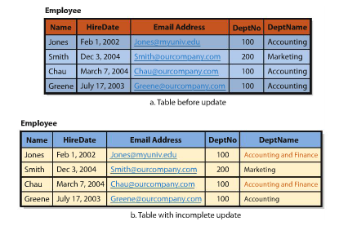

Representing relationships:
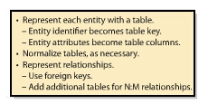
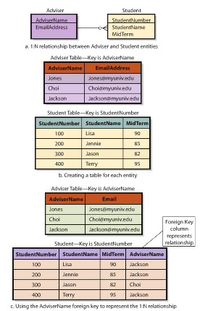

Chapter 6 Supporting Processes with ERP Systems

Q1. What Problem Does an ERP System Solve
- Before, departments ran their own processes, using their own information systems and databases
- Many were not well designed, relatively ineffective an inefficient, hard to integrate with processes in other departments
- Fiber optic cable allowed large, centralized, well-connected databases to be formed. ONE CENTRAL DATABASE
- ERP Solved Silo problem
- EAI- Enterprise Application Integration
  - Tackles silo problem by providing layers of software that connect information together, and allows them to communicate with each other
  - Information sent between systems, EAI intercepts data from first system, then converts its to the format of the second system
  - No centralized Database, keeps files of Metadata, that describes where all the organizations data are located and how it has to be transformed to work at each location
- EAI Does the Following:
  - Connects information silos via a new layer of software
  - Enables existing applications to communicate and share data
  - Provides integrate data
  - Leverages existing systems, leaving departmental information systems as is, but providing an integration layer over the top
  - Enables a gradual move to ERP
- ERP- Enterprise Resource Planning:
  - A suite of software, a database, procedures and a set of processes for supporting business operations with a single consistent information system
  - Standardizes processes and brings the data from a company’s processes into one place so that the data can go out to many places in real time
  - Consolidates all prevalent data into a single database
  - Makes all data up-to-date and available in real time to be used by any process
  - After implementing ERP system, a new procurement process is used by every department (the same process for each department)

Q2. Elements of an ERP System

- Companies have been using IS to support their processes for 50 years
- 1970’s Material Requirements Planning (MRP)- manages inventory, productions and Labor
- MRPII- added financial tracking capabilities as well as the opportunity to schedule equipment and facilities
- Just in Time (JIT)- synchronizes manufacturing and supply
  - Required unimpeded flows of data
- Sarbanes-Oxley Act (SOX)- required companies t exercise greater control over their financial processes
- ERP product must include applications that integrate the following processes:
  - Supply chain management (procurement, sales, order processing, inventory management, supplier management, and related activities)
  - Manufacturing (scheduling, capacity planning, quality control, bill of materials, and related activities
  - CRM (sales prospecting, customer management, marketing, customer support, call center support)
  - HR (payroll, time and attendance, HR management, commission, benefits administration)
  - Accounting (general ledger, accounts receivable, accounts payable, cash management, fixed-asset accounting)

5 Components of an ERP System:

- Software
  - Accomplishes inter process data integration
  - Resides on serves and on client machines
  - Configuration- customization for customers without changing program code
  - If configuration is outside program code, customer must either adapt, or a code must be written to meet requirements
- Databases
  - Gigantic, but largely unpopulated, database; database design; and initial configuration data
  - Does not contain companies operational data- that is entered during development and use
  - Key component to relational databases is that they are module: meaning that tables can be added or removed without significant impact on the overall structure
  - Example databases: IBM DB2, Oracle Database, Microsoft SQL server
- Procedures
  - Instructions and methods for users to interact with the application
  - Training employees is expensive/time consuming
  - ERP vendors create training classes/programs to enable users
  - Train the trainer- vendors train someone so training can be done by a specific person(s) in-house
  - System functionality and data is limited by the role of an employee
- Hardware
  - Disk storage, servers, clients, printers, scanners, network devices, and cables
  - To determine level of hardware, must estimate users,, processes supported, and volume of data for the system
  - Smartphones allow employees to do work with the ERP system- should company provide phones?
  - Cloud computing- lowers cost of hardware, allows off-site storage
  - Installing new hardware is costly
- People
  - Three roles:
    - Users: employees
    - Analysts: (system/business analysts) special training tht allows them to support, maintain, and adapt the system after it has been implemented (also employees)
    - Consultants: may work for ERP vendor or third-party, helps budget, plan, train, configure, and implement the system before during or after
  - Most Common ERP positions
Title | Job Description | Salary
Consultant | Employed by firm, or ERP Vendor, can perform any of the following roles during implementation | 60-100
Systems Analyst | Understands technical aspects of ERP; helps plan, configure and implement | 70-90
Developer | Writes additional code where necessary | 76-90
Project Manager | Defines objectives, organizes, plans,and leads team that implements ERP solution | 70-110
Business Analyst | Understands process aspects, helps plan, configure and implements system for company use | 75-95
Architect | High-level Planner of IS at an organization; ensures compatibility of technology and directs technology toward strategic goals | 90-130
Trainer | Trains end users on how to use ERP system | 65-78

Q3. Benefits of ERP System

- Implements processes that are industry best practices
- Data sharing occurs in real time
- Management can be more insightful and provide better oversight
- Information silo problem is solved

Q4. What are the challenges of implementing an ERP System?

- Implementing ERP “corporate root canal”
- Before implementation, users must be trained
- Need to create a simulation to detect problems
- Must convert data, procedures, and personnel to the new ERP system (all while company till runs on the old system)
- Easier for firms that have implemented some type or enterprise system in the past
- Implementation Decisions
  - select item identifier
  - resupply times
  - order sizes
  - BOM format to use
  - Who approves customer credit
  - Who approves production capacity
  - Who approves schedule and terms
  - Actions taken if customer modifies order
  - How does management obtain oversight on sales activities
- People Issues
  - Work is changed
  - Top management involvement after initial decision to implement
  - Top management oversells capabilities
  - Perceived threat to department autonomy
  - Failure to specify objectives and measures for new processes

Q5. What types of organization use ERP?
- ERP by Industry:
  - First customers- large manufacturers: aerospace, automotive, industrial equipment etc.
  - Moved to suppliers and healthcare
  - List: manufacturing, distribution, mining, material, extraction, petroleum, medical care, government and public service, utilities, retail, education
- ERP by organization size:
  - Originally for large manufacturing organizations, now used by companies with revenue as low as 5 million
  - Processes are the same in small and large businesses
  - Difference: availability of skilled business and IT analysts
  - Midsize firms expand from one person to small staff, but this staff is separate from senior-level management
- International ERP:
  - International ERP solution can handle: different currencies, international transfers of goods, international supply chains
  - Provides a worldwide consolidation of financial statements on a timely basis

Q6. Who are the major ERP vendors?

Company | ERP Market Rank | Remarks | Future
Epicor | 5 | Strong industry-specific solutions, especially retail | -Epicor 9 designed for flexibility (SOA)  -highly configurable ERP. Lower Cost
Microsoft Dynamics | 4 | Four products acquired by acquisition:  AX, Nav, GP, and Solomon(on the way out) | Products not well integrated with Office. Not integrated at all with Microsoft development languages. Product direction uncertain. Watch for Microsoft ERP announcement on the cloud (Azure)
Infor | 3 | Privately help corporation that has acquired an ERP product named Baan, along with more than 20 others | Span larger small companies to smaller large companies. Has many solutions
Oracle | 2 | Combination of in-house and acquired (PeopleSoft, Siebel) products | Intensly competitive company with strong technology base. Large customer base. Flexible SOA architecture. Expensive Oracle CEo Ellison owns 70% of NetSuite
SAP | 1 | Led ERP success. Largest vendor, most comprehensive solutions. Largest Customers | Technology older. Expensive and seriously challenged by less expensive alternative. Huge customer base. Future growth uncertain

- Erp Vendor Market Share:
  - Sap largest market share 35%
  - Oracle 2nd, Microsoft distant 3rd
  - Infor 4th, Epicor 5th
  - Growth in small to medium companies has cause growth for infor and epicor
- ERP Products
  - Epicor
    - Retail oriented
    - Epicor 9-higly customizable
  - Infor
    - Acquired more than 20 companies
    - Sells ERP for any type of business/industry
  - Microsoft Dynamics
    - Composed of 4 ERP products all obtained through acquisition
    - AX, Nav, GP and SL (AX and Nav most capabilities)
  - Oracle
    - Designed according to SOA principles, adaptable and customizable
    - Cloud possibilities in the future
    - Not easy to use
  - SAP
    - Gold standard for ERP
    - mid size to large companies
    - most expensive

Q7. What makes SAP different from other ERP products?

- Product of SAP AG, german firm, (Systems Application Products)
- Core business is selling licenses(consulting, training and other services for its software solutions)
- Third largest software company in the world (50000 employees,100000 customers, 10 million users, 100 countries)
- 80% of fortune 500 companies use sap
- 100 million to install SAP, 20-25% hardware, 20-25% software, 50-60% human ware
- Sell industry specific platforms to speed up configuration process
- SAP is a collection of interconnected and interdependent models
- Module: distinct and logical grouping of processes

SAP Module:
QM | Quality Management | PP | Production Planning
FI | Financial accounting | CO | Controlling
PM | Plant Maintenance | SD | Sales and Distribution
HR | Human Resources | MM | Materials Management
PS | Project Systems | BI | Business Intelligence

- First ERP software designed to work with different companies
- R/3- first truly integrated system that was able to support most of an organizations major operational processes
- It was a thick client, client-server architecture, and thin clients became popular
- Rebranded to SAP Business suite
- Runs on Netweaver
- ABAP- SAP’s high-level application language used to enhance the functionality of a SAP implementation

Chapter 7 Supporting the Procurement Process with SAP

Q1- Fundamentals of the Procurement Process
- Procurement- is the process of obtaining goods and services (most common organizational process)
- Order
- Receive
- Pay
- A good procurement process can spend half as much money as a bad one
- Only process that spans the entire new organization after an acquisition
Primary Activity | Description | Process and Chapter
Inbound Logistics | Receiving, storing, and disseminating inputs to products | Procurement, chapter 7
Operations | Transforming inputs into final products
Outbound Logistics | Collecting, storing, and physically distributing products to buyers
Sales and Marketing | Inducing buyers to purchase products and providing the means for them to do so | Sales, Chapter 8
Customer Service | Assisting customers used of products and thus maintain and enhancing the products

- Purchase order- written document requesting delivery of a specified quantity of a product or service in return for payment
- Inventory
  - Raw materials
  - Finished goods

Q2. Procurement process before SAP
- Plan, keep track and manage people so that tasks were accomplished
- Assign roles to people, or computers
- Three-way match- invoice, purchase order, and goods receipt all agree with each other

Q3. Problems with the procurement process before SAP

Role | Problems
WAREHOUSE | -Growth in finished good inventory reduces warehouse space for raw materials  -Warehouse manager does not have data on sales price discounts
ACCOUNTING | -Three-way Match discrepancies take time to correct  -Accounting data are not real time
PURCHASING | -Purchasing agents not centralized; training experience and motivation difference  -Weak internal controls lead to limited scrutiny of purchases

- Internal Controls- systematically limit the actions and behaviors of employees, process, and systems within the organization to safeguard assets and to achieve objectives

Q4. Implementing SAP

Strategy Process:
- Determine Industry Structure

Industry Structure

Determines

- Bargaining Power of Customers
- Threat of substitutes
- Bargaining power of suppliers
- Threat of new entrants
- Rivalry

- Commit to a specific competitive strategy
 | COST | DIFFERENTIATION
INDUSTRY WIDE | Lowest cost across the industry | Better product/service across the industry
FOCUS | Lowest cost within an industry segment | Better product/ service within an industry segment

- Develop objectives and measure for processes to support the competitive strategy
OBJECTIVE | MEASURE
Efficiency
Smaller finished goods inventory | -Inventory Turnover  -Total cost of inventory on hand
Fewer Errors | -Number of three-way match errors
Effectiveness
Better Financial Control | -Time required for end of period rollup  -Number of managers requesting financial reports
More Responsiveness to Customers | -Order fulfillment time  - Numbers of managers requesting financial reports  -Stockouts of new, hot-selling products

- Inventory turnover- number of times inventory is sold over a given period, most commonly a year.

Q5. Procurement process after SAP

- Eliminates problems associated with no SAP system in place
- Helps pursue particular Strategy the company has set to achieve
- Reduce Errors

Q6. SAP improve the Integration of Supply Chain Processes

- Easier to combine different process with an ERP system(SAP)
Process Scope | Supply Chain Processes
Operational | Procurement
Managerial | Supplier Relationship Management (SRM)  Returns Management
Strategic | Supplier Evaluation

- Supplier Relationship Management (SRM) process- automates, simplifies, and accelerates a variety of supply chain processes
- Returns management Process- manages returns of faulty products for business
- Supplier evaluation Process- determines the criteria for supplier selection and adds and removes suppliers from the list of approved suppliers
- Supply Chain Management- integration of supply chain processes
  - Design, planning, execution and integration of all supply chain processes
  - Collection of tools, techniques, and management activities to help businesses develop integrated supply chains that support the organizations strategy
  - Integration improved when data is shared
- Bullwhip effect- when companies order more supplies than are needed due to a sudden change in demand
  - Reduced with integration

- Increase process synergy- when processes are mutually supported which means when one process is done well, the objectives of the others are supported
- Bottleneck- when a limited resource greatly reduces the output of an integrated series of activities or processes
- New technologies not yet integrated with SAP

Technologies | Info
Augmented Reality (AR) | Computer data or graphics are overlaid onto the physical environment
RFID (Radio- Frequency identification) | Used to identify and track items in the supply chain, broadcast data to receivers that can display and record data
Sensors | Improve tracking, improve use of materials, and equipment etc.
Robotics
3D Printing (additive manufacturing) | Objects are manufactures through the deposition of successive layers of material

Q7 how does the use of SAP affect change companies?

- New skills needed
- Process focus
- More data sharing
- Outsourcing

Chapter 6
Networks and Collaboration
Wireless Network (802.11)
LAN – (802.3) – provides wireless Internet access
WAN (Wide Area Network)
-When connecting to the Internet you are a part of a network of networks comprised of millions of computers

Networks & Collaboration
- Collaboration – occurs when two or more people work together to complete a common goal, result, or product
  - If done properly/effectively the results of the group would be greater than if done individually.
4 Critical Factors of Effectiveness in Collaboration
- Communication Skills
- Communication System
- Content Management
- Workflow Control

Workflow:
-process or procedure by which content is created, edited, used and disposed of.
- Same as business process
- Business Process – provide goods and services externally
- Workflow – provide goods and services internally
The “Network Effect” or (Network Externalities)
- the larger the number of people using the network the more valuable the network becomes.

Computer Networks
- Network – a collection of computers that transmit and/or receive electronic signals through transmission media.
  - The transmission media can be:
    - Physical – copper cables and optical fibres
    - Wireless – transmitting light or radio frequencies (including cellular and satellite signals)
Three major types of networks:
- Local Area Network (LAN)
- Wide Area Network (WAN)
- Internets

Local Area Networks:
- Connect computers within a relatively small, single geographical area
- Can range from 2 – several hundreds of computers at a time
- Distinguishing factor of a LAN is a SINGLE location.
Wide Area Networks
- Connect computers in different geographical areas
  - Must get license by vendor approved by the government to be able to run connection from different cities.
Internets
- Network of networks
- Connect LANS, WANS, and other internets
  - Private networks of networks are called internets
- Because the internet uses so many different communication methods and conversions, to provide seamless flow, an elaborate scheme called layered protocol is used.
- Protocol – a set of rules that two communicating devices must follow
  - There are many different protocols
  - The two devices communicating with each other must have the same protocol
- There are different protocols for each LANS, WANS, and Internets
Components of LAN
- LAN is a group of computers connected together on a single company site
- Usually computers are located within a kilometer of each other
- The key distinction is that all of the computers are located on property owned or controlled by the company LAN.
Switch:
- A special-purpose computer that receives and transmits messages through devices
  - Ex: computer sends print job to switch -> switch redirects the job to the printer
  - Large LANS usually use more than one switch.

- Each LAN device (computer, printer, etc) has a hardware component called a network interface card (NIC)
  - Connects the device circuitry to the network cable
  - The (NIC) works with programs in each device to implement the protocols necessary for communication
  - Newer machines have onboard NIC, NIC that is built into the computer
    - Each NIC has a unique identifier number called the MAC (Media Access Control) address

- Most connections are made using unshielded twisted pair (UTP) cables
  - The device called the RJ-45 connector is used to connect the UTP cable into the NIC device on the LAN
- The reason wires are twisted is because it reduces cross wire signal interference, which occurs when wires run parallel to each other.
- If the UTP cables are far apart or if they carry a lot of traffic, they can be replaced by optical fibre cables.
  - The signals on optical fibres are light rays carried inside the glass core of the cables
  - The core is surrounded by cladding to contain these light signals
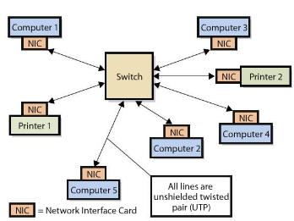

IEEE 802.3, or Ethernet, Protocol
- Institute for Electrical and Electronic Engineers (IEEE)
  - Sponsors committees to create and publish protocols and other standards
  - The committee that address LAN standards is called IEEE 802
  - LAN protocols always start the number 802
  - Today the most popular protocol for LAN’s is based on IEEE 802.3 or (Ethernet)
  - Most computers with onboard Network Interface Cards (NIC) are equipped with NIC that supports 10/100/1000 Ethernet
      - These protocols conform to 802.3 prtocol, always for a transmission rate of 10/100/1000 Mbps
Why is Mobile Computing Important?
Two trends for accessing the Internet:
- Your computer is likely to be a portable laptop than desktop
- Your new smartphone or other highly portable device such as a tablet
- Cellular phones are no longer just phones
- Mobile devices provide a wide variety of services
- Mobile devices are built for communication and collaboration

Smartphones
- Smarts phones are now enabling m-commerce (mobile commerce)
  - Conducting transactions over mobile devices (mobile banking, coupons, etc)
- Issues are arising in differences in operating systems
Tablets and eReaders
- The two major issues are 1. Complexity in synchronization and 2. Ownership

- Many organizations are adopting what is called Bring Your Own Device (BYOD) – whereby employees are encouraged to simply use their own devices for work rather than being provided company-issued devices.

  - This issue would further blurr the line between personal and professional use of electronic devices at work

Connecting to the Internet
- An important component of WAN is a router.
- Routers are special purpose computers that implement the protocols for WAN’s
- The router will connect your computer to computers owned and operated by the internet service provider (ISP)

ISP’s have 3 important functions:
- Provide router with IP (Internet Protocol) address
- Serves as a gateway to the internet
  - Receives communication from the router and passes them on to the internet
  - Also the ISP’s receive communication from the internet and pass them back to your router and then to you
- Collect money from customers and pay other charges on your behalf

The WEB and the Internet are not the same
- The web, which is a subset of the internet, consists of sites and users that process the hypertext transfer protocol (HTTP)
  - Programs that implement the HTTP protocol are called browsers
- The Internet is the communication infrastructure that supports all application-layer protocols, including HTTP, the simple mail transfer protocol (SMTP), and the file transfer protocol (FTP)
  - Send an E-mail (SMTP)
  - View Web pages (HTTP)
  - Transfer files between computers (FTP)
IP Addresses
- Public IP Address
  - Used on the internet
  - Every address is unique
- Private IP Address
  - Used within private networks and internets
Domain Names
- How the computer obtains the IP address with only the URL
  - This is through the Domain Name System (DNS)
  - The process of converting a domain name into a public IP address is called domain name resolution.
    - Done by computers called domain name resolvers

Digital Subscriber Line (DSL) Modem
- Operates on the same line as voice telephones but operates in such a way that the signals do not interfere
- Because they do not interfere with each other DSL data transmission and telephone conversion can happen simultaneously
There are various levels of DSL speed
- DSL lines can download data of speeds ranging from 256-768 kbps
  - These differences in speeds are called asymmetric digital subscriber lines. (ADSL)
  - DSL lines with the same receiving and transmitting speeds are called symmetric digital subscriber lines (SDSL)
    - They can have speeds of up to 1.544 Mbps
- A cable modem provides high speed data transfer using cable television lines
- For the most part the speed of the most part the speed of cable modems and DSL modems are about the same.
- Modems are originally referred to as Modulators/Demodulator because they modulate signals to analog signals.

Narrowband Vs. Broadband
- Narrowband lines typically have transmission speeds less than 56kbps
- Broadband lines have speeds in excess of 256kbps
  - Dial-Up modem provides narrow access
  - DSL – Cable Modems provide broadband access

Wireless WAN
Different from WLAN in two ways:
- A WWAN covers a larger area than WLAN and WWANS use cellular networks to transfer data
  - Works much like cellphone data
  - WANN cards – have the ability to make voice calls as well as pass data traffic on WWAN networks

How does E-mail actually work:
- Transmission Control Program/ Internet Protocol (TCP/IP)

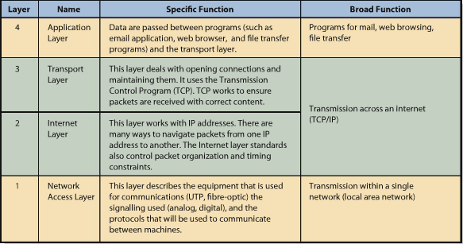

Firewall
- Computing device that prevents unauthorized access and gets its name from the way the forest fires are often contained by open spaces.
- A firewall can be a special purpose computer it can be a program on a general-purpose computer
  - Or in a router

Port
- A port is a number used to uniquely identify a transaction over a network
- Port number s can be used to create firewalls
- A firewall also uses an access control list (ACL)
  - This keeps track of which IP address are to be allowed and which are to be prohibited
Pocket-Filtering Firewalls
- Examines each part of the message and determines if it should be let pass
  - Can examine source addresses
  - Destination addresses
  - And other data
- Firewalls can filter out band traffic
  - Keep employees from accessing
    - Porn
    - File sharing sites
    - Social networking/sharing sites (FB, Youtube)
- Organizations may have multiple firewalls
  - Perimeter Firewalls – outside organizational network
  - Internal Firewalls – inside the network
  - Pocket-Filtering

Encryption
- Process of transforming clear text into coded, intelligible text for secure storage or communication
- A key is a number used to encrypt data
- Coding and decoding messages are done using encryption algorithms

Types of Encryptions
- Symmetric: the same key is used to encode the message and decode the message
- Asymmetric: different keys are used to encode and decode
- Symmetric is simpler and much faster

Flow of Encryptions:
- Your computer obtains the public key of the website to which it will connect
- Your computer generates a key for the symmetric encryption
- Your computer encodes that hey using the websites public key. It sends the encrypted symmetric key to the website.
- The website then decodes the symmetric key using its private key
- From that point forward, your computer and the website communicate using symmetric encryption.

Virtual Private Networks (VPN)
- Uses internet and private internet to create the appearance of private point-to-point connections
- The connection is called a tunnel, it is a virtual private pathway over public or shared networks from the VPN client to the VPN server.
- The message is sent through the tunnel encrypted the is stripped of its address when received and finally decrypted.
  - This is how private messages are sent over public networks through VPN’s
Search Engines
- Web search engines require two things
- A way to collect URLs
- A method for storing/accessing URLs so that they can be searched.
- Finding URL’s is usually the job of web crawlers
  - Web crawlers (spiders) is a software program that browses the web in a very methodical way
  - The crawler starts with a list of seed URL’s
Ex: if your email address is on a webpage a web crawler will find it.
- These crawlers can also be used to maintain corporate websites by checking links and validating HTML code.
Chapter 9 E-Commerce, Social Networking and Web 2.0 Comm 226

Q1. What is E-commerce and How is it used?

- E-commerce: the buying and selling of goods and services over public and private computer networks
Merchant Companies
- Business-to-customer (B2C)- sales between a supplier and a retail customer
- Web storefront- web-based application by which customers enter and manage their orders
- Business-to-business (B2B)- sales between companies
- Business-to-Government (B2G)- sales between companies and governmental organizations
Nonmerchant E-commerce
- E-commerce auctions- match buyers and sellers by using an e-commerce version of a standard auction
- Clearinghouses- provides goods and services at a stated price and arrange for the delivery of the goods, but never take title. (Ex. Electronic exchanges- match buyers and sellers; the business process is similar to that of a stock exchange)

Benefits of e-commerce
- Disintermediation- the removal of intermediaries between parties
  - Higher manufacture profits, lower consumer prices
  - Intermediation and re-intermediation people inserting themselves into the sales and distribution processes of e-commerce
- Improves the flow of price information
  - Find the price for the product you want from many different sources and retailers
- Produces information about price elasticity (for sellers)
  - Price elasticity- measures how much demand rises or falls based on a price change
  - Loses bidder auction prices
  - Price experimentation
  - More accurate information obtained directly from customer
Issues with e-commerce
- Channel Conflict- competition between retailers and manufacturers may arise
- Price conflict- manufacturer and retailer can have disagreements about price, even if their individual markets aren’t effected
- Logistics Expense- manufacturers have to deal with this expense because the distribution chains provided value, and were not just a cost
- Customer service expense- have to provide services to less-sophisticated users on a one-on-one basis
- Show rooming- occurs when a customer learns about or tries a product or services in the high cost bricks-and-mortar retail store while completing the sales transaction at the low-cost Internet sales channel of another retailer
- Taxation- where to allocate and how much to tax based on where the good/service is made and used is difficult to determine.

Q2. What is Social Networking and how is it enabled and affected by IS/ IT

- Physical Capital- investment of resources for future profit
- Human capital- is the investment in human knowledge and skills for future profit
- Social capital- is the investment in social relations with the expectation of return in the marketplace. Add value through:
  - Information
    - About opportunities, alternatives, problems, and other factors important to business professionals
  - Influence
    - Influence decision makers in ones employer, or in other organizations who are critical to your success
  - Social Credential
    - Being linked to a network of highly regarded contacts gives you this
  - Personal reinforcement
    - Reinforces your personal image and position in an organization or industry
- Strength of social network is based on number and strength of relationships

Importance of weak relationships
- People you know the least contribute the most to your network
- Depending on who you connect with, put you steps closer to connecting with others

How do Social Networks Add Value to Business?
- Organizations have social capital- number of relationships, strength of relationships, and resources controlled by friends
How is social networking enables by IS/IT
- Improved search capabilities- enable us to quickly sort though large amounts of data and find specific people or relationships
- Reduction in the trade-off of richness and reach- keep track of more people and enhance personalization (keeping track of important dates for example)
- Network effects-bigger network is more valuable, as it grows benefit and utility that each person adds tends to grow. Accelerates speed of growth and usefulness of a network

Q2. What is Web 2.0
- Provide software as a service (SAAS)
- Revenue relies on advertising or other revenue that results as users employ the software as a service
- Thing clients- do not require installation on users’ computers
  - Web servers download web 2.0 programs as code (html, flash, Silverlight) and they are frequently updated
- Software services clash, traditional software vendors release software infrequently and in controlled ways
- Little marketing is done in web 2.0, users spread the word (viral marketing)
- Value of Web 2.0 software increases with users and use
- User-Generated Content (UGC)- website content that is contributed by users
- Crowd Sourcing- users can provide customer support, create product specifications and designs, and complete products
  - Combines social networking, viral marketing and open-source design, saving considerable cost while cultivating customers
- Traditional software controls the users experience
- Web 2.0 is organic, users have to figure out their ay around the software
- Encourages Mashups: when the output from two or more websites is combined into a single user experience (Google maps)
- Web 2.0 is about participation
  - Users upload information
  - Ownership- in web 2.0 only some rights are locked down
- Benefits from web 2.0 for companies
  - Advertising
    - Cost to reach a qualified buy is cheaper
  - Mashups
    - Mashing up product info with a product that is used in two different industries (e.g. jewelry in a movie is sold at the bay)
  - Not for all business
    - Not all systems will benefit from the organic nature of WEB 2.0
- Web 3.0
  - Cannot predict what it will look like or if it will even be called web 3.0

Chapter 10

Q1. How can Information systems be acquired?

5 ways to acquire Software:
- Buy it and use it as is
- But it and customize it (most common)
- Rent or lease it
- Build it yourself
- Outsource it

- Acquiring new software is not the same as acquiring new information systems(IS includes hardware, software, data, procedures, and people and thus involves more than just acquiring new software)
- You must obtain new software and integrate into the :
  - Technological Infrastructure (hardware, Operating Systems, Installed applications)
  - Data (existing data in the data bases)
  - People and procedures (business processes and organizational context)
- Even if the software is free or open source, the organization will still face the cost of integrating the software with its current hardware, data, and procedures. Costs are substantial and must be taken into consideration

Q2. What are IT projects, and what does PMBOK mean?

- Project Management Body of Knowledge (PMBOK)
  - Project consists of a temporary endeavor undertaken to create a unique product, service or result
  - Projects often begin with a set of goals or objectives
  - From these set of goals and objectives, a scope is developed for the project
  - Projects usually have a start and an end date
  - Accomplish something new
- Hard to estimate time, budget, and scope

Information Technology Project Management (ITPM)
- ITPM is the collection of techniques and methods that project managers use to plan, coordinate, and complete IT projects, including:
  - Planning tools
  - Budgeting methods
  - Graphical scheduling methods
  - Risk management techniques
  - Communication planning
  - High-tech team development
- PMBOK 5 process groups:
- Initiating
- planning
- executing
- controlling and monitoring
- closing

What Should You Know About IT Operations and IT Projects?
- IT Operations: The delivery of service, maintenance, protection, and management of IT infrastructure. (KTLO, keeping the lights on)
- 2 basic activities required for IT services:
  - Maintaining current IT infrastructure
  - Renewing and adapting the infrastructure
- IT projects: The renewal and adaptation of IT infrastructure is normally accomplished through projects
- The distinction between operations and projects is important for several reasons
  - Operational work and project work tend to attract two different types of IT professionals (IT ppl who prefer to work in operations[ e.g.network specialists, os specialists, data-base administrators, and hardware technicians]
- These workers continually seek ways to improve the efficiency and security of the entire set of systems that support operations and these active systems are known as production systems
- Stability, predictability, accountability, reliability, and security are key words in IT operations.
What the IT Department Does?
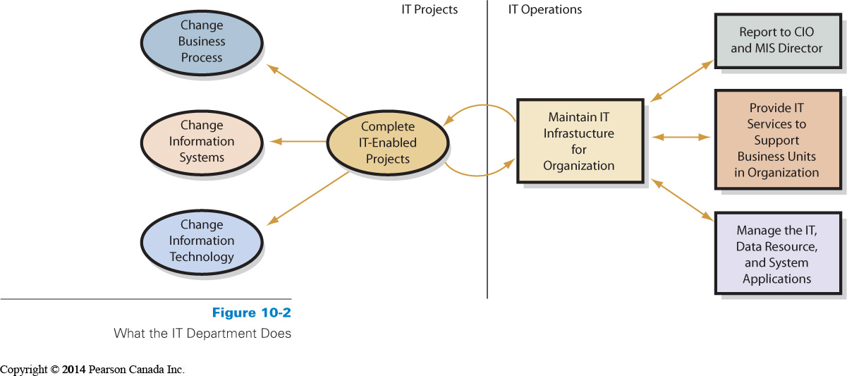
Information Technology Infrastructure Library (ITIL)
- ITIL is a well-recognized collection of books that provide a framework of best-practice approaches to IT operations
- ITIL offers a large set of management procedures that are designed to help businesses achieve value from IT operations
- ITIL has gone through several revisions; core books from the latest refresh (ITIL V3)
- It basically refers to a well-developed set of best practices that can support IT operations
Web
- Web plays a vital role in the transmission of information and support for internal and external users (intranet for employees, extranet for customers, FAQs, customer support info, company director and contact info on the company’s website, etc.)

Why Are IT Projects So Risky?
- Most IT project definitions are not easy to graphically represent
- Lack of a good model is an important risk to recognize in IT projects
- Good estimates of costs are difficult to develop because the technology is continually changing. E.g computers are getting cheaper and faster, programming languages, OS, and databases get more complex.)
- Being able to monitor progress is another challenge for IT projects (e.g system requirements change as the system is developed, and the bigger the system, the longer the project, the more those requirements change).
- Some Risks Inherent in IT Projects
  - Lack of experience in the team
  - Lack of support from top management
  - Lack of participation from system users
  - Unclear and uncertain project requirements
  - A high level of technical complexity, and changes in the project environments
What Is the SDLC?
- The systems development life cycle (SDLC) is the classic process used to acquire information systems
- To successfully acquire and maintain information systems, there are basic tasks that need to be performed
- These basic tasks are combined into phases of systems development
- Classical process with five phases:
- Systems definition
- Management’s statement defines new system
- Requirements analysis
- Identify features and functions
- Component design
- Based on approved user requirements
- Implementation
- Implement, test, and install new system
- System maintenance
  - Repair, add new features, maintain
Phases in the SDLC
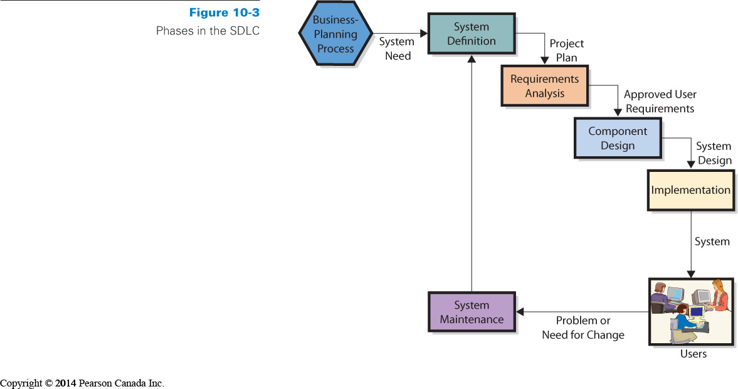

Phases of System Analysis

Phase 1: Defining Systems
- Define goals and purpose for new system
  - Must facilitate organization’s competitive strategy
  - Supports business processes
  - Improves decision making
- Defining project’s scope
  - Simplifies requirements determination and other subsequent development work
- Assess feasibility of project
  - Cost
  - Schedule
  - Technical
  - Organizational
Phase 2: Requirements Analysis
- Management of scope in an IT project
- Team includes both It personnel and user representatives
- System analysts, programmers, software testers and users and managers
- Business analysts-current procedures, interact with stake holders
- System analysis usually IT professionals
- Determine and document specific features and functions of the new system
- Approve requirements
- Users have an active involvement
- Less expensive to change system in this phase

How are IS Designed, Implemented, and Maintained?
- Four ways to acquire information systems:
  - Buy
  - Buy and customize
  - Rent
  - Build it yourself
  - Outsource
- For options 1-3, organization must match its requirements with the capabilities of the available software application
- Matching Organizational Needs and COTS (commercial-off-the-shelf) Software Capabilities
- COTS will never fit your organization perfectly

Phase 3: Component Design
- Develop and evaluate alternatives
  - Accurate requirements critical
- Hardware design determined by project team
- Software design depends on source
  - Off-the-shelf
  - Off-the-shelf with alterations
  - Custom-developed programs
- Data model converted to database design
- Procedures designed for BI system
- Job descriptions created for users and operations personnel

Phase 4: Implementation
- System must be built
  - Components constructed independently
  - Document and review
- System testing
  - Individual components tested
  - System integrated and tested
- Users must be converted to new system

Systems Testing
- Test plan
  - Sequences of actions that users take when employing system
  - Both normal and incorrect actions should be considered
  - Labour intensive
- Product quality assurance (PQA)
  - Testing specialists
  - Plan with the advice of assistance users and monitor the test throughout
- Beta testing
  - Future system users try out system on their own

System Conversion

Converting business activity from the old system to the new
- Pilot
  - Organization implements entire system on single, limited unit
  - If systems fails, it only affects limited boundary
  - Reduces exposure
- Phased
  - New system installed in phases
  - Tested after each phase
  - Continues until installed at entire organization
  - Can’t be used in tightly integrated systems
- Parallel
  - New system runs in parallel with old system during testing
  - Expensive and time consuming
  - Data must be entered twice
  - Provides easy fallback position
- Plunge
  - Direct installation
  - Install new system and discontinue old
  - There is no backup position
Design and Implementation for the Five Components
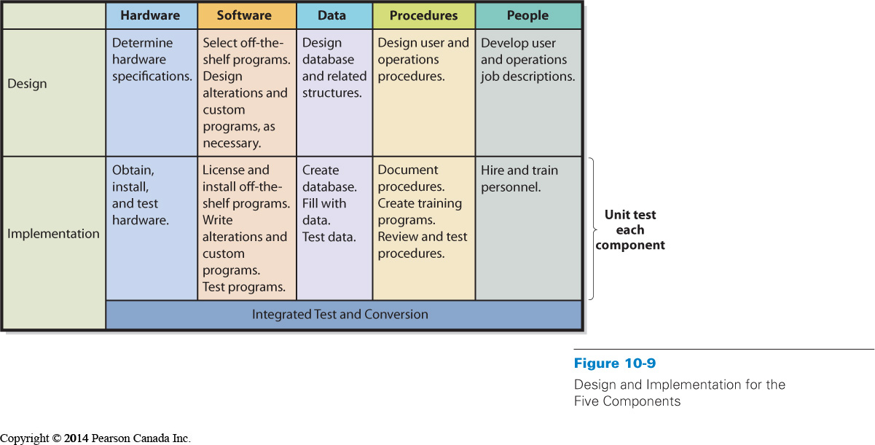
Phase 5: Maintenance
- Fixing the system so that it works correctly
or adapting system to changes in requirements
- Need method to track system failures and enhancements
- Corrections usually prioritized based on severity
  - creation and installation of patches & service packs
- Enhancements usually prioritized based on business decision
  - must generate reasonable rate of return
  - decision to restart systems development process
  - Patches and service pack given to fix small problems
Problems With SDLC
- SDLC waterfall
  - Phases are not supposed to be repeated
  - Often teams have need to repeat requirements and/or design phases
- Difficulty in documenting requirements
  - Analysis paralysis or uncertain requirements
  - Problem lost in pages of coding
- Scheduling and budget difficulties
  - Multiyear projects difficult to properly schedule
  - Estimations on labour often produce insufficient budgets

What is outsourcing and what are Application Service Providers?

- Outsourcing is the process of hiring another organization to perform a service
- The outsourced vendor can be domestic or international
  - Offshoring is when vendor is overseas
(e.g., China, India, and Russia)
- Application service providers (ASPs) are a special form of outsourcing

Reasons for Outsourcing
- An easy way to gain expertise
- Concern cost reductions
- To reduce development risk
- Outsourcing risks:
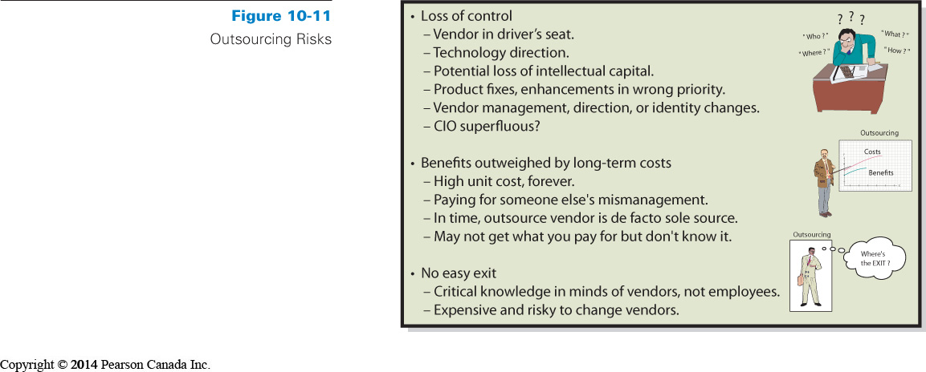

Application Service Providers
- ASP agreement
  - Organization contracts with a vendor to “rent” applications from the vendor company on a fee-for-service basis
- Vendor maintains the system at its own web location and the client organization accesses the application on the vendor’s website
- Payments
  - Monthly or yearly
  - Based on number of employees or “users”

Chapter 11

How is the IT Department Organized?
- Most organizations rely on information technology (IT) services
- All these services - email systems, accounting applications, desktop computers, and mobile devices - used in an organization require some form of technical support
- The department of people who support this is often referred to as “IT Services” or “Information Systems Services”
- CIO-Chief Information Officer (head)
- Technology office- investigate new information systems
- CTO- Chief technology officer
- Typical Top-level Reporting Relationships
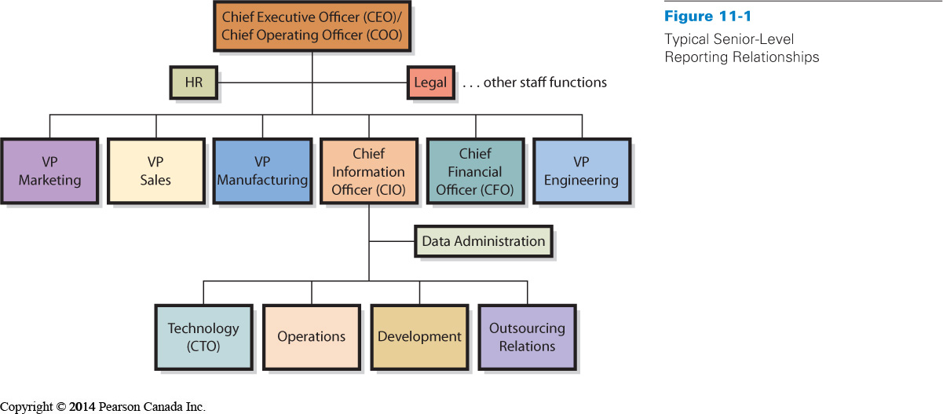
What About the Web?
- The Web has had a significant impact on the organization of IT departments
- Traditionally, IT department was responsible for designing and maintain a website
- This task now belongs to marketing department to keep up with branding and control of content while IT provides technical support for the website
- Creating well-designed company web pages requires knowledge of branding and marketing
- Requires a lot of people to make a good website, it is a difficult job:
  - Project managr
  - Leader designer/analyst
  - Developer
  - Technical architect
What Jobs exists in IT Services?
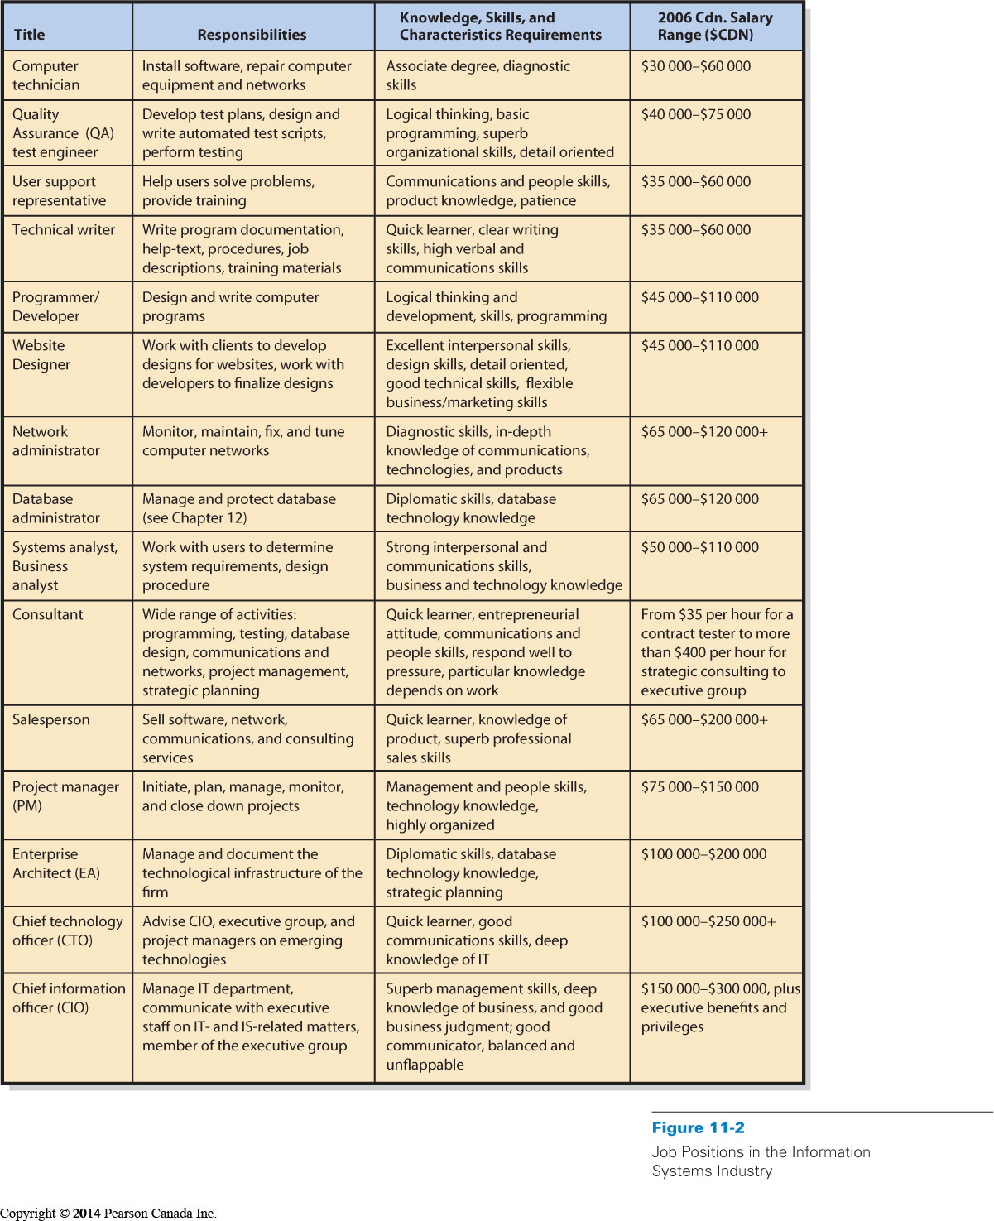
- IT industries have a wide range of interesting and well-paying jobs
- Some think that the industry consists only of programmers and computer technicians who have great technical skills
- The reality is that most jobs that are in the highest demand in the IT industry require a mix of interpersonal and technical skills
- The industry needs people who can bridge the knowledge gap between computer technicians and business system users

- For most technical positions, knowledge of business specialty increases marketability
- High-paying jobs require communication, leadership, and business skills
- For students, a dual major can be an excellent choice to open up opportunities
What is Information Technology Architecture?
- IT architecture is the basic framework for all the computers, systems, and information management that support organizational services
- Enterprise architect creates a blueprint of an organization’s information systems and the management of these systems
- Organizational objectives, business processes, databases, information flows, operating systems, applications and software, and supporting technology
- Zachman Framework( John Zachman 1980s IBM):
- 2 layers
  - Reasons for communication
    - What? data
    - How? function
    - Where? Network
    - Who? People
    - When? Time
    - Why? Motivation
  - Stakeholders
    - Planner
    - Owner
    - Builder
    - Implementer
    - Worker

Organizational Strategy and Information Systems
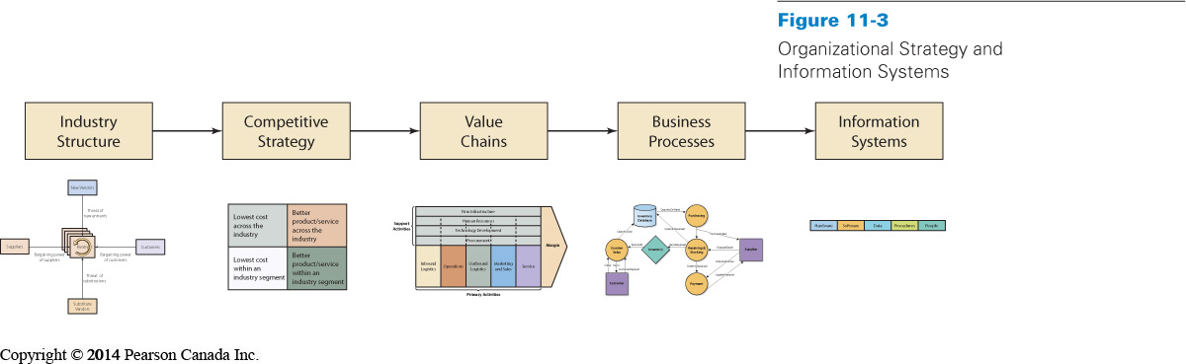

What is Alignment, Why is it Important, and Why is it Difficult?
- Alignment: Process of matching organizational objectives with IT architecture
- Ongoing -- fitting IT architecture to business objectives is continuous challenge
- Measured as the degree to which the IT department’s missions, objectives, and plans overlapped with the overall business missions, objectives, and plans

- Communication between business and IT executives is the most important indicator of alignment
- Difficult for many firms but can help provide a competitive advantage

What is Information Systems Governance?
- Goal of IS governance is to improve the benefits of an organization’s IT investment over time
- Reporting structures
- Review processes
- Improve quality
- Reduce service costs and delivery time
- Reduce IT risks
- Better support business processes
- Creating Benefits from IT Governance
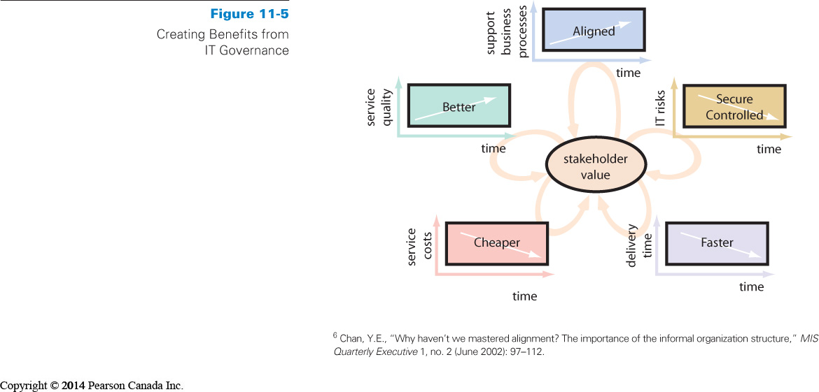
Sarbanes-Oxley Act (SOX) 2002
- Governs reporting requirements of publicy held companies
- Prevents corporate fraud (enron, WorldCom)
Bill 198 (Budget Measures Act)
- IN Ontario, same idea as SOX

- Both require management to create internal controls
- Criminal offence if they are violated (by auditor and company)
- IT is now recognizable, not just a “blackbox” that can’t be understood

What is an Information Systems Audit?
- Examination and verification of a company’s information resources that are used to collect, store, process, and retrieve information – including organization’s IS policies and procedures
- Many firms offer IS audit services:
  - ISACA (information systems audit and control association)
  - CISA (Certified information systems auditor)

- Control Objectives for Information and Related Technology (COBIT) is a framework of best practices designed for IT management

Why Should You Care about IS Governance?
- Increased need to report and disclose IS operational information will require employees at all levels of an organization to become more familiar with the issues facing information technology management
- Senior business managers are required to make assertions about the controls on IS that will expose them to both financial and criminal penalties

What is Information Systems Ethics?
- Information systems ethics is about people involved with the system, not hardware or software
- IS ethics is about understanding our own behaviour—the way we think and act in situations where our choices affect others
- Ethical principles
- United Nations Declaration of Human Rights
- Canada’s Charter of Rights and Freedoms
- Association of Computing Machinery’s code of ethics
Sarbanes-Oxley: Boon or Bane?
- Goal to strengthen and upgrade financial reporting, and thus maintain and improve trust in public companies’ financial reports
- Large companies expect to divert more than 15 percent of their IS budgets to Sarbanes-Oxley compliance
- Sarbanes-Oxley Act will provide full employment for internal and IT auditors

Green IT
- Green IT (green computing)- using IT resources to better supports the triple bottom line
- Triple bottom line:
  - Traditional profit
  - Ecological performance
  - Social performance
- Primary goals:
  - Improve energy efficiency
  - Promote recyclability
  - Reduce the use of hazardous material for the environment
- Companies:
  - Energy start
  - OMG- object management group
- E-cycling: recycling of electronic computing devices
- E-waste companies face tough government regulations
Chapter 12
Managing Information Security and Privacy

Identity Theft
- Vital information such as a persons name, address, date of birth, Social Insurance number etc
  - Needed to facilitate impersonation
- With this info an identity thief can take over someone’s financial accounts, credit cards, and so on
- One of the fastest growing crimes in Canada because it is easy to do
- PublicSafetyCanada website good place to look for information

PIPEDA
- Personal Information Protection and Electronic Documents Act
- Intended to balance an individuals right to the privacy of his or her personal information
- Every business professional needs to be aware of PIPEDA because it governs how data are collected and used
  - Individuals have the right to know what information is being collected on them
  - Organizations can not use the information collected for any reason other that the reason they stated it was for
- According to PIPEDA organization have an obligation to protect/secure the information they collect
- PIPEDA ensures the data be collected in fair means and that their terms and policies are clearly expressed so that people understand them before using the service of the organization.
- PIPEDA has helped to establish some confidence in the collection of digital information to support e-commerce.

Organizational Security Threats
Three sources of security threats:
- Human error or mistake
- Malicious human activity
- Natural events/disasters

Unauthorized data disclosure
- Can occur by human error hen someone inadvertently releases data in violation of policy
- Can occur through malicious human activity
  - Pretexting – someone pretends to be someone else
  - Phishing – pretexting over email
  - Spoofing – pretending to be someone else as well
    - IP spoofing – using someone else’s IP address
  - Sniffing – technique for intercepting computer communications
    - Requires a physical connection to the network
    - Drive by sniffers – takes computers with wireless connections through an area and search from unprotected wireless networks.
Incorrect Data Modification
- Incorrectly entering data about someone into a file (ex: discounts, salaries)
- Can occur through human error
- Hacking – when someone gains unauthorized access to you computer system they can modify data

Faulty Service
- Systems working incorrectly
- Eg: sending wrong goods to customer etc
- Humans can make mistake and cause faulty service

Denial of Service (DOS)
- Often launched maliciously
- Through hackers or worms

Loss of Infrastructure
- Human accidents
- Can also be theft and terrorist events
- Can be cause through viruses (zombies)
- Can be done though natural disaster
Elements of a Security Program
- Senior Management Involvement
- Safeguards of various kinds
- Incident response

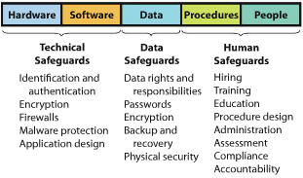

Technical Safeguards
- Involve hardware and software components of an information system

Identification and Authentication
- User name identity’s the user and the password authenticates the user
  - Smart Cards – card chips with PIN’s
  - Biometrics – finger print scanner
  - Single sign in for Multiple Systems

Encryption and firewalls
  - From chapter 6

Malware Protection
Viruses
Worms
Spyware – programs installed on the users computer without the knowledge of the user
Adware – pop ups ad spams

Malware safeguards
  - Install antivirus and anti-spyware programs
  - Scan hard drive and e-mail frequently
  - Update malware definitions
  - Open e-mail attachments only from known sources
  - Install software updates promptly
  - Browse only reputable Web sites

Data safeguards
- protect databases and other organizational data
- two organizational units of data safeguards are:
- Data administration
Organization-wide function
develops data policies
enforce data standards
- Database administration
Particular database function
  - Applies to a specific database (ERP, SCM, CRM)
- Both data and database administration are involved in establishing these data safeguards:

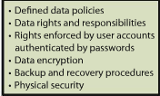

Human safeguards to protect against security threats:
- Involve the people and procedures components of information systems
- Human safeguards result when the authorized user follow appropriate procedures for system use and recovery

Human safeguards for Employees

- Position Definitions
  - Creating definitions of job tasks and responsibilities
  - Job descriptions should provide a separation of duties and authorities
  - User accounts should be given the least possible privilege needed to perform their jobs
  - The security sensitivity should be documented for each position
  - Documenting position sensitivity enables security personnel to prioritize their activities in accordance with the possible risk and loss
- Hiring and Screening
  - Security considerations should be part of the hiring process
- Dissemination and Enforcement
  - Three independent factors
    - Responsibility – security responsibilities
    - Accountability – what employees are help accountable for
    - Compliance – encourage security compliance with employees
- Termination
  - Companies must establish security policies and procedures for the termination of employees
    - Removing clearance after they are fired
    - Changing passwords and ID (system admin must be notified when an employee is let go)
Human Safeguards for Non-employees
- Screening Process
- Public users can not be screened
  - The best safeguard from public users is to harden the website
  - Hardening a site means to take extraordinary measures to reduce the systems vulnerability
    - Uses special versions of the operating system and lock down or eliminate (OS) features and functions that are not required by the applications
Account Management
- Concerns the creation of new user accounts, the modification of existing account permission, and the removal of unneeded accounts.

Password Management
- Contains seven or more characters
- Does not contain username, real name, or company name
- No real full words
- Different from previous passwords used
- Contains both upper and lower case, and special characters
- Password Etiquette
  - Protect your password

Help Desk Policies
- Used to retrieve lost or forgotten passwords, usernames etc
  - Can be a security risk because the front desk does not know if they are talking to the right person or not if asked for private information
  - The front desk rep most ask very personal questions in order to determine the real user
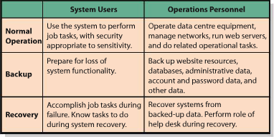

System Procedure
- Normal operations
- Backup
- Recovery
  - Develop procedures for each of these processes to maintain a secure system
Security Monitoring
- The last of the human safeguards
- Activity log analysis, security testing, investigating and learning from security incidents
Disaster Preparedness
- Place infrastructure in safe areas (away from possibility of flood, earthquakes, hurricanes etc)
- Hot Sites – remote processing centers run by commercial disaster-recovery service.
- Cold Sites – provide office space, but the customers themselves provide and install the equipment needed to continue operations.
How should You Respond to Security Incidents?


