Databases and Analyzing Data

Using text mining and text managing managers receive reports on detailed customer experiences down to the store level within minutes

data: raw facts that describe the characteristics of an event
information: data converted into a meaningful and useful context
database: maintains information about various types of objects, events, people and places
ex) raw data: shares exchanged in the stock market; information: how did a particular stock perform during the last six months? how did it perform compared to other stocks?

Q1) What is/are the important asset(s) of an organization?
It's capital, people and information

Data is everywhere in an organization
Data have become central and even vital to organizations
Organizations need to manage their data assets very carefully to make sure that the data are easily accessed by managers and employees across the organizations
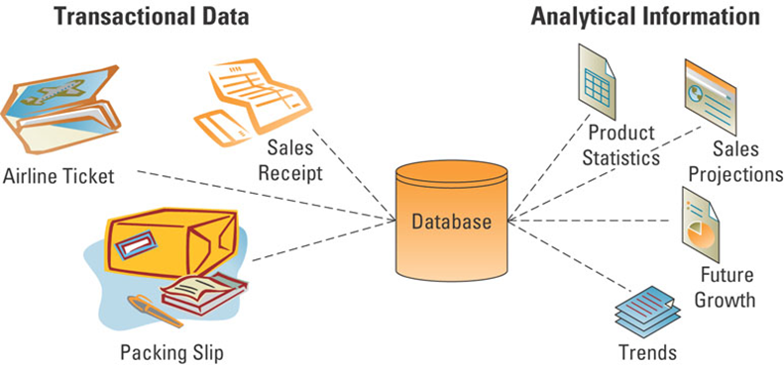

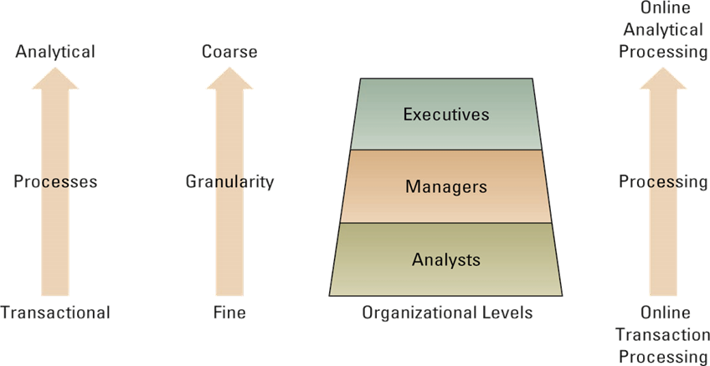
Data management is a structured approach for capturing, storing, processing, integrating, distributing, securing and archiving effectively throughout their lifecycle.
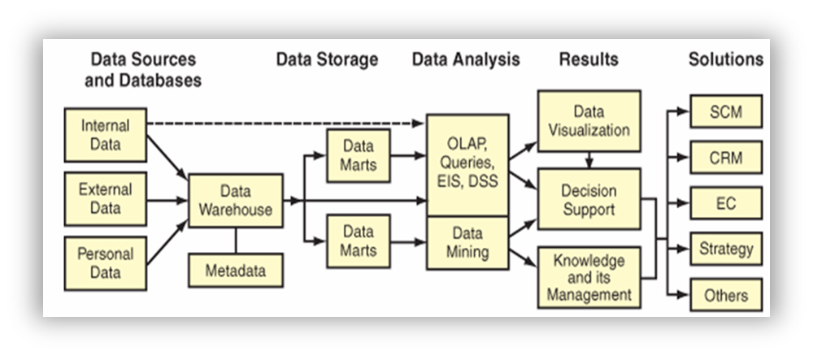
Data Principles
- diminishing data value~older the data gets, the less value
- 90/90 data use~90% of data is used in the first 90 days
- data in context

Q2) Which one of the following statements is NOT correct?
A) Transactional data capture close interactions with customers
B) Executives use Transactional data to make strategic decisions-wrong
C) Transactional data are usually large, and with so many details

Why does data management matter?
no enterprise can be effective without high quality data that is accessible when needed
organizations with at least 1000 knowledge workers lose 5.7 million annually in time waster by employees reformatting data as they move among applications
What is the goal of data management?
to provide the infrastructure and tools to transform raw data into usable information of the highest quality
Challenges
- volume of data is increasing exponentially
- data is scattered throughout the organization
- data is created and used offline without going through quality control checks
- data may be redundant and out-of-date, creating a huge maintenance problem

file: group of records of same type
record: group of related fields
field: group of words or a complete number
byte: group of bits that represents a single character
bit: smallest unit of data, binary unit (0,1)

Traditional (stand-alone) File Environment
- When organizations began using computers, they started with one application at a time, usually accounting, billing, and payroll. Each app was designed to be a stand-alone system, which led to data problems
- problems: duplicate information. call one department to change phone number, and then only one department knows of the new change. the department is living in isolation
Data isolation: information cannot flow freely across different functional areas or parts of the organization
poor security: management may have no knowledge of who is accessing or making changes to the organizations’ data

Database Management System
- a software package to create and maintain databases
- acts as interface between application programs and physical data files
- separates logical and physical views of data
Many data sources
- clickstream data from Web and e-commerce applications
- detailed data from POS terminals
- filtered data from CRM, supply chain, and enterprise resource planning applications
DBMS permits an organization to centralize data, manage them efficiently, and give applixation programs access to the stored data
entity~ a person, place, transaction or event about which information is stored
- the rows in each table contain the entities
entity class (table)~ a collection of similar entities
- CUSTOMER, ORDER, ORDER LINE, DISTRIBUTOR, and PRODUCT entity classes
attributes (fields, columns)~ characteristics or properties or an entity class
- the columns in each table contain the attributes
- customer ID
- customer name
- contact name
- phone
Relational DBMS represents data as two-dimensional tables
relates data based on common data element ex) MS access
Primary Keys and foreign keys identify the various entity classes (tables) in the database
primary: a field (or group of fields) that uniquely identifies a given entity in a table
foreign: a primary key of one table that appears as an attribute in another table and acts to provide a logical relationship between the two tables

SQL; Structured Query Language
example: SELECT part_Number, Part_Description, Unit_Price
FROM PART
WHERE Unit_Price < 25.00
Functions of a Database Management System
data filtering and profiling: inspecting the data from errors, inconsistencies, redundancies, and incomplete information
data quality: correcting, standardizing, and verifying the integrity of the data
data synchronization: integrating, matching or linking data from disparate sources
data enrichment: enhancing data using information from internal and external data sources
data maintenance: checking and controlling data integrity over time

Data Warehouse, Document Management, and Enterprise Content Management

data quality: data is always dirty. There could be missing data incomplete data, inaccurate data, duplicate data, wrong data. This is because there is always some person collecting the data
Data that is incorrect will usually end up causing your business to lose money
Sources of low-quality information include:
- Data or information from different systems have different entry standards and formats
- Call center operators enter abbreviated or erroneous information by accident or to save time
- Third party and external information contains inconsistencies, inaccuracies and errors

Information Cleansing or Scrubbing
- a process that weeds out and fixes or discards inconsistent, incorrect or incomplete information
- standardizing customer name from operational systems

Healthcare Sector
Data errors cost billions of dollars and put lives at risk
- Everyday, healthcare administrators and others throughout the healthcare supply chain waste 24-30% of their time correcting data errors
- Each incorrect transaction costs 60-80 dollars to correct
- Benefits from data synchronization in the healthcare sector and supply chain:
- Easier and faster product sourcing because of accurate and consistent item information
- Significantly reduces the amount of unauthorized purchasing
- Reduces unnecessary inventories
- Lowers prices because purchase volumes become apparent
- Improves patient safety

Data Warehouse
Transactions-> customers + orders + vendors-> data warehouse-> data mining
Transactions enter the enterprise 'database' where they are copied, organized and summarized which then goes into the data warehouse which goes to data mining
characteristics: data is clean, a copy of the transaction
- for organizational learning purposes, data from many sources and over many time periods must be gathered together and organized in a consistent and useful way
- a data warehouse is a copy of transaction data specifically structured for querying, analysis, reporting, and more rigorous data mining
- note that the data warehouse contains a copy of the transactions which are not updated or changed later by the transaction system

- a massive database that store current and historical data
- data are standardized into a common data model
- data warehousing is a data store and a process for bringing together disparate data from throughout an organization for decision-support purposes
- consolidates data for management analysis and decision making

E C T L
Extracting, Cleaning, Transforming, Loading
Data from various sources are extracted, transformed and loaded into a data warehouse; then used to support functions and apps throughout the enterprise
Data Mart
- subset of data warehouse
- contains summarized or highly focused portion of data for a specified business unit or group of users

main components of a data centre: hardware, communication, software
Data Centers
- host and integrate networks, computer systems, and storage devices
- high reliability and availability

Two types of databases:
a) centralized database
b) distributed database with complete or partial copies of the central database in more than one location
distributed: can be decentralized either by partitioning or by replicating
Partitioned database-- parts of the database are stored in different physical locations
Replicated database-- duplicate the entire database at all remote locations

Data Analytics

multidimensional data analysis = “Online Analytical Processing” OLAP
interactive, exploratory analysis of multidimensional data from multiple perspectives using operations such as slice-and-dice, drill-down and aggregate

Cubes are stored in a relational databases (Star Schema)
there are dimension tables, and a central fact table. Each key in the fact table is called a dimension.
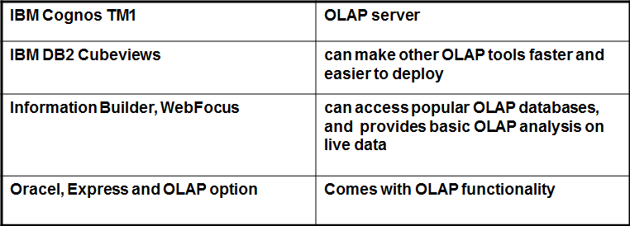
Data Mining
tools for deep down analysis of large pools of data
to find hidden patterns, predict future behavior, to infer rules to guide decision-making
Looking for secret patterns
Data Mining techniques make use of the data in a Data Warehouse
!!!Concern of privacy!!
data mining: uses a variety of techniques to find patterns and relationships in large volumes of information and infers rules that predict future behavior and guide decision making
common forms of analysis:
- classification
- cluster analysis
- association detection
Classification
classes are pre-defined
assign each data point to one class

examples: Grades {A B C D} Customer Credit Assignment {low medium high} medical treatments {critical, noncritical}
Clustering
a technique to divide an information set into mutually exclusive groups such that the members o each group are as close together as possible to one another and the different groups are as far apart as possible
CRM systems depend on cluster analysis to segment customer information and identify behavioral traits

Customer Segmentation
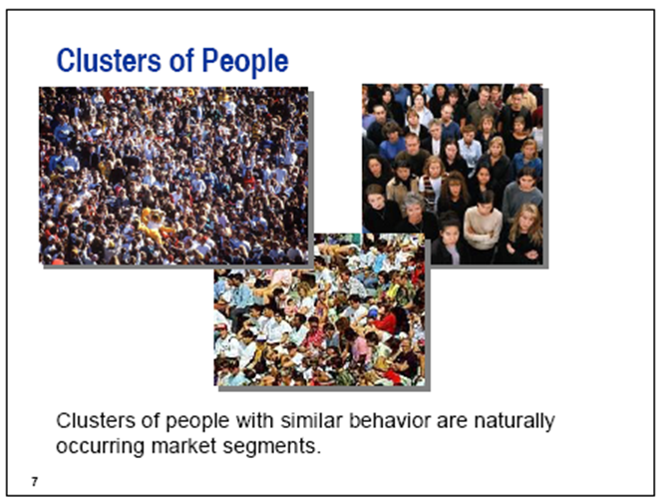
Data Mining and Target Marketing
- exclusion according to geography, age, ability to pay, need for product
- data mining can help in prospecting:
- identifying good prospects
- choosing appropriate communication channels
- picking suitable messages

Data Mining and Customer Relationship Management
matching campaigns to customers
- exclusion according to geography, age, ability to pay
- cross-sell campaign, up-sell campaign, loyalty program
customer segmentation
- finding behavioral segments
reducing exposure to credit risk
- predicting who will default

Association detection: reveals the degree to which variables are related and the nature and frequency of these relationships in the information
market basket analysis: analyzes such items as Web sites and checkout scanner information to detect customers’ buying behaviour and predict future behaviour by identifying affinities among customers’ choices of products and services

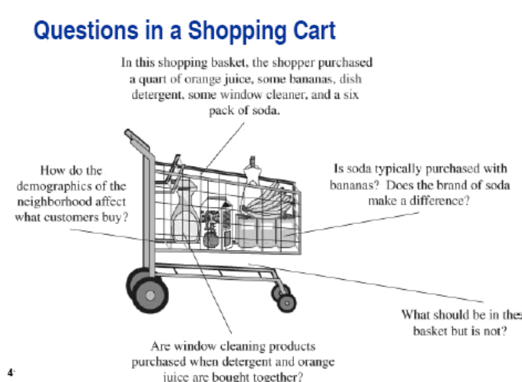

Association Rules at Amazon.com
- a person buys a book at amazon
- task: recommend other books this person is likely to buy
- amazon does a clustering based on books bought
Text Mining
- interpreting words and concepts in context
- discovery of trends and patterns from textual information
- Exploration
word counts, creating topics
- Pre-processing
misspelled words, abbreviations(btw, lvm)
- Modeling
building a decision tree, neural network, etc

examples:
medical records, twitter, social networking, negotiations, contracts, classification of documents

