Module 3: Prof. Raahemi
- Data: raw facts that describe the characteristics of an event. , Data have become central and even vital to organizations, Organizations need to manage their data assets very carefully to make sure that the data are easily accessed by managers and employees across the organization

- Information: data converted into a meaningful and useful context.

Data vs. Information:

- Raw Data:
  - shares exchanged in the stock market
- Information:
  - How did a particular stock perform during the last 6 month?
  - How did it perform compare to other stocks?

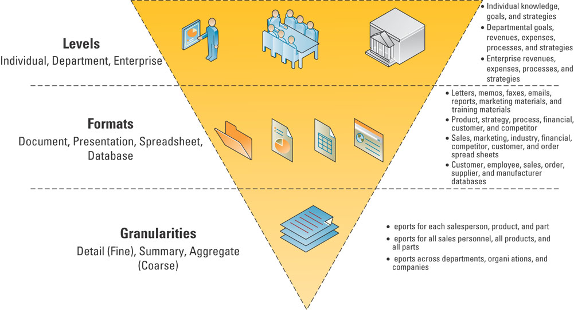
- Database – maintains information about various types of objects (inventory), events (transactions), people (employees), and places (warehouses)

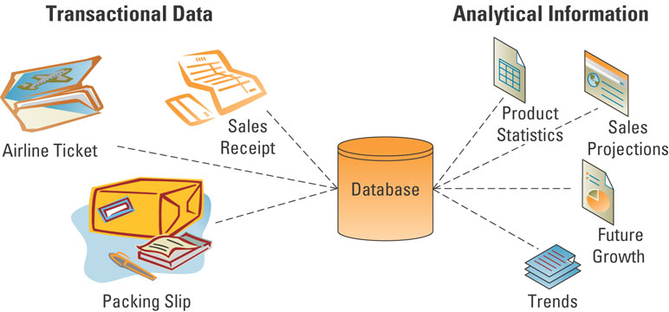

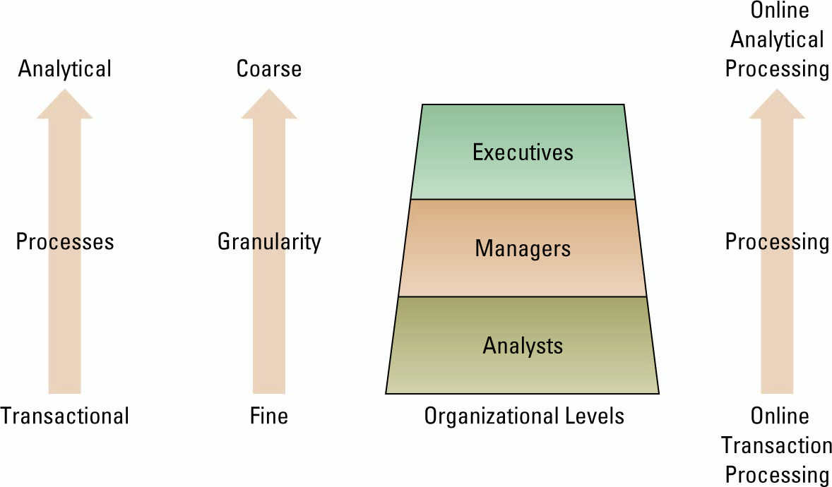

Traditional File Organization
- File: Group of records of same type
- Record: Group of related fields
- Field: Group of words or a complete number
- Byte: Group of bits that represents a single character
- Bit: Smallest unit of data; binary digit (0,1)

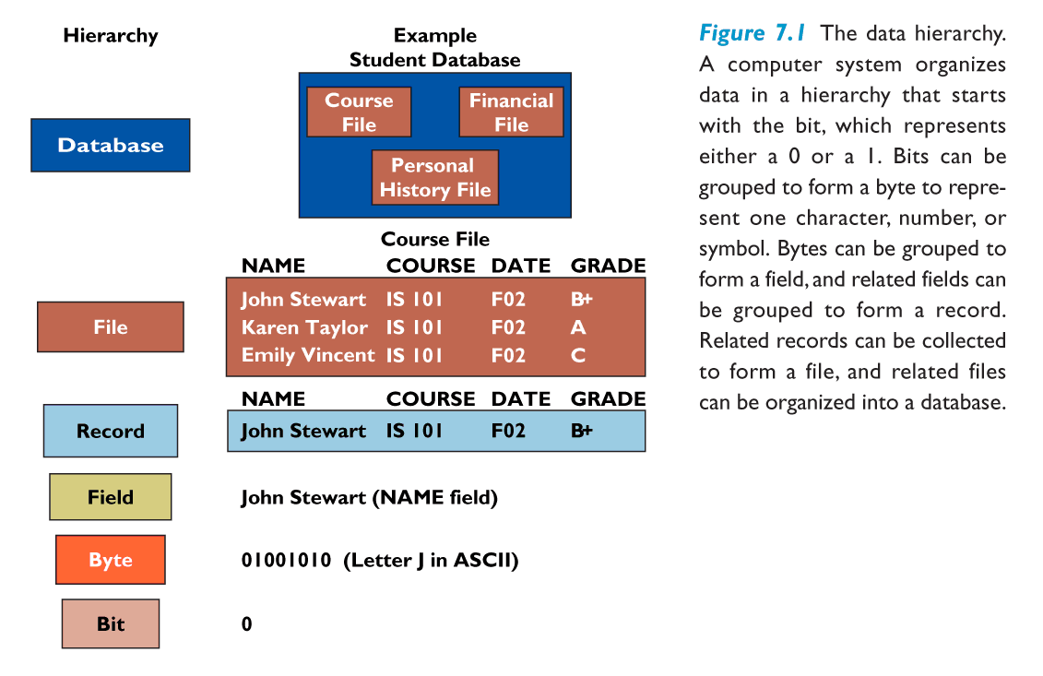

- Database: Group of related files
- Entity: Person, place, thing, event about which information is maintained
- Attribute: Description of a particular entity
- Key Field: Identifier field used to retrieve, update, sort a record

The Value of Quality Data and Information:
- Some sources of low-quality information include:
- Online customers intentionally enter inaccurate information to protect their privacy
- Data or information from different systems have different entry standards and formats
- Call centre operators enter abbreviated or erroneous information by accident or to save time
- Third party and external information contains inconsistencies, inaccuracies, and errors

Problems with Traditional File Organization:
- Data redundancy:
- The presence of duplicate data in multiple data files so that the same data are stored in more than one place or location
  - Data inconsistency:
- The same attribute may have different values.
- Program-Data Dependence:
  - The coupling of data stored in files and the specific programs
  - changes in programs require changes to the data
  - Lack of Flexibility
  - A traditional file system cannot deliver ad-hoc reports or respond to unanticipated information requirements in a timely fashion
- Poor security
  - Management may have no knowledge of who is accessing or making changes to the organization’s data
  - Lack of data sharing and availability
- Information cannot flow freely across different functional areas or different parts of the organization

Understanding the Costs of Poor Information
  - Inability to accurately track customers
  - Difficulty identifying valuable customers
  - Inability to identify selling opportunities
  - Marketing to nonexistent customers
  - Difficulty tracking revenue due to inaccurate invoices
  - Inability to build strong customer relationships

The Database Approach
- Database
A collection of data organized to serve many applications efficiently by centralizing data and controlling redundant data

- The Database Management System (DBMS)
  - A software package to create and maintain databases
  - Acts as interface between application programs and physical data files
  - Separates logical and physical views of data

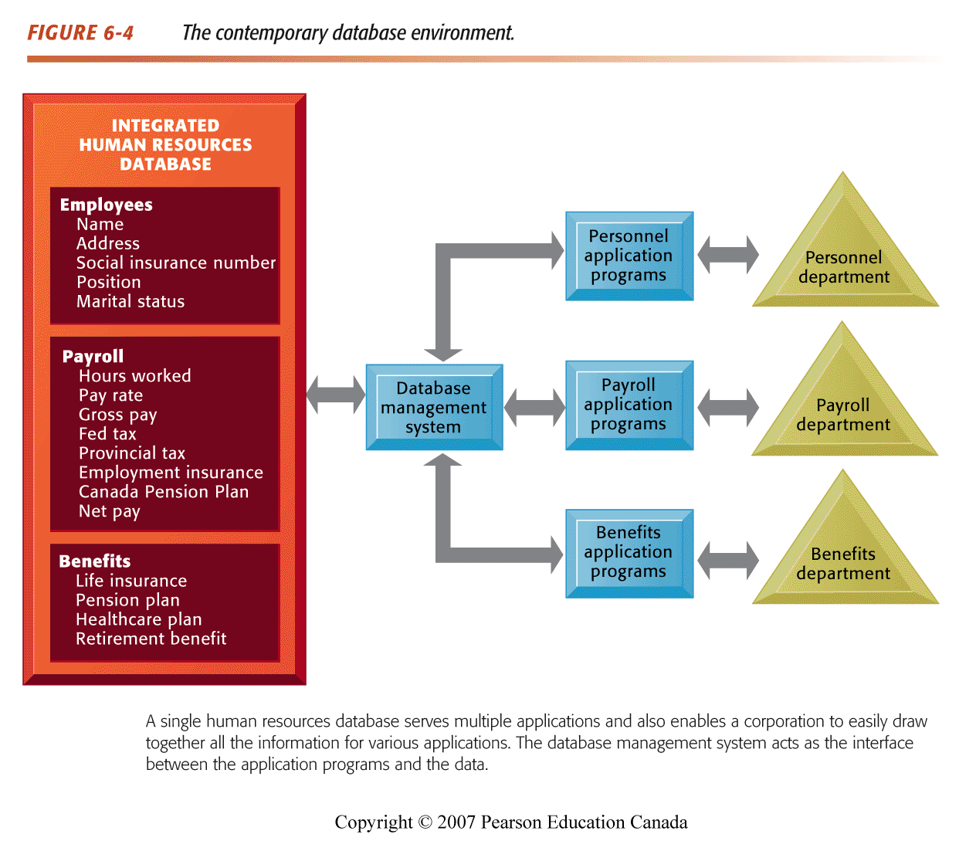
Types of Databases:
- Relational DBMS
Represents data as two-dimensional tables
Relates data across tables based on common data element
Examples of Relational DBMS: DB2, Oracle, MS SQL Server
Definitions:
- Entity – a person, place, thing, transaction, or event about which information is stored
  - The rows in each table contain the entities
- Entity class (table) – a collection of similar entities
  - CUSTOMER, ORDER, ORDER LINE, DISTRIBUTOR, and PRODUCT entity classes
- Attributes (fields, columns) – characteristics or properties of an entity class
  - The columns in each table contain the attributes
    - Customer ID
    - Customer Name
    - Contact Name
    - Phone
- Primary keys and foreign keys identify the various entity classes (tables) in the database
  - Primary key – a field (or group of fields) that uniquely identifies a given entity in a table
  - Foreign key – a primary key of one table that appears as an attribute in another table and acts to provide a logical relationship between the two tables

Three Basic Operations in a Relational DBMS
- Select: Creates subset of rows that meet specific criteria
- Join: Combines relational tables to provide users with information
- Project: Enables users to create new tables containing only relevant information

- Hierarchical and Network DBMS
Hierachical:
  - Organizes data in a tree-like structure
  - Supports one-to-many parent-child relationships
  - Commonly used in large legacy systems
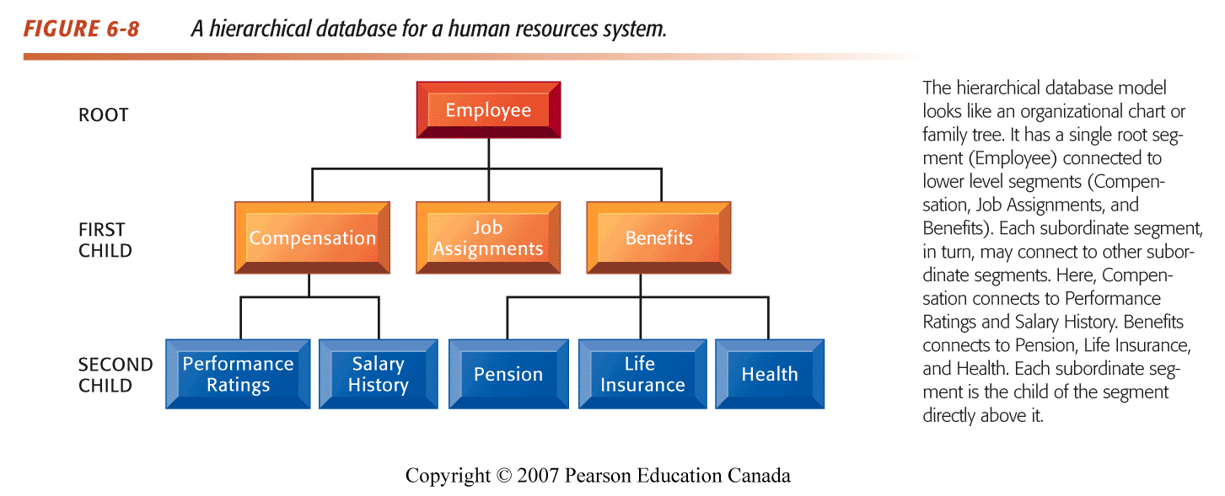

Network:
  - Logical many-to-many relationships between Data
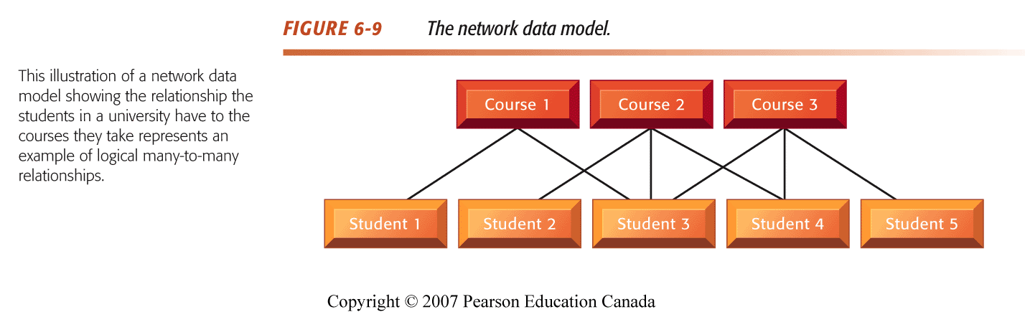
- Disadvantages of Hierarchical and Network DBMS
- Outdated, not used for new applications
- Less flexible than Relational DBMS
- Lack support for ad-hoc and English language-like queries

- Object-Oriented Databases
- Object-Oriented DBMS (OODBMS)
  - Stores data and procedures as objects that can be retrieved and shared automatically
  - The objects can contain multimedia
  - Hybrid OODBMS
  - combine benefits of relational and object-oriented DBMS

Designing Databases:
- Conceptual design:
Abstract model of database from a business perspective
- Physical design:
Detailed description of business information needs
- Entity-relationship diagram:
Methodology for documenting databases illustrating relationships between database entities
- Normalization:
Process of creating small stable data structures from complex groups of data
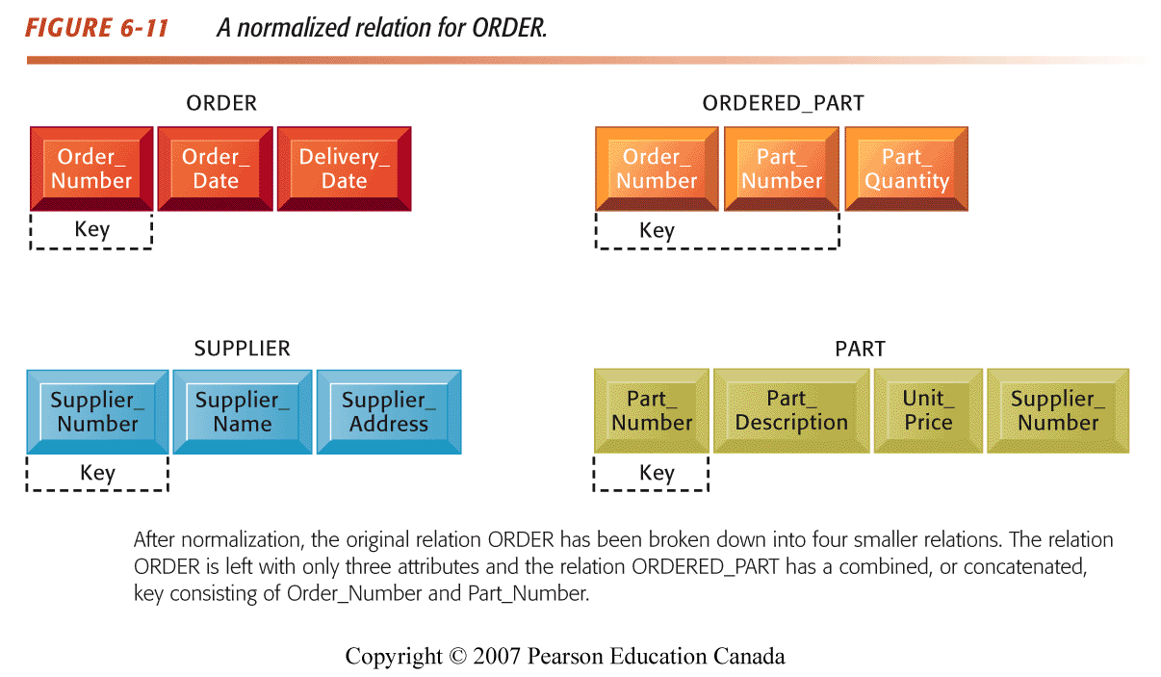

Distributed Database
- A database that is stored in more than one physical location
- Reduce the vulnerability of a single, massive central site
- Increase service and responsiveness to local users
- Can be decentralized either by partitioning or by replicating
- Partitioned database:
  - Parts of the database are stored in different physical locations
- Replicated database:
  - Duplicate the entire database at all remote locations
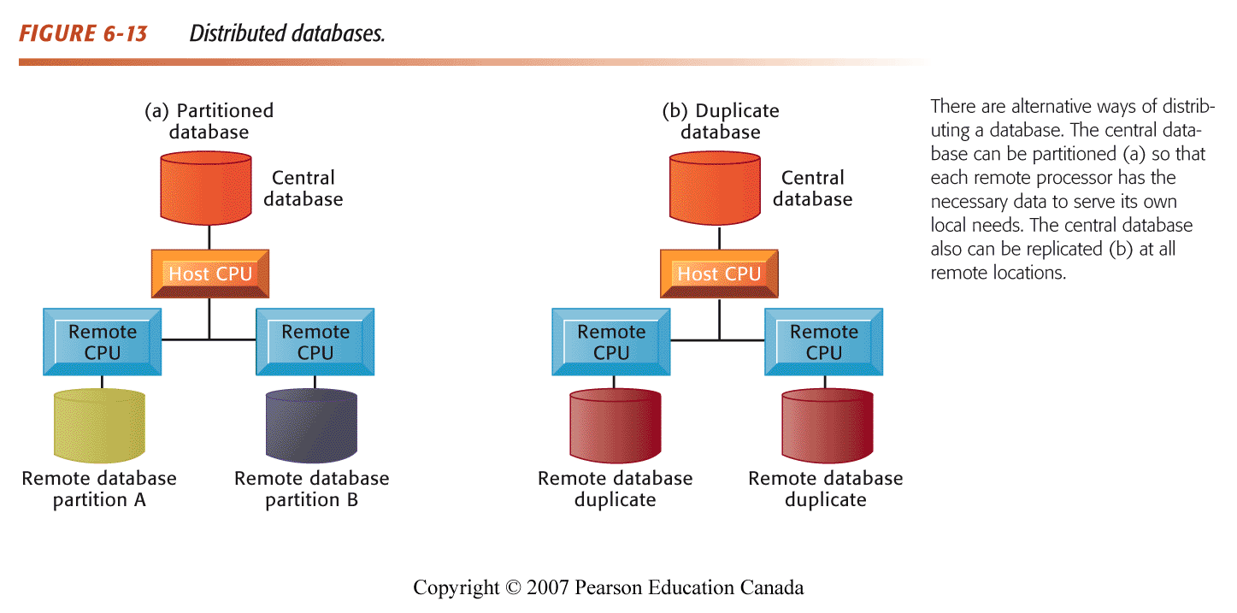

Ensuring Data Quality
- Data Quality Audit: Structured survey of the accuracy and level of completeness of the data in an information system
- Data Cleansing: Consists of activities for detecting and correcting data in a database or file that are incorrect, incomplete, improperly formatted, or redundant

Data Warehouse
- A data warehouse is a copy of transaction data specifically structured for querying, analysis, reporting, and more rigorous data mining

- A massive database that store current and historical data
- Data are standardized into a common data model
- Consolidates data for management analysis and decision making
Data Warehouse:
- Data warehousing is a data store (eg., a database of some sort) and a process for bringing together disparate data from throughout an organization for decision-support purposes.
- Relational Database Management Systems (RDBMS), such as Oracle, DB2, SQL Server are often used for data warehousing.
Data Warehouse Fundamentals:
- Extraction, transformation, and loading (ETL) – a process that extracts information from internal and external databases, transforms the information using a common set of enterprise definitions, and loads the information into a data warehouse
- Data mart – contains a subset of data warehouse information

Data Mart:
- Contains summarized or highly focused portion of data for a specified business unit or group of users

- Information cleansing or scrubbing – a process that weeds out and fixes or discards inconsistent, incorrect, or incomplete information

Multidimensional Data Analysis
- Interactive, exploratory analysis of multidimensional data from multiple dimensions/perspectives

Hypermedia Database
  - Organizes data as network of nodes
  - Supports text, graphics, sound, video and executable programs
  - Links nodes in pattern specified by user

Linking Internal Databases to the Web
- Database Server
  - Computer in a client/server environment runs a DBMS to process SQL statements and perform database management tasks
- Application Server
  - Software handling all application operations
- More and more businesses are using Web based database (convenient, user-friendly, compatible with multiple platforms)

Data Mining:

- Tools for deep down analysis of large pools of data
  - To find hidden patters
  - To predict future behavior
  - To infer rules to guide decision-making

- Common forms of data-mining analysis capabilities include:
  - Cluster analysis
- Cluster analysis – a technique used to divide an information set into mutually exclusive groups such that the members of each group are as close together as possible to one another and the different groups are as far apart as possible

  - Classification
Classes are pre-defined
Assgn each data point to one class

Association detection
- Association detection – reveals the degree to which variables are related and the nature and frequency of these relationships in the information
  - Market basket analysis – analyzes such items as Web sites and checkout scanner information to detect customers’ buying behaviour and predict future behaviour by identifying affinities among customers’ choices of products and services

- Data mining can help in prospecting:
  - Identifying good prospects
  - Choosing appropriate communication channels
Picking suitable messages

Data Mining and Customer relationship Management
- Matching campaigns to customers
  - Marketing does not stop once customers have been acquired
  - Cross-sell campaign, up-sell campaign, loyalty program
- Customer Segmentation
  - Finding behavioral segments use undirected clustering techniques
- Reducing exposure to credit risk
  - Learning to avoid bad customers
  - Predicting who will default
- Business intelligence – information that people use to support their decision-making efforts
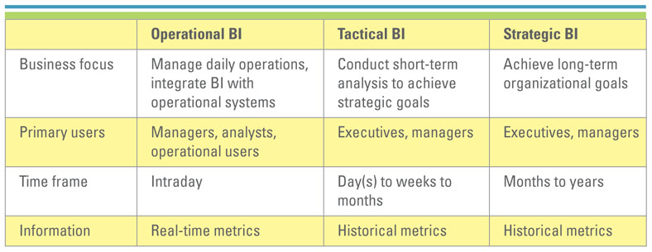

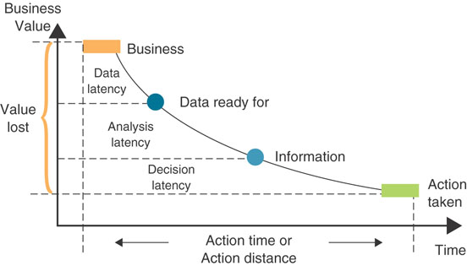

Management Opportunities and Challenges
Opportunities
- Organizational performance can be improved by making better use of data
  - Investments in data mining and customer relationship management technology
Challenges
- Organizational obstacles to a database environment
  - Need cooperation to develop corporate-wide data administration
- Cost/benefit considerations
  - Significant change in the database environment of a firm can be very expensive and time consuming

