Unit 1: Deviance, Normality, and Social Control
What is deviance?
In statistical terms:
-statistical rarity (statistically unusual)
-deviant behaviour/people defined by their rarity
-statistical definitions of deviance make it difficult to distinguish between “negative” deviance and “positive” deviance
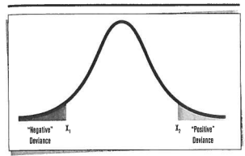
As Harmful:
-we equate deviant action with action that produces destructive outcomes
-ex: murderers, thieves, liars, sexual abusers, etc.
-BUT many people who are deviant aren’t harmful
-ex: mentally delayed, mentally ill, genius, gays
-outside of mainstream ≠ harmful
-things that aren’t considered deviant can be harmful
-ex: greedy motherfuckers on Wall Street
Deviance as a Social Concept
-deviance = product of social interaction and group structure
-study of deviance = study of people, behaviours and conditions that are subject to social control
-social control various and myriad ways in which members of social groups express their disapproval of people and behaviour
-ex: name-calling, ridicule, ostracism, incarceration, killing, etc.
-deviance = ways of acting/being that elicit moral condemnation
-context is important (historical period, country, place)
-ex: woman driving in Saudi Arabia = deviant … woman driving in Canada = normal
-objective character of deviance particular ways of thinking, acting, and being
-subjective character of deviance moral status accorded such thoughts, actions, and characteristics
-to be deemed deviant, a particular behaviour must hold the potential for being called deviant (be unusual or rare) and also must be labelled as “deviant” by powerful others who are willing to use the labels
-the ability of some in society to use resources in order to resist the efforts of others to consider them deviant is also of sociological interest
-ex: corporations that undermine economic well-being of many in society define themselves
as moral corporate citizens through donations to universities and hospitals, etc.
Researching Deviance
-experiments, surveys, content analyses, field research
-many problems arise when trying to study deviance
Secrecy:
-people want to keep their deviant behaviour secret to protect themselves from social reactions
-how to do research without intruding excessively into the lives of subjects?
-research can:
-gain confidence of subject by posing as one who shares their deviant status ETHICAL DILEMMAS
Discovery of Reportable Behaviour:
-if subjects reveal information about illegal or harmful circumstances, does the researcher have an obligation to report it?
-on one hand: researcher has professional obligation to respect confidentiality
-on the other hand: one has a social and moral obligation to protect safety of the public,
including the subject
Safety:
-researchers should take no action that could result in harm to those who participate in the research
-emotional, mental, economic, physical harm
-many ways in which research could produce harmful outcomes
-ex: study about women who are abused by their spouse, researcher could call while the husband is nearby
-must train interviewers to be sensitive to cues that the respondent might be under some immediate stress
-research involves looking into the lives of the most vulnerable members of society
-ex: poor, homeless, etc
-findings can often be used against these vulnerable groups especially when you don’t take time to qualify conclusions or suggest appropriate interpretations of evidence
The Sociology of Deviant Behaviour
-deviance is viewed by most as wrong, immoral, disreputable, bizarre, or unusual
-Objective dimension of deviance refers to the behaviour or condition itself
-Subjective dimension of deviance refers to the placement of that condition by members of society in their moral stratification (levels)
Areas that are the focus of theoretical attention in sociology of deviance:
-1) causes and forms of deviant behaviour
-2) content and character of moral definitions
-3) issues that arise over labels of deviance
-**Why do deviants do what they do?** important question!!
-this question contains a number of important assumptions
-1) implies that most of us share a conformist view of the world (why do “they” refuse to act the way “we” act?)
-2) the moral status of deviant behaviour is never called into question
-3) society is a pretty stable and orderly place and there is widespread agreement about what is right and what is wrong
-mostly functionalist perspectives
-3 dominant ways of thinking about “why they do it”
-strain theory
-cultural support theory
-control theory
Strain Theory
Theory:
-Robert Merton
-sought to understand why so many types of non-conformity are much more pervasive among members of the lower social classes
-ex: crime, delinquency, drug addiction, alcoholism, etc
-these things are more of a problem as you go down the socio-economic structure
Arguments:
-argued that the answer was because there is a lack of fit between the cultural goals people are encouraged to seek and the means available to pursue these goals creates a social strain to which deviant behaviour is an adjustment
-class barriers plays a role in social life
-ex: stealing attempting to use “illegitimate means” to achieve success
-ex: drugs pulled out of the competition for stratification outcomes
-juvenile crime is prompted by the inability of lower-class youth to achieve the things that heir culture encourages them to seek
Criticisms:
-proceeds from the assumption that the distribution of crime and deviance that we find in officials stats is accurate (may not be)
-does not extend argument to explain how crime and deviance occur in middle- and upper-class
Findings:
-different types of deviance in different neighourhoods WHY?
-3 kinds of delinquent adaptations
-1) criminal pattern characterized by instrumental delinquency activities, particularly for gain, in which
they seek to generate illegal profits
-ex: drug dealing, theft, etc
-2) conflict pattern characterized by the presence of “fighting gangs” who battle over turn and
neighbourhood boundaries
-3) retreatist pattern organized around the acquisition and use of hard drugs
More Recent Version of Strain Theory:
-theorizes that the inability to achieve the things we want in life is only one type of socially induced strain
-2nd source of strain inability to avoid or escape some negative condition
-ex: abusive parents, bullying
-3rd source of strain results from when individuals lose something that they value
-ex: child forced to move and leave important friendships

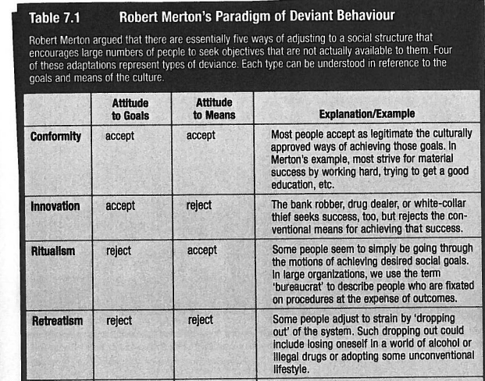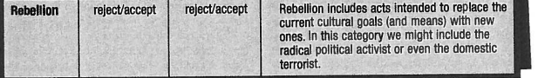
Cultural Support Theory
Theory:
-Sutherland
-focuses on the way patterns of cultural beliefs create and sustain deviant behaviour
-according to this, people behave in ways that reflect the cultural values to which they have been exposed and that they have internalized
-if conventional values support conventional behaviour, it should follow that deviant values support deviant behaviour
-ex: binge drinking is deviant but it is valued as being a sign of masculinity and group conformity among
young men
-tries to understand how cultural meanings people associate with deviant conduct make that conduct more likely
-supposes that people become deviant because they have been exposed to learning experiences that make deivane more likely
-result of exposure to influencial learning experiences
-people become deviant because they have learned in the context of interpersonal relationships how to become deviant
-explains corporate crime culture of competition that legtimizes wrong-doing
What does learning to be deviant involve:
-learning of specific direction of drives, motives, attitudes, and rationalizations
-we must learn to think about deviant conduct as acceptable to ourselves
-ex: why do we not kill people when we’re mad? Because it is morally unacceptable to us.
-helps us to understand how people come to value actions that the rest of society despises
Complications:
-we live in a society that seems to simultaneously condemn and support deviant behaviour
-we have learned to define deviant situations as ones to which rules don’t apply
-ex: everyone thinks stealing is wrong however you might steal at work because you’re underpaid and “you
deserve it” (rules don’t apply in this situation)
Criticisms:
-arguments that use culture to explain deviance employ circular reasoning
-ex: if we observe people stealing and then infer that they have come to acquire values that are supportive
of stealing and that these values explain the stealing we have reasoned in a circle and haven’t explained
anything at all
Control Theory
Theory:
-people lie, cheat, steal, take drugs, or engage in sexual excess when and if they are free to do so
-lying and cheating can be efficient ways of getting what we want in life
-experimenting with drugs and sexual promiscuity can be more fun than working or studying
-important question is not “Why do some people break rules the rest of us abide by?” the right question is “Why don’t more of us engage in “forbidden” behaviour?
-deviant behaviour occurs wherever it is allowed to occur
-thus, we can expect to find deviance when social controls that are supposed to prevent it are weak or broken
-deviance is not a special kind of behaviour that requires a special kind of motivation
-rather it is behaviour that results from the absence of pressures that would constrain deviance
Suicide:
-Durkheim
-sought to explain why some groups in society have higher rates of suicide and why suicide rates vary over time
-Catholics lower suicide rates that Protestants
-married lower than singles
-increase in times of economic boom and economic depression
-WHY? social control
-social control forces us to take others into account and discourages behaviours that are extremely individualistic
-Catholics have more social control (mandatory church attendance, confession, etc)
-married = more external regulation (obligations, duties, etc)
-periods of boom and depression throw large #s of people outside of their customary social grooves and disconnect them from social regulations
-suicide is more likely when people are left to their own resources
Youthful Offenders:
-each of us has a bond or connection to the world of conventional others
-in the case of youth, the world of conventional others parents, teachers, members of legitimate adult community, etc.
-if youthful bonds to conventional others are strong, youths need to take others into account when they act
-if youthful bonds to conventional others are weak free to act in ways that reflect self interest
-weak bond = more deviance and crime = self interested behaviour
Crime:
-crimes of all types tend to be committed by people who are impulsive, short-short sighted, risk takers, etc
-low self-control** more likely to commit crime or other deviant acts
-low self-control originates from bad child-rearing
Criticisms:
-assumption that motivation is essentially irrelevant to the study of crime and deviance
-theory inadequate in explaining why those members of society whose bonds to the conventional world seem strongest also engage in prohibited acts
The Transactional Character of Deviance
-the three theories focus on the INDIVIDUAL
-other sociologists want us to look at deviant behaviour as an INTERACTIONAL PRODUCT
-deviant behavior as a JOINT or collective, rather than individual, outcome
Example: Murder
-murder can be understood as a situated transaction in many cases
-some murders may not be seen as an individual act but rather as an interaction sequence in which the participants (eventual murderer, eventual victim, audience) interact in a common physical territory
-concludes that murders move through 6 common stages:
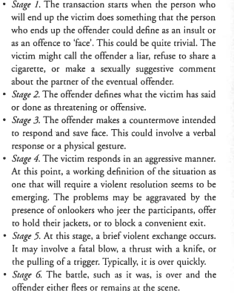
-this shows that acts of deviance can be quite complex and can involve significant interactional dimensions
-can be useful to think of murder, theft, etc as “social events” rather than acts of individuals in isolation
-social event implies that events involve more than what the killer does; also depends on what bystanders do, whether the victims are alone/with friends, how quickly police/paramedics arrive, etc.
Making Sense of the Facts of Deviant Behaviour
-deviant acts are not randomly distributed in the population
-people with certain social and demographic characteristics are more likely to be involved in deviant behaviour than others
-**why are there different levels of involvement?**
Gender:
-males more likely to do deviant acts
-males more likely to be involved in criminal behaviour (except prostitution!)
-males more likely to do violent crimes
-crime is male dominated
-males more likely to do drugs/drink
-males more likely to commit suicide (more likely to use guns or explosives)
-rates of mental illness not very diff between men and women
-women more likely to have depression/anxiety
-men more likely to have addiction and psychosis
-deviance that affects women: intimate violence (abusive partner), sexual harassment

Age:
-crime highest during late teens/early adulthood
-decline sharply after that
-young husbands more likely than older husbands to beat wives
-white collar crimes (fraud, cheating on taxes) go up later in life
-alcohol and drug use more among young people
-suicide rates lower for young people in Canada
-onset of mental illness: adolescence and young adulthood
Class and Ethnicity:
-poorer people and minority groups more likely to be involved in many forms of crime and delinquency, to use drugs and alcohol, and to develop various kinds of mental illnesses
-explanation clear using strain theory
-consensus does not exist regarding how concepts such as poverty, economic inequality, ethnicity, or minority group status should be measured for research purposes
-less consistency in research findings for this
-some studies say working class youth are more likely to be delinquent; other studies tell us the opposite
-minority group status related to higher rates of crime in some cases (ex: First Nations people) it seems to be related to lower rats of crime in others (ex: Asian immigrants)
-are poorer or minority people more likely to be deviant or are they just more lily to get caught and be labelled as “deviant”?
-do our definitions of what constitute crime and deviance reflect class biases? (ex: false advertising, embezzlement, vs. robbery, theft)
The Sociology of Deviant Categories
-on a daily basis we treat distinction between deviance/non-deviance as common sense
-social constructionism acts and people are not inherently deviant but are defined as such by those in society with the power to do so
-how do we make the moral distinctions we make?
-social condemnation changes over time
-things deviant in the past are not deviant in the present
-ex: having a child outside of marriage
-there are things that used to be tolerated that are now deviant
-ex: cigarette smoking
Devianace as a Claims-Making Process
-what are distinctions that members of a society make beween what is and is not deviant?
-social constructionist writers call this “claims-making process”
-refers to the process by which groups assert grievances about the troublesome character of “other” people or their behaviours
-involves the promotion of a particular moral vision of social life
-claims-making is anything anybody does to propogate a view of who or what is deivnat and what needs to be done about it
-ex: protestors marching tohave the police do something about local crime
3 Broad Objectives of Claims-Making:
-1) publicizing the problematic character of the people with the behaviour in question
-trying to convice why they are troublesome
-dangerous? irresponsible? contagious behaviour?
-2) shaping a particular view of the problem
-claims-makers want to convince us that certain people are a problem and that they are a problem of a
particular problem
-ex: problem drinking can be seen as a sin (religious problem), can be seen as a crime (legal
problem), can be seen as a sickness (medical problem)
-different constructions = different implications for what we need to do about the deviant person (punish?
help?)
-3) building consensus around the new moral category
-claims-makers want to build widespread agreement about the correctness of a particular moral vision
-done by winning support of media, officialdom, and general public THIS IS WHAT MAKES IT
“COMMON SENSE”
Who Are Claims-Makers?
-moral entrepreneur those who discover and attempt to publicize deviant conditions; crusading reformers whoa re disturbed by some evil that they see in the world and who will not rest until something is done to correct it
-ex: MAAD emotional reason
-lawmakers, journalists, daytime talk show hosts, etc emotionally removed from reason
What Are Claims?
-the actual message content that conveys a moral vision of deviance and non-deviance
-rhetorical communication
-things people say to persuade audiences (ex: stats, use emotionally compelling examples, link emergent concernt to problems already in the public agenda)
-can demonstrate the gravity of a problem
Deviance Ownership
-how a problem is framed determines who will be responsible for repsonding to or dealwing with the problem
-ex: if drinking is a medical problem, we turn to doctors and psychiatrists
-we tend to think about deviant solutions with medicalization
-we think many behaviours are forms of medical disorder and require treatment, not punishment
-implies individuals are not entirely to blame for their behaviour
-medical models imply these problems occur because people “get sick” not because social structural conditions make some kinds of behaviours more likely
-shifts some of the responsibility off the individual and onto society in general
Deviance and Social Conflict
-disagreements in society regarding who or what should be seen as deviant
-ex: abortion, gay marriage, legalization or marijuana
-conservative conflict theory vs. radical conflict theory
Conservative Conflict Theory:
-societies need strong elites to rule and maintain order
-democracy makes this tougher
-various ways to keep the masses malleable and continue to rule
-there are the “haves” (bourgeoisie) and the “have-nots” (proletariat) and the haves try to maintiain their status and keep the others down
Radical Conflict Theory:
-views economic organization of society as key to understanding moral stratification
-social construction of deivance reflects the economic realities of capitalism and class exploitation
-capitalism requires some people be exploited and have low wages
-there will always be more workers than jobs (unemployment)
-the poor people will be at greater risk of criminal involvement and of being labelled as criminal
The Sociology of Deviant Stigma
-focuses on the social interaction between those who have social control and those who are thought of as deviant
The Process of Labelling
-people come to be seen as deviant because of what others believe they have done or because of what others believe them to be
-labels of deviant charged with a great deal of emotion
-indicate the person’s identity
-master status assignment of stigma
-label of deviant overrides all other status considerations
-ex: being known as a muderer trumps all other characteristics of a person; you are a murderer 1st
-status degradation ceremony refers to the rituals during which the status of “deviant” is conferred
-publically and officially acknowledge a shift in the social rols and the emergence of a new identity
-ex: incompetency hearings, psychiatric examinations, courtroom trials
-we don’t have ceremonies to move people out of being deviant and back to being normal
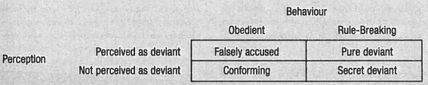
Resistance to Labelling:
-having a legal team that argues that you’re not guilty (not deviant)
-evasion don’t get caught and you won’t be labelled
-performance intended to neutralize the efforts to impose a deviant designation
-ex: crying when being pulled over by a cop and saying you’re sorry
-disclaimer mannerisms actions intended to signal to agents of social control that they are not the appropriate targets of deviant attribution
Deviant Careers and Deviant Identities
-one potential consequence of the labelling process deviancy amplification
-the ironic situation in which the very attempt to control deviance makes deviance more likely
-primary deviance deviance in which we all engage from time to time and has no real consequence for how we see ourselves or how others might see us
-ex: we all lie from time to time
-secondary deviance marked by a life organized around deviance
-ex: being a thief
-what sometimes turns primary deviance into secondary deviance? societal reaction
-the ways in which agents of social control respond to initial acts of deviance (stereotyping, rejection, degradation of status) can actually make future deviance more likely
-transformation of the self
-individuals who are constantly stigmatized may come to accept others’ definition of their deviant identity and see themselves as others ee them
-more likely to behave in ways consistent with the label of “deviant”
-individuals become committed to a life of deivance because others have expected them to
-deviance becomes self-fulfilling prophecy
Managing Stigma
-how do people manage the labels of “deviant”?
Disreditable:
-discreditable people who might become discredited if knowledge about their stigma were to become public
-control information others have about them
-may face constant worry about people rejecting them if they knew
-may attempt to pass assume identit other than that which they might be stigmatized
-ex: gay man might stay in the closet and pretend to be straight
Discredited:
-discredited stigma is evident or can be assumed to be known
-stigma is apparent so no need to keep secret
-restrict its relevance to the ways others tream them
-purification individual attempts to convince others that he has left a deviant identity behind
-ex: tell others you have become religious or “finally grown up”
-collective form of stigma management indiviuals who are bearers of the stigma may join together to form some sort of association intent on changing the public perceptions of their disvalued character
-organizations intented to “undeviantize” behaviour
-ex: National Organization for the Reform of Marijuana Laws (NORML)
Conclusion
-deviance can be thought of as having 2 dimensions : objective and subjective
-objective behaviour, condition, or cognitive style itself
-subjective collective understanding of the behaviour, condition or cognitive style as being disreputable
-must consider both objective and subjective elements

