Lecture 5: Energy & Thermodynamics

Energy
- Capacity to do work
- Kinetic
  - Energy possessed by an object because it is in motion
- Potential/Chemical Potential
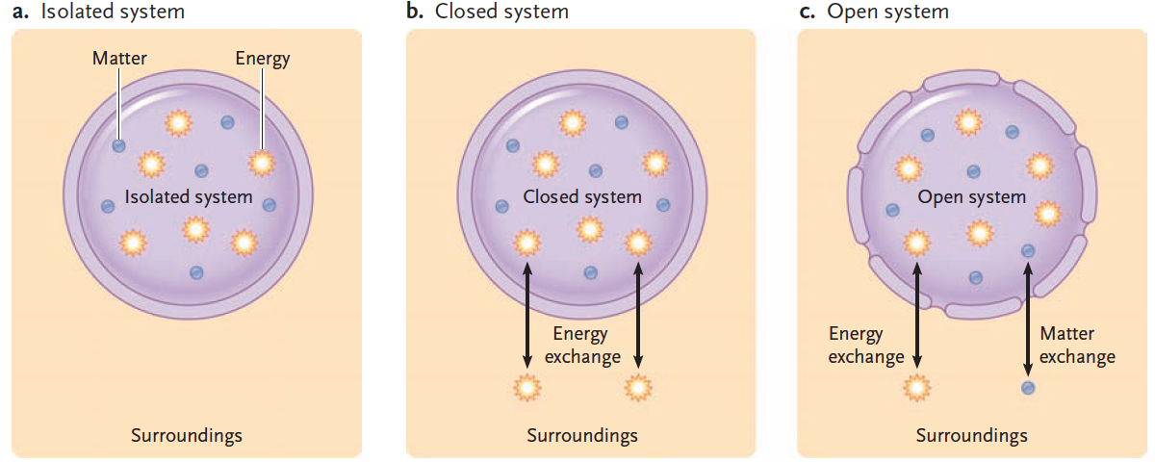
  - Stored energy: the energy an object has because of its location or chemical structure

Thermodynamics
- Study of energy and its transformations
- System
  - Object being studied
  - Three Types
    - Isolated System
      - Does not exchanged matter or energy with surroundings
      - Ex. Insulated thermos bottle
    - Closed System
      - Can exchange energy but not matter with surroundings
      - Ex. Earth
    - Open System
      - Both matter and energy can move freely between system and surroundings
      - Ex. Anything living
- Surroundings
  - Everything outside the system

First Law of Thermodynamics
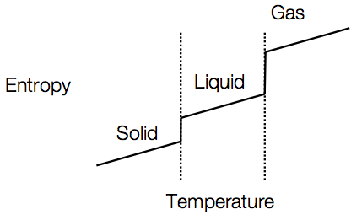
- Energy can be transformed from one form into another or transferred from one place to another, but it cannot be created or destroyed
- Ex. Niagara Falls

Second Law of Thermodynamics
- Energy transformations are not always efficient
  - Energy is lost and unable to do work
  - Lost in the form of heat (random molecular motion)
- Every energy transformation increases the disorder/randomness of the universe (Entropy)
- Disorder of an isolated system always increase (entropy)
- Physical objects always break down
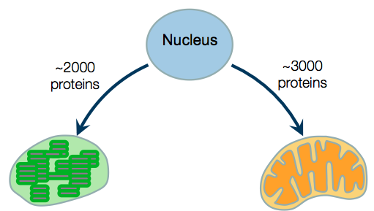
- Proteins always break down

Life & Second Law of Thermodynamics
- Quality of all life: highly ordered
  - Ex. DNA helix, protein, ribosome
- Living cells = open systems
  - Exchanging energy and matter with surroundings and use that to generate order
- Eat food to maintain low entropy
- Living things give off heat and carbon dioxide (obeys 2nd law by increasing order)

Spontaneous Reactions
- No input of energy is required
- Products have lower potential energy than the reactants
  - Potential Energy = Enthalpy (H):
  - ΔH = H_{final} – H_{initial}
  - Exothermic: -ΔH
    - Release energy
  - Endothermic: +ΔH
    - Absorb energy
- Products are less ordered than the reactants
  - Products have greater entropy
  - Entropy (S) increases

Gibbs Free Energy
- Portion of a system’s energy that is available to do work
∆G = ∆H - T∆S
∆ G = G _{final state} - G _{starting state}
Exergonic Reaction (ΔG < 0) Endergonic Reaction (ΔG > 0)
Spontaneous Non-Spontaneous
Catabolic Anabolic
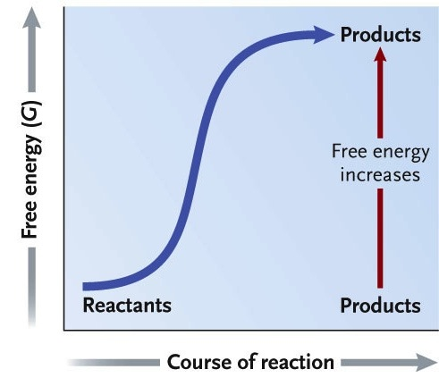
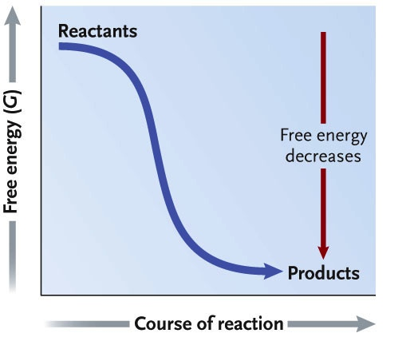

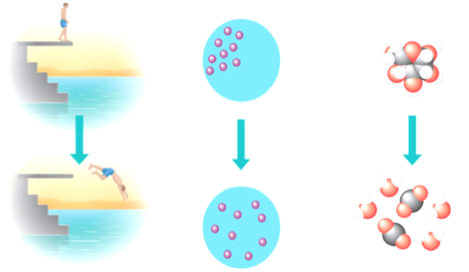

Contributions of Enthalpy & Entropy
- High Free Energy
  - Less stable
  - Greater work capacity
- Systems spontaneously change into more stable state
  - Ex. Glucose into carbon dioxide
  - Ex. Concentration gradient
- Transformation from solid liquid gas allows for an increase in entropy

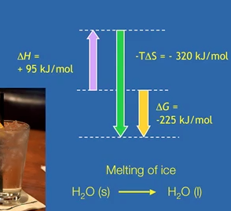
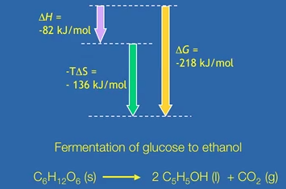
Adenosine Triphosphate
- Contains large amounts of free energy due to high-energy phosphate bonds
- Phosphate groups closely associated with each other - negative charges repel = bonding arrangement unstable
- Removal of phosphate group – spontaneous reaction – releases large amounts of free energy
- Hydrolysis reaction = warming reaction – DOES NOT OCCUR (RARELY) IN CELLS
- Energy Coupling
  - ATP is brought into close contact with reactant group
  - Terminal phosphate group is transferred to the reactant molecule making it less stable (phosphorylated)
    - High phosphoryl group transfer potential
  - Enzyme mediated (active site does not bind to water – only ATP and reactant molecule)
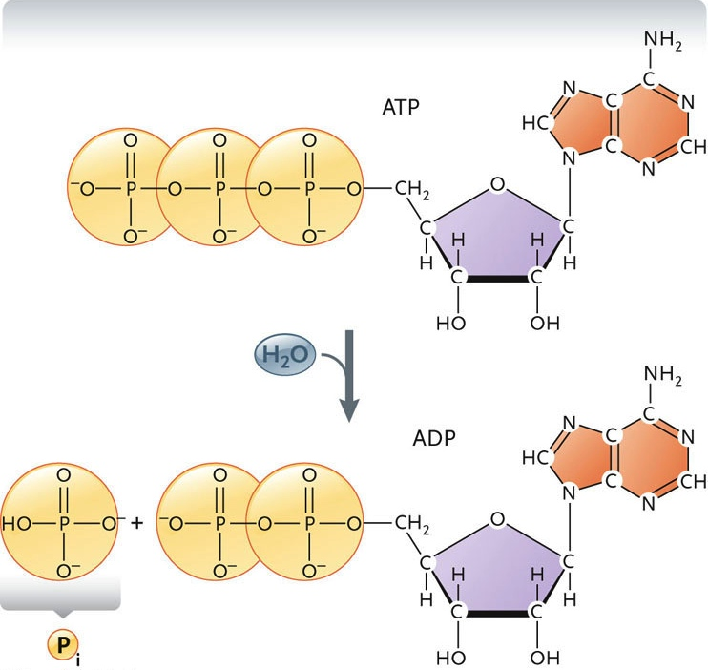
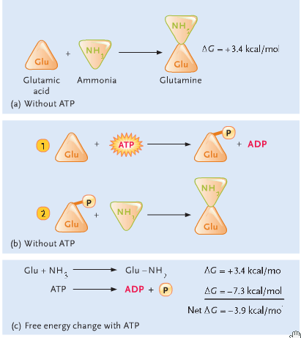

Equilibrium & Open Systems

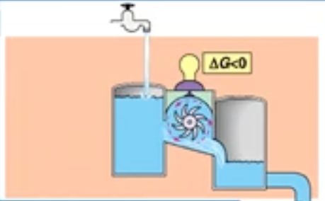
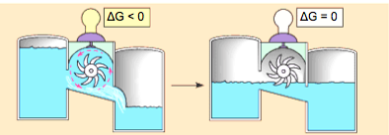
Isolated systems reach equilibrium
Maximum stability

Open systems do not reach equilibrium
Minimum stability

