Meiosis (Chapter 3)
Somatic Cells:
- Mitotically dividing and G-arrested cells
- Make up vast majority of individuals tissues
- Diploid in humans (2n)
Germ Cells:
- Pockets of specialized cells (2n in humans)
- Produce gametes (eggs/sperm)
- Undergo meiosis

Meiosis 1: separation of chromosome pairs (2n-n)
Meiosis 2: separation of sister chromatids

Changes in Chromosome Number (6)

Aneuploidy
Results from the loss or gain of one or more chromosomes

Aneuploid: an individual who doesn’t have an exact multiple of the haploid number of chromosomes
Monosomic: refers to individuals lacking one chromosome
Trisomic: refers to an individual having one chromosome in addition to the diploid set
Tetrasomic: refers to individuals with four copies of a particular chromosome
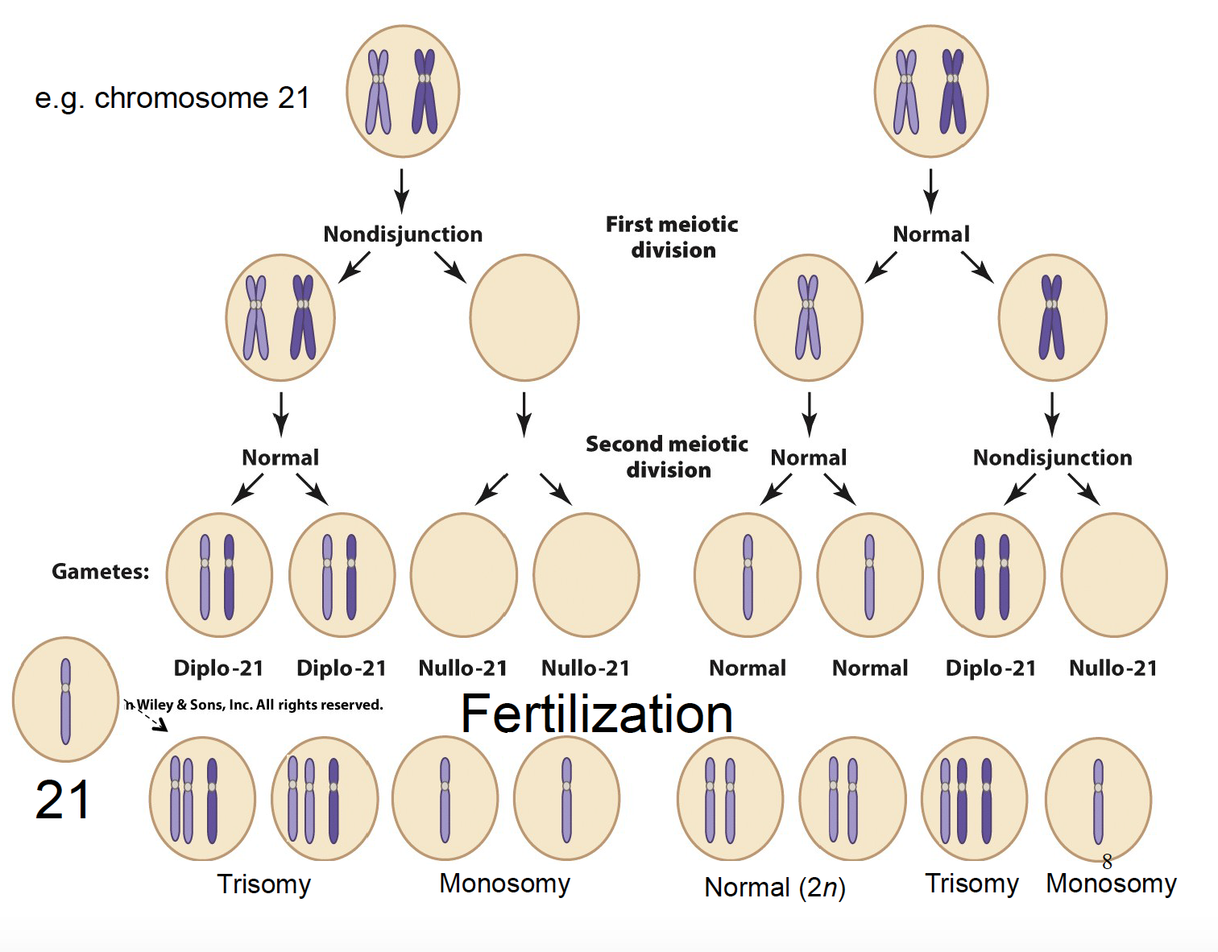
Note that it can happen at both the first and second meiotic division. Also notice how the chromosomes split (first time, full chromosomes, then in second they get split one of each colour)

Variations in Sex Chromosome Number
XXX: normal, fertile female
XO: turner syndrome (abnormal, infertile female)
XXY: Klinefelter syndrome (abnormal, infertile male)
XYY: normal, fertile male
OY: lethal

Linkage and Recombination (Chapter 4)
In a dihybrid cross, departures from a 1:1:1:1 genotypic ratio of F1 indicates the genes are on the same chromosome, they are genetically linked.
Parental: looks like the parental generation NOT necessarily their own parents
Recombinant: doesn’t look like P generation

Remember, just because you don’t see any recombinance doesn’t mean it didn’t happen, just didn’t happen in the gene you’re looking at.

Map Distances (Chapter 4)
Review from Tutorial Manual

$$Coefficient of Coincidence=\frac{Frequency Observed}{Frequency Expected}$$
Interference=1-Coefficient of Coincidence

DNA (Chapter 5)
What is DNA made up of?
Chain of nucleotides joined by phosphodiester bonds

Transformation
Frederick Griffith: discovered Transformation in Bacteria through his studies with rough and smooth streptoccus pneumonia.

The ability of a substance to change the genetic characteristics of an organism

Lab of Oswald Avery: determined what component is responsible for transformation

Hershey and Chase: conducted experiments with bacteriophages
- Labelled cells with a specific marking for DNA and protein and saw which one passed onto offspring

Chemical Makeup of DNA
- Phosphate
- Doxyribose sugar
- Nitrogenous Bases

Watson and Crick: proved it was a double helix

Nucleotides
Phosphate are added on 5’, nucleotides joined with 3’. Nucleotides link in 5’3’ with phosphodiester bonds

DNA Replication (Chapter 5)

Watson-Crick model of DNA
“DNA replications is semiconservative”
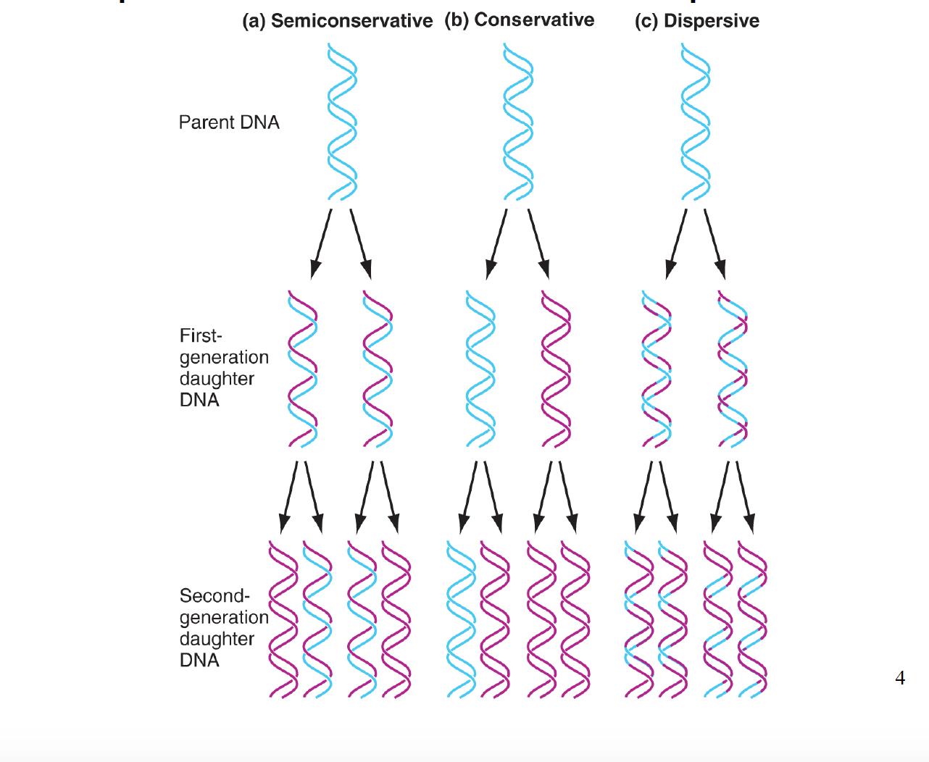
Used nitrogen because it’s in all DNA (nitrogenous bases). Created a heavy DNA to see if it shows through in the offspring.

Two steps to DNA replication: initiation and enlongation.

Initiation – Prokaryote
- DNA helicase physically separates and unwinds the DNA
- Single stranded DNA-binding proteins go in an attach so that DNA doesn’t recoil

Elongation – Prokaryote
- DNA polymerase needs a free 3’ OH to extend upon
- An RNA primer is needed to begin synthesis, as soon as primers roll up, synthesis can start
- Primers are consistently being put down to allow the leading strand to continue synthesis of nucleotides (DNA polymerase)
- Ligase seals up

The Genetic Code (Chapter 7)
Gene Expression: the flow of genetic information from DNA via RNA to protein.
Central Dogma: DNA (transcription) RNA (translation) Protein

Stop and Start Codons

Start Codon
AUG

Stop Codons
UGA
UAG
UAA

5’3’
In proteins it’s “NH2 COOH” because they don’t have 5’ and 3’
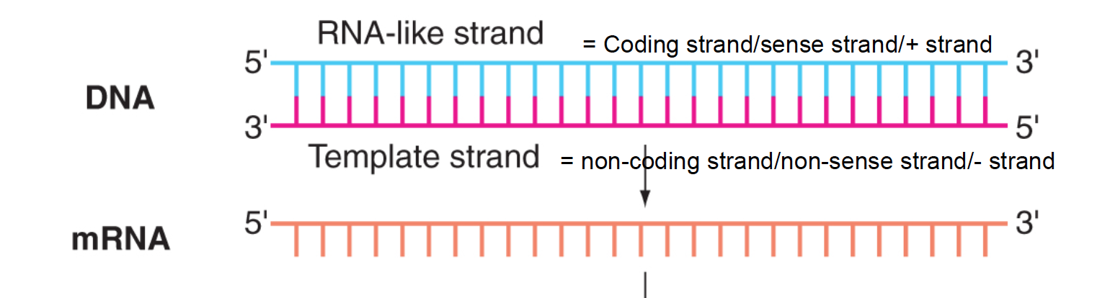
Remember that the coding strand looks identical to the strand of mRNA except for the T/U difference.

Transcription (Chapter 7)
Transcription: the process by which the polymerization of nucleotides guided by complementary base pairing produces an RNA transcript of a gene.

Nucleotides are added in the 5’3’.

General Knowledge
RNA Polymerase: the enzyme that catalyzes transcription
Promoters: DNA sequences near the beginning of genes that signal RNA polymerase to begin transcription.
Terminators: sequences in the RNA products that tell RNA polymerase where to stop

Prokaryotes
WYSIWYG: mRNA and proteins can be directly deduced from the DNA sequence.

Eukaryotes
RNA processing after transcription produces a mature mRNA.
- Addition of methylated cap at the 5’ end
- Capping enzyme adds a guanine cap to the first few nucleotides.
- Poly-A Tail at the 3’ end
- RNA splicing
- Removal of the introns

Translation (Chapter 7)
Translation the process in which the genetic code carried by mRNA directs the synthesis of proteins from amino acids.

General Knowledge
tRNA: Transfer RNAs that carry modified bases

Base pairing between an mRNA codon and a tRNA anticodon determines where an amino acid becomes incorporated.

Codons and anticodons are always read/referred to in the 5’3’ direction.

Wobble
Some tRNAs recognize more than one codon for the amino acid they carry because the 5’ of the anticodon can pair up with a variety of different 3’ anticodons

Ribosomes
Ribosomes are the site of protein synthesis

What are ribosomes made up of?
- Ribosomes have large and small subunits, the size differs between prokaryotes and eukaryotes.
- The small subunit in the prokaryote carries a 16S rRNA and the eukaryote carries an 18S rRNA.

Sites on a Ribosome
From right to left:
A (Aminoacyl site)
P (Peptidyl Site)
E (Exit Site)

Steps of Translation - Prokaryotes

Shine-Dalgarno Sequence
Only in E. coli, where the ribosome gets loaded on

Initiation Phase
- Once the ribosome is on the SD sequence, the downstream AUG codon codes for formylmethionine.
- The large ribosomal subunit then binds so that AUG is placed on the P site.

Elongation Phase
- A second amino acid is brought into the A site and they are stuck together with a peptide bond.
- The ribosomes keep on moving down the line forming together a strand

Termination Phase
- When a nonsense (stop) codon is encountered, a release factor moves into the A site. The mRNA and tRNA dissociate from each other.

Steps of Translation – Eukaryotes

Initiation Phase
- Ribosome binds to 5’ cap, scans for the AUG start codon which codes for methionine in mammals

Elongation Phase
- A second amino acid is brought into the A site and they are stuck together with a peptide bond.
- The ribosomes keep on moving down the line forming together a strand

Termination Phase
- When a nonsense (stop) codon is encountered, a release factor moves into the A site. The mRNA and tRNA dissociate from each other.

Posttranslational Processing
- Modifications that occur on the protein after translation
- Methyl group removed (done by enzymes)

Mutations
Silent Mutation: switched out a base but the type of amino acid remained the same
Missense Mutation: new base creates a new amino acid (doesn’t necessarily change anything)
Nonsense Mutation: new amino acid is a stop codon
Frameshift Mutation: an insertion of a new base that causes a shift in the ORF.

Gene Regulation in Prokaryotes (7)
The role of RNA polymerase in transcription is to recognize and bind to the promoter.

Lac Operon

Structural genes
lac Z: encodes B-galactosidase (breaks down lactose into glucose and galactose)
lac Y: encodes permease (transports lactose into the cell)
lac A: encodes transacetylase that adds an acetyl group to lactose

The structural genes are transcribed together. When lacZ expression is repressed or induced, the same expression is seen in the following structural genes.

Operon: a unit of DNA composed of specific genes, a promoter, and an operator which all act in unison to regulate the response of the structural genes.

REVIEW FROM TUTORIAL BOOK

Gene Regulation in Eukaryotes (11)
Prokaryotes:
- Can organize their genes into operons
- Bind at SD sequence
Eukaryotes cannot do this because:
- No SD sequence so it would simply start at 5’ and scans for AUG
- Once it found it, would make Z, however will then go back to %’
- Z would only ever be made

Transcription between the two is very similar, however control has to be much more complex.

In eukaryotes, there are three different RNA polymerases that transcribe various genes. We will focus on RNA polymerase II, which transcribes structural genes.

RNA Polymerase II
RNA polymerase II recognizes:
- Core promoter (absolutely NEED this region)
- Includes initiation site (+1 where transcription begins)
- “TATA box”, located at ~ 30 position, “TATA(A/T)A(A/T)” (seven nucleotides)
- Enhancer
- Regulatory site that can be located far away for promoter

Basal Factors
are required for binding to the promoter to maintain a basal level of transcription. They bind and all for polymerase.
- TBP: TATA Box-binding Protein. Essential to the initiation of transcription.
- TAFs: TBP Associated Factors (bind to TBP)

Transcriptional Activators
Transcriptional activators bind to enhancer sequences which can increase the rate of basal level transcription.

Most eukaryotic activators must form dimers (complexes) to function.
- Homomers – multimeric proteins composed of identical subunits. When they’re only two subunits they’re considered homodimers.
- Heteromers – multimeric proteins composed of nonidentical subunits. When they’re only two subunits, they’re considered heterodimers.

Transcriptional Repressors
Transcriptional repressors diminish transcriptional activity. They may bind to enhancer elements (competitive) to prevent enhancement or may bind to other DNA encoded sequences (silencers) to diminish transcription.
How they work
- Competition: Repressor binds to DNA before the activator can (repressor binds directly to DNA)
- Quenching: Repressor binds to and blocks the DNA-binding region OR repressor binds to and blocks the activation domain (Repressor does not directly bind DNA)

Basal Level Expression
- DNA of eukaryotes is packaged into chromatin by wrapping of DNA around histone proteins to form units of nucleosomes. This “arrangement” keeps it turned off so transcription is very low or non-existent in individual genes.

Gene Expression
Gene expression can be governed by altering chromatin structure (the wrapping) and DNA methylation patterns.
- Chromatin Remodelling
- Remodelling proteins by changing:
- The sidegroups of the histones
- Repositioning of the histones along the DNA
- Methylation patterns of DNA and histones
- Histones: acetyl groups added to histone tails reduce electrical attraction of negative DNA to otherwise positive lysine in tails (electrostatic force is keeping them wrapped)
- Relaxed structure makes it easier to unwrap the DNA from the histone and expose the gene (turned ON)
- Once the tails are acetylated they loosen the chromatin, more DNA is available and DNA is turned on and transcription can occur

Heterochromatin (extreme case)
- These genes are basically permanently turned off because the chromatin are so tightly wound. The gene is silenced.

Genomic Imprinting
- DNA methylation patterns are inherited from mother or father
- These are maintained during mitosis, the body only expresses one copy and the other is silenced. This can explain why twins look different, because tons of things can change these methylation patterns (ie. Diet). THIS RESULTS IN A DIFFERENT PHENOTYPE EVEN DESPITE HAVING THE SAME DNA SEQUENCE.

Restriction Enzymes (Chapter 14)
What is a restriction enzyme?
- Endonucleases that exist naturally in prokaryotes
- Their function is to recognize foreign DNA sequences and cut it into pieces for further degradation
- Restricts what type of DNA can exist in the home

Restriction enzymes cut and produce either blunt ends or sticky ends (with a 5’ or 3’ overhang.

Restriction enzymes recognize orientation. Just because they cut a fragment when read from 5’3’ does not mean it will cut it when read from 3’5’.

Electrophoresis: the movement of charged molecules in an electric field

Restriction Mapping
Shows the order of different size fragments within a clone. Shows were all the restriction enzymes are.

Molecular Cloning
The process of using living cells to make exact replicas of a fragment

Steps to Inserting linear, cut fragments of DNA
- Purify a DNA fragment and insert it into a vector
- Transfer the vector with its insert into cells. Copies will be made through replication.

Types of Vectors
- Plasmids
- Circular double-stranded DNA. Has an origin of replication, several unique sites for restriction enzymes and a gene referred to as a selectable marker.
- Yeast Artifical Chromosomes (YAC)
- Linear vectors built to mimic a yeast chromosome
- This allows the YACs to segregate as if they were natural chromosomes in the host.

Using Plasmid Vectors
- Take sample and digest it with a restriction endonuclease (REN)
- The E. coli/bacteria will act as a photocopier. Some will build up plasmids. They have an antibiotic resistance gene and will survive while others won’t.

Genomic Library
A collection of DNA clones that theoretically contain copies of every DNA fragment in the whole genome. We don’t care about the entire gene, we only want the coding/exon sequence!

cDNA Library
As mentioned, we don’t want the introns. The cDNA only stores the coding/exon sequences that are copied from mRNA transcripts.

Population Genetics (Chapter 12)

General Definitions
Population: a group of inter-breeding individuals of the same species.
Gene Pool: collection of alleles carried in the population
Phenotype Frequency: the proportion of individuals in a population that are of a particular phenotype
Genotype Frequency: the proportion of individuals in a population that are of a particular genotype
Allele Frequency: the proportion of all copies of a gene in a population that are of a given allele type

Hardy-Weinberg Law
Defines the relationship between genotype and allele frequencies within a generation and from one generation to the next.

Five Assumptions
- The population includes an infinite number of individuals that all have equal access to mating
- The individuals mate at random in the sense that each individual’s genotype (not including interest) does not influence his or her choice of mate
- No new mutations appear in the gene pool (the alleles in question do not change)
- There is no migration into or out of the population
- There are no genotype-dependent differences in the ability to survive to reproductive age and transmit genes to the next generation (natural selection isn’t occurring)
Population that satisfy all five of these assumptions are said to be in H-W equilibrium (no real population on Earth can ever be in H-W equilibrium because if it was, it’d stop evolving)

p²+2pq+q²=1
Genetic Drift: unpredictable, chance fluctuations in allele frequency that have no effect on survival. The smaller the population size, the greater the effect of drift.

Natural Selection
Natural Selection: the process that progressively eliminates individuals whose fitness is low and chooses individuals of high fitness to survive and become parents of the next generation
Fitness: an individual's relative ability to survive and transmit its genes to the next generation. Two basic components: viability (how long someone can live) and reproductive success.
Natural selection does not produce variation, but can select for certain alleles.

Genes and Mutation (Chapter 8)

General Knowledge
What is a mutation? A heritable change in base sequence that modifies the information in the DNA
Wildtype Allele – generally, a wildtype allele is the one that dominates in a population. However this is not always the case so just know that it’s any allele present in more than 1% of the population.
- Wildtype alleles can be recessive or dominant
- More than one wildtype allele can exist for a gene (polymorphic gene)
How do different alleles form? Different alleles result form changes in the DNA sequence.

Classes of Mutations

Substitution
Transversion Mutation: a base substitution where a different type of base is substituted (ie. a pyrimidine for a purine, and vice versa).
Transition Mutation: a base substitution of the same kind (ie. purine for a purine, pyrimidine for a pyrimidine).

Deletion
The deletion of one or more base pairs, can change the reading frame.

Insertion
The insertion of one or more base pairs, can change the reading frame.

Inversion
Both flips it over both the x-axis and y-axis.

Reciprocal Translocation
Part of one chromosome has been replaced with a region from another chromosome and vice versa, changing places.

Spontaneous Mutations Occur at a Very Slow Rate
- Mutation rates are about 2-12 x 10⁻⁶ per gene, per generation.
- Some of these do not affect the phenotype so the only way to detect these is through molecular methods (ie. DNA sequencing)
- In multicellular organisms: only mutations in the germ cells will be passed to future offspring

Evolution (Adaptation vs. Mutation)
Evolution: the change in the inherited characteristics of populations over generations (takes a vast amount of times in human because of how long it takes to reproduce)

Mutations are change occurrences modifying the genome

The Luria-Delbrück Experiment
Salvador Luria and Max Delbrück
- Used E. coli and bacteriophage T1 to test hypotheses regarding mechanisms responsible for the appearance of a new phenotype

Experiment:
- Set up small vials of bacterial culture and let them grow for a specified amount of time
- Add equal portions of each culture to plates containing media (along with the phage)
Hypothesis 1: Resistance is a physiological response to a bactericide
- Resistance is the result of active adaptation to the selective pressure (phage)
- The selective pressure causes/drives the mutation
- This would be like saying: if you develop large muscles from delivering refrigerators for a living that you will pass on the large muscles to your offspring
- If this is the case, then all plated cultures should adapt similarly, resulting in similar numbers of resistant colonies
Hypothesis 2: Resistance Arises from Random Mutations
- Resistance is the result of random mutations, exclusive of the selective pressure
- Based on Darwin’s theory of evolution of natural variation and selection
- If this is the case, then there will be differences in the numbers of resistant colonies obtained due to random mutation

Conclusion:
- Resistance occurs as a result of random, spontaneous mutations that happen at various time points before exposure to the selective agent (selective pressure is not causing the mutation)
- Mutations occurring early in the growth of the liquid culture, resulted in many resistant colonies when plated; those occurring late resulted in few resistant colonies (fluctuations in numbers obtained)
Spontaneous mutations occur naturally

Mutations: mistakes in DNA occur at a low frequency all the time, natural processes of deamination, UV light, errors by DNA Polymerase

Mutagens: mutagens induce mutations and are any physical or chemical agent that raises the frequency of mutations above the spontaneous rate (X-Rays, ethidium bromide)

UV Light
UV-Light is able to create thymine dimers by connecting two thymine. There is a “kink” in the double helix which makes DNA Polymerase unable to copy it.
We have to have evolved a process to fix this though because we’re exposed to UV light so often.

Photolyase: Light-dependent repair of DNA in bacteria but eukaryotes don’t have photolyase so the T-T dimers are repaired a different way

Exinucleases: Nucleotide Excision repair, endonuclease removes lesions of damaged DNA in bacteria and humans. It removes the whole damaged piece and uses the template strand and DNA Polymerase remakes it. Ligase seals it up. The more times this has to happen, the less likely it will be perfect every time.

Skin Cancers
Melanoma: 75% of deaths due to skin cancer, rare but can metastasize extremely rapidly. It’s extremely deep as well which is why it can move around so easily.

Squamous cell carcinoma: Barely even penetrates the dermis layer of skin, easily removed. Rarely metastasizes.

Basal Cell Carcinoma: most common form of skin cancer, hardly ever metastastizes.

Base Excision Repair
- removes damaged DNA in bacteria and humans

Glycosylase
- different glycosylases recognize different modified bases. They will recognize different modified bases and cleave the error.

Mistakes during DNA replication can alter genetic information
- DNA Polymerase Mismatch Repair
DNA polymerase is able to recognize and remove mispaired bases during synthesis and then adds in the correct ones.

What happens if the mismatch isn’t caught?

- Methyl-directed mismatch repair
Bacterial recognition and repair system that can fix mutations after DNA replication
- Relies on tagging parental strands with methyl tags
Eukaryotes also have a mismatch repair system but we don’t know what the tag is.

In certain sequences, this system will methylate adenine.

Mutations that cannot be corrected are usually large mutations where there is nothing wrong with the physical DNA.

Unequal Crossing Over (Changing DNA Contents)

Unequal Crossing Over
One chromosome ends up with a duplication while the other ends up with a deletion. Sometimes, because they’re so similar they may synapse together.
The good thing about these uneven crossovers is that the duplicates sometimes produce a new, beneficial phenotype.

Clone Isolation/Analysis, PCR, DNA Sequencing (Chapter 14)
What is a Genomic Library?
A collection of DNA clones that theoretically* contain copies of every DNA fragment in the whole genome, inserted into a suitable vector and placed into storage.

DNA Probes
Short, single-stranded stretches of DNA of a known composition. To visualize them, the probes are labeled using either a radioactive or fluorescent dye. They are used to identify clones that contain complementary DNA sequences.

There are several ways to make labeled probes through chemical synthesis.

Screening Libraries by Hybridization
(colony hybridization)
Requirements and Limitations of Hybridization Probes
The complementarity between probe and target sequence must be long enough to allow sufficient hydrogen bonds to provide a cohesive force (basically the probe needs to be of a certain life)

Polymerase Chain Reaction (PCR)
Artificial DNA Xeroxing, uses two specific oligonucleotides (primers).

Steps
- Design two primers that are complementary to each end of the sequence of interest. These are the forward (Left) and Reverse (Right) primers. They will both move in the 5’3’ direction.
- Mix the primers, template DNA, thermostable DNA polymerase (it will have to go through heat) and the four nucleotide bases in a microtube.
- Denature: heat it up to high temperatures
- Anneal: attach the primers, at the sites flanking the target sequence of genomic DNA.
- Extend: Polymerization from primers along templates. Synthesize the entire fragment 5’3’.

Each cycle of PCR results in duplication of the strands. In a short amount of time, you can get billions of copies.

DNA Sequencing
Provides the highest resolution of a cloned DNA fragment: a compete description of its genetic information at the level of the nucleotide.
- Can be used to identify people

Sanger Dideoxy Sequencing
- Based on lack of 3’ OH group to terminate chain elongation
- Put solution of primer, DNA polymerase, and one of the bases into a test tube (should have four test tubes with one of each base in it)
- Synthesis results from a single tube and orient the strands.
- End up with a mixture of strand lengths, each ending where the dideoxy has been incorporated.
- Polyacrylamide gels can resolve strands that differ in length by just a single nucleotide.
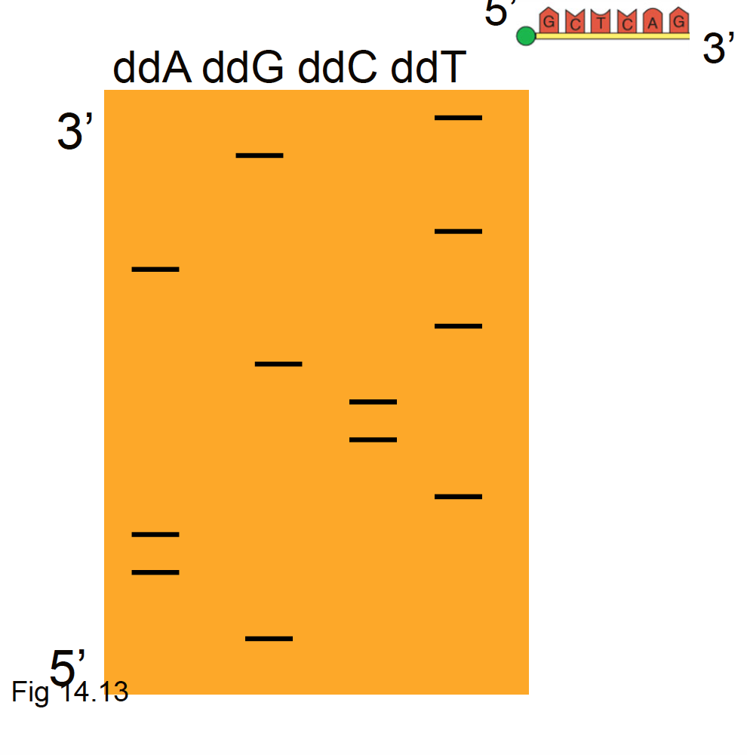
- Wherever there’s a line, tells you that base is there. Work your way up, from 5’3’ to get unknown sequence!

Cancer Genetics
Incidence vs Prevalence: Incidence is the number of new diagnoses where prevalence is the number of people living with it

Cancer is a genetic disorder, involving mutations in cells. Cancer itself is not inherited, however there are certain inherited mutations that can predispose someone to cancer.

Cancer (oncogenesis) begins with loss of cell cycle control, which create a tumour. This is not necessarily cancer. It becomes cancer when tumour cells undergo changes that allow them to invade and disrupt other tissues.

Cancer arises when controls over cell division are no longer functioning properly.

Tumour Suppressor Genes
- Involved in cell cycle control
- Act recessively (to lose cell cycle control, both copies must be recessive)
- p53 and RB

p53 – The Gatekeeper
Regulates the G1 to S Checkpoint

Normally when DNA is damaged in G1 phase, entry into S phase is delayed to allow repair before DNA replication proceeds. In mammals, this delay is caused by p53. Once p53 gets to a high concentrations (from waiting so long), the cell will undergo apoptosis.

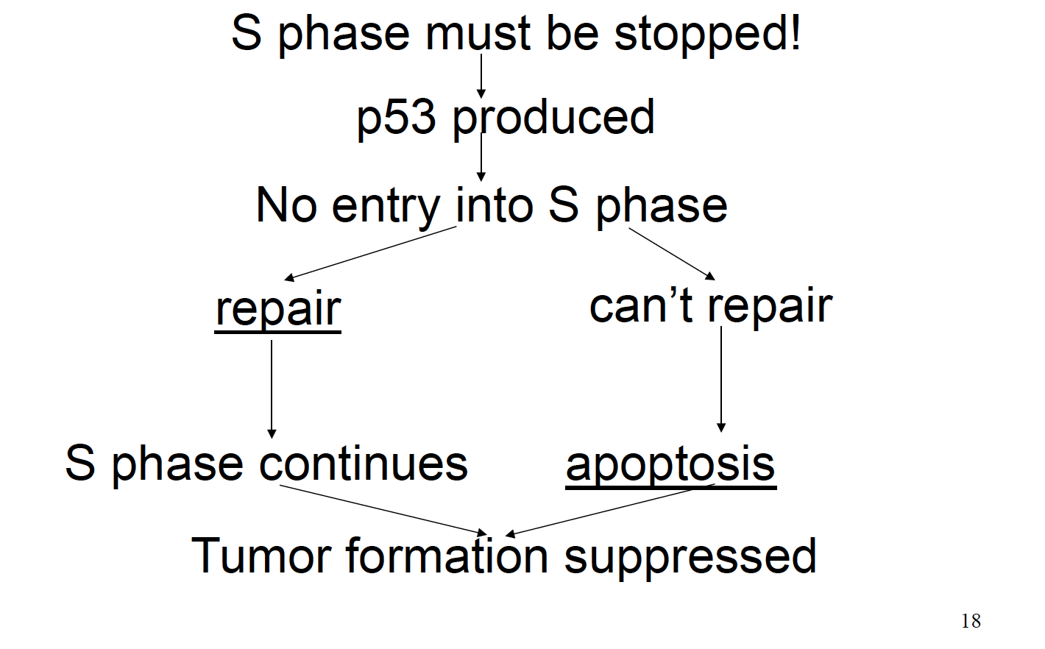

RB – The Brake
- regulates G1 to S checkpoint
- Protein controls cell cycle
- In absence of Rb, S phase cannot be prevented

Mutated RB can be inherited and can be passed on in offspring. It’s a recessive allele. Inheritance of one copy of the RB allele predisposes individuals to cancer of the retina.

BRCA1 and BRCA2
- Tumour-suppressors
- Products are a surveillance system needed for repairing broken fragments of DNA. If these genes get mutated, DNA issues can be replicated.

Oncogenes
Oncogenes are mutant alleles that act dominantly to stimulate cell proliferation (rapid growth). Some DNA viruses carry oncogenes.

Accidental Integration of Viral DNA
- Disruption of cell cycle
- Cells therefore aren’t killed and continue to replicate
- Increases probability of mutations
Note: only certain oncogenic strains (16 and 18) are able to destroy p53 and Rb proteins. Non-oncogenic strains cannot bind p53 and bind Rb, but do not destroy it. When they integrate, they don’t continue to disrupt cell cycle. HOWEVER, just because they’re non-oncogenic doesn’t mean they’re completely okay.

Usually cells with damaged DNA are caught by p53 and are repaired or killed but with these mutations, p53 can’t detect the damage, which leads to all sorts of chromosomal abnormalities.

Cancer Develops Over Time
The incidence of cancer rises with age. This supports the idea that cancer is generally caused by mutations. It’s thought to arise by successive mutations in a clone of proliferating cells.

Lack of Communication
Most cells have a chemical communication system. Cancer cells have contact inhibition and can’t chemically communicate what is going on.

Metastasis
When cells metastasize they disrupt local tissues and invade distant tissues. Cancer breaks down all basement membranes of current tissues with pressure and spread.

Angiogenesis
Bringing in blood vessels so because cells within the tumour need to survive. Tumours are usually so large they aren't near an edge. Blood vessels are brought into the middle so that waste and nutrients can be transported.

