Exam Recap
March 30, 2015 1:02 PM

• 2.5 hrs
• Less content than midterm
• MC-40
• Only cover post midterm topics
• Short answer/written-4

Topics
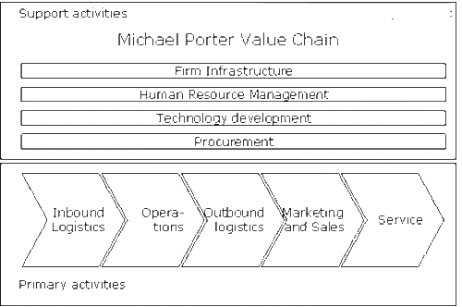
• Michael porter's value chain (chart)

•

• Very likely to build/draw value chain
○ Have supporting bullets under primary activities
○ Suggestions for what core activities comprise of
○ Give examples of what outsourcing channels include/can be
○ Tailor it to company/industry
○ 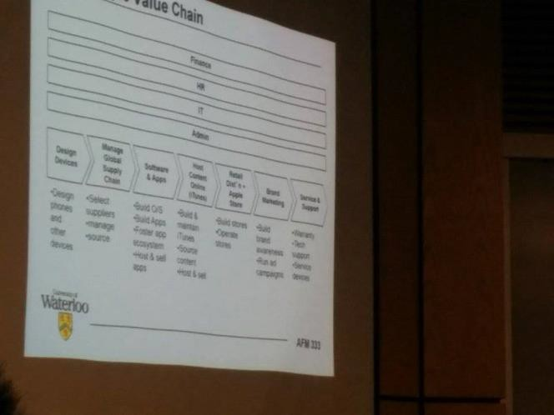

○ Steps for creating a value chain
▪ Brainstorm a list of key activities that a business performs and list them out nd group them into 5-8 high level activities
▪ Think about rough sequence of activities
▪ Draw them in sequence as series of chevrons
▪ Add the support activities (IT, fin, admin)
▪ Fill in the bullets (2-3 for each chevron) to describe the core activities
• Drivers of global sourcing
○ Outsourcing
○ Offshoring
• Choices in outsourcing value chain activities

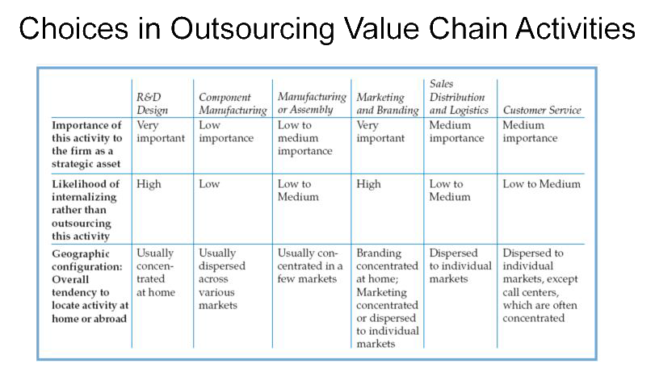
•

• Risks & benefits of outsourcing
Global Industry
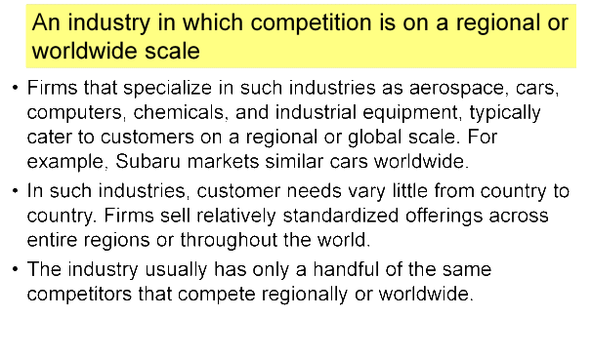
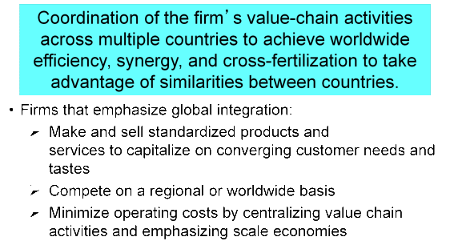
• Global Integration (Standardization)

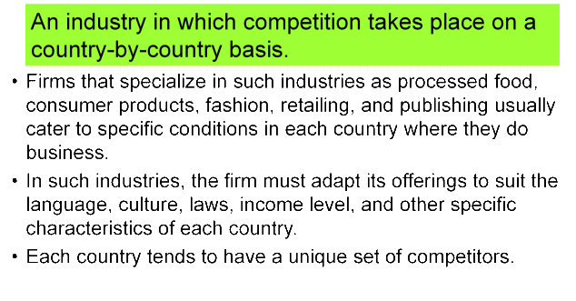
Multidomestic Industry

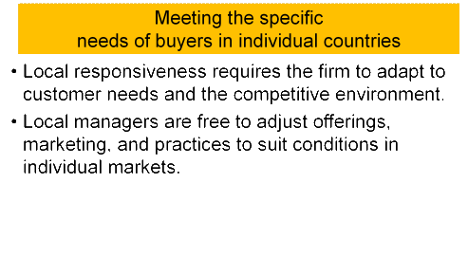
• Local Responsiveness (Adaptation)

• When operating internationally, firms try to strike the right balance between global integration and local responsiveness

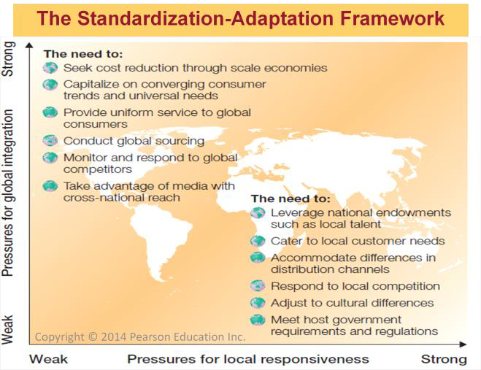
• Standardization/Adaptation Framework

• Summarizes the balance that firms seek to achieve between two basic strategic needs:
1. to integrate value chain activities globally, and
2. to create products and practices responsive to local market needs.
• The main goal of firms that emphasize global integration is to maximize the efficiency of their value chain activities on a worldwide scale.
• The main goal of firms that emphasize local responsiveness is to maximize sales and market share by being highly responsive to local needs.
•
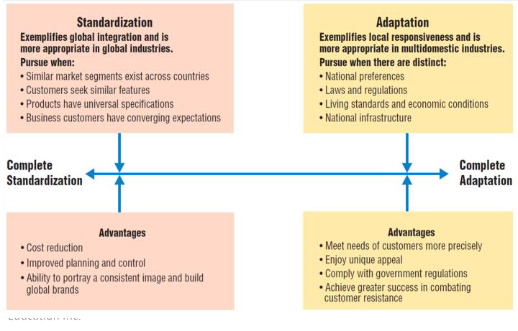
Tradeoffs between Standardization and Adaptation

•
• Four Strategies Emerging from

the Standardization-Adaptation Framework
• 1. Home replication strategy
• 2. Multidomestic strategy
• 3. Global strategy
• 4. Transnational strategy

Four Strategies Emerging from the Integration Responsiveness Framework
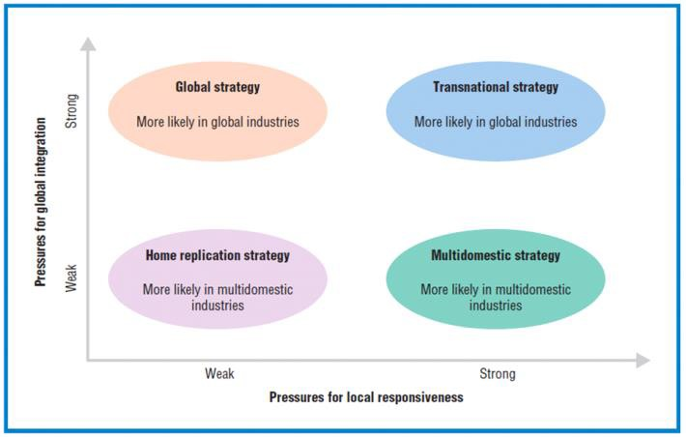
•
• Home Replication Strategy
• The firm views international business as separate
from, and secondary to, its domestic business. Expansion abroad is an opportunity to
generate incremental sales for domestic product lines.
• Products are designed for domestic customers, and international business is pursued mainly to extend the life of domestic products and replicate home market success.
• Management holds little interest in foreign markets and expects little knowledge to flow from foreign operations.
• No tailor or adjustment
• Multidomestic Strategy
• The firm develops subsidiaries or affiliates in each of its foreign markets and appoints local managers to operate independently and be locally responsive.
• Products and services are adapted to suit the needs and wants of buyers in each country.
• Because headquarters acknowledges differences between national markets, subsidiaries are allowed to vary products and practices by country.
• Country managers are often nationals of the host country and generally don’t share knowledge and experience with managers in other countries.
• Global Strategy
• Headquarters seeks substantial control over all country operations in order to minimize redundancy and achieve maximum efficiency, learning, and integration worldwide.
• Global strategy asks “why not make the same thing, the same way, everywhere?”
Products, marketing, and company practices are relatively standardized.
• R&D, manufacturing, marketing and other activities tend to be concentrated at headquarters, where they can be centrally coordinated and controlled.
• Management views the world as one large marketplace.
• Transnational Strategy
• A coordinated approach to internationalization in which the firm strives to be more responsive to local needs while retaining sufficient central control of operations to ensure efficiency and learning.
• The firm seeks to combine the major advantages of multidomestic and global strategies, while minimizing their disadvantages.
• It’s a flexible approach: standardize where feasible; adapt where appropriate.
• But, most firms find implementing transnational strategy very challenging
• Ex: coca cola- even if the labelling is in different languages, coca cola's packaging and brand is the same globally; slightly adjustment to formula according to people's liking for sweetness
• Transnational Strategy requires the firm to:
• Exploit scale economies by sourcing from a reduced set of global suppliers and concentrating production in relatively few locations where competitive advantages can be maximized
• Organize production, marketing, and other value-chain activities on a global scale
• Optimize local responsiveness and flexibility
• Facilitate global learning and knowledge transfer

• Coordinate global competitive moves — that is, deal with competitors on a global, integrated basis.
The Four Risks of International Business
• 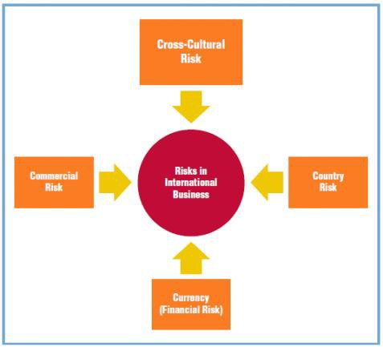

Culture
Culture: “Set of values, norms, beliefs, rules, and institutions held by a specific group of people”
Cross-cultural risk: A situation or event
where a cultural miscommunication puts some human value at stake. It arises in environments characterized by unfamiliar languages and unique value systems, beliefs, and behaviors.
Ethnocentricity: Belief that one’s own ethnic group or culture is superior to that of others
Cultural literacy: Detailed knowledge of a culture that enables a person to function happily and effectively within it

Culture is Learned
• Socialization: The process of learning the rules
and behavioral patterns appropriate to one's society.
• Acculturation: The process of adjusting and adapting to a culture other than one's own; commonly experienced by expatriate workers
• Culture is like an iceberg—above the surface, certain characteristics are visible; below the surface is a massive base of assumptions, attitudes, and values that strongly influence decision-making, relationships, and other dimensions of business.

Sub-cultures
• Larger cultures contain sub-cultures who share a unique way of life within the larger culture (language, race, lifestyle, attitudes, etc.)
• Need to be aware of the sub-culture since it influences behaviour
• It often extends across borders

Components of Culture
• 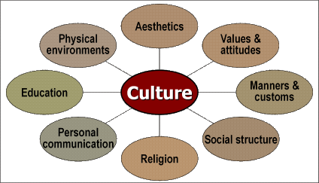

Components of Culture
• Aesthetics as all that a culture considers to be in “good taste” in the arts, the imagery evoked by certain expressions, and the symbolism of colors
• Manners are generally acceptable ways of behaving, speaking, and dressing.
• Customs are habits and behaviors in specific circumstances and situations
• Values are Ideas, beliefs, and customs to which people are emotionally attached
• Attitudes are Positive or negative evaluations, feelings, and tendencies people hold toward objects or concepts
• Social Structure consists of groupings such as family; stratification or the layers that

exist in the structure; and mobility which is the ease with which people can move between the social strata.
• Religion the major religions of the world are: Christian, Muslim, Hindu, Buddhism, Confucianism, Judaism.
• Personal Communication – Language. Be aware of not only a nation’s core language
but also of the many dialects when translating brands, advertising or documents
• Education. Cultures pass on traditions, customs, and values through schooling, parenting, group memberships, etc.
• Physical environment. Topography and climate can affect culture

Frameworks
• Two well known frameworks used to describe culture are:
• E.T Hall’s Context typology
• Hofstede’s Framework

E. T. Hall’s High- and Low-Context Cultures
• Low-context cultures rely on explicit explanations, with emphasis on spoken words.
Such cultures emphasize clear, efficient, logical delivery of verbal messages.
Communication is direct. Agreements are concluded with specific, legal contracts.
• High-context cultures emphasize nonverbal or indirect language. Communication aims to promote smooth, harmonious relationships. Such cultures prefer a polite, “face- saving” style that emphasizes a mutual sense of care and respect for others. Care is taken not to embarrass or offend others.

Hall’s High- and Low-Context Typology of Culture
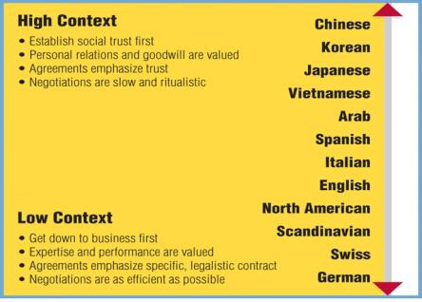
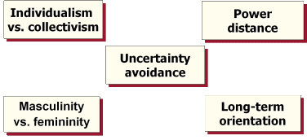
Hofstede’s Framework

Uncertainty avoidance: This framework compares cultures along five dimensions: Individualism versus Collectivism. Individualist cultures value hard work, entrepreneurial risk-taking, and freedom to focus on personal goals. Collectivist cultures emphasize a strong association with family and work groups to maintain harmony and to work toward collective goals.
Power Distance. Large power distance means greater inequality between superiors and subordinates, more hierarchical organizations, and power derives from prestige, force, and inheritance. Small power distance implies more equally shared prestige and rewards, and power derives from hard work and is often considered more legitimate. Uncertainty Avoidance. Cultures having large uncertainty avoidance tend to value security, systems of rules and procedures, low employee turnover, and relatively slower change. Those with low uncertainty avoidance are more open to change and new ideas.
more receptive to change, resistance
Masculinity versus Femininity. Cultures with high masculinity versus femininity scores emphasize assertiveness, the accumulation of wealth, and an entrepreneurial drive. Cultures rating low on masculinity versus femininity value relaxed lifestyles and are more concerned for others than they are with material gain.
Long-term Orientation. Cultures scoring high on long-term orientation place value on respect for tradition, thrift, perseverance, and a sense of personal shame. Cultures scoring low on long-term orientation tend to value individual stability and reputation, fulfilling social obligations, and reciprocation of greetings and gifts.
Written questions: comment on countries and comment on cultures, apply framework

Global Marketing Strategy

• Working with the diversity of individual country markets, managers then will need to formulate a global marketing strategy, represented by the middle layer in Exhibit 17.1.
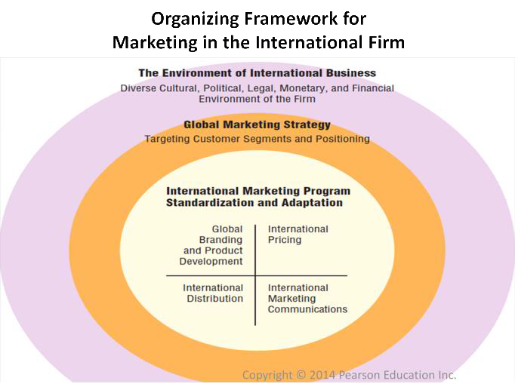
• Global marketing strategy -- a plan of action that guides the firm in: (1) how to position itself and its offerings in foreign markets and which customer segments to target; and (2) the degree to which its marketing program elements should be standardized and adapted.

International marketing communications: promotion, naming, packaging
Adapt or standardize across market
Need to know for assignment due on the 20th

• Elements of a Global Marketing Program
• Global marketing strategy also articulates the degree to which the firm's marketing program should vary across foreign markets (innermost layer in the framework).
• global branding and product development
• international pricing
• international marketing communications
• international distribution.
• The key challenge is how to resolve the trade-offs between standardizing the firm's marketing program elements and adapting them for individual international markets.
• The issue of how best to coordinate international marketing activities across multiple markets also arises.
Standardization and Adaptation
• Adaptation refers to firm efforts to modify elements of the international marketing program to accommodate specific customer requirements in a particular market.
•
• Standardization refers to firm efforts to make the marketing program elements uniform, with a view to targeting entire regions of countries, or even the global marketplace, with a similar product or service.
• Make 4P uniform around the globe
• Ex: Apple
• The more you standardize, higher economies of scale, higher profit margin
• Achieving a balance between adaptation and standardization is part of a broader corporate strategy that has the firm debating its position between global integration and local responsiveness.
• Tradeoffs between
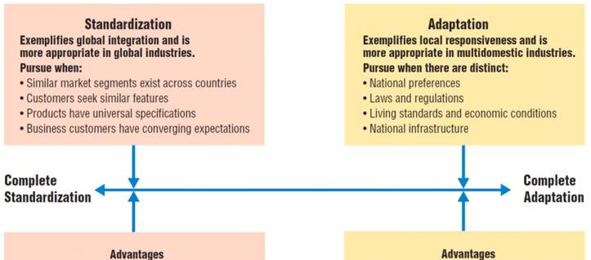
Standardization and Adaptation

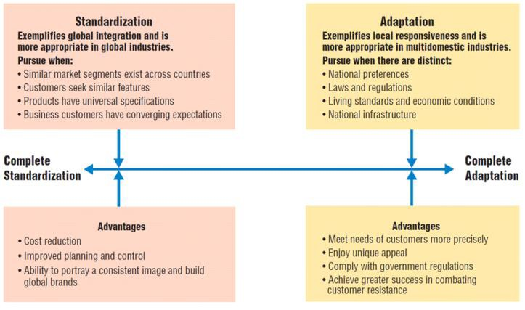
• Always a blend between standardization and adaptation

When managers build on commonalities in customer preferences and attempt to standardize their international marketing program, they can expect at least three types of favorable outcomes.
■ Cost reduction. Standardization reduces costs by making possible economies of scale in design, sourcing, manufacturing, and marketing. Offering a similar marketing program to the global marketplace or across entire regions is more efficient than having to adapt products for each of the numerous individual markets. Electrolux (based in Sweden, www.electrolux.com) once made hundreds of refrigerator models to accommodate the diverse tastes and regulatory requirements of each country in Europe. As product standards and tastes gradually harmonized across the European Union, Electrolux was able to reduce the number of its refrigerator models to a few dozen, consolidate manufacturing facilities, and streamline its marketing activities across the EU. The resulting consolidation saved Electrolux millions of euros. With fewer offerings, the company now focuses its R&D activities on advanced features and superior technology.
■ Improved planning and control. Standardization provides for improved planning and control of value-adding activities. Fewer offerings simplify quality control and reduce the number of replacement parts Electrolux needs to stock. Marketing activities are also simplified. Instead of designing a unique marketing campaign for each country in Europe, the firm is able to simultaneously offer a largely standardized campaign for numerous countries.
■ Ability to portray a consistent image and build global brands. A brand is a name, sign, symbol, or design intended to identify the firm’s product and to differentiate it from those of competitors. A global brand is one whose positioning, advertising strategy, look, and personality are standardized worldwide. It increases customer interest and reduces the confusion that can arise when the firm offers numerous adapted products and marketing programs.
Gillette (www.gillette.com), the U.S. shaving products division owned by Procter & Gamble, sells the same products using uniform marketing in all the countries where it does business and often introduces them with simultaneous global launches, under universal brand names such as Trak II, Sensor, and Fusion. Gillette’s global approach has achieved an impressive 70 percent global market share and reduced marketing and distribution costs.
•

Factors that Affect International Pricing

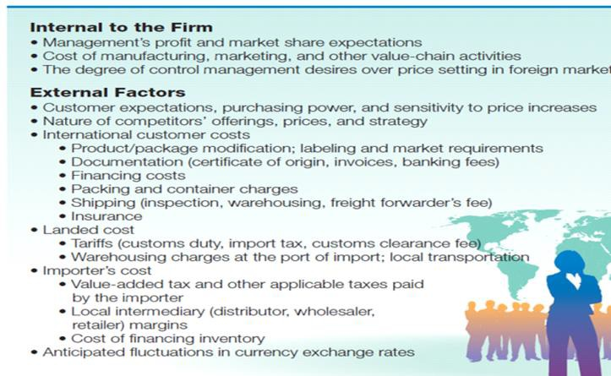
Steps in Setting the Price of a Product Abroad
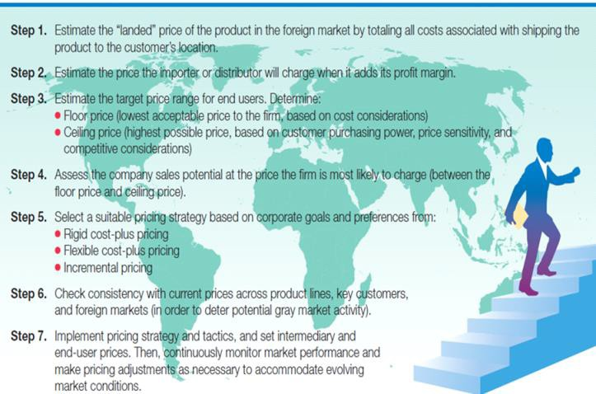
Three Pricing Strategies
• Rigid cost-plus pricing: setting a fixed price for all export markets. Management simply adds a flat percentage to the domestic price to compensate for the added costs of doing business abroad. The export customer’s final price includes a mark-up to cover transporting, as well as profit margins for intermediaries and the manufacturer.
• Same % markup margin for all prices across all regions
• In flexible cost-plus pricing. Management includes any added costs of doing business abroad in its final price. Prices are adjusted to accommodate local market and competitive conditions, such as customer purchasing power, demand, and competitor prices.
• Vary cost in market place depending on costs and risk incurred
• Allocate specific cost to specific market place
• In highly competitive markets, the firm may set prices to cover only its variable costs, not its fixed costs. This is known as incremental pricing. Management assumes that fixed costs are already paid from sales of the product in the firm’s home country.

International Price Escalation
• International price escalation refers to the problem of end-user prices reaching exorbitant levels in the export market caused by multi-layered distribution channels, intermediary margins, tariffs, and other international customer costs.
• Extra cost of doing business in foreign markets (tariff, insurance, intermediaries) will increase price
• Depending on country and market
• Cost plus price is higher than what consumer can bear
• International price escalation may mean that the retail price in the export market may be two or three times the domestic price, creating a competitive disadvantage for the exporter.

Strategies to Combat International Price Escalation
1. The exporter can attempt to shorten the distribution channel. It can bypass some intermediaries in the channel.
2. The product can be redesigned to remove costly features. Whirlpool developed a no-frills,

simplified washing machine which it sells for a lower price in developing economies.
• Make unique product for specific market
• Cell phone, electronics
3. The firm can ship its products unassembled, as parts and components, qualifying for lower import tariffs. The firm will then perform final assembly in the foreign market, often by low - cost labor (or assemble in Foreign Trade Zones).
• Reduce tariffs, move components around at a lower tariff/duties
4. Some firms explore whether the product can be re-classified using a different tariff classification to qualify for lower tariffs. Often imported products fit more than one product category.
5. The firm may decide to move production or sourcing to another country to take advantage of lower production costs or favorable currency rates.
Transfer Pricing (Intra-Corporate Pricing)
• Transfer pricing refers to the practice of pricing intermediate or finished products exchanged among the subsidiaries and affiliates of the same corporate family located in different countries.
• When Ford’s factory in South Africa sells parts and components to the Ford manufacturing plant in Spain, it charges a transfer price for this intra-corporate transaction.
• These prices, for products transferred within the Ford corporate family, generally differ from the market prices that Ford charges its external customers.

Reasons for Transfer Pricing
• Firms use transfer pricing to repatriate, that is, bring back to the home country, profits from countries that restrict MNEs from taking their earnings out of the country.
• Second, transfer pricing can serve as a vehicle for MNEs to shift profits out of a high corporate tax county into a low corporate tax one and thereby increase company-wide profitability.
• MNEs typically centralize transfer pricing under the direction of the CFO at corporate headquarters.
• If have high corporate tax, maximize transfer price and cost and minimize profit to avoid tax
• Move profit between companies in different countries
• Income tax rate, tariffs all factor into it

Transfer Pricing Factors
• Corporate income-tax rates
• Tariffs for the product in question
• Accounting rules for calculating income
• Political stability
• Restrictions on profit repatriation
• Strategic importance to the MNE
International Financial Management
• It is the acquisition and use of funds for cross-border trade, investment, and other commercial activities.
• MNEs must carry out transactions in a multitude of foreign currencies and diverse environments characterized by restrictions on capital flows, country risk, and varying accounting and tax systems.
• Firms access funds from a variety of sources – foreign bond markets, local stock exchanges, foreign banks, venture capital firms, and intra-corporate financing – based on wherever in
the world that capital is cheapest.

6.

7.

8.

9.

10.

11.
International Financial Management Tasks (written question!)
Decide on the Capital Structure – determine the ideal long-term mix of debt versus equity financing.
Raise Funds for the Firm – acquire equity, debt, or intra-corporate financing for funding activities and investments.
Working Capital and Cash Flow Management – manage funds passing in and out of the firm’s value-adding activities.
Capital Budgeting – assess financial attractiveness of major investment projects (e.g., foreign market expansion and entry).
Currency Risk Management – manage the multiple-currency transactions of the firm and the exposure to exchange-rate fluctuations.
Manage the Diversity of International Accounting and Tax Practices – learn to operate in a global environment with diverse accounting practices and international tax regimes.

•

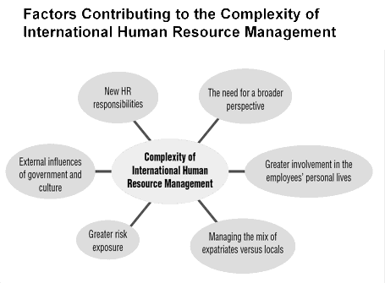
•

• Some centralized controls, instill global culture, distribute patriots, create & infuse culture into global teams

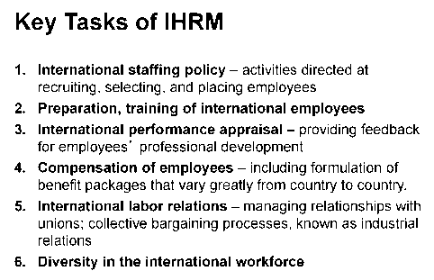
MC:
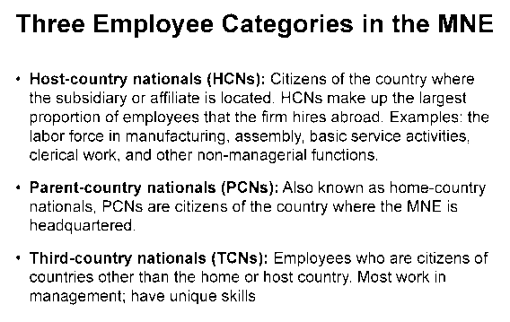

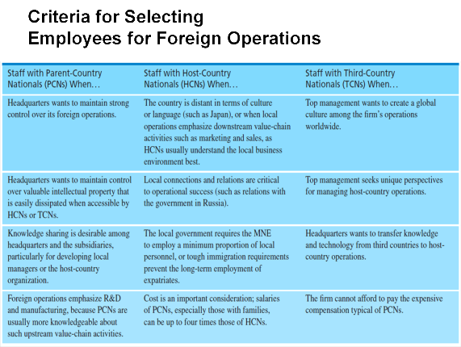

Ethics Systems and Ethical
Dilemmas

What is
Rewarded
The Stated
Code of Ethics


The Practiced
Code of Ethics

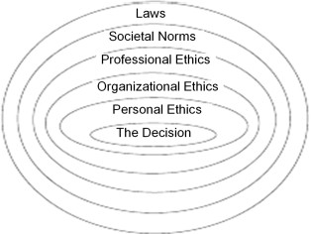
Each ethical system rings and constrains what is ethical.
The# of acceptable decision options is reduced as you move to a decision

Corporate Social
Responsibility

Human Rights and Employment Standards
in the
Workplace

Ethical Sourcing and
Procurement

Marketing and Consumer Issues

Environmental, Health, and Safety Concerns

Community and "Good Neighbour" Policies








Figure 3.2 Five Pillars of CSR
Corporate social responsibility is the collection of policies covering five major areas and can be the foundation of a business.

Cc>pyriglu. e. 2.013 Pe-ar!IO•\ C; .mul;a Inc.





