Chapter Notes MARK 453
Advertising

Chapter 1
Integrated Marketing Communications

Communication: transmitting, receiving, and processing information.
Receiver
Decoding
Transmission Device
Encoding
Sender

Feedback

Sender: the company behind the message – aspirational message to create desire
Encoding: take message and turn it into some form of communication (television, banner ad, billboard)
TD: occurs when a channel or medium delivers the message. TV carrying an advertisement, Sunday Newspaper with a coupon, letter to the pourchaing agent, blog on the company website
Decoding: when it reaches the receiver’s senses. See, hear touch, smell
Receiver: quality ad when they decode the message as intended by the sender
Feedback: receives feedback form purchases, inquiries, questions, visits to the store, blogs, website hits
Noise: anything that distorts or disrupts a message – can occur at any time in the process. Most common = clutter = exposure to hundreds of marketing messages daily

Integrated Marketing Communications: The coordination of seller-initiated efforts to promote an idea and/or to persuade consumers to buy goods and services. This integrations affects all of the firms B2B, marketing channel, customer-focused and internally directed communications
Product
Price
Place
Promotion
Advertising
Digital marketing
Sales
Promotion
Public Relations
Direct marketing
TV, Radio
Email, blog websites
Tele-marketing
Coupons, contests
Sponsorship, media relations

Advertising: Paid form of non-personal communication about an organization, product, service or idea by an identified sponsor
Digital Marketing: Users can participate in and modify the form and content of information they receive = social presence via Facebook, twitter, consumer-generated ads
Direct Marketing: Communication directly with target consumers to generate a response = email marketing, direct mail, telemarketing
Sales Promotions: Provide extra value or incentive to the sales force, distributors or the consumer = coupons, contests, sampling, rebates, etc.
Public Relations: Can be used to enhance an organization’s image and damage control = fundraising, sponsorship, special events, WestJet example

2 main problems that plague traditional Mark Comm:
- Focus on advertising as the core and other channels were just add-ons
- Various parts of the communication channel were managed by different people who didn’t work on the master plan=unfocused, competing messages
- NOW with IMC consumers receive clear, consistent messages. Not only just advertising or sales promotion but like Tim’s integrates on the outside of its cups . it includes limitless number of contact points with the audience, with new ones emerging each year with technology

The Rise of IMC = Factors attributing to the growth of IMC
- Increased Accountability
  - Pushed by CEO and CFO, and BOD who seek visible, measureable results
  - Instead of just putting out a 30-ad = alternative venues are combined with special events where names, profiles and addresses can be collected/tracked
- Audience adoption of new media
  - The shift to technology – youtube, iphones = engaging with and interact with customers
- Information technology
  - UPC codes (barcodes) allow large amounts of data about customers to be gathered – no longer just for inventory. They can determine who is buying products and what channels to use to effectively reach them
- Increased competition
  - Consumers want quality and low price. Tangible difference are small, now more focused on brand parity: shoppers purchase from a group of brands not a specific one. Quality is no longer a differentiating factor, now price, availability, and specific promo deal

The IMC Industry
Marketing Managers: the person who works directly for the company that will invest in MC. They work for ex. Tim’s, Labatt, The Bay, Canadian Cancer Society. ROLE:
- Setting objectives: - increase market share by 15% - setting MC to acheive
- Setting Budgets: allocation and negotiating budgets
- Coordinating MC with other firm activities
- Coordinating agencies: choosing to use internal/external

Marketing Communications Agencies
In-house, full-service agency or niche agency
Communication Tactic
Certain Markets
Target Audiences

- Account services: strategy development and project management
- Account Planning: research
- Creative: role visualized by outsiders – the eureka moment
- Media Managers: planning and buying media for target
- Production managers: bring the ideas from creative/media to life – manage a broad range of outside production companies that deliver the client’s message to the target audience

Should you hire an external marketing comm agency?
- Do you need objective expertise?
- Complicated message? – Takes a lot of time to get agency up to speed with a complex product
- Can you afford it? More expensive externally
- Flexibility? Hiring internal less flexibility = harder to break contract/ is business s cyclical better to hire for only the 4 months you need
- Coordination with other marketing activities? Difficult to coordinated with external agencies – grocery store flyers produced weekly and unstable

Choosing a MC Agency
Set goals – Define selection criteria – Request references – The pitch – Select agency

Agency Compensation
Good Client-Agency Relationship
- Open Communication #1
  - Drives the others
- Creative Ideas/Embracing Change
- Partnership/Trust/Accountability
- Shared Passion

Client-Agency Relationships
Bad Habits of Agencies  (According to Clients) | Bad Habits of Clients  (According to Agencies)
- Lack of interest or understanding of the client’s business  - A “loose ship” on timelines & budgets  - Defensiveness, especially when creative is critiqued or rejected  - Aversion towards research | - Not sharing information  - Unrealistic expectations of what can be achieved for the budget/timelines provided  - Unwillingness to approve breakthrough ideas  - Over-reliance on research

What Clients look for?
The 3 “I”s:
- Intelligence
Collect, report and analyze data Adapt to changes!
- Ideas
Not just messages or ads non-traditional ideas
- Interaction
Engagement and connection not just a banner ad or Facebook page

Examples: SEE NOTES
Imagine that you are an agency, and that it costs $25,000 to place your client’s ad on television. You are also able to take advantage of a 2% media discount. Assuming a 12% commission:
- How much does it cost to place the ad on TV (with the discount)?
$25,000 – $25,000*.02 = $24,500
- What is your commission?
  - Commission + media (no discount) = total
$25,000/.88 = $28,409
$28,409 - $25,000 = $3,409

Question 1:
Imagine that you are an agency, and that it costs $325,000 to place your client’s ad on television. Since your agency places ads there frequently, they offer you an additional 4% media discount. Assuming a 9% commission rate:
- How much does it cost to place the ad on TV (with the discount)?
- What is your commission?

Question 2:
Imagine that the magazine where you want to place your client’s ad (e.g., Chatelaine) charges $36,000. Assuming a traditional commission rate:
- How much does it cost to place the ad in the magazine (with the discount)?
- What is your commission?
- How much will you “bill” your client?

Brief Discussion
- Why are clients moving away from the traditional commission system and using incentive-based compensation?

- If you were an agency, would you be reluctant to accept an incentive-based compensation system? Why or why not?
Hint: consider different types of agencies, whether the relationship with the client is relatively new or old, etc.

Chapter 3
IMC Continued & Buyer Behaviour
Consumer Behaviour:
The process people engage in when searching for, selecting, purchasing, using, and evaluating products/services = to satisfy their needs and desires
Motivation: A need sufficiently stimulated that an individual is moved to seek satisfaction Motivation is a key factor in driving need

The Purchase-Decision Making Process - NIEPP
- Need Recognition
  - Can be highly complex and simultaneous – functional, emotional, social
  - Can occur without any exposure to marketing communications – regularly used item (milk) has run out/car has mechanical breakdown
  - Changes within the buyers lifestyle – parents adopt a baby now need diapers
  - MC either create or shape a need: Disney’s little Einstein products are promoted with the claim to aid in child’s development: this may not be apparent until they receive the MC and decide that their child should be exposed to these products
  - Induce dissatisfaction: with currently used products = comparative claims that position vs. a comp
  - Purchase of a complementary product
  - Businesses Needs: derived demand generated by the production and sale of some other goods or service. Demand for steel based on #of cars sold each year/ mortgages and housing sales

- Information Search
  - Internal Search
    - Scan memory to recall experiences and knowledge about past purchase alternatives
    - Eliminates brands he/she knows little about
    - Using MC to get in the buyer’s potential set of alternatives*
  - External Search (following an internal)
    - Undertaken if internal search does not yield enough information
    - E.g., friends, co-workers, advertisements, PR, experts, personal experiences, Internet
    - Amount of time buyer spend on external search depends on:
      - Ability: education level (more = more search)
      - Motivation:
        - Level of involvement: high involvement more likely to perform external search. (expensive purchase/occasion)
        - Need for cognition: personality characteristic an individual displays when he engages in/enjoys mental activities high need for C = gather more info
        - Level of shopping enthusiasm: like to shop = more in-depth search
      - Costs vs. benefits: Higher perceived benefit = inc tendency to search
        - Actual cost
        - Subjective cost: time spent and anxiety experienced w decis
        - Opportunity cost of forgoing other activities
Greater perceived subjective cost of external search = less likely to conduct search
      - Knowledge of product: more knowledge = less time searching
Buyers Attitude:
Mental position taken towards a topic, a person, or an event that influences the holder’s feelings perceptions, learning processes and subsequent behaviors

Attitudes consist of 3 components: market communication objectives
- Cognitive: how we THINK
Metal images, understanding, and interpretations of an ad/brand
- Affective: how we FEEL
Emotions a person has about an ad/brand
- Conative: what a consumer DOES in response to a MC
Consumers’ intentions/ behaviors

This sequence is referred to as the hierarchy of effects:
- Cognitive – Affective – Conative
  - Commonly for high involvement products
- Affective – Conative – Cognitive
  - Ads about perfume or skin care often associate with emotional images of beauty or nature – develop strong emotional response –buy –then learn about features though packaging and direction for use
- Conative – Cognitive – Affective
  - Low involvement goods where consumers put little effort into decision making process = impulse purchases buying new cookies on sale – then learns about taste/texture = leads to development of feeling towards the product

Social Aspects of Buyer Behavior
- Users – those who actually use the product
- Buyers – makes the purchase transaction
- Influencers – shape purchasing decisions by providing influencing criteria
- Deciders – decide whether or not something will be purchased and what
- Gatekeepers – control the flow of into to others int the purchasing process

Business Decision-making process
Buying centre: group of individuals making a purchase decision on behalf of the business. Roles overlap; usually gatekeeper is the user etc.
    - Organizational factors influence process: company goals, operating environment (recession, growth, law suits – constrained by finances, capital assets, HR, country)
    - 6 factors influence each member of buyer centre:
      - Personality features
      - Roles & perceived roles
      - Motivational levels
      - Levels of power
      - Attitude toward risk
      - Level of cognitive involvement

- Evaluation of Alternatives
  - The Evoked Set: brands considered in the purchasing decision.
    - Goal of MC: Place the brand in the evoked set
  - The Inert Set: brands they are aware of but hold neither negative or positive feeling about product – lack of knowledge
  - The Inept Set: brands a part of a persons memory that are not considered because they elicit negative feelings – bade experience

Formal Rules: The Multi-Attribute Approach
- Particularly with high level of involvement products (examine sets of product attributes cross an array of brands)
- Attitude determined by:
  - Brands performance on product or brand attributes
  - Importance of each attribute to the consumer
- Marketing Communications - impact how consumer formulates Ao= ∑BiEi
  - How views performance = frozen food and taste (pictures, chef reco)
  - Views of performance of competing brand on a particular attribute
  - Influence importance of an attribute: move frozen food to deli section
  - Introduction of new attributes = unscented, leg-room, chemical free

Informal integration: Conjunctive Heuristics:
- Establishes a minimum, or threshold – considering only brands that meet that point
- Cheapest or most expensive
- Sale
- Tims & Labbatt - impact switchers
  - Emotional play Affective with the trying to evoke emotion
  - = AFFECT REFERAL DECISION RULE – non-conscious level

Affect Referral
- Consumers choose brands that they like best or ones that they have developed an emotional connections
- Buys based on like and positive experience – toothpaste, ketchup, milk
- Low levels of involvement and purchased frequently. Or “socially visible”
  - Saves mental energy/ previously done info search/ emotional bond

Roles of Social Influences in Evaluation of Alternatives (Multi-attribute approach)
- MC plays a critical role in shaping brand preference in evaluation stage:
  - How the consumer sees evaluation of others
    - mother buying for applesauce for child (change perception of mothers that their children will not like it
  - Influence the importance of the opinions of others to the consumer
    - Medical professional stressing fruit in child diet + brand is solution
  - Referent Groups:
    - Associative: groups the consumer wishes to belong
    - Dissociative: more powerful - be separate from this group of people. Define competition as undesirable or repulsive

Alternative Evaluation in the Business Decision-making process
- More formalized evaluation of vendors
  - Initial screening – vendor audit – share vendor audit information

- Purchase Decision
A purchase intention will be developed, but, the consumer must still implement it and make the actual purchase. Packaging, warrantees – everything must be considered to develop long-term repeat relationships

- Post-purchase evaluation
Compare the level of performance with expectations
  - Satisfaction
  - Dissatisfaction
  - Cognitive dissonance - REDUCE

Implications of the CB process for IMC
- Know when consumers are most likely to experience buying needs (and learn how to cause customers to feel needs)
- Ensure that the consumer recalls your brand when those needs are experienced
- Tie communications to consumer attitudes and values
- Emphasize key features as being important (or design ads to make features you have important)
- Make it easy to complete the purchase
- Provide post purchase reassurance
- Be aware of trends in CB that impact IMC decisions*
- Age Complexity
  - Children growing up faster, bombarded with ads and sexual content + adults are refusing to “grow old” same clothe, sport cars, want to stay young so purchase younger products
- Gender Complexity
  - Traditional roles, lifestyles, interests of m&f are becoming blurred
- Individualism
  - Customers want product just for them – customized jeans and shoes, food (increase varieties, sizes flavors – functional benefits anti-oxidants/vitamins, all-natural, low calorie)
- Health Emphasis
  - Developing better eating habits = healthy diet-orientated foods
  - Bust lifestyles =want convenience-less willing to cook from scratch
- Active, Busy Lifestyles
  - Less focus on material items – prefer experience based vacations/events/entertainment
  - Time pressures – increase in convenience items
- Cocooning
  - Retreat to home after a busy week at work
  - Making the home as soothing as possible – elaborate homes, sound systems, big tv, swimming pools, saunas,
- Changes in family units
  - Divorce – changes purchasing habits “second chancers” – less time pleasing other seek fuller more enriching lives for themself
- Pleasure pursuits
  - Respond to stress by making indulgent purchases r vacations - Indulgence aspect of products
- The Environment
  - Green-products – fair-trade, good for enviro
  - But don’t put too much emphasis or consumers think there must be a tradeoff
http://www.jwtintelligence.com/2012/12/10-trends-shape-consumer-mindset-behavior-2013/#axzz2quKjuDPW

Chapter 4
Promotion Opportunity Analysis
Purpose:
  - To identify target audiences for message and the communication strategies need to reach these audiences
  - Must accomplish: (1) determine promotional opportunities (2) identify characteristics of each target audience
Steps:
  - Conduct a communication market analysis - SWOT
    - Process of discovering the org. strengths and weaknesses in the area of marketing comm. And combining that info with an analysis of the opportunities and threats
    - Competitors:
- Who they are and what they do in terms of MC – how they contact the target
- The messages they make about themselves and that other people say
- Determine where they are positioned relative to the brand & uncover the GAPS in the market

    - Opportunities
- Explore new communications opps – unfilled niche where competitors are doing a bad job at meeting consumers needs - distinct competence – market niche not be targeted effectively – technology enables new – consumer trends

    - Target markets – divide market into smaller market segments
- Market Segmentation:
  - Identifying specific purchasing groups based on needs/attitudes/interest
  - Matching company strength with lucrative set of customers
Segmentation by Consumer groups:
- Demographics: Gender, age, geography, etc.
- Psychographic profiles
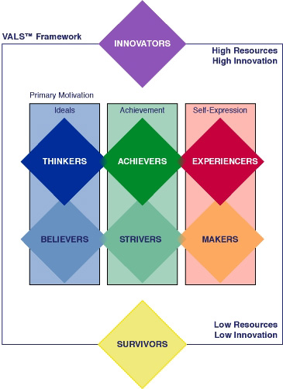
- Benefit segmentation – fitness market “winners/dieters/self-improvers”
- Usage segmentation (loyal, switchers)
- Generations
Business-Business Segmentation:
- Industry – NAICS code
- Company size
- Geographic location
- Product usage – ex use of the hotel’s facilities
- Customer value
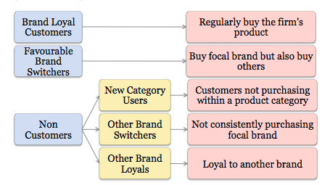
PMB = print measurement bureau – DATABASE
provide information on your target audience
sales promotion is important for first 2 blue. Red#4 don’t care strong heuristics. Red #5 leave others’ loyal with small budget

  - Establish communication objectives – 4 criteria in defining objectives
    - Specific target audience

    - Specific tasks
- Objective should relate to some defined behaviour or attitude on the part of the target segment. Ex is target is non-users, one objective might be to change levels of non-users awareness of product or trial of product -choosing one of these would lead to vey different messages and delivery of the IMC campaign since trial requires much more effort than changing attitude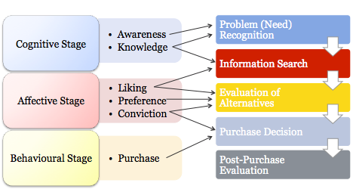
As an objective on of these needs to be addressed

    - Specific changes
- Increase awareness levels from 50% to 75% (a 25% increase)
- Ex. 10% on non-users have tried the product – one task might be to develop a trial level of 50% among non-users – this include the initial benchmark
    - Specific time
- 12 month period
Taken together, what does a communication objective look like:
- To increase knowledge from 50% to 75% (25% increase) among females aged 18-24 in 12-months
- Increase trial amoung non-users from 10 to 50% over 1 year

  - Create a communications budget (PREVIEW)
    - Payout plan
    - % of sales
    - Affordability
    - Competitors
    - Objective & Task** Takes budget and puts it into objective
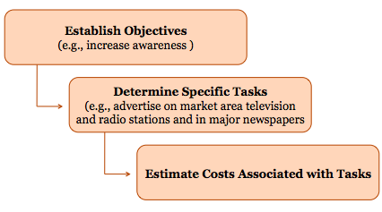
Small Budgets/Large Budgets Rules to follow to achieve success:
- Start Research, (2) Focus on objectives, (3) Get Creative
Ex. Weather Network, and Camp Okkuta
more impactful when working with a small budget – every $ counts!

Chapter 5 & 6
Creative Strategy and Creative Tactics
Hierarchy of Effects
The order related to FCB Grid

ELM: Elaboration Likelihood Model
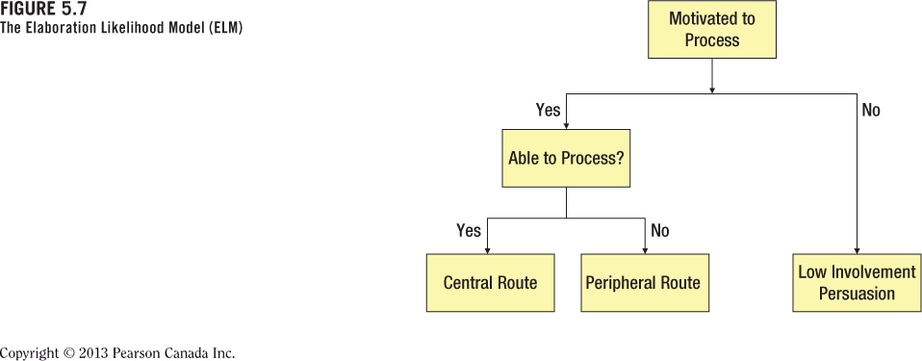
Combining now
Everything that is not central
Closely listening
Much more LONG LASTING

Classical Conditioning peripheral (salivating Dog)
- Unconditional Stimulus unconditional response
- Neutral stimulus nothing
- UCS + neutral stimulus UCR (during conditioning)
- Bell (CS) CR (after conditioning)

In advertising
UCS (kittens) consumers think soft & positive
Neutral Stimulus (Kleenex) we think neutral
PUT KITTEN ON BOXUCS+ neutral stimulus consumers think soft & positive
Now: CS (Kleenex) CR we think soft & positive (after conditioning)

Creative
The BIG idea should SOLVE your communication problem

2 Components: ****KNOW THE DIFFERENCE BETWEEN THEM

(1) CREATIVE STRATEGY | (2) CREATIVE EXECUTION
- The “logic”  - WHAT the IMC should say  - The business end of the creative process (client, account service, research) | - The “magic”  - HOW to say it  - The creative end of the process (copywriters & art directors followed by photographers, cinematographers, models etc.)
What your telling them --------------------------------HOW your telling them
Example:
      - A pharmaceutical maker has developed a product that will significantly increase the human life span
        - Creative Strategy? ONE SENTENCE
          - By taking our product you will live longer than you ever thought possible
        - Creative Execution

Message Appeals (Strategic Creative)
(1) Rational | (2) Emotional
- Price  - Performance (Weather Network)  - Scarcity | - Humor (WN execution)  - Sex  - Fear

Fear Appeals and Message Acceptance
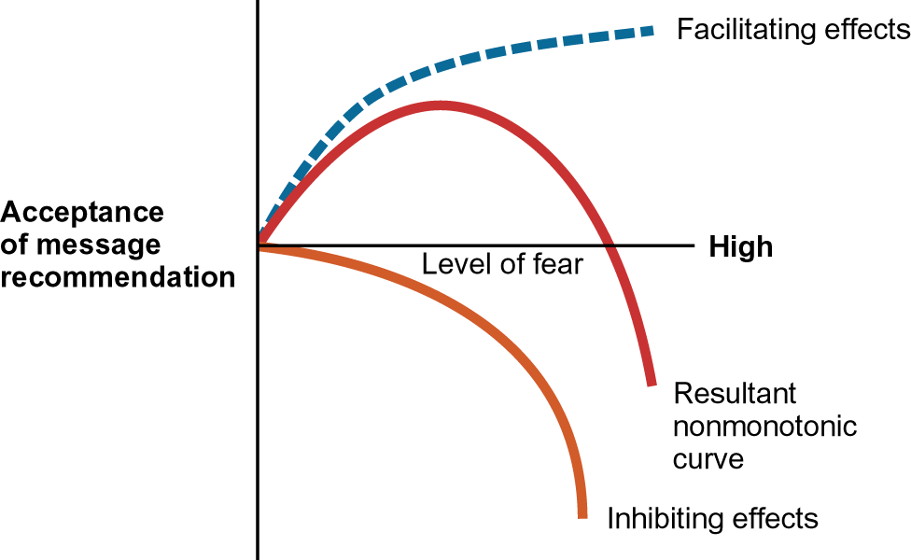
Resultant nonmonotonic curve

Jetta Safe Happens:
FEAR = #1 Wear-out rate
Strategy = performance
Safe in an unforeseen accident
Execution = emotional-fear

Creative Tactics
- Message tactics – dependent on APPEAL
  - Cognitive Tactics **Get them into processing mode/ awareness
    - 3 conditions must be met!
Benefit/Unique/Strong – switch to your product
    - These tactic work very well for Rational Appeal
    - Generic messages
    - Pre-emptive messages
    - USP (Unique Selling Point)
    - Hyperbole
    - Comparative messages: use for BRAND DIFFERENTIATION

WHY USE? | WHY NOT USE?
- Communicate advantages relative to competitor(s)  - Consumer’s evoked set | - Believability/credibility of claims  - May focus more attention on the competitor’s brand
New product use more often to get in evoked set
Market leaders don’t usually use this tactic OR if product is similar

  - Affective Tactics
    - Emotion Driven Cheerio commercial
  - Conative Tactics
    - Goal: Elicit behavior = Buy first – figure out the rest later
    - EX. Flash Sale = price driven

- Executional Framework USED IN COMBINATIONS
  - Comparison
  - Slice of Life
  - Dramatization
  - Animation
  - Humour
  - Fantasy

  - Informative
  - Authoritative
  - Demonstration
  - Testimonial

- Sources
The person involved in communicating a marketing message. For example:
The current trend is using a combination of both PEOPLE and CELEBRITY
  - Experts
  - CEO
  - Typical-person ads/Models
    - Usually likeable, similar therefore trustworthy
  - Celebrities
    - Likeability usually trumps others
    - Problem with trustworthyness

Source Characteristics
Budlight – what ever happens:
Arnold:
Kind of attractive/truswothy, but VERY Likeable,

Ian:
Similar, like, trust -> because like you!

- Storyboard/ Radio Script (outside of the textbook)
  - More for team projects
  - Emotions are in [italics]
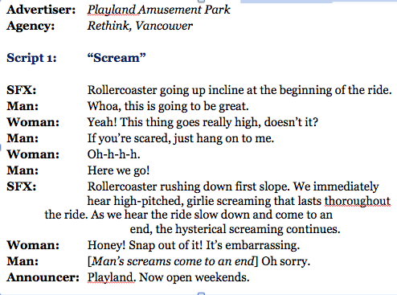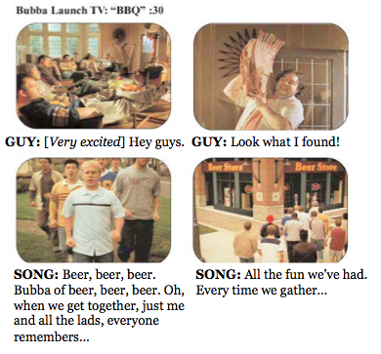

When building a campaign what is important?
- Creative consistency
  - Consistency over time
    - Message repetition
  - Consistency over appeals
    - Visual consistency
    - Consistent taglines
  - Variability Theory
    - Use combination of different tools

Chapter 7 (Pg. 199 – End)
Media Selection
Broadcast (radio) – read in text
TV
Strengths | Limitations
- High reach  - High frequency potential  - Low cost per contact  - Quality creative opportunities  - High intrusion value  Low recall due to Clutter  - Segmentation possibilities through cable outlets | - Greater clutter  - Channel surfing during commercials  - Short amount of copy  - High cost per ad  - Low recall due to clutter
Production/ media cost are very expensive, but great reach (therefore per person can be affordable)

TV Audience Measurement Terms
- Universe Estimate (U.E.) : the total number of households (10 houses)
- Households Using Television (HUT) or Persons Viewing Television (PVT) = Households using TV/Total TV households ( (6/10) = 60%
  - 1 household = 1 person
- Share (of Audience) – The percent of HUTs (or PVTs) tuned to a specific program Channel 9? 3 on channel 9 so (3/6 = 50%)
- Rating % - The estimate percent of all TV households or persons tuned to a specific station 3/10 = 30%
  - Rating is most important as it dictates advertising rates
- Top 10 Canadian Program
  - Free data – 2 and Over (age) global look

Nielsen Media 101
more targeted look at who is watching/ therefore more targeted advertising

Out-Of-Home (OOH)

Strengths | Limitations
- Large, spectacular ads possible  - Able to select geographic areas  - Accessible for local ads  - Low cost per impression  - Broad reach  - High frequency on major commute routes | - Short exposure time  Strong bold messages  - Brief messages  - Little segmentation possible  no control over who walks by  - Cluttered travel routes

Place-Based on screen in a shopping mall info page – scans face presents targeted ad. Or at Tim’s reads you while ordering offer a donut to go with purchase

Print
Strengths | Limitations
- High market segmentation  - Targeted audience interest by magazine  - High color quality  - Long life  - Direct response techniques  - Read during leisure time  - Longer attention to ads | - Long lead time for ads  - Little flexibility  - High cost  - High level of clutter  - Declining readership

Circulation and Readership
- Circulation – the # of individual who receive a publication through subscription or store purchase, or through controlled distribution (free) – controlled distribution (get from a hotel)
  - Circulation INC = Rates INC
- Readership = Circulation x Readers Per Copy
  - Long process coming door to door
  - Readers per copy usually = Avrg. Of 3
  - Direct Relationship Readership INC = INC cost

Trends
- Interactive ads in the digital editions
- Applying motion to standard magazines
- Russia Vogue ( Bacardi)

