The Cell Cycle

Interphase
- G₁ Phase – Period of cell growth before the DNA replicates
- G₀ Phase – Cell cycle arrest – required to give cell more time to prepare for DNA replication - some cells never pause, and other stay in the G0 phase for a long time and then go back into the cycle
- S Phase – Period when DNA replicates and chromosomal proteins are duplicated
- G₂ Phase – Period after DNA replicates; cell prepares for division
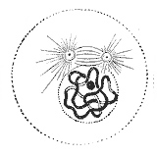
Mitosis (M-Phase)
- Prophase - The two round objects above the nucleus are the centrosomes. The chromatin is condensing into chromosomes.

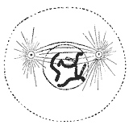

- Prometaphase - The nuclear envelope disintegrates, and microtubules have invaded the nuclear space. These microtubules can attach to kinetochores or they can interact with opposing microtubules.

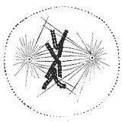
- Metaphase - The chromosomes align at the metaphase plate.

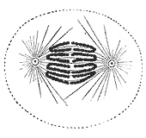
- Anaphase - The chromosomes split and the kinetochore microtubules shorten.

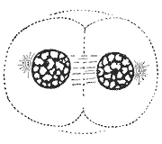
- Telophase & Cytokineses - The decondensing chromosomes are surrounded by newly formed nuclear envelopes. Cytokinesis has already begun; the pinched area is known as the cleavage furrow.

Cell Cycle Regulation
- Some cell divide very often – Ex) roots (plants), epithelium (skin, intestines), etc.
- Some do not divide in adults (RBC, muscles, most neurons)
- How does the cell know what to do and when to do it? – checkpoints that look for molecular signals and determine cell’s fate
- 3 main checkpoints
- At the end of G₁ (G₁/S checkpoint – G₁ restriction point) - allows you to ensure that cell growth is sufficient and lets you go into S phase
- At the very end of G₂ (G₂/M checkpoint)
- In the transition from metaphase to anaphase during M phase (M phase checkpoint)

Checkpoints
- G1/S checkpoint (restriction point; start) - check if cell size is adequate and if DNA is damaged, if there are the proper nutrients to sustain new and larger cells - triggered by growth factors (signaling cascade; TRK)
- G2/M checkpoint - look at size and make sure DNA has replicated properly – influenced by cell size, DNA damage, DNA replication
- M-phase checkpoint (Metaphase-Anaphase transition) - makes sure all of the spindles are attached properly
- If all this is working properly it can give the cell some more time or let it go on to next step
- If the cell is too damaged apoptosis

Growth Factors –NGR
- One of these growth factors go on to activate cyclins and cyclin dependant kinase - protein and enzymes that regulate the checkpoints
- Both translated at the same time - cyclin is already active and Cdk get activated by cyclins

Cdk (Cyclin Dependant Kinases)
- Control the cell cycle
- Kinases that depend on cyclins to become activated
- The levels of Cdk’s (and cyclins) rise and fall during the cycle – this controls each step
- They are sorted based on the checkpoint they govern
- G₁/S cyclins: bind Cdk near end of G₁ and lead cell into DNA replication
- S-cyclins: bind Cdk during S-phase and are required for DNA replication
- M-cyclins: promote the events of mitosis
- G₁-cyclins: (in most cells) promotes passage through restriction point in late G₁
- Checkpoints - moments in cell cycle where we can assess whether we can move forward - done using molecular checkpoint - molecules that need to be present in a sufficient amount in order to pass checkpoint
- When cell receives proper signalling - growth factors initiate cascade that leads to translation of cyclin and Cdks - form a complex that needs to be active to pass checkpoint
- Maturation Promoting Factor (MPF) = Cyclins + Cdk complex
- Concentrations rise and fall according to stage in cell cycle
- As growth occurs cyclins and Cdks are made - cyclins and kinases are saved from previous cycle - as you progress concentration of MFB build up - when there is enough the cell goes into S phase – same thing happens for all other checkpoints
- After check point is passed cyclins are degrades – other cyclins are being made for the next checkpoint
- If there are not enough cyclins the cell can go into G₀ and give it more time to produce cyclins, or it there is too much damage it can send it off to apoptosis using intrinsic signalling pathways
- p53 - watch dog - interacts with many different other proteins in the cell - puts cell into G0 and resume G1/S later on
- If DNA is too damaged - p53 triggers apoptosis - p53 dephosphorylates Bad
- p53 can also trigger miRNA - mRNA degradation or delay translation

Mitotic Spindle Fiber
- Depolymerization of microtubules - no covalent bonding in microtubule - easy to separate and easy to grow
- Motor protein pulls it toward centromere - dyenine - moving to inside of centromere

