Deoxyribonucleic Acid (DNA): The Hereditary Molecule
- 1911 – Thomas Hunt Morgan associates traits (genes) to chromosome by studying sex-linked inheritance in Drosophila melanogaster
- 1928- Fredrick Griffith identifies properties of strains of Streptococcus pneumoniae related to their virulence in mammals
- 1940 – Oswald Avery determined that these properties were related to DNA (not RNA or proteins)
- 1952 – Alfred Hershey demonstrates that DNA was indeed the hereditary molecule using phages in E. coli
- 1953 – James Watson and Francis Crick determine double helix structure of DNA
- 1962 – Watson and Crick given Nobel Prize (with Maurice Wilkons), BUT NOT Rosalind Franklin
- 50 years later – were able to sequence entire genome

DNA Structure
- Knew that DNA was made of ATGC (pyramidines and purines) – but not structure
- Used X-ray crystallography – determined that DNA was 2nm in diameter
- Only possible structure was helix with A-T and G-C
- Nucleotides bases are attached to a 5C sugar (deoxyribose) and a phosphate group (at 5’ end)
- Nucleotides connected to each other with phosphodiester bond between 3rd carbon of the sugar and the P group of the next nucleotide
- Orientation – first nucleotide is at 5’ end (P-group), last nucleotide on 5’ end (C-OH group)
- Elongation is always 5’ to 3’
- Double Helix – strands are in opposite direction, N bases are facing inside the helix and provide stability by H-bonding – sugar and phosphate form a ribbon backbone

Ribonucleic Acid (RNA)
- Made in similar fashion to DNA – made using a different sugar, ribose, and uracil instead of thymine
- Single stranded
- Many types: mRNA, tRNA, rRNA

Organizing DNA
- DNA is wrapped around histone proteins to make nucleosomes – nucleosomes wrapped together to make chromatin – chromatin wrapped together to make solenoid – solenoid forms chromosomes

Central Dogma
DNA Transcription mRNA Translation Proteins
DNA is replicated before cell division

DNA Replication – 3 Models
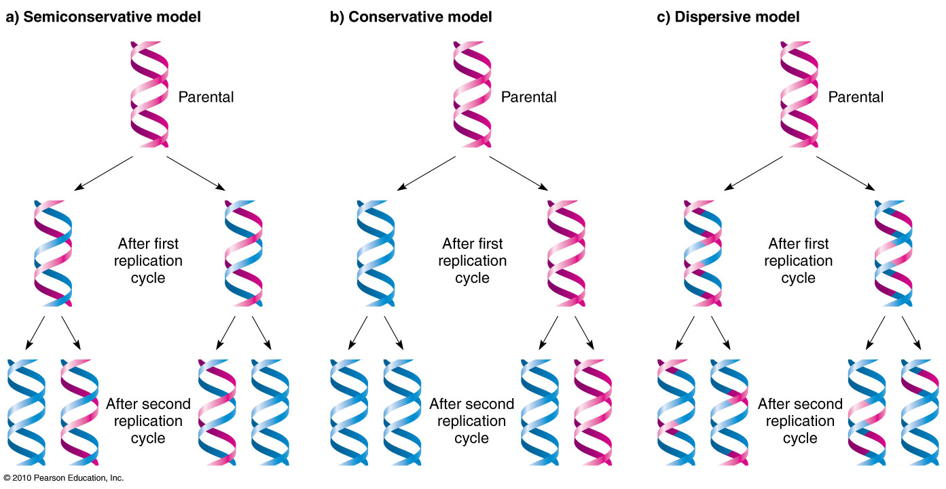

Meselson-Stahl Expetiment
- Grew bacteria in heavy nitrogen (15N) to make nitrogenous bases, and then put them in regular nitrogen. Bacteria offspring had half of the DNA from the parent; therefore semi-conservative model was correct.

DNA Replication
- DNA helicase unwinds DNA
- Single Strand Binding (SSB) proteins binds to strands to keep them apart
- Primase makes short RNA primers in 5’ to 3’ direction on both strands; towards fork in leading and away from fork in lagging
- Topoisomerase (gyrase) is an enzyme that releases tension by cutting between nucleotides to prevent DNA supercoiling
- On leading strand DNA pol III (can only bind to double strand) comes in with sliding clamp to add nucleotides to RNA primer (5’ to 3’)
- On lagging strand DNA pol III add nucleotides away from fork; another RNA primer is added closer to the fork and DNA pol III adds nucleotides until it reaches the first RNA primer. DNA nucleotide sequences that are separated by RNA primer are called Okazaki fragments
- DNA pol I replaces all the RNA nucleotides for DNA nucleotides
- DNA ligase seals the nick between lagging strand fragments
- Proofreading
- DNA pol III can scan for mistakes. If DNA pol III adds wrong nucleotide it will reverse, then use exonucleases to cut out the incorrect nucleotide and replace it with the correct one
- Endonucleases can scan for mistakes. When mistake is made, they will cut out a portion of the nucleotide sequence and DNA pol III will add the correct nucleotides. This leaves nicks; DNA ligase comes in to seal them.
- Mistakes can be recognized based on the size of the base and improper hydrogen bonding
- After replication, the lagging strand daughter DNA ends up with an overhanging strand. DNA becomes shorter with each set of replications

Telomeres
- Repeating additional non-coding DNA sequence (TTAGGG in humans) that act as a buffer zone and protect DNA from sticking to other chromosomes (mutations)
- Telomerase enzyme has own RNA primer template can extend and add nucleotides to single stranded 3’ end
- Detaches when all nucleotides are added and can then attach and repeat on newly synthesized telomere DNA
- Primase adds primer to telomere; now DNA pol III can add nucleotides. Primer is then removed
- Overhang that results from removal primer can loop over itself, no longer single stranded
- RNA makes DNA – goes against Cenral Dogma

Working with DNA
- DNA cloning – isolate DNA genome and cut it into fragments. Put fragments into bacterial plasmid to make recombinant DNA plasmids. Put plasmids into bacteria and wait for bacteria to replicate and grow with the gene of interest
- Restriction enzymes – cleave sugar-phosphate backbone to make sticky ends. Add another DNA fragment with complementary sticky end between the separated sequences to make recombinant DNA. Nicks form; ligase used to seal them
- Polymerase Chain Reaction (PCR)
- Denaturation – Heat DNA containing target sequence to denature it into single strands
- Annealing – cool mixture to allow primers to anneal to complementary sequences
- Heat again to extend the primers and repeat process
- Primase and DNA pol III are added to the mixture from the beginning

