Why Do Cells Die?
- They have outlived their use – as we age we no longer need some cells
- Brain cells die to strengthen the connection between brain cells that used more – up to 50% of brain cells are eliminated by programmed cells death
- Embryonic development – destroying skin cells between fingers; tadpoles losing their tails
- Controlling the size of organism
- Irreparable cell/DNA damage; infection

What triggers Cell Death?
- Chemical messengers (growth factors, mitogens, survival tactics)
- Toxicity
- Damage
- Cell cycle check points

Necrosis Vs. Apoptosis
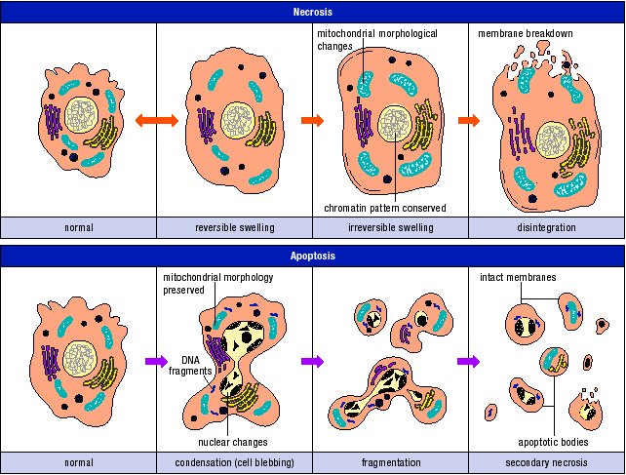

Necrosis
- Cell starts swelling until the membrane disintegrates
- Lots of water diffuses into the cell
- Caused by a change in osmotic pressure
- Membrane is also selectively permeable - permeability to ions and water has changed - now permeable to everything
- Active transport and membrane potential (gradient) is all off
- Swells and eventually everything explodes (cell lyses)
- Cytoplasm - contains enzymes that are able to cut neighboring cells
- Occurs due to a negative stress (damage)
- Results in non-functioning mitochondria

Apoptosis
- Apoptotic bodies are encompassed by membranes
- There are no enzymes free to degrade other cells
- The membranes with organelles will be phagocytosized into and incorporated into other cells
- Caused by intrinsic or extrinsic stress signals – not only caused by negative stressors
- Programmed cell death (autophagy) – on purpose
- Maintain mitochondria functionality

Apoptosis – Structural Changes
- Cell is healthy - then something triggers it to die
- Message is interpreted and initiates a cascade of death
- Chromatin is condensed in nucleus
- Cytoplasm begins shrinking
- Nuclear envelope disintegrates
- Nucleus get fragmented - DNA is cut into smaller portion - DNA laddering - specific enzymes cut it into smaller chunks
- Small portions that are being engulfed by a membrane
- What was keeping the cell attached to neighbor is not doing its job
- Cell junctions - gap, adhesion, anchoring - is not doing their jobs - no more attaching
- Forms little vesicle engulfed by membrane - blebbing
- Little blebs detach from cell and are engulfed by macrophages through phagocytosis
- Neighboring cells are unaffected

Phagocytosis
- Asymmetric distribution of plasma membrane is lost
- Phosphatidylserine (negatively charged) moves to outer leaflet of membrane
- PS on outside marks cells for phagocytosis by macrophages (WBC)
- How does PS move to the outer leaflet?
  - Some of it is spontaneous (rare)
  - Flipase - P type ATPase - active transport - translocates towards inner leaflet - used to maintain asymmetry - not apoptosis
  - ABC (ATP-binding cassette) flipase - need ATP translocates PS to outer leaflet
  - Scramblase – doesn’t need energy - depends on calcium and caspase (enzymes) - large intergral proteins that are inactive - activated by calcium along with caspases (initiated by cell death signal) - translocates in both directions - favours moving PS to outer leaflet

Apoptosis – Signaling Pathways
- Intrinsic – internal stress triggers apoptosis
  - Triggers: loss of survival factor or DNA damage
  - Leads to dephosphorylation and activation of Bad (pro-apoptotic protein)
    - Pro apoptotic protein is on a leash by being phosphorylated- dephosphorylation activates unleashes Bad
  - Bad inhibits Bcl2 (anti-apoptotic) on mitochondria – also activates Bax and Bak – lets Ca into mitochondria – creates PTP – cytochrome C released
  - Results is caspase cascade
- Extrinsic – external stress triggers apoptosis
- Caspases – family of proteases (enzymes that cleave proteins)
  - 2 groups of caspases – initiators and executioners
  - Initiator caspase initiates executioner caspases
    - Inhibits protein kinases – disrupts cell adhesion – cell detaches and blebs
    - Inhibits lamins – nuclear envelope disassembles -nuclear fragmentation
    - Activate DNAse – Fragments DNA
    - Inhibit parts of cytoskeleton – change in shape and size – blebbing – cell fragmentation
    - Activates scramblase – moves PS from inner leaflet to outer leaflet of membrane

- Calcium
  - Toxic to cell - if there is too much Ca inside cell its toxic to cell
  - Where is Ca stored - mitochondria, ER, calcium binding protein
  - What if there is too much calcium that nothing can accommodate them?
    - Becomes toxic to mitochondria as well
    - Punches hole in mito membrane
    - Mitochondria has double membrane - with important proteins in between
    - When calcium is high cristae is rearranged
    - Punches a hole - permeability transition pore (PTP)
    - Allows a protein called cytochrome C to exit mitochondria and go trigger caspase cascade
  - Lots of Ca in ER
  - How does it go out?
    - Calcium channels gated by IP3
    - Bcl2 prevent IP3 from binding to channel
    - Prevent ER from releasing calcium
    - When Bcl2 is inactivated by bad - Bak and Bax are activated
    - Bak and Bax facilitate IP3 binding to channel
  - Where does Ca go?
    - Goes to mitochondria
    - Facilitates reaching that critical Ca concentration that causes the hole to form in the mitochondria to allow cytochrome C out of mito into cytsol
  - Calcium is also a consequence or trigger of necrosis

Mitochondria in Apoptosis
- Mitochondria in cell that receives trigger to start apoptosis
- Activates Bad (dephosphorylation) – pro-apoptotic protein
- Inactivates Bcl2 – pro-survival protein
- Activates Bak and Bax (pro-apoptotic proteins) – facilitate IP3 gated ion channel on ER
- IP3 is also activated – attaches to GPCR on ER and releases Ca²⁺
- Excess Ca²⁺ goes into mitochondria - Causes Ca concentration to increase on inside of mitochondrial membrane
  - Change in concentration creates Permeability Transition Pores (PTP) on mitochondrial membrane - allowing cytochrome C out into cytosol
What does cytochrome C do?
- Initiates caspase cascade
- Cytochrome C binds with APAF-1 and caspase 9 – creates wagon wheel structure called apoptosome
- Activates initiator caspases which activate execution (effector) caspases
  - Leads to apoptosis processes

Mitophagy
- Controlled regulation of number of mitochondria according to metabolic needs
- Involves various signaling proteins and lysosomes
- Important for aging, development, and certain pathologies (AD, Parkinson’s, etc.)
- Can reduce number of mitochondria or get rid of damaged portion of mitochondria
- Both cases extra membrane proteins allow signaling cascade in cell to direct mechanism
- Occurs normally in aging and activity levels, also involved in pathologies involving mitochondria
- Something damages the mitochondria, or there are too many
- In this example - stress damages a portion of the mitochondria
- Mitochondria can divide itself - healthy portion breaks off (only a part) - fuses with another healthy mitochondria - recovering the healthy portion
- How to get rid of damaged mitochondria - express one the surface proteins called PINK 1 - recruits other protein called Parkin - adds ubiquitin groups on cell surface - signals cell to direct organelle to lysosome - using microtubules

